TechLab

TechLab Student Manual
A step-by-step guide for students. Each step has a real screenshot of what you will see on screen.

Screenshots use a demo student, Maria Santos (codename StarMaria), taking Computer Programming 1 in Self-paced mode. Captured 18 October 2026.

Contents

If the contents list is empty, right-click it in Word and choose Update Field.

STUDENT · PART 1

Create your account
Takes about three minutes. You will sign up, agree to the rules, and build your astronaut.

Step 1. Open TechLab and start your mission
Go to the TechLab home page. Click Start your mission to make a new account.
Already have one? Click Log in instead and skip to Part 2.
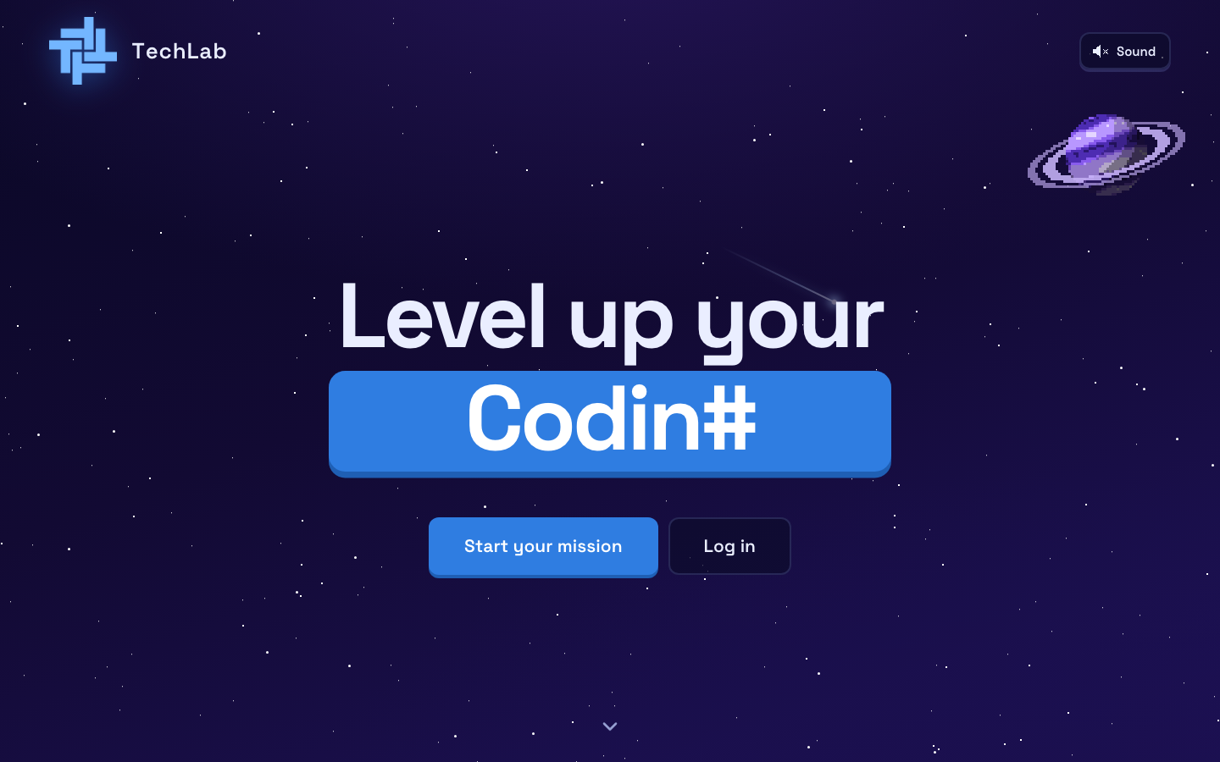
The TechLab home page

Step 2. Fill in the sign-up form
- Type your first name and last name. Use your real name.
- Type your email. This is what you log in with, and it can't be changed later.
- Pick a password with at least 8 characters, then type it again to confirm.
- Choose your program (IT, IS, CS, BLIS or EMC) and year level.
- Pick the planet you want to learn first: Programming, Networking or Cybersecurity. You can only pick one now. The others unlock later.
Click Create account.
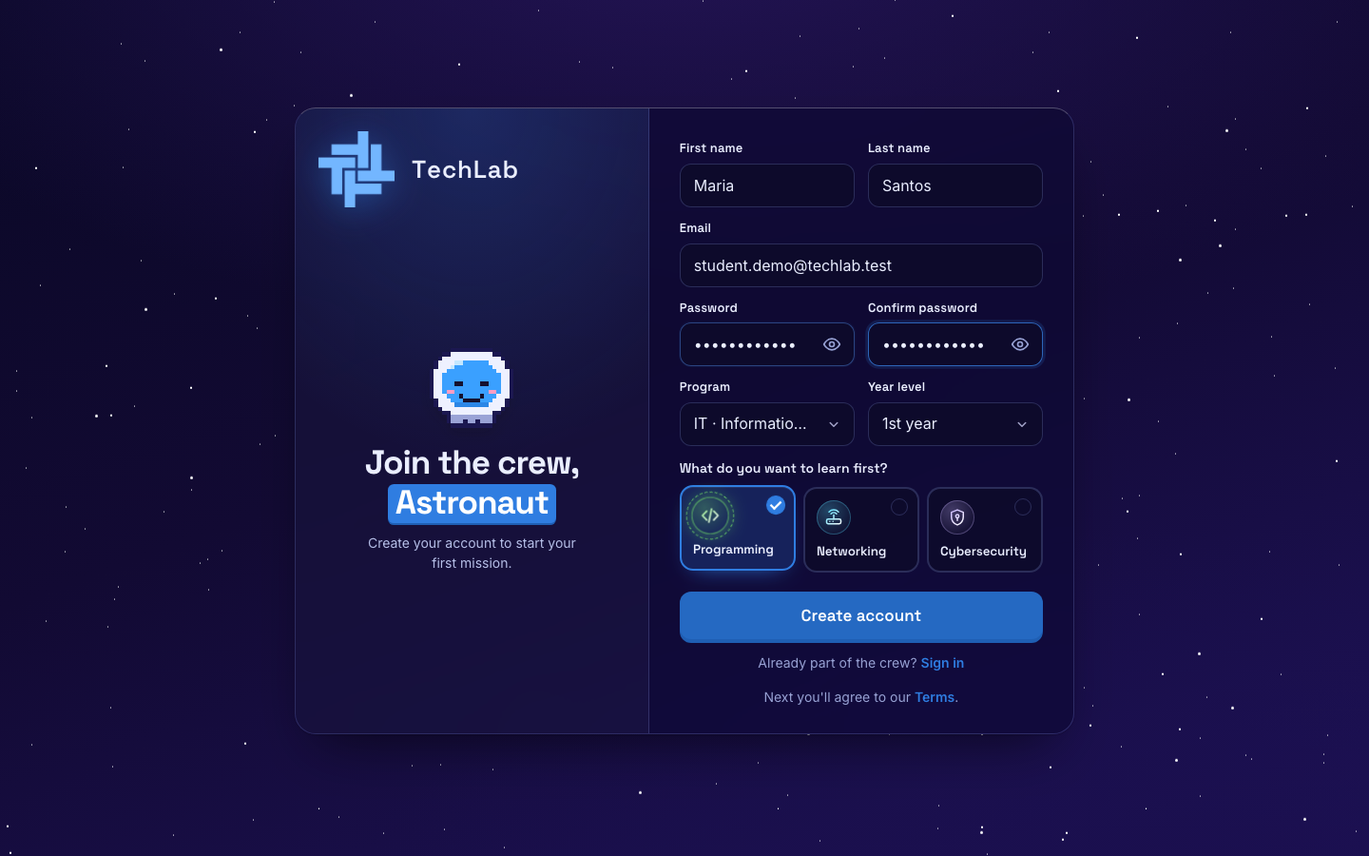
The sign-up form, filled in

Step 3. Read and agree to the rules
TechLab has 7 short rules. Read them, tick I have read and agree, then click Agree and continue.
KNOW THIS EARLY: Quizzes give you one try with a timer. In the Final Boss, switching tabs, leaving full screen or taking screenshots fails the exam and gives you a strike. Two strikes and you are banned from that course.
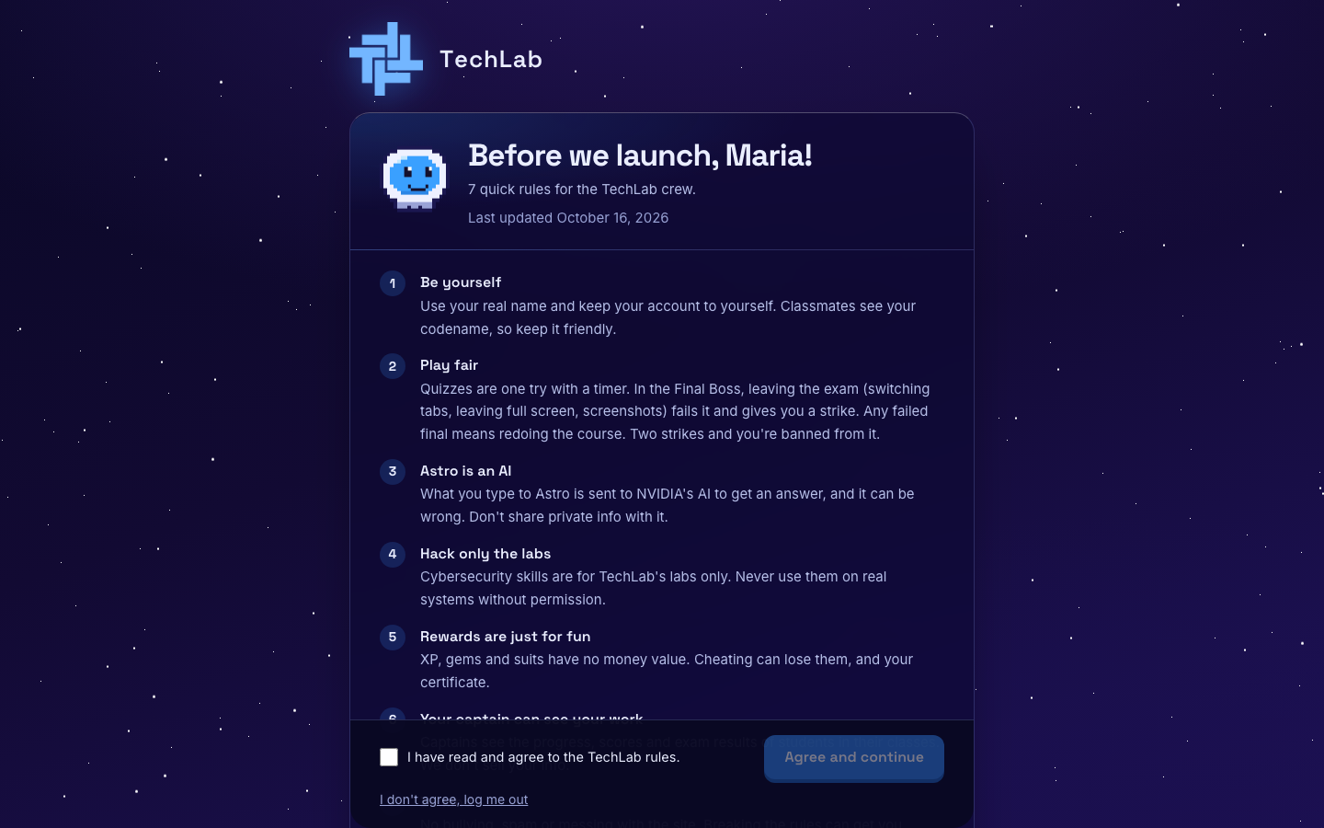
The TechLab rules

Step 4. Meet Astro
Astro is your AI guide. Click Continue to read each message, then Make my astronaut.
Music plays here. Use the Music on button in the corner to turn it off.
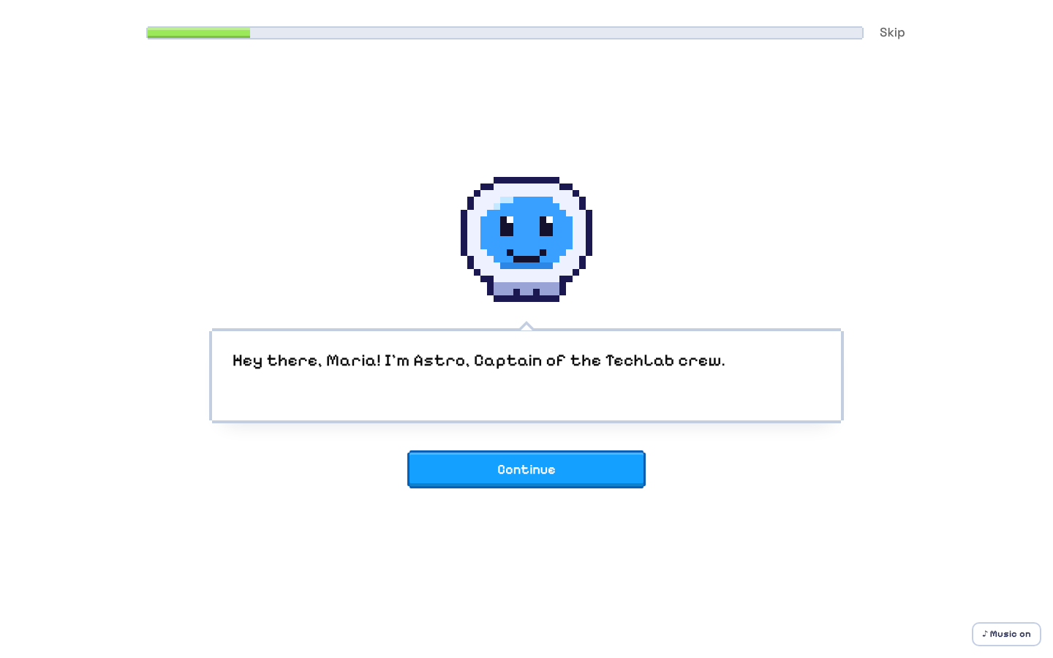
Astro says hello

Step 5. Build your astronaut
Use the Animal, Suit and Helmet tabs to choose your look. The Cat is free. Other animals cost XP, so you can buy them later in the Shop.
Click Random for a surprise, or Looks good! when you're done.
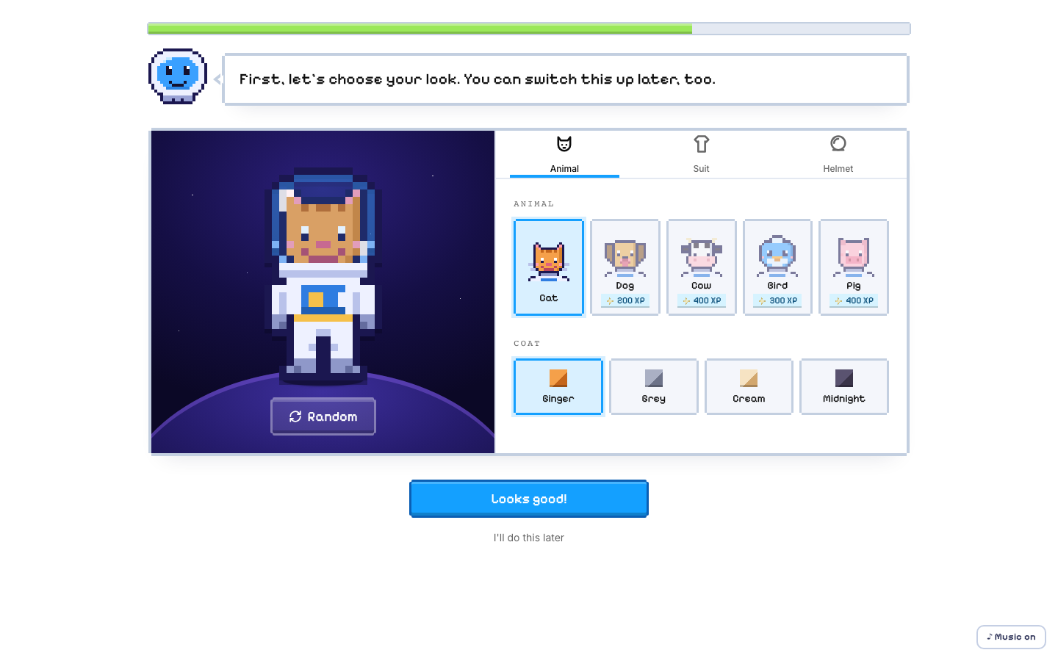
The astronaut builder

Step 6. Pick a codename
Your classmates see your codename, not your real name. Keep it friendly. Stuck? Click Give me a codename idea.
Click That's me!, then Start my mission.
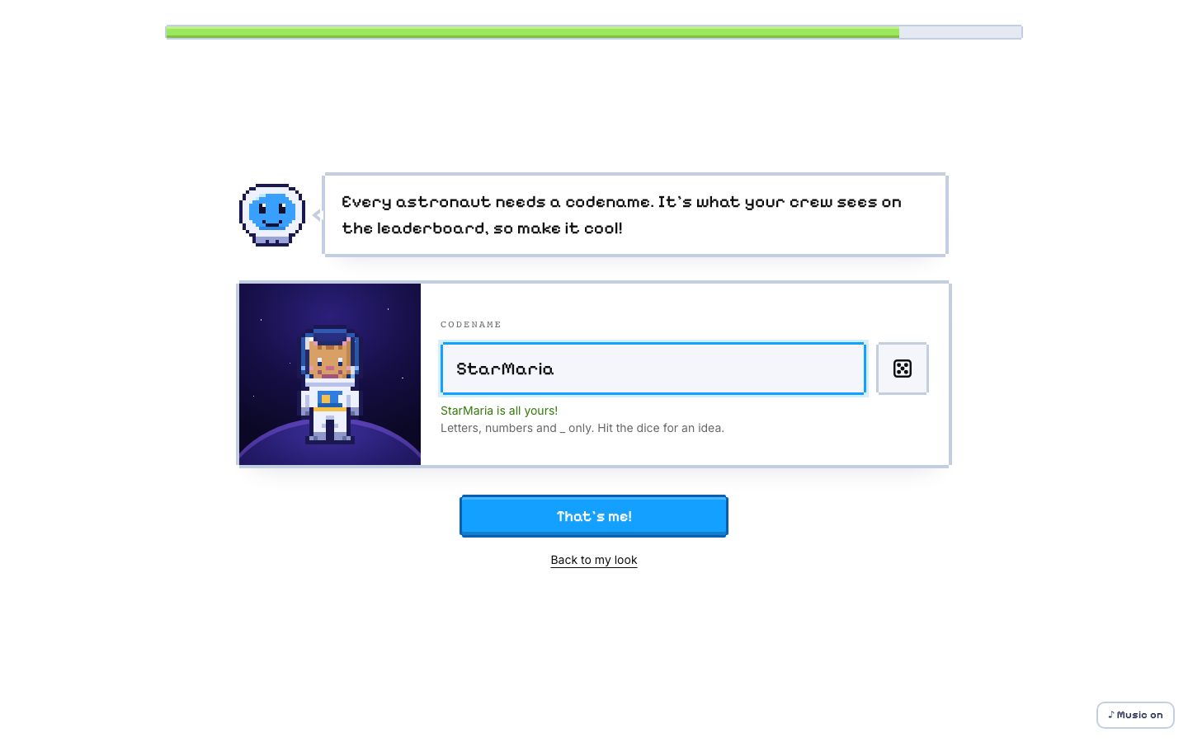
Choosing a codename
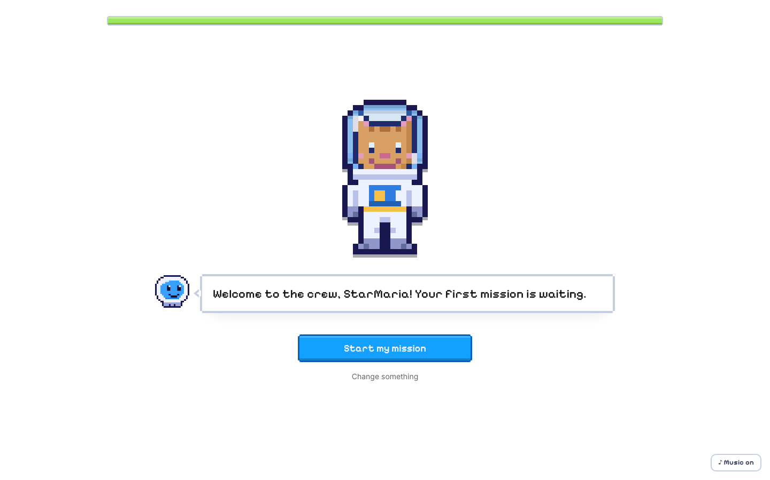
Ready to start

STUDENT · PART 2

Your dashboard
Home base. It shows your planet, your level and the leaderboard.

Step 7. Follow Astro's tour
The first time you arrive, Astro gives a short tour (13 stops). Click Next or press the right arrow key to move on. Click Skip tour to close it.
Want it again later? Click the ? (Tour) button in the left sidebar.
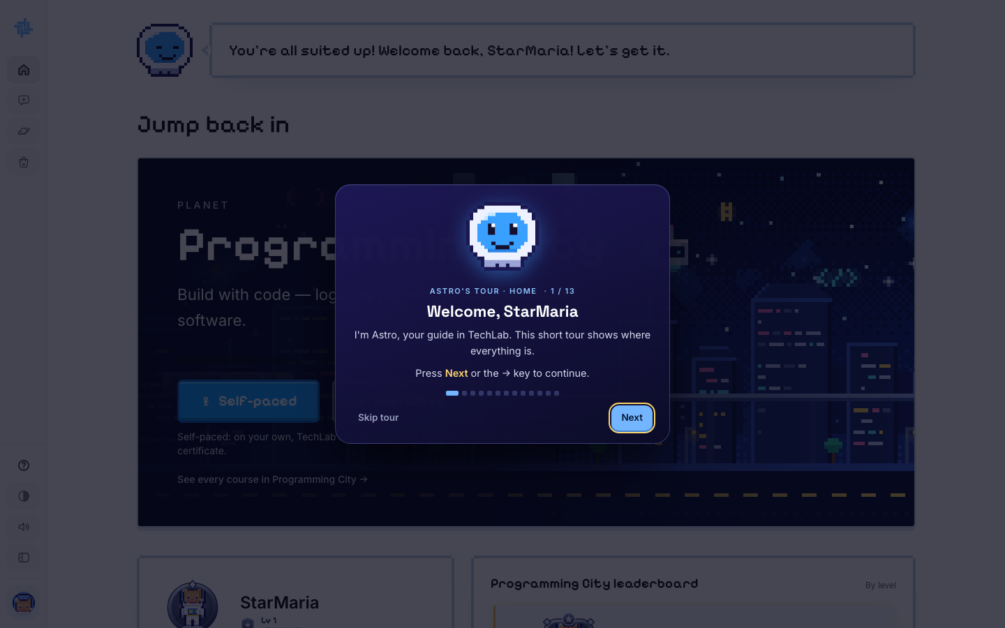
Astro's tour, stop 1 of 13

Step 8. Find your way around
The left sidebar is on every page:
- Home: this dashboard
- Chat: talk to Astro
- Planets: all three planets and their courses
- Shop: spend XP on frames, animals and suits
- At the bottom: Tour, light/dark theme, sound, and your account menu (your avatar)
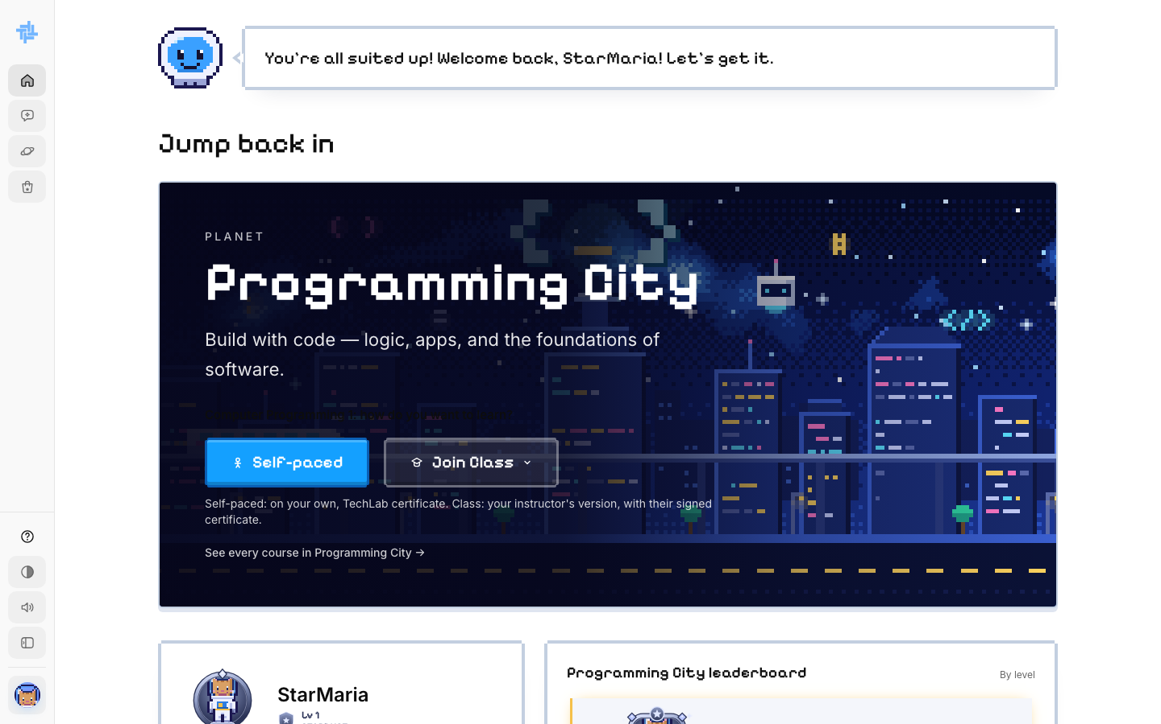
The dashboard and sidebar

STUDENT · PART 3

Join a course
There are two ways to take a course. You can be on only one of them per course.
 | Self-paced | Join Class
Who teaches | Just you and Astro | Your instructor (the Captain)
How you join | Right away, one click | Send a request; your instructor accepts it
Lessons | The standard TechLab version | Your instructor's version, which may be edited
Mini boss you fail | Next module stays locked, wait 60 min, try again | One try, score is recorded, nothing locks
Certificate | TechLab certificate (PDF) | PDF with your instructor's digital signature

Step 9. Choose Self-paced or Join Class
On the dashboard's planet card:
- Click Self-paced to start on your own right now.
- Or click Join Class, find your instructor's name, and click Ask to join. You will get in once they accept.
CHOOSE CAREFULLY: Once you pick Self-paced or a class for a course, it can't be changed later. Pick the one you want before you click.
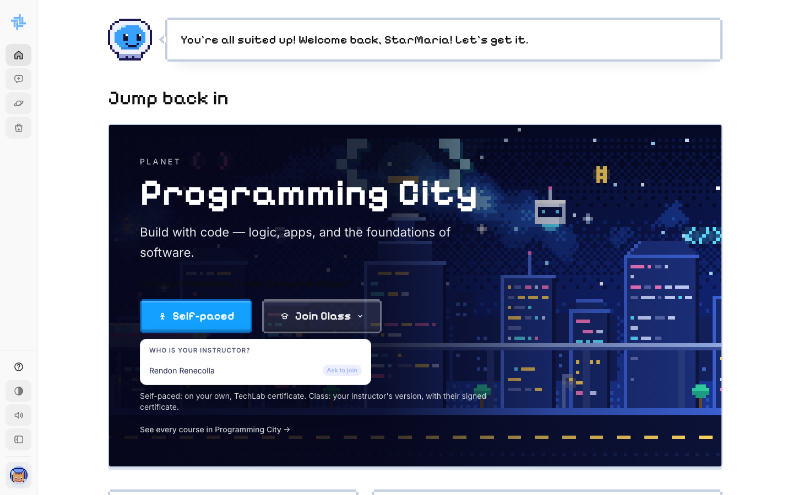
The Join Class menu

Step 10. Look at your course page
After you join, you land on the course page. It lists every chapter (module) and its lessons. Lessons unlock in order.
The right side shows the syllabus PDF, your progress and the gems you can earn. The Crew tab shows your captain and a crew leaderboard.
Click Start Learning.
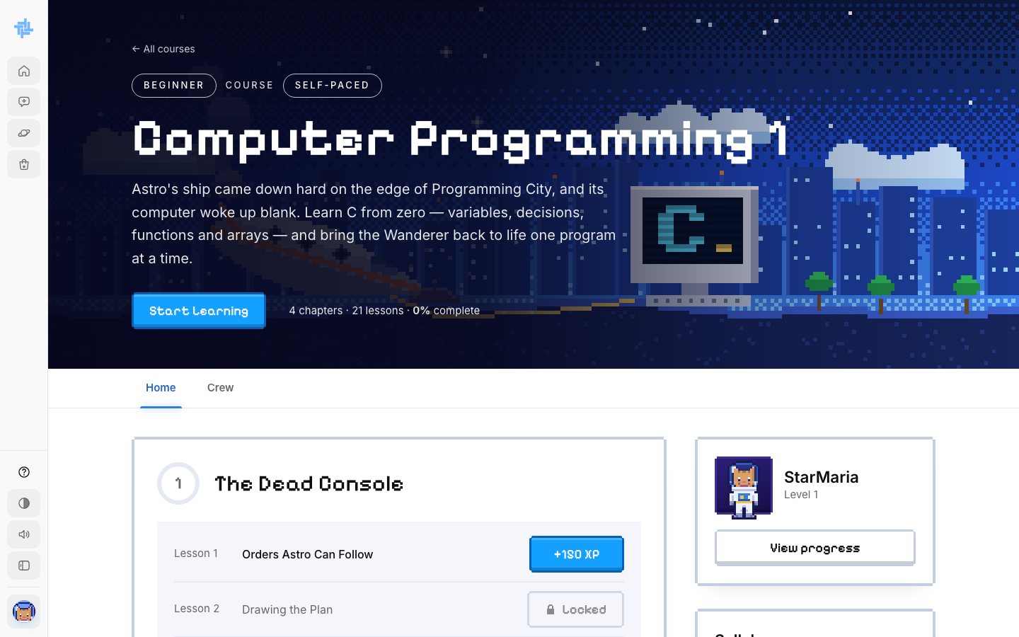
The course page
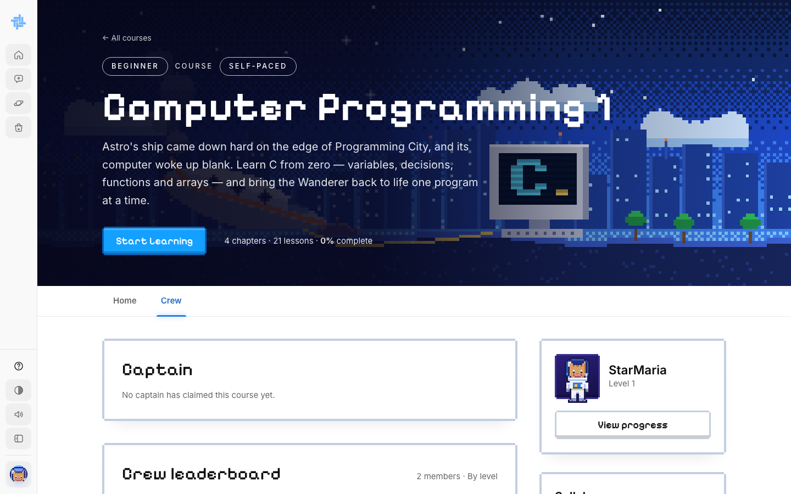
The Crew tab

Step 11. Find your courses later
Every course you have joined is listed on My Courses. Open one to get back to its lessons, quizzes and crew.
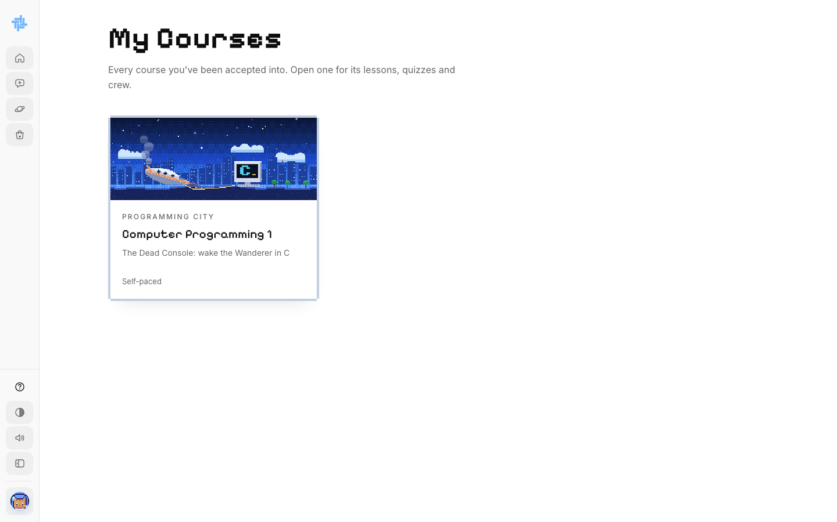
My Courses

STUDENT · PART 4

Take a lesson
Every lesson has the same 5 stages. You unlock each stage by passing a short checkpoint question.
Stage | Name | What you do
1 | Mission Brief | Read the simple explanation
2 | Picture It | See the idea as an everyday example with a picture
3 | Field Diagram | Study the diagram and the code example
4 | Knowledge Check | Answer the quiz (10 XP per right answer)
5 | Coding Exercise / Lab | Write code or do a hands-on lab (100 XP)

Step 12. Read the lesson screen
- Left: the Course Outline. Open a module to see its lessons. The Resources tab has files.
- Top: your XP, gems and day streak.
- Right edge: dots that jump to each stage.
- The expand button (top right) makes the lesson full screen.
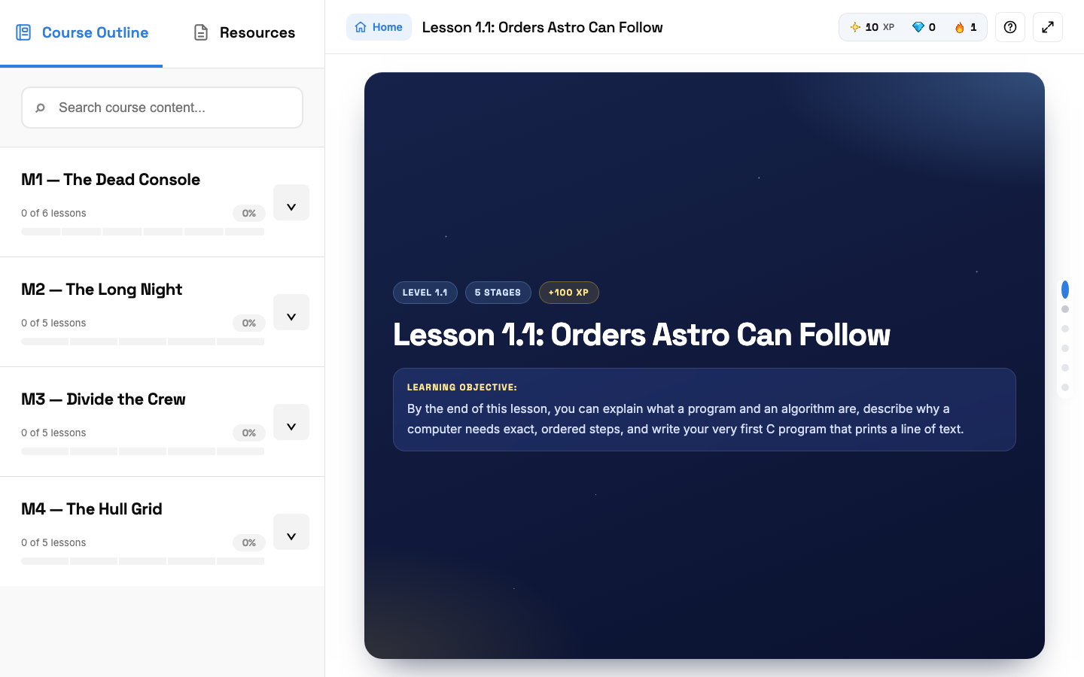
The start of Lesson 1.1

Step 13. Read Stage 1 and take the checkpoint
Read the explanation. At the bottom, click I've read it: start the checkpoint.
Answer the one question. A right answer opens the next stage straight away.
WRONG ANSWER? You have to wait a short time before trying again. The wait gets longer each time you miss, so read carefully.
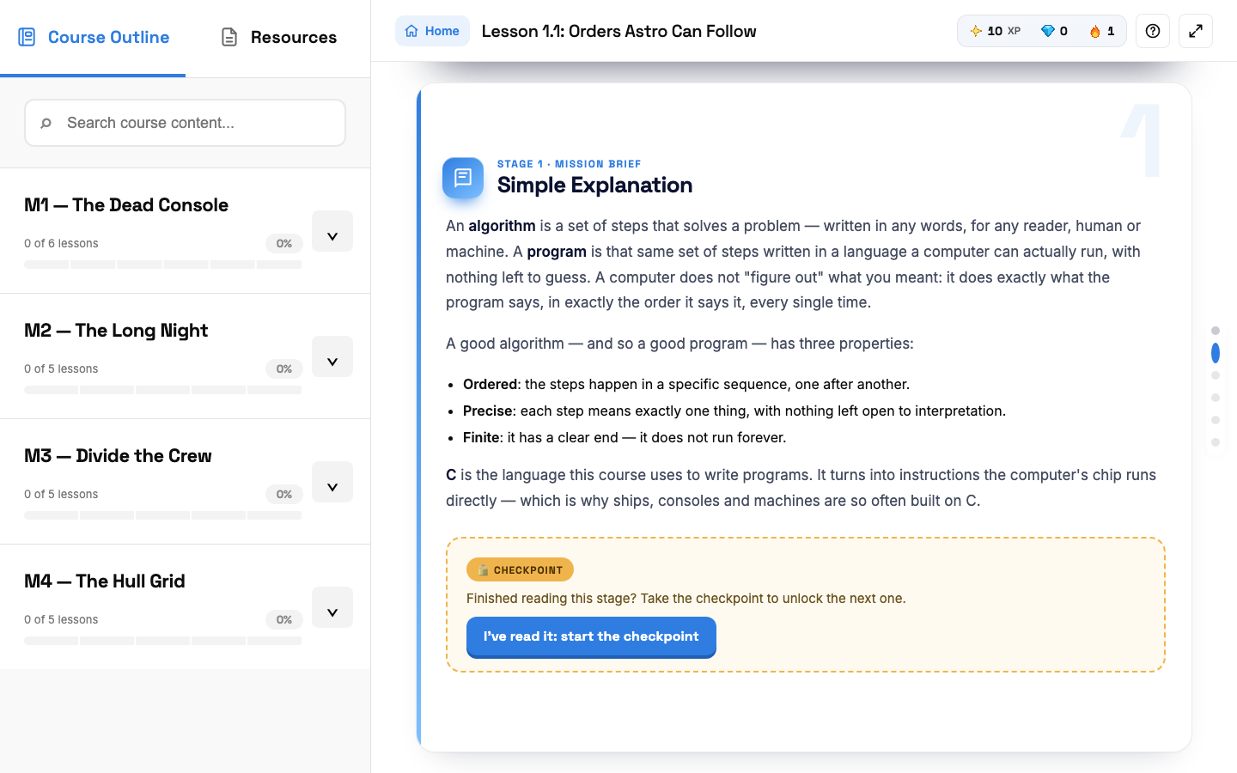
Stage 1 and its checkpoint button
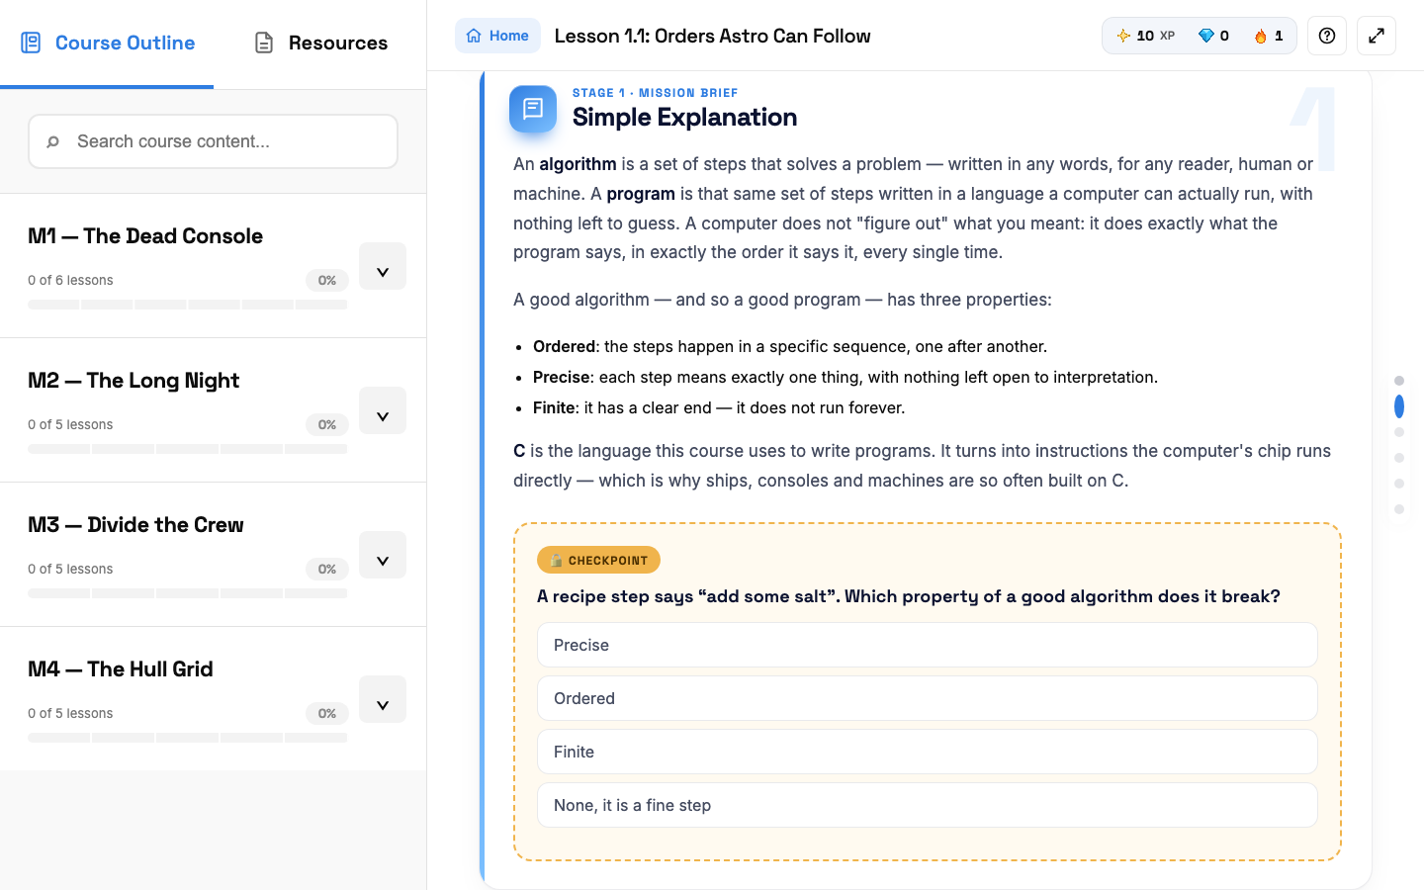
A checkpoint question

Step 14. Keep going through Stages 2 and 3
Each stage ends with its own checkpoint. A stage you haven't unlocked yet shows a lock message.
Stage 3 often has a code example. Click Copy to copy it.
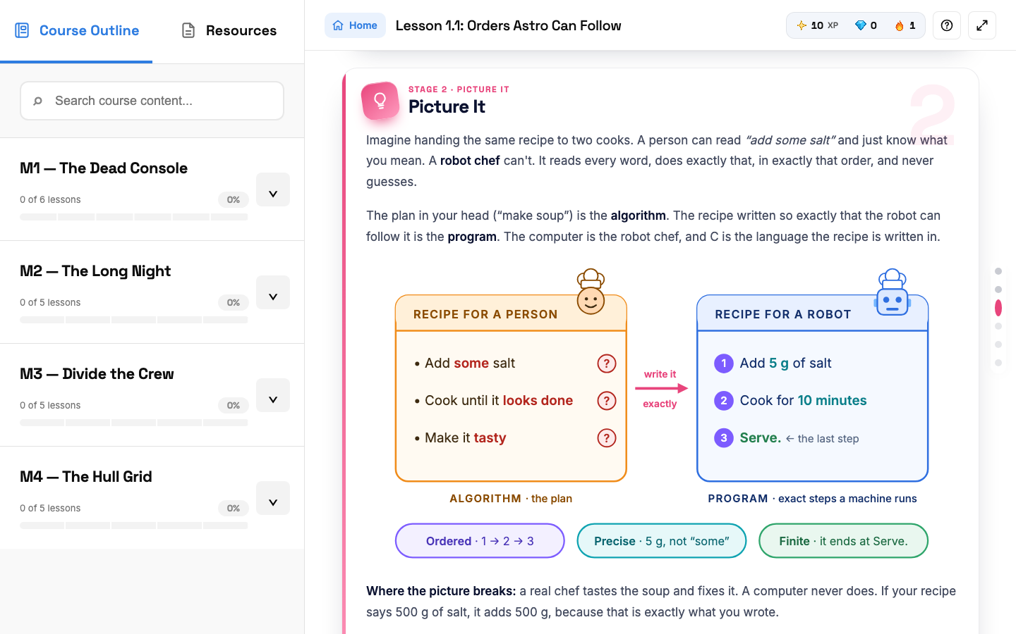
Stage 2: Picture It
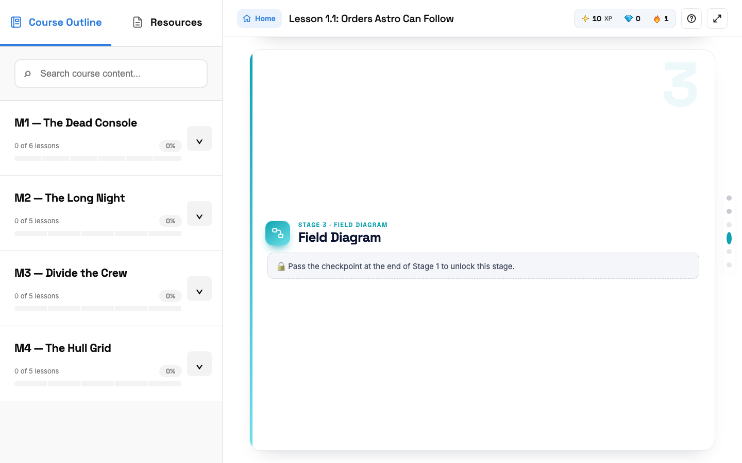
A locked stage

Step 15. Answer the Knowledge Check
Click one answer per question. You see right away if it was correct, plus a short explanation. Each right answer gives +10 XP.
RULE: You can miss at most 2 questions. Miss more and the coding stage stays locked until you retake the quiz.
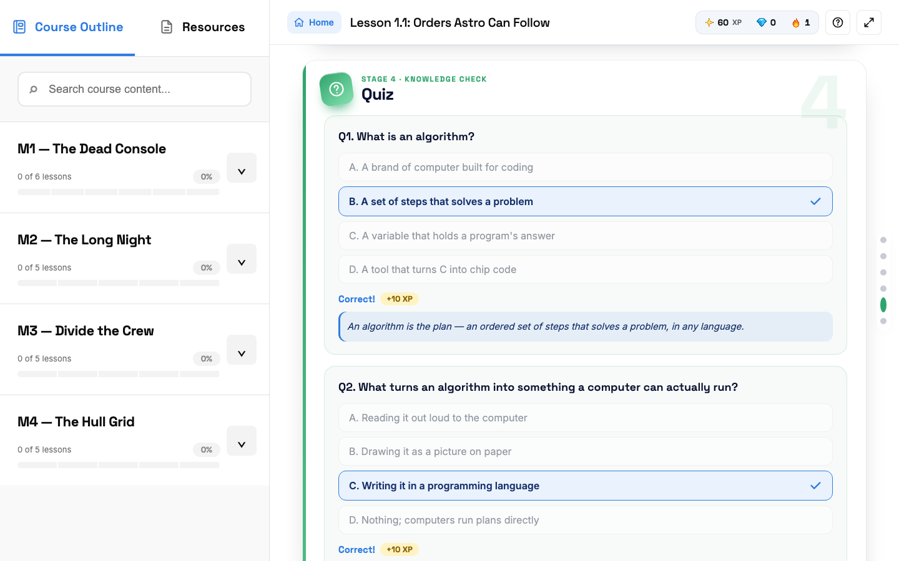
Knowledge Check answers marked Correct

Step 16. Do the coding exercise
Click Code it yourself. The editor opens with the instructions on the left.
- Type your code in the editor.
- If your program asks for input, type it in Program Input, one value per line.
- Click Run to test. The result shows in the Terminal.
- Click Submit answer when it looks right.
Stuck? Flip to get help from Astro costs 50 XP.
Networking and Cybersecurity lessons open a simulator lab here instead of a code editor.
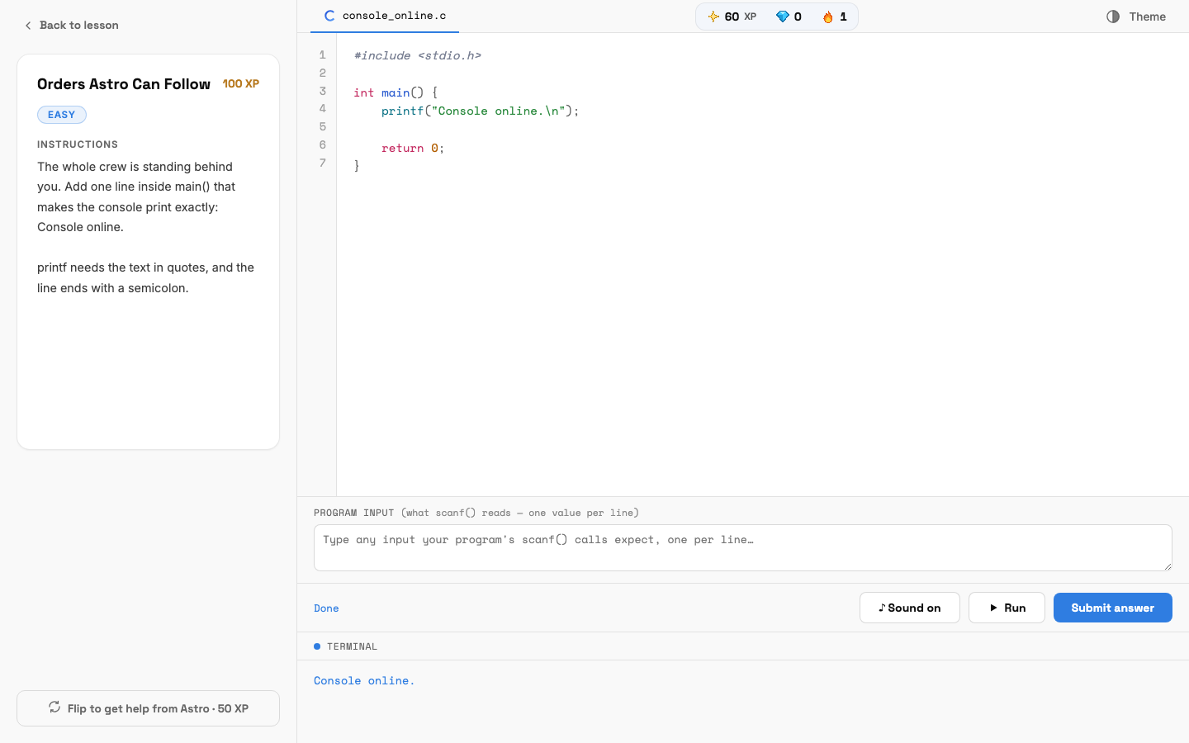
The code editor with the program output

Step 17. Finish the lesson
If the answer is wrong, you see Not quite. Check the terminal output, fix your code and submit again.
When it's right, Astro cheers and you get +100 XP. Click Next lesson to keep going.
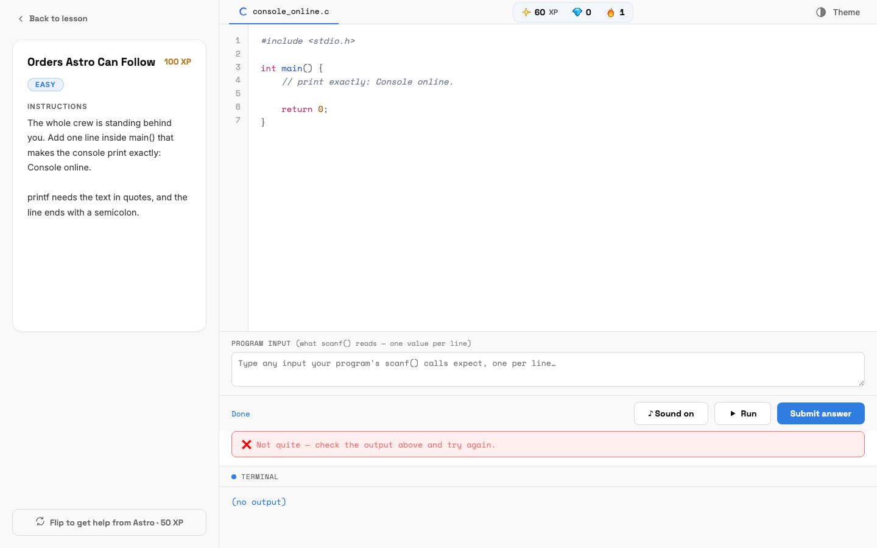
A wrong answer
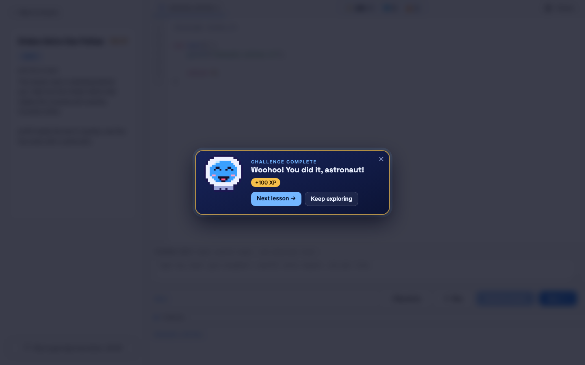
Challenge complete

STUDENT · PART 5

Mini bosses and the Final Boss
Big exams that open full screen. Read the rules before you start one.

Step 18. Beat the Mini Boss at the end of each module
After the last lesson of a module, the Mini Boss unlocks. It has about 30 questions, a 45-minute timer, and you need 75% to win. Each right answer is +10 XP.
- Self-paced: you must win to open the next module. If you lose, you get 0 XP and wait 60 minutes to try again.
- Class: one try only. Your score is saved for your instructor and nothing locks.
Finishing a module also earns you a gem.
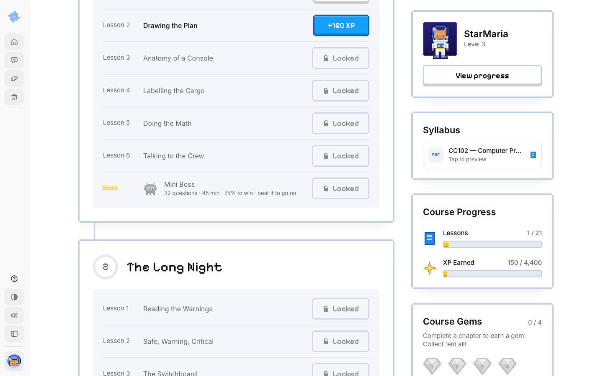
The Mini Boss at the end of Module 1

Step 19. Face the Final Boss to earn your certificate
Clear every chapter and the Final Exam unlocks at the bottom of the course page. Pass it and your certificate appears in the Certificate box.
STRICT RULES: Stay on the exam page the whole time. Switching tabs, leaving full screen or taking a screenshot fails the exam and adds a strike. Two strikes means you are banned from the course. Failing the final also resets your course progress, so you redo the course. You only see your score after, not which answers you missed.
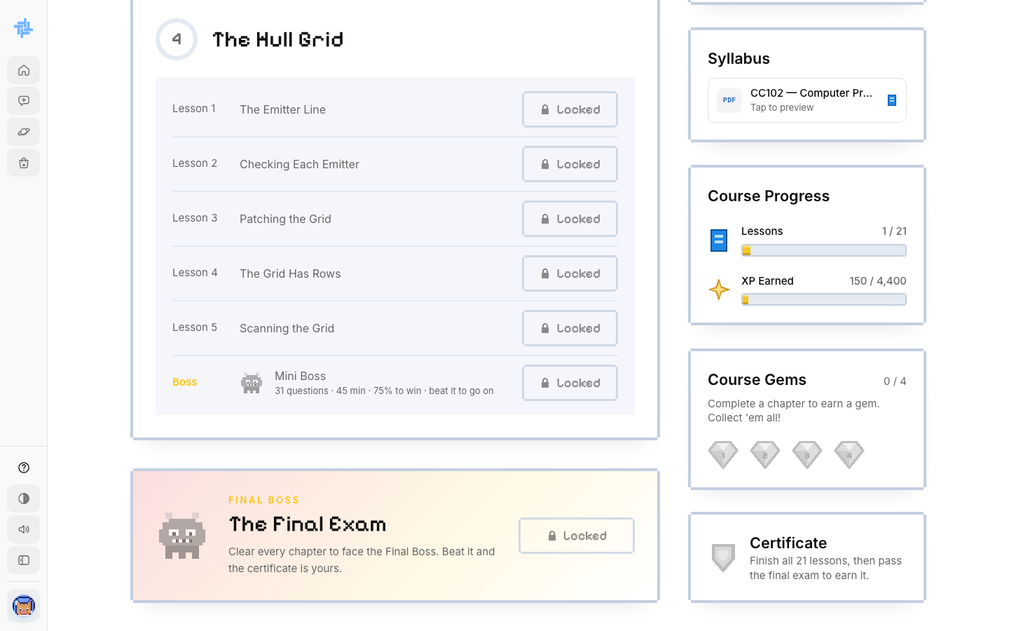
The Final Boss and Certificate

Step 20. Open your certificate
After you pass the Final Boss, click View certificate in the Certificate box on the course page.
- Self-paced: your certificate opens as a PDF with your name, the course, the date you passed and a certificate number. Save it or print it from your browser.
- Class: your certificate is a PDF too, with your instructor's digital signature and name.
The name on the certificate comes from your profile. Check it in Settings before you take the Final Boss.
GOOD TO KNOW: A TechLab certificate shows you finished the course on TechLab. It is not yet recognized by schools or the IT industry, and it does not replace school credit or an official industry certification.
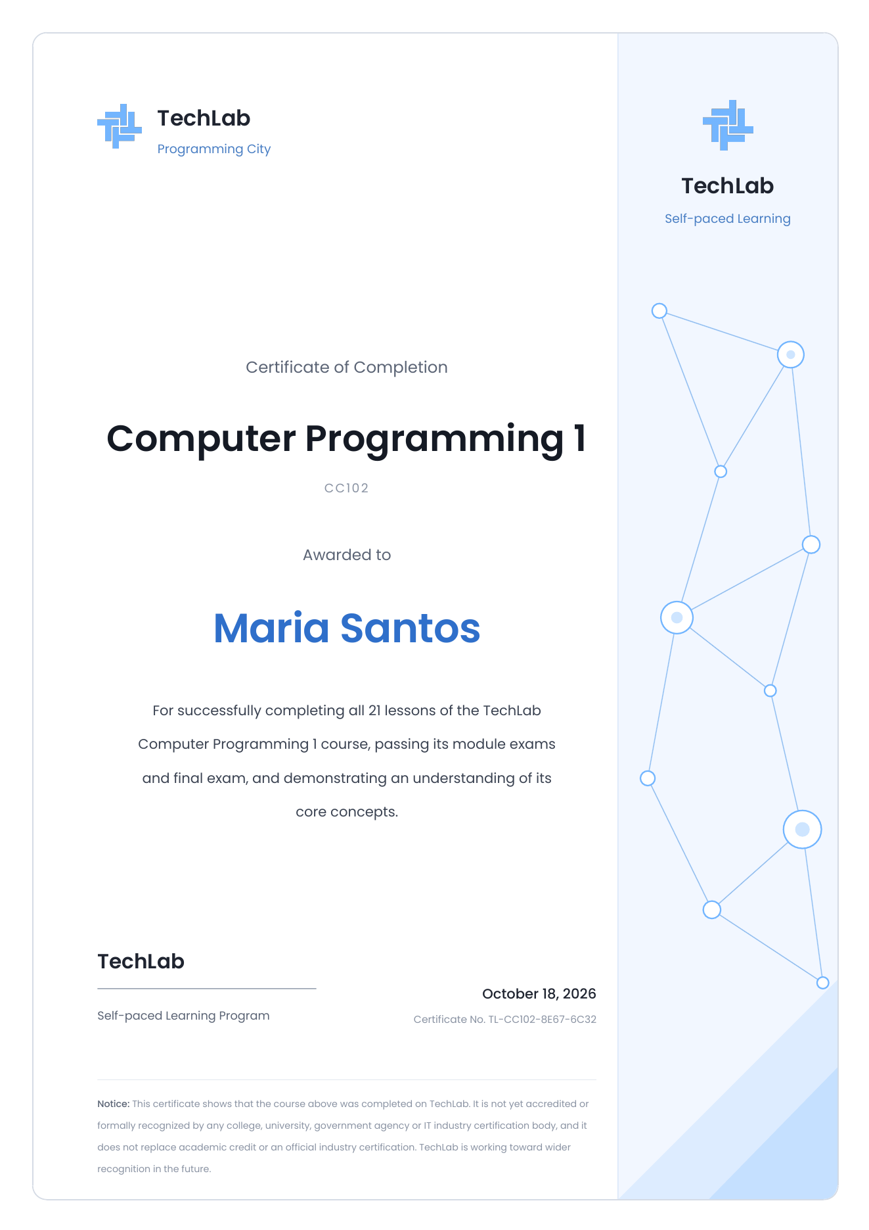
Maria Santos's self-paced certificate for Computer Programming 1
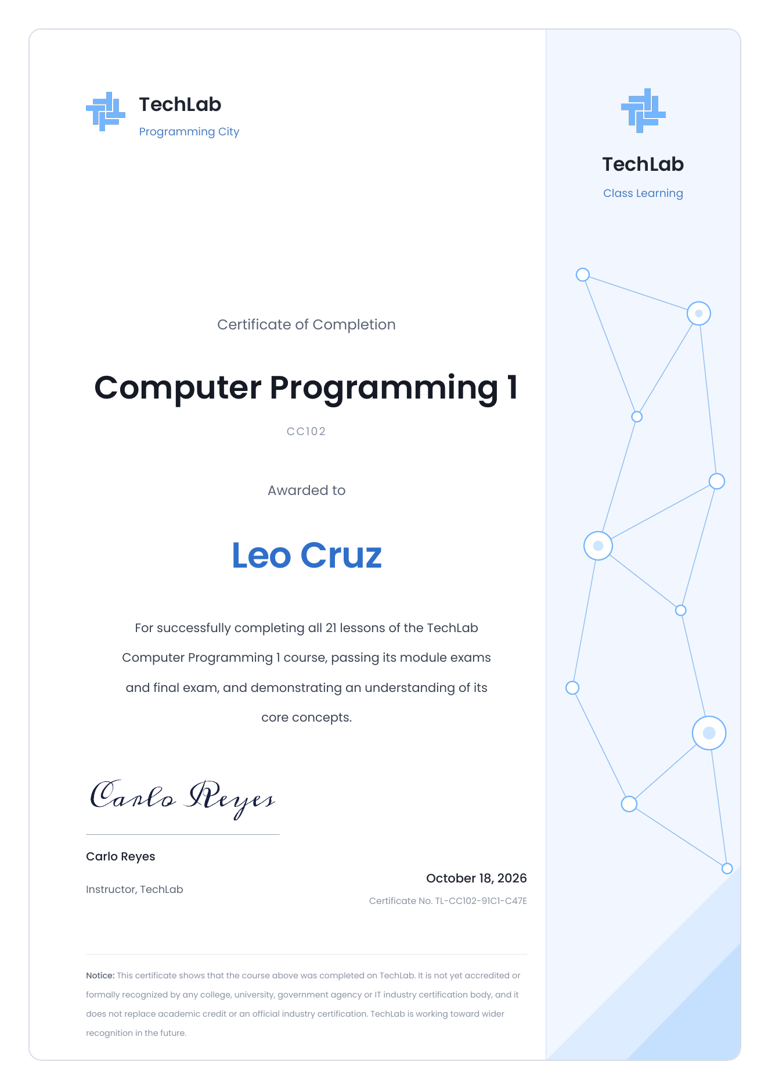
Leo Cruz's class certificate, signed by Carlo Reyes

STUDENT · PART 6

Ask Astro
Astro is an AI tutor. Ask it to explain anything you are stuck on.

Step 21. Start a chat
Click Chat in the sidebar. Type your question in Ask Astro or create something and press Enter.
Click + to attach a file (PDF, Word, PowerPoint, text or code) or a photo. Up to 4 files, 2 MB each.
You have a set number of free messages, shown under the box. Click New chat to start a fresh topic.
REMEMBER: Astro can be wrong. Don't share passwords or private info. If you see an error, wait a moment and send your message again.
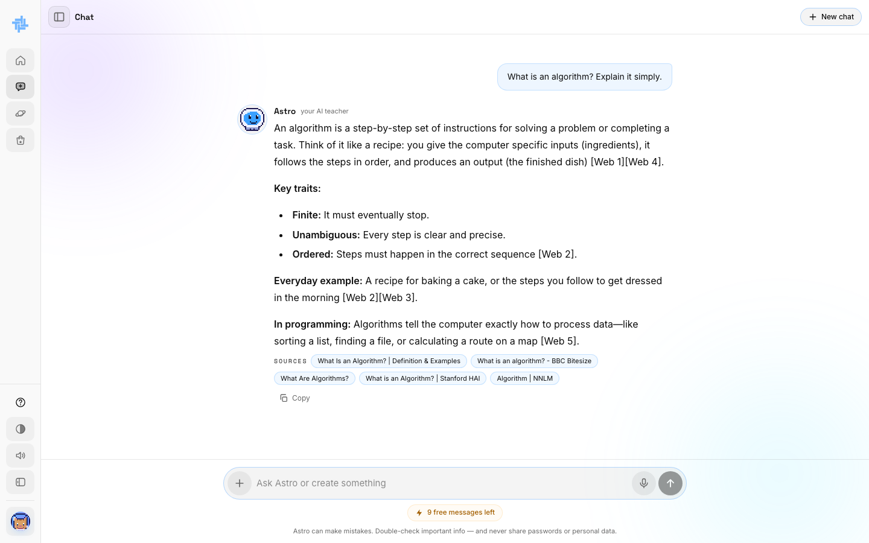
Astro answering a question
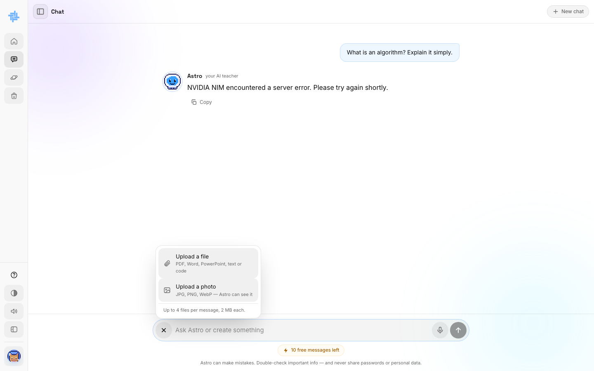
Attaching a file or photo

STUDENT · PART 7

Planets, XP and the Shop
Learning earns XP and gems. They raise your level and unlock new planets and gear.
You do this | You get
Log in for the day | +10 XP
Right answer in a lesson quiz or Mini Boss | +10 XP
Pass a coding exercise or lab | +100 XP
Finish a module | 1 gem
Trade in the Shop's Gem exchange | 1 gem = 50 XP

Step 22. Unlock new planets
Click Planets. Your first planet is open. The others show what they need to unlock. For example, Networking Nebula needs 500 XP and 3 gems.
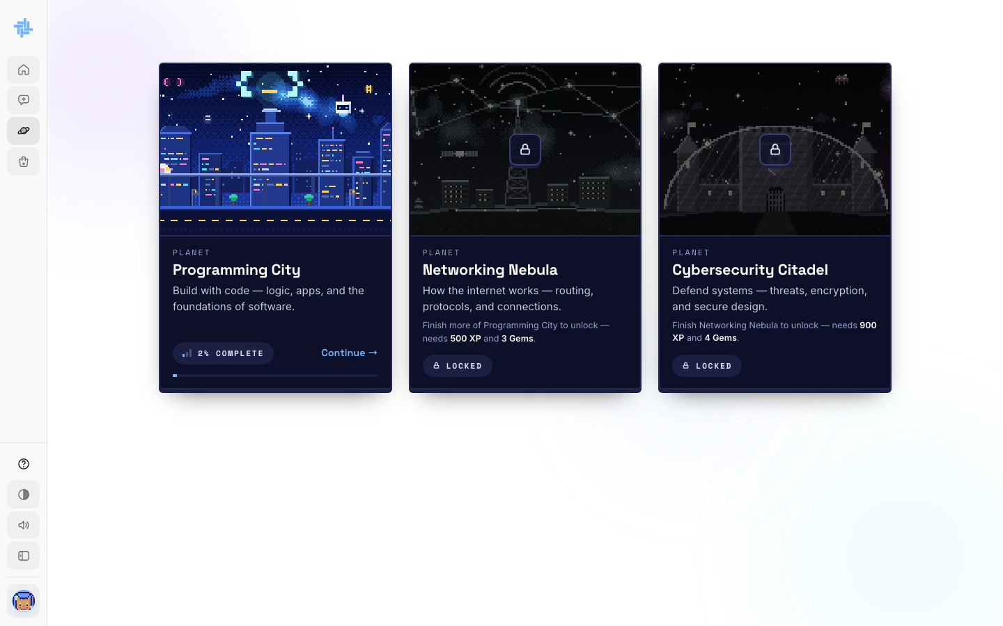
The three planets

Step 23. Spend XP in the Shop
Click Shop. Use the tabs to buy Frames, Animals and Suits, or trade gems in Gem exchange.
Spending XP does not lower your level. Your level counts all the XP you ever earned.
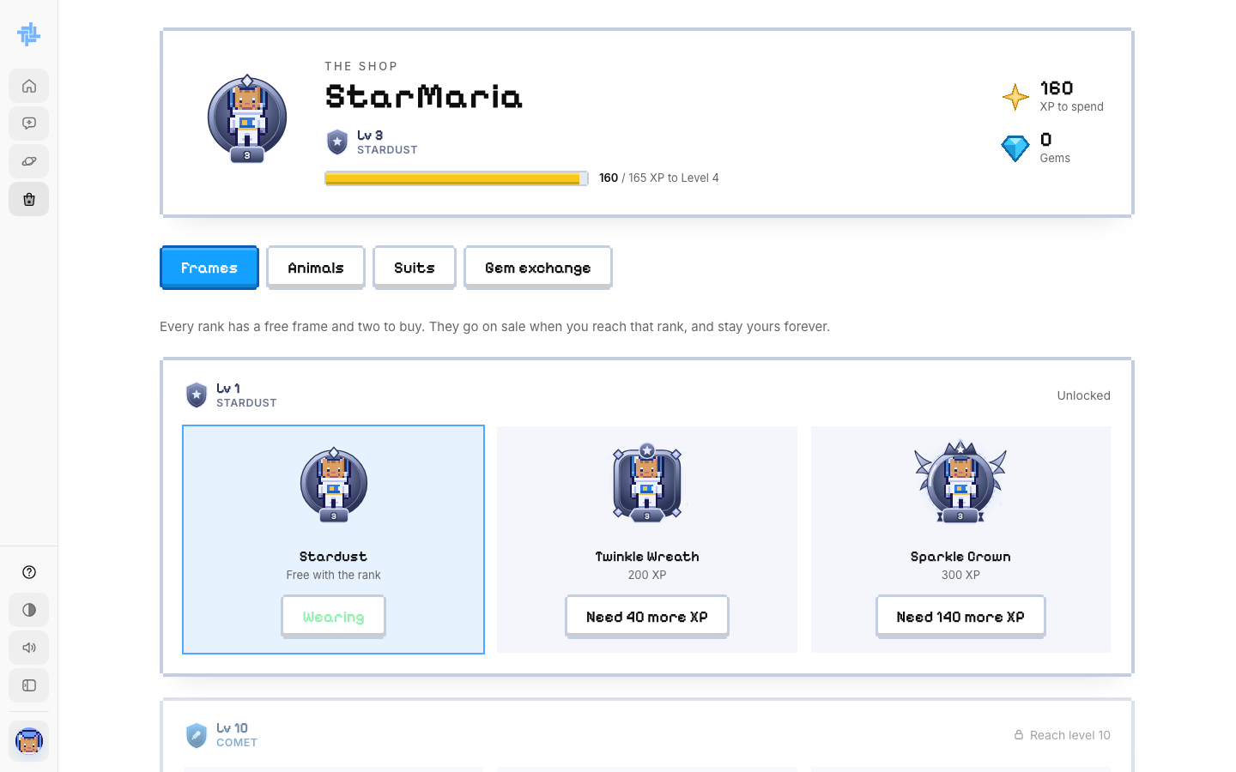
The Shop

Step 24. Check your progress
Click View progress on the dashboard or course page. You see your total XP, day streak, gems, planet rank, active hours and the lesson to continue.
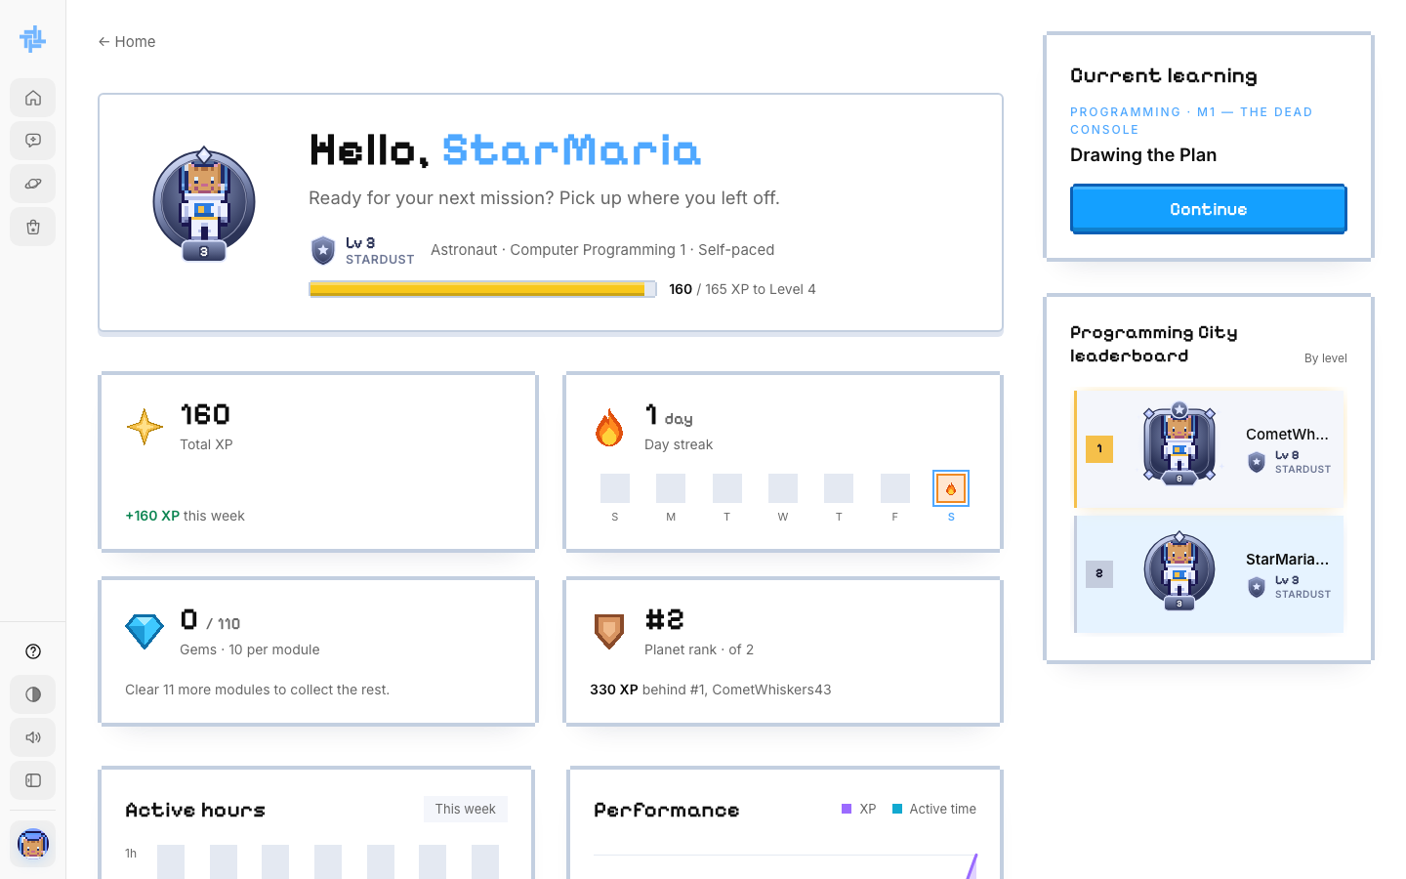
The progress page

STUDENT · PART 8

Settings and logging out
Change your details, your look and your preferences.

Step 25. Open the account menu
Click your avatar at the bottom of the sidebar. Choose Settings or Log out.
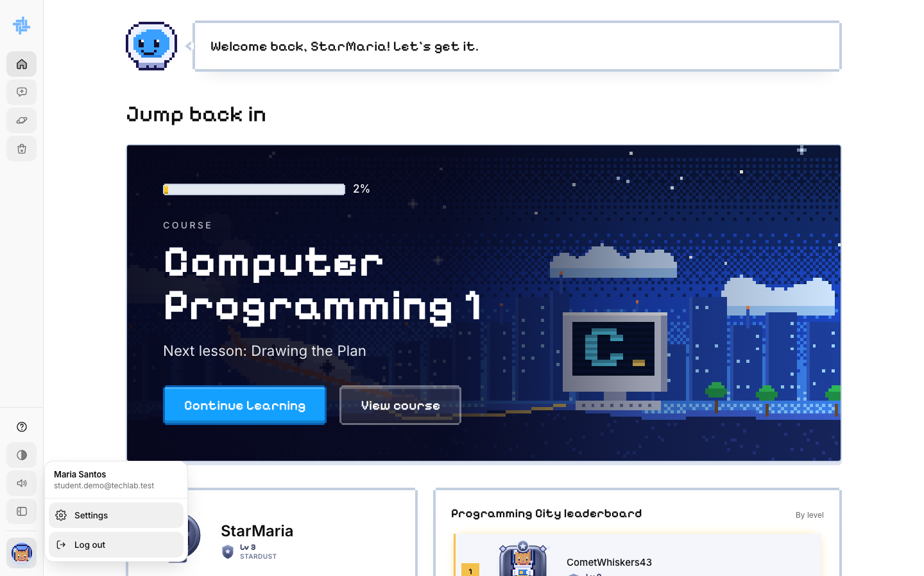
The account menu

Step 26. Update your settings
- Profile: change your name, program or year, then click Save profile.
- Your astronaut: click Change my astronaut to edit your look or codename.
- Preferences: sound and light mode (saved on this browser only).
- Further down: change your password, or delete your account.
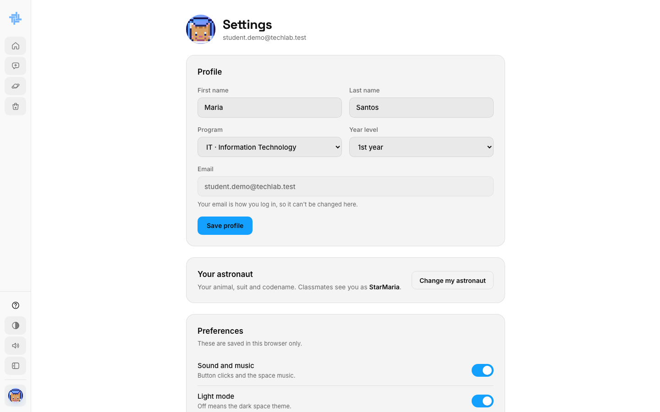
Settings

Step 27. Log back in next time
Go to TechLab and click Log in. Type your email and password, then click Sign in.
Forgot your password? Click Forgot password? to get a new one by email.
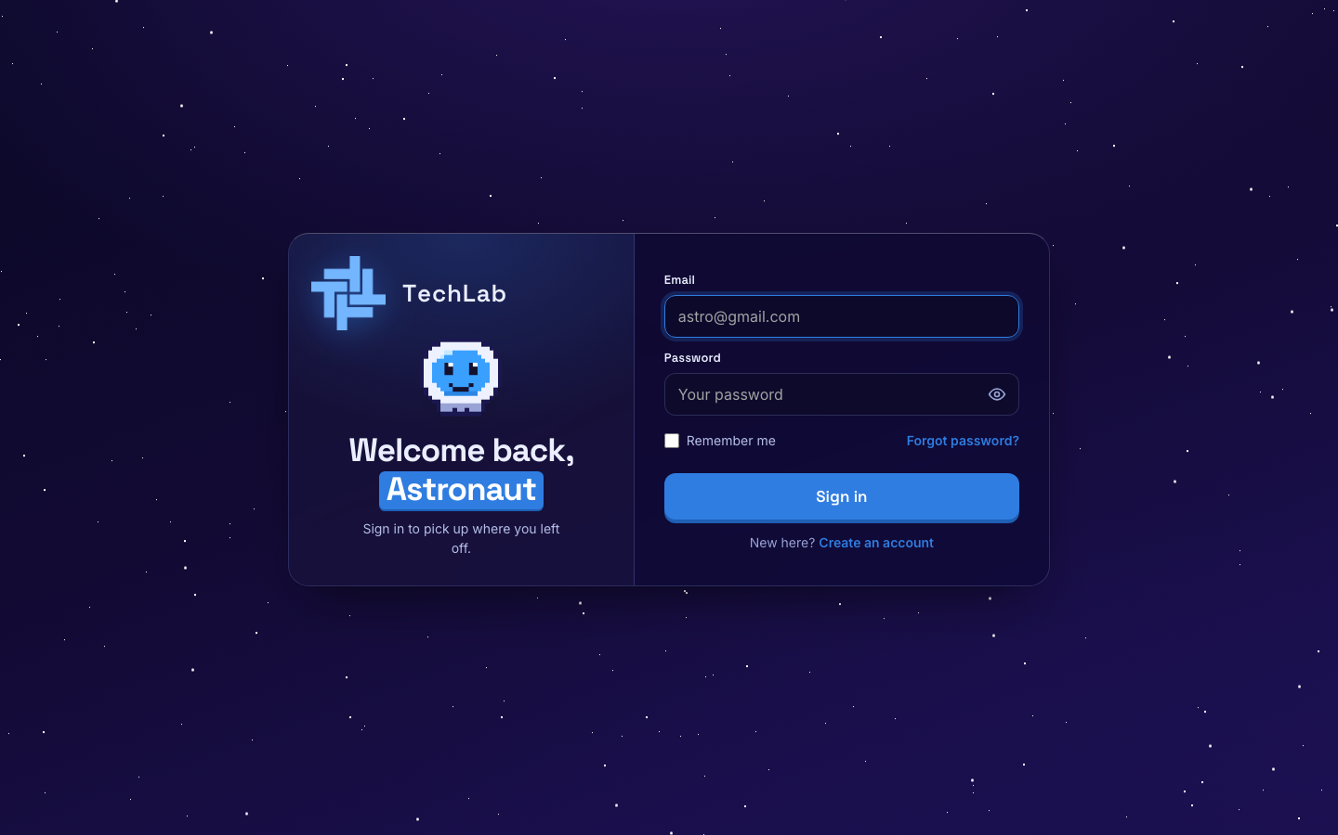
The sign-in page

