Installing the Keyboardio Programmer on Windows 10

1: Connect RED programmer to computer with USB

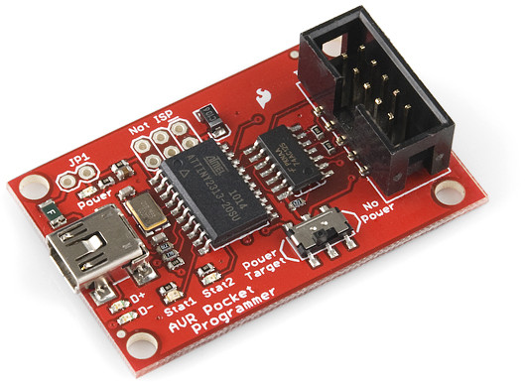

2. You may see a dialog like this. Click “Close”

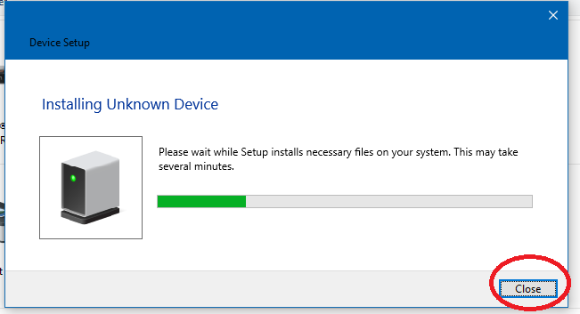

3: Inside the programmer folder, open the “bin” folder

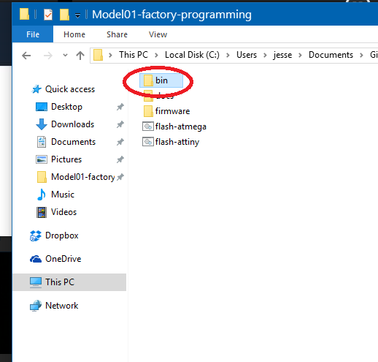

4: Open the program “zadig_2.2”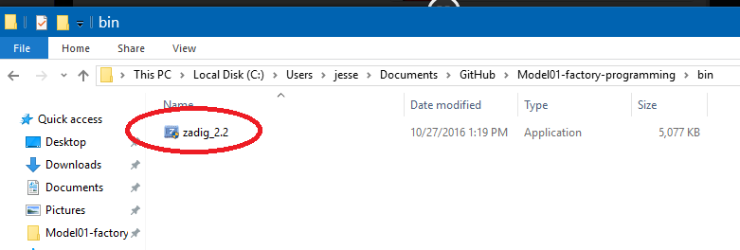

5: Zadig will ask to check for updates. Click “no”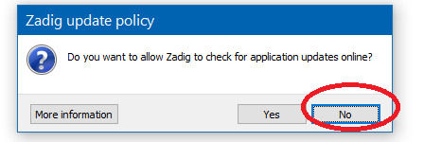

6: Windows will ask if you will let Zadig make changes to your computer. Click YES or OK

7: In the big dropdown menu at the top of Zadig, pick “Unknown device #1”

If you have picked the correct device, you will see 1781 0C9F in the USB ID box.

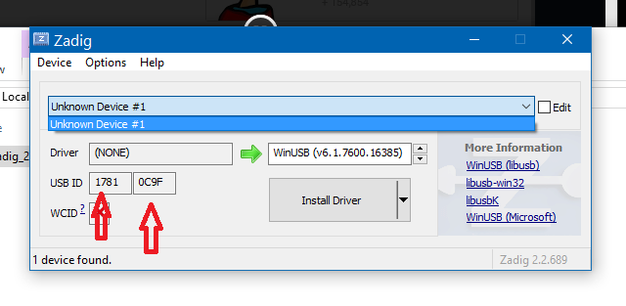

8: Select “libusb-win32” in the driver box. 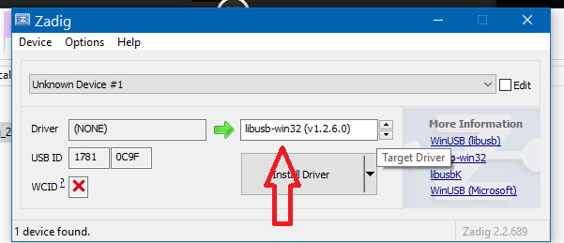

9: Click “Install Driver”

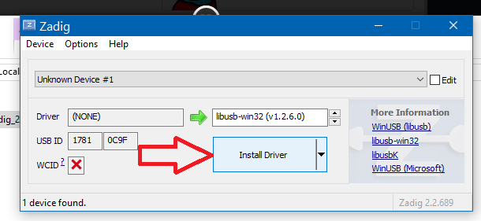

10: “Click ‘Close’

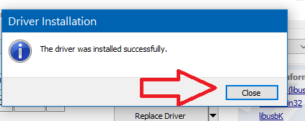

11: Reboot your PC.