Hammond-Clone HOAX/HX3

"Hammond on a Xilinx FPGA," single-board emulator for connecting any keyboard, for installation into existing organs or MIDI control

Prelimiary, Version 3.2
For latest updates and installation manuals, see http://wiki.keyboardpartner.de

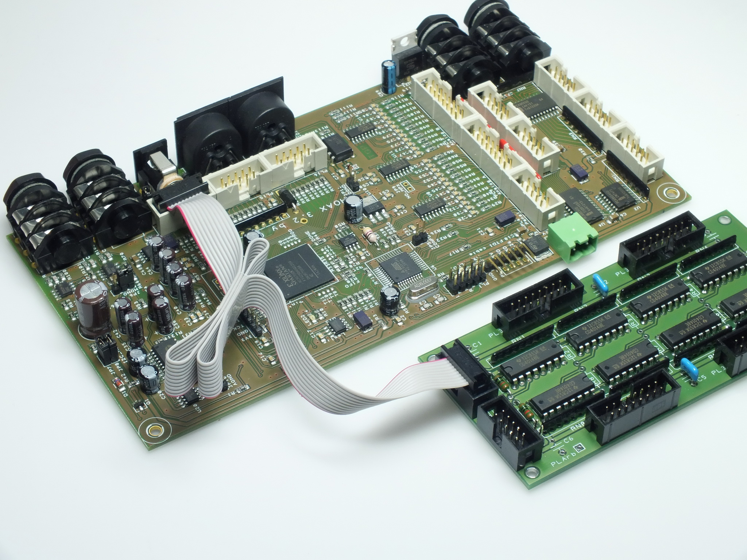
© Carsten Meyer, info@keyboardpartner.de

Compact emulator module for OEM installation. Authentic reproduction of generator, tapering, key contacts, percussion and vibrato by FPGA (Field Programmable Gate Array).
Features:
• Extremely low latency of 50 microseconds Key-to-Audio (not >20 ms as with other MIDI expanders and software emulation)
• Natural key click by "rattling" contacts
• Accurate Leslie simulation with separate outputs
• Drawbar connection by 9 to 24 analog control voltages
• Connection for switches (active low) or digital switch control voltages (Percussion ON, Soft / Normal, 2nd/3rd, vibrato, vibrato ON upper/lower, chorus / vibrato)
• MIDI-in/out (no controllers, just key on/off and key dynamic)
• Connection of any type of keyboards (key contact to ground or matrix) with separate adapter board possible; prepared for Doepfer / Fatar waterfall keyboard

Installation

HOAX should be installed by a qualified technician only. You should be familiar with ribbon cable mounting, crimp contact installation and soldering of delicate parts. Important: HOAX contains static sensitive components. Be shure to use anti-static tools and grounded soldering toolset. Some instructions do not apply for HOAX2.1M MIDI-only version.
First Test: Connect PL2 power connector to +5V stabilized DC supply, capable of at least 300mA. Be shure not to swap polarity; follow silk print on circuit board!

Overvoltage or interchanged polarity will destroy HOAX circuitry. After connecting power, LED1 (red) should light up for a few seconds, subsequentially followed by LED2 (yellow or green) flickering. If LED1 (red) blinks fast for a while, FPGA image data in flash memory has been tampered or is corrupted. Please return HOAX to manufacturer for repair. Flickering LED2 (on HOAX2) shows that HOAX engine is working. Switch off before connecting anything else.

Connecting Drawbars

At least connect 9 Drawbars and volume control to “Analog Input A” (PL9), or connect drawbar/volume inputs (pin 1 to 11 of PL9) temporarily to “DB Ref 3.3+” (pin 15 and 16 of PL9) for full volume test. Input voltage range is from 0V (off or minimal volume) to +3.3V (max. volume). Connect “Right/Main” (PL22) RCA audio output to amplifier. Level is in the 300 mV range.

Loud noise may be heard on Right/Main output if you ordered HOAX with Fatar scan board firmware driver, as no scan board is connected yet. Continue with scan board installation before.

Otherwise, connect a MIDI keyboard to MIDI in (PL18/PL20). HOAX accepts MIDI channel 1 for upper, channel 2 for lower (both 61 notes C-C) and channel 3 for bass (25 notes C-C). Plain organ sound should be heard when playing on channel 1. Check function of all drawbars. HOAX 2.1 and up accept any MIDI controller messages conforming to VOCE Drawbars or NI B4 resp. Doepfer d3c standard (see addendum). Important: You may omit those switches/connections/drawbars/pots you don’t plan to use. If volume/swell input is not used and not disabled by special order, connect to Ref 3.3V+ for full volume.

PL9 Analog Controller A (Upper Manual) Header Pins
Pin - function
1: Drawbar 16
2: Drawbar 5 1/3
3: Drawbar 8
4: Drawbar 4
5: Drawbar 2 2/3
6: Drawbar 2
7: Drawbar 1 5/9
8: Drawbar 1 1/3
9: Drawbar 1
10: Tone Pot (may be enabled by special order)
11: Leslie Volume Pot
12: Swell Pedal
13, 14: Drawbar Gnd
15, 16: Drawbar End 3.3V+ (Reference)

PL13 Analog Controller B (Lower Manual) Header Pins
Pin - function
1: Drawbar 16
2: Drawbar 5 1/3
3: Drawbar 8
4: Drawbar 4
5: Drawbar 2 2/3
6: Drawbar 2
7: Drawbar 1 5/9
8: Drawbar 1 1/3
9: Drawbar 1
10: Drawbar Bass 16
11: Drawbar Bass 8
12: Drawbar/Pot Bass Sustain
13, 14: Drawbar Gnd
15, 16: Drawbar End 3.3V+ (Reference)

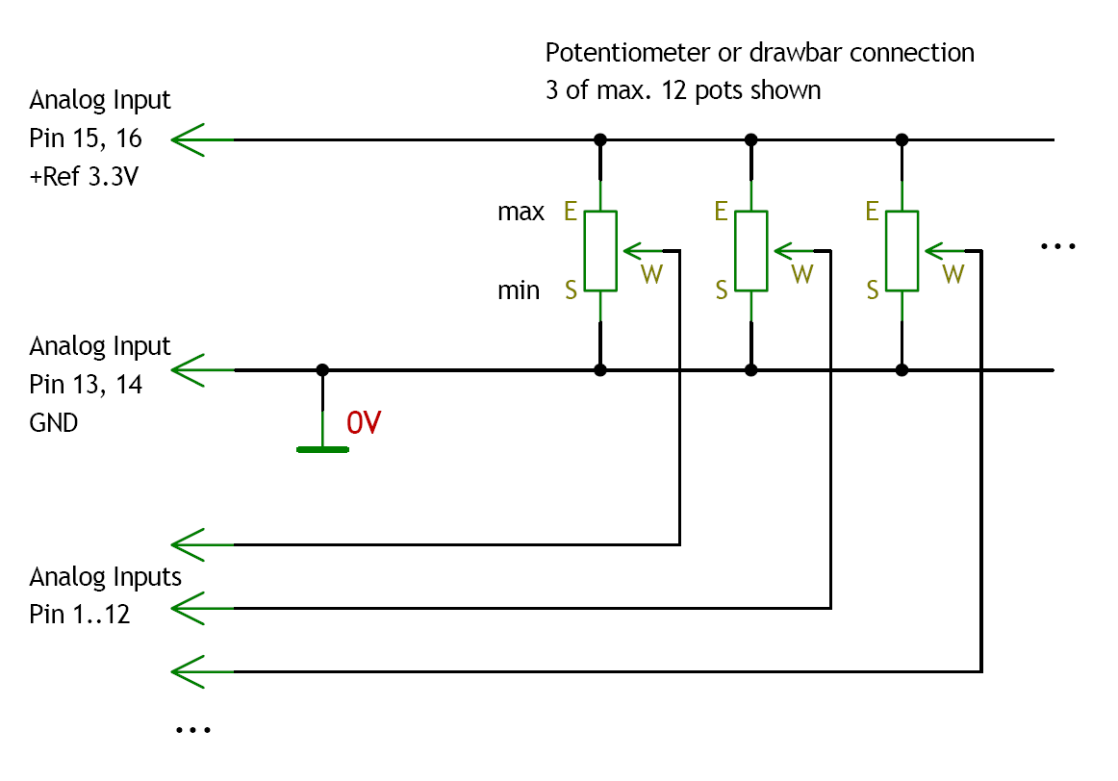
DC swell/volume control is active also on pin 12 of PL9. Even with MIDI control, a swell pedal may be connected to SWELL jack. This overrides MIDI volume control. You may connect a swell pedal like Yamaha FC-7 or a simple volume pot to the SWELL jack.

HOAX may be ordered with tone/treble control input active. Tone pot center is connected to pin 10 of PL9. If digital Leslie emulation is enabled on HOAX3, pin 11 becomes the Leslie amp volume/drive control. Both pots begin with Gnd and end with Ref 3.3V+.

If upper drawbar control works properly, continue with lower/bass drawbars on PL13 (if needed) as indicated on “Connector Layout” chart.

Pins PL5 Vibrato rotary
Pin Number: Function (active low – switch to Gnd)
nc: Vib1 (no connection)
1: Cho1
2: Vib2
3: Cho2
4: Vib3
5: Cho3
6: MEM btn upper
7: MEM btn lower
8: MEM LED-
9: MEM LED+
10: Common Gnd

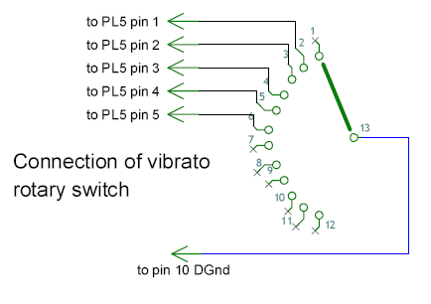
Pins PL7 LED buttons or PL11 (switches)
Pin Number - Function (active low – switch to Gnd)
1: Perc ON, like B3
2: Perc SOFT
3: Perc FAST
4: Perc THIRD
5: Vib ON upper
6: Vib ON lower
7: Leslie ON (HOAX3 only)
8: Leslie FAST (HOAX3 only)
9: (+5V, used only for button LEDs supply on ButtonTab8/16)
10: Common Gnd

Pins PL11 LED buttons or PL12 (switches)
Pin Number - Function (active low – switch to Gnd)
1: Common Preset 1 (PL11 LED button only)
2: Common Preset 2 (PL11 LED button only)
3: Common Preset 3 (PL11 LED button only)
4: Common Preset 4 (PL11 LED button only)
5: EFX 1 / Reverb 1 (HOAX3 only)
6: EFX 2 / Reverb 2 (HOAX3 only)
7: Bass on Leslie (HOAX3 only)
8: Split Bass Lower
9: +5V, used only for button LEDs supply
10: Common Gnd

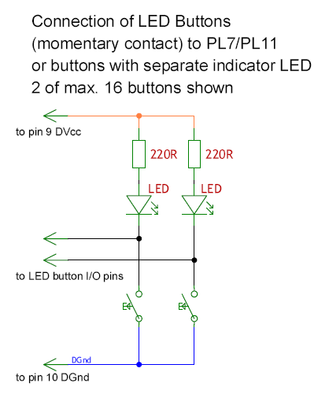
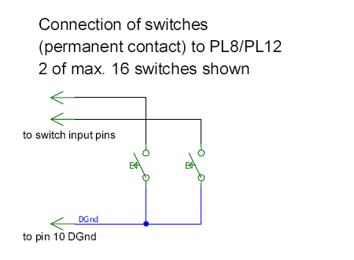
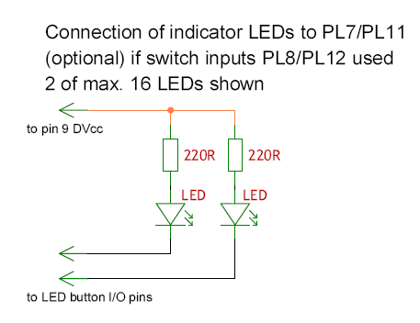
You may omit those switches you don’t plan to use.
Connecting buttons and/or switches

Every function may be activated by a button on PL7/PL11 or a switch on PL8/PL12. Pin functions are equivalent, but PL7/PL11 toggle status on every push and drive indicator LEDs (see schematic). You may omit those buttons you don’t plan to use.

A button panel named Panel16 with 16 LED buttons is available if you want to have a hassle-free compact solution. It connects directly to PL7 and PL11. It also contains the 4 common preset buttons.

Connecting Preset Switches

Up to 4 common presets (plus one “live” setting) are recalled by pressing buttons at PL8 pin 1 to 4 shortly. If a preset is “on”, corresponding LED lights on. Pushing a lighted preset button again returns to “live” setting.

To save a preset:
- select “live” setting of manual to be saved
- adjust drawbars and tabs to new sound
- pressing the appropriate preset button for 2 seconds this preset is replaced by the “live” setting (or a different preset) you used last.

The preset LEDs should blink a few times to indicate preset save is completed.

Our Preset12 boards extend drawbar inputs to two sets of 18 drawbars plus 10+2 presets (incl. two “live” dawbar settings) per manual like on B3. Preset16 has 15+1 presets, but no addtionional drawbar multiplexer.

Connecting OrganScan61 board set

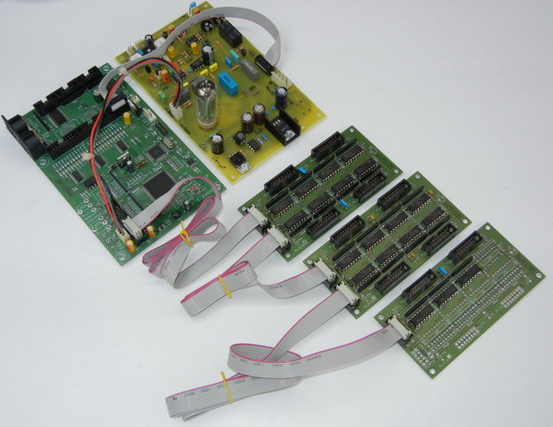

A set of up to 3 “daisy-chained” OrganScan61 (obsolete soon - limited supply) boards are connected to PL14 if HOAX was ordered with OrganScan61 firmware driver. Refer to picture. Be shure not to twist connectors (red marked ribbon lead must match with pin 1 of all ribbon cable connectors, indicated by a triangle marking). Total cable length should not exceed 1,5m. First board in row is upper manual, second is lower manual and third (rightmost in picture) is bass pedal (not completely populated since only 25 keys are present).

Inputs are active low (switch to ground), so connecting them to Gnd pins 13 to 16 of PL33 (PL31 on bass) on OrganScan61 board should yield the appropriate note. See OrganScan61 schematic for connector pinout.

OrganScan61 boards are activated by serial command:

wen=1
519=0

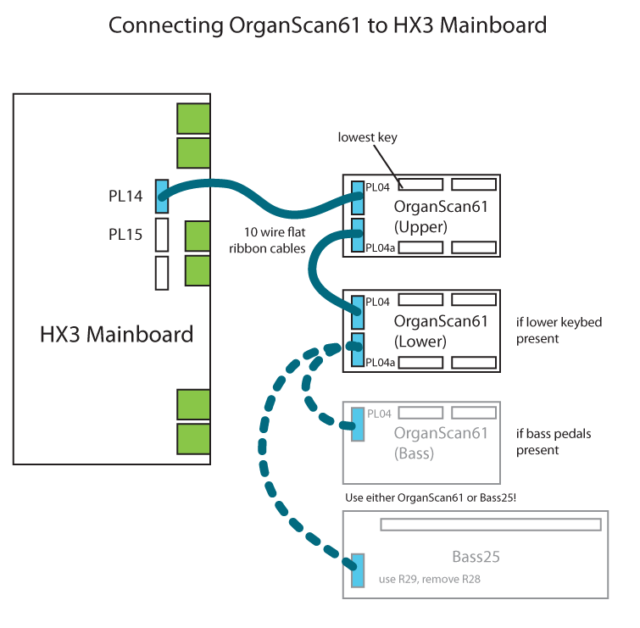
Connecting FatarScan2 board

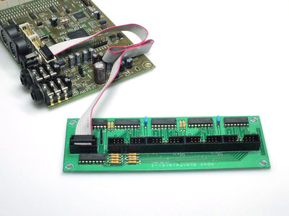

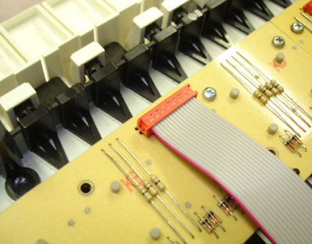

A single FatarScan2 board is connected to PL14 if Fatar firmware is installed on HOAX board. Two Fatar 61 key manuals may be connected to one FatarScan2 board using a special cable set (MicroMatch connectors to keyboard scanning strips).

Bass pedals may be connected to an additional OrganScan61 or OrganScan16 board wich is wired to PL15 (!).

FatarScan2 board is are activated by serial command:

wen=1
519=0
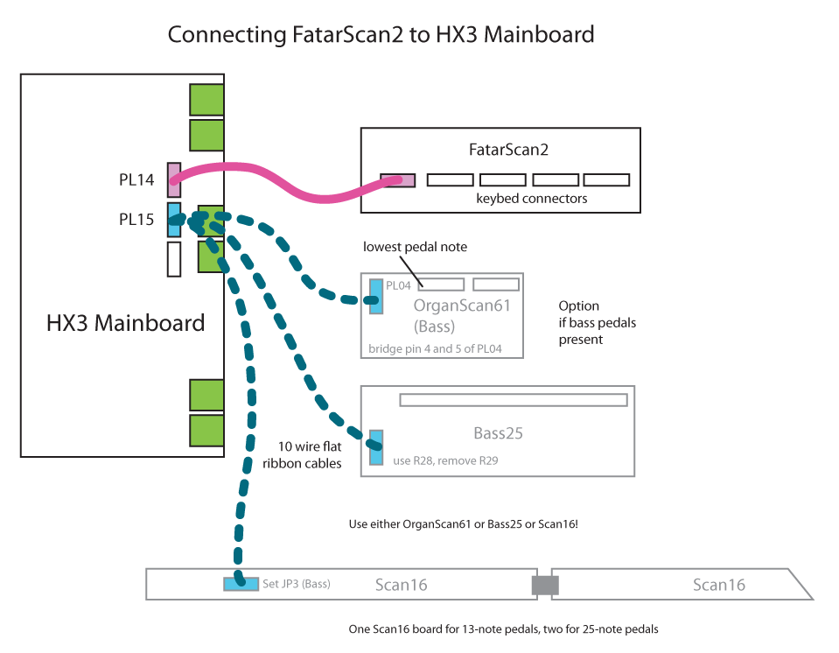

Connecting Serial USB cable

HOAX may be configured by parameters by use of a serial interface on PL26. Connect FTDI TTL-232 5V cable header to PL26 so black cable sits on GND pin and red cable sits on +5V pin. Plug in PL26 cable first, then connect to USB.

Use terminal software like TeraTerm (free) to communicate with HOAX board. Parameters are 57600/8n1, send CR, receive CR+LF. As +5V is supplied by USB, external power supply may be disconnected. Do not use unpowered USB hubs as HOAX needs 250mA to run.

HOAX will restart on command

9999

and output some status messages. Restart every time you change scan routine setting like above. MIDI only mode is invoked by serial command:

wen=1
519=1

Please see wiki.keyboardpartner.de for further details.

Using HOAX with Doepfer d3c or Voce MIDI Drawbars

Standard HOAX firmware version either supports the Voce MIDI Drawbars standard or the Native Instrument B4 standard (default, supported by Doepfer d3c drawbar controller and Böhm/Keyswerk d4b controller). The HOAX NI/d3c implementation is not compatible with the Voce MIDI Drawbars implementation and vice versa, so be shure you order or use the appropriate version.

General

Please connect MIDI out of your MIDI controller to HOAX MIDI input. The Voce MIDI Drawbars as well as the Doepfer d3c both have MIDI merge inputs. Your keyboard connects here. If your keyboard supports MIDI merge, the MIDI controller should be first, routed to the keyboard and from keyboard to HOAX. This may avoid a few milliseconds of latency. Please note: HOAX does not introduce any audio latency.

As MIDI being a one-way interface, HOAX cannot determine the setting of any MIDI controller value until you touch/use it once. As default, all HOAX controllers are OFF. Do not use any controller button or drawbar unless HOAX is ready to accept its data; it is a good idea to power up HOAX first and later your MIDI master keyboard or master controller.

By receiving any MIDI controller message on channel 1, HOAX shuts down its own controls. Directly attached drawbars, knobs and buttons do not longer work – with the exception of a swell pedal. If you use your HOAX-attached swell pedal, any MIDI expression message will be overwritten. Otherwise, by not touching the attached swell pedal, MIDI expression messages are accepted.

Use with Voce MIDI Drawbars

Using your HOAX board with Voce MIDI Drawbars is straightforward, as the Voce module supports only one MIDI channel (i.e. upper manual) at any time. Please note that Voce MIDI Drawbars does not send drawbar data unless you press the “Drawbar/Save” button, so it’s LED lits up. Local HOAX controls can be switched on again by pressing the “Save” button more than 4 seconds. Be shure not to touch any Voce MIDI Drawbars button as this will lockout the HOAX controls again, as mentioned above.

You may change the Voce MIDI Drawbars send channel (back rotary HEX switch) at any time to lower (2) and bass channel (3), although this is somewhat inconvenient. Have your technician install a toggle switch on the back side so channels may be changed easily.

Use with Doepfer d3c or other NI B4 drawbar controller

The Doepfer d3c drawbar controller is a very nice and rugged piece of gear, so we recommend it for use with our HOAX board. It has support for foot controllers and foot switches. You should connect your swell pedal (recommendation: Yamaha FC-7) to FC1 input of your Doepfer d3c. Otherwise, you may control volume with the volume pot alternatively (as it overrides the swell pedal, whichever is used last).

Upper, lower and bass drawbars work as usual. It is a good idea to set all to zero before switching on as this is a “known state” for HOAX. Also the Percussion and Vibrato buttons work as described in d3c manual. There is a small drawback, anyway: Default HOAX Vibrato setting is V1 (but upper/lower vibrato OFF), while the V1 LED will not light when powering up the d3c (there is no “V0” on a real Hammond!). So pressing the V1 button will not change the sound – just it’s LED turns on.

The “Body” and “Brightness” knobs control AO28 equalization in HOAX, not in a Leslie. There is no key click emulation in HOAX (it is just there!), so you may not adjust key click (a real Hammond does not have key click adjustment, either). The “Key Click” knob controls the bass sustain instead. You may argue “a real Hammond does not have a bass pedal sustain, too”. Right, but many aftermarket kits are installed, so this is OK (for me). Do not use the “Harmonic content” knob as it sends the “Percussion” button’s controller number like a continuous controller. Why that? No idea. This is definitely of no use.

Preset buttons may be used, but in a restricted way. First, HOAX yields 15 presets per manual, not 127 like NI B4. When selecting “Bank 1”, all 12 available preset buttons work on upper manual. When selecting “Bank 2”, all 12 preset buttons work on lower manual. Doepfer d3c resends the program change message when changing the bank, which may be annoying. Choose bank 2, lower preset first, then bank 1, upper preset. BTW: Bank buttons do not send bank select messages, they just add an offset to the preset buttons. Blame Doepfer for that.

Doepfer d3c preset 1 is the HOAX “Live” position. It will be saved automatically when switching to a preset sound (2 to 12). If you return to preset 1 “Live”, your last drawbar/button setting will be recalled. Please note: HOAX tracks drawbar and button changes even when in preset position 2 to 12, so it keeps itself updated all the time.

There is no way to save a upper or lower preset/program remotely. You have to use the local HOAX “Save Upper” or “Save Lower” buttons instead. To create a sound, choose the preset button you want. Set upper or lower drawbars and buttons to your taste. Press HOAX “Save” button for at least 2 seconds. The “Memory” LED will blink a few times, showing that your preset has been saved. It is not possible to save a sound to preset 1 as this is the “Live” preset.

HOAX local controllers are switched on again if a preset number larger 24 is received (i.e. bank 3 and up on d3c).

Have fun!

Carsten Meyer

www.keyboardpartner.de

