数据库第5次上机报告



罗阳豪 16130120191

需求分析



该学籍管理系统要求能够记录学籍管理所需的必要信息，需要记录学院、专业、班级、学生、课程、教师等信息，还有他们之间的关系。在这些信息之上，要能实现一定的查询操作，包括查询学生成绩，统计平均成绩，查询教过某学生的全部老师，查询应被开除的学生名单。

概念结构设计

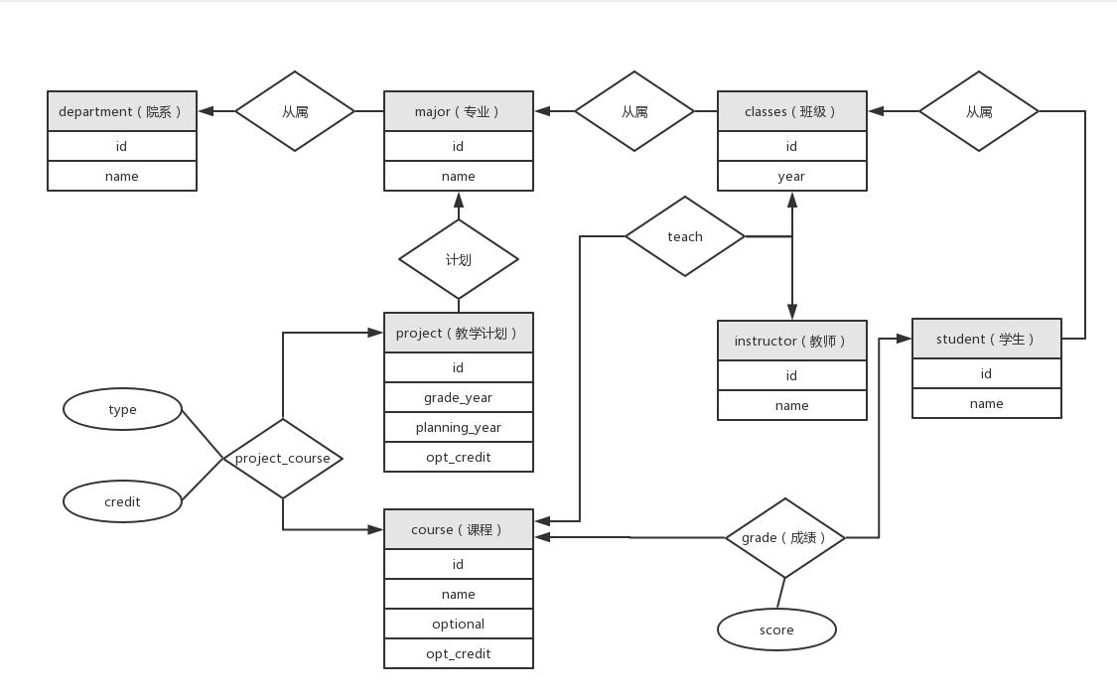

逻辑结构设计



根据E-R图建立10张表，如下

department(id, name);



major(id, dept_id, name);



classes(id, major_id, grade_year);



student(id, class_id, name);



instructor(id, name);



course(id, name, optional, opt_credit);



project(id, major_id, grade_year, planning_year, opt_credit); project_course(project_id, course_id, type, credit); grade(student_id, course_id, score);



teach(class_id, instructor_id, course_id).



应用程序设计中遇到的问题及解决方法



在该应用设计过程中，主要遇到了两个问题

一是，表太多，为了使数据库设计尽可能符合三范式，数据被拆分在很多表中，完成一个查询通常要连接四五个表。这样一来，连接的顺序和连接的条件的斟酌就变得很麻烦，很容易引起混乱。解决的方法就是，通过图来辅助自己分析，比如在E-R图中找关系，这比看SQL要直观得多。

二是，数据之间的依赖关系很复杂，插入数据时，保持关系的完整性就十分有挑战。解决方法就是，尽量多得设置约束，如外键、主键，还有就是通过业务流程保证数据的完整性，做仔细的参数检查。

建立数据库的主要代码



CREATE TABLE department (

id VARCHAR(32) PRIMARY KEY NOT NULL,

name VARCHAR(128) NOT NULL

);

CREATE TABLE major (

id VARCHAR(32) PRIMARY KEY NOT NULL,

dept_id VARCHAR(32),

name VARCHAR(128) NOT NULL,

FOREIGN KEY (dept_id) REFERENCES department (id)

);

CREATE TABLE classes (

id VARCHAR(32) PRIMARY KEY NOT NULL,

major_id VARCHAR(32),

grade_year YEAR,

FOREIGN KEY (major_id) REFERENCES major (id)

);

CREATE TABLE student (

id VARCHAR(32) PRIMARY KEY NOT NULL,

class_id VARCHAR(32),

name VARCHAR(128) NOT NULL,

FOREIGN KEY (class_id) REFERENCES classes (id)

);

CREATE TABLE instructor (

id INTEGER PRIMARY KEY AUTO_INCREMENT NOT NULL,

name VARCHAR(128)

);

CREATE TABLE course (

id VARCHAR(32) PRIMARY KEY NOT NULL,

name VARCHAR(128) NOT NULL,

optional BOOLEAN DEFAULT FALSE NOT NULL,

opt_credit NUMERIC(2, 1) DEFAULT 0 NOT NULL

);

CREATE TABLE project (

id INTEGER PRIMARY KEY AUTO_INCREMENT NOT NULL,

major_id VARCHAR(32),

grade_year YEAR,

planning_year YEAR,

opt_credit INTEGER,

FOREIGN KEY (major_id) REFERENCES major (id)

);

CREATE TABLE project_course (

project_id INTEGER,

course_id VARCHAR(32),

type INTEGER,

credit NUMERIC(2, 1),

PRIMARY KEY (project_id, course_id),

FOREIGN KEY (project_id) REFERENCES project (id), FOREIGN KEY (course_id) REFERENCES course (id)

);

CREATE TABLE grade (

student_id VARCHAR(32),

course_id VARCHAR(32),

score NUMERIC(4, 1),

PRIMARY KEY (student_id, course_id),

FOREIGN KEY (student_id) REFERENCES student (id), FOREIGN KEY (course_id) REFERENCES course (id)

);

CREATE TABLE teach (

class_id VARCHAR(32),

instructor_id INTEGER,

course_id VARCHAR(32),

CONSTRAINT uni_class_instructor UNIQUE (class_id, instructor_id),

PRIMARY KEY (class_id, instructor_id, course_id),

FOREIGN KEY (class_id) REFERENCES classes (id),

FOREIGN KEY (instructor_id) REFERENCES instructor (id),

FOREIGN KEY (course_id) REFERENCES course (id)

);

查询的主要代码



查询学生所选修的课程及成绩，并给出必修课平均成绩和选修课平均成绩



# 1. 查询学生所选修的课程及成绩，并给出必修课平均成绩和选修课平均成绩；

* 查询成绩

SELECT

student.id AS "Student ID", student.name AS "Student Name", course.id AS "Course ID",

course.name AS "Course Name",

grade.score AS "Score"

FROM

grade

JOIN student ON grade.student_id = student.id

JOIN course ON grade.course_id = course.id

ORDER BY student_id, course_id;

* 计算平均成绩

SELECT * FROM (

SELECT grade.student_id AS "Student ID", student.name AS "Student Name", avg(grade.score) AS "Required Course Average Score"

FROM grade JOIN student ON grade.student_id = student.id WHERE course_id IN (

SELECT course_id

FROM project_course JOIN

project ON project_course.project_id = project.id JOIN classes ON project.major_id = classes.major_id JOIN student ON classes.id = student.class_id

WHERE student.id = grade.student_id AND project_course.type = 1

)

GROUP BY student_id ORDER BY student_id ) req NATURAL JOIN (

SELECT grade.student_id AS "Student ID", student.name AS "Student Name", avg(grade.score) AS "Selected Course Average Score"

FROM grade JOIN student ON grade.student_id = student.id WHERE course_id IN (

SELECT course_id

FROM project_course JOIN

project ON project_course.project_id = project.id JOIN classes ON project.major_id = classes.major_id JOIN student ON classes.id = student.class_id

WHERE student.id = grade.student_id AND project_course.type = 2

)

GROUP BY student_id ORDER BY student_id ) sel NATURAL JOIN (

SELECT grade.student_id AS "Student ID", student.name AS "Student Name", avg(grade.score) AS "Optional Course Average Score"

FROM grade JOIN student ON grade.student_id = student.id WHERE course_id NOT IN (

SELECT course_id

FROM project_course JOIN

project ON project_course.project_id = project.id JOIN classes ON project.major_id = classes.major_id JOIN student ON classes.id = student.class_id

WHERE student.id = grade.student_id

)

GROUP BY student_id

ORDER BY student_id

) opt;

查某一个学生被哪些教师教过课



# 2. 查某一个学生被哪些教师教过课；

# 假定其学号为“16130120191”

SELECT course.id AS "Course ID", course.name AS "Course Name", instructor.name AS "Instructor Name"

FROM

project_course JOIN

course ON course.id = project_course.course_id JOIN project ON project_course.project_id = project.id JOIN classes ON project.major_id = classes.major_id JOIN student ON classes.id = student.class_id JOIN

teach ON classes.id = teach.class_id AND project_course.course_id = teach.course_id JOIN instructor ON instructor.id = teach.instructor_id

WHERE student.id = '16130120191';

查询应被开除的学生（假定差2学分即被开除）



# 3. 查询应被开除的学生（假定差2学分即被开除）。

SELECT fail_1.id, fail_1.name

FROM (

SELECT student.id, student.name, sum(project_course.credit) AS fail_credit

FROM

project_course JOIN

project ON project.id = project_course.project_id JOIN classes ON classes.major_id = project.major_id JOIN student ON classes.id = student.class_id JOIN

grade ON project_course.course_id = grade.course_id AND project_course.type = 1 AND student.id = grade.student_id AND grade.score < 60

GROUP BY project.id, student.id

UNION (

SELECT student.id, student.name, sum(project_course.credit) AS fail_credit

FROM

project_course JOIN

project ON project.id = project_course.project_id JOIN classes ON classes.major_id = project.major_id JOIN student ON classes.id = student.class_id JOIN

grade ON project_course.course_id = grade.course_id AND project_course.type = 1 AND student.id = grade.student_id AND grade.score < 60

GROUP BY student.id

* UNION (

SELECT grade.student_id AS "Student ID", student.name AS "Student Name",

sum(course.opt_credit) AS fail_credit

FROM grade JOIN student ON grade.student_id = student.id JOIN course ON course.id = grade.course_id

WHERE course_id NOT IN (

SELECT course_id

FROM

project_course JOIN

project ON project_course.project_id = project.id JOIN classes ON project.major_id = classes.major_id JOIN student ON classes.id = student.class_id

WHERE student.id = grade.student_id

* AND grade.score < 60 GROUP BY student_id ORDER BY student_id

)) fail_1

WHERE fail_credit > 2;