Class 12 Notes | Computer Science
Contents
Class 12 Notes | Computer Science 1
What is a Computer Network 2
Types of Networks: 4
Differences Between LAN, MAN, and WAN 6
Components of Data communication 6
Communication Media 8
Guided Media or wired communication channel 8
Data Switching Techniques: 11
Circuit Switching, Message Switching and Packet Switching. 11
Network Devices and their uses: 12
Network Topologies: 15
Network Protocols 18
Internet and Web Services 19
What is Internet? 19
World Wide Web 19
HTML (Hypertext Markup Language) 19
Website 19
URL 20
Domain Names 20
Web Server 20
Web Hosting 21
Web Browser 21
Dynamic Hyper Text Mark-up Language (DHTML) 21
Search Engines 22
File Transfer: Downloading vs. Uploading 22
Cyber Security: Hacking vs. Cracking 22

What is a Computer Network
Interconnection between two or more computers is known as a computer network. Computer networks can share hardware and software resources within the network system.
Networks: Fundamentals
Definition
A computer network is a collection of interconnected computers, servers, and devices that share data, resources, and applications.
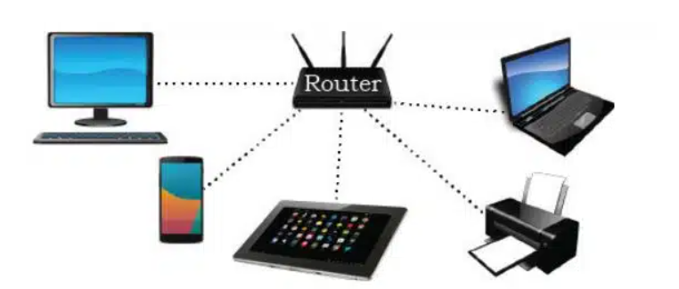
Core Components
- Sender: The device that originates and sends the data.
- Receiver: The target device that receives the transmitted data.
- Transmission Medium: The physical path (wired or wireless) data travels along.
- Protocols: The set of rules governing data communication.
- Data/Message: The actual information being communicated.
Need for Networking
- Resource Sharing: Allows multiple users to share printers, storage, and software.
- Communication: Enables instant messaging, emails, and video conferencing.
- Centralized Management: Simplifies data backups and security updates from one location.
Advantages of Computer Network
- Resource Sharing: Users can share resources within the network; users can share three types of resources.
  - Hardware resources: User can share printer or scanner to the other computers.
  - Software resources: The user can share the software file, like open-source software.
  - Information sharing: Users can share documents, reports, etc.Computer Science
- Reliability: Reliability means keeping the copy of files on multiple computers using a network. It helps to retrieve the file when the computer has crashed.
- Cost Factor: Computer networks reduce the cost of resource sharing between computers. For example, suppose you have 10 computers on the network but only one printer; in that condition, you can share the printer resources with the other computers.
- Exchange of information – Users in a network can quickly communicate using text, video, audio, data, and information with other users.
Elementary Terminology of Networks
Nodes (Workstations):- The term nodes refer to the computers that are attached to a network and are seeking to share the resources
Server:- A computer that facilitates the sharing of data, software and hardware resources on the network.
MAC Address: A (Media access Control) address is a hardware identification number that uniquely identifies each device on a network (assigned to a NIC by the manufacturer).
IP Address: Each computer on internet is identified by a unique number called IP Address. E.g: 192.168.1.1
Evolution of Computer Network
- ARPANET (1969) – The US government formed ARPANET (Advanced Research Project Agency Network) to connect various universities and defence agencies to share information. ARPANET was the first operational computer network, which became the foundation of the modern internet.
- NSFNET (1985) – A more powerful network than ARPANET, NSFNET stands for the National Science Foundation Network, established by the National Science Foundation (NSF) to promote advanced research and education in networks.
- INTERNET (1990) – Internet is a worldwide system of interconnected computer networks.

Disadvantages of Computer Networking
Some of the main disadvantages of Computer Networking are discussed below:
- Expensive: Execution of the network can be expensive in the case of an initial setup, as the wires and the cost of the cable are high and sometimes equipment is also costly.
- Virus and Malware: Computer Networking can lead to the spreading of viruses to another computer through the network.
- Management of the network: Management of the Network is quite difficult as it requires skilled persons to handle that large network. It requires training of people who are employed in this work.
- Loss of Information: In case of a crash of the Computer Network, it can lead to the loss of information or not being able to access information for some time.

Types of Networks:
LAN (Local Area Network)
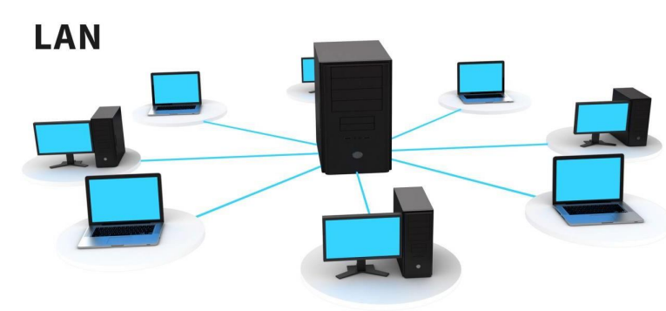
- Definition: A network connecting devices within a small geographic area.
- Example: A single office building, home, or school.
- Speed: Very high data transfer rates.
- Ownership: Private ownership by an individual or organization.
MAN (Metropolitan Area Network)
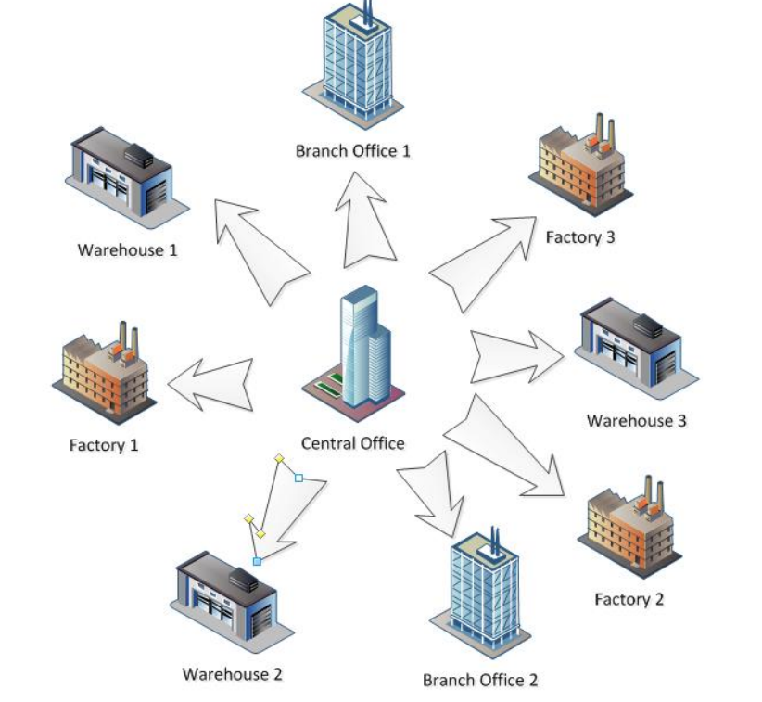
- Definition: A network covering a larger geographic area than a LAN but smaller than a WAN.
- Example: A network connecting multiple offices across a whole city.
- Speed: Moderate data transfer rates.
- Ownership: Can be private or owned by a public consortium.
WAN (Wide Area Network)
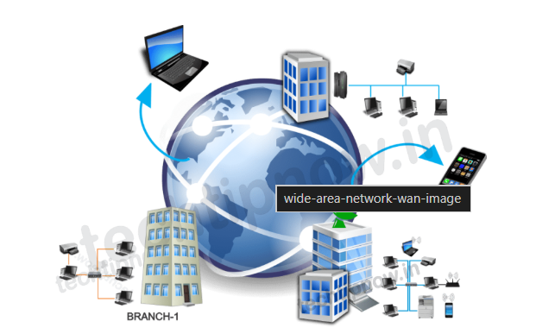
- Definition: A network spanning massive geographic areas, often crossing countries or continents.
- Example: The global Internet.
- Speed: Slower data transfer rates due to distance.
- Ownership: Public or shared ownership across multiple providers.

Differences Between LAN, MAN, and WAN
Basis | LAN | MAN | WAN
Full-Form | LAN stands for local area network. | MAN stands for metropolitan area network. | WAN stands for wide area network.
Geographic Span | Operates in small areas such as the same building or campus. | Operates in large areas such as a city. | Operates in larger areas such as country or continent.
Ownership | LAN’s ownership is private. | MAN’s ownership can be private or public. | While WAN also might not be owned by one organization.
Transmission Speed | The transmission speed of a LAN is high. | While the transmission speed of a MAN is average. | Whereas the transmission speed of a WAN is low.
Propagation delay | The propagation delay is short in a LAN. | There is a moderate propagation delay in a MAN. | Whereas, there is a long propagation delay in a WAN.
Congestion | There is less congestion in LAN. | While there is more congestion in MAN. | Whereas there is more congestion than MAN in WAN.
Design & Maintenance | LAN’s design and maintenance are easy. | While MAN’s design and maintenance are difficult than LAN. | Whereas WAN’s design and maintenance are also difficult than LAN as well MAN.
Fault tolerance | There is more fault tolerance in LAN. | While there is less fault tolerance. | In WAN, there is also less fault tolerance

Components of Data communication
- Sender & Receiver: The sender and receiver are both electronic devices. The sender can send data through the network system, and the receiver receives data from the network. For example, laptops and smartphones can send and receive the data through a network, also known as a node in a network system.
- Node: Any device connected to a network and can send, receive or process data is known as a node.
- Message: It is information which can be shared between the sender and receivers.
- Communication Media – It is a method used to transport messages from the sender to the receiver are referred to as communication medium. Communication Media can be sent message through wired or wireless.
- Protocols – A protocol is a set of rules for exchanging data. Each step and process of communication between two or more computers has a set of rules that apply to it. For networks to transport data successfully, they must abide by certain guidelines.

Communication Media
Transmission media or communications channel refers to the cables or links used in networking. Basically, the transmission media or communication channels are classified into two categories:
- Guided Media or Wired communication Channel
  - Twisted Pair Cable
  - Coaxial Cable
  - Optical Fibres
- Unguided Media or Wireless communication Channel
  - Microwave
  - Radio Wave
  - Satellite
  - Infrared
  - Bluetooth

Guided Media or wired communication channel
The guided media refers to the different types of cables used in the network. As you have seen above list, now let us talk about all types of guided media.
Communication channels are the mediums used to transfer data from one device to another over a network. They are split into physical (guided) and wireless (unguided) mediums.
Physical Channels (Guided Media)
Twisted Pair Cable
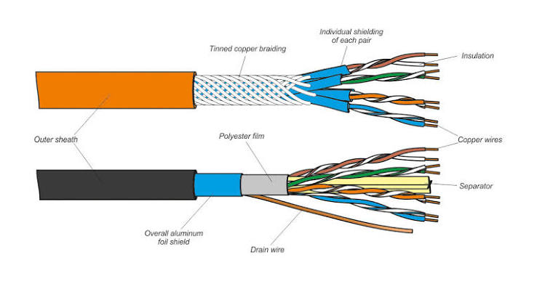
- Description: Consists of pairs of insulated copper wires twisted around each other to reduce electromagnetic interference. Available as Shielded (STP) or Unshielded (UTP). twisted pair cable is also known as Ethernet cable
- Application: Used extensively in local telephone lines and office LAN connections (Ethernet).
- Advantages of Ethernet Cable
  - Cost – Effective
  - Easy to install and Maintain
  - It is simple
  - It is very flexible
  - It has low weight
  - It can be connected easily
- Disadvantages of Ethernet Cable
  - Very difficult to manage for long distance
  - Low bandwidth
  - Not suitable for broadband applications
Co-axial Cable
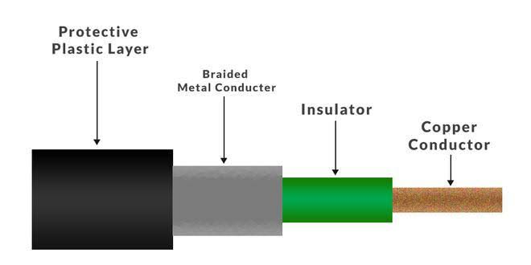
- Description: Features a central solid copper conductor surrounded by an insulating layer, a metallic braided shield, and a plastic outer jacket.
- Application: Standard use cases include cable television networks and high-frequency broadband connections.
- Advantages
  - Suitable for high-speed communication
  - Better than twisted-pair cables
  - Can be used in shared cable network
  - Can be used for broadband transmission
  - Offers bandwidth up to 400Mbps
- Disadvantages
  - Expensive than twisted pair cable
  - Not compatible with twisted pair cable

Optical Fibre Cable
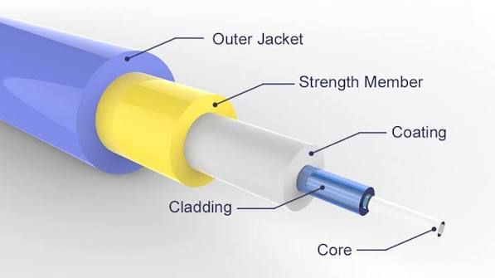
- Description: Transmits data as light pulses through thin strands of high-quality glass or plastic fibers. It operates on the principle of total internal reflection.
- Application: Essential for high-speed backbone internet connections, long-distance telecommunications, and deep-sea data trunks.
Advantages
- Provides high-speed data transmission
- Strong and protected cables
- Provides secure transmission
- Can be used for broadband transmission
Disadvantages
- The installation process is not easy
- virtually impossible to to tap
- Connection losses are more common problem
- Most expensive cables

Wireless Channels (Unguided Media)
- Microwave: High-frequency line-of-sight electromagnetic waves used for point-to-point communication across antennas mounted on towers.
Advantages
- Cheaper than cables
- Land is required to fix towers only, saves the space of land to spread the cables
- It can provide easy communication over difficult terrain
- It can communicate over oceans
Disadvantages
- Insecure connection
- The network can be affected by weather effects such as rains, thunderstorms etc.
- Limited bandwidth
- Very high-cost maintenance

- Radio wave: Omnidirectional electromagnetic waves that can easily travel through long distances and pass through solid walls. Used in Wi-Fi and radio broadcasting.
- Satellite Links: Geostationary space satellites receive microwave signals from earth stations, amplify them, and broadcast them back to wide areas on Earth.
Advantages
- Covers a large area
- Best alternative of cables
- It provides good option for commercial use
Disadvantages
- Due to some technical limitations, cannot spread over large area
- over-crowding at low antennas
- High cost
- Significant probability of failure

Data Switching Techniques:

Circuit Switching, Message Switching and Packet Switching.
Comparison of Switching Types
Message Switching | Circuit Switching | Packet Switching
No dedicated path; the entire message is stored and forwarded at each node. | A fixed, dedicated path is established before transmission. | Data is split into packets that follow dynamic or virtual paths.
Very inefficient due to full message storage and forwarding. | Inefficient because bandwidth remains reserved even when idle. | Highly efficient due to optimal bandwidth utilization.
High transmission delay. | Low delay after initial setup. | Delay varies based on network conditions.
Less reliable and obsolete. | Reliable with guaranteed connection. | Reliable with error control and retransmission.
Used in telegraph systems. | Used in traditional telephone networks. | Used in the Internet.

Network Devices and their uses:
- Modem
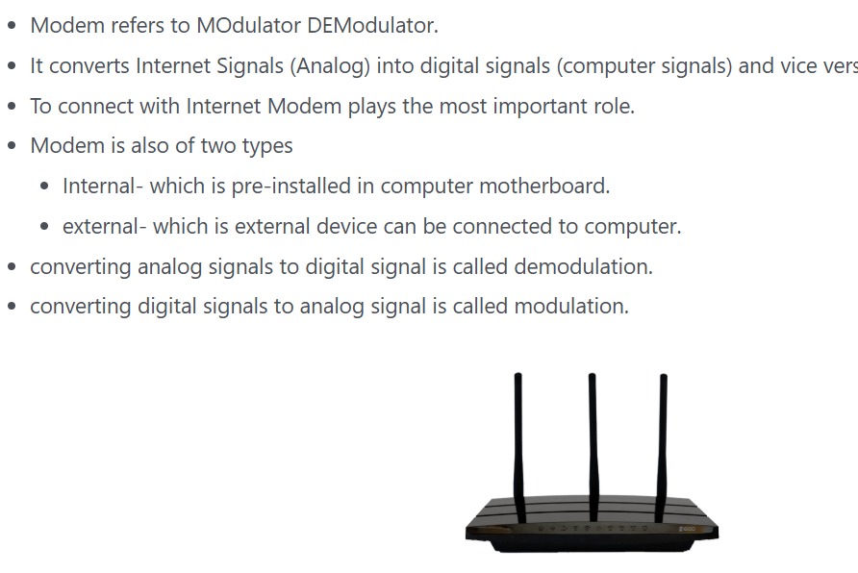
- Hub
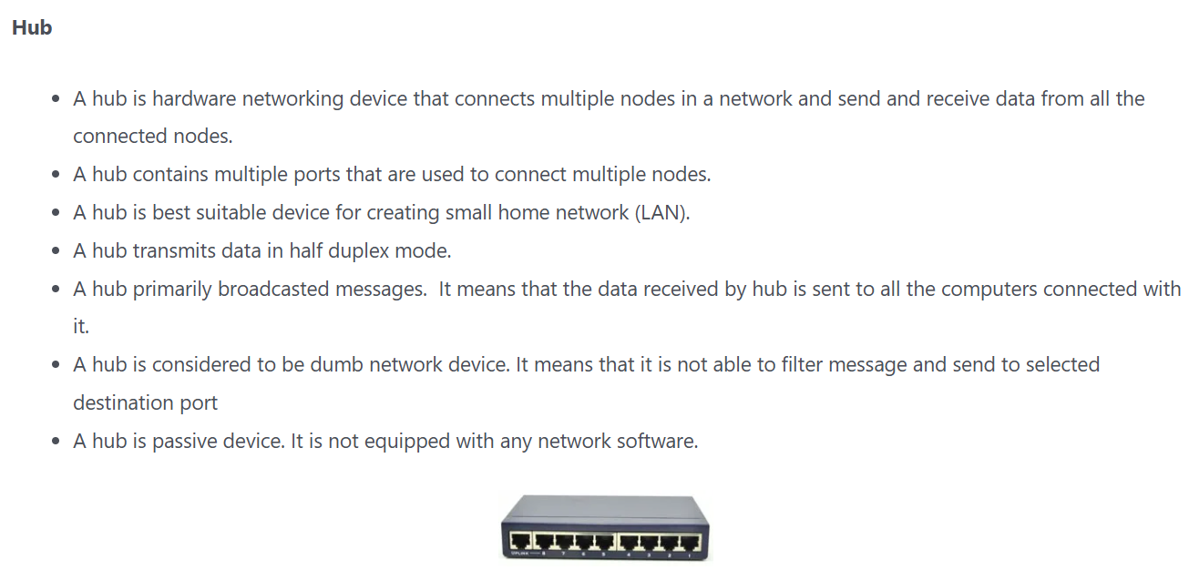
- Repeaters
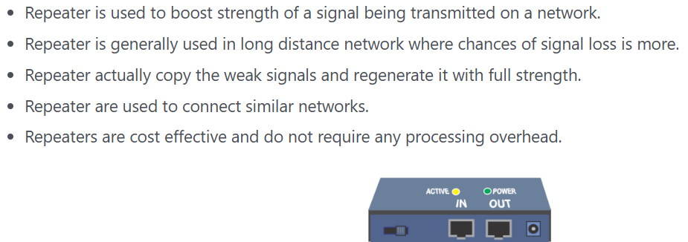
- Bridge
A bridge is a networking device that connects two or more Local Area Network (LAN) segments and enables communication between them.
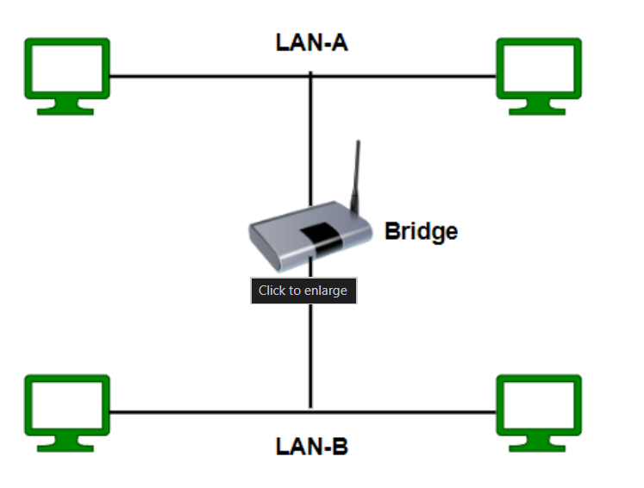
- Router
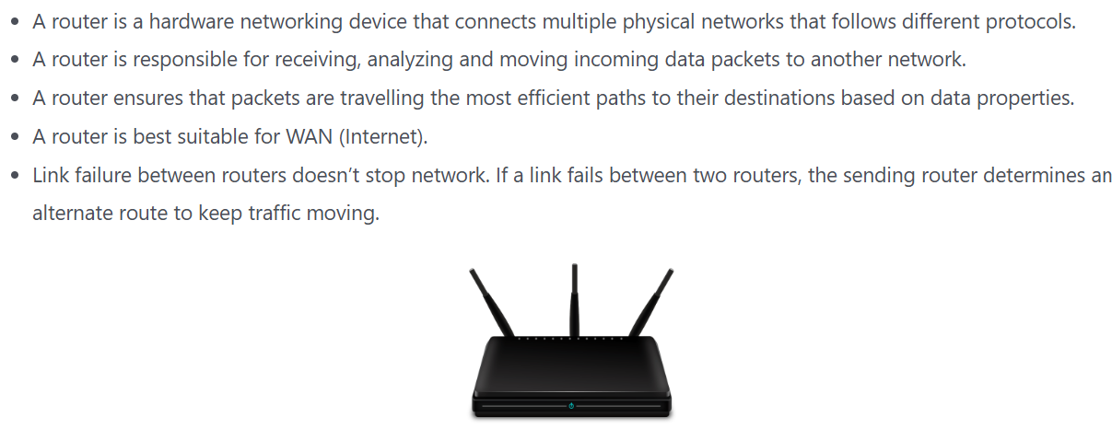
- Gateway
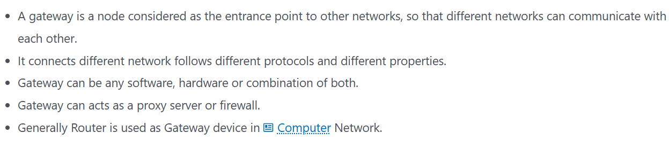
- Switch
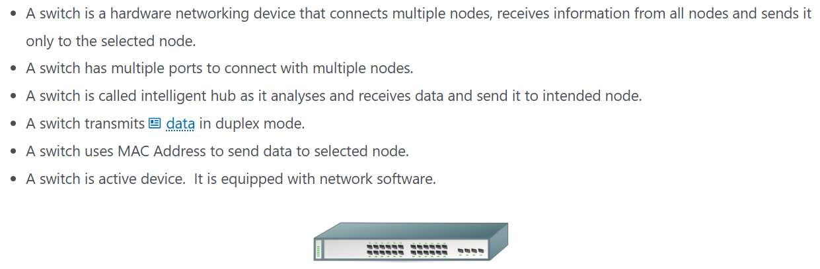

Network Topologies: 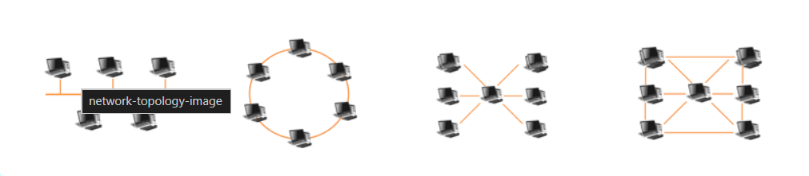

Network topology is a physical and logical arrangement of devices. It is responsible for how the data is flowing within a network. The layout of interconnection of devices in a network is called topology. Example, Bus, Ring, mesh and tree topology.
Bus Topology
Bus topology, often called line topology, is a type of network topology in which each device is connected to the network by a single coaxial or RJ-45 network wire.
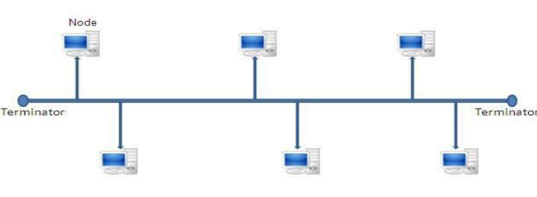
Advantages
- Easy to use.
- Low cost of installation.
- Can be easily extended.
Disadvantages
- If the cable fails, then the entire network will not work.
- At the same time, only one message can travel.
- Difficult to troubleshoot an error.
Star Topology
All of the devices in a star topology are linked to a central controller called a hub since communication between any two devices occurs through the hub. Installation and configuration of the Star network are simple. Furthermore, fault isolation and detection are simple.
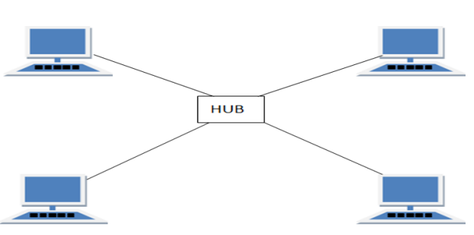
Advantages
- Easy to troubleshoot
- If any wire has a fault, then it will not affect the entire network.
- Fault detection and removal is easy.
- If a workstation fails, the network is not affected.
Disadvantages
- Difficult to expand.
- A longer cable is required.
- More expensive.
- All nodes are dependent on the central node. If the central node is not working, then the entire network will go down.
Tree Topology
A hybrid topology that combines bus and star topologies is called tree topology. In a bus topology, backbone cable functions as the tree’s stem, while star networks (and even individual nodes) are connected to the primary tree by star cables.
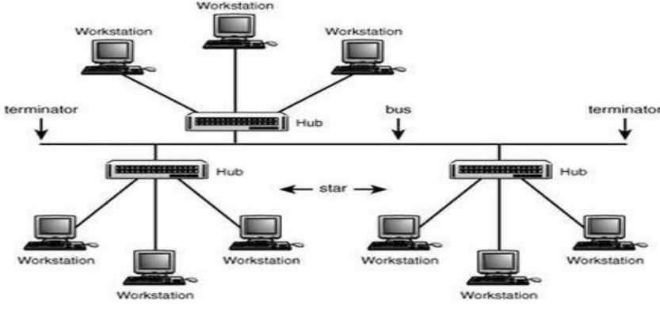
Advantages
- if one node fails, it does not affect entire network
- The network can be easily extended.
Disadvantages
- Uses large cable.
- Requires a large amount of hardware components.
- Difficult for installation and reconfiguration.
Ring (Circular) Topology
In Ring or Circular topology all connected nodes form a circular path. Each node is connected to it’s two neighboring nodes. In this topology Information sent by a node transmits from one node to another node until it reaches to destination node. Usually, data is transmitted in half duplex mode in this topology but it can be duplex mode.
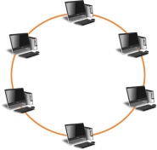
Advantages of Ring (Circular) Topology
- No need of Server control for data transmission.
- Data collision rate is very low as data travels unidirectionaly.
- Easy maintenance and troubleshooting
- High Speed Communication Network.
- Each node has equal access to resources
Disadvantages of Ring (Circular) Topology
- Failure of any node may cause entire network down.
- Less secured network
- Slower than star topology
- Expensive network as it uses expensive components to establish the network.

Network Protocols
HTTP (Hypertext Transfer Protocol) – HTTP stands for Hypertext Transfer Protocol, which is basically designed for communication between web browsers and web servers. A http is an application-layer protocol with some set of rules for transmitting hypermedia documents between network devices. Now we have a more secure version of http that is https. https can send information in encrypted form to provide a more secure method.
FTP (File Transfer Protocol): A File Transfer Protocol is used for downloading, uploading, and transferring files between the client and server computers.
PPP (Point to Point Protocol): Point-to-Point Protocol is used to make a connection between two devices using dial-up modems. This protocol is used when we want to connect two computers using a telephone network and both computers have the same state.
SMTP (Simple mail transport Protocol): Simple Mail Transfer Protocol is used for sending email messages over a network where the sender server sends the message to the recipient server.
TCP/IP (Transmission Control Protocol): TCP/IP stands for Transmission Control Protocol/Internet Protocol, used for communication on a network, including the internet. TCP/IP handles a two-layer protocol where TCP is used for end-to-end communication and IP handles routing data packets between devices.
POP3 (Post Office Protocol 3): POP3 is a method for receiving incoming emails. Post Office Protocol 3 is an email protocol used to receive emails from the client server.
Data Formats & Protocols
HTTPS (Hypertext Transfer Protocol Secure): HTTPS stands for Hypertext Transfer Protocol Secure. This protocol is used for sending and receiving data between a browser and a website using an encryption method.
TELNET: Telnet is a text-based communication between a client and a server; the Telnet can connect to remote machines.
VoIP: It enables voice to be transported over a packet switched network as opposed to a public switched telephone network. VOIP software enables making phone calls over a standard internet connection. Today, ATA, IP phones, and computer-to-computer VoIP services are the three main categories that are regularly used.

Internet and Web Services

What is Internet?
“Interconnected Network”
Internet is independent global network system of countless computers and electronic devices scattered around the globe connected to each other wirelessly or wirely with the help of various devices such as satellite, routers, wires and modems, for sharing information and communicating with each other.

World Wide Web
World Wide Web popularly called ‘Web’ is a leading information sharing service of the Internet, which was developed by Tim Berners Lee in 1989 to give user access to wide range of documents that are connected to each other by hyperlink and written in HTML.
- Content of HTML documents can be any text, graphics, audio or video.
- Every HTML Document is can be accessed by its unique address known as URL
- To read HTML Documents Web Browser is used.
- HTTP is used to transfer documents from Server to Client.
Difference between Internet and WWW
Internet | WWW
Internet is primarily hardware based | WWW is primarily software based
Internet is networking infrastructure that connects devices together | WWW is collection of information that can be access through Internet
Internet uses TCP/IP for communication | WWW uses HTTP/HTTPS for communication

HTML (Hypertext Markup Language)
- HTML or Hypertext Markup Language is basically used to design and format a web page.
- HTML were developed by Tim Berner Lee in 1991
- HTML contains different tags putted inside <> used in designing web page.
- Ideally it is a formatting language not a programming language.

Website
A website is collection of web pages which can be interlinked with each other, hosted on a web server and written using HTML.
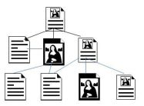

URL
A URL stands for Uniform Resource Locator also referred to as web address is a unique identifier used to specify unique address of a website. For example https://www.microsoft.com
Components of URL:
- Protocol
- Name or Address of Server
- Location of File on Server
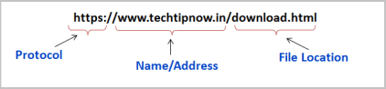

Domain Names
- Domain name is referred as the name given to a website hosted in computer server, so that it can be accessed over the Internet.
- Domain names also called hostnames is given against IP address of computer server hosting website.

Web Server
Web Server: A web server is a computer used to store and respond to web related request. It handles HTTP request and delivers web pages.
Computer Hardware
- Web Server is used for Web hosting or hosting for website or web application.
- Web Server can also support FTP and SMTP.
- A Web Server may consist of Hardware and Software both.
- Web Server hardware is basically a computer which stores Web Server software and content related to website such as text, images, html and css code, script code, audio/video files etc.
- Web Server software are programs that accept http request from web browser and respond those request.

Web Hosting
Web hosting is a service that provide resources such as CPU, RAM, Storage, connection and necessary services to store, manage and serve a website or application in Internet and make it part of www. Once a website or application is hosted, it can be accessed from any computer connected to Internet.

Web Browser
A Web browser is an application software which enable use to view information available in Internet. It display information retrieved from web server in HTML format.
Examples-
- Google Chrome
- Mozilla Firefox
- Internet Explorer
- Opera

Dynamic Hyper Text Mark-up Language (DHTML)
Definition
DHTML is not a standalone programming language. It is a collection of complementary web technologies used together to create interactive and animated websites.
Core Components
- HTML: Defines the static structure and content of the webpage.
- CSS: Controls the visual presentation, styling, layout, and appearance.
- JavaScript: The scripting language that manipulates webpage elements dynamically in real-time.
- DOM (Document Object Model): The structured interface that allows JavaScript to access and modify HTML elements on the fly.
Key Features & Advantages
- Client-Side Processing: Changes happen instantly in the user's browser without reloading the page from the server.
- Dynamic Styling: Elements change color, size, or position automatically when clicked or hovered over.
- Animations: Supports moving text, drop-down menus, and rollover buttons effortlessly.
- Low Server Load: Reduces data traffic because the server does not need to re-render the whole page for small updates.

Search Engines
Definition
A search engine is a web-based software application designed to systematically search the World Wide Web for specific information based on user-entered keywords. Popular Examples
- Google
- Microsoft Bing
- DuckDuckGo

File Transfer: Downloading vs. Uploading
File transfer is the process of moving data files between a local computer and a remote network server over the internet.
Feature | Downloading | Uploading
Data Direction | From a remote server to a local device. | From a local device to a remote server.
User Goal | To save files, media, or programs onto your machine. | To share data, backup files, or publish content online.
Typical Protocols | HTTP, HTTPS, FTP | HTTP, HTTPS, SFTP
Common Examples | Saving a PDF report or streaming a movie. | Attaching a file to an email or posting a photo on Instagram.

Cyber Security: Hacking vs. Cracking
While often used interchangeably in casual conversation, hacking and cracking have fundamentally different intents and legal standings in computer science.
Hacking
- Definition: The process of identifying and exploring vulnerabilities in a computer system or network to understand its architecture or improve its security. [1]
- Intent: Can be ethical (White Hat) or malicious (Black Hat). Ethical hackers are authorized professionals hired to find flaws before criminals do.
- Skill Level: Highly advanced knowledge of computer programming, operating systems, and network protocols.
- Legal Status: Fully legal when authorized by the system owner.
Cracking
- Definition: The unauthorized, destructive breaking into a secure computer system or software with explicit malicious intent.
- Intent: Always malicious or criminal. The goal is to steal sensitive data, destroy files, deface websites, or bypass paid software licenses (cracking serial keys).
- Skill Level:
Often relies on pre-made automated malicious tools, though some copy-protection crackers possess high reverse-engineering skills.
- Legal Status: Completely illegal and punishable under cyber law.

