Color code:

Added in latest version of methodology
Deleted from first version of methodology
Explanations on why changes were made
References to appendices

Experimental Approach
Shoulder Surfing Attacks (SSA), where attackers discreetly observe keystrokes to obtain sensitive information such as passwords or authentication codes, pose a growing threat to data security in various environments, including professional, financial, and personal settings.
The keycube is a keyboard that takes a cubic shape. It is designed to offer an alternative and potentially more secure method of data entry against SSA. Its three-dimensional design and unique key layout can make it more difficult for an attacker to observe and memorise keystrokes. In a context where data security and the protection of sensitive information are paramount, it is crucial to evaluate the practical implications of this new technology.
This research project aims to address this issue by assessing the effectiveness of the keycube in preventing SSA. By empirically analysing typing performance and observing user behavior, we seek to determine whether using the keycube can reduce the risk of SSA compared to a standard computer keyboard and to a phone 2D keyboard. The results of this study will provide a better understanding of the advantages and limitations of this technology in terms of data security and will provide tangible data to inform future decisions regarding its adoption and integration into environments sensitive to security concerns.

Participant Recruitment
Participant recruitment is a crucial step in the research project, aiming to ensure a diverse and meaningful representation of potential keycube users. We have defined specific criteria for participant selection to maximise the relevance and reliability of the results obtained.

Selection Criteria

Inclusion Criteria
Participants must meet the following inclusion criteria:
- Age: Be an adult, i.e., 18 years or older. Appendix 2, see 3.3 Survey Protocol
- Cognitive and/or Motor Ability: Be capable of understanding and following the instructions given for the study. Thorough explanations may be given if asked, but no medical and/or mental condition should prevent the understanding and/or the execution of the instructions. Explanations on what is meant by « Cognitive and/or Motor Ability » Appendix 2, see 3.3 Survey Protocol
3.Prior Experience: Be a potential keycube user or have prior experience with standard keyboards. It could be interesting to have different participants having different levels on typing on a keyboard to compare with the keycube Contradiction with appendix 1, see conclusion 8.
- Language and Keyboard's locale: Be able to understand and to type in English on a Canadian QWERTY keyboard. This is necessary in order to have a minimal error rate and a maximal typing speed Appendix 1, see conclusion 1.
- Informed Consent: Be able to give informed consent to participate in the study. Appendix 2, see 3.3 Survey Protocol

Exclusion Criteria
Participants will be excluded from the study if they meet any of the following criteria:
- Age: Be a minor, i.e., under 18 years old. Appendix 2, see 3.3 Survey Protocol
- Cognitive and/or Motor Ability: Have comprehension or communication difficulties and/or medical conditions that could compromise participation in the study such as but not limited to schizophrenia, BPD or the loss of (at least) a finger. Again, explanations on what is meant by « Cognitive and/or Motor Ability » Appendix 2, see 3.3 Survey Protocol
3.Prior Experience: Have no prior experience with computer keyboards or similar input devices. Again, it could be interesting to have different participants having different levels on typing on a keyboard to compare with the keycube Contradiction with appendix 1, see conclusion 8.
- Language and Keyboard's locale: Be unable to understand and/or to type in the English language with a Canadian QWERTY keyboard. Again, this is necessary in order to have a minimal error rate and a maximal typing speed Appendix 1, see conclusion 1.
- Informed Consent: Be unable to give informed consent to participate in the study. Appendix 2, see 3.3 Survey Protocol
5.Medical Conditions or Physical Disabilities: Have medical conditions or physical disabilities that could interfere with typing on a standard keyboard or keycube. This is already comprised in the second point « Cognitive and/or Motor Ability »
The recruitment of participants will strictly adhere to these criteria to ensure the safety, well-being, and validity of the data collected during the experiment.

Recruitment Process
Participant recruitment will be conducted using the following methods:
- Internal Announcements: Announcements will be made within our academic institution through internal communication channels such as bulletin boards, electronic newsletters, and emails to faculty members, students, and administrative staff. These announcements will invite interested individuals to participate in our study and provide information on the inclusion criteria and participation process.
- Word of Mouth: We also encourage word-of-mouth within our academic structure by inviting faculty members, students, and administrative staff to recommend individuals who may meet the inclusion criteria of our study. This approach will help reach individuals who may not be actively engaged in formal communication channels but may still be interested in participating in our research.
Once participants are identified, we will conduct a random selection to avoid potential biases and ensure the representativeness of our sample.

Experimental Environment Preparation
The experimental environment will be configured to simulate realistic scenarios of keycube usage in various contexts. We will focus on two specific scenarios to evaluate the effectiveness of the keycube in preventing Shoulder Surfing Attacks (SSA).

Scenario: Bank employee working on a train
In this scenario, we will simulate a banking environment where a bank employee performs sensitive - or not - computer tasks on a laptop on a train.
- Setup: The setup will be comprized of laptop equipped with a standard 2D keyboard and a mouse, or with a keycube and a mouse, or a smartphone.
- Simulated Tasks: The participant will be asked to perform common tasks performed by a bank employee, such as entering critical passwords and writing meaningful sentences. These tasks will involve intensive keyboard use to enter sensitive information.
- Experimentation: The participant will perform the tasks on only one type of keyboard. During each session, we will closely observe the participant's behavior, and cameras will also record the entire experience for later analysis.
The scenario has been reworked. A single scenario should be used in order to not confuse participants. Is has also been simplified to give us a bit more leeway on the things that will be typed.
Appendix 1, see conclusion 5.

Scenario 1: Bank Employee at a Fixed Computer
In this scenario, we will simulate a banking environment where an employee performs sensitive computer tasks at a fixed workstation.
- Setup: A workstation will be equipped with a desktop computer, a standard 2D keyboard, and a mouse.
- Simulated Tasks: The participant will be asked to perform common tasks performed by a bank employee, such as checking customer accounts, entering transactions, and writing reports. These tasks will involve intensive keyboard use to enter sensitive information.
- Experimentation: The participant will initially perform the tasks on the standard 2D keyboard and then on the keycube. During each session, we will closely observe the participant's behavior, and cameras will also record the entire experience for later analysis.

Scenario 2: Employee on a Train with a Laptop
In this scenario, we will simulate a mobile work environment where an employee performs computer tasks while traveling on a train.
- Setup: A space will be arranged to resemble the interior of a train compartment, with a foldable table, a laptop, a keycube, and a mouse.
- Simulated Tasks: The participant will be asked to perform common tasks performed by an employee on the move, such as writing emails, updating documents, and browsing the internet. These tasks will require regular keyboard use and the use of the keycube.
- Experimentation: The participant will initially perform the tasks on the standard 2D keyboard and then on the keycube. During each session, we will closely observe the participant's behavior, and cameras will also record the entire experience for later analysis.

Camera Placement
In both scenarios, cameras will be positioned at multiple strategic locations in the room to capture different perspectives and viewing angles. This will allow comprehensive monitoring of the experimental environment.
- far left - over target's left shoulder at a height of 6’
- near left - over target's left shoulder at a height of 5’
- top - over target's head at a height of 6’
- near right - over target's right shoulder at a height of 5’
- far right - over target's right shoulder at a height of 6’
- low right - at keyboard's/phone's height
- back left - at a height of 5’ , symmetrical with near right with keyboard as point of symmetry
Here are more instructions regarding general angles and placement:
- two far cameras and near cameras from the same side are placed 2.5’ apart
- far cameras are placed directly above near ones
- they are all angled directly facing the hands/phone
Appendix 2, see 4. RESULTS.
Appendix 4, 3D models.

Experimental Procedure
Each participant will be guided through several steps during the experiment, with clear instructions on the tasks to be completed and the equipment to be used.
- Welcome and Preparation: Upon arrival, participants will be welcomed and given a brief introduction to the experiment's procedure. They will be informed about the study's objectives and safety guidelines.
- Survey: Participants will fill out a survey where they will indicate information about themselves such as gender (if deemed useful), age, eyesight, and skill in regard to typing on phones and computer keyboards. Appendix 2, see 3.3 Survey Protocol
- Equipment Assignment: Each participant will be assigned a specific workstation equipped with either a computer keyboard, a phone standard 2D keyboard or a keycube, based on the planned experimental sequence.
- Typing Tasks: Participants will be asked to perform the designated tasks on the assigned equipment. They will be provided with a series of pre-defined texts to use. These texts will be designed to simulate realistic usage scenarios, such as entering passwords, typing emails etc writing emails, entering financial data, or creating professional documents Appendix 1, see conclusion 5. Each participant will complete the tasks following the given instructions.
- Data Recording: While participants perform the typing tasks, we will record relevant data, such as pressed inputs (letters, backspace...), time of each input and will then be analyzed to give us the number of typing errors, time and speed (WPM) typing time, number of errors, and typing speed Data collected by the tool in appendix 3.. Additionally, cameras positioned in the room will capture various perspectives and viewing angles, allowing comprehensive monitoring of the experiment and later analyses.
- Debriefing and End of Experiment: At the end of the experiment, participants will be invited to share their impressions and feedback with the researchers. An informal debriefing session will be organised to gather participants' reactions and address any questions or concerns.

Data Analysis
Once all data is collected during the experiment, a thorough statistical analysis will be performed to evaluate typing performance on the different types of keyboards (computer keyboard, phone standard 2D keyboard and keycube) and to compare the effectiveness of the keycube in preventing Shoulder Surfing Attacks (SSA).

Typing Performance Evaluation
The recorded data during the experiment will be analysed to evaluate typing performance on each type of keyboard.
- Typing Time: The time required to complete each typing task will be recorded and compared between the computer keyboard, phone standard 2D keyboard and keycube.
- Number of Errors: The number of typing errors will be counted for each participant on each type of keyboard.
- Typing Speed: Typing speed, measured in words per minute (WPM), will be calculated for each participant on each type of keyboard.

SSA Prevention Evaluation
In addition to typing performance, the data will be analysed to evaluate the effectiveness of the keycube in preventing SSA.
- Observations and Calculations: Observations will focus on predefined indicators to determine the participant's protection rate against SSA.
- Video Analysis: Video recordings of the experimental sessions will be thoroughly analysed to identify any situations where the keycube provided additional protection against SSA. Moved below the next paragraph for logic. First analysis, then Evaluation

Statistical Analysis
The collected data will be subjected to appropriate statistical analyses, such as t-tests, analysis of variance (ANOVA), and non-parametric tests, depending on the data distribution and the study's specific objectives. The results will be interpreted to determine significant differences in typing performance between the two types of keyboards and to evaluate the effectiveness of the keycube in preventing SSA. Videos from all angles are going to be seen by researchers in order to try to recover the strings participants will have typed.

SSA Prevention Evaluation
Previously collected data will be analysed to evaluate the effectiveness of the keycube in preventing SSA.
- Observations and Calculations: Observations will focus on predefined indicators to determine the participant's protection rate against SSA.
- Video Analysis: Video recordings of the experimental sessions will be thoroughly analysed to identify any situations where the keycube provided additional protection against SSA.

Interpretation of Results
The results of the data analysis will be interpreted to provide meaningful conclusions about the keycube's effectiveness in preventing SSA. The practical implications of the results will be discussed, particularly regarding the potential adoption of the keycube in environments sensitive to data security concerns. The study's limitations will also be identified and considered in the interpretation of the results.

Present known limitations
- Expertise on keycube: We know that most people nowadays are are familiar with computer and/or phone keyboards. The keycube being an experimental device, we also know that little to no people are familiar with three-dimensional typing devices. This ultimately will cause the typing speed to be significantly lower and the error rate to be particularly high, but we will take that into account when interpreting the results.
- Analysis and Recovery: Us, researchers, being the ones who created the strings that the participants will have to type, will probably subconsciously know them all by the end of the analysis and it could greatly facilitate the finding of the strings by viewing the videos.
A random system using regular expressions (regex) could be found to generate random passwords meeting our requirements by being the same complexity for all participants, while being unknown to us.
A text could be randomly generated, but the question of coherence in the text would have to be discussed because if said text is a sequence of random words, the error rate might not reflect the same as if it made sense. A solution could be to take coherent sentences from copyright-free books and novels, randomly selected from a large selection, and thus, being unknown to researchers.
Section frequently cited, it is good to acknowledge in order to know what next papers should/shouldn’t do Appendix 2, see 3.5 Realism and Limitations.

Conclusion
Conducting this experiment to evaluate the keycube's effectiveness in preventing Shoulder Surfing Attacks (SSA) demonstrates a rigorous and informative process. The various stages of the experimentation aim to collect significant data and gain valuable insights into the use of the keycube in simulated scenarios.
The experimental approach undertaken to evaluate the keycube in preventing SSA is an important step in understanding this innovative technology. The lessons learned and the results obtained will serve as a solid foundation for future studies and contribute to advancing data security in an ever-evolving digital world.

References
- Comité d’éthique de la recherche de l’Université du Québec à Chicoutimi (CER-UQAC)
- EPTC2
- Nagano UQAC

Appendix:
1. Pitfalls of Shoulder Surfing Studies, Wiese and Roth, 2015, https://doi.org/10.14722/usec.2015.23007
2. Towards Baselines for Shoulder Surfing on Mobile Authentication, Aviv, Davin, Wolf and Kuber, 2017, https://doi.org/10.1145/3134600.3134609
3. TextTest++, Mingrui “DrustZ” Zhang, https://github.com/DrustZ/TextTestPP
4.
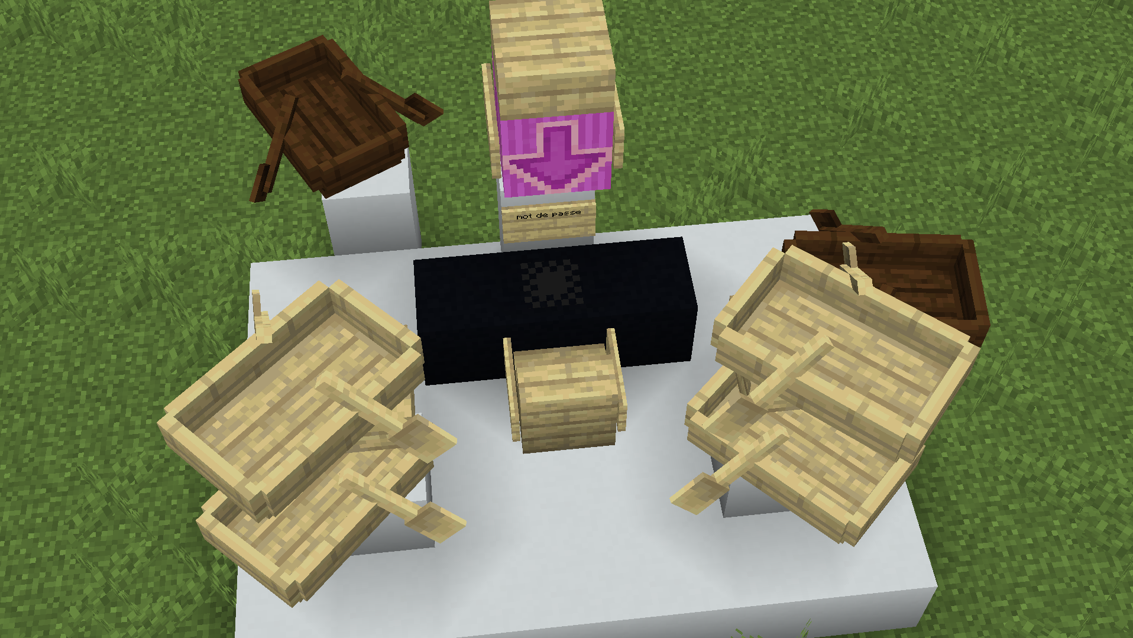
Keyboard is the black dots in the middle of the 3 black blocks. White boats and top slab are cameras that are already confirmed thanks to paper in appendix 2. I suggest adding black boats to cover potential angles from which attackers could spy.
Here is why I think the rightmost black boat is relevant:
In our scenario, we are imagining ourselves in a train. It wouldn’t be unusual for people next to us to lay down on the table and to spy on our keyboard.
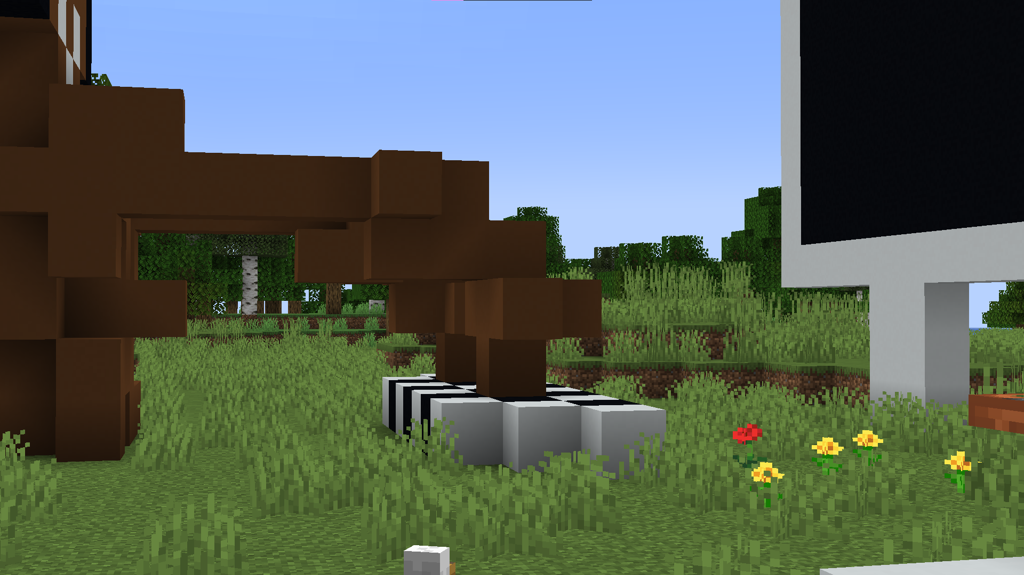
As we can see here, we can see way more clearly what the inputs are when we the vision is at the height of the keyboard. I thought it could be interesting.
As for the back-left black boat, I would think in a similar way, but if prople were in diagonal from us on a table of four people (or across the aisle).
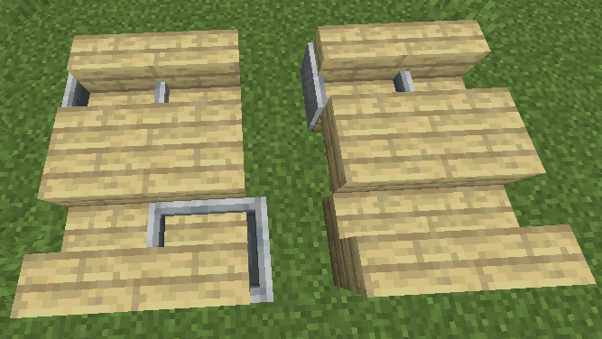
Here is a depiction of what I mean. Let’s imagine our target is the downmost minecart. People in front of it, either on the same table, or across the table could spy on it. This would be interesting because they would see well what is going on on their part of the keyboard (the other one being covered by the screen) but they wouldn’t see it in its entirety.
The world map (minecraft_map_k3_ssa.zip) is available on the Github repo, and is designed for Java Edition 1.20.4. For info on how to load it in game, you can use this guide https://minecraft.wiki/w/Tutorial:Importing_and_exporting_worlds#Java_Edition. It requires a Minecraft Java Edition paid account, and the 1.20.4 version installed and launched at least once through the official launcher.

