**Keyes YX5200-24SS MP3 Module**

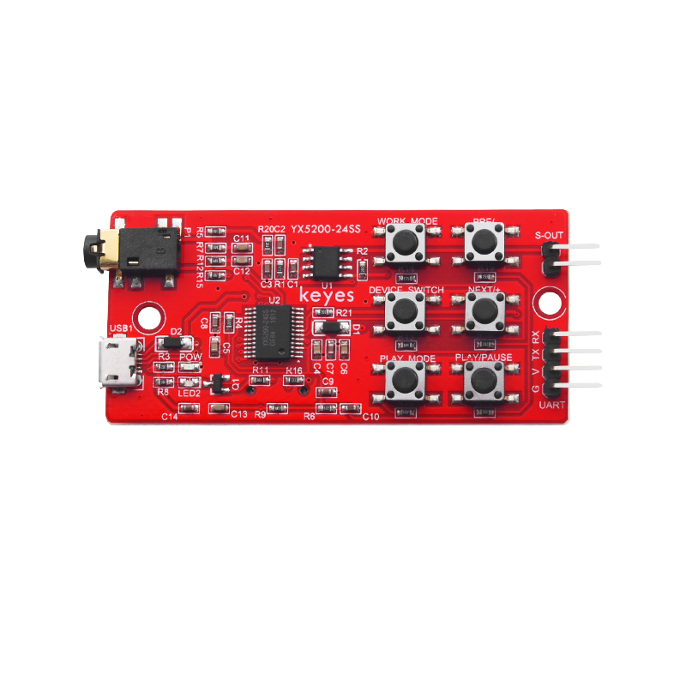

1. **Description**

As a learning module, the core of Keyes YX5200-24SS MP3 module is YX5200-24SS sound chip which perfectly integrates the hard interface of MP3, WAV and WMA and supports TF card driver, with the characteristics of convenience and stability and reliability.

The features of this module are as below:

1. With TF card slot, we can directly read and play music in the card.
2. With a serial communication port(UART), control music playback via serial communication.
3. With micro USB interface(USB1), read SD card content and download music
4. With earphone port（P1）, convenient to listen to music
5. Integrated audio amplifier chip and built-in speaker interface (S-OUT), which can be directly plugged in the speaker to play. The audio magnification is 8 times. The power connected to speaker must be large enough. The initial sound on powering on is maximum by default. Please lower the sound before playing. When the speaker resistance is 8 ohms, the maximum output power is 1.2W.
6. Six commonly used buttons are installed externally to facilitate control and verification instructions.

**2. Specification**

Working voltage: DC 5V  
Working current: maximum 1A  
Maximum power consumption: 5W  
Working temperature: 10~40℃  
Audio magnification: 8 times  
Support TF card: up to 32G  
Size: 33*77*9mm  
Weight: 11.2g

**3. Keys Function**

|  |  |  |  |
| --- | --- | --- | --- |
| **Key** | **Short Press** | **Lone Press** | **Note** |
| WORK_MODE | Play Mode |  | Switch/No-interrupt |
| PRE/- | Previous Song | Turn down |  |
| NEXT/+ | Next Song | Turn up |  |
| DEVICE_SWITCH | Switch device |  | U/TF/SPI/Sleep |
| PLAY_MODE | Working Mode |  | Loop playback |
| PLAY/PAUSE | Play/Stop |  |  |

**4.YX5200-24SS Command**

|  |  |  |  |
| --- | --- | --- | --- |
| Control Command | Function | Send Command | Note |
| [Next Song] | 7E FF 06 01 00 00 00 FE FA EF |  |
| [Previous Song] | 7E FF 06 02 00 00 00 FE F9 EF |  |
| [designated song] | 7E FF 06 03 00 00 01 FE F7 EF | Designate the  first song to play |
| 7E FF 06 03 00 00 02 FE F6 EF | Designate the  second song |
| 7E FF 06 03 00 00 0A FE EE EF | Designate the  tenth song |
| Turn up | 7E FF 06 04 00 00 00 FE F7 EF |  |
| Turn down | 7E FF 06 05 00 00 00 FE F6 EF |  |
| [designated Volume] | 7E FF 06 06 00 00 1E FE D7 EF | Specified volume is  level 30 |
| [designated EQ] | 7E FF 06 07 00 00 01 FE F3 EF | Remain |
| [Loop Playback Songs] | 7E FF 06 08 00 00 01 FE F2 EF | Loop the first song |
| 7E FF 06 08 00 00 02 FE F1 EF | Loop the second song |
| 7E FF 06 08 00 00 0A FE E9 EF | play the tenth song on loop |
| [Specific Playback Device] | 7E FF 06 09 00 00 01 FE F1 EF | Specified Playback UDISK |
| 7E FF 06 09 00 00 02 FE F0 EF | Specified Playback TF |
| 7E FF 06 09 00 00 03 FE EF EF | Specified Playback Devices-PC(Download Mode) |
| 7E FF 06 09 00 00 04 FE EE EF | Specified Playback FLASH |
| 7E FF 06 09 00 00 05 FE ED EF | Designate Play Device-SLEEP |
| [Enter Sleep Mode] | 7E FF 06 0A 00 00 00 FE F1 EF |  |
| [Enable Sleep] | 7E FF 06 0B 00 00 00 FE F0 EF |  |
| [Reset Module] | 7E FF 06 0C 00 00 00 FE EF EF |  |
| [Play] | 7E FF 06 0D 00 00 00 FE EE EF |  |
| [Stop] | 7E FF 06 0E 00 00 00 FE ED EF |  |
| [Designate Folders and Files] | 7E FF 06 0F 00 01 01 FE EA EF | Song "001" is in  the "01" folder |
| 7E FF 06 0F 00 01 02 FE E9 EF | Song "002" is in  the "01" folder |
| Stop Playback | 7E FF 06 16 00 00 00 FE E5 EF | Stop software to decode |
| Specify Folders to Loop Playback | 7E FF 06 17 00 00 01 FE E3 EF | Specify 01 folder to loop playback |
| 7E FF 06 17 00 00 02 FE E2 EF | Specify 02 folder to loop playback |
| Single Circle Playback | 7E FF 06 19 00 00 00 FE E2 EF | Turn on single circle playback |
| 7E FF 06 19 00 00 01 FE E1 EF | Turn off Single circle playback |
| Play with Volume | 7E FF 06 22 00 1E 01 FE BA EF | Play the first song at level 30 |
| 7E FF 06 22 00 0F 01 FE C9 EF | Play the first song  at level 15 |
| 7E FF 06 22 00 0F 02 FE C8 EF | Play the second song  at level 15 |
| Set DAC | 7E FF 06 1A 00 00 00 FE E1 EF | Turn on DAC |
| 7E FF 06 1A 00 00 01 FE E0 EF | Turn off DAC  [High impedance ] |
| Combination Play | 7E FF 09 21 01 02 02 03 01 04 EF | The first number is folder name in [1,2][2,3][1,4] , and the second number is song name |
| 7E FF 15 21 01 02 02 03 01 04 01 03 01 04 01 05 02 08 03 04 03 01 FE 9A EF | With verification [1,2][2,3][1,4][1,3][1,4][1,5][1,8][3,4][3,1] |
| 7E FF 15 21 01 02 02 03 01 04 01 03 01 04 01 05 02 08 03 04 03 01 EF | [1,2][2,3][1,4][1,3][1,4][1,5][1,8][3,4][3,1] |
| Stop Advertising | 7E FF 06 15 00 00 00 FE E6 EF | Stop Advertising，back to background music |
| Stop Play | 7E FF 06 16 00 00 00 FE E5 EF | Stop software decoding |
| Spot Announcement | 7E FF 06 13 00 00 01 FE E7 EF | Song "0001" is in the folder "ADVERT" |
|  | 7E FF 06 13 00 00 02 FE E6 EF | Song "0002" is in the folder "ADVERT" |
|  | 7E FF 06 13 00 00 FF FD E9 EF | Song "0255"  is in the folder "ADVERT" |
|  | 7E FF 06 13 00 07 CF FE 12 EF | Song "1999"  is in the folder "ADVERT" |
|  | 7E FF 06 13 00 0B B8 FE 25 EF | Song "3000" is in the folder "ADVERT" |
| Spot announcement-Multiple folders | 7E FF 06 25 00 01 01 FE D4 EF | Song "001" is in the "ADVERT1" folder |
|  | 7E FF 06 25 00 01 02 FE D3 EF | Song "002" is in the "ADVERT1" folder |
|  | 7E FF 06 25 00 02 01 FE D3 EF | Song "001" is in the "ADVERT2" folder |
| Random Play | 7E FF 06 18 00 00 00 FE E3 EF | Random Play on  Entire Device |
|  |  |  |  |
| Query Instructions | [Query Volume] | 7E FF 06 43 00 00 00 FE B8 EF |  |
| [Inquiry Current EQ] | 7E FF 06 44 00 00 00 FE B7 EF | Maintain this function |
| Total number of folders USB disk | 7E FF 06 47 00 00 00 FE B4 EF | The total number of files on current devices |
| Total number of folders TF | 7E FF 06 48 00 00 00 FE B3 EF |  |
| Total number of folders FLASH | 7E FF 06 49 00 00 00 FE B2 EF |  |
| USB Disk Current Song | 7E FF 06 4B 00 00 00 FE B0 EF | Current playing song |
| TF Current Song | 7E FF 06 4C 00 00 00 FE AF EF |  |
| FLASH Current Song | 7E FF 06 4D 00 00 00 FE AE EF |  |
| Inquiry the total number of songs in folders | 7E FF 06 4E 00 00 01 FE AC EF |  |
| Inquiry the total number of folders on current devices | 7E FF 06 4F 00 00 00 FE AC EF | Support TF card and  USB disk FLASH |
| Return Information | Plug in USB disk | 7E FF 06 3A 00 00 01 xx xx EF |  |
| Plug in TF | 7E FF 06 3A 00 00 02 xx xx EF |  |
| Plug in PC | 7E FF 06 3A 00 00 04 xx xx EF |  |
| Plug out PC USB Disk | 7E FF 06 3B 00 00 01 xx xx EF |  |
| Plug out TF | 7E FF 06 3B 00 00 02 xx xx EF |  |
| Plug out PC | 7E FF 06 3B 00 00 04 xx xx EF |  |
| USB Disk finishes playing the first song | 7E FF 06 3C 00 00 01 xx xx EF | USB disk finishes  playing the first song |
| USB disk finishes playing the second song | 7E FF 06 3C 00 00 02 xx xx EF | USB disk finishes  playing the  second song |
| TF card finishes playing the first song | 7E FF 06 3D 00 00 01 xx xx EF | TF finishes playing the first song |
| TF finishes playing the second song | 7E FF 06 3D 00 00 02 xx xx EF | TF finishes playing the second song |
| FLASH finishes playing the first song | 7E FF 06 3E 00 01 01 xx xx EF | Finish playing the first song of FOLDER1 |
| FLASH finishes playing the second song | 7E FF 06 3E 00 02 02 xx xx EF | Finish playing the second song of FOLDER2 |
| USB disk -- Online | 7E FF 06 3F 00 00 01 xx xx EF |  |
| TF -- Online | 7E FF 06 3F 00 00 02 xx xx EF |  |
| PC -- Online | 7E FF 06 3F 00 00 04 xx xx EF |  |
| FLASH -- Online | 7E FF 06 3F 00 00 08 xx xx EF |  |
| USB disk, TF -- Online | 7E FF 06 3F 00 00 03 xx xx EF |  |
| TF and FLASH Online | 7E FF 06 3F 00 00 0A xx xx EF |  |
| TF and PC Online | 7E FF 06 3F 00 00 06 FE B6 EF |  |
| USB disk、 TF card, PC, FLASH Online | 7E FF 06 3F 00 00 1F xx xx EF |  |
| USB disk finishes playing the first song | 7E FF 06 3C 00 00 01 xx xx EF | USB disk finishes playing the first song |
| USB disk finishes playing the second song | 7E FF 06 3C 00 00 02 xx xx EF | USB disk finishes playing the second song |
| TF card finishes playing the first song | 7E FF 06 3D 00 00 01 xx xx EF | TF card finishes playing the first song |
| TF card finishes playing the second song | 7E FF 06 3D 00 00 02 xx xx EF | TF card finishes playing the second song |
| FLASH finishes playing the first song | 7E FF 06 3E 00 01 01 xx xx EF | Finish playing the first song of FOLDER1 |
| FLASH finishes playing the second song | 7E FF 06 3E 00 02 02 xx xx EF | Finish playing the second song of FOLDER2 |
|  |  |  |  |
| Error Message | Busy Back | 7E FF 06 40 00 00 01 xx xx EF | Module is in initialization state of file system |
| Sleep Mode | 7E FF 06 40 00 00 02 xx xx EF | Support designated devices |
| Serial Reception Errors | 7E FF 06 40 00 00 03 xx xx EF | One frame data on serial monitor is not received |
| Verify Error | 7E FF 06 40 00 00 04 xx xx EF | Verify Error |
| Designated file exceeds the scope | 7E FF 06 40 00 00 05 xx xx EF | Designated file exceeds the scope |
| Specified file  is no found | 7E FF 06 40 00 00 06 xx xx EF | Specified file  is no found |
| Playback Error | 7E FF 06 40 00 00 07 xx xx EF |  |
| Error Playback on TF Card | 7E FF 06 40 00 00 08 xx xx EF | Fail to read TF card or plug out TF card |
| FLASH Initialization Error | 7E FF 06 40 00 00 09 xx xx EF | Information Errors of File System in FLASH |
| Enter Sleep Mode | 7E FF 06 40 00 00 0A xx xx EF | Enter SLEEP Mode |

1. **Schematic Diagram**

