**static final int** TRANSACTION_onSuccess = (android.os.IBinder.FIRST_CALL_TRANSACTION + 0);

onSuccess

# 彻底理解Binder架构

### 引言

#### 1.1 Binder架构的思考

在说到Binder架构之前, 先简单说说大家熟悉的TCP/IP的五层通信体系结构:

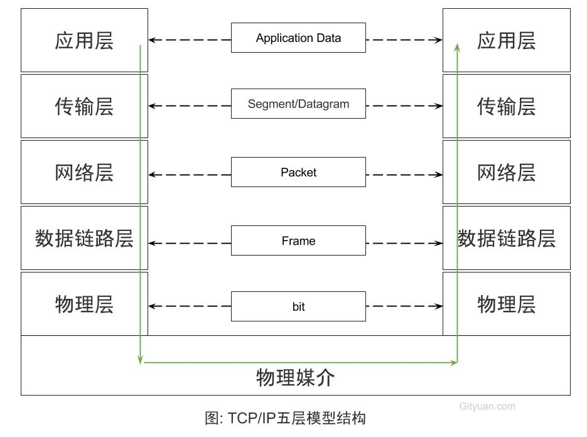

* 应用层: 直接为用户提供服务;
* 传输层: 传输的是报文(TCP数据)或者用户数据报(UDP数据)
* 网络层: 传输的是包(Packet), 例如路由器
* 数据链路层: 传输的是帧(Frame), 例如以太网交换机
* 物理层: 相邻节点间传输bit, 例如集线器,双绞线等

这是经典的五层TPC/IP协议体系, 这样分层设计的思想, 让每一个子问题都设计成一个独立的协议, 这协议的设计/分析/实现/测试都变得更加简单:

* 层与层具有独立性, 例如应用层可以使用传输层提供的功能而无需知晓其实现原理;
* 设计灵活, 层与层之间都定义好接口, 即便层内方法发生变化,只有接口不变, 对这个系统便毫无影响;
* 结构的解耦合, 让每一层可以用更适合的技术方案, 更合适的语言;
* 方便维护, 可分层调试和定位问题;

Binder架构也是采用分层架构设计, 每一层都有其不同的功能:

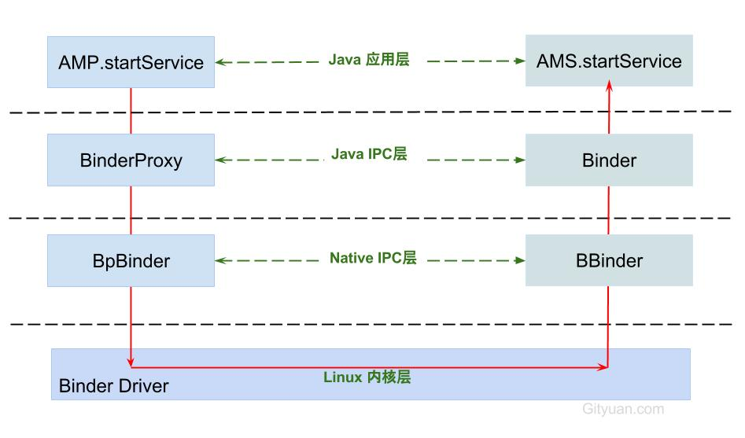

* **Java应用层:** 对于上层应用通过调用AMP.startService, 完全可以不用关心底层,经过层层调用,最终必然会调用到AMS.startService.
* **Java IPC层:** Binder通信是采用C/S架构, Android系统的基础架构便已设计好Binder在Java framework层的Binder客户类BinderProxy和服务类Binder;
* **Native IPC层:** 对于Native层,如果需要直接使用Binder(比如media相关), 则可以直接使用BpBinder和BBinder(当然这里还有JavaBBinder)即可, 对于上一层Java IPC的通信也是基于这个层面.
* **Kernel物理层:** 这里是Binder Driver, 前面3层都跑在用户空间,对于用户空间的内存资源是不共享的,每个Android的进程只能运行在自己进程所拥有的虚拟地址空间, 而内核空间却是可共享的. 真正通信的核心环节还是在Binder Driver.

### 分析起点

前面通过一个[Binder系列-开篇](http://gityuan.com/2015/10/31/binder-prepare/)来从源码讲解了Binder的各个层面, 但是Binder牵涉颇为广泛, 几乎是整个Android架构的顶梁柱, 虽说用了十几篇文章来阐述Binder的各个过程. 但依然还是没有将Binder IPC(进程间通信)的过程彻底说透.

Binder系统如此庞大, 那么这里需要寻求一个出发点来穿针引线, 一窥视Binder全貌. 那么本文将从全新的视角,以[startService流程分析](http://gityuan.com/2016/03/06/start-service/)为例子来说说Binder所其作用. 首先在发起方进程调用AMP.startService，经过binder驱动，最终调用系统进程AMS.startService,如下图:

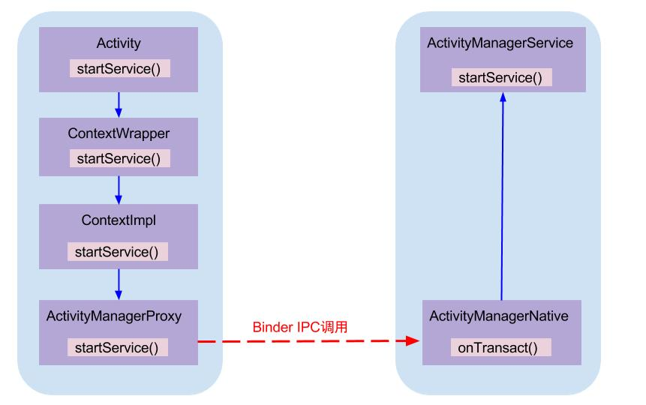

AMP和AMN都是实现了IActivityManager接口,AMS继承于AMN. 其中AMP作为Binder的客户端,运行在各个app所在进程, AMN(或AMS)运行在系统进程system_server.

### Binder IPC原理

Binder通信采用C/S架构，从组件视角来说，包含Client、Server、ServiceManager以及binder驱动，其中ServiceManager用于管理系统中的各种服务。下面说说startService过程所涉及的Binder对象的架构图：

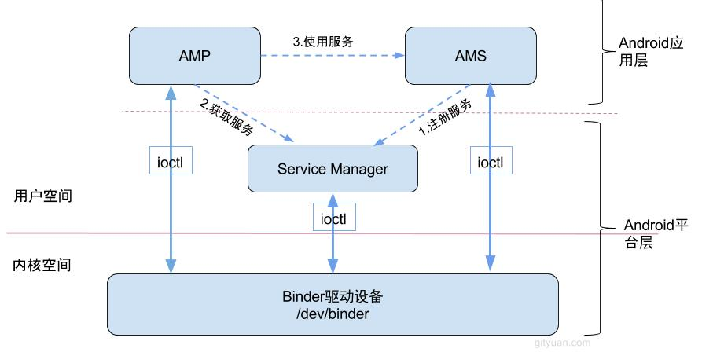

可以看出

这3大过程每一次都是一个完整的Binder IPC过程, 接下来从源码角度, 仅介绍**第3过程使用服务**, 即展开AMP.startService是如何调用到AMS.startService的过程.

## 二. 通信过程

### 2.1 AMP.startService

[-> ActivityManagerNative.java ::ActivityManagerProxy]

public ComponentName startService(IApplicationThread caller, Intent service, String resolvedType, String callingPackage, int userId) throws RemoteException {

//获取或创建Parcel对象【见小节2.2】

Parcel data = Parcel.obtain();

Parcel reply = Parcel.obtain();

data.writeInterfaceToken(IActivityManager.descriptor);

data.writeStrongBinder(caller != null ? caller.asBinder() : null);

service.writeToParcel(data, 0);

//写入Parcel数据 【见小节2.3】

data.writeString(resolvedType);

data.writeString(callingPackage);

data.writeInt(userId);

//通过Binder传递数据【见小节2.5】

mRemote.transact(START_SERVICE_TRANSACTION, data, reply, 0);

//读取应答消息的异常情况

reply.readException();

//根据reply数据来创建ComponentName对象

ComponentName res = ComponentName.readFromParcel(reply);

//【见小节2.2.3】

data.recycle();

reply.recycle();

return res;

}

主要功能:

* 获取或创建两个Parcel对象,data用于发送数据，reply用于接收应答数据.
* 将startService相关数据都封装到Parcel对象data, 其中descriptor = “android.app.IActivityManager”;
* 通过Binder传递数据,并将应答消息写入reply;
* 读取reply应答消息的异常情况和组件对象;

### 2.2 Parcel.obtain

[-> Parcel.java]

public static Parcel obtain() {

final Parcel[] pool = sOwnedPool;

synchronized (pool) {

Parcel p;

//POOL_SIZE = 6

for (int i=0; i<POOL_SIZE; i++) {

p = pool[i];

if (p != null) {

pool[i] = null;

return p;

}

}

}

//当缓存池没有现成的Parcel对象，则直接创建[见流程2.2.1]

return new Parcel(0);

}

sOwnedPool是一个大小为6，存放着parcel对象的缓存池,这样设计的目标是用于节省每次都创建Parcel对象的开销。obtain()方法的作用：

1. 先尝试从缓存池sOwnedPool中查询是否存在缓存Parcel对象，当存在则直接返回该对象;
2. 如果没有可用的Parcel对象，则直接创建Parcel对象。

#### 2.2.1 new Parcel

[-> Parcel.java]

private Parcel(long nativePtr) {

//初始化本地指针

init(nativePtr);

}

private void init(long nativePtr) {

if (nativePtr != 0) {

mNativePtr = nativePtr;

mOwnsNativeParcelObject = false;

} else {

// 首次创建,进入该分支[见流程2.2.2]

mNativePtr = nativeCreate();

mOwnsNativeParcelObject = true;

}

}

nativeCreate这是native方法,经过JNI进入native层, 调用android_os_Parcel_create()方法.

#### 2.2.2 android_os_Parcel_create

[-> android_os_Parcel.cpp]

static jlong android_os_Parcel_create(JNIEnv* env, jclass clazz) {

Parcel* parcel = new Parcel();

return reinterpret_cast<jlong>(parcel);

}

创建C++层的Parcel对象, 该对象指针强制转换为long型, 并保存到Java层的mNativePtr对象. 创建完Parcel对象利用Parcel对象写数据. 接下来以writeString为例.

#### 2.2.3 Parcel.recycle

public final void recycle() {

//释放native parcel对象

freeBuffer();

final Parcel[] pool;

//根据情况来选择加入相应池

if (mOwnsNativeParcelObject) {

pool = sOwnedPool;

} else {

mNativePtr = 0;

pool = sHolderPool;

}

synchronized (pool) {

for (int i=0; i<POOL_SIZE; i++) {

if (pool[i] == null) {

pool[i] = this;

return;

}

}

}

}

将不再使用的Parcel对象放入缓存池，可回收重复利用，当缓存池已满则不再加入缓存池。这里有两个Parcel线程池,mOwnsNativeParcelObject变量来决定:

* mOwnsNativeParcelObject=true, 即调用不带参数obtain()方法获取的对象, 回收时会放入sOwnedPool对象池;
* mOwnsNativeParcelObject=false, 即调用带nativePtr参数的obtain(long)方法获取的对象, 回收时会放入sHolderPool对象池;

### 2.3 writeString

[-> Parcel.java]

public final void writeString(String val) {

//[见流程2.3.1]

nativeWriteString(mNativePtr, val);

}

#### 2.3.1 nativeWriteString

[-> android_os_Parcel.cpp]

static void android_os_Parcel_writeString(JNIEnv* env, jclass clazz, jlong nativePtr, jstring val) {

Parcel* parcel = reinterpret_cast<Parcel*>(nativePtr);

if (parcel != NULL) {

status_t err = NO_MEMORY;

if (val) {

const jchar* str = env->GetStringCritical(val, 0);

if (str) {

//[见流程2.3.2]

err = parcel->writeString16(

reinterpret_cast<const char16_t*>(str),

env->GetStringLength(val));

env->ReleaseStringCritical(val, str);

}

} else {

err = parcel->writeString16(NULL, 0);

}

if (err != NO_ERROR) {

signalExceptionForError(env, clazz, err);

}

}

}

#### 2.3.2 writeString16

[-> Parcel.cpp]

status_t Parcel::writeString16(const char16_t* str, size_t len)

{

if (str == NULL) return writeInt32(-1);

status_t err = writeInt32(len);

if (err == NO_ERROR) {

len *= sizeof(char16_t);

uint8_t* data = (uint8_t*)writeInplace(len+sizeof(char16_t));

if (data) {

//数据拷贝到data所指向的位置

memcpy(data, str, len);

*reinterpret_cast<char16_t*>(data+len) = 0;

return NO_ERROR;

}

err = mError;

}

return err;

}

**Tips:** 除了writeString(),在Parcel.java中大量的native方法, 都是调用android_os_Parcel.cpp相对应的方法, 该方法再调用Parcel.cpp中对应的方法.   
调用流程: Parcel.java –> android_os_Parcel.cpp –> Parcel.cpp.

frameworks/base/core/java/android/os/Parcel.java

frameworks/base/core/jni/android_os_Parcel.cpp

frameworks/native/libs/binder/Parcel.cpp

简单说,就是

### 2.4 mRemote究竟为何物

mRemote的出生,要出先说说ActivityManagerProxy对象(简称AMP)创建说起, AMP是通过ActivityManagerNative.getDefault()来获取的.

#### 2.4.1 AMN.getDefault

[-> ActivityManagerNative.java]

static public IActivityManager getDefault() {

// [见流程2.4.2]

return gDefault.get();

}

gDefault的数据类型为Singleton<IActivityManager>, 这是一个单例模式, 接下来看看Singleto.get()的过程

#### 2.4.2 gDefault.get

public abstract class Singleton<IActivityManager> {

public final IActivityManager get() {

synchronized (this) {

if (mInstance == null) {

//首次调用create()来获取AMP对象[见流程2.4.3]

mInstance = create();

}

return mInstance;

}

}

}

首次调用时需要创建,创建完之后保持到mInstance对象,之后可直接使用.

#### 2.4.3 gDefault.create

private static final Singleton<IActivityManager> gDefault = new Singleton<IActivityManager>() {

protected IActivityManager create() {

//获取名为"activity"的服务

IBinder b = ServiceManager.getService("activity");

//创建AMP对象[见流程2.4.4]

IActivityManager am = asInterface(b);

return am;

}

};

文章[Binder系列7—framework层分析](http://gityuan.com/2015/11/21/binder-framework/#section-4)，可知ServiceManager.getService(“activity”)返回的是指向目标服务AMS的代理对象BinderProxy对象，由该代理对象可以找到目标服务AMS所在进程

#### 2.4.4 AMN.asInterface

[-> ActivityManagerNative.java]

//此处obj = BinderProxy, descriptor = "android.app.IActivityManager"; [见流程2.4.5]

**static public** IActivityManager asInterface(IBinder obj) {  
 IActivityManager in =  
 (IActivityManager)obj.queryLocalInterface(descriptor);  
 **if** (in != **null**) {////此处为null  
 **return** in;  
 }  
**//[见流程2.4.6]**  
 **return new** ActivityManagerProxy(obj);  
}

此时obj为BinderProxy对象, 记录着远程进程system_server中AMS服务的binder线程的handle.

#### 2.4.5 queryLocalInterface

[Binder.java]

public class Binder implements IBinder {

//对于Binder对象的调用,则返回值不为空

public IInterface queryLocalInterface(String descriptor) {

//mDescriptor的初始化在attachInterface()过程中赋值

if (mDescriptor.equals(descriptor)) {

return mOwner;

}

return null;

}

}

//由上一小节[2.4.4]调用的流程便是此处,返回Null

final class BinderProxy implements IBinder {

//BinderProxy对象的调用, 则返回值为空

public IInterface queryLocalInterface(String descriptor) {

return null;

}

}

对于Binder IPC的过程中, 同一个进程的调用则会是asInterface()方法返回的便是本地的Binder对象;对于不同进程的调用则会是远程代理对象BinderProxy.

#### 2.4.6 创建AMP

[-> ActivityManagerNative.java :: AMP]

class ActivityManagerProxy implements IActivityManager {

public ActivityManagerProxy(IBinder remote) {

mRemote = remote;

}

}

可知mRemote便是指向AMS服务的BinderProxy对象。

### 2.5 mRemote.transact

[-> Binder.java ::BinderProxy]

final class BinderProxy implements IBinder {

public boolean transact(int code, Parcel data, Parcel reply, int flags) throws RemoteException {

//用于检测Parcel大小是否大于800k

Binder.checkParcel(this, code, data, "Unreasonably large binder buffer");

//【见2.6】

return transactNative(code, data, reply, flags);

}

}

mRemote.transact()方法中的code=START_SERVICE_TRANSACTION, data保存了descriptor，caller, intent, resolvedType, callingPackage, userId这6项信息。

transactNative是native方法，经过jni调用android_os_BinderProxy_transact方法。

### 2.6 android_os_BinderProxy_transact

[-> android_util_Binder.cpp]

static jboolean android_os_BinderProxy_transact(JNIEnv* env, jobject obj,

jint code, jobject dataObj, jobject replyObj, jint flags)

{

...

//将java Parcel转为c++ Parcel

Parcel* data = parcelForJavaObject(env, dataObj);

Parcel* reply = parcelForJavaObject(env, replyObj);

//gBinderProxyOffsets.mObject中保存的是new BpBinder(handle)对象

IBinder* target = (IBinder*) env->GetLongField(obj, gBinderProxyOffsets.mObject);

...

//此处便是BpBinder::transact()【见小节2.7】

status_t err = target->transact(code, *data, reply, flags);

...

//最后根据transact执行具体情况，抛出相应的Exception

signalExceptionForError(env, obj, err, true , data->dataSize());

return JNI_FALSE;

}

gBinderProxyOffsets.mObject中保存的是BpBinder对象, 这是开机时Zygote调用AndroidRuntime::startReg方法来完成jni方法的注册.

其中register_android_os_Binder()过程就有一个初始并注册BinderProxy的操作,完成gBinderProxyOffsets的赋值过程. 接下来就进入该方法.

### 2.7 BpBinder.transact

[-> BpBinder.cpp]

status_t BpBinder::transact(

uint32_t code, const Parcel& data, Parcel* reply, uint32_t flags)

{

if (mAlive) {

// 【见小节2.8】

status_t status = IPCThreadState::self()->transact(

mHandle, code, data, reply, flags);

if (status == DEAD_OBJECT) mAlive = 0;

return status;

}

return DEAD_OBJECT;

}

IPCThreadState::self()采用单例模式，保证每个线程只有一个实例对象。

### 2.8 IPC.transact

[-> IPCThreadState.cpp]

status_t IPCThreadState::transact(int32_t handle,

uint32_t code, const Parcel& data,

Parcel* reply, uint32_t flags)

{

status_t err = data.errorCheck(); //数据错误检查

flags |= TF_ACCEPT_FDS;

....

if (err == NO_ERROR) {

// 传输数据 【见小节2.9】

err = writeTransactionData(BC_TRANSACTION, flags, handle, code, data, NULL);

}

if (err != NO_ERROR) {

if (reply) reply->setError(err);

return (mLastError = err);

}

// 默认情况下,都是采用非oneway的方式, 也就是需要等待服务端的返回结果

if ((flags & TF_ONE_WAY) == 0) {

if (reply) {

//reply对象不为空 【见小节2.10】

err = waitForResponse(reply);

}else {

Parcel fakeReply;

err = waitForResponse(&fakeReply);

}

} else {

err = waitForResponse(NULL, NULL);

}

return err;

}

transact主要过程:

* 先执行writeTransactionData()已向Parcel数据类型的mOut写入数据，此时mIn还没有数据；
* 然后执行waitForResponse()方法，循环执行，直到收到应答消息. 调用talkWithDriver()跟驱动交互，收到应答消息，便会写入mIn, 则根据收到的不同响应吗，执行相应的操作。

此处调用waitForResponse根据是否有设置TF_ONE_WAY的标记:

* 当已设置oneway时, 则调用waitForResponse(NULL, NULL);
* 当未设置oneway时, 则调用waitForResponse(reply) 或 waitForResponse(&fakeReply)

### 2.9 IPC.writeTransactionData

[-> IPCThreadState.cpp]

status_t IPCThreadState::writeTransactionData(int32_t cmd, uint32_t binderFlags,

int32_t handle, uint32_t code, const Parcel& data, status_t* statusBuffer)

{

binder_transaction_data tr;

tr.target.ptr = 0;

tr.target.handle = handle; // handle指向AMS

tr.code = code; // START_SERVICE_TRANSACTION

tr.flags = binderFlags; // 0

tr.cookie = 0;

tr.sender_pid = 0;

tr.sender_euid = 0;

const status_t err = data.errorCheck();

if (err == NO_ERROR) {

// data为startService相关信息

tr.data_size = data.ipcDataSize(); // mDataSize

tr.data.ptr.buffer = data.ipcData(); // mData指针

tr.offsets_size = data.ipcObjectsCount()*sizeof(binder_size_t); //mObjectsSize

tr.data.ptr.offsets = data.ipcObjects(); //mObjects指针

}

...

mOut.writeInt32(cmd); //cmd = BC_TRANSACTION

mOut.write(&tr, sizeof(tr)); //写入binder_transaction_data数据

return NO_ERROR;

}

将数据写入mOut

### 2.10 IPC.waitForResponse

status_t IPCThreadState::waitForResponse(Parcel *reply, status_t *acquireResult)

{

int32_t cmd;

int32_t err;

while (1) {

if ((err=talkWithDriver()) < NO_ERROR) break; // 【见小节2.11】

err = mIn.errorCheck();

if (err < NO_ERROR) break; //当存在error则退出循环

//每当跟Driver交互一次，若mIn收到数据则往下执行一次BR命令

if (mIn.dataAvail() == 0) continue;

cmd = mIn.readInt32();

switch (cmd) {

case BR_TRANSACTION_COMPLETE:

//只有当不需要reply, 也就是oneway时 才会跳出循环,否则还需要等待.

if (!reply && !acquireResult) goto finish; break;

case BR_DEAD_REPLY:

err = DEAD_OBJECT; goto finish;

case BR_FAILED_REPLY:

err = FAILED_TRANSACTION; goto finish;

case BR_REPLY: ... goto finish;

default:

err = executeCommand(cmd); //【见小节2.12】

if (err != NO_ERROR) goto finish;

break;

}

}

finish:

if (err != NO_ERROR) {

if (reply) reply->setError(err); //将发送的错误代码返回给最初的调用者

}

return err;

}

在这个过程中, 收到以下任一BR_命令，处理后便会退出waitForResponse()的状态:

* BR_TRANSACTION_COMPLETE: binder驱动收到BC_TRANSACTION事件后的应答消息; 对于oneway transaction,当收到该消息,则完成了本次Binder通信;
* BR_DEAD_REPLY: 回复失败，往往是线程或节点为空. 则结束本次通信Binder;
* BR_FAILED_REPLY:回复失败，往往是transaction出错导致. 则结束本次通信Binder;
* BR_REPLY: Binder驱动向Client端发送回应消息; 对于非oneway transaction时,当收到该消息,则完整地完成本次Binder通信;

除了以上命令，其他命令的处理流程【见小节2.12】

### 2.11 IPC.talkWithDriver

//mOut有数据，mIn还没有数据。doReceive默认值为true

status_t IPCThreadState::talkWithDriver(bool doReceive)

{

binder_write_read bwr;

const bool needRead = mIn.dataPosition() >= mIn.dataSize();

const size_t outAvail = (!doReceive || needRead) ? mOut.dataSize() : 0;

bwr.write_size = outAvail;

bwr.write_buffer = (uintptr_t)mOut.data();

if (doReceive && needRead) {

//接收数据缓冲区信息的填充。当收到驱动的数据，则写入mIn

bwr.read_size = mIn.dataCapacity();

bwr.read_buffer = (uintptr_t)mIn.data();

} else {

bwr.read_size = 0;

bwr.read_buffer = 0;

}

// 当同时没有输入和输出数据则直接返回

if ((bwr.write_size == 0) && (bwr.read_size == 0)) return NO_ERROR;

bwr.write_consumed = 0;

bwr.read_consumed = 0;

status_t err;

do {

//ioctl执行binder读写操作，经过syscall，进入Binder驱动。调用Binder_ioctl【小节3.1】

if (ioctl(mProcess->mDriverFD, BINDER_WRITE_READ, &bwr) >= 0)

err = NO_ERROR;

else

err = -errno;

...

} while (err == -EINTR);

if (err >= NO_ERROR) {

if (bwr.write_consumed > 0) {

if (bwr.write_consumed < mOut.dataSize())

mOut.remove(0, bwr.write_consumed);

else

mOut.setDataSize(0);

}

if (bwr.read_consumed > 0) {

mIn.setDataSize(bwr.read_consumed);

mIn.setDataPosition(0);

}

return NO_ERROR;

}

return err;

}

[binder_write_read结构体](http://gityuan.com/2015/11/01/binder-driver/#binderwriteread)用来与Binder设备交换数据的结构, 通过ioctl与mDriverFD通信，是真正与Binder驱动进行数据读写交互的过程。

### 2.12 IPC.executeCommand

status_t IPCThreadState::executeCommand(int32_t cmd)

{

BBinder* obj;

RefBase::weakref_type* refs;

status_t result = NO_ERROR;

switch ((uint32_t)cmd) {

case BR_ERROR: ...

case BR_OK: ...

case BR_ACQUIRE: ...

case BR_RELEASE: ...

case BR_INCREFS: ...

case BR_TRANSACTION: ... //Binder驱动向Server端发送消息

case BR_DEAD_BINDER: ...

case BR_CLEAR_DEATH_NOTIFICATION_DONE: ...

case BR_NOOP: ...

case BR_SPAWN_LOOPER: ... //创建新binder线程

default: ...

}

}

再回到【小节2.11】，可知ioctl()方法经过syscall最终调用到Binder_ioctl()方法.

## 三、Binder driver

#### 3.1 binder_ioctl

[-> Binder.c]

由【小节2.11】传递过出来的参数 cmd=BINDER_WRITE_READ

static long binder_ioctl(struct file *filp, unsigned int cmd, unsigned long arg)

{

int ret;

struct binder_proc *proc = filp->private_data;

struct binder_thread *thread;

//当binder_stop_on_user_error>=2时，则该线程加入等待队列并进入休眠状态. 该值默认为0

ret = wait_event_interruptible(binder_user_error_wait, binder_stop_on_user_error < 2);

...

binder_lock(__func__);

//查找或创建binder_thread结构体

thread = binder_get_thread(proc);

...

switch (cmd) {

case BINDER_WRITE_READ:

//【见小节3.2】

ret = binder_ioctl_write_read(filp, cmd, arg, thread);

break;

...

}

ret = 0;

err:

if (thread)

thread->looper &= ~BINDER_LOOPER_STATE_NEED_RETURN;

binder_unlock(__func__);

wait_event_interruptible(binder_user_error_wait, binder_stop_on_user_error < 2);

return ret;

}

首先,根据传递过来的文件句柄指针获取相应的binder_proc结构体, 再从中查找binder_thread,如果当前线程已经加入到proc的线程队列则直接返回， 如果不存在则创建binder_thread，并将当前线程添加到当前的proc.

* 当返回值为-ENOMEM，则意味着内存不足，往往会出现创建binder_thread对象失败;
* 当返回值为-EINVAL，则意味着CMD命令参数无效；

#### 3.2 binder_ioctl_write_read

static int binder_ioctl_write_read(struct file *filp,

unsigned int cmd, unsigned long arg,

struct binder_thread *thread)

{

int ret = 0;

struct binder_proc *proc = filp->private_data;

unsigned int size = _IOC_SIZE(cmd);

void __user *ubuf = (void __user *)arg;

struct binder_write_read bwr;

if (size != sizeof(struct binder_write_read)) {

ret = -EINVAL;

goto out;

}

//将用户空间bwr结构体拷贝到内核空间

if (copy_from_user(&bwr, ubuf, sizeof(bwr))) {

ret = -EFAULT;

goto out;

}

if (bwr.write_size > 0) {

//将数据放入目标进程【见小节3.3】

ret = binder_thread_write(proc, thread,

bwr.write_buffer,

bwr.write_size,

&bwr.write_consumed);

//当执行失败，则直接将内核bwr结构体写回用户空间，并跳出该方法

if (ret < 0) {

bwr.read_consumed = 0;

if (copy_to_user_preempt_disabled(ubuf, &bwr, sizeof(bwr)))

ret = -EFAULT;

goto out;

}

}

if (bwr.read_size > 0) {

//读取自己队列的数据 【见小节3.5】

ret = binder_thread_read(proc, thread, bwr.read_buffer,

bwr.read_size,

&bwr.read_consumed,

filp->f_flags & O_NONBLOCK);

//当进程的todo队列有数据,则唤醒在该队列等待的进程

if (!list_empty(&proc->todo))

wake_up_interruptible(&proc->wait);

//当执行失败，则直接将内核bwr结构体写回用户空间，并跳出该方法

if (ret < 0) {

if (copy_to_user_preempt_disabled(ubuf, &bwr, sizeof(bwr)))

ret = -EFAULT;

goto out;

}

}

if (copy_to_user(ubuf, &bwr, sizeof(bwr))) {

ret = -EFAULT;

goto out;

}

out:

return ret;

}

此时arg是一个binder_write_read结构体，mOut数据保存在write_buffer，所以write_size>0，但此时read_size=0。首先,将用户空间bwr结构体拷贝到内核空间,然后执行binder_thread_write()操作.

#### 3.3 binder_thread_write

static int binder_thread_write(struct binder_proc *proc,

struct binder_thread *thread,

binder_uintptr_t binder_buffer, size_t size,

binder_size_t *consumed)

{

uint32_t cmd;

void __user *buffer = (void __user *)(uintptr_t)binder_buffer;

void __user *ptr = buffer + *consumed;

void __user *end = buffer + size;

while (ptr < end && thread->return_error == BR_OK) {

//拷贝用户空间的cmd命令，此时为BC_TRANSACTION

if (get_user(cmd, (uint32_t __user *)ptr)) -EFAULT;

ptr += sizeof(uint32_t);

switch (cmd) {

case BC_TRANSACTION:

case BC_REPLY: {

struct binder_transaction_data tr;

//拷贝用户空间的binder_transaction_data

if (copy_from_user(&tr, ptr, sizeof(tr))) return -EFAULT;

ptr += sizeof(tr);

// 见小节3.4】

binder_transaction(proc, thread, &tr, cmd == BC_REPLY);

break;

}

...

}

*consumed = ptr - buffer;

}

return 0;

}

不断从binder_buffer所指向的地址获取cmd, 当只有BC_TRANSACTION或者BC_REPLY时, 则调用binder_transaction()来处理事务.

#### 3.4 binder_transaction

发送的是BC_TRANSACTION时，此时reply=0。

static void binder_transaction(struct binder_proc *proc,

struct binder_thread *thread,

struct binder_transaction_data *tr, int reply){

struct binder_transaction *t;

struct binder_work *tcomplete;

binder_size_t *offp, *off_end;

binder_size_t off_min;

struct binder_proc *target_proc;

struct binder_thread *target_thread = NULL;

struct binder_node *target_node = NULL;

struct list_head *target_list;

wait_queue_head_t *target_wait;

struct binder_transaction *in_reply_to = NULL;

if (reply) {

...

}else {

if (tr->target.handle) {

struct binder_ref *ref;

// 由handle 找到相应 binder_ref, 由binder_ref 找到相应 binder_node

ref = binder_get_ref(proc, tr->target.handle);

target_node = ref->node;

} else {

target_node = binder_context_mgr_node;

}

// 由binder_node 找到相应 binder_proc

target_proc = target_node->proc;

}

if (target_thread) {

e->to_thread = target_thread->pid;

target_list = &target_thread->todo;

target_wait = &target_thread->wait;

} else {

//首次执行target_thread为空

target_list = &target_proc->todo;

target_wait = &target_proc->wait;

}

t = kzalloc(sizeof(*t), GFP_KERNEL);

tcomplete = kzalloc(sizeof(*tcomplete), GFP_KERNEL);

//非oneway的通信方式，把当前thread保存到transaction的from字段

if (!reply && !(tr->flags & TF_ONE_WAY))

t->from = thread;

else

t->from = NULL;

t->sender_euid = task_euid(proc->tsk);

t->to_proc = target_proc; //此次通信目标进程为system_server

t->to_thread = target_thread;

t->code = tr->code; //此次通信code = START_SERVICE_TRANSACTION

t->flags = tr->flags; // 此次通信flags = 0

t->priority = task_nice(current);

//从目标进程target_proc中分配内存空间【3.4.1】

t->buffer = binder_alloc_buf(target_proc, tr->data_size,

tr->offsets_size, !reply && (t->flags & TF_ONE_WAY));

t->buffer->allow_user_free = 0;

t->buffer->transaction = t;

t->buffer->target_node = target_node;

if (target_node)

binder_inc_node(target_node, 1, 0, NULL); //引用计数加1

//binder对象的偏移量

offp = (binder_size_t *)(t->buffer->data + ALIGN(tr->data_size, sizeof(void *)));

//分别拷贝用户空间的binder_transaction_data中ptr.buffer和ptr.offsets到目标进程的binder_buffer

copy_from_user(t->buffer->data,

(const void __user *)(uintptr_t)tr->data.ptr.buffer, tr->data_size);

copy_from_user(offp,

(const void __user *)(uintptr_t)tr->data.ptr.offsets, tr->offsets_size);

off_end = (void *)offp + tr->offsets_size;

for (; offp < off_end; offp++) {

struct flat_binder_object *fp;

fp = (struct flat_binder_object *)(t->buffer->data + *offp);

off_min = *offp + sizeof(struct flat_binder_object);

switch (fp->type) {

...

case BINDER_TYPE_HANDLE:

case BINDER_TYPE_WEAK_HANDLE: {

//处理引用计数情况

struct binder_ref *ref = binder_get_ref(proc, fp->handle);

if (ref->node->proc == target_proc) {

if (fp->type == BINDER_TYPE_HANDLE)

fp->type = BINDER_TYPE_BINDER;

else

fp->type = BINDER_TYPE_WEAK_BINDER;

fp->binder = ref->node->ptr;

fp->cookie = ref->node->cookie;

binder_inc_node(ref->node, fp->type == BINDER_TYPE_BINDER, 0, NULL);

} else {

struct binder_ref *new_ref;

new_ref = binder_get_ref_for_node(target_proc, ref->node);

fp->handle = new_ref->desc;

binder_inc_ref(new_ref, fp->type == BINDER_TYPE_HANDLE, NULL);

}

} break;

...

default:

return_error = BR_FAILED_REPLY;

goto err_bad_object_type;

}

}

if (reply) {

//BC_REPLY的过程

binder_pop_transaction(target_thread, in_reply_to);

} else if (!(t->flags & TF_ONE_WAY)) {

//BC_TRANSACTION 且 非oneway,则设置事务栈信息

t->need_reply = 1;

t->from_parent = thread->transaction_stack;

thread->transaction_stack = t;

} else {

//BC_TRANSACTION 且 oneway,则加入异步todo队列

if (target_node->has_async_transaction) {

target_list = &target_node->async_todo;

target_wait = NULL;

} else

target_node->has_async_transaction = 1;

}

//将BINDER_WORK_TRANSACTION添加到目标队列,即target_proc->todo

t->work.type = BINDER_WORK_TRANSACTION;

list_add_tail(&t->work.entry, target_list);

//将BINDER_WORK_TRANSACTION_COMPLETE添加到当前线程队列，即thread->todo

tcomplete->type = BINDER_WORK_TRANSACTION_COMPLETE;

list_add_tail(&tcomplete->entry, &thread->todo);

//唤醒等待队列，本次通信的目标队列为target_proc->wait

if (target_wait)

wake_up_interruptible(target_wait);

return;

}

主要功能:

1. 查询目标进程的过程： handle -> binder_ref -> binder_node -> binder_proc
2. 将BINDER_WORK_TRANSACTION添加到目标队列target_list:
   * call事务， 则目标队列target_list=target_proc->todo;
   * reply事务，则目标队列target_list=target_thread->todo;
   * async事务，则目标队列target_list=target_node->async_todo.
3. 数据拷贝
   * 将用户空间binder_transaction_data中ptr.buffer和ptr.offsets拷贝到目标进程的binder_buffer->data；
   * 这就是只拷贝一次的真理所在；
4. 设置事务栈信息
   * BC_TRANSACTION且非oneway, 则将当前事务添加到thread->transaction_stack；
5. 事务分发过程：
   * 将BINDER_WORK_TRANSACTION添加到目标队列(此时为target_proc->todo队列);
   * 将BINDER_WORK_TRANSACTION_COMPLETE添加到当前线程thread->todo队列;
6. 唤醒目标进程target_proc开始执行事务。

该方法中proc/thread是指当前发起方的进程信息，而binder_proc是指目标接收端进程。 此时当前线程thread的todo队列已经有事务, 接下来便会进入binder_thread_read来处理相关的事务.

#### 3.4.1 binder_alloc_buf

static struct binder_buffer *binder_alloc_buf(struct binder_proc *proc,

size_t data_size, size_t offsets_size, int is_async)

{

struct rb_node *n = proc->free_buffers.rb_node;

struct binder_buffer *buffer;

size_t buffer_size;

struct rb_node *best_fit = NULL;

void *has_page_addr;

void *end_page_addr;

size_t size;

..

size = ALIGN(data_size, sizeof(void *)) + ALIGN(offsets_size, sizeof(void *));

if (is_async && proc->free_async_space < size + sizeof(struct binder_buffer)) {

return NULL; // 剩余可用的异步空间，小于所需的大小

}

while (n) { //从binder_buffer的红黑树中查找大小相等的buffer块

buffer = rb_entry(n, struct binder_buffer, rb_node);

buffer_size = binder_buffer_size(proc, buffer);

if (size < buffer_size) {

best_fit = n;

n = n->rb_left;

} else if (size > buffer_size)

n = n->rb_right;

else {

best_fit = n;

break;

}

}

...

if (n == NULL) {

buffer = rb_entry(best_fit, struct binder_buffer, rb_node);

buffer_size = binder_buffer_size(proc, buffer);

}

has_page_addr =(void *)(((uintptr_t)buffer->data + buffer_size) & PAGE_MASK);

if (n == NULL) {

if (size + sizeof(struct binder_buffer) + 4 >= buffer_size)

buffer_size = size;

else

buffer_size = size + sizeof(struct binder_buffer);

}

//末端地址

end_page_addr = (void *)PAGE_ALIGN((uintptr_t)buffer->data + buffer_size);

...

//分配物理页

if (binder_update_page_range(proc, 1,

(void *)PAGE_ALIGN((uintptr_t)buffer->data), end_page_addr, NULL))

return NULL;

rb_erase(best_fit, &proc->free_buffers);

buffer->free = 0;

binder_insert_allocated_buffer(proc, buffer);

if (buffer_size != size) {

struct binder_buffer *new_buffer = (void *)buffer->data + size;

list_add(&new_buffer->entry, &buffer->entry);

new_buffer->free = 1;

binder_insert_free_buffer(proc, new_buffer);

}

buffer->data_size = data_size;

buffer->offsets_size = offsets_size;

buffer->async_transaction = is_async;

if (is_async) { //调整异步可用内存空间大小

proc->free_async_space -= size + sizeof(struct binder_buffer);

}

return buffer;

}

#### 3.5 binder_thread_read

binder_thread_read（）{

//当已使用字节数为0时，将BR_NOOP响应码放入指针ptr

if (*consumed == 0) {

if (put_user(BR_NOOP, (uint32_t __user *)ptr))

return -EFAULT;

ptr += sizeof(uint32_t);

}

retry:

//binder_transaction()已设置transaction_stack不为空，则wait_for_proc_work为false.

wait_for_proc_work = thread->transaction_stack == NULL &&

list_empty(&thread->todo);

thread->looper |= BINDER_LOOPER_STATE_WAITING;

if (wait_for_proc_work)

proc->ready_threads++; //进程中空闲binder线程加1

//只有当前线程todo队列为空，并且transaction_stack也为空，才会开始处于当前进程的事务

if (wait_for_proc_work) {

if (non_block) {

...

} else

//当进程todo队列没有数据,则进入休眠等待状态

ret = wait_event_freezable_exclusive(proc->wait, binder_has_proc_work(proc, thread));

} else {

if (non_block) {

...

} else

//当线程todo队列有数据则执行往下执行；当线程todo队列没有数据，则进入休眠等待状态

ret = wait_event_freezable(thread->wait, binder_has_thread_work(thread));

}

if (wait_for_proc_work)

proc->ready_threads--; //退出等待状态, 则进程中空闲binder线程减1

thread->looper &= ~BINDER_LOOPER_STATE_WAITING;

...

while (1) {

uint32_t cmd;

struct binder_transaction_data tr;

struct binder_work *w;

struct binder_transaction *t = NULL;

//先从线程todo队列获取事务数据

if (!list_empty(&thread->todo)) {

w = list_first_entry(&thread->todo, struct binder_work, entry);

// 线程todo队列没有数据, 则从进程todo对获取事务数据

} else if (!list_empty(&proc->todo) && wait_for_proc_work) {

w = list_first_entry(&proc->todo, struct binder_work, entry);

} else {

//没有数据,则返回retry

if (ptr - buffer == 4 &&

!(thread->looper & BINDER_LOOPER_STATE_NEED_RETURN))

goto retry;

break;

}

switch (w->type) {

case BINDER_WORK_TRANSACTION:

//获取transaction数据

t = container_of(w, struct binder_transaction, work);

break;

case BINDER_WORK_TRANSACTION_COMPLETE:

cmd = BR_TRANSACTION_COMPLETE;

//将BR_TRANSACTION_COMPLETE写入*ptr，并跳出循环。

put_user(cmd, (uint32_t __user *)ptr)；

list_del(&w->entry);

kfree(w);

break;

case BINDER_WORK_NODE: ... break;

case BINDER_WORK_DEAD_BINDER:

case BINDER_WORK_DEAD_BINDER_AND_CLEAR:

case BINDER_WORK_CLEAR_DEATH_NOTIFICATION: ... break;

}

//只有BINDER_WORK_TRANSACTION命令才能继续往下执行

if (!t)

continue;

if (t->buffer->target_node) {

//获取目标node

struct binder_node *target_node = t->buffer->target_node;

tr.target.ptr = target_node->ptr;

tr.cookie = target_node->cookie;

t->saved_priority = task_nice(current);

...

cmd = BR_TRANSACTION; //设置命令为BR_TRANSACTION

} else {

tr.target.ptr = NULL;

tr.cookie = NULL;

cmd = BR_REPLY; //设置命令为BR_REPLY

}

tr.code = t->code;

tr.flags = t->flags;

tr.sender_euid = t->sender_euid;

if (t->from) {

struct task_struct *sender = t->from->proc->tsk;

//当非oneway的情况下,将调用者进程的pid保存到sender_pid

tr.sender_pid = task_tgid_nr_ns(sender,

current->nsproxy->pid_ns);

} else {

//当oneway的的情况下,则该值为0

tr.sender_pid = 0;

}

tr.data_size = t->buffer->data_size;

tr.offsets_size = t->buffer->offsets_size;

tr.data.ptr.buffer = (void *)t->buffer->data + proc->user_buffer_offset;

tr.data.ptr.offsets = tr.data.ptr.buffer +

ALIGN(t->buffer->data_size, sizeof(void *));

//将cmd和数据写回用户空间

if (put_user(cmd, (uint32_t __user *)ptr))

return -EFAULT;

ptr += sizeof(uint32_t);

if (copy_to_user(ptr, &tr, sizeof(tr)))

return -EFAULT;

ptr += sizeof(tr);

list_del(&t->work.entry);

t->buffer->allow_user_free = 1;

if (cmd == BR_TRANSACTION && !(t->flags & TF_ONE_WAY)) {

t->to_parent = thread->transaction_stack;

t->to_thread = thread;

thread->transaction_stack = t;

} else {

t->buffer->transaction = NULL;

kfree(t); //通信完成,则运行释放

}

break;

}

done:

*consumed = ptr - buffer;

//当满足请求线程加已准备线程数等于0，已启动线程数小于最大线程数(15)，

//且looper状态为已注册或已进入时创建新的线程。

if (proc->requested_threads + proc->ready_threads == 0 &&

proc->requested_threads_started < proc->max_threads &&

(thread->looper & (BINDER_LOOPER_STATE_REGISTERED |

BINDER_LOOPER_STATE_ENTERED))) {

proc->requested_threads++;

// 生成BR_SPAWN_LOOPER命令，用于创建新的线程

put_user(BR_SPAWN_LOOPER, (uint32_t __user *)buffer)；

}

return 0;

}

该方法功能说明:

此处wait_for_proc_work是指当前线程todo队列为空，并且transaction_stack也为空,该值为true.

1. 当wait_for_proc_work = false, 则进入线程的等待队列thread->wait, 直到thread->todo队列有事务才往下执行;
   * 获取并处理thread->todo队列中的事务;将相应的cmd和数据写回用户空间.
2. 当wait_for_proc_work = true, 则进入线程的等待队列proc->wait, 直到proc->todo队列有事务才往下执行;
   * 获取并处理proc->todo队列中的事务;将相应的cmd和数据写回用户空间.

到这里,可能有人好奇,对于[小节3.4]介绍了target_list有3种, 这里只会处理前2种:thread->todo, proc->todo.那么对于 target_node->async_todo的处理过程时间呢? [见小节5.4]

#### 3.6 下一步何去何从

1. 执行完binder_thread_write方法后, 通过binder_transaction()首先写入BINDER_WORK_TRANSACTION_COMPLETE写入当前线程.
2. 这时bwr.read_size > 0, 回到binder_ioctl_write_read方法, 便开始执行binder_thread_read();
3. 在binder_thread_read()方法, 将获取cmd=BR_TRANSACTION_COMPLETE, 再将cmd和数据写回用户空间;
4. 一次Binder_ioctl完成,接着回调用户空间方法talkWithDriver(),刚才的数据以写入mIn.
5. 这时mIn有可读数据, 回到【小节2.10】IPC.waitForResponse()方法,完成BR_TRANSACTION_COMPLETE过程. 如果本次transaction采用非oneway方式, 这次Binder通信便完成, 否则还是要等待Binder服务端的返回。

对于startService过程, 采用的便是非oneway方式,那么发起者进程还会继续停留在waitForResponse()方法,继续talkWithDriver()，然后休眠在binder_thread_read()的wait_event_freezable()过程，等待当前线程的todo队列有数据的到来，即等待收到BR_REPLY消息.

由于在前面binder_transaction()除了向自己所在线程写入了BINDER_WORK_TRANSACTION_COMPLETE, 还向目标进程(此处为system_server)写入了BINDER_WORK_TRANSACTION命令，那么接下里介绍system_server进程的工作。

## 四. 回到用户空间

system_server的binder线程是如何运转的，那么就需要从Binder线程的创建开始说起， Binder线程的创建有两种方式：

* ProcessState::self()->startThreadPool();
* IPCThreadState::self()->joinThreadPool();

从文章[addService 小节4.1](http://gityuan.com/2015/11/14/binder-add-service/)，可知，调用链如下： startThreadPool()过程会创建新Binder线程，再经过层层调用也会进入joinThreadPool()方法。 system_server的binder线程从IPC.joinThreadPool –> IPC.getAndExecuteCommand() -> IPC.talkWithDriver() ,但talkWithDriver收到事务之后, 便进入IPC.executeCommand()方法。

接下来从joinThreadPool说起：

### 4.1 IPC.joinThreadPool

void IPCThreadState::joinThreadPool(bool isMain)

{

mOut.writeInt32(isMain ? BC_ENTER_LOOPER : BC_REGISTER_LOOPER);

set_sched_policy(mMyThreadId, SP_FOREGROUND);

status_t result;

do {

processPendingDerefs(); //处理对象引用

result = getAndExecuteCommand();//获取并执行命令【见小节4.2】

if (result < NO_ERROR && result != TIMED_OUT && result != -ECONNREFUSED && result != -EBADF) {

ALOGE("getAndExecuteCommand(fd=%d) returned unexpected error %d, aborting",

mProcess->mDriverFD, result);

abort();

}

//对于binder非主线程不再使用，则退出

if(result == TIMED_OUT && !isMain) {

break;

}

} while (result != -ECONNREFUSED && result != -EBADF);

mOut.writeInt32(BC_EXIT_LOOPER);

talkWithDriver(false);

}

### 4.2 IPC.getAndExecuteCommand

status_t IPCThreadState::getAndExecuteCommand()

{

status_t result;

int32_t cmd;

result = talkWithDriver(); //该Binder Driver进行交互

if (result >= NO_ERROR) {

size_t IN = mIn.dataAvail();

if (IN < sizeof(int32_t)) return result;

cmd = mIn.readInt32(); //读取命令

pthread_mutex_lock(&mProcess->mThreadCountLock);

mProcess->mExecutingThreadsCount++;

pthread_mutex_unlock(&mProcess->mThreadCountLock);

result = executeCommand(cmd); //【见小节4.3】

pthread_mutex_lock(&mProcess->mThreadCountLock);

mProcess->mExecutingThreadsCount--;

pthread_cond_broadcast(&mProcess->mThreadCountDecrement);

pthread_mutex_unlock(&mProcess->mThreadCountLock);

set_sched_policy(mMyThreadId, SP_FOREGROUND);

}

return result;

}

此时system_server的binder线程空闲便是停留在binder_thread_read()方法来处理进程/线程新的事务。 由【小节3.4】可知收到的是BINDER_WORK_TRANSACTION命令, 再经过inder_thread_read()后生成命令cmd=BR_TRANSACTION.再将cmd和数据写回用户空间。

### 4.3 IPC.executeCommand

status_t IPCThreadState::executeCommand(int32_t cmd)

{

BBinder* obj;

RefBase::weakref_type* refs;

status_t result = NO_ERROR;

switch ((uint32_t)cmd) {

case BR_TRANSACTION:

{

binder_transaction_data tr;

result = mIn.read(&tr, sizeof(tr)); //读取mIn数据

if (result != NO_ERROR) break;

Parcel buffer;

//当buffer对象回收时，则会调用freeBuffer来回收内存【见小节4.3.1】

buffer.ipcSetDataReference(

reinterpret_cast<const uint8_t*>(tr.data.ptr.buffer),

tr.data_size,

reinterpret_cast<const binder_size_t*>(tr.data.ptr.offsets),

tr.offsets_size/sizeof(binder_size_t), freeBuffer, this);

const pid_t origPid = mCallingPid;

const uid_t origUid = mCallingUid;

const int32_t origStrictModePolicy = mStrictModePolicy;

const int32_t origTransactionBinderFlags = mLastTransactionBinderFlags;

//设置调用者的pid和uid

mCallingPid = tr.sender_pid;

mCallingUid = tr.sender_euid;

mLastTransactionBinderFlags = tr.flags;

int curPrio = getpriority(PRIO_PROCESS, mMyThreadId);

if (gDisableBackgroundScheduling) {

... //不进入此分支

} else {

if (curPrio >= ANDROID_PRIORITY_BACKGROUND) {

set_sched_policy(mMyThreadId, SP_BACKGROUND);

}

}

Parcel reply;

status_t error;

if (tr.target.ptr) {

//尝试通过弱引用获取强引用

if (reinterpret_cast<RefBase::weakref_type*>(

tr.target.ptr)->attemptIncStrong(this)) {

// tr.cookie里存放的是BBinder子类JavaBBinder [见流程4.4]

error = reinterpret_cast<BBinder*>(tr.cookie)->transact(tr.code, buffer,

&reply, tr.flags);

reinterpret_cast<BBinder*>(tr.cookie)->decStrong(this);

} else {

error = UNKNOWN_TRANSACTION;

}

} else {

error = the_context_object->transact(tr.code, buffer, &reply, tr.flags);

}

if ((tr.flags & TF_ONE_WAY) == 0) {

if (error < NO_ERROR) reply.setError(error);

//对于非oneway, 需要reply通信过程,则向Binder驱动发送BC_REPLY命令【见小节4.3.1】

sendReply(reply, 0);

}

//恢复pid和uid信息

mCallingPid = origPid;

mCallingUid = origUid;

...

}

break;

case ...

default:

result = UNKNOWN_ERROR;

break;

}

if (result != NO_ERROR) {

mLastError = result;

}

return result;

}

* 对于oneway的场景, 执行完本次transact()则全部结束.
* 对于非oneway, 需要reply的通信过程,则向Binder驱动发送BC_REPLY命令【见小节5.1】

#### 4.3.1 ipcSetDataReference

[-> Parcel.cpp]

void Parcel::ipcSetDataReference(const uint8_t* data, size_t dataSize,

const binder_size_t* objects, size_t objectsCount, release_func relFunc, void* relCookie)

{

binder_size_t minOffset = 0;

freeDataNoInit(); //【见小节4.3.2】

mError = NO_ERROR;

mData = const_cast<uint8_t*>(data);

mDataSize = mDataCapacity = dataSize;

mDataPos = 0;

mObjects = const_cast<binder_size_t*>(objects);

mObjectsSize = mObjectsCapacity = objectsCount;

mNextObjectHint = 0;

mOwner = relFunc;

mOwnerCookie = relCookie;

for (size_t i = 0; i < mObjectsSize; i++) {

binder_size_t offset = mObjects[i];

if (offset < minOffset) {

mObjectsSize = 0;

break;

}

minOffset = offset + sizeof(flat_binder_object);

}

scanForFds();

}

该方法的功能，Parcel成员变量说明：

* mData：parcel数据起始地址
* mDataSize：parcel数据大小
* mObjects：flat_binder_object地址偏移量
* mObjectsSize：parcel中flat_binder_object个数
* mOwner：释放函数freebuffer
* mOwnerCookie：释放函数所需信息

#### 4.3.2 freeDataNoInit

[-> Parcel.cpp]

void Parcel::freeDataNoInit()

{

if (mOwner) {

mOwner(this, mData, mDataSize, mObjects, mObjectsSize, mOwnerCookie);

} else { //mOwner为空， 进入该分支

releaseObjects(); //【见小节4.3.3】

if (mData) {

pthread_mutex_lock(&gParcelGlobalAllocSizeLock);

if (mDataCapacity <= gParcelGlobalAllocSize) {

gParcelGlobalAllocSize = gParcelGlobalAllocSize - mDataCapacity;

} else {

gParcelGlobalAllocSize = 0;

}

if (gParcelGlobalAllocCount > 0) {

gParcelGlobalAllocCount--;

}

pthread_mutex_unlock(&gParcelGlobalAllocSizeLock);

free(mData);

}

if (mObjects) free(mObjects);

}

}

#### 4.3.3 releaseObjects

void Parcel::releaseObjects()

{

const sp<ProcessState> proc(ProcessState::self());

size_t i = mObjectsSize;

uint8_t* const data = mData;

binder_size_t* const objects = mObjects;

while (i > 0) {

i--;

const flat_binder_object* flat

= reinterpret_cast<flat_binder_object*>(data+objects[i]);

//【见小节4.3.4】

release_object(proc, *flat, this, &mOpenAshmemSize);

}

}

#### 4.3.4 release_object

static void release_object(const sp<ProcessState>& proc, const flat_binder_object& obj, const void* who, size_t* outAshmemSize) {

switch (obj.type) {

case BINDER_TYPE_BINDER:

if (obj.binder) {

reinterpret_cast<IBinder*>(obj.cookie)->decStrong(who);

}

return;

case BINDER_TYPE_WEAK_BINDER:

if (obj.binder)

reinterpret_cast<RefBase::weakref_type*>(obj.binder)->decWeak(who);

return;

case BINDER_TYPE_HANDLE: {

const sp<IBinder> b = proc->getStrongProxyForHandle(obj.handle);

if (b != NULL) {

b->decStrong(who);

}

return;

}

case BINDER_TYPE_WEAK_HANDLE: {

const wp<IBinder> b = proc->getWeakProxyForHandle(obj.handle);

if (b != NULL) b.get_refs()->decWeak(who);

return;

}

case BINDER_TYPE_FD: {

...

return;

}

}

}

根据flat_binder_object的类型，来决定减少相应的强弱引用。

#### 4.3.5 ~Parcel

[-> Parcel.cpp]

当[小节4.3]executeCommand执行完成后， 便会释放局部变量Parcel buffer，则会析构Parcel。

Parcel::~Parcel()

{

freeDataNoInit();

}

void Parcel::freeDataNoInit()

{

if (mOwner) { //此处mOwner等于freeBuffer 【见小节4.3.6】

mOwner(this, mData, mDataSize, mObjects, mObjectsSize, mOwnerCookie);

} else {

...

}

}

接下来，进入IPC的freeBuffer过程。

#### 4.3.6 freeBuffer

[-> IPCThreadState.cpp]

void IPCThreadState::freeBuffer(Parcel* parcel, const uint8_t* data,

size_t /*dataSize*/,

const binder_size_t* /*objects*/,

size_t /*objectsSize*/, void* /*cookie*/)

{

if (parcel != NULL) parcel->closeFileDescriptors();

IPCThreadState* state = self();

state->mOut.writeInt32(BC_FREE_BUFFER);

state->mOut.writePointer((uintptr_t)data);

}

向Binder驱动写入BC_FREE_BUFFER命令。

### 4.4 BBinder.transact

[-> Binder.cpp ::BBinder ]

status_t BBinder::transact(

uint32_t code, const Parcel& data, Parcel* reply, uint32_t flags)

{

data.setDataPosition(0);

status_t err = NO_ERROR;

switch (code) {

case PING_TRANSACTION:

reply->writeInt32(pingBinder());

break;

default:

err = onTransact(code, data, reply, flags); //【见流程4.5】

break;

}

if (reply != NULL) {

reply->setDataPosition(0);

}

return err;

}

### 4.5 JavaBBinder.onTransact

[-> android_util_Binder.cpp]

virtual status_t onTransact(

uint32_t code, const Parcel& data, Parcel* reply, uint32_t flags = 0)

{

JNIEnv* env = javavm_to_jnienv(mVM);

IPCThreadState* thread_state = IPCThreadState::self();

//调用Binder.execTransact [见流程4.6]

jboolean res = env->CallBooleanMethod(mObject, gBinderOffsets.mExecTransact,

code, reinterpret_cast<jlong>(&data), reinterpret_cast<jlong>(reply), flags);

jthrowable excep = env->ExceptionOccurred();

if (excep) {

res = JNI_FALSE;

//发生异常, 则清理JNI本地引用

env->DeleteLocalRef(excep);

}

...

return res != JNI_FALSE ? NO_ERROR : UNKNOWN_TRANSACTION;

}

还记得AndroidRuntime::startReg过程吗, 其中有一个过程便是register_android_os_Binder(),该过程会把gBinderOffsets.mExecTransact便是Binder.java中的execTransact()方法.详见见[Binder系列7—framework层分析](http://gityuan.com/2015/11/21/binder-framework/)文章中的第二节初始化的过程.

另外,此处mObject是在服务注册addService过程,会调用writeStrongBinder方法, 将Binder对象传入了JavaBBinder构造函数的参数, 最终赋值给mObject. 在本次通信过程中Object为ActivityManagerNative对象.

此处斗转星移, 从C++代码回到了Java代码. 进入AMN.execTransact, 由于AMN继续于Binder对象, 接下来进入Binder.execTransact

### 4.6 Binder.execTransact

[Binder.java]

private boolean execTransact(int code, long dataObj, long replyObj, int flags) {

Parcel data = Parcel.obtain(dataObj);

Parcel reply = Parcel.obtain(replyObj);

boolean res;

try {

// 调用子类AMN.onTransact方法 [见流程4.7]

res = onTransact(code, data, reply, flags);

} catch (RemoteException e) {

if ((flags & FLAG_ONEWAY) != 0) {

...

} else {

//非oneway的方式,则会将异常写回reply

reply.setDataPosition(0);

reply.writeException(e);

}

res = true;

} catch (RuntimeException e) {

if ((flags & FLAG_ONEWAY) != 0) {

...

} else {

reply.setDataPosition(0);

reply.writeException(e);

}

res = true;

} catch (OutOfMemoryError e) {

RuntimeException re = new RuntimeException("Out of memory", e);

reply.setDataPosition(0);

reply.writeException(re);

res = true;

}

reply.recycle();

data.recycle();

return res;

}

当发生RemoteException, RuntimeException, OutOfMemoryError, 对于非oneway的情况下都会把异常传递给调用者.

### 4.7 AMN.onTransact

[-> ActivityManagerNative.java]

public boolean onTransact(int code, Parcel data, Parcel reply, int flags) throws RemoteException {

switch (code) {

...

case START_SERVICE_TRANSACTION: {

data.enforceInterface(IActivityManager.descriptor);

IBinder b = data.readStrongBinder();

//生成ApplicationThreadNative的代理对象，即ApplicationThreadProxy对象

IApplicationThread app = ApplicationThreadNative.asInterface(b);

Intent service = Intent.CREATOR.createFromParcel(data);

String resolvedType = data.readString();

String callingPackage = data.readString();

int userId = data.readInt();

//调用ActivityManagerService的startService()方法【见流程4.8】

ComponentName cn = startService(app, service, resolvedType, callingPackage, userId);

reply.writeNoException();

ComponentName.writeToParcel(cn, reply);

return true;

}

}

### 4.8 AMS.startService

public ComponentName startService(IApplicationThread caller, Intent service, String resolvedType, String callingPackage, int userId) throws TransactionTooLargeException {

synchronized(this) {

...

ComponentName res = mServices.startServiceLocked(caller, service,

resolvedType, callingPid, callingUid, callingPackage, userId);

Binder.restoreCallingIdentity(origId);

return res;

}

}

历经千山万水, 总算是进入了AMS.startService. 当system_server收到BR_TRANSACTION的过程后，通信并没有完全结束，还需将服务启动完成的回应消息 告诉给发起端进程。

## 五. Reply流程

还记得前面【小节2.10】IPC.waitForResponse()过程，对于非oneway的方式，还仍在一直等待system_server这边的响应呢，只有收到BR_REPLY，或者BR_DEAD_REPLY，或者BR_FAILED_REPLY，再或许其他BR_命令执行出错的情况下，该waitForResponse()才会退出。

BR_REPLY命令是如何来的呢？【小节4.3】IPC.executeCommand()过程处理完BR_TRANSACTION命令的同时，还会通过sendReply()向Binder Driver发送BC_REPLY消息，接下来从该方法说起。

#### 5.1 IPC.sendReply

status_t IPCThreadState::sendReply(const Parcel& reply, uint32_t flags)

{

status_t err;

status_t statusBuffer;

//[见小节2.10]

err = writeTransactionData(BC_REPLY, flags, -1, 0, reply, &statusBuffer);

if (err < NO_ERROR) return err;

//[见小节5.3]

return waitForResponse(NULL, NULL);

}

先将数据写入mOut；再进waitForResponse，等待应答，此时同理也是等待BR_TRANSACTION_COMPLETE。 同理经过IPC.talkWithDriver -> binder_ioctl -> binder_ioctl_write_read -> binder_thread_write， 再就是进入binder_transaction方法。

#### 5.2 BC_REPLY

// reply =true

static void binder_transaction(struct binder_proc *proc,

struct binder_thread *thread,

struct binder_transaction_data *tr, int reply)

{

...

if (reply) {

in_reply_to = thread->transaction_stack; //接收端的事务栈

...

thread->transaction_stack = in_reply_to->to_parent;

target_thread = in_reply_to->from; //发起端的线程

//发起端线程不能为空

if (target_thread == NULL) {

return_error = BR_DEAD_REPLY;

goto err_dead_binder;

}

//发起端线程的事务栈 要等于 接收端的事务栈

if (target_thread->transaction_stack != in_reply_to) {

return_error = BR_FAILED_REPLY;

in_reply_to = NULL;

target_thread = NULL;

goto err_dead_binder;

}

target_proc = target_thread->proc; //发起端的进程

} else {

...

}

if (target_thread) {

//发起端的线程

target_list = &target_thread->todo;

target_wait = &target_thread->wait;

} else {

...

}

t = kzalloc(sizeof(*t), GFP_KERNEL);

tcomplete = kzalloc(sizeof(*tcomplete), GFP_KERNEL);

...

if (!reply && !(tr->flags & TF_ONE_WAY))

t->from = thread;

else

t->from = NULL; //进入该分支

t->sender_euid = task_euid(proc->tsk);

t->to_proc = target_proc;

t->to_thread = target_thread;

t->code = tr->code;

t->flags = tr->flags;

t->priority = task_nice(current);

// 发起端进程分配buffer

t->buffer = binder_alloc_buf(target_proc, tr->data_size,

tr->offsets_size, !reply && (t->flags & TF_ONE_WAY));

...

t->buffer->allow_user_free = 0;

t->buffer->transaction = t;

t->buffer->target_node = target_node;

if (target_node)

binder_inc_node(target_node, 1, 0, NULL);

//分别拷贝用户空间的binder_transaction_data中ptr.buffer和ptr.offsets到内核

copy_from_user(t->buffer->data,

(const void __user *)(uintptr_t)tr->data.ptr.buffer, tr->data_size);

copy_from_user(offp,

(const void __user *)(uintptr_t)tr->data.ptr.offsets, tr->offsets_size);

...

if (reply) {

binder_pop_transaction(target_thread, in_reply_to);

} else if (!(t->flags & TF_ONE_WAY)) {

...

} else {

...

}

//将BINDER_WORK_TRANSACTION添加到目标队列，本次通信的目标队列为target_thread->todo

t->work.type = BINDER_WORK_TRANSACTION;

list_add_tail(&t->work.entry, target_list);

//将BINDER_WORK_TRANSACTION_COMPLETE添加到当前线程的todo队列

tcomplete->type = BINDER_WORK_TRANSACTION_COMPLETE;

list_add_tail(&tcomplete->entry, &thread->todo);

//唤醒等待队列，本次通信的目标队列为target_thread->wait

if (target_wait)

wake_up_interruptible(target_wait);

return;

binder_transaction -> binder_thread_read -> IPC.waitForResponse，收到BR_REPLY来回收buffer.

#### 5.3 BR_REPLY

status_t IPCThreadState::waitForResponse(Parcel *reply, status_t *acquireResult)

{

int32_t cmd;

int32_t err;

while (1) {

if ((err=talkWithDriver()) < NO_ERROR) break; // 【见小节2.11】

if (mIn.dataAvail() == 0) continue;

...

cmd = mIn.readInt32();

switch (cmd) {

...

case BR_REPLY:

{

binder_transaction_data tr;

err = mIn.read(&tr, sizeof(tr));

if (err != NO_ERROR) goto finish;

if (reply) {

...

} else {

// 释放buffer[见小节5.4]

freeBuffer(NULL,

reinterpret_cast<const uint8_t*>(tr.data.ptr.buffer),

tr.data_size,

reinterpret_cast<const binder_size_t*>(tr.data.ptr.offsets),

tr.offsets_size/sizeof(binder_size_t), this);

continue;

}

}

goto finish;

default:

err = executeCommand(cmd);

...

break;

}

}

...

}

#### 5.4 IPC.freeBuffer

void IPCThreadState::freeBuffer(Parcel* parcel, const uint8_t* data,

size_t /*dataSize*/,

const binder_size_t* /*objects*/,

size_t /*objectsSize*/, void* /*cookie*/)

{

if (parcel != NULL) parcel->closeFileDescriptors();

IPCThreadState* state = self();

state->mOut.writeInt32(BC_FREE_BUFFER);

state->mOut.writePointer((uintptr_t)data);

}

将BC_FREE_BUFFER写入mOut,再talkWithDriver()

##### 5.5 BC_FREE_BUFFER

static int binder_thread_write(struct binder_proc *proc,

struct binder_thread *thread,

binder_uintptr_t binder_buffer, size_t size,

binder_size_t *consumed)

{

uint32_t cmd;

void __user *buffer = (void __user *)(uintptr_t)binder_buffer;

void __user *ptr = buffer + *consumed;

void __user *end = buffer + size;

while (ptr < end && thread->return_error == BR_OK) {

//拷贝用户空间的cmd命令，此时为BC_FREE_BUFFER

if (get_user(cmd, (uint32_t __user *)ptr)) -EFAULT;

ptr += sizeof(uint32_t);

switch (cmd) {

case BC_TRANSACTION:

case BC_REPLY: ...

case BC_FREE_BUFFER: {

void __user *data_ptr;

struct binder_buffer *buffer;

if (get_user(data_ptr, (void * __user *)ptr)) return -EFAULT;

ptr += sizeof(void *);

buffer = binder_buffer_lookup(proc, data_ptr);

...

if (buffer->transaction) {

buffer->transaction->buffer = NULL;

buffer->transaction = NULL;

}

// binder_buffer存在异步事务,且binder_node不为空

if (buffer->async_transaction && buffer->target_node) {

if (list_empty(&buffer->target_node->async_todo))

buffer->target_node->has_async_transaction = 0;

else

//当异步队列async_todo也不为空,则事务追加到该线程todo队列.

list_move_tail(buffer->target_node->async_todo.next, &thread->todo);

}

binder_transaction_buffer_release(proc, buffer, NULL);

binder_free_buf(proc, buffer);

break;

}

}

*consumed = ptr - buffer;

}

return 0;

}

接收端线程处理BC_FREE_BUFFER命令:

* 当binder_buffer存在异步事务,当异步队列async_todo也不为空,则事务追加到该线程todo队列.
* 释放当前的buffer.

##### 5.6 binder_thread_read

binder_thread_read（）{

...

while (1) {

uint32_t cmd;

struct binder_transaction_data tr;

struct binder_work *w;

struct binder_transaction *t = NULL;

//从线程todo队列获取事务数据

if (!list_empty(&thread->todo)) {

w = list_first_entry(&thread->todo, struct binder_work, entry);

} else if (!list_empty(&proc->todo) && wait_for_proc_work) {

...

} else {

...

}

switch (w->type) {

case BINDER_WORK_TRANSACTION:

//获取transaction数据

t = container_of(w, struct binder_transaction, work);

break;

...

}

...

if (t->buffer->target_node) {

//获取目标node

struct binder_node *target_node = t->buffer->target_node;

tr.target.ptr = target_node->ptr;

tr.cookie = target_node->cookie;

t->saved_priority = task_nice(current);

...

cmd = BR_TRANSACTION; //设置命令为BR_TRANSACTION

} else {

tr.target.ptr = NULL;

tr.cookie = NULL;

cmd = BR_REPLY; //设置命令为BR_REPLY

}

tr.code = t->code;

tr.flags = t->flags;

tr.sender_euid = t->sender_euid;

...

//将cmd和数据写回用户空间

if (put_user(cmd, (uint32_t __user *)ptr)) return -EFAULT;

ptr += sizeof(uint32_t);

if (copy_to_user(ptr, &tr, sizeof(tr))) return -EFAULT;

ptr += sizeof(tr);

list_del(&t->work.entry);

t->buffer->allow_user_free = 1;

if (cmd == BR_TRANSACTION && !(t->flags & TF_ONE_WAY)) {

t->to_parent = thread->transaction_stack;

t->to_thread = thread;

thread->transaction_stack = t;

} else {

t->buffer->transaction = NULL;

kfree(t); //通信完成,则运行释放

}

break;

}

...

return 0;

}

## 六. 总结

本文详细地介绍如何从AMP.startService是如何通过Binder一步步调用进入到system_server进程的AMS.startService. 整个过程涉及Java framework, native, kernel driver各个层面知识. 仅仅一个Binder IPC调用, 就花费了如此大篇幅来讲解, 可见系统之庞大. 整个过程的调用流程:

### 6.1 通信流程

从通信流程角度来看整个过程: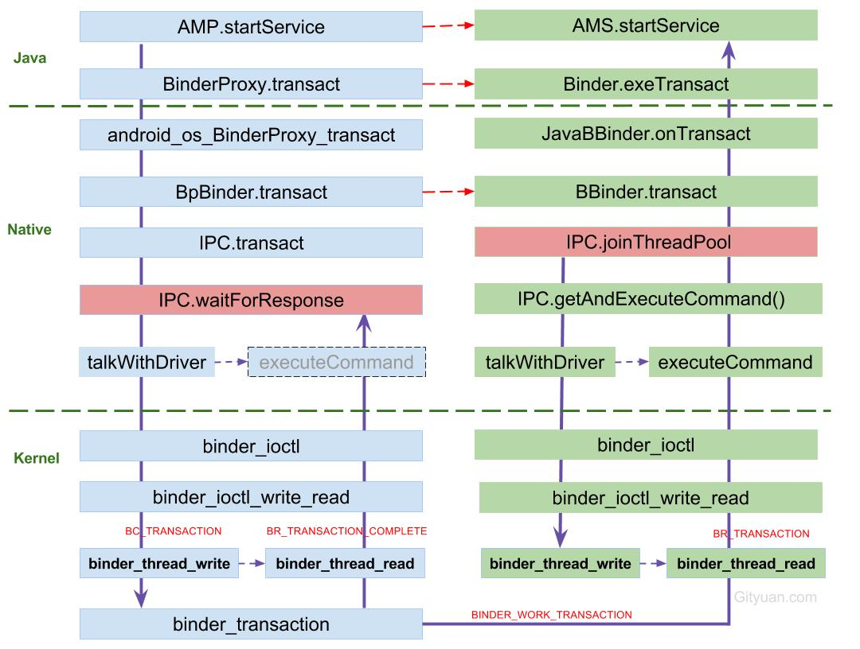

图解:

1. 发起端线程向Binder Driver发起binder ioctl请求后, 便采用环不断talkWithDriver,此时该线程处于阻塞状态, 直到收到如下BR_XXX命令才会结束该过程.
   * BR_TRANSACTION_COMPLETE: oneway模式下,收到该命令则退出
   * BR_REPLY: 非oneway模式下,收到该命令才退出;
   * BR_DEAD_REPLY: 目标进程/线程/binder实体为空, 以及释放正在等待reply的binder thread或者binder buffer;
   * BR_FAILED_REPLY: 情况较多,比如非法handle, 错误事务栈, security, 内存不足, buffer不足, 数据拷贝失败, 节点创建失败, 各种不匹配等问题
   * BR_ACQUIRE_RESULT: 目前未使用的协议;
2. 左图中waitForResponse收到BR_TRANSACTION_COMPLETE,则直接退出循环, 则没有机会执行executeCommand()方法, 故将其颜色画为灰色. 除以上5种BR_XXX命令, 当收到其他BR命令,则都会执行executeCommand过程.
3. 目标Binder线程创建后, 便进入joinThreadPool()方法, 采用循环不断地循环执行getAndExecuteCommand()方法, 当bwr的读写buffer都没有数据时,则阻塞在binder_thread_read的wait_event过程. 另外,正常情况下binder线程一旦创建则不会退出.

### 6.2 通信协议

从通信协议的角度来看这个过程:

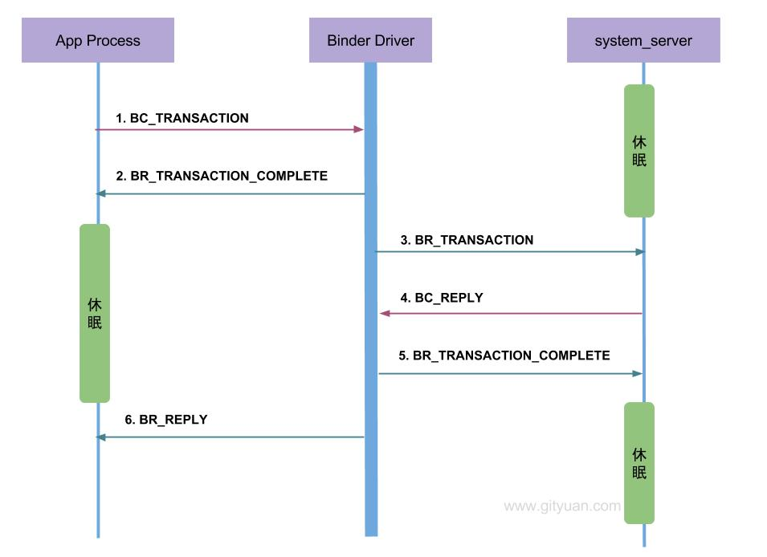

* Binder客户端或者服务端向Binder Driver发送的命令都是以BC_开头,例如本文的BC_TRANSACTION和BC_REPLY, 所有Binder Driver向Binder客户端或者服务端发送的命令则都是以BR_开头, 例如本文中的BR_TRANSACTION和BR_REPLY.
* 只有当BC_TRANSACTION或者BC_REPLY时, 才调用binder_transaction()来处理事务. 并且都会回应调用者一个BINDER_WORK_TRANSACTION_COMPLETE事务, 经过binder_thread_read()会转变成BR_TRANSACTION_COMPLETE.
* startService过程便是一个非oneway的过程, 那么oneway的通信过程如下所述.

### 6.3 说一说oneway

上图是非oneway通信过程的协议图, 下图则是对于oneway场景下的通信协议图:

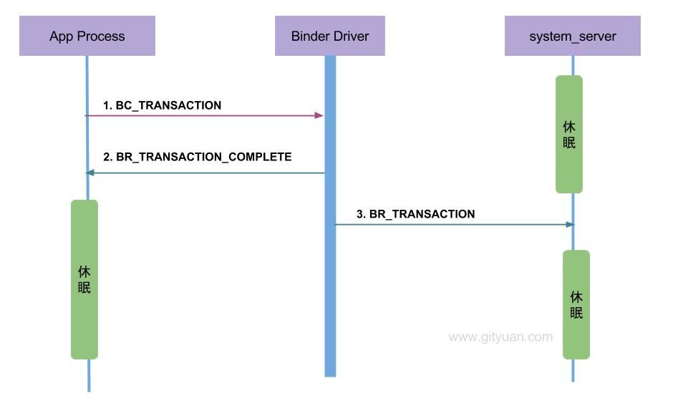

当收到BR_TRANSACTION_COMPLETE则程序返回,有人可能觉得好奇,为何oneway怎么还要等待回应消息? 我举个例子,你就明白了.

你(app进程)要给远方的家人(system_server进程)邮寄一封信(transaction), 你需要通过邮寄员(Binder Driver)来完成.整个过程如下:

1. 你把信交给邮寄员(BC_TRANSACTION);
2. 邮寄员收到信后, 填一张单子给你作为一份回执(BR_TRANSACTION_COMPLETE). 这样你才放心知道邮递员已确定接收信, 否则就这样走了,信到底有没有交到邮递员手里都不知道,这样的通信实在太让人不省心, 长时间收不到远方家人的回信, 无法得知是在路的中途信件丢失呢,还是压根就没有交到邮递员的手里. 所以说oneway也得知道信是投递状态是否成功.
3. 邮递员利用交通工具(Binder Driver),将信交给了你的家人(BR_TRANSACTION);

当你收到回执(BR_TRANSACTION_COMPLETE)时心里也不期待家人回信, 那么这便是一次oneway的通信过程.

如果你希望家人回信, 那便是非oneway的过程,在上述步骤2后并不是直接返回,而是继续等待着收到家人的回信, 经历前3个步骤之后继续执行:

1. 家人收到信后, 立马写了个回信交给邮递员BC_REPLY;
2. 同样,邮递员要写一个回执(BR_TRANSACTION_COMPLETE)给你家人;
3. 邮递员再次利用交通工具(Binder Driver), 将回信成功交到你的手上(BR_REPLY)

这便是一次完成的非oneway通信过程.

oneway与非oneway: 都是需要等待Binder Driver的回应消息BR_TRANSACTION_COMPLETE. 主要区别在于oneway的通信收到BR_TRANSACTION_COMPLETE则返回,而不会再等待BR_REPLY消息的到来. 另外，oneway的binder IPC则接收端无法获取对方的pid.

### 6.4 小规律

* BC_TRANSACTION + BC_REPLY = BR_TRANSACTION_COMPLETE + BR_DEAD_REPLY + BR_FAILED_REPLY
* Binder线程只有当本线程的thread->todo队列为空，并且thread->transaction_stack也为空，才会去处理当前进程的事务， 否则会继续处理或等待当前线程的todo队列事务。换句话说，就是只有当前线程的事务;
* binder_thread_write: 添加成员到todo队列;
* binder_thread_read: 消耗todo队列;
* 对于处于空闲可用的,或者Ready的binder线程是指停在binder_thread_read()的wait_event地方的Binder线程;
* 每一次BR_TRANSACTION或者BR_REPLY结束之后都会调用freeBuffer().
* ProcessState.mHandleToObject记录着handle与对应的BpBinder信息。

整个过程copy once便是指binder_transaction()过程把binder_transaction_data->data拷贝到目标进程的buffer。

### 6.5 数据流

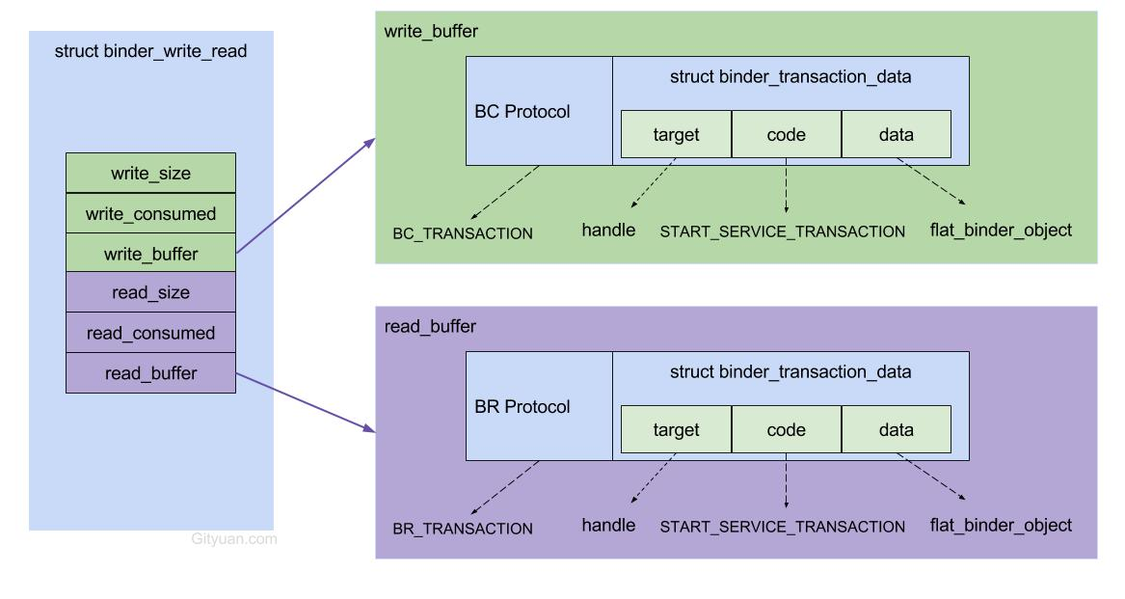

* [2.1]AMP.startService：组装flat_binder_object对象等组成的Parcel data；
* [2.9]IPC.writeTransactionData：组装BC_TRANSACTION和binder_transaction_data结构体，写入mOut;
* [2.11]IPC.talkWithDriver: 组装BINDER_WRITE_READ和binder_write_read结构体，通过ioctl传输到驱动层。

进入驱动后

* [3.3]binder_thread_write: 处理binder_write_read.write_buffer数据
* [3.4]binder_transaction: 处理write_buffer.binder_transaction_data数据；
  + 创建binder_transaction结构体，记录事务通信的线程来源以及事务链条等相关信息；
  + 分配binder_buffer结构体，拷贝当前线程binder_transaction_data的data数据到binder_buffer->data；
* [3.5]binder_thread_read: 处理binder_transaction结构体数据
  + 组装cmd=BR_TRANSACTION和binder_transaction_data结构体，写入binder_write_read.read_buffer数据

回到用户空间

* [4.3]IPC.executeCommand：处理BR_TRANSACTION命令, 将binder_transaction_data数据解析成BBinder.transact()所需的参数
* [4.7] AMN.onTransact: 层层回调，进入该方法，反序列化数据后，调用startService()方法。

## 參考

<https://gityuan.com/2016/09/04/binder-start-service/>