KW：SyntheticJoystickHandler android Joystick ViewRootImpl 拦截MotionEvent update

Keycode方向键 D-pad KeyEvent

D-pad KeyEvent 全局 拦截

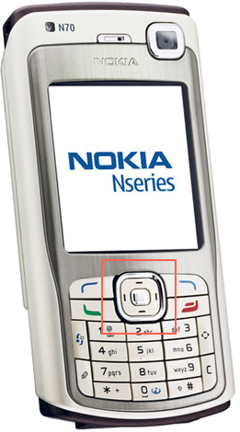 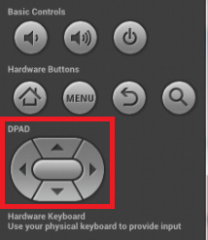

# 思路

在phoneWindowManger拦截？

**ViewRootImpl再往下面走走**

logcat -b main -b system -b radio -b events -v time

com.android.settings I/DualScreen: onKeyUp->keyCode:19

Db通信

灭屏下不要触发事件了

全局事件，在systemui监听？有用么？

/** Key code constant: Directional Pad Up key.

* May also be synthesized from trackball motions. */

public static final int KEYCODE_DPAD_UP = 19;

/** Key code constant: Directional Pad Down key.

* May also be synthesized from trackball motions. */

public static final int KEYCODE_DPAD_DOWN = 20;

/** Key code constant: Directional Pad Left key.

* May also be synthesized from trackball motions. */

public static final int KEYCODE_DPAD_LEFT = 21;

/** Key code constant: Directional Pad Right key.

* May also be synthesized from trackball motions. */

public static final int KEYCODE_DPAD_RIGHT = 22;

/** Key code constant: Directional Pad Center key.

* May also be synthesized from trackball motions. */

public static final int KEYCODE_DPAD_CENTER = 23;

# 相关类

**InputDevice**.java (core\java\android\view):

**MotionEvent**.java (core\java\android\view)

**ViewRootImpl**.java (core\java\android\view):

View.java (core\java\android\view):

InputEventConsistencyVerifier.java (core\java\android\view):

PointerLocationView.java (core\java\com\android\internal\widget):

System-current.txt (api):

Test-current.txt (api):

Current.txt (api): field public static final int SOURCE_CLASS_JOYSTICK = 16; // 0x10

KeyEvent.java (core\java\android\view): * joystick is pressed. */

MLand.java (packages\systemui\src\com\android\systemui\egg):

# ViewRootImpl

# 虚拟按键定义

/** Key code constant: Left Thumb Button key.

* On a game controller, the left thumb button indicates that the left (or only)

* joystick is pressed. */

public static final int KEYCODE_BUTTON_THUMBL = 106;

/** Key code constant: Right Thumb Button key.

* On a game controller, the right thumb button indicates that the right

* joystick is pressed. */

public static final int KEYCODE_BUTTON_THUMBR = 107;

# Core层

# TASk

# 同事交流，明建

## Xnady

<https://github.com/KoVszone/GamePad>

[https://blog.csdn.net/s278777851/article/details/6956226](javascript:%20void%200)

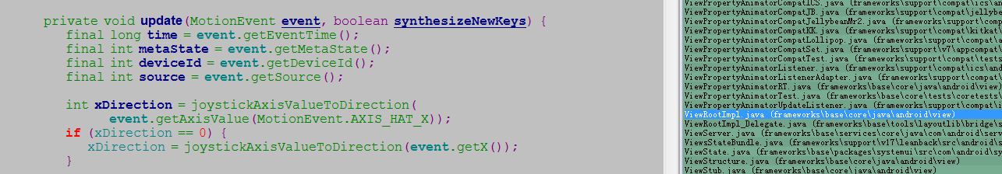

https://github.com/KoVszone/GamePad

06-08 17:24

http://www.technorange.com/2017/01/how-to-map-gamepad-or-joystick-on-android-to-play-games-using-usb-bt-joycenter/

06-08 18:11

https://blog.csdn.net/AWNUXCVBN/article/details/12285761

06-08 20:26

https://blog.csdn.net/luoshengyang/article/details/6882903

11:24

https://developer.android.com/reference/android/view/MotionEvent

# Rian之前的游戏同事

# 方案

## app进程局部拦截：

[**Android Tv 中的按键事件 KeyEvent 分发处理流程**](https://www.cnblogs.com/dasusu/p/7403698.html)

ViewRootImpl拦截

<https://www.jianshu.com/p/9528114bcded?utm_campaign=maleskine&utm_content=note&utm_medium=seo_notes&utm_source=recommendation>

## AccessibilityService拦截失败。。

<https://blog.csdn.net/w815878564/article/details/53331086>

　第四种办法是使用系统的无障碍服务，也就是AccessibilityService。我最终采用的方式就是这个，因为这个不仅可以监听按键，还能拦截。关于AccessibilityService的实现，网上讲的比较多了。我这里只提几个需要注意的点：   
　　1、按键拦截需要覆写onKeyEvent方法   
　　2、AndroidManifest.xml文件中配置如下：

http://www.voidcn.com/article/p-qskfndfg-bqe.html

# REF

[virtual-joystick-android](https://github.com/controlwear/virtual-joystick-android)

**https://github.com/erz05/JoyStick** <http://www.instructables.com/id/A-Simple-Android-UI-Joystick/>

# **TASK**

**应用层api**

https://www.jianshu.com/p/641f96c19203