# ToDO

06-11 14:56:54.247 1015-1015/? D/CameraParams: #00 pc 000263e3 /system/lib/libcamera_client.so (_ZN7android16CameraParameters14setPreviewSizeEii+26)

06-11 14:56:54.247 1015-1015/? D/CameraParams: #01 pc 00037b95 /system/lib/hw/camera.rk30board.so (_ZN7android17CameraFakeAdapter21initDefaultParametersEi+68)

06-11 14:56:54.247 1015-1015/? D/CameraParams: #02 pc 00027429 /system/lib/hw/camera.rk30board.so (_ZN7android13CameraAdapter10initializeEv+44)

06-11 14:56:54.247 1015-1015/? D/CameraParams: #03 pc 0003a6b5 /system/lib/hw/camera.rk30board.so (_ZN7android9CameraHalC1Ei+960)

06-11 14:56:54.247 1015-1015/? D/CameraParams: #04 pc 0001f4f9 /system/lib/hw/camera.rk30board.so

06-11 14:56:54.247 1015-1015/? D/CameraParams: #05 pc 00060ac3 /system/lib/libcameraservice.so (_ZN7android12CameraModule4openEPKcPP11hw_device_t+66)

06-11 14:56:54.247 1015-1015/? D/CameraParams: #06 pc 0005d601 /system/lib/libcameraservice.so

06-11 14:56:54.247 1015-1015/? D/CameraParams: #07 pc 00061f69 /system/lib/libcameraservice.so (_ZN7android12CameraClient10initializeEPNS_12CameraModuleE+176)

06-11 14:56:54.247 1015-1015/? D/CameraParams: #08 pc 00052bc7 /system/lib/libcameraservice.so (_ZN7android13CameraService13connectHelperINS_8hardware13ICameraClientENS0_6ClientEEENS_6binder6StatusERKNS_2spIT_EERKNS_7String8EiRKNS_8String16EiiNS0_8apiLevelEbbRNS7_IT0_EE+1270)

06-11 14:56:54.247 1015-1015/? D/CameraParams: #09 pc 00054929 /system/lib/libcameraservice.so (_ZN7android13CameraService13connectLegacyERKNS_2spINS_8hardware13ICameraClientEEEiiRKNS_8String16EiPNS1_INS2_7ICameraEEE+280)

06-11 14:56:54.247 1015-1015/? D/CameraParams: #10 pc 0002f619 /system/lib/libcamera_client.so (_ZN7android8hardware15BnCameraService10onTransactEjRKNS_6ParcelEPS2_j+704)

06-11 14:56:54.247 1015-1015/? D/CameraParams: #11 pc 00056f23 /system/lib/libcameraservice.so (_ZN7android13CameraService10onTransactEjRKNS_6ParcelEPS1_j+86)

06-11 14:56:54.247 1015-1015/? D/CameraParams: #12 pc 000359f3 /system/lib/libbinder.so (_ZN7android7BBinder8transactEjRKNS_6ParcelEPS1_j+70)

06-11 14:56:54.247 1015-1015/? D/CameraParams: #13 pc 0003d1eb /system/lib/libbinder.so (_ZN7android14IPCThreadState14executeCommandEi+702)

06-11 14:56:54.248 1015-1015/? D/CameraParams: #14 pc 0003ce37 /system/lib/libbinder.so (_ZN7android14IPCThreadState20getAndExecuteCommandEv+114)

06-11 14:56:54.248 1015-1015/? D/CameraParams: #15 pc 0003d34b /system/lib/libbinder.so (_ZN7android14IPCThreadState14joinThreadPoolEb+46)

06-11 14:56:54.248 1015-1015/? D/CameraParams: #16 pc 00000b4d /system/bin/cameraserver

06-11 14:56:54.248 1015-1015/? D/CameraParams: #17 pc 00016ced /system/lib/libc.so (__libc_init+48)

06-11 14:56:54.248 1015-1015/? D/CameraParams: #18 pc 00000a18 /system/bin/cameraserver

--------------------------------------------------

<libcamera_client.so>

CameraParameters.setPreviewSize()

</hw/camera.rk30board.so>

CameraFakeAdapter->initDefaultParameters

CameraAdapter->initialize

CameraHal()

<libcameraservice.so>

av/services/camera/libcameraservice/common/CameraModule:CameraModule.open

res = filterOpenErrorCode(mModule->common.methods->open(&mModule->common, id, device));

/av/services/camera/libcameraservice/api1/CameraClient.cpp:63:status_t CameraClient::initialize(CameraModule *module) {

res = CameraHardwareInterface->initialize(module);( module->open(mName.string(), (hw_device_t **)&mDevice);)

/av/services/camera/libcameraservice/CameraService.h:821:binder:::connectHelper:client->initialize(mModule))///property_set("sys.camera.callprocess", clientName8.string());

./av/services/camera/libcameraservice/CameraService.cpp connectLegacy()

结论就是

adb shell dumpsys media.camera

preview size:2592 x 1944,

mParameters.getPreviewSize(&prev_width, &prev_height);

----

预览尺寸：，没有用的，为啥还是Texture.setDefaultBufferSize。。

<https://github.com/smewise/Camera2>

app:Android Camera2教程之打开相机、开启预览、实现PreviewCallback、拍照

<https://blog.csdn.net/u012248972/article/details/78747419>

android6.0源码分析之Camera API2.0下的video流程分析

<https://blog.csdn.net/qq_16775897/article/details/81240600>

序列：https://blog.csdn.net/yangzhihuiguming/article/details/51837084

Android框架之Camera(2)HAL及so库的加载

<https://blog.csdn.net/u013686019/article/details/72834774>

android camera动态库加载过程

<https://blog.csdn.net/armwind/article/details/52076879>

<http://www.voidcn.com/article/p-gpwudzqw-gc.html>

Camera成像原理介绍

<https://www.cnblogs.com/senior-engineer/p/4935506.html>

Camera2 数据流从framework到Hal源码分析

<https://www.jianshu.com/p/ecb1be82e6a8>

CS架构

<https://www.androidos.net.cn/android/2.3.7_r1/xref/frameworks/base/services/camera/libcameraservice>

<https://blog.csdn.net/kangear/article/details/8239330>

BatteryStatsService.java

noteStartCamera

原理的作用

String8 packageName = String8{clientSp->getPackageName()};

packageName.string()

java.lang.SecurityException: Permission Denial:

broadcast from android asks to run as user -2 but is calling from user 0;

this requires android.permission.INTERACT_ACROSS_USERS_FULL or android.permission.INTERACT_ACROSS_USERS

Capture流程分析

https://blog.csdn.net/yangzhihuiguming/article/details/51822384

video流程分析

[无。。。](https://blog.csdn.net/yangzhihuiguming/article/details/51837084)

Camera API2.0的应用

无。。。

<https://blog.csdn.net/wangjicong_215/article/details/73278757>

# Camera 2简介

2014年，在Google 推出Android 5.0的时， Android Camera API 版本升级到了API2(android.hardware.camera2), 之前使用的API1(android.hardware.camera)就被标为 Deprecated 了. Camera API2相较于API1有很大不同, 并且API2是为了配合HAL3进行使用的, API2有很多API1不支持的特性, 比如:

1. 更先进的API架构
2. 可以获取更多的帧(预览/拍照)信息以及手动控制每一帧的参数
3. 对Camera的控制更加完全(比如支持调整focus distance, 剪裁预览/拍照图片)
4. 支持更多图片格式(yuv/raw)以及高速连拍  
   ......

不过实际功能支持情况要看HAL层是否完成了相关功能, 也就是说API有很多功能来满足拍照/录像需求, 但实际是否能用和具体设备有关.

## HARDWARE_LEVEL

有些中低端手机使用的HAL1, 使用HAL1就会导致Camera2一些高级功能都没法使用了,设备对应Camera2的支持情况通过**INFO_SUPPORTED_HARDWARE_LEVEL**. 定义，主要分为5个等级:

* INFO_SUPPORTED_HARDWARE_LEVEL_LEGACY
* INFO_SUPPORTED_HARDWARE_LEVEL_LIMITED
* INFO_SUPPORTED_HARDWARE_LEVEL_FULL
* INFO_SUPPORTED_HARDWARE_LEVEL_3
* INFO_SUPPORTED_HARDWARE_LEVEL_EXTERNAL

LEVEL_LEGACY: 向后兼容模式, 如果是此等级, 基本没有额外功能, HAL层大概率就是HAL1(我遇到过的都是)  
LEVEL_LIMITED: 有最基本的功能, 还支持一些额外的高级功能, 这些高级功能是LEVEL_FULL的子集  
LEVEL_FULL: 支持对每一帧数据进行控制,还支持高速率的图片拍摄  
LEVEL_3: 支持YUV后处理和Raw格式图片拍摄, 还支持额外的输出流配置  
LEVEL_EXTERNAL: API28中加入的, 应该是外接的摄像头, 功能和LIMITED类似

各个等级从支持的功能多少排序为: LEGACY < LIMITED < FULL < LEVEL_3

具体到源码怎么定义的呢？

char = CameraManager.getCameraCharacteristics()

int level = char.get(CameraCharacteristics.INFO_SUPPORTED_HARDWARE_LEVEL);

## **REQUEST_AVAILABLE_CAPABILITIES**

上面讲的几个等级是从整体上说明Camera2支持情况, 我们还可以查询更多细节功能,REQUEST_AVAILABLE_CAPABILITIES 则可以知道具体支持哪些实际功能, 具体有如下功能:

| **BACKWARD_COMPATIBLE** | **READ_SENSOR_SETTINGS** |
| --- | --- |
| MANUAL_SENSOR | BURST_CAPTURE |
| MANUAL_POST_PROCESSING | YUV_REPROCESSING |
| RAW | DEPTH_OUTPUT |
| PRIVATE_REPROCESSING | CONSTRAINED_HIGH_SPEED_VIDEO |

大多数支持等级为 LEGACY 的设备, 只支持 BACKWARD_COMPATIBLE ,

## AE/AF Region

在使用Camera2 API过程中, 设置测光和对焦区域这部分刚开始一直不知道该怎么写代码, 后面折腾了一番, 终于找到正确的方法了, 在此记录一下.  
AE/AF 区域需要通过用户在屏幕上的点击位置来进行设置, 因此我们要做的就是将屏幕点击点映射到底层对焦和测光位置点, 同时发送请求触发对焦这个动作. 首先要知道一点就是, 屏幕点击点坐标和Camera底层坐标不是对应的, 基本关系如下图:

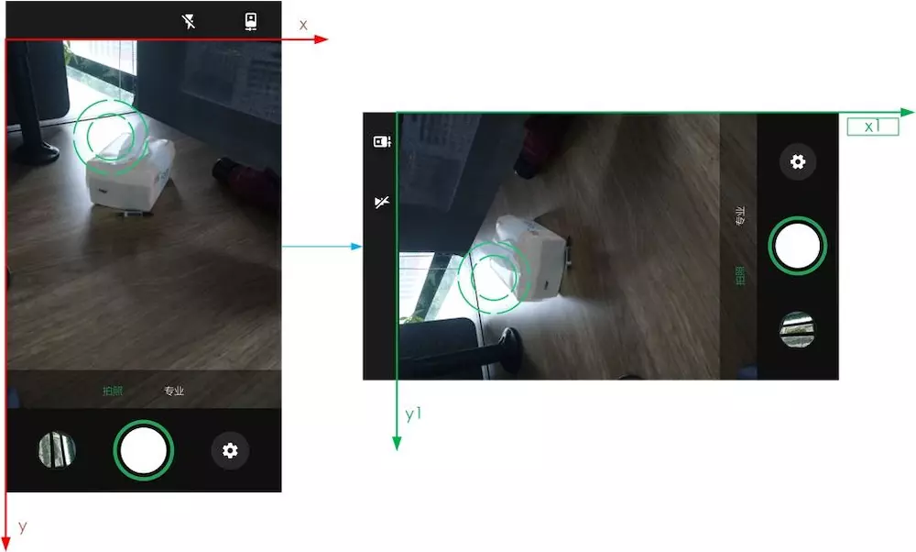 x,y坐标系表示屏幕坐标, x1,y1表示Camera对应坐标  
可见屏幕点击和底层有个90度旋转关系, 实际设置AF/AE区域步骤如下:

1.首先获取SENSOR_INFO_ACTIVE_ARRAY_SIZE, 即底层Camera坐标点的范围, API中通过一个Rect表示

characteristics.get(CameraCharacteristics.SENSOR_INFO_ACTIVE_ARRAY_SIZE)

得到``Rect```通常为支持的最大图片尺寸, 比如(0, 0, 4160, 3120)

2.坐标映射  
我们需要将屏幕点击点映射到 SENSOR_INFO_ACTIVE_ARRAY_SIZE对应的Rect中, 从图中可以很容易看出, 坐标转换关系为 : x1 = y , y1 = previewWidth - x, 坐标转换完成后只需乘以 图片宽度/预览宽度的比例即可得到转换后的坐标, 然后以坐标点为中心生成一个矩形, 这个矩形就是我们要的结果, 实际代码片段如下:

private MeteringRectangle calcTapAreaForCamera2(CameraCharacteristics c, int areaSize, int

weight) {

// 获取Size

Rect rect = c.get(CameraCharacteristics.SENSOR_INFO_ACTIVE_ARRAY_SIZE);

Log.d(TAG, "active Rect:" + rect.toString());

Rect newRect;

int leftPos, topPos;

// 坐标转换

float newX = currentY;

float newY = previewWidth - currentX;

// 大小转换

leftPos = (int) ((newX / previewHeight) * rect.right);

topPos = (int) ((newY / previewWidth) * rect.bottom);

// 以坐标点为中心生成一个矩形, 需要防止上下左右的值溢出

int left = clamp(leftPos - areaSize, 0, rect.right);

int top = clamp(topPos - areaSize, 0, rect.bottom);

int right = clamp(leftPos + areaSize, leftPos, rect.right);

int bottom = clamp(topPos + areaSize, topPos, rect.bottom);

newRect = new Rect(left, top, right, bottom);

Log.d(TAG, newRect.toString());

// 构造MeteringRectangle

return new MeteringRectangle(newRect, weight);

}

private int clamp(int x, int min, int max) {

if (x > max) {

return max;

}

if (x < min) {

return min;

}

return x;

}

注: 此处坐标映射可以通过Matrix进行, 熟悉Matrix的同学可以尝试下

3.设置AE/AF区域并触发对焦, 代码片段如下

public void startControlAFRequest(MeteringRectangle rect,

CameraCaptureSession.CaptureCallback captureCallback) {

MeteringRectangle[] rectangle = new MeteringRectangle[]{rect};

// 对焦模式必须设置为AUTO

mPreviewBuilder.set(CaptureRequest.CONTROL_AF_MODE,CaptureRequest.CONTROL_AF_MODE_AUTO);

//AE

mPreviewBuilder.set(CaptureRequest.CONTROL_AE_REGIONS,rectangle);

//AF 此处AF和AE用的同一个rect, 实际AE矩形面积比AF稍大, 这样测光效果更好

mPreviewBuilder.set(CaptureRequest.CONTROL_AF_REGIONS,rectangle);

try {

// AE/AF区域设置通过setRepeatingRequest不断发请求

mSession.setRepeatingRequest(mPreviewBuilder.build(), null, mHandler);

} catch (CameraAccessException e) {

e.printStackTrace();

}

//触发对焦

mPreviewBuilder.set(CaptureRequest.CONTROL_AF_TRIGGER,CaptureRequest.CONTROL_AF_TRIGGER_START);

try {

//触发对焦通过capture发送请求, 因为用户点击屏幕后只需触发一次对焦

mSession.capture(mPreviewBuilder.build(), captureCallback, mHandler);

} catch (CameraAccessException e) {

e.printStackTrace();

}

}

作者：smewise  
链接：https://www.jianshu.com/p/23e8789fbc10  
来源：简书  
简书著作权归作者所有，任何形式的转载都请联系作者获得授权并注明出处。

作者：smewise  
链接：https://www.jianshu.com/p/23e8789fbc10  
来源：简书  
简书著作权归作者所有，任何形式的转载都请联系作者获得授权并注明出处。

作者：smewise  
链接：https://www.jianshu.com/p/23e8789fbc10  
来源：简书  
简书著作权归作者所有，任何形式的转载都请联系作者获得授权并注明出处。

作者：smewise  
链接：https://www.jianshu.com/p/23e8789fbc10  
来源：简书  
简书著作权归作者所有，任何形式的转载都请联系作者获得授权并注明出处。

## 架构图

在API架构方面, Camera2和之前的Camera有很大区别, APP和底层Camera之前可以想象成用管道方式连接, 如下图:

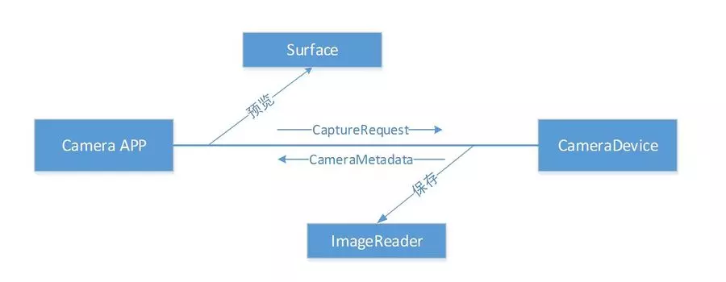

如上图所示, Camera APP 通过CameraCaptureSession发送CaptureRequest, CameraDevices收到请求后返回对应数据到对应的Surface,预览数据一般都是到TextureView, 拍照数据则在ImageReader中, 整体来说就是一个请求--响应过程, 请求完成后, 可以在回调中查询到相应的请求参数和CameraDevice当前状态, 总的来说, Camera2中预览/拍照/录像数据统一由Surface来接收, CaptureRequest代表请求控制的Camera参数, CameraMetadata(CaptureResult)则表示当前返回帧中Camera使用的参数以及当前状态.

### 使用流程

API使用流程大体如下:

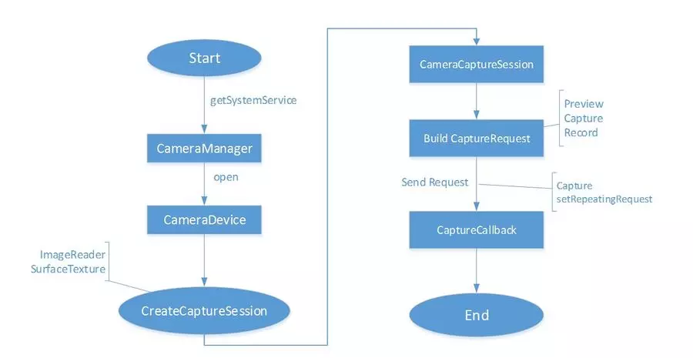

• 通过context.getSystemService(Context.CAMERA_SERVICE) 获取CameraManager.

• 调用CameraManager .open()方法在回调中得到CameraDevice.

• 通过CameraDevice.createCaptureSession() 在回调中获取CameraCaptureSession.

• 构建CaptureRequest, 有三种模式可选 预览/拍照/录像.

• 通过 CameraCaptureSession发送CaptureRequest, capture表示只发一次请求, setRepeatingRequest表示不断发送请求.

• 拍照数据可以在ImageReader.OnImageAvailableListener回调中获取, CaptureCallback中则可获取拍照实际的参数和Camera当前状态.

### 数据从framework传递到上层

在framework层会创建一个Surface，而Surface持有一个ANativeWindow接口，ANativeWindow负责管理Buffer的创建与共享.在Consumer端ANativeWindow创建Buffer，在Surface通过dequeuebuffer获取buffer handle到本地进行共享，在数据填充完后通过quenebuffer告诉Consumer当前buffer可用，这样就形成了一个buffer生成与消费的关系。这种模式是通过建立不同类型的Consumer，然后在Native层建立一个BufferQueue,并将这个BufferQueue的IGraphicBufferConsumer用于构建CPUConsumer,将IGraphicBufferProducter通过createStream给CameraDevice增加一个Stream。即是说我们是通过buffer从低向上传递数据。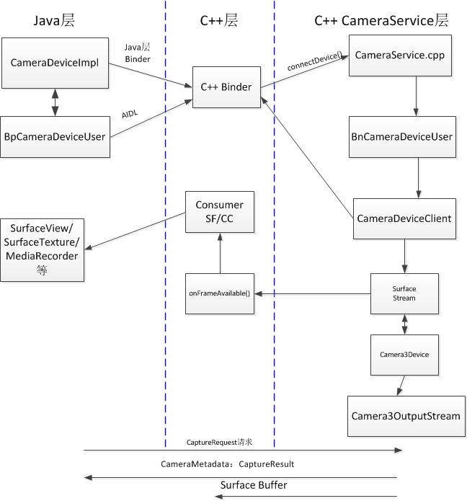

Java层要想与C++层的CameraService层进行通信，都是通过Java层的IPC Binder进制进行的，主要包括ICameraService.aidl以及ICameraDeviceUser.aidl两个接口来实现，其会在Java层维护一个CameraDeviceImpl即Camera设备的代理，而CameraService以及CameraDeviceImpl的初始化会在此文的第二，第三节进行分析。

而Java层对Camera的具体操作的操作流程大致为，Java层通过Device代理发送一个CaptureRequest，而C++层进行相应的处理，再调用相应的回调来通知Java相应的处理结果，并将相应的Capture数据保存在Surface Buffer里，这样Java层在回调函数中可以对数据进行相应的处理。

## Java层的CameraService的实现和应用

从Camera API2开始，Camera的实现方式有所不同，最主要的区别是不再使用JNI来调用本地代码，从而获得本地CameraService，并实现其C/S模式的通信，而是直接在Java层通过Java层的IPC Binder机制来获取Java层的CameraService的代理对象，从而直接在Java层获取本地的CameraService与Camera Device进行相应的通信。

相应的代码及目录：

CameraManager.java:frameworks/base/core/java/android/hardware/camera2

ICameraService.aidl:frameworks/base/core/java/android/hardware

CameraService.cpp:frameworks/av/services/camera/libcameraservice

获取CameraService的核心代码如下

//CameraManager.java

prvate void connectCameraServiceLocked(){

if(mCameraService != null)return;

//获取Binder

IBinder cameraServiceBinder = ServiceManager.getService(CAMERA_SERVICE_BINDER_NAME);

if(cameraServiceBinder == null){

return;

}

try{

cameraServiceBinder.linkToDeath(this,/*flags*/ 0);

}catch(RemoteException e){

return;

}

ICameraService cameraServiceRaw = ICameraService.Stub.asInterface(cameraServiceBinder);

//根据cameraServiceRaw 创建CameraService实例

ICameraService cameraService = CameraServiceDecorator.newInstance(cameraServiceRaw);

...

try{

//添加监听

cameraService.addListener(this);

//赋值给mCameraService的全局变量

mCameraService = cameraService;

}catch(CameraRuntimeException e){

...

}

}

由代码可知，通过Java层的Binder从ServiceManager里获取了一个Java层的CameraService实例，在打开Camera的流程中，会通过此CameraService(Native的CameraService)与Camera通信，CameraManager获取相机的基本信息，不是码流

而其中的通信通过ICameraDeviceUser来实现，接下来分析ICameraDeviceUser的实现。

## ICameraDeviceUser.aidl的通信实现

Java层与C++ CameraService层之间的通信，通过封装了一个CameraDeviceUser来实现，它只是在Java层使用了AIDL技术来实现Client，即在Java层维护了一个CameraDevice，这样的好处是响应速度更快，因为这样不需要通过每次进入Native层来完成通信，而可以通过Java层的IPC Binder机制即可完成。即API2.0通过AIDL实现一个接口ICameraDeviceUser，从而在Java层维护一个Camera proxy，之后的通信都是通过此代理CameraDeviceImpl来实现。

相关代码及目录：

ICameraDeviceUser.aidl:frameworks/base/core/java/android/hardware/camera2

ICameraDeviceUser.cpp:frameworks/av/camera/camera2

CameraDeviceImpl.java:frameworks/base/core/java/android/hardware/camera2/impl

获取Camera Device的Java层代理的核心代码如下：

//CameraManager.java

private CameraDevice openCameraDeviceUserAsync(...){

//初始化Camera Java层代理对象

CameraDevice device = null;

try{

synchronized(mLock){

//初始化ICameraDeviceUser

ICameraDeviceUser cameraUser = null;

//初始化具体的CameraDevice代理

android.hardware.camera2.impl.CameraDeviceImpl deviceImpl = new android.hardware.

camera2.impl.CameraDeviceImpl(cameraId,callback,handler,characteristics);

BinderHolder holder = new BinderHolder();

ICameraDeviceCallbacks callbacks = deviceImpl.getCallbacks();

...

try{

//如果支持HAL3.2+的devices

if(supportsCamera2ApiLocked(cameraId)){

//获取CameraService

ICameraService cameraService = CameraManagerGlobal.get().getCameraService();

...

//连接设备

cameraService.connectDevice(callbacks,id,mContextgetOpPackageName()

,USE_CALLING_UID,holder);

//通过Binder获得打开的Camera设备返回的Camera代理

cameraUser = ICameraDeviceUser.Stub.asInterface(holder.getBinder());

}else{//否则用遗产API

cameraUser = CameraDeviceUserShim.connectBinderShim(callbacks,id);

}

}catch(...){

...

}

//包装代理对象

deviceImpl.setRemoteDevice(cameraUser);

device = deviceImpl;

}

}catch(...){

...

}

返回Camera代理

return device;

}

由代码可知，首先获取CameraService，然后通过它来开启Camera，而开启成功后，C++层会返回一个Camera device代理对象，此处即为ICameraDeviceUser，所以在Java层对其进行相应的封装，变成一个CameraDeviceImpl对象，此后，只要需要对Camera进行操作，都会调用CameraDeviceImpl对象的相关方法，并通过ICameraDeviceUser以及Java IPC Binder来与本地的Camera device进行通信，至此，Camera API2.0的框架就分析结束了，具体的操作，如Camera的初始化，preview,capture等流程的分析

## surface和CpuConsumer下生产者和消费者间的处理框架简述

如果对SurfaceFlinger架构的工作原理较为熟悉的话，本文阅读起来会相对容易些。之所以撰写本文是因为在阅读Camera HAL3的实现过程中大量的出现了类似与SurfaceFlinger的工作模式。本文将以CallbackProcessor模块的为入口，和大家进行分享。

### Preview模块Surface与SurfaceFlinger的基础知识

开发过Android Camera模块的人，基本都应该熟悉实时采集的视频如果要显示到手机屏上，对应的Framework层就应该构建一个Surface对象，这对所有Android版本都是通用的。该Surface本质是一个在APP端的ANativeWindow，是需要从SurfaceFlinger端的Gralloc模块获取Buffer的，然后填充帧图像数据并送显示的过程。详细内容可以参考之前的专栏我心所向之Android4.2关于SurfaceFlinger相关的内容。

由于目前Android系统版本升级过快，在5.0以上的版本中SurfaceFlinger部分框架发生了变化(目前还没有深入去研读过)，了解到的是：

一方面他去掉了SurfaceTexture/SurfaceTextureClient等内容，增强了Surface的功能。

另一方面BufferQueue的使用也更加简单与明了，Producer与Consumer的关系也更加明确，BufferQueue不再是以前的消费者角色，转而成为ProducerBufferQueue和Consumer相互关联的桥梁。

此外，如果你在深入的话，会了解到Gralloc模块中非framebuff的缓存管理与共享不在是那个Ashmem匿名共享内存，而是出现了一种新的内存管理机制/dev/ION/，后面会和大家分享他部分的工作机制。

对于SurfaceFlinger与Camera Preview Surface而言，ANativeWindow作为两者的共性负责管理和维护Buffer的创建与共享，在SurfaceFlinger端ANativeWindow创建buffer，在Surface侧通过dequeuebuffer获取buffer handle到本地进行共享，在填充完数据后通过queuebuffer告诉SurfaceFlinger当前buffer可用，这样就形成了一个buffer生产与消费的关系，基于这种原理我们在Camera3Device中除了看到正常的Preview Surface之外还看到了其他模块中出现了Surface的创建。

### CallbackProcessor::updateStream() 创建Surface

sp<IGraphicBufferProducer> producer;

sp<IGraphicBufferConsumer> consumer;

BufferQueue::createBufferQueue(&producer, &consumer);//BufferQueueProducer与BufferQueueConsumer

mCallbackConsumer = new CpuConsumer(consumer, kCallbackHeapCount);

mCallbackConsumer->setFrameAvailableListener(this);//当前CallbackProcessor继承于CpuConsumer::FrameAvailableListener

mCallbackConsumer->setName(String8("Camera2Client::CallbackConsumer"));

mCallbackWindow = new Surface(producer);//用于queue操作，这里直接进

上述代码看上去很简单，但就是他最终形成了一个bufferstream Product和Consumer的处理，这种方式也为Camera2Client下出现多路stream，多路数据流存在奠定了基础，下面我们来简单的描述他的工作机制。

#### 2.1 BufferQueue::createBufferQueue

Sadf

void BufferQueue::createBufferQueue(sp<IGraphicBufferProducer>* outProducer,

sp<IGraphicBufferConsumer>* outConsumer,

const sp<IGraphicBufferAlloc>& allocator) {

LOG_ALWAYS_FATAL_IF(outProducer == NULL,

"BufferQueue: outProducer must not be NULL");

LOG_ALWAYS_FATAL_IF(outConsumer == NULL,

"BufferQueue: outConsumer must not be NULL");

sp<BufferQueueCore> core(new BufferQueueCore(allocator));

LOG_ALWAYS_FATAL_IF(core == NULL,

"BufferQueue: failed to create BufferQueueCore");

sp<IGraphicBufferProducer> producer(new BufferQueueProducer(core));//本地Bn的BufferQueueProducer

LOG_ALWAYS_FATAL_IF(producer == NULL,

"BufferQueue: failed to create BufferQueueProducer");

sp<IGraphicBufferConsumer> consumer(new BufferQueueConsumer(core));//本地Bn的BufferQueueConsumer

LOG_ALWAYS_FATAL_IF(consumer == NULL,

"BufferQueue: failed to create BufferQueueConsumer");

*outProducer = producer;

*outConsumer = consumer;

当前Android5.1版本中可以看到BufferQueue已经改变了原先的角色，成为了一个用于创建一组操作BufferQueue的接口，实现了BufferQueueProducer与BufferQueueConsumer的创建。更本质说现在BufferQueue的工作量已经很小，基本由Surface来全盘操作。这里通过BufferQueueCore会将BufferQueueProducer与BufferQueueConsumer绑定在一起，BufferQueueProducer可以说是替代了旧版本Android4.2中的SurfaceTextureClient，而BufferQueueConsumer则直接是SurfaceTexture以及BufferQueue的替代者。下图是在Android4.2.2中Surface和SurfaceFlinger间基于Bn/BpSurfaceTexture的多进程间buffer的queue操作机制

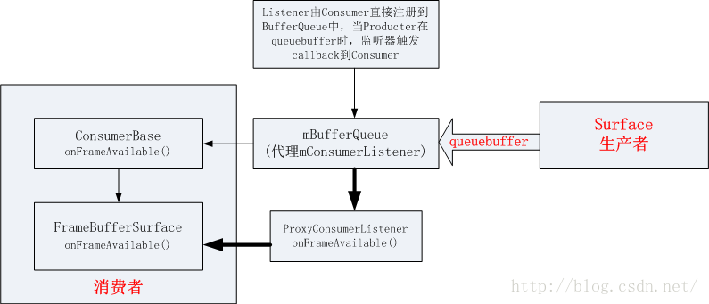

#### CpuConsumer

在2.1中本质上是创建了BufferQueueProducer和BufferQueueConsumer，一般是成对出现。

这个CpuConsumer的地位本质是和SurfaceFlinger是一样的，主要角色就是来处理已经带有帧数据的buffer块，所以整个的处理机制都是类型的，其中两者均为继承一个ConsumerBase类，用于实现对buffer块的处理。

CpuConsumer::CpuConsumer(const sp<IGraphicBufferConsumer>& bq,

uint32_t maxLockedBuffers, bool controlledByApp) :

ConsumerBase(bq, controlledByApp),

mMaxLockedBuffers(maxLockedBuffers),

mCurrentLockedBuffers(0)

{

// Create tracking entries for locked buffers

mAcquiredBuffers.insertAt(0, maxLockedBuffers);

mConsumer->setConsumerUsageBits(GRALLOC_USAGE_SW_READ_OFTEN);

mConsumer->setMaxAcquiredBufferCount(maxLockedBuffers);

}

#### mCallbackConsumer->setFrameAvailableListener(this)

这里所完成的过程是需要Consumer去将一个listener加入到Productor端去，便于在帧数据可用时，可以监听到并告知Consumer去做数据的处理，Product需要在数据可用时触发这个listener的onFrameAvailable，从而让数据从Productor转到Consumer则，数据处理应该是在同一进程的而不是跨进程。

如果作为Consumer如CPUConsumer没有使用setFrameAvailableListener将自己加入到listener中去，会由ConsumerBase的接口onFrameAvailable来替代完成。

#### mCallbackWindow = new Surface(producer)

这里是建立一个Surface，也就是类型于Preview模式下创建的Surface，两者的本质是一样的。在Android5.1中，Surface已经拥有了绝对的控制权，Preview模式下的Surface是跨进程的和SF进行交互，故构造函数传入的sp<IGraphicBufferProducer>& bufferProducer参数一般是一个BufferQueue中BufferQueueProducer侧匿名的binder BpGraphicBufferProducer。对于CPUConsumer而言，两者是处于同一进程之中的，Surface主要行驶如下的操作，而在旧版本中这些主要由SurfaceTextureClient来管理的：

ANativeWindow::setSwapInterval = hook_setSwapInterval;

ANativeWindow::dequeueBuffer = hook_dequeueBuffer;

ANativeWindow::cancelBuffer = hook_cancelBuffer;

ANativeWindow::queueBuffer = hook_queueBuffer;

ANativeWindow::query = hook_query;

ANativeWindow::perform = hook_perform;

ANativeWindow::dequeueBuffer_DEPRECATED = hook_dequeueBuffer_DEPRECATED;

ANativeWindow::cancelBuffer_DEPRECATED = hook_cancelBuffer_DEPRECATED;

ANativeWindow::lockBuffer_DEPRECATED = hook_lockBuffer_DEPRECATED;

ANativeWindow::queueBuffer_DEPRECATED = hook_queueBuffer_DEPRECATED;

一般对Buffer的操作都先是基于Struct ANativeWindow这个本地的窗口类来处理，再是通过hook到实际的surface再交由GraphicBufferProducer来完成的。

### Android5.1下Surface的queuebuffer操作逻辑

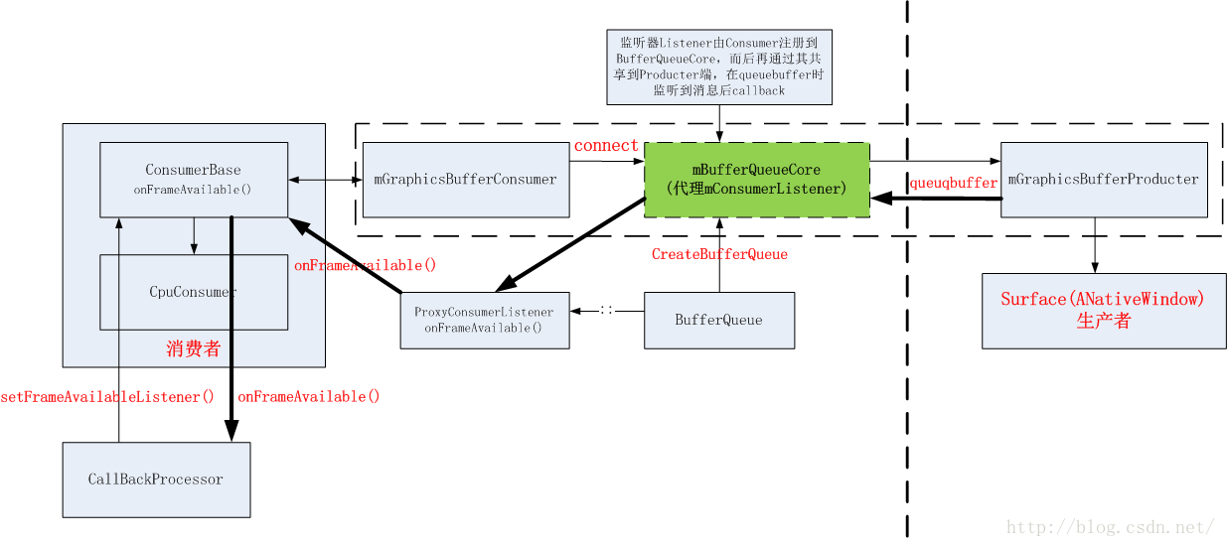

对比上一图可知，当前CPUConsumer模式下，从queuebuffer的处理过程来看更加体现出Productor和Consumer这种设计模式，整个架构代码看起来也更明了，这也是谷歌不断升级系统去冗存精的道理吧。整个用户在调用这种逻辑是，只需几句代码就可以获得对一个buffer块的读与写的操作接口，具体后续在分析Camera HAL3的数据流时可以很深刻的看到。

总的来说Surface在Camera3Device的架构下，与HAL3相组合是充当了消费者，与CPUCOnsumer或者Surfaceflinger来说就是生产者。或者说surface充当了buffer信息的传输与过渡。



# Camera2打开流程

## 应用层

Camera2的初始化流程与Camera1.0有所区别，本文将就Camera2的内置应用来分析Camera2.0的初始化过程。Camera2.0首先启动的是CameraActivity，而它继承自QuickActivity，在代码中你会发现没有重写OnCreate等生命周期方法，因为此处采用的是模板方法的设计模式，在QuickActivity中的onCreate方法调用的是onCreateTasks等方法，所以要看onCreate方法就只须看onCreateTasks方法即可：

### onCreateTasks

//CameraActivity.java

@Override

public void onCreateTasks(Bundle state) {

Profile profile = mProfiler.create("CameraActivity.onCreateTasks")

.start();

...

mOnCreateTime = System.currentTimeMillis();

mAppContext = getApplicationContext();

mMainHandler = new MainHandler(this, getMainLooper());

…

try {

//初始化OneCameraOpener对象

①mOneCameraOpener = OneCameraModule.provideOneCameraOpener(

mFeatureConfig, mAppContext,mActiveCameraDeviceTracker,

ResolutionUtil.getDisplayMetrics(this));

mOneCameraManager = OneCameraModule.provideOneCameraManager();

} catch (OneCameraException e) {...}

…

//建立模块信息

②ModulesInfo.setupModules(mAppContext, mModuleManager, mFeatureConfig);

…

//进行初始化

③mCurrentModule.init(this, isSecureCamera(), isCaptureIntent());

…

}

如代码所示，重要的有以上三点，先看第一点：

//OneCameraModule.java

public static OneCameraOpener provideOneCameraOpener(OneCameraFeatureConfig

featureConfig, Context context, ActiveCameraDeviceTracker

activeCameraDeviceTracker,DisplayMetrics displayMetrics)

throws OneCameraException {

//创建OneCameraOpener对象

Optional<OneCameraOpener> manager = Camera2OneCameraOpenerImpl.create(

featureConfig, context, activeCameraDeviceTracker, displayMetrics);

if (!manager.isPresent()) {

manager = LegacyOneCameraOpenerImpl.create();

}

...

return manager.get();

}

它调用Camera2OneCameraOpenerImpl的create方法来获得一个OneCameraOpener对象，以供CameraActivity之后的操作使用，继续看create方法：

//Camera2OneCameraOpenerImpl.java

public static Optional<OneCameraOpener> create(OneCameraFeatureConfig

featureConfig, Context context, ActiveCameraDeviceTracker

activeCameraDeviceTracker, DisplayMetrics displayMetrics) {

...

CameraManager cameraManager;

try {

cameraManager = AndroidServices.instance().provideCameraManager();

} catch (IllegalStateException ex) {...}

//新建一个Camera2OneCameraOpenerImpl对象

OneCameraOpener oneCameraOpener = new Camera2OneCameraOpenerImpl(

featureConfig, context, cameraManager,

activeCameraDeviceTracker, displayMetrics);

return Optional.of(oneCameraOpener);

}

很明显，它首先获取一个cameraManger对象，然后根据这个cameraManager对象来新创建了一个Camera2OneCameraOpenerImpl对象，所以第一步主要是为了获取一个OneCameraOpener对象，它的实现为Camera2OneCameraOpenerImpl类。

继续看第二步，ModulesInfo.setupModules:

// ModulesInfo.java

public static void setupModules(Context context, ModuleManager moduleManager,

OneCameraFeatureConfig config) {

Resources res = context.getResources();

int photoModuleId = context.getResources().getInteger(

R.integer.camera_mode_photo);

//注册Photo模块

registerPhotoModule(moduleManager, photoModuleId,

SettingsScopeNamespaces.PHOTO,config.isUsingCaptureModule());

//计算你还Photo模块设置为默认的模块

moduleManager.setDefaultModuleIndex(photoModuleId);

//注册Videa模块

registerVideoModule(moduleManager, res.getInteger(

R.integer.camera_mode_video),SettingsScopeNamespaces.VIDEO);

if (PhotoSphereHelper.hasLightCycleCapture(context)) {//开启闪光

//注册广角镜头

registerWideAngleModule(moduleManager, res.getInteger(

R.integer.camera_mode_panorama),SettingsScopeNamespaces

.PANORAMA);

//注册光球模块

registerPhotoSphereModule(moduleManager,res.getInteger(

R.integer.camera_mode_photosphere),

SettingsScopeNamespaces.PANORAMA);

}

//若需重新聚焦

if (RefocusHelper.hasRefocusCapture(context)) {

//注册重聚焦模块

registerRefocusModule(moduleManager, res.getInteger(

R.integer.camera_mode_refocus),

SettingsScopeNamespaces.REFOCUS);

}

//如果有色分离模块

if (GcamHelper.hasGcamAsSeparateModule(config)) {

//注册色分离模块

registerGcamModule(moduleManager, res.getInteger(

R.integer.camera_mode_gcam),SettingsScopeNamespaces.PHOTO,

config.getHdrPlusSupportLevel(OneCamera.Facing.BACK));

}

int imageCaptureIntentModuleId = res.getInteger(

R.integer.camera_mode_capture_intent);

registerCaptureIntentModule(moduleManager,

imageCaptureIntentModuleId,SettingsScopeNamespaces.PHOTO,

config.isUsingCaptureModule());

}

代码根据配置信息，进行一系列模块的注册，其中PhotoModule和VideoModule被注册，而其他的module则是根据配置来进行的，因为打开Camera应用，既可以拍照片也可以拍视频，此处，只分析PhoneModule的注册：

### PhoneModule

/ ModulesInfo.java

private static void registerPhotoModule(ModuleManager moduleManager, final

int moduleId, final String namespace,

final boolean enableCaptureModule) {

//向ModuleManager注册PhotoModule模块

moduleManager.registerModule(new ModuleManager.ModuleAgent() {

@Override

public int getModuleId() {

return moduleId;

}

@Override

public boolean requestAppForCamera() {

return !enableCaptureModule;

}

@Override

public String getScopeNamespace() {

return namespace;

}

@Override

public ModuleController createModule(AppController app, Intent

intent) {

Log.v(TAG, "EnableCaptureModule = " + enableCaptureModule);

//创建ModuleController

return enableCaptureModule ? new CaptureModule(app)

: new PhotoModule(app);

}

});

}

由代码可知，它最终是由ModuleManager来新建一个CaptureModule实例，而CaptureModule其实实现了ModuleController ，即创建了一个CaptureModule模式下的ModuleController对象，而真正的CaptureModule的具体实现为ModuleManagerImpl。

至此，前两步已经获得了OneCameraOpener以及新建了ModuleController，并进行了注册，接下来分析第三步

### mCurrentModule.init(this, isSecureCamera(), isCaptureIntent()):

//CaptureModule.java

public void init(CameraActivity activity, boolean isSecureCamera, boolean

isCaptureIntent) {

...

HandlerThread thread = new HandlerThread("CaptureModule.mCameraHandler");

thread.start();

mCameraHandler = new Handler(thread.getLooper());

//获取第一步中创建的OneCameraOpener对象

mOneCameraOpener = mAppController.getCameraOpener();

try {

//获取前面创建的OneCameraManager对象

mOneCameraManager = OneCameraModule.provideOneCameraManager();

} catch (OneCameraException e) {

Log.e(TAG, "Unable to provide a OneCameraManager. ", e);

}

`...

//新建CaptureModule的UI

mUI = new CaptureModuleUI(activity, mAppController.

getModuleLayoutRoot(), mUIListener);

//设置预览状态的监听

mAppController.setPreviewStatusListener(mPreviewStatusListener);

synchronized (mSurfaceTextureLock) {

//获取SurfaceTexture

mPreviewSurfaceTexture = mAppController.getCameraAppUI()

.getSurfaceTexture();

}

}

首先获取前面创建的OneCameraOpener对象以及OneCameraManager对象，然后再设置预览状态监听，这里主要分析预览状态的监听：

### PreviewStatusListener

/CaptureModule.java

private final PreviewStatusListener mPreviewStatusListener = new

PreviewStatusListener() {

...

@Override

public void onSurfaceTextureAvailable(SurfaceTexture surface,

int width, int height) {

updatePreviewTransform(width, height, true);

synchronized (mSurfaceTextureLock) {

mPreviewSurfaceTexture = surface;

}

//打开Camera

reopenCamera();

}

@Override

public boolean onSurfaceTextureDestroyed(SurfaceTexture surface) {

Log.d(TAG, "onSurfaceTextureDestroyed");

synchronized (mSurfaceTextureLock) {

mPreviewSurfaceTexture = null;

}

//关闭Camera

closeCamera();

return true;

}

@Override

public void onSurfaceTextureSizeChanged(SurfaceTexture surface,

int width, int height) {

//更新预览尺寸

updatePreviewBufferSize();

}

...

};

由代码可知，当SurfaceTexture的状态变成可用的时候，会调用reopenCamera()方法来打开Camera，所以继续分析reopenCamera()方法：

#### reopenCamera

dsa

/CaptureModule.java

private void reopenCamera() {

if (mPaused) {

return;

}

AsyncTask.THREAD_POOL_EXECUTOR.execute(new Runnable() {

@Override

public void run() {

closeCamera();

if(!mAppController.isPaused()) {

//开启Camera并开始预览

openCameraAndStartPreview();

}

}

});

}

它采用异步任务的方法，开启一个异步线程来进行启动操作，首先关闭打开的Camera，然后如果AppController不处于暂停状态，则打开Camera并启动Preview操作，所以继续分析openCameraAndStartPreview方法：

#### openCameraAndStartPreview

//CaptureModule.java

private void openCameraAndStartPreview() {

...

if (mOneCameraOpener == null) {

Log.e(TAG, "no available OneCameraManager, showing error dialog");

//释放CameraOpenCloseLock锁

mCameraOpenCloseLock.release();

mAppController.getFatalErrorHandler().onGenericCameraAccessFailure();

guard.stop("No OneCameraManager");

return;

}

// Derive objects necessary for camera creation.

MainThread mainThread = MainThread.create();

//查找需要打开的CameraId

CameraId cameraId = mOneCameraManager.findFirstCameraFacing(

mCameraFacing);

...

//打开Camera

mOneCameraOpener.open(cameraId, captureSetting, mCameraHandler,

mainThread, imageRotationCalculator, mBurstController,

mSoundPlayer,new OpenCallback() {

@Override

public void onFailure() {

//进行失败的处理

...

}

@Override

public void onCameraClosed() {

...

}

@Override

public void onCameraOpened(@Nonnull final OneCamera camera) {

Log.d(TAG, "onCameraOpened: " + camera);

mCamera = camera;

if (mAppController.isPaused()) {

onFailure();

return;

}

...

mMainThread.execute(new Runnable() {

@Override

public void run() {

//通知UI，Camera状态变化

mAppController.getCameraAppUI().onChangeCamera();

//使能拍照按钮

mAppController.getButtonManager().enableCameraButton();

}

});

//至此，Camera打开成功，开始预览

camera.startPreview(new Surface(getPreviewSurfaceTexture()),

new CaptureReadyCallback() {

@Override

public void onSetupFailed() {

...

}

@Override

public void onReadyForCapture() {

//释放锁

mCameraOpenCloseLock.release();

mMainThread.execute(new Runnable() {

@Override

public void run() {

...

onPreviewStarted();

...

onReadyStateChanged(true);

//设置CaptureModule为Capture准备的状态监听

mCamera.setReadyStateChangedListener(

CaptureModule.this);

mUI.initializeZoom(mCamera.getMaxZoom());

mCamera.setFocusStateListener(

CaptureModule.this);

}

});

}

});

}

}, mAppController.getFatalErrorHandler());

guard.stop("mOneCameraOpener.open()");

}

}

首先，它主要会调用Camera2OneCameraOpenerImpl的open方法来打开Camera，并定义了开启的回调函数，对开启结束后的结果进行处理，如失败则释放mCameraOpenCloseLock，并暂停mAppController，如果打开成功，通知UI成功，并开启Camera的Preview，并且定义了Preview的各种回调操作，这里主要分析Open过程，所以继续分析：

//Camera2OneCameraOpenerImpl.java

@Override

public void open(

...

mActiveCameraDeviceTracker.onCameraOpening(cameraKey);

//打开Camera，此处调用框架层的CameraManager类的openCamera，进入frameworks层

mCameraManager.openCamera(cameraKey.getValue(),

new CameraDevice.StateCallback() {

private boolean isFirstCallback = true;

@Override

...

@Override

public void onOpened(CameraDevice device) {

//第一次调用此回调

if (isFirstCallback) {

isFirstCallback = false;

try {

CameraCharacteristics characteristics = mCameraManager

.getCameraCharacteristics(device.getId());

...

//创建OneCamera对象

OneCamera oneCamera = OneCameraCreator.create(device,

characteristics, mFeatureConfig, captureSetting,

mDisplayMetrics, mContext, mainThread,

imageRotationCalculator, burstController, soundPlayer,

fatalErrorHandler);

if (oneCamera != null) {

//如果oneCamera不为空，则回调onCameraOpened，后面将做分析

openCallback.onCameraOpened(oneCamera);

} else {

...

openCallback.onFailure();

}

} catch (CameraAccessException e) {

openCallback.onFailure();

} catch (OneCameraAccessException e) {

Log.d(TAG, "Could not create OneCamera", e);

openCallback.onFailure();

}

}

}

}, handler);

...

}

至此，Camera的初始化流程中应用层的分析就差不多了，下一步将会调用CameraManager的openCamera方法来进入框架层，并进行Camera的初始化，下面将应用层的初始化时序图：

### 初始化时序图

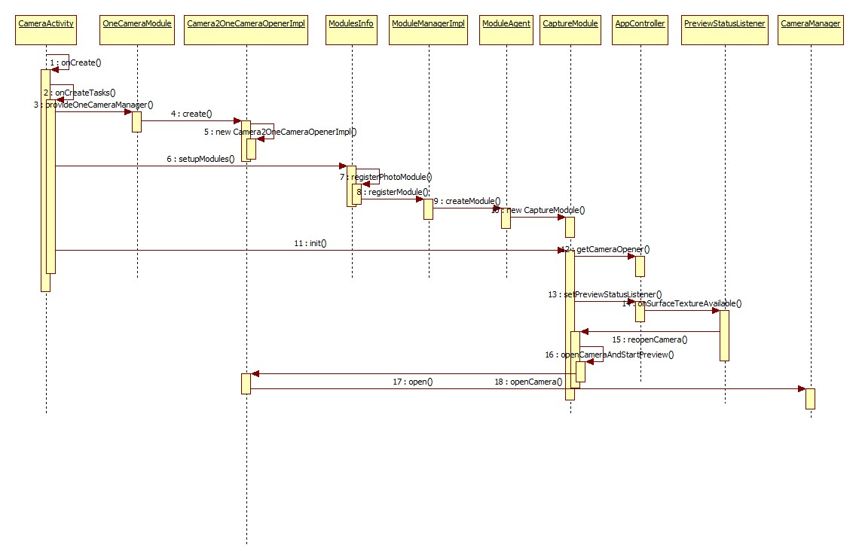

## 框架层

由上面的分析可知，将由应用层进入到框架层处理，将会调用CameraManager的openCamera方法，并且定义了CameraDevice的状态回调函数，具体的回调操作此处不做分析，继续跟踪openCamera()方法：

//CameraManager.java(frameworks/base/core/java/android/hardware/camera2)

@RequiresPermission(android.Manifest.permission.CAMERA)

public void openCamera(@NonNull String cameraId,@NonNull final

CameraDevice.StateCallback callback, @Nullable Handler handler)

throws CameraAccessException {

...

openCameraDeviceUserAsync(cameraId, callback, handler);

}

由代码可知，此处与Camera1.0有明显不同，Camera1.0是通过一个异步的线程以及JNI来调用android_hardware_camera.java里面的native_setup方法来连接Camera，其使用的是C++的Binder来与CameraService进行通信的，而此处则不一样，它直接使用的是Java层的Binder来进行通信，先看openCameraDeviceUserAsync代码:

//CameraManager.java(frameworks/base/core/java/android/hardware/camera2)

private CameraDevice openCameraDeviceUserAsync(String cameraId,

CameraDevice.StateCallback callback, Handler handler)

throws CameraAccessException {

CameraCharacteristics characteristics = getCameraCharacteristics(

cameraId);

CameraDevice device = null;

try {

synchronized (mLock) {

ICameraDeviceUser cameraUser = null;

//初始化一个CameraDevice对象

android.hardware.camera2.impl.CameraDeviceImpl deviceImpl =

new android.hardware.camera2.impl.CameraDeviceImpl(cameraId,

callback, handler, characteristics);

BinderHolder holder = new BinderHolder();

//获取回调

ICameraDeviceCallbacks callbacks = deviceImpl.getCallbacks();

int id = Integer.parseInt(cameraId);

try {

if (supportsCamera2ApiLocked(cameraId)) {

//通过Java层的Binder获取CameraService

ICameraService cameraService = CameraManagerGlobal.get()

.getCameraService();

...

//通过CameraService连接Camera设备

cameraService.connectDevice(callbacks, id, mContext

.getOpPackageName(), USE_CALLING_UID, holder);

//获取连接成功的CameraUser对象，它用来与CameraService通信

cameraUser = ICameraDeviceUser.Stub.asInterface(

holder.getBinder());

} else {

//使用遗留的API

cameraUser = CameraDeviceUserShim.connectBinderShim(

callbacks, id);

}

} catch (CameraRuntimeException e) {

...

} catch (RemoteException e) {

...

//将其包装成DeviceImpl对象，供应用层使用

deviceImpl.setRemoteDevice(cameraUser);

device = deviceImpl;

}

} catch (NumberFormatException e) {

...

} catch (CameraRuntimeException e) {

throw e.asChecked();

}

return device;

}

1

50

此方法的目的是通过CameraService来连接并获取CameraDevice对象，该对象用来与Camera进行通信操作。代码首先通过Java层的Binder机制获取CameraService，然后调用其connectDevice方法来连接CaneraDevice，最后Camera返回的是CameraDeviceUser对象，而接着将其封装成Jav层CameraDevice对象，而之后所有与Camera的通信都通过CameraDevice的接口来进行。接下来分析一下Native层下的CameraDevice的初始化过程：

//CameraService.cpp，其中device为输出对象

status_t CameraService::connectDevice(const sp<ICameraDeviceCallbacks>& cameraCb,int cameraId,

const String16& clientPackageName,int clientUid,/*out*/sp<ICameraDeviceUser>& device) {

status_t ret = NO_ERROR;

String8 id = String8::format("%d", cameraId);

sp<CameraDeviceClient> client = nullptr;

ret = connectHelper<ICameraDeviceCallbacks,CameraDeviceClient>(cameraCb, id,

CAMERA_HAL_API_VERSION_UNSPECIFIED, clientPackageName, clientUid, API_2, false, false,

/*out*/client);//client为输出对象

...

device = client;

return NO_ERROR;

}

Native层的connectDevice方法就是调用了connectHelper方法，所以继续分析connectHelper：

//CameraService.h

template<class CALLBACK, class CLIENT>

status_t CameraService::connectHelper(const sp<CALLBACK>& cameraCb, const String8& cameraId,

int halVersion, const String16& clientPackageName, int clientUid,

apiLevel effectiveApiLevel, bool legacyMode, bool shimUpdateOnly,

/*out*/sp<CLIENT>& device) {

status_t ret = NO_ERROR;

String8 clientName8(clientPackageName);

int clientPid = getCallingPid();

...

sp<CLIENT> client = nullptr;

{

...

//如果有必要，给FlashLight关闭设备的机会

mFlashlight->prepareDeviceOpen(cameraId);

//获取CameraId

int id = cameraIdToInt(cameraId);

...

//获取Device的版本，此处为Device3

int deviceVersion = getDeviceVersion(id, /*out*/&facing);

sp<BasicClient> tmp = nullptr;

//获取client对象

if((ret = makeClient(this, cameraCb, clientPackageName, cameraId, facing, clientPid,

clientUid, getpid(), legacyMode, halVersion, deviceVersion, effectiveApiLevel,

/*out*/&tmp)) != NO_ERROR) {

return ret;

}

client = static_cast<CLIENT*>(tmp.get());

//调用client的初始化函数来初始化模块

if ((ret = client->initialize(mModule)) != OK) {

ALOGE("%s: Could not initialize client from HAL module.", __FUNCTION__);

return ret;

}

sp<IBinder> remoteCallback = client->getRemote();

if (remoteCallback != nullptr) {

remoteCallback->linkToDeath(this);

}

} // lock is destroyed, allow further connect calls

//将client赋值给输出Device

device = client;

return NO_ERROR;

}

1

45

CameraService根据Camera的相关参数来获取一个client，如makeClient方法，然后再调用client的initialize来进行初始化，首先看makeClient：

//CameraService.cpp

status_t CameraService::makeClient(const sp<CameraService>& cameraService,

const sp<IInterface>& cameraCb, const String16& packageName, const String8& cameraId,

int facing, int clientPid, uid_t clientUid, int servicePid, bool legacyMode,

int halVersion, int deviceVersion, apiLevel effectiveApiLevel,

/*out*/sp<BasicClient>* client) {

//将字符串的CameraId转换成整形

int id = cameraIdToInt(cameraId);

...

if (halVersion < 0 || halVersion == deviceVersion) {//判断Camera HAL版本是否和Device的版本相同

switch(deviceVersion) {

case CAMERA_DEVICE_API_VERSION_1_0:

if (effectiveApiLevel == API_1) { // Camera1 API route

sp<ICameraClient> tmp = static_cast<ICameraClient*>(cameraCb.get());

*client = new CameraClient(cameraService, tmp, packageName, id, facing,

clientPid, clientUid, getpid(), legacyMode);

} else { // Camera2 API route

ALOGW("Camera using old HAL version: %d", deviceVersion);

return -EOPNOTSUPP;

}

break;

case CAMERA_DEVICE_API_VERSION_2_0:

case CAMERA_DEVICE_API_VERSION_2_1:

case CAMERA_DEVICE_API_VERSION_3_0:

case CAMERA_DEVICE_API_VERSION_3_1:

case CAMERA_DEVICE_API_VERSION_3_2:

case CAMERA_DEVICE_API_VERSION_3_3:

if (effectiveApiLevel == API_1) { // Camera1 API route

sp<ICameraClient> tmp = static_cast<ICameraClient*>(cameraCb.get());

*client = new Camera2Client(cameraService, tmp, packageName, id, facing,

clientPid, clientUid, servicePid, legacyMode);

} else { // Camera2 API route

sp<ICameraDeviceCallbacks> tmp =

static_cast<ICameraDeviceCallbacks*>(cameraCb.get());

*client = new CameraDeviceClient(cameraService, tmp, packageName, id,

facing, clientPid, clientUid, servicePid);

}

break;

default:

// Should not be reachable

ALOGE("Unknown camera device HAL version: %d", deviceVersion);

return INVALID_OPERATION;

}

} else {

// A particular HAL version is requested by caller. Create CameraClient

// based on the requested HAL version.

if (deviceVersion > CAMERA_DEVICE_API_VERSION_1_0 &&

halVersion == CAMERA_DEVICE_API_VERSION_1_0) {

// Only support higher HAL version device opened as HAL1.0 device.

sp<ICameraClient> tmp = static_cast<ICameraClient*>(cameraCb.get());

*client = new CameraClient(cameraService, tmp, packageName, id, facing,

clientPid, clientUid, servicePid, legacyMode);

} else {

// Other combinations (e.g. HAL3.x open as HAL2.x) are not supported yet.

ALOGE("Invalid camera HAL version %x: HAL %x device can only be"

" opened as HAL %x device", halVersion, deviceVersion,

CAMERA_DEVICE_API_VERSION_1_0);

return INVALID_OPERATION;

}

}

return NO_ERROR;

}

其中就是创建一个Client对象，由于此处分析的是Camera API2.0，其HAL的版本是3.0+，而Device的版本则其Device的版本即为3.0+，所以会创建一个CameraDeviceClient对象，至此，makeClient已经创建了client对象，并返回了，接着看它的初始化：

//CameraDeviceClient.cpp

status_t CameraDeviceClient::initialize(CameraModule *module)

{

ATRACE_CALL();

status_t res;

//调用Camera2ClientBase的初始化函数来初始化CameraModule模块

res = Camera2ClientBase::initialize(module);

if (res != OK) {

return res;

}

String8 threadName;

//初始化FrameProcessor

mFrameProcessor = new FrameProcessorBase(mDevice);

threadName = String8::format("CDU-%d-FrameProc", mCameraId);

mFrameProcessor->run(threadName.string());

//并注册监听，监听的实现就在CameraDeviceClient类中

mFrameProcessor->registerListener(FRAME_PROCESSOR_LISTENER_MIN_ID,

FRAME_PROCESSOR_LISTENER_MAX_ID, /*listener*/this,/*sendPartials*/true);

return OK;

}

它会调用Camera2ClientBase的initialize方法来初始化，并且会初始化一个FrameProcessor来进行帧处理，主要是回调每一帧的ExtraResult到应用中，也就是3A相关的数据信息。而Camera1.0中各种Processor模块，即将数据打包处理后再返回到应用的模块都已经不存在，而Camera2.0中将由MediaRecorder、SurfaceView、ImageReader等来直接处理，总体来说效率更好。继续看initialize：

// Camera2ClientBase.cpp

template <typename TClientBase>

status_t Camera2ClientBase<TClientBase>::initialize(CameraModule *module) {

...

//调用Device的initialie方法

res = mDevice->initialize(module);

...

res = mDevice->setNotifyCallback(this);

return OK;

}

代码就是调用了Device的initialize方法，此处的Device是在Camera2ClientBase的构造函数中创建的：

// Camera2ClientBase.cpp

template <typename TClientBase>

Camera2ClientBase<TClientBase>::Camera2ClientBase(const sp<CameraService>& cameraService,

const sp<TCamCallbacks>& remoteCallback,const String16& clientPackageName,

int cameraId,int cameraFacing,int clientPid,uid_t clientUid,int servicePid):

TClientBase(cameraService, remoteCallback, clientPackageName,cameraId, cameraFacing,

clientPid, clientUid, servicePid),mSharedCameraCallbacks(remoteCallback),

mDeviceVersion(cameraService->getDeviceVersion(cameraId))

{

...

mInitialClientPid = clientPid;

mDevice = CameraDeviceFactory::createDevice(cameraId);

...

}

目前Camera API是2.0，而Device的API已经是3.0+了，继续看CameraDeviceFactory的createDevice方法：

// CameraDeviceFactory.cpp

sp<CameraDeviceBase> CameraDeviceFactory::createDevice(int cameraId) {

sp<CameraService> svc = sService.promote();

...

int deviceVersion = svc->getDeviceVersion(cameraId, /*facing*/NULL);

sp<CameraDeviceBase> device;

switch (deviceVersion) {

case CAMERA_DEVICE_API_VERSION_2_0:

case CAMERA_DEVICE_API_VERSION_2_1:

device = new Camera2Device(cameraId);

break;

case CAMERA_DEVICE_API_VERSION_3_0:

case CAMERA_DEVICE_API_VERSION_3_1:

case CAMERA_DEVICE_API_VERSION_3_2:

case CAMERA_DEVICE_API_VERSION_3_3:

device = new Camera3Device(cameraId);

break;

default:

ALOGE("%s: Camera %d: Unknown HAL device version %d",

__FUNCTION__, cameraId, deviceVersion);

device = NULL;

break;

}

return device;

}

1

2

很显然，它将会创建一个Camera3Device对象，所以，Device的initialize就是调用了Camera3Device的initialize方法：

// Camera3Device.cpp

status_t Camera3Device::initialize(CameraModule *module)

{

...

camera3_device_t *device;

//打开Camera HAL层的Deivce

res = module->open(deviceName.string(),

reinterpret_cast<hw_device_t**>(&device));

...

//交叉检查Device的版本

if (device->common.version < CAMERA_DEVICE_API_VERSION_3_0) {

SET_ERR_L("Could not open camera: "

"Camera device should be at least %x, reports %x instead",

CAMERA_DEVICE_API_VERSION_3_0,

device->common.version);

device->common.close(&device->common);

return BAD_VALUE;

}

...

//调用回调函数来进行初始化，即调用打开Device的initialize方法来进行初始化

res = device->ops->initialize(device, this);

...

//启动请求队列线程

mRequestThread = new RequestThread(this, mStatusTracker, device, aeLockAvailable);

res = mRequestThread->run(String8::format("C3Dev-%d-ReqQueue", mId).string());

if (res != OK) {

SET_ERR_L("Unable to start request queue thread: %s (%d)",

strerror(-res), res);

device->common.close(&device->common);

mRequestThread.clear();

return res;

}

...

//返回初始成功

return OK;

}

1

首先，会依赖HAL框架打开并获得相应的Device对象，具体的流程请参考android6.0源码分析之Camera2 HAL分析，然后再回调此对象的initialize方法进行初始化，最后再启动RequestThread等线程，并返回initialize成功。至此Camera API2.0下的初始化过程就分析结束了。框架层的初始化时序图如下：

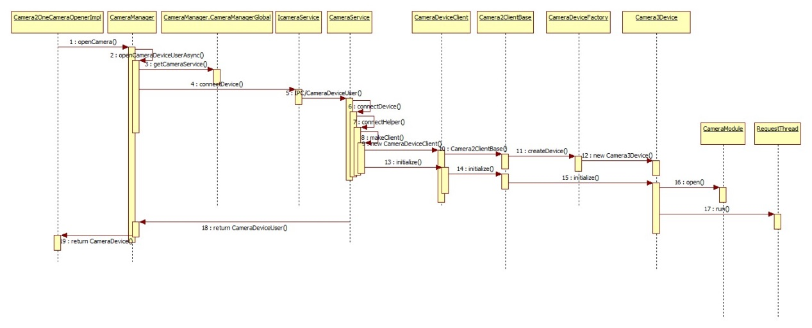

## HAL

### Camera HAL的初始化

Camera HAL的初始加载是在Native的CameraService初始化流程中的，而CameraService初始化是在Main_mediaServer.cpp的main方法开始的

Camera HAL的初始加载是在Native的CameraService初始化流程中的，而CameraService初始化是在Main_mediaServer.cpp的main方法开始的：

//Main_mediaServer.cpp

int main(int argc __unused, char** argv){

…

sp<ProcessState> proc(ProcessState::self());

//获取ServieManager

sp<IServiceManager> sm = defaultServiceManager();

ALOGI("ServiceManager: %p", sm.get());

AudioFlinger::instantiate();

//初始化media服务

MediaPlayerService::instantiate();

//初始化资源管理服务

ResourceManagerService::instantiate();

//初始化Camera服务

CameraService::instantiate();

//初始化音频服务

AudioPolicyService::instantiate();

SoundTriggerHwService::instantiate();

//初始化Radio服务

RadioService::instantiate();

registerExtensions();

//开始线程池

ProcessState::self()->startThreadPool();

IPCThreadState::self()->joinThreadPool();

}

其中，CameraService继承自BinderService，instantiate也是在BinderService中定义的，此方法就是调用publish方法，所以来看publish方法：

// BinderService.h

static status_t publish(bool allowIsolated = false) {

sp<IServiceManager> sm(defaultServiceManager());

//将服务添加到ServiceManager

return sm->addService(String16(SERVICE::getServiceName()),new SERVICE(), allowIsolated);

}

这里，将会把CameraService服务加入到ServiceManager进行管理。

而在前面的文章android6.0源码分析之Camera API2.0简介中，需要通过Java层的IPC Binder来获取此CameraService对象，在此过程中会初始CameraService的sp类型的对象，而对于sp，此处不做过多的分析，具体的可以查看深入理解Android卷Ⅰ中的第五章中的相关内容。此处，在CameraService的构造时，会调用CameraService的onFirstRef方法

/CameraService.cpp

void CameraService::onFirstRef()

{

BnCameraService::onFirstRef();

...

camera_module_t *rawModule;

//根据CAMERA_HARDWARE_MODULE_ID(字符串camera)来获取camera_module_t对象

int err = hw_get_module(CAMERA_HARDWARE_MODULE_ID,

(const hw_module_t **)&rawModule);

//创建CameraModule对象

mModule = new CameraModule(rawModule);

//模块初始化

err = mModule->init();

...

//通过Module获取Camera的数量

mNumberOfCameras = mModule->getNumberOfCameras();

mNumberOfNormalCameras = mNumberOfCameras;

//初始化闪光灯

mFlashlight = new CameraFlashlight(*mModule, *this);

status_t res = mFlashlight->findFlashUnits();

int latestStrangeCameraId = INT_MAX;

for (int i = 0; i < mNumberOfCameras; i++) {

//初始化CameraID

String8 cameraId = String8::format("%d", i);

struct camera_info info;

bool haveInfo = true;

//获取Camera信息

status_t rc = mModule->getCameraInfo(i, &info);

...

//如果Module版本高于2.4，找出冲突的设备参数

if (mModule->getModuleApiVersion() >= CAMERA_MODULE_API_VERSION_2_4 && haveInfo) {

cost = info.resource_cost;

conflicting_devices = info.conflicting_devices;

conflicting_devices_length = info.conflicting_devices_length;

}

//将冲突设备加入冲突set集中

std::set<String8> conflicting;

for (size_t i = 0; i < conflicting_devices_length; i++) {

conflicting.emplace(String8(conflicting_devices[i]));

}

...

}

//如果Module的API大于2.1，则设置回调

if (mModule->getModuleApiVersion() >= CAMERA_MODULE_API_VERSION_2_1) {

mModule->setCallbacks(this);

}

//若大于2.2，则设置供应商的Tag

if (mModule->getModuleApiVersion() >= CAMERA_MODULE_API_VERSION_2_2) {

setUpVendorTags();

}

//将此服务注册到CameraDeviceFactory

CameraDeviceFactory::registerService(this);

CameraService::pingCameraServiceProxy();

}

onFirstRef方法中，首先会通过HAL框架的hw_get_module来获取CameraModule对象，然后会对其进行相应的初始化，并会进行一些参数的设置，如camera的数量，闪光灯的初始化，以及回调函数的设置等，到这里，Camera2 HAL的模块就初始化结束了，下面给出初始化时序图：

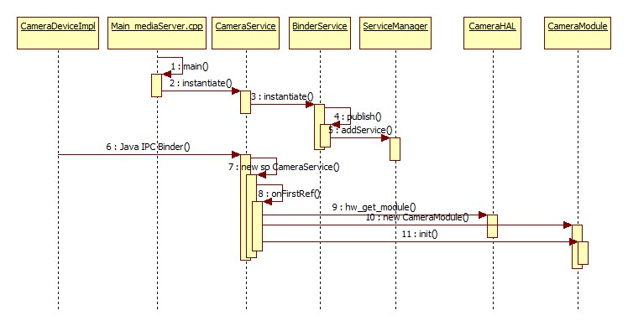

### open流程分析

通过阅读android6.0源码发现，它提供了高通的Camera实现，并且提供了高通的Camera库，也实现了高通的Camera HAL的相应接口，对于高通的Camera，它在后台会有一个守护进程daemon，daemon是介于应用和驱动之间翻译ioctl的中间层(委托处理)。本节将以Camera中的open流程为例，来分析Camera HAL的工作过程，在应用对硬件发出open请求后，会通过Camera HAL来发起open请求，而Camera HAL的open入口在QCamera2Hal.cpp进行了定义：

/QCamera2Hal.cpp

camera_module_t HAL_MODULE_INFO_SYM = {

//它里面包含模块的公共方法信息

common: camera_common,

get_number_of_cameras: qcamera::QCamera2Factory::get_number_of_cameras,

get_camera_info: qcamera::QCamera2Factory::get_camera_info,

set_callbacks: qcamera::QCamera2Factory::set_callbacks,

get_vendor_tag_ops: qcamera::QCamera3VendorTags::get_vendor_tag_ops,

open_legacy: qcamera::QCamera2Factory::open_legacy,

set_torch_mode: NULL,

init : NULL,

reserved: {0}

};

static hw_module_t camera_common = {

tag: HARDWARE_MODULE_TAG,

module_api_version: CAMERA_MODULE_API_VERSION_2_3,

hal_api_version: HARDWARE_HAL_API_VERSION,

id: CAMERA_HARDWARE_MODULE_ID,

name: "QCamera Module",

author: "Qualcomm Innovation Center Inc",

//它的方法数组里绑定了open接口

methods: &qcamera::QCamera2Factory::mModuleMethods,

dso: NULL,

reserved: {0}

};

struct hw_module_methods_t QCamera2Factory::mModuleMethods = {

//open方法的绑定

open: QCamera2Factory::camera_device_open,

};

Camera HAL层的open入口其实就是camera_device_open方法：

// QCamera2Factory.cpp

int QCamera2Factory::camera_device_open(const struct hw_module_t *module, const char *id,

struct hw_device_t **hw_device){

...

return gQCamera2Factory->cameraDeviceOpen(atoi(id), hw_device);

}

它调用了cameraDeviceOpen方法，而其中的hw_device就是最后要返回给应用层的CameraDeviceImpl在Camera HAL层的对象，继续分析cameraDeviceOpen方法：

// QCamera2Factory.cpp

int QCamera2Factory::cameraDeviceOpen(int camera_id, struct hw_device_t **hw_device){

...

//Camera2采用的Camera HAL版本为HAL3.0

if ( mHalDescriptors[camera_id].device_version == CAMERA_DEVICE_API_VERSION_3_0 ) {

//初始化QCamera3HardwareInterface对象，这里构造函数里将会进行configure_streams以及

//process_capture_result等的绑定

QCamera3HardwareInterface *hw = new QCamera3HardwareInterface(

mHalDescriptors[camera_id].cameraId, mCallbacks);

//通过QCamera3HardwareInterface来打开Camera

rc = hw->openCamera(hw_device);

...

} else if (mHalDescriptors[camera_id].device_version == CAMERA_DEVICE_API_VERSION_1_0) {

//HAL API为2.0

QCamera2HardwareInterface *hw = new QCamera2HardwareInterface((uint32_t)camera_id);

rc = hw->openCamera(hw_device);

...

} else {

...

}

return rc;

}

此方法有两个关键点：一个是QCamera3HardwareInterface对象的创建，它是用户空间与内核空间进行交互的接口；另一个是调用它的openCamera方法来打开Camera，下面将分别进行分析。

#### QCamera3HardwareInterface构造函数分析

在它的构造函数里面有一个关键的初始化，即mCameraDevice.ops = &mCameraOps，它会定义Device操作的接口：

//QCamera3HWI.cpp

camera3_device_ops_t QCamera3HardwareInterface::mCameraOps = {

initialize: QCamera3HardwareInterface::initialize,

//配置流数据的相关处理

configure_streams: QCamera3HardwareInterface::configure_streams,

register_stream_buffers: NULL,

construct_default_request_settings:

QCamera3HardwareInterface::construct_default_request_settings,

//处理结果的接口

process_capture_request:

QCamera3HardwareInterface::process_capture_request,

get_metadata_vendor_tag_ops: NULL,

dump: QCamera3HardwareInterface::dump,

flush: QCamera3HardwareInterface::flush,

reserved: {0},

};

其中，会在configure_streams中配置好流的处理handle：

//QCamera3HWI.cpp

int QCamera3HardwareInterface::configure_streams(const struct camera3_device *device,

camera3_stream_configuration_t *stream_list){

//获得QCamera3HardwareInterface对象

QCamera3HardwareInterface *hw =reinterpret_cast<QCamera3HardwareInterface *>(device->priv);

...

//调用它的configureStreams进行配置

int rc = hw->configureStreams(stream_list);

..

return rc;

}

1

2

3

4

5

6

7

8

9

10

11

继续追踪configureStream方法：

//QCamera3HWI.cpp

int QCamera3HardwareInterface::configureStreams(camera3_stream_configuration_t *streamList){

...

//初始化Camera版本

al_version = CAM_HAL_V3;

...

//开始配置stream

...

//初始化相关Channel为NULL

if (mMetadataChannel) {

delete mMetadataChannel;

mMetadataChannel = NULL;

}

if (mSupportChannel) {

delete mSupportChannel;

mSupportChannel = NULL;

}

if (mAnalysisChannel) {

delete mAnalysisChannel;

mAnalysisChannel = NULL;

}

//创建Metadata Channel，并对其进行初始化

mMetadataChannel = new QCamera3MetadataChannel(mCameraHandle->camera_handle,

mCameraHandle->ops, captureResultCb,&gCamCapability[mCameraId]->padding_info,

CAM_QCOM_FEATURE_NONE, this);

...

//初始化

rc = mMetadataChannel->initialize(IS_TYPE_NONE);

...

//如果h/w support可用，则创建分析stream的Channel

if (gCamCapability[mCameraId]->hw_analysis_supported) {

mAnalysisChannel = new QCamera3SupportChannel(mCameraHandle->camera_handle,

mCameraHandle->ops,&gCamCapability[mCameraId]->padding_info,

CAM_QCOM_FEATURE_PP_SUPERSET_HAL3,CAM_STREAM_TYPE_ANALYSIS,

&gCamCapability[mCameraId]->analysis_recommended_res,this);

...

}

bool isRawStreamRequested = false;

//清空stream配置信息

memset(&mStreamConfigInfo, 0, sizeof(cam_stream_size_info_t));

//为requested stream分配相关的channel对象

for (size_t i = 0; i < streamList->num_streams; i++) {

camera3_stream_t *newStream = streamList->streams[i];

uint32_t stream_usage = newStream->usage;

mStreamConfigInfo.stream_sizes[mStreamConfigInfo.num_streams].width = (int32_t)newStream-

>width;

mStreamConfigInfo.stream_sizes[mStreamConfigInfo.num_streams].height = (int32_t)newStream-

>height;

if ((newStream->stream_type == CAMERA3_STREAM_BIDIRECTIONAL||newStream->usage &

GRALLOC_USAGE_HW_CAMERA_ZSL) &&newStream->format ==

HAL_PIXEL_FORMAT_IMPLEMENTATION_DEFINED && jpegStream){

mStreamConfigInfo.type[mStreamConfigInfo.num_streams] = CAM_STREAM_TYPE_SNAPSHOT;

mStreamConfigInfo.postprocess_mask[mStreamConfigInfo.num_streams] =

CAM_QCOM_FEATURE_NONE;

} else if(newStream->stream_type == CAMERA3_STREAM_INPUT) {

} else {

switch (newStream->format) {

//为非zsl streams查找他们的format

...

}

}

if (newStream->priv == NULL) {

//为新的stream构造Channel

switch (newStream->stream_type) {//分类型构造

case CAMERA3_STREAM_INPUT:

newStream->usage |= GRALLOC_USAGE_HW_CAMERA_READ;

newStream->usage |= GRALLOC_USAGE_HW_CAMERA_WRITE;//WR for inplace algo's

break;

case CAMERA3_STREAM_BIDIRECTIONAL:

...

break;

case CAMERA3_STREAM_OUTPUT:

...

break;

default:

break;

}

//根据前面的得到的stream的参数类型以及format分别对各类型的channel进行构造

if (newStream->stream_type == CAMERA3_STREAM_OUTPUT ||

newStream->stream_type == CAMERA3_STREAM_BIDIRECTIONAL) {

QCamera3Channel *channel = NULL;

switch (newStream->format) {

case HAL_PIXEL_FORMAT_IMPLEMENTATION_DEFINED:

/* use higher number of buffers for HFR mode */

...

//创建Regular Channel

channel = new QCamera3RegularChannel(mCameraHandle->camera_handle,

mCameraHandle->ops, captureResultCb,&gCamCapability[mCameraId]-

>padding_info,this,newStream,(cam_stream_type_t)mStreamConfigInfo.type[

mStreamConfigInfo.num_streams],mStreamConfigInfo.postprocess_mask[

mStreamConfigInfo.num_streams],mMetadataChannel,numBuffers);

...

newStream->max_buffers = channel->getNumBuffers();

newStream->priv = channel;

break;

case HAL_PIXEL_FORMAT_YCbCr_420_888:

//创建YWV Channel

...

break;

case HAL_PIXEL_FORMAT_RAW_OPAQUE:

case HAL_PIXEL_FORMAT_RAW16:

case HAL_PIXEL_FORMAT_RAW10:

//创建Raw Channel

...

break;

case HAL_PIXEL_FORMAT_BLOB:

//创建QCamera3PicChannel

...

break;

default:

break;

}

} else if (newStream->stream_type == CAMERA3_STREAM_INPUT) {

newStream->max_buffers = MAX_INFLIGHT_REPROCESS_REQUESTS;

} else {

}

for (List<stream_info_t*>::iterator it=mStreamInfo.begin();it != mStreamInfo.end();

it++) {

if ((*it)->stream == newStream) {

(*it)->channel = (QCamera3Channel*) newStream->priv;

break;

}

}

} else {

}

if (newStream->stream_type != CAMERA3_STREAM_INPUT)

mStreamConfigInfo.num_streams++;

}

}

if (isZsl) {

if (mPictureChannel) {

mPictureChannel->overrideYuvSize(zslStream->width, zslStream->height);

}

} else if (mPictureChannel && m_bIs4KVideo) {

mPictureChannel->overrideYuvSize(videoWidth, videoHeight);

}

//RAW DUMP channel

if (mEnableRawDump && isRawStreamRequested == false){

cam_dimension_t rawDumpSize;

rawDumpSize = getMaxRawSize(mCameraId);

mRawDumpChannel = new QCamera3RawDumpChannel(mCameraHandle->camera_handle,

mCameraHandle->ops,rawDumpSize,&gCamCapability[mCameraId]->padding_info,

this, CAM_QCOM_FEATURE_NONE);

...

}

//进行相关Channel的配置

...

/* Initialize mPendingRequestInfo and mPendnigBuffersMap */

for (List<PendingRequestInfo>::iterator i = mPendingRequestsList.begin();

i != mPendingRequestsList.end(); i++) {

clearInputBuffer(i->input_buffer);

i = mPendingRequestsList.erase(i);

}

mPendingFrameDropList.clear();

// Initialize/Reset the pending buffers list

mPendingBuffersMap.num_buffers = 0;

mPendingBuffersMap.mPendingBufferList.clear();

mPendingReprocessResultList.clear();

return rc;

}

此方法内容比较多，只抽取其中核心的代码进行说明，它首先会根据HAL的版本来对stream进行相应的配置初始化，然后再根据stream类型对stream_list的stream创建相应的Channel，主要有QCamera3MetadataChannel，QCamera3SupportChannel等，然后再进行相应的配置，其中QCamera3MetadataChannel在后面的处理capture request的时候会用到，这里就不做分析，而Camerametadata则是Java层和CameraService之间传递的元数据，见android6.0源码分析之Camera API2.0简介中的Camera2架构图，至此，QCamera3HardwareInterface构造结束，与本文相关的就是配置了mCameraDevice.ops。

#### openCamera分析

本节主要分析Module是如何打开Camera的，openCamera的代码如下：

//QCamera3HWI.cpp

int QCamera3HardwareInterface::openCamera(struct hw_device_t **hw_device){

int rc = 0;

if (mCameraOpened) {//如果Camera已经被打开，则此次打开的设备为NULL，并且打开结果为PERMISSION_DENIED

*hw_device = NULL;

return PERMISSION_DENIED;

}

//调用openCamera方法来打开

rc = openCamera();

//打开结果处理

if (rc == 0) {

//获取打开成功的hw_device_t对象

*hw_device = &mCameraDevice.common;

} else

*hw_device = NULL;

}

return rc;

}

它调用了openCamera()方法来打开Camera:

// QCamera3HWI.cpp

int QCamera3HardwareInterface::openCamera()

{

...

//打开camera，获取mCameraHandle

mCameraHandle = camera_open((uint8_t)mCameraId);

...

mCameraOpened = true;

//注册mm-camera-interface里的事件处理,其中camEctHandle为事件处理Handle

rc = mCameraHandle->ops->register_event_notify(mCameraHandle->camera_handle,camEvtHandle

,(void *)this);

return NO_ERROR;

}

它调用camera_open方法来打开Camera，并且向CameraHandle注册了Camera 时间处理的Handle–camEvtHandle，首先分析camera_open方法，这里就将进入高通的Camera的实现了，而Mm_camera_interface.c是高通提供的相关操作的接口，接下来分析高通Camera的camera_open方法：

//Mm_camera_interface.c

mm_camera_vtbl_t * camera_open(uint8_t camera_idx)

{

int32_t rc = 0;

mm_camera_obj_t* cam_obj = NULL;

/* opened already 如果已经打开*/

if(NULL != g_cam_ctrl.cam_obj[camera_idx]) {

/* Add reference */

g_cam_ctrl.cam_obj[camera_idx]->ref_count++;

pthread_mutex_unlock(&g_intf_lock);

return &g_cam_ctrl.cam_obj[camera_idx]->vtbl;

}

cam_obj = (mm_camera_obj_t *)malloc(sizeof(mm_camera_obj_t));

...

/* initialize camera obj */

memset(cam_obj, 0, sizeof(mm_camera_obj_t));

cam_obj->ctrl_fd = -1;

cam_obj->ds_fd = -1;

cam_obj->ref_count++;

cam_obj->my_hdl = mm_camera_util_generate_handler(camera_idx);

cam_obj->vtbl.camera_handle = cam_obj->my_hdl; /* set handler */

//mm_camera_ops里绑定了相关的操作接口

cam_obj->vtbl.ops = &mm_camera_ops;

pthread_mutex_init(&cam_obj->cam_lock, NULL);

pthread_mutex_lock(&cam_obj->cam_lock);

pthread_mutex_unlock(&g_intf_lock);

//调用mm_camera_open方法来打开camera

rc = mm_camera_open(cam_obj);

pthread_mutex_lock(&g_intf_lock);

...

//结果处理，并返回

...

}

1

2

3

4

5

6

7

8

9

10

11

12

13

14

15

16

17

18

19

20

21

22

23

24

25

26

27

28

29

30

31

32

33

34

35

由代码可知，这里将会初始化一个mm_camera_obj_t对象，其中，ds_fd为socket fd，而mm_camera_ops则绑定了相关的接口，最后调用mm_camera_open来打开Camera，首先来看看mm_camera_ops绑定了哪些方法：

//Mm_camera_interface.c

static mm_camera_ops_t mm_camera_ops = {

.query_capability = mm_camera_intf_query_capability,

//注册事件通知的方法

.register_event_notify = mm_camera_intf_register_event_notify,

.close_camera = mm_camera_intf_close,

.set_parms = mm_camera_intf_set_parms,

.get_parms = mm_camera_intf_get_parms,

.do_auto_focus = mm_camera_intf_do_auto_focus,

.cancel_auto_focus = mm_camera_intf_cancel_auto_focus,

.prepare_snapshot = mm_camera_intf_prepare_snapshot,

.start_zsl_snapshot = mm_camera_intf_start_zsl_snapshot,

.stop_zsl_snapshot = mm_camera_intf_stop_zsl_snapshot,

.map_buf = mm_camera_intf_map_buf,

.unmap_buf = mm_camera_intf_unmap_buf,

.add_channel = mm_camera_intf_add_channel,

.delete_channel = mm_camera_intf_del_channel,

.get_bundle_info = mm_camera_intf_get_bundle_info,

.add_stream = mm_camera_intf_add_stream,

.link_stream = mm_camera_intf_link_stream,

.delete_stream = mm_camera_intf_del_stream,

//配置stream的方法

.config_stream = mm_camera_intf_config_stream,

.qbuf = mm_camera_intf_qbuf,

.get_queued_buf_count = mm_camera_intf_get_queued_buf_count,

.map_stream_buf = mm_camera_intf_map_stream_buf,

.unmap_stream_buf = mm_camera_intf_unmap_stream_buf,

.set_stream_parms = mm_camera_intf_set_stream_parms,

.get_stream_parms = mm_camera_intf_get_stream_parms,

.start_channel = mm_camera_intf_start_channel,

.stop_channel = mm_camera_intf_stop_channel,

.request_super_buf = mm_camera_intf_request_super_buf,

.cancel_super_buf_request = mm_camera_intf_cancel_super_buf_request,

.flush_super_buf_queue = mm_camera_intf_flush_super_buf_queue,

.configure_notify_mode = mm_camera_intf_configure_notify_mode,

//处理capture的方法

.process_advanced_capture = mm_camera_intf_process_advanced_capture

};

1

2

3

4

5

6

7

8

9

10

11

12

13

14

15

16

17

18

19

20

21

22

23

24

25

26

27

28

29

30

31

32

33

34

35

36

37

38

接着分析mm_camera_open方法：

//Mm_camera.c

int32_t mm_camera_open(mm_camera_obj_t *my_obj){

...

do{

n_try--;

//根据设备名字，打开相应的设备驱动fd

my_obj->ctrl_fd = open(dev_name, O_RDWR | O_NONBLOCK);

if((my_obj->ctrl_fd >= 0) || (errno != EIO) || (n_try <= 0 )) {

break;

}

usleep(sleep_msec * 1000U);

}while (n_try > 0);

...

//打开domain socket

n_try = MM_CAMERA_DEV_OPEN_TRIES;

do {

n_try--;

my_obj->ds_fd = mm_camera_socket_create(cam_idx, MM_CAMERA_SOCK_TYPE_UDP);

usleep(sleep_msec * 1000U);

} while (n_try > 0);

...

//初始化锁

pthread_mutex_init(&my_obj->msg_lock, NULL);

pthread_mutex_init(&my_obj->cb_lock, NULL);

pthread_mutex_init(&my_obj->evt_lock, NULL);

pthread_cond_init(&my_obj->evt_cond, NULL);

//开启线程，它的线程体在mm_camera_dispatch_app_event方法中

mm_camera_cmd_thread_launch(&my_obj->evt_thread,

mm_camera_dispatch_app_event,

(void *)my_obj);

mm_camera_poll_thread_launch(&my_obj->evt_poll_thread,

MM_CAMERA_POLL_TYPE_EVT);

mm_camera_evt_sub(my_obj, TRUE);

return rc;

...

}

由代码可知，它会打开Camera的设备文件，然后开启dispatch_app_event线程，线程方法体mm_camera_dispatch_app_event方法代码如下：

//Mm_camera.c

static void mm_camera_dispatch_app_event(mm_camera_cmdcb_t *cmd_cb,void* user_data){

mm_camera_cmd_thread_name("mm_cam_event");

int i;

mm_camera_event_t *event = &cmd_cb->u.evt;

mm_camera_obj_t * my_obj = (mm_camera_obj_t *)user_data;

if (NULL != my_obj) {

pthread_mutex_lock(&my_obj->cb_lock);

for(i = 0; i < MM_CAMERA_EVT_ENTRY_MAX; i++) {

if(my_obj->evt.evt[i].evt_cb) {

//调用camEvtHandle方法

my_obj->evt.evt[i].evt_cb(

my_obj->my_hdl,

event,

my_obj->evt.evt[i].user_data);

}

}

pthread_mutex_unlock(&my_obj->cb_lock);

}

}

最后会调用mm-camera-interface中注册好的事件处理evt_cb，它就是在前面注册好的camEvtHandle：

//QCamera3HWI.cpp

void QCamera3HardwareInterface::camEvtHandle(uint32_t /*camera_handle*/,mm_camera_event_t *evt,

void *user_data){

//获取QCamera3HardwareInterface接口指针

QCamera3HardwareInterface *obj = (QCamera3HardwareInterface *)user_data;

if (obj && evt) {

switch(evt->server_event_type) {

case CAM_EVENT_TYPE_DAEMON_DIED:

camera3_notify_msg_t notify_msg;

memset(&notify_msg, 0, sizeof(camera3_notify_msg_t));

notify_msg.type = CAMERA3_MSG_ERROR;

notify_msg.message.error.error_code = CAMERA3_MSG_ERROR_DEVICE;

notify_msg.message.error.error_stream = NULL;

notify_msg.message.error.frame_number = 0;

obj->mCallbackOps->notify(obj->mCallbackOps, &notify_msg);

break;

case CAM_EVENT_TYPE_DAEMON_PULL_REQ:

pthread_mutex_lock(&obj->mMutex);

obj->mWokenUpByDaemon = true;

//开启process_capture_request

obj->unblockRequestIfNecessary();

pthread_mutex_unlock(&obj->mMutex);

break;

default:

break;

}

} else {

}

}

由代码可知，它会调用QCamera3HardwareInterface的unblockRequestIfNecessary来发起结果处理请求：

//QCamera3HWI.cpp

void QCamera3HardwareInterface::unblockRequestIfNecessary()

{

// Unblock process_capture_request

//开启process_capture_request

pthread_cond_signal(&mRequestCond);

}

在初始化QCamera3HardwareInterface对象的时候，就绑定了处理Metadata的回调captureResultCb方法：它主要是对数据源进行相应的处理，而具体的capture请求的结果处理还是由process_capture_request来进行处理的，而这里会调用方法unblockRequestIfNecessary来触发process_capture_request方法执行，而在Camera框架中，发起请求时会启动一个RequestThread线程，在它的threadLoop方法中，会不停的调用process_capture_request方法来进行请求的处理，而它最后会回调Camera3Device中的processCaptureResult方法来进行结果处理：

//Camera3Device.cpp

void Camera3Device::processCaptureResult(const camera3_capture_result *result) {

...

{

...

if (mUsePartialResult && result->result != NULL) {

if (mDeviceVersion >= CAMERA_DEVICE_API_VERSION_3_2) {

...

if (isPartialResult) {

request.partialResult.collectedResult.append(result->result);

}

} else {

camera_metadata_ro_entry_t partialResultEntry;

res = find_camera_metadata_ro_entry(result->result,

ANDROID_QUIRKS_PARTIAL_RESULT, &partialResultEntry);

if (res != NAME_NOT_FOUND &&partialResultEntry.count > 0 &&

partialResultEntry.data.u8[0] ==ANDROID_QUIRKS_PARTIAL_RESULT_PARTIAL) {

isPartialResult = true;

request.partialResult.collectedResult.append(

result->result);

request.partialResult.collectedResult.erase(

ANDROID_QUIRKS_PARTIAL_RESULT);

}

}

if (isPartialResult) {

// Fire off a 3A-only result if possible

if (!request.partialResult.haveSent3A) {

//处理3A结果

request.partialResult.haveSent3A =processPartial3AResult(frameNumber,

request.partialResult.collectedResult,request.resultExtras);

}

}

}

...

//查找camera元数据入口

camera_metadata_ro_entry_t entry;

res = find_camera_metadata_ro_entry(result->result,

ANDROID_SENSOR_TIMESTAMP, &entry);

if (shutterTimestamp == 0) {

request.pendingOutputBuffers.appendArray(result->output_buffers,

result->num_output_buffers);

} else {

重要的分析//返回处理的outputbuffer

returnOutputBuffers(result->output_buffers,

result->num_output_buffers, shutterTimestamp);

}

if (result->result != NULL && !isPartialResult) {

if (shutterTimestamp == 0) {

request.pendingMetadata = result->result;

request.partialResult.collectedResult = collectedPartialResult;

} else {

CameraMetadata metadata;

metadata = result->result;

//发送Capture结构，即调用通知回调

sendCaptureResult(metadata, request.resultExtras,

collectedPartialResult, frameNumber, hasInputBufferInRequest,

request.aeTriggerCancelOverride);

}

}

removeInFlightRequestIfReadyLocked(idx);

} // scope for mInFlightLock

if (result->input_buffer != NULL) {

if (hasInputBufferInRequest) {

Camera3Stream *stream =

Camera3Stream::cast(result->input_buffer->stream);

重要的分析//返回处理的inputbuffer

res = stream->returnInputBuffer(*(result->input_buffer));

} else {}

}

}

分析returnOutputBuffers方法，inputbuffer的runturnInputBuffer方法流程类似：

//Camera3Device.cpp

void Camera3Device::returnOutputBuffers(const camera3_stream_buffer_t *outputBuffers, size_t

numBuffers, nsecs_t timestamp) {

for (size_t i = 0; i < numBuffers; i++)

{

Camera3Stream *stream = Camera3Stream::cast(outputBuffers[i].stream);

status_t res = stream->returnBuffer(outputBuffers[i], timestamp);

...

}

}

方法里调用了returnBuffer方法：

//Camera3Stream.cpp

status_t Camera3Stream::returnBuffer(const camera3_stream_buffer &buffer,nsecs_t timestamp) {

//返回buffer

status_t res = returnBufferLocked(buffer, timestamp);

if (res == OK) {

fireBufferListenersLocked(buffer, /*acquired*/false, /*output*/true);

mOutputBufferReturnedSignal.signal();

}

return res;

}

再继续看returnBufferLocked,它调用了returnAnyBufferLocked方法，而returnAnyBufferLocked方法又调用了returnBufferCheckedLocked方法，现在分析returnBufferCheckedLocked：

// Camera3OutputStream.cpp

status_t Camera3OutputStream::returnBufferCheckedLocked(const camera3_stream_buffer &buffer,

nsecs_t timestamp,bool output,/*out*/sp<Fence> *releaseFenceOut) {

...

// Fence management - always honor release fence from HAL

sp<Fence> releaseFence = new Fence(buffer.release_fence);

int anwReleaseFence = releaseFence->dup();

if (buffer.status == CAMERA3_BUFFER_STATUS_ERROR) {

// Cancel buffer

res = currentConsumer->cancelBuffer(currentConsumer.get(),

container_of(buffer.buffer, ANativeWindowBuffer, handle),

anwReleaseFence);

...

} else {

...

res = currentConsumer->queueBuffer(currentConsumer.get(),

container_of(buffer.buffer, ANativeWindowBuffer, handle),

anwReleaseFence);

...

}

...

return res;

}

由代码可知，如果Buffer没有出现状态错误，它会调用currentConsumer的queueBuffer方法，而具体的Consumer则是在应用层初始化Camera时进行绑定的，典型的Consumer有SurfaceTexture，ImageReader等，而在Native层中，它会调用BufferQueueProducer的queueBuffer方法：

##### queueBuffer

f

/ BufferQueueProducer.cpp

status_t BufferQueueProducer::queueBuffer(int slot,

const QueueBufferInput &input, QueueBufferOutput *output) {

...

//初始化Frame可用的监听器

sp<IConsumerListener> frameAvailableListener;

sp<IConsumerListener> frameReplacedListener;

int callbackTicket = 0;

BufferItem item;

{ // Autolock scope

...

const sp<GraphicBuffer>& graphicBuffer(mSlots[slot].mGraphicBuffer);

Rect bufferRect(graphicBuffer->getWidth(), graphicBuffer->getHeight());

Rect croppedRect;

crop.intersect(bufferRect, &croppedRect);

...

//如果队列为空

if (mCore->mQueue.empty()) {

mCore->mQueue.push_back(item);

frameAvailableListener = mCore->mConsumerListener;

} else {

//否则，不为空，对Buffer进行处理，并获取FrameAvailableListener监听

BufferQueueCore::Fifo::iterator front(mCore->mQueue.begin());

if (front->mIsDroppable) {

if (mCore->stillTracking(front)) {

mSlots[front->mSlot].mBufferState = BufferSlot::FREE;

mCore->mFreeBuffers.push_front(front->mSlot);

}

*front = item;

frameReplacedListener = mCore->mConsumerListener;

} else {

mCore->mQueue.push_back(item);

frameAvailableListener = mCore->mConsumerListener;

}

}

mCore->mBufferHasBeenQueued = true;

mCore->mDequeueCondition.broadcast();

output->inflate(mCore->mDefaultWidth, mCore->mDefaultHeight,mCore->mTransformHint,

static_cast<uint32_t>(mCore->mQueue.size()));

// Take a ticket for the callback functions

callbackTicket = mNextCallbackTicket++;

mCore->validateConsistencyLocked();

} // Autolock scope

...

{

...

if (frameAvailableListener != NULL) {

//回调SurfaceTexture中定义好的监听IConsumerListener的onFrameAvailable方法来对数据进行处理

frameAvailableListener->onFrameAvailable(item);

} else if (frameReplacedListener != NULL) {

frameReplacedListener->onFrameReplaced(item);

}

++mCurrentCallbackTicket;

mCallbackCondition.broadcast();

}

return NO_ERROR;

}

由代码可知，它最后会调用Consumer的回调FrameAvailableListener的onFrameAvailable方法，到这里，就比较清晰为什么我们在写Camera应用，为其初始化Surface时，我们需要重写FrameAvailableListener了，因为在此方法里面，会进行结果的处理，至此，Camera HAL的Open流程就分析结束了。下面给出流程的时序图

##### 时序图

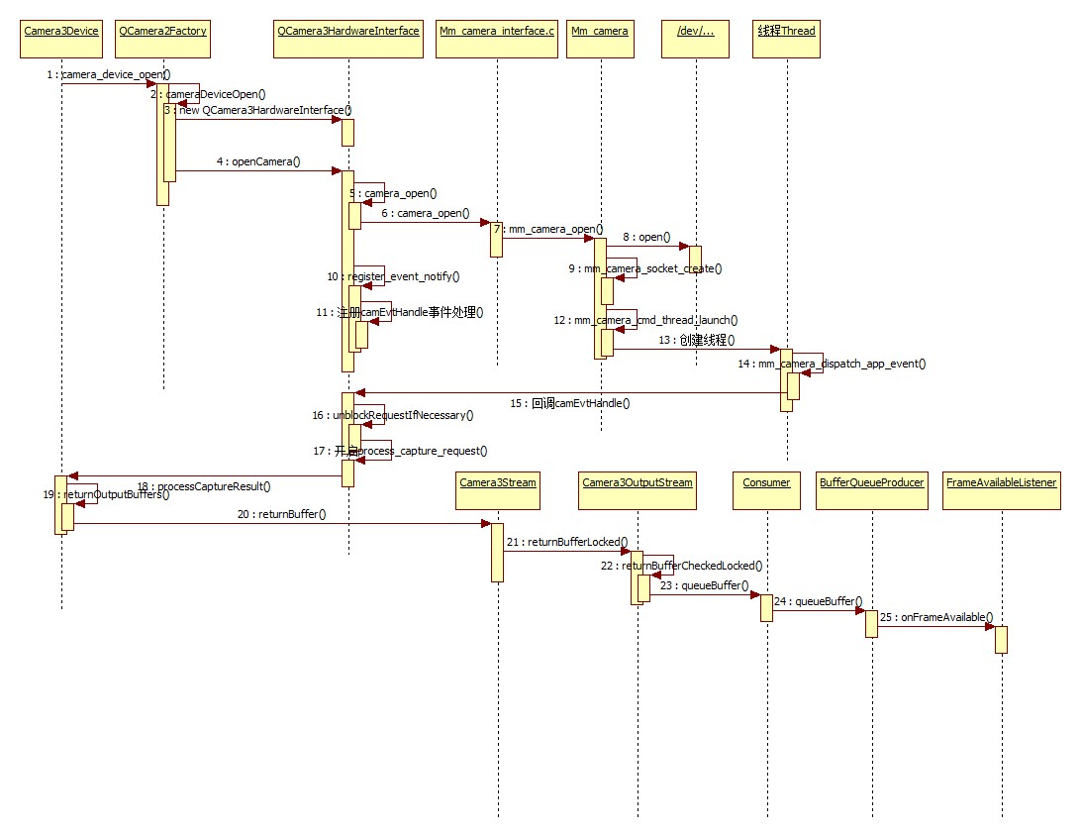

# Preview(预览)流程

<https://blog.csdn.net/yangzhihuiguming/article/details/51800587>

## 应用层

preview流程都是从startPreview开始的，所以来看startPreview方法的代码：

### startPreview

//OneCameraImpl.java

@Override

public void startPreview(Surface previewSurface, CaptureReadyCallback listener) {

mPreviewSurface = previewSurface;

//根据Surface以及CaptureReadyCallback回调来建立preview环境

setupAsync(mPreviewSurface, listener);

}‘

这其中有一个比较重要的回调CaptureReadyCallback，先分析setupAsync方法：

### setupAsync

//OneCameraImpl.java

private void setupAsync(final Surface previewSurface, final CaptureReadyCallback listener) {

mCameraHandler.post(new Runnable() {

@Override

public void run() {

//建立preview环境

setup(previewSurface, listener);

}

});

}

1

这里通过CameraHandler来post一个Runnable对象，它只会调用Runnable的run方法，它仍然属于UI线程，并没有创建新的线程。所以，继续分析setup方法：

### setup

// OneCameraImpl.java

private void setup(Surface previewSurface, final CaptureReadyCallback listener) {

try {

if (mCaptureSession != null) {

mCaptureSession.abortCaptures();

mCaptureSession = null;

}

List<Surface> outputSurfaces = new ArrayList<Surface>(2);

outputSurfaces.add(previewSurface);

outputSurfaces.add(mCaptureImageReader.getSurface());

//创建CaptureSession会话来与Camera Device发送Preview请求

mDevice.createCaptureSession(outputSurfaces, new CameraCaptureSession.StateCallback() {

@Override

public void onConfigureFailed(CameraCaptureSession session) {

//如果配置失败，则回调CaptureReadyCallback的onSetupFailed方法

listener.onSetupFailed();

}

@Override

public void onConfigured(CameraCaptureSession session) {

mCaptureSession = session;

mAFRegions = ZERO_WEIGHT_3A_REGION;

mAERegions = ZERO_WEIGHT_3A_REGION;

mZoomValue = 1f;

mCropRegion = cropRegionForZoom(mZoomValue);

//调用repeatingPreview来启动preview

boolean success = repeatingPreview(null);

if (success) {

//若启动成功，则回调CaptureReadyCallback的onReadyForCapture，表示准备拍照成功

listener.onReadyForCapture();

} else {

//若启动失败，则回调CaptureReadyCallback的onSetupFailed，表示preview建立失败

listener.onSetupFailed();

}

}

@Override

public void onClosed(CameraCaptureSession session) {

super.onClosed(session);

}

}, mCameraHandler);

} catch (CameraAccessException ex) {

Log.e(TAG, "Could not set up capture session", ex);

listener.onSetupFailed();

}

}

6

47

首先，调用Device的createCaptureSession方法来创建一个会话，并定义了会话的状态回调CameraCaptureSession.StateCallback()，其中，当会话创建成功，则会回调onConfigured()方法,在其中，首先调用repeatingPreview来启动preview，然后处理preview的结果并调用先前定义的CaptureReadyCallback来通知用户进行Capture操作。先分析repeatingPreview方法：

### repeatingPreview

// OneCameraImpl.java

private boolean repeatingPreview(Object tag) {

try {

//通过CameraDevice对象创建一个CaptureRequest的preview请求

CaptureRequest.Builder builder = mDevice.createCaptureRequest(

CameraDevice.TEMPLATE_PREVIEW);

//添加预览的目标Surface

builder.addTarget(mPreviewSurface);

//设置预览模式

builder.set(CaptureRequest.CONTROL_MODE, CameraMetadata.CONTROL_MODE_AUTO);

addBaselineCaptureKeysToRequest(builder);

//利用会话发送请求，mCaptureCallback为

mCaptureSession.setRepeatingRequest(builder.build(), mCaptureCallback,mCameraHandler);

Log.v(TAG, String.format("Sent repeating Preview request, zoom = %.2f", mZoomValue));

return true;

} catch (CameraAccessException ex) {

Log.e(TAG, "Could not access camera setting up preview.", ex);

return false;

}

}

首先调用CameraDeviceImpl的createCaptureRequest方法创建类型为TEMPLATE_PREVIEW 的CaptureRequest，然后调用CameraCaptureSessionImpl的setRepeatingRequest方法将此请求发送出去：

### setRepeatingRequest

//CameraCaptureSessionImpl.java

@Override

public synchronized int setRepeatingRequest(CaptureRequest request, CaptureCallback callback,

Handler handler) throws CameraAccessException {

if (request == null) {

throw new IllegalArgumentException("request must not be null");

} else if (request.isReprocess()) {

throw new IllegalArgumentException("repeating reprocess requests are not supported");

}

checkNotClosed();

handler = checkHandler(handler, callback);

...

//将此请求添加到待处理的序列里

return addPendingSequence(mDeviceImpl.setRepeatingRequest(request,createCaptureCallbackProxy(

handler, callback), mDeviceHandler));

}

### CaptureReadyCallback

至此应用层的preview的请求流程分析结束，继续分析其结果处理，如果preview开启成功，则会回调CaptureReadyCallback的onReadyForCapture方法，现在分析CaptureReadyCallback回调：

//CaptureModule.java

new CaptureReadyCallback() {

@Override

public void onSetupFailed() {

mCameraOpenCloseLock.release();

Log.e(TAG, "Could not set up preview.");

mMainThread.execute(new Runnable() {

@Override

public void run() {

if (mCamera == null) {

Log.d(TAG, "Camera closed, aborting.");

return;

}

mCamera.close();

mCamera = null;

}

});

}

@Override

public void onReadyForCapture() {

mCameraOpenCloseLock.release();

mMainThread.execute(new Runnable() {

@Override

public void run() {

Log.d(TAG, "Ready for capture.");

if (mCamera == null) {

Log.d(TAG, "Camera closed, aborting.");

return;

}

//

onPreviewStarted();

onReadyStateChanged(true);

mCamera.setReadyStateChangedListener(CaptureModule.this);

mUI.initializeZoom(mCamera.getMaxZoom());

mCamera.setFocusStateListener(CaptureModule.this);

}

});

}

}

### onReadyForCapture

根据前面的分析，预览成功后会回调onReadyForCapture方法，它主要是通知主线程的状态改变，并设置Camera的ReadyStateChangedListener的监听，其回调方法如下：

//CaptureModule.java

@Override

public void onReadyStateChanged(boolean readyForCapture) {

if (readyForCapture) {

mAppController.getCameraAppUI().enableModeOptions();

}

mAppController.setShutterEnabled(readyForCapture);

}

1

如代码所示，当其状态变成准备好拍照，则将会调用CameraActivity的setShutterEnabled方法，即使能快门按键，此时也就是说预览成功结束，可以按快门进行拍照了，所以，到这里，应用层的preview的流程基本分析完毕，下图是应用层的关键调用的流程时序图：

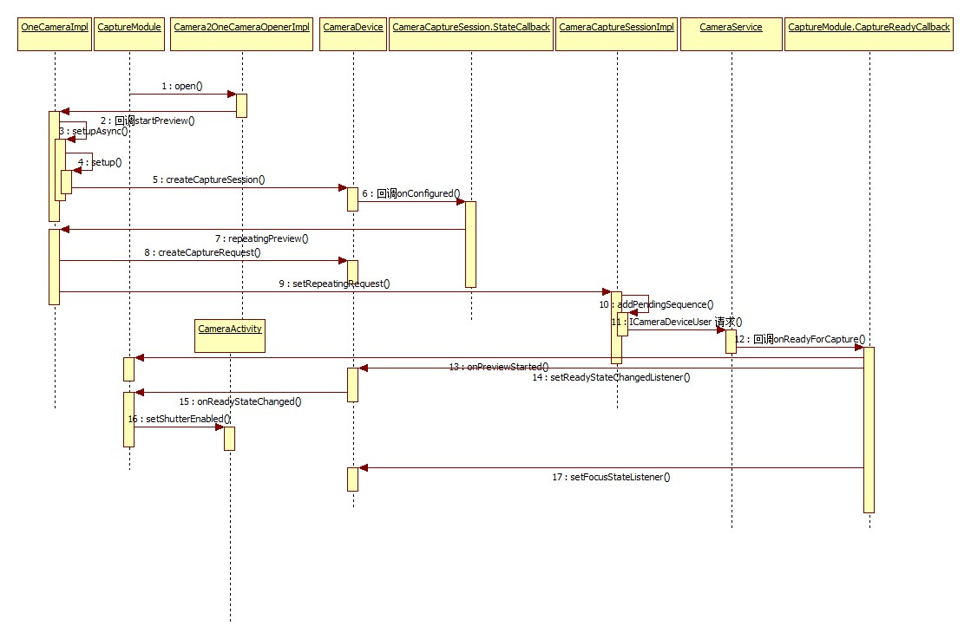

## Native层

分析Preview的Native的代码真是费了九牛二虎之力，若有分析不正确之处，请各位大神指正，在第一小节的后段最后会调用CameraDeviceImpl的setRepeatingRequest方法来提交请求，而在android6.0源码分析之Camera API2.0简介中，分析了Camera2框架Java IPC通信使用了CameraDeviceUser来进行通信，所以看Native层的ICameraDeviceUser的onTransact方法来处理请求的提交：

### onTransact

//ICameraDeviceUser.cpp

status_t BnCameraDeviceUser::onTransact(uint32_t code, const Parcel& data, Parcel* reply,

uint32_t flags){

switch(code) {

…

//请求提交

case SUBMIT_REQUEST: {

CHECK_INTERFACE(ICameraDeviceUser, data, reply);

// arg0 = request

sp<CaptureRequest> request;

if (data.readInt32() != 0) {

request = new CaptureRequest();

request->readFromParcel(const_cast<Parcel*>(&data));

}

// arg1 = streaming (bool)

bool repeating = data.readInt32();

// return code: requestId (int32)

reply->writeNoException();

int64_t lastFrameNumber = -1;

//将实现BnCameraDeviceUser的对下岗的submitRequest方法代码写入Binder

reply->writeInt32(submitRequest(request, repeating, &lastFrameNumber));

reply->writeInt32(1);

reply->writeInt64(lastFrameNumber);

return NO_ERROR;

} break;

...

}

CameraDeviceClientBase继承了BnCameraDeviceUser类，所以CameraDeviceClientBase相当于IPC Binder中的client，所以会调用其submitRequest方法，此处，至于IPC Binder通信原理不做分析，其参照其它资料：

### submitRequest

//CameraDeviceClient.cpp

status_t CameraDeviceClient::submitRequest(sp<CaptureRequest> request,bool streaming,

/*out*/int64_t* lastFrameNumber) {

List<sp<CaptureRequest> > requestList;

requestList.push_back(request);

return submitRequestList(requestList, streaming, lastFrameNumber);

}

简单的调用，继续分析submitRequestList：

// CameraDeviceClient

status_t CameraDeviceClient::submitRequestList(List<sp<CaptureRequest> > requests,bool streaming,

int64_t* lastFrameNumber) {

...

//Metadata链表

List<const CameraMetadata> metadataRequestList;

...

for (List<sp<CaptureRequest> >::iterator it = requests.begin(); it != requests.end(); ++it) {

sp<CaptureRequest> request = *it;

...

//初始化Metadata数据

CameraMetadata metadata(request->mMetadata);

...

//设置Stream的容量

Vector<int32_t> outputStreamIds;

outputStreamIds.setCapacity(request->mSurfaceList.size());

//循环初始化Surface

for (size_t i = 0; i < request->mSurfaceList.size(); ++i) {

sp<Surface> surface = request->mSurfaceList[i];

if (surface == 0) continue;

sp<IGraphicBufferProducer> gbp = surface->getIGraphicBufferProducer();

int idx = mStreamMap.indexOfKey(IInterface::asBinder(gbp));

...

int streamId = mStreamMap.valueAt(idx);

outputStreamIds.push_back(streamId);

}

//更新数据

metadata.update(ANDROID_REQUEST_OUTPUT_STREAMS, &outputStreamIds[0],

outputStreamIds.size());

if (request->mIsReprocess) {

metadata.update(ANDROID_REQUEST_INPUT_STREAMS, &mInputStream.id, 1);

}

metadata.update(ANDROID_REQUEST_ID, &requestId, /*size*/1);

loopCounter++; // loopCounter starts from 1

//压栈

metadataRequestList.push_back(metadata);

}

mRequestIdCounter++;

if (streaming) {

//预览会走此条通道

res = mDevice->setStreamingRequestList(metadataRequestList, lastFrameNumber);

if (res != OK) {

...

} else {

mStreamingRequestList.push_back(requestId);

}

} else {

//Capture等走此条通道

res = mDevice->captureList(metadataRequestList, lastFrameNumber);

if (res != OK) {

...

}

}

if (res == OK) {

return requestId;

}

return res;

}

setStreamingRequestList和captureList方法都调用了submitRequestsHelper方法，只是他们的repeating参数一个ture,一个为false，而本节分析的preview调用的是setStreamingRequestList方法，并且API2.0下Device的实现为Camera3Device，所以看它的submitRequestsHelper实现：

// Camera3Device.cpp

status_t Camera3Device::submitRequestsHelper(const List<const CameraMetadata> &requests,

bool repeating,/*out*/int64_t *lastFrameNumber) {

...

RequestList requestList;

//在这里面会进行CaptureRequest的创建，并调用configureStreamLocked进行stream的配置，主要是设置了一个回调captureResultCb，即后面要分析的重要的回调

res = convertMetadataListToRequestListLocked(requests, /*out*/&requestList);

...

if (repeating) {

//眼熟不，这个方法名和应用层中CameraDevice的setRepeatingRequests一样

res = mRequestThread->setRepeatingRequests(requestList, lastFrameNumber);

} else {

//不需重复，即repeating为false时，调用此方法来讲请求提交

res = mRequestThread->queueRequestList(requestList, lastFrameNumber);

}

...

return res;

}

从代码可知，在Camera3Device里创建了要给RequestThread线程，调用它的setRepeatingRequests或者queueRequestList方法来将应用层发送过来的Request提交，继续看setRepeatingRequests方法：

### setRepeatingRequests

// Camera3Device.cpp

status_t Camera3Device::RequestThread::setRepeatingRequests(const RequestList &requests,

/*out*/int64_t *lastFrameNumber) {

Mutex::Autolock l(mRequestLock);

if (lastFrameNumber != NULL) {

*lastFrameNumber = mRepeatingLastFrameNumber;

}

mRepeatingRequests.clear();

//将其插入mRepeatingRequest链表

mRepeatingRequests.insert(mRepeatingRequests.begin(),

requests.begin(), requests.end());

unpauseForNewRequests();

mRepeatingLastFrameNumber = NO_IN_FLIGHT_REPEATING_FRAMES;

return OK;

}

至此，Native层的preview过程基本分析结束，下面的工作将会交给Camera HAL层来处理，先给出Native层的调用时序图

### 时序图：

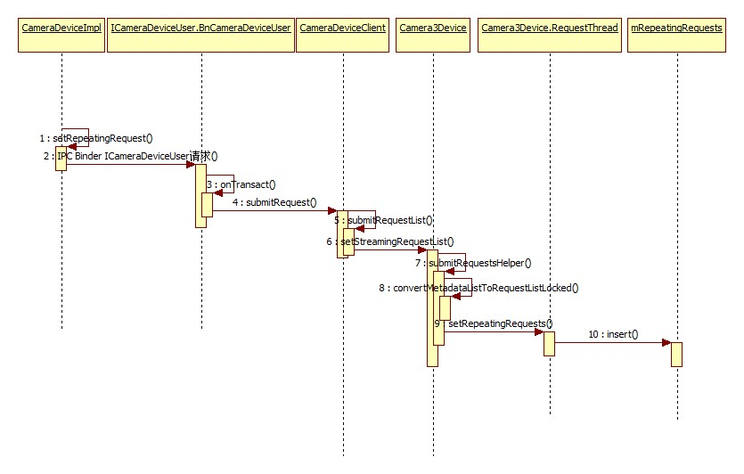

## HAL层

本节将不再对Camera的HAL层的初始化以及相关配置进行分析，只对preview等相关流程中的frame metadata的处理流程进行分析，具体的CameraHAL分析请参考android6.0源码分析之Camera2 HAL分析.在第二小节的submitRequestsHelper方法中调用convertMetadataListToRequestListLocked的时候会进行CaptureRequest的创建，并调用configureStreamLocked进行stream的配置，主要是设置了一个回调captureResultCb，所以Native层在request提交后，会回调此captureResultCb方法，首先分析captureResultCb：

### captureResultCb

// QCamera3HWI.cpp

void QCamera3HardwareInterface::captureResultCb(mm_camera_super_buf_t *metadata_buf,

camera3_stream_buffer_t *buffer, uint32_t frame_number)

{

if (metadata_buf) {

if (mBatchSize) {

//批处理模式，但代码也是循环调用handleMetadataWithLock方法

handleBatchMetadata(metadata_buf, true /* free_and_bufdone_meta_buf */);

} else { /* mBatchSize = 0 */

pthread_mutex_lock(&mMutex);

//处理元数据

handleMetadataWithLock(metadata_buf, true /* free_and_bufdone_meta_buf */);

pthread_mutex_unlock(&mMutex);

}

} else {

pthread_mutex_lock(&mMutex);

handleBufferWithLock(buffer, frame_number);

pthread_mutex_unlock(&mMutex);

}

return;

}

一种是通过循环来进行元数据的批处理，另一种是直接进行元数据的处理，但是批处理最终也是循环调用handleMetadataWithLock来处理：

### handleMetadataWithLock

sdf

// QCamera3HWI.cpp

void QCamera3HardwareInterface::handleMetadataWithLock(mm_camera_super_buf_t *metadata_buf,

bool free_and_bufdone_meta_buf){

...

//Partial result on process_capture_result for timestamp

if (urgent_frame_number_valid) {

...

for (List<PendingRequestInfo>::iterator i =mPendingRequestsList.begin();

i != mPendingRequestsList.end(); i++) {

...

if (i->frame_number == urgent_frame_number &&i->bUrgentReceived == 0) {

camera3_capture_result_t result;

memset(&result, 0, sizeof(camera3_capture_result_t));

i->partial_result_cnt++;

i->bUrgentReceived = 1;

//提取3A数据

result.result =translateCbUrgentMetadataToResultMetadata(metadata);

...

//对Capture Result进行处理

mCallbackOps->process_capture_result(mCallbackOps, &result);

//释放camera_metadata_t

free_camera_metadata((camera_metadata_t *)result.result);

break;

}

}

}

...

for (List<PendingRequestInfo>::iterator i = mPendingRequestsList.begin();

i != mPendingRequestsList.end() && i->frame_number <= frame_number;) {

camera3_capture_result_t result;

memset(&result, 0, sizeof(camera3_capture_result_t));

...

if (i->frame_number < frame_number) {

//清空数据结构

camera3_notify_msg_t notify_msg;

memset(&notify_msg, 0, sizeof(camera3_notify_msg_t));

//定义消息类型

notify_msg.type = CAMERA3_MSG_SHUTTER;

notify_msg.message.shutter.frame_number = i->frame_number;

notify_msg.message.shutter.timestamp = (uint64_t)capture_time (urgent_frame_number -

i->frame_number) * NSEC_PER_33MSEC;

//调用回调通知应用层发生CAMERA3_MSG_SHUTTER消息

mCallbackOps->notify(mCallbackOps, &notify_msg);

...

CameraMetadata dummyMetadata;

//更新元数据

dummyMetadata.update(ANDROID_SENSOR_TIMESTAMP,

&i->timestamp, 1);

dummyMetadata.update(ANDROID_REQUEST_ID,

&(i->request_id), 1);

//得到元数据释放结果

result.result = dummyMetadata.release();

} else {

camera3_notify_msg_t notify_msg;

memset(&notify_msg, 0, sizeof(camera3_notify_msg_t));

// Send shutter notify to frameworks

notify_msg.type = CAMERA3_MSG_SHUTTER;

...

//从HAL中获得Metadata

result.result = translateFromHalMetadata(metadata,

i->timestamp, i->request_id, i->jpegMetadata, i->pipeline_depth,

i->capture_intent);

saveExifParams(metadata);

if (i->blob_request) {

...

if (enabled && metadata->is_tuning_params_valid) {

//将Metadata复制到文件

dumpMetadataToFile(metadata->tuning_params, mMetaFrameCount, enabled,

"Snapshot",frame_number);

}

mPictureChannel->queueReprocMetadata(metadata_buf);

} else {

// Return metadata buffer

if (free_and_bufdone_meta_buf) {

mMetadataChannel->bufDone(metadata_buf);

free(metadata_buf);

}

}

}

...

}

}

其中，首先会调用回调的process_capture_result方法来对Capture Result进行处理，然后会调用回调的notify方法来发送一个CAMERA3_MSG_SHUTTER消息，而process_capture_result所对应的实现其实就是Camera3Device的processCaptureResult方法，先分析processCaptureResult：

//Camera3Device.cpp

void Camera3Device::processCaptureResult(const camera3_capture_result *result) {

...

//对于HAL3.2+,如果HAL不支持partial，当metadata被包含在result中时，它必须将partial_result设置为1

...

{

Mutex::Autolock l(mInFlightLock);

ssize_t idx = mInFlightMap.indexOfKey(frameNumber);

...

InFlightRequest &request = mInFlightMap.editValueAt(idx);

if (result->partial_result != 0)

request.resultExtras.partialResultCount = result->partial_result;

// 检查结果是否只有partial metadata

if (mUsePartialResult && result->result != NULL) {

if (mDeviceVersion >= CAMERA_DEVICE_API_VERSION_3_2) {//HAL版本高于3.2

if (result->partial_result > mNumPartialResults || result->partial_result < 1) {

//Log显示错误

return;

}

isPartialResult = (result->partial_result < mNumPartialResults);

if (isPartialResult) {

//将结果加入到请求的结果集中

request.partialResult.collectedResult.append(result->result);

}

} else {//低于3.2

...

}

if (isPartialResult) {

// Fire off a 3A-only result if possible

if (!request.partialResult.haveSent3A) {

request.partialResult.haveSent3A =processPartial3AResult(frameNumber,

request.partialResult.collectedResult,request.resultExtras);

}

}

}

...

if (result->result != NULL && !isPartialResult) {

if (shutterTimestamp == 0) {

request.pendingMetadata = result->result;

request.partialResult.collectedResult = collectedPartialResult;

} else {

CameraMetadata metadata;

metadata = result->result;

//发送Capture Result

sendCaptureResult(metadata, request.resultExtras, collectedPartialResult,

frameNumber, hasInputBufferInRequest,request.aeTriggerCancelOverride);

}

}

//结果处理好了，将请求移除

removeInFlightRequestIfReadyLocked(idx);

} // scope for mInFlightLock

...

}

由代码可知，它会处理局部的或者全部的metadata数据，最后如果result不为空，且得到的是请求处理的全部数据，则会调用sendCaptureResult方法来将请求结果发送出去：

//Camera3Device.cpp

void Camera3Device::sendCaptureResult(CameraMetadata &pendingMetadata,CaptureResultExtras

&resultExtras,CameraMetadata &collectedPartialResult,uint32_t frameNumber,bool reprocess,

const AeTriggerCancelOverride_t &aeTriggerCancelOverride) {

if (pendingMetadata.isEmpty())//如果数据为空，直接返回

return;

...

CaptureResult captureResult;

captureResult.mResultExtras = resultExtras;

captureResult.mMetadata = pendingMetadata;

//更新metadata

if (captureResult.mMetadata.update(ANDROID_REQUEST_FRAME_COUNT(int32_t*)&frameNumber, 1)

!= OK) {

SET_ERR("Failed to set frame# in metadata (%d)",frameNumber);

return;

} else {

...

}

// Append any previous partials to form a complete result

if (mUsePartialResult && !collectedPartialResult.isEmpty()) {

captureResult.mMetadata.append(collectedPartialResult);

}

//排序

captureResult.mMetadata.sort();

// Check that there's a timestamp in the result metadata

camera_metadata_entry entry = captureResult.mMetadata.find(ANDROID_SENSOR_TIMESTAMP);

...

overrideResultForPrecaptureCancel(&captureResult.mMetadata, aeTriggerCancelOverride);

// 有效的结果，将其插入Buffer

List<CaptureResult>::iterator queuedResult =mResultQueue.insert(mResultQueue.end(),

CaptureResult(captureResult));

...

mResultSignal.signal();

}

最后，它将Capture Result插入了结果队列，并释放了结果的信号量，所以到这里，Capture Result处理成功，下面分析前面的notify发送CAMERA3_MSG_SHUTTER消息：

//Camera3Device.cpp

void Camera3Device::notify(const camera3_notify_msg *msg) {

NotificationListener *listener;

{

Mutex::Autolock l(mOutputLock);

listener = mListener;

}

...

switch (msg->type) {

case CAMERA3_MSG_ERROR: {

notifyError(msg->message.error, listener);

break;

}

case CAMERA3_MSG_SHUTTER: {

notifyShutter(msg->message.shutter, listener);

break;

}

default:

SET_ERR("Unknown notify message from HAL: %d",

msg->type);

}

}

1

2

3

4

5

6

7

8

9

10

11

12

13

14

15

16

17

18

19

20

21

22

23

它调用了notifyShutter方法：

// Camera3Device.cpp

void Camera3Device::notifyShutter(const camera3_shutter_msg_t &msg,

NotificationListener *listener) {

...

// Set timestamp for the request in the in-flight tracking

// and get the request ID to send upstream

{

Mutex::Autolock l(mInFlightLock);

idx = mInFlightMap.indexOfKey(msg.frame_number);

if (idx >= 0) {

InFlightRequest &r = mInFlightMap.editValueAt(idx);

// Call listener, if any

if (listener != NULL) {

//调用监听的notifyShutter法国法

listener->notifyShutter(r.resultExtras, msg.timestamp);

}

...

//将待处理的result发送到Buffer

sendCaptureResult(r.pendingMetadata, r.resultExtras,

r.partialResult.collectedResult, msg.frame_number,

r.hasInputBuffer, r.aeTriggerCancelOverride);

returnOutputBuffers(r.pendingOutputBuffers.array(),

r.pendingOutputBuffers.size(), r.shutterTimestamp);

r.pendingOutputBuffers.clear();

removeInFlightRequestIfReadyLocked(idx);

}

}

...

}

1

2

3

4

5

6

7

8

9

10

11

12

13

14

15

16

17

18

19

20

21

22

23

24

25

26

27

28

29

30

首先它会通知listener preview成功，最后会调用sendCaptureResult将结果加入到结果队列。它会调用listener的notifyShutter方法，此处的listener其实是CameraDeviceClient类，所以会调用CameraDeviceClient类的notifyShutter方法：

//CameraDeviceClient.cpp

void CameraDeviceClient::notifyShutter(const CaptureResultExtras& resultExtras,nsecs_t timestamp) {

// Thread safe. Don't bother locking.

sp<ICameraDeviceCallbacks> remoteCb = getRemoteCallback();

if (remoteCb != 0) {

//调用应用层的回调(CaptureCallback的onCaptureStarted方法)

remoteCb->onCaptureStarted(resultExtras, timestamp);

}

}

1

2

3

4

5

6

7

8

9

此处的ICameraDeviceCallbacks对应的是Java层的CameraDeviceImpl.java中的内部类CameraDeviceCallbacks，所以会调用它的onCaptureStarted方法：

//CameraDeviceImpl.java

@Override

public void onCaptureStarted(final CaptureResultExtras resultExtras, final long timestamp) {

int requestId = resultExtras.getRequestId();

final long frameNumber = resultExtras.getFrameNumber();

final CaptureCallbackHolder holder;

synchronized(mInterfaceLock) {

if (mRemoteDevice == null) return; // Camera already closed

// Get the callback for this frame ID, if there is one

holder = CameraDeviceImpl.this.mCaptureCallbackMap.get(requestId);

...

// Dispatch capture start notice

holder.getHandler().post(new Runnable() {

@Override

public void run() {

if (!CameraDeviceImpl.this.isClosed()) {

holder.getCallback().onCaptureStarted(CameraDeviceImpl.this,holder.getRequest(

resultExtras.getSubsequenceId()),timestamp, frameNumber);

}

}

});

}

}

1

2

3

4

5

6

7

8

9

10

11

12

13

14

15

16

17

18

19

20

21

22

23

24

它会调用OneCameraImpl.java中的mCaptureCallback的onCaptureStarted方法：

//OneCameraImpl.java

//Common listener for preview frame metadata.

private final CameraCaptureSession.CaptureCallback mCaptureCallback =

new CameraCaptureSession.CaptureCallback() {

@Override

public void onCaptureStarted(CameraCaptureSession session,CaptureRequest request,

long timestamp,long frameNumber) {

if (request.getTag() == RequestTag.CAPTURE&& mLastPictureCallback != null) {

mLastPictureCallback.onQuickExpose();

}

}

…

}

注意：Capture,preview以及autoFocus都是使用的这个回调，而Capture调用的时候，其RequestTag为CAPTURE，而autoFocus的时候为TAP_TO_FOCUS,而preview请求时没有对RequestTag进行设置，所以回调到onCaptureStarted方法时，不需要进行处理，但是到此时，preview已经启动成功，可以进行预览了，其数据都在buffer里。所以到此时，preview的流程全部分析结束，下面给出HAL层上的流程

### 时序图

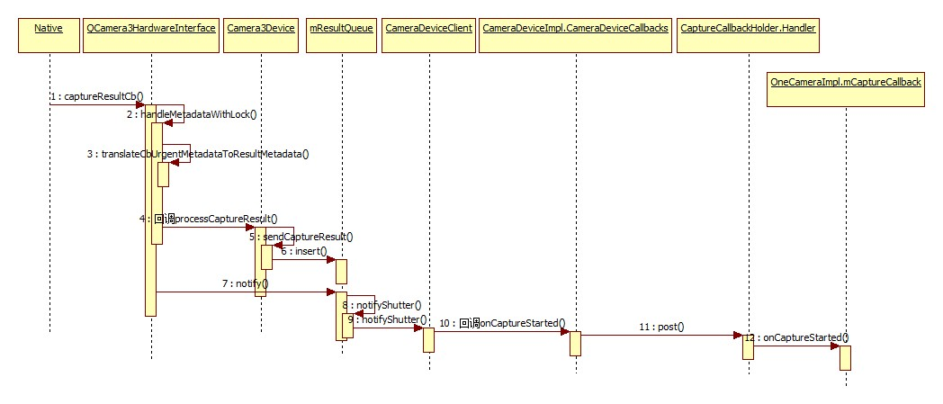

# CameraService

## Dumpsys

frameworks\av\services\camera\libcameraservice\CameraService.cpp

Active Camera Clients:

[]

Allowed users:

0

Vendor tags left unimplemented.

Device 0 is closed, no client instance

No active camera clients yet.

status_t CameraService::dump(**int** fd, **const** Vector<String16>& args) {  
 ATRACE_CALL();

Active Camera Clients:

[

(Camera ID: 0, Cost: 100, PID: 12898, Priority: 2147483645, User Id: 0, Client Package Name: com.android.camera2, Conflicting Client Devices: {})

]

mActiveClientManager

# 其他模块

## systemserver.CameraService

本身作为一个系统服务**media.camera.proxy**，用于监听media.camera对camera操作的变化

*/**  
 * This must match the ICameraService.aidl definition  
 */***private static final** String ***CAMERA_SERVICE_BINDER_NAME*** = **"media.camera"**;  
**public static final** String ***CAMERA_SERVICE_PROXY_BINDER_NAME*** = **"media.camera.proxy"**;**public static final int *CAMERA_STATE_OPEN*** = 0;  
**public static final int *CAMERA_STATE_ACTIVE*** = 1;  
**public static final int *CAMERA_STATE_IDLE*** = 2;  
**public static final int *CAMERA_STATE_CLOSED*** = 3;

@Override  
**public void** onStart() {  
 publishBinderService(***CAMERA_SERVICE_PROXY_BINDER_NAME***, **mCameraServiceProxy**);  
}

源码设计得非常简单，不具备dumpsys的功能，也不会上报pid出来，没啥卵用

## 原生app

Camera 应用独立

<https://www.jianshu.com/p/2d72e118ec4a>

将 Google Camera2 迁移为 Gradle 编译

<https://juejin.im/post/5c2f52786fb9a049a42f3077>

# 案例

## [Android-Camera2Video的demo源码和调试心得](https://www.cnblogs.com/lihaiping/p/6142512.html)

# REF

[Android5.1中surface和CpuConsumer下生产者和消费者间的处理框架简述](https://blog.csdn.net/gzzaigcnforever/article/details/49025297)

Android Camera2 简介

https://www.jianshu.com/p/23e8789fbc10