1. I already create my credential but I can’t login. MY Credential is not working.
2. Forget Button is not working.
3. I Can’t view my password because eye button is not working
4. All mails are going to spam. Please see below screen shot.

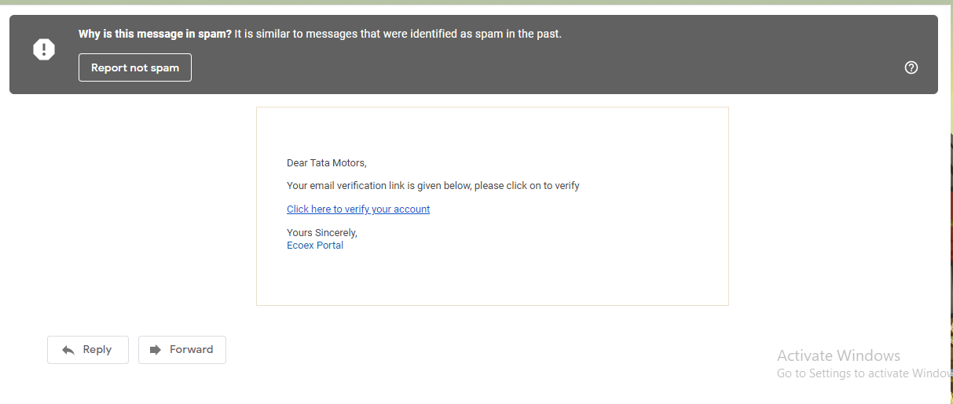

1. When I create the one brand or recycler that time portal pick mobile no and mail id that is correct but next time I creating other brand that time portal does pick previous mail id and mobile Number it is wrong .Please check the below Screen short. Both times Brand Name is different but mobile no and mail id is same.

If we create the new brand that time portal should accept new no or mail id if portal pick up old mobile no that time portal should give the error.

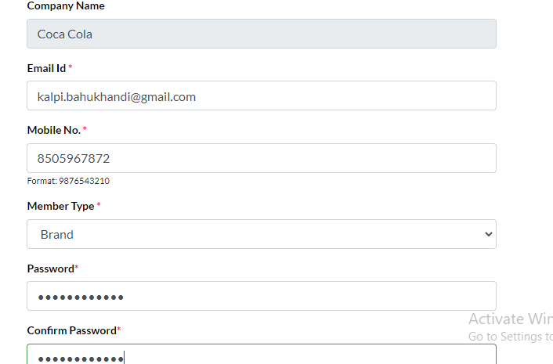

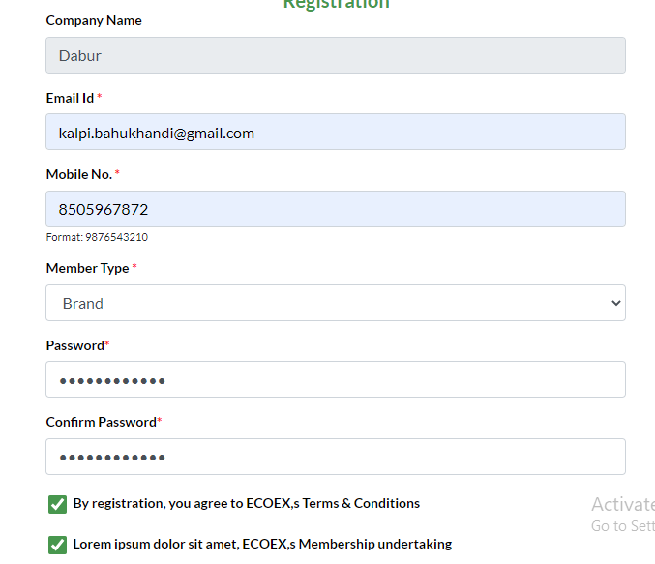

1. City name is not mention. There is mention City1, City 2

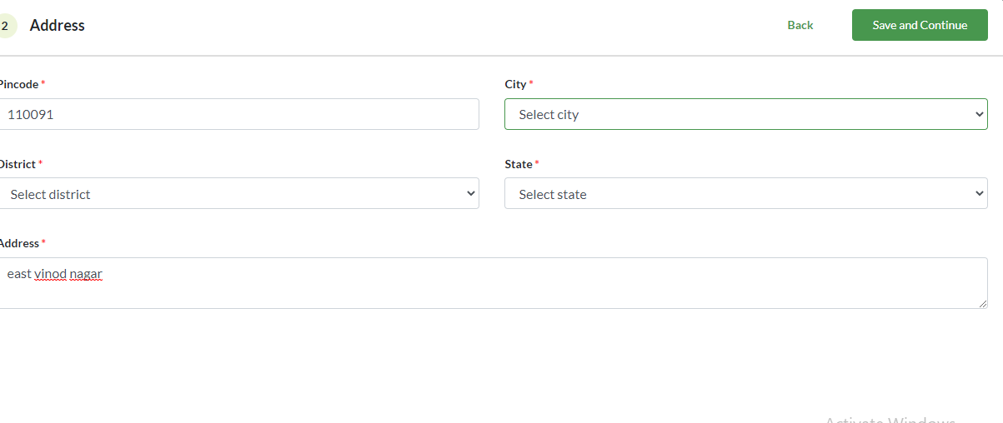

1. I fill all things but when I click save and continue then I can’t go head

