Company pages issues

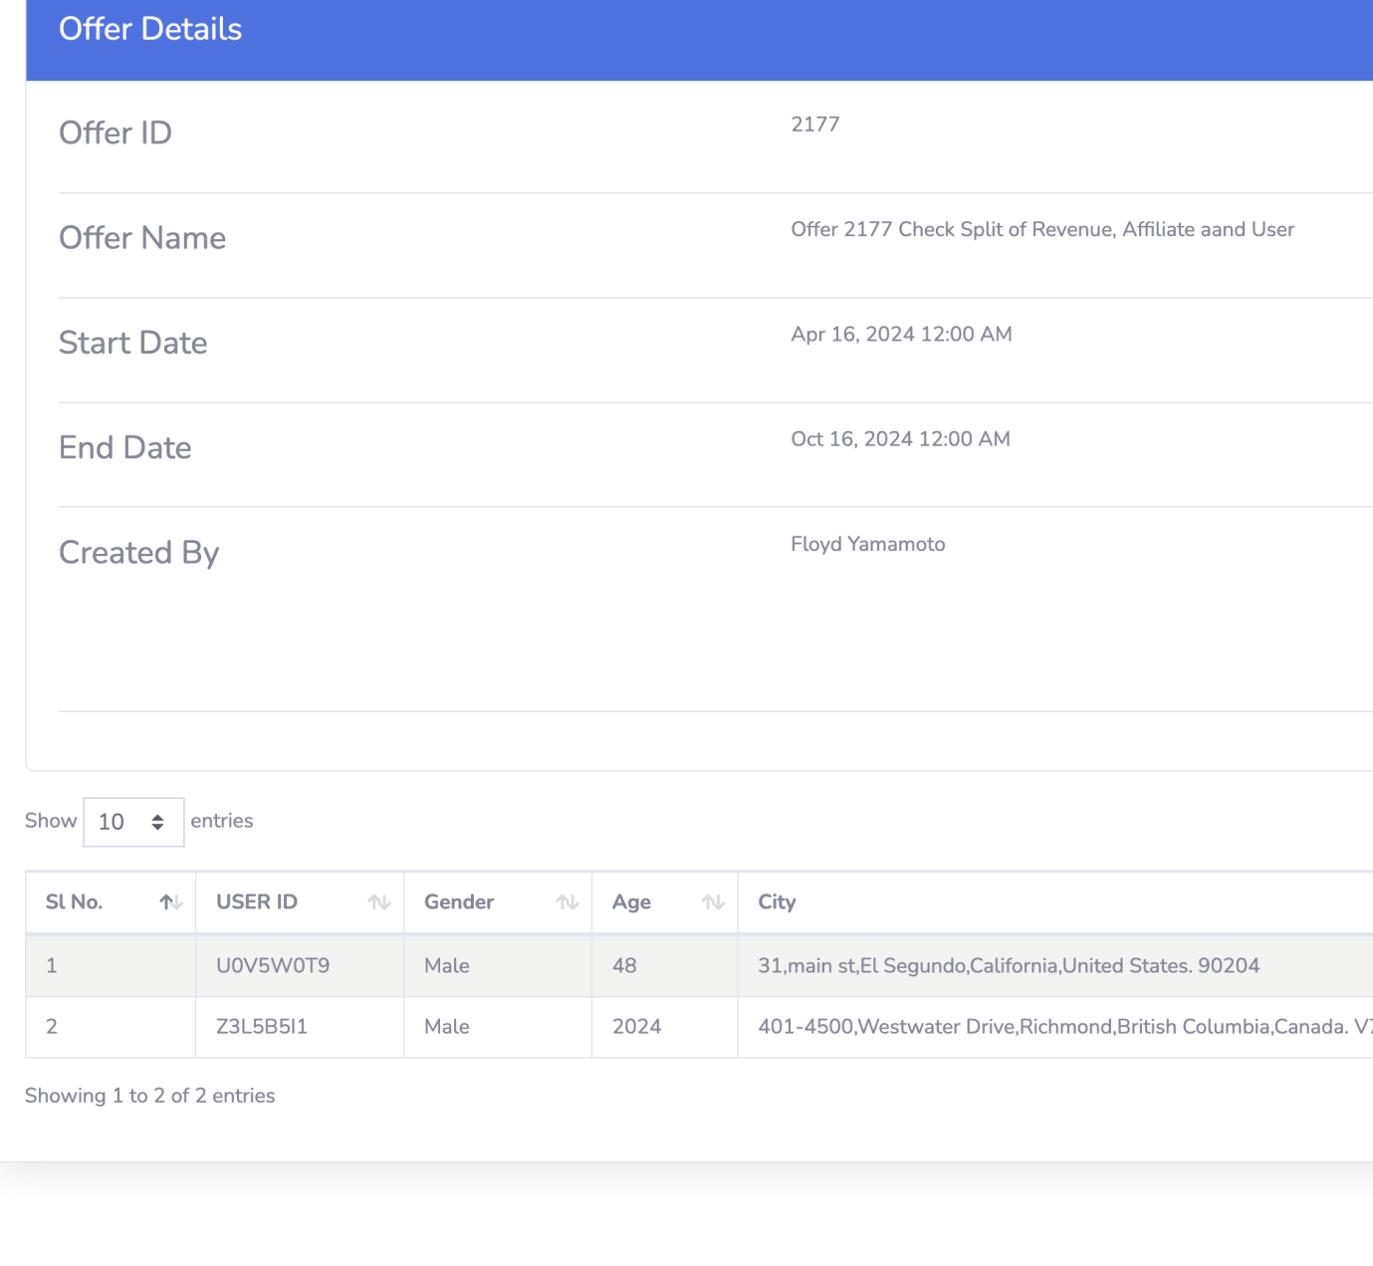

1. Why is age showing in two different ways here?

**## Fixed**

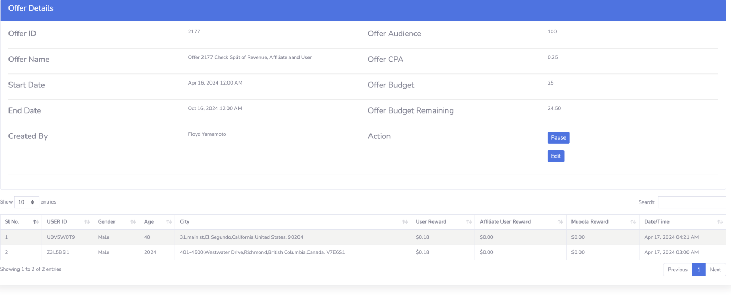

1. Bug: why is the muoola and affiliate numbers 0.00?

**## This muoola & affiliate numbers are come from `offer_usages` table. This two fields are added later after cash distribution logic implemented. That’s first 20-25 transactions don’t have data in tbale. They have o values. But now data is perfectly inserted into this table. I have checked.**

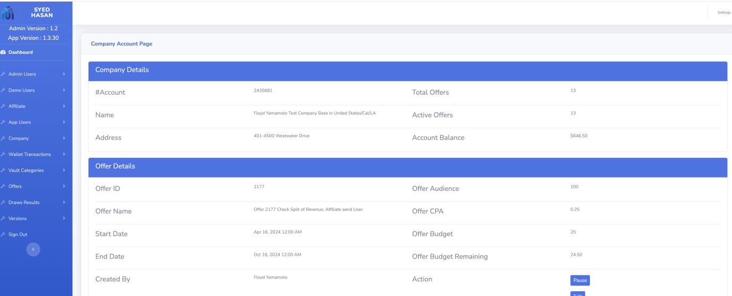

1. UI: reduce label font and compress this part of the page.

**## Fixed**

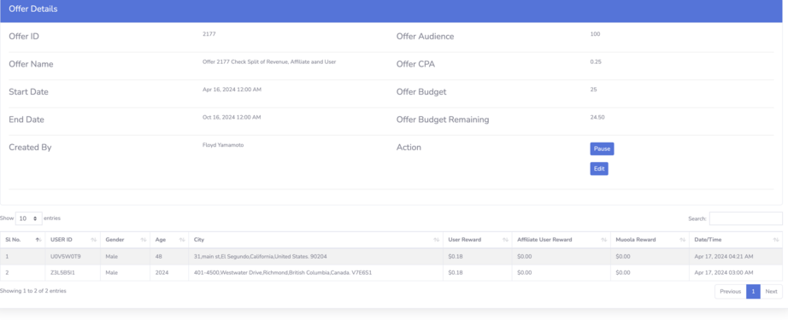

1. add a remaining balance column and a column for affiliate user id if one was paid. The affiliate and muoola payout columns are only going to be visible to admin users from Muoola not company users.

**## Fixed**



1. city column should only show city and country, not full address.

**## Fixed**



1. can you add a totals at the top for , % users accepted (% users accepted/shown), % users completed (%completed/accepted), and total completed.

**## Fixed**

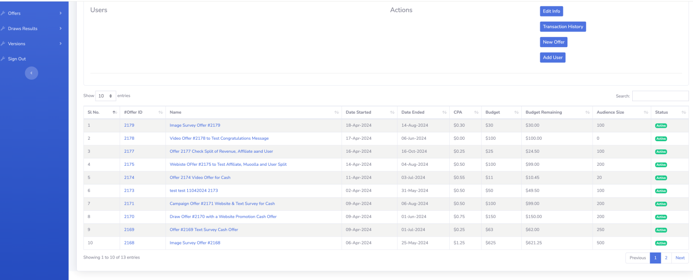

1. can you add columns on this page for , % users accepted (% users accepted/shown), % users completed (%completed/accepted), and total completed. on this page.

**## Fixed**

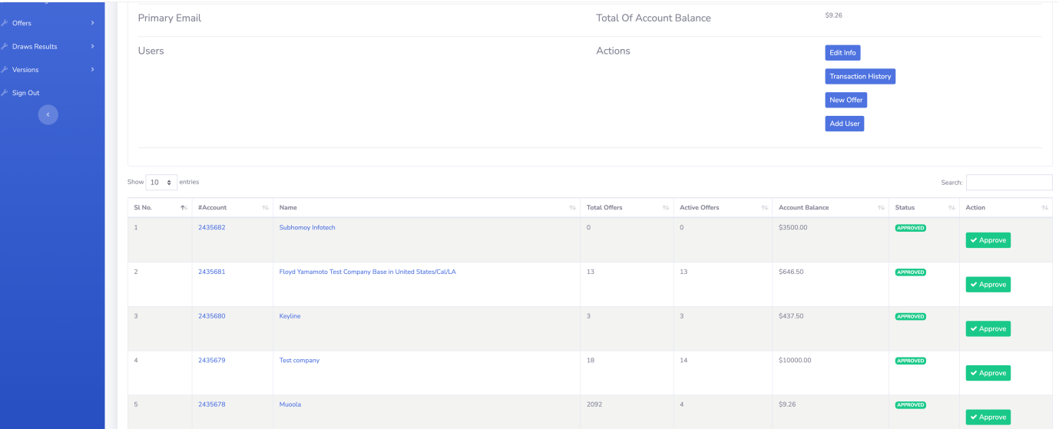

1. this page needs columns for $ paid to users, $ for affiliates and $ for Muoola. It also needs a date range selector and it needs totals at the top for:  
   Total company balances,  
   Total paid to users  
   Total Paid to affiliates  
   Total paid to Muoola  
   Total users paid

**## Fixed**



1. Compress row heights to look more like excel sheet.

**## fixed**