**Revision History**

| Latest Revision | Date | **By** | **Comments** |
| --- | --- | --- | --- |
| 01.02 | 07/08/2018 | Preston K. Parsard | Added question 52 |

1. What are the repository links to Azure supported Linux images?

A1. OpenLogic Repro: <http://olcentgbl.trafficmanager.net/openlogic/6/openlogic/x86_64/RPMS/>

A2. CentOS 6.3 download: <http://go.microsoft.com/fwlink/?LinkID=403033&clcid=0x409>

A3. CoreOS LIS Agent Source Code:

<https://github.com/coreos/coreos-overlay/tree/master/app-emulation/wa-linux-agent>

A4. Debi an Source Code: <https://github.com/Azure/WALinuxAgent>

A5. Oracle Linux: <http://go.microsoft.com/fwlink/p/?LinkID=250998>

A6. Windows Azure Linux Agent Source: <https://github.com/Azure/WALinuxAgent>

2. Where can I find the latest information on the Microsoft Azure Endorsed Distribution List for Linux?

A1. <https://docs.microsoft.com/en-us/azure/virtual-machines/virtual-machines-linux-endorsed-distros?toc=%2fazure%2fvirtual-machines%2flinux%2ftoc.json>

3. Where can I find instructions to prepare an unsupported Linux image for Azure?

A1. <https://docs.microsoft.com/en-us/azure/virtual-machines/virtual-machines-linux-create-upload-generic?toc=%2fazure%2fvirtual-machines%2flinux%2ftoc.json>

4. How can I deploy an Azure Linux image using PowerShell?

A1. <https://docs.microsoft.com/en-us/azure/virtual-machines/windows/quick-create-powershell\>

5. How can I deploy an Azure Linux image using the Azure CLI 2.0 ?

A1. <https://docs.microsoft.com/en-us/azure/virtual-machines/windows/quick-create-cli>

6. Where can I find a reference for the structure and syntax of Azure Resource Manager templates?

A1. <https://docs.microsoft.com/en-us/azure/azure-resource-manager/resource-group-authoring-templates>

7. How can I get started with DSC for Linux?

A1. <https://msdn.microsoft.com/en-us/powershell/dsc/lnxgettingstarted>

8. What sample JSON template code snippet can be used to specify the DSC extension for Linux machines in the resources section of a JSON deployment template?

A1.

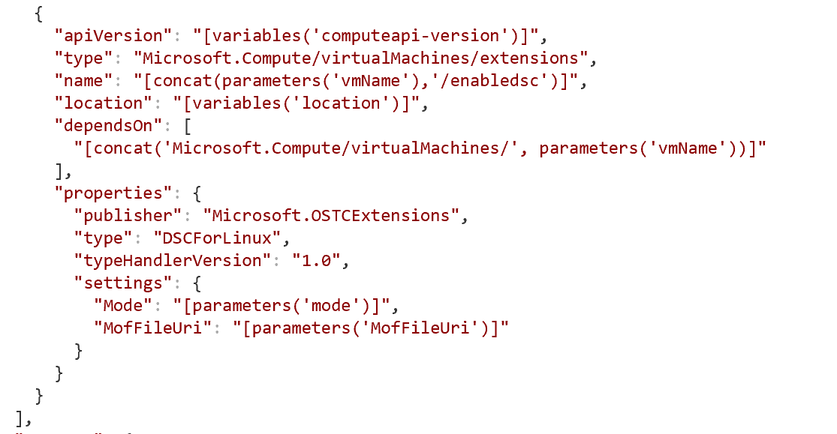

9. Where can I find instructions for generating and using an ssh-key pair to authenticate to a new Azure VM?

A1. In Linux: <https://azure.microsoft.com/en-us/documentation/articles/virtual-machines-linux-use-ssh-key/>

A2. In Windows: <https://azure.microsoft.com/en-us/documentation/articles/virtual-machines-windows-use-ssh-key/>

10. Where can I find the Windows Azure Linux Agent?

A1. <https://github.com/WindowsAzure/WALinuxAgent>

11. Where is the Linux Agent User Guide located?

A1. <http://www.windowsazure.com/en-us/documentation/articles/virtual-machines-linux-agent-user-guide/>

12. How can I get started using Azure CLI 2.0 ?

A1. <https://docs.microsoft.com/en-us/cli/azure/overview>

13. How can I learn JMESPath query?

A1. <http://jmespath.org/tutorial.html>

14. How do I install the Azure CLI 2.0 ?

A1. <https://docs.microsoft.com/en-us/cli/azure/install-azure-cli>

15. How can I create a custom Linux image for uploading to Azure?

A1. <https://azure.microsoft.com/en-us/documentation/articles/virtual-machines-linux-create-upload-vhd-generic/#linuxinstall>

16. How can I sign up for the new Azure Command Line interface preview feature to test and provide feedback?

A1. <https://azure.microsoft.com/en-us/blog/sneak-peek-a-new-azure-cloud-console/>

17. How can I deploy a new VM into an existing virtual network in Azure?

A1. <https://docs.microsoft.com/en-us/azure/virtual-machines/linux/deploy-linux-vm-into-existing-vnet-using-cli>

18. How can I create an Ubuntu Server docker host running NGNIX with PowerShell?

A1. <https://docs.microsoft.com/en-us/azure/virtual-machines/scripts/virtual-machines-linux-powershell-sample-create-docker-host>

19. Is there a cheat-sheet available for the mdadm raid management utility ?

A1. Yes. <http://www.ducea.com/2009/03/08/mdadm-cheat-sheet/>

20. Where can I find 1) the Log Analytics query syntax reference, and 2) In-depth tutorials?

A1. <https://docs.microsoft.com/en-us/azure/log-analytics/log-analytics-search-reference>

A2. <https://docs.microsoft.com/en-us/azure/log-analytics/log-analytics-log-searches>

21. How can I use PowerShell to convert a *.vmdk to *.vhd to upload to Azure?

A1. <https://blogs.msdn.microsoft.com/timomta/2015/06/11/how-to-convert-a-vmware-vmdk-to-hyper-v-vhd/>

22. Where can I find Azure CLI Samples for Linux virtual machines?

A1. <https://docs.microsoft.com/en-us/azure/virtual-machines/linux/cli-samples>

23. How do I generalize and capture a Linux Virtual Machine ?

A1. <https://docs.microsoft.com/en-us/azure/virtual-machines/linux/capture-image>

24. Where are the public and private SSH key files stored when using the **–ssh-key-value** and **–generate-ssh-keys** parameters of Azure CLI 2.0 ?

A1. These keys are stored at: **/home/<userid>/.ssh/id_rsa** [private key] and **/home/<userid>/.ssh/id_rsa.pub** [public key]

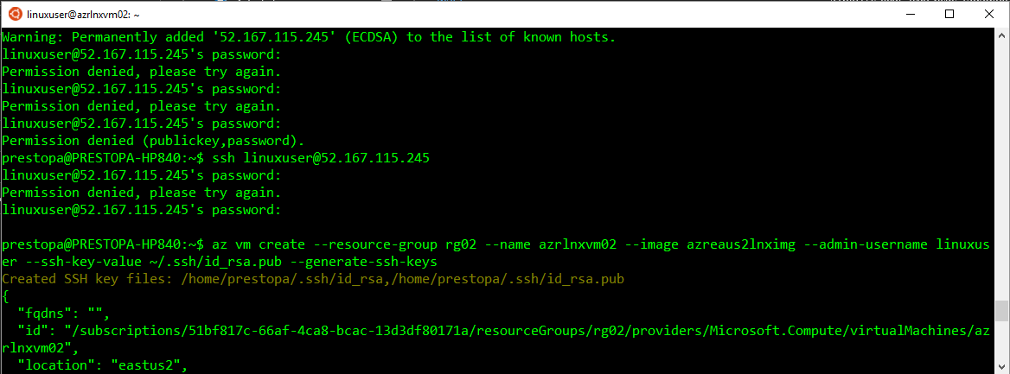

26. How can I install an Ubuntu VM with the DSC Linux Extension with configuration files placed in Azure Storage?

A1. <https://github.com/Azure/azure-quickstart-templates/tree/master/201-dsc-linux-azure-storage-on-ubuntu>

27. How do I enable the Windows Subsystem for Linux on Windows 10 ?

A1 <https://answers.microsoft.com/en-us/insider/wiki/insider_wintp-insider_install/how-to-enable-the-windows-subsystem-for-linux/16e8f2e8-4a6a-4325-a89a-fd28c7841775>

28. If I have the anniversary update of Windows 10, and have already installed the Windows Subsystem for Linux based on Ubuntu 14.04 LTS, when I upgrade my Windows 10 version to the creator update (build 1703), how do I also upgrade the version of Ubuntu from 14.04 LTS to 16.04 LTS ?

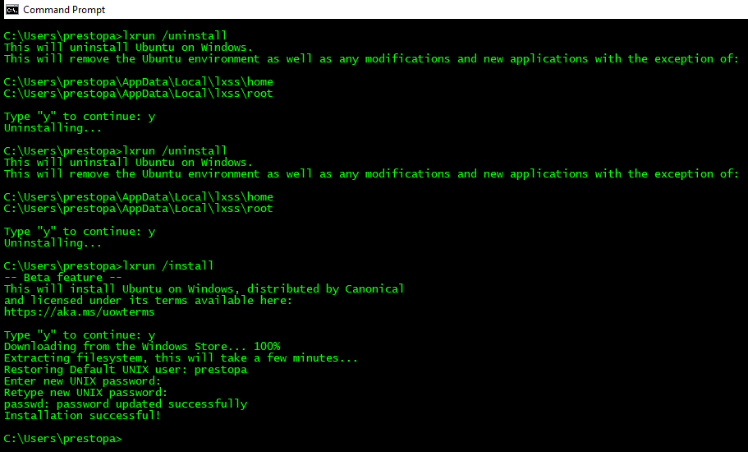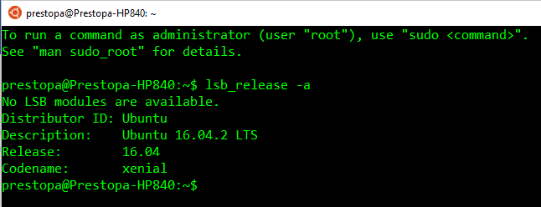

A1. <https://www.f3nws.com/news/how-to-upgrade-bash-windows-subsystem-for-linux-in-windows-10-creators-update-betanews-2pmZaG?js=off>

29. How do I install the Azure CLI tool?

A1. <https://docs.microsoft.com/en-us/cli/azure/install-azure-cli>

30. How do I log into Azure with Azure CLI ?

A1. <https://docs.microsoft.com/en-us/cli/azure/authenticate-azure-cli>

31. How do I create an SSH Key pair?

A1. <https://docs.microsoft.com/en-us/azure/virtual-machines/virtual-machines-linux-ssh-from-windows>

32. How do I create an Operational Management and Security (OMS) Workspace ?

A1. <https://docs.microsoft.com/en-us/azure/log-analytics/log-analytics-get-started>

33. How do I deploy a Linux VM from the Azure Portal?

A1. <https://docs.microsoft.com/en-us/azure/virtual-machines/virtual-machines-linux-quick-create-portal>

34. How do I deploy a Linux VM using the Azure CLI?

A1. <https://docs.microsoft.com/en-us/azure/virtual-machines/virtual-machines-linux-quick-create-cli?toc=%2fazure%2fvirtual-machines%2flinux%2ftoc.json>

35. What’s the difference between legacy BIOS and UEFI?

A1. <https://www.bing.com/videos/search?q=what+is+UEFI+%3f&&view=detail&mid=9F8C9F4A8C4349C307469F8C9F4A8C4349C30746&FORM=VRDGAR>

36. How do I get started with Docker?

A1. <https://docs.docker.com/get-started/>

A2. <http://training.play-with-docker.com/ops-landing/>

37. What is Windows Subsystem for Linux?

A1. <https://msdn.microsoft.com/en-us/commandline/wsl/faq>

A2. <https://blogs.msdn.microsoft.com/wsl/>

38. How do I upgrade my existing Windows Subsystem for Linux on Win10 Ubuntu 14.04 instance?

A1. <https://docs.microsoft.com/en-us/windows/wsl/install-win10>

A1. <https://blogs.msdn.microsoft.com/commandline/2016/10/19/wsl-adds-ubuntu-16-04-xenial-support/>

39. Can failures or activities trigger a web-hook at an external site or application?

A1. Yes. Here is a sample query to detect errors and respond with notifications and other actions.

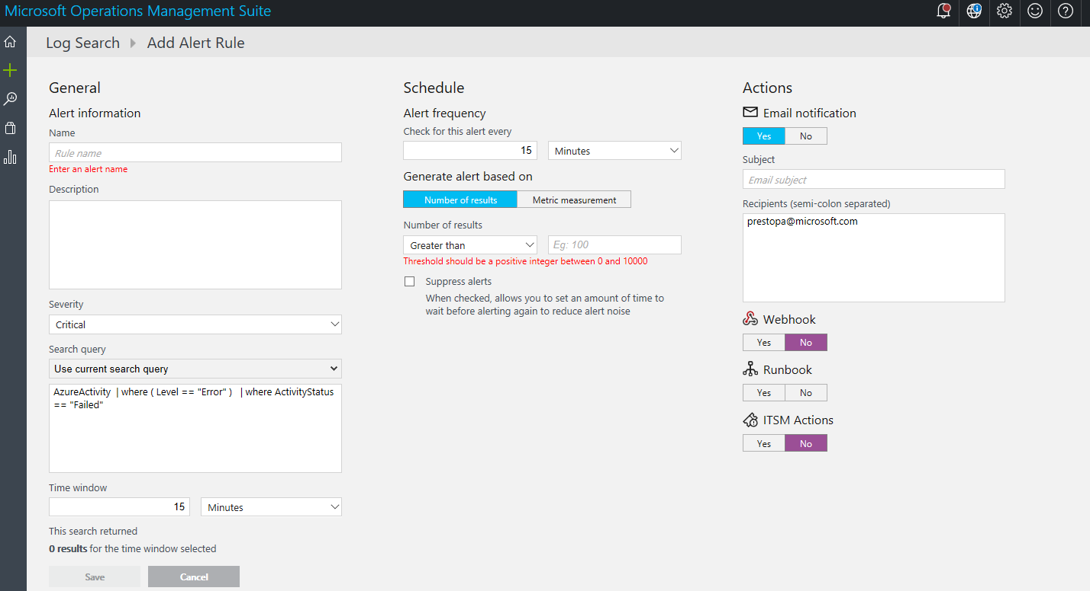

40. Does storage services encrypt data at rest for Azure Files ? Yes

<https://docs.microsoft.com/en-us/azure/storage/common/storage-service-encryption>

1. What is the max size of VM drives?

A1. 4095 GB

<https://docs.microsoft.com/en-us/azure/azure-subscription-service-limits#virtual-machines-limits>

1. How do I convert an OVA to VHD?

[www.nullsession.com/2017/12/14/converting-ova-vmdk-to-vhd-for-use-in-azure/](http://www.nullsession.com/2017/12/14/converting-ova-vmdk-to-vhd-for-use-in-azure/)

1. How do I persist files in Azure Cloud Shell?

<https://docs.microsoft.com/en-us/azure/cloud-shell/persisting-shell-storage>

1. Can I upload a file to an Azure storage account blob with a uri?

No, the syntax is:

Examples

Upload to a blob.

az storage blob upload -f /path/to/file -c MyContainer -n MyBlob

1. How do I build Microservices with AKS and VSTS ?

A1. <https://blogs.msdn.microsoft.com/azuredev/2018/03/27/building-microservices-with-aks-and-vsts-part-1/>

A2. <https://docs.microsoft.com/en-us/azure/aks/intro-kubernetes>

A3. <https://github.com/kubernetes/helm>

A4. <https://github.com/azure/draft>

1. How do I install Docker for Windows?

A1. <https://docs.docker.com/docker-for-windows/install/>

1. How can I install Docker CE for Ubuntu?

A1. <https://docs.docker.com/install/linux/docker-ce/ubuntu/>

1. What is the default option for hot/cool storage tiers for a blob storage account?

A1. TBD

1. How do I monitor when a load balancer fails over or fails back VMs.

A1. TBD

1. How can I generate passwords in bash?

<https://www.howtogeek.com/howto/30184/10-ways-to-generate-a-random-password-from-the-command-line/>

1. How can I use Azure Key Vault to pass a secure parameter valued during deployment?

A1. <https://docs.microsoft.com/en-us/azure/azure-resource-manager/resource-manager-keyvault-parameter>

1. What is the Azure CLI interactive mode?

A1. <https://azure.microsoft.com/en-us/blog/welcome-to-azure-cli-shell/>