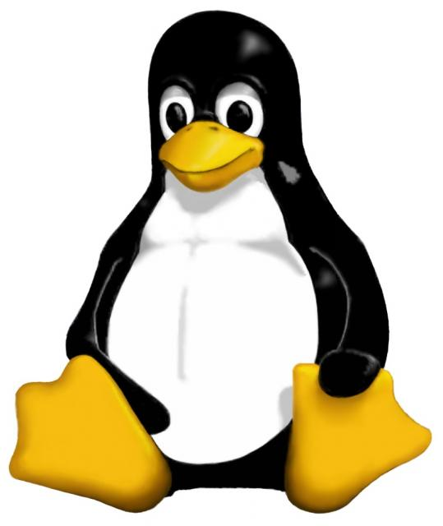
What Is Linux?
Linux is a free and open source software (FOSS) operating system available for many different types of computers. In 1991, Linus Torvalds, a student at the University of Helsinki, started Linux as a hobby. He chose to release the core of Linux—the kernel—under the GNU General Public License (GPL), making its source code freely available on the Internet. Today, hundreds of thousands of programmers around the world are developing Linux and programs that run on it—and Linux is used in all types of applications from mobile phones to personal laptops to corporate enterprise, and in the cloud.

What Can I Do With Linux?
Linux works equally well as a personal computing system, or as a high-powered server. There are many Linux distributions available, which bundle the kernel with thousands of software programs that make it useful for almost any purpose. Distributions usually come with software for many purposes:
Web browsing | Email and calendar
Word processing | Instant messaging
Music, movies and media | Creating illustrations
Presentations | Spreadsheets
Games | Programming
Network address calculations (IPv4/IPv6) | Scanning and retouching photos

Isn’t It Hard to Use?
Not at all! Linux used to have a fairly steep learning curve—but now it’s no harder to use than Windows or a Mac. It’s easy to install, and practically everything you need to do is just a couple mouse clicks away. Linux is incredibly stable, too—many systems running Linux go years without having to be rebooted. And it’s free to modify, so you can add any programs you like without having to worry about paying for it.

What If I Do Run Into Trouble?
There is a huge and vibrant community of Linux users worldwide that run help forums where you can find assistance and ideas. Each distribution has official help channels that offer advice to help you get the most out of your Linux system. User groups—like KeyLUG!—meet regularly, and allow experts and beginners alike to socialize, exchange ideas, and help each other in solving problems. Linux users come from all walks of life, and cover the entire political and cultural spectrum.

Are You Sure This Is Free?
ABSOLUTELY! And not just free as in “free doughnuts,” but also as in “free speech.” Some people can’t or don’t want to buy proprietary software, and resort to illegal and unethical copying. Free software does away with all those worries—you can have it all, perfectly legal and proper.

So How Do They Make Money?
Just because you can give it away doesn’t mean you have to. Companies large and small make money by building all sorts of products for their customers on Linux, or by selling services such as support and training. Small businesses benefit from Linux too, since they can buy inexpensive computer equipment and install Linux to run their web site, email, or file and print services.

I Still Don’t Get It—Why Give Away Something So Good for Free?
Think of Linux and free software like recipes for cooking. People who like to cook also like to come up with yummy recipes. And they almost always like to share them with family, friends, neighbors, and coworkers. They share their recipes partly out of a sense of pride in their accomplishment, but also to spread the joy of eating good food.
If you are a good cook, or professionally trained (a chef), you can make money from good recipes. You don’t have to write every recipe yourself, but you do have to be good at preparing them. Many chefs share their recipes with the cooking world, and don’t restrict those dishes just to those who live nearby or visit their restaurants. Chefs appreciate that sharing recipes them to succeed in their field.
Computer software is like recipes—sets of instructions for doing something useful, like managing a photo library. The people who make software enjoy doing that, just like cooks love making food. Being able to share the results is part of the joy of doing it. If you’re good at doing it, it’s easy to sell the results, or get a job doing it for a living. You’re free to share open source licensed software, just like a good recipe. That’s the way that Linux and all FOSS works, and also why it works so well!

Okay, I’m Convinced. Where Do I Get Linux?
Linux usually comes in large files that you can safely download and turn into CDs or DVDs. If you have a fast Internet connection, you can download Linux freely from any of a number of sites. Each distribution has a Web site, from which you can find links for downloading.

How Do I Install It?
Just insert the CD or DVD disc and reboot your computer. You may need to look at the manual for your computer system to find out how to start it from the disc.

Will It Destroy Microsoft Windows?
Not at all, but you will need to make sure there is space on your hard disk to install Linux. Most computers ship with the entire hard disk reserved for Windows. But Linux distributions understand this, and can shrink the space used by Windows without harming it, to make room for themselves too (you can also pre-shrink the Windows area from within Windows). Simply follow the directions during installation, and consult the documentation or help forums for your particular Linux distribution for details.

When and Where Do You Meet?
KeyLUG meets on the 1st Saturday of each month at the Mosaic Power, 145 E All Saints St, Frederick, MD. We also meet at other times for special events. For details and updates check https://www.meetup.com/KeyLUG/.
All experience levels, from beginner to expert, are warmly welcomed.
We have users of many popular distributions, including Fedora, Ubuntu, OpenSUSE, CentOS, Gentoo, Slackware, Red Hat Enterprise Linux, and others.
USING A LIVE DISC TO TEST DRIVE LINUX:
Insert the disc into your computer. You can boot right into Linux by selecting to boot from your computer's CD/DVD drive, or a USB stick—IT WILL NOT ALTER YOUR HARD DRIVE UNLESS YOU DELIBERATELY TELL IT TO. If you want to install Linux to your computer’s hard drive, use the icon provided on the desktop.

WANT MORE INFORMATION?
If you’d like to find out more or you want help installing Linux, stop by any of the KeyLUG meetings on the 1st Saturday of the month at the Mosaic Power on All Saints Street. The Frederick Linux Users Group will be there from 10:00 a.m. to 12:00 p.m. with an interesting presentation about FOSS, and to answer your questions to help install and use Linux. Also check out the meeting schedule and other resources on our MeetUp site at
https://www.meetup.com/KeyLUG/
and
https://github.com/keylug
For help with Fedora Linux, visit:
https://getfedora.org/

For help with Ubuntu Linux, visit:
http://www.ubuntu.com/download

Further background on Software Freedom Day is at
http://softwarefreedomday.org/

