Ge’ezWord Amharic Mobile Typing Manual

TOPICS
- Mobile Keyboard Typing
- GeezWord Mobile Keyboard Typing
- Speed Typing (“Press Twice”)
- Additional Speed for (“ሥ, ኅ, ኤ, እ, ዕ”)
- Phonetic Keyboard Assignments
- Lower Case Assignment:
- Upper Case Assignment:
- Vowel Key Assignment:
- Stand Alone Vowel Keys
- Modifiers Vowel Keys:
- Long Press for Geez Vowels :
- Long Press to Select Punctuations:
- Long Press to Select Geez Numerals:
- Special Key ( “^”) to Duplicate Letter.
- Typing Diphthong Letters

Slow Mobile Keyboard Typing
In mobile keyboard, the user must frequently toggle to different layers (lower, upper, numeric) to type some of the Geez letters. This toggling makes it inconvenient and slows down the flow of typing speed. This issue has been resolved in GeezWord Mobile.

Faster GeezWord Mobile Keyboard Typing
We have enhanced GeezWord mobile keyboard layout for speed and convenience. Two main enhancements were made. In the first enhancement, you Press Twice a key, instead of switching to the Shift layer to type a letter or instead of selecting a letter from popup screen.
Speed Typing (“Press Twice”)
Pressing Key twice is much faster typing, than pressing shift key to select a letter or even selecting from a popup screen. As a matter of fact, there is little difference between pressing once and pressing the same key twice. We recommend to never use the Shift key or the popup, but instead “Press Twice” method as shown in the following examples.

ሕ | ሽ | ቕ | ጥ | ጭ | ኝ | ኽ | ዥ | ዽ | ጝ | ፅ | ጵ
hh | hh | qq | tt | cc | nn | kk | zz | dd | gg | xx | pp

Example: mexhhef = መጽሐፍ (“book”)
Example: ppilattos = ጲላጦስ (Pilate Biblical name)

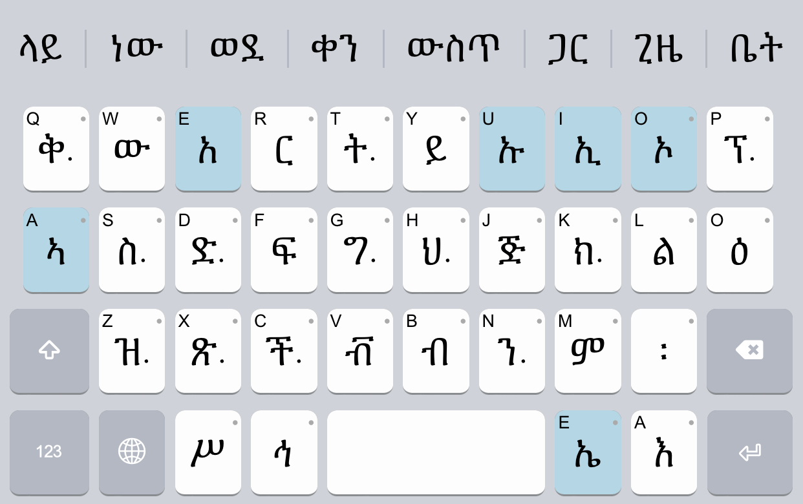
The keys with two dots indicate “Press Twice”.

Amharic Example:
መ | ጽ | ሐ | ፍ |  | ስ | ጠ | ኝ
me | X | hhe | f |  | s | tte | nn

Additional Speed Typing for (“ሥ, ኅ, ኤ, እ, ዕ”)
In the second enhancement, high frequently consonants (እ, ዕ) and vowel ኤ, are directly accessible as shown below.

Special consonant keys (እ,ዕ) and vowel ኤ, are directly accessible – no need to press the Shift key

Press እ, followed by any of the vowel keys (e u i a o) to generate the vowels = አኡኢኣኤእኦ
Example: በ ኡ ነ ት = be Au ne t
Press ዕ, followed by any of the vowel keys (e u i a o) to generate the vowels = ዐዑዒዓዔዕዖ
Example: በ ዓ መ ት = be Oa me t
Press ኤ is short cut for “ie”. It serves as standalone letter in a case when it is the first letter in a word or serves as a modifier vowel in other cases.
Example: በ ኤ ም ባ ሲ = be Aie m ba si (as standalone)
Example: ሴ ት = sie t (as vowel)

Phonetic Keyboard Assignment

Lower Case Assignment:
The following Geez letters, mostly with soft sounds, are assigned to lower case keys. They are phonetically matched with Lain letters.

ህ | ል | ም | ር | ስ | ቅ | ብ | ቭ | ት | ች | ን | ክ
h | l | m | r | s | q | b | v | t | c | n | k

ው | ዝ | ይ | ድ | ጅ | ግ | ጽ | ፍ | ፕ
w | z | y | d | j | g | x | f | p

Upper Case Key Assignment:
Many of the following letters have hard/explosive sound, are assigned to UPPER case keys. Even though, most of these sounds don’t exist in English, they are matched with their closest Latin letters.

እ | ሕ | ሽ | ቕ | ጥ | ጭ | ኝ | ኽ | ዥ | ዽ | ጝ | ፅ | ጵ
A | H | S | Q | T | C | N | K | Z | D | G | X | P

Vowel Keys Assignment:
Latin vowel keys (a e i o u) have dual assignments in GeezWord - as Standalone letters and as Modifiers to consonants.

Special Standalone Vowels
The Latin keys (e u i a ie o) generate Geez letters only when they appear at the beginning of a word as shown in the example below. Otherwise, they serve as modifiers to other consonants.

አ | ኡ | ኢ | ኣ | ኤ | እ | ኦ | ኧ
e | u | i | a | ie | A | o | Aue

Example: አስመራ = (esmera in Tigrinya spelling)
Example: አዲስ አበባ = (edis ebeba in Amharic spelling)
Modifiers to Consonants:
The Latin keys (e u i a o) function as modifiers to the 35+ consonants. Here is an example for the consonant “b”:

በ | ቡ | ቢ | ባ | ቤ | ብ | ቦ | ቧ
be | bu | bi | ba | bie | b | bo | bua

Example: ሰላምታችን ይድረሳችሁ። selamtacn ydresachu
Long Press for Geez Vowels :
Long Press (means press and hold it a bit linger) any Geez key, a pop screen of vowels associated with the letter pressed will popup as shown below for the letter “ት”.
You can move up your finger to the popup screen to select the right Geez letter. In this example, we see two rows representing “ት”, and “ጥ”. Others may show a single row, for example the letter “ል”. Long Press is not recommended for speed typing as it is too slow. Instead use pressing a key once or twice.

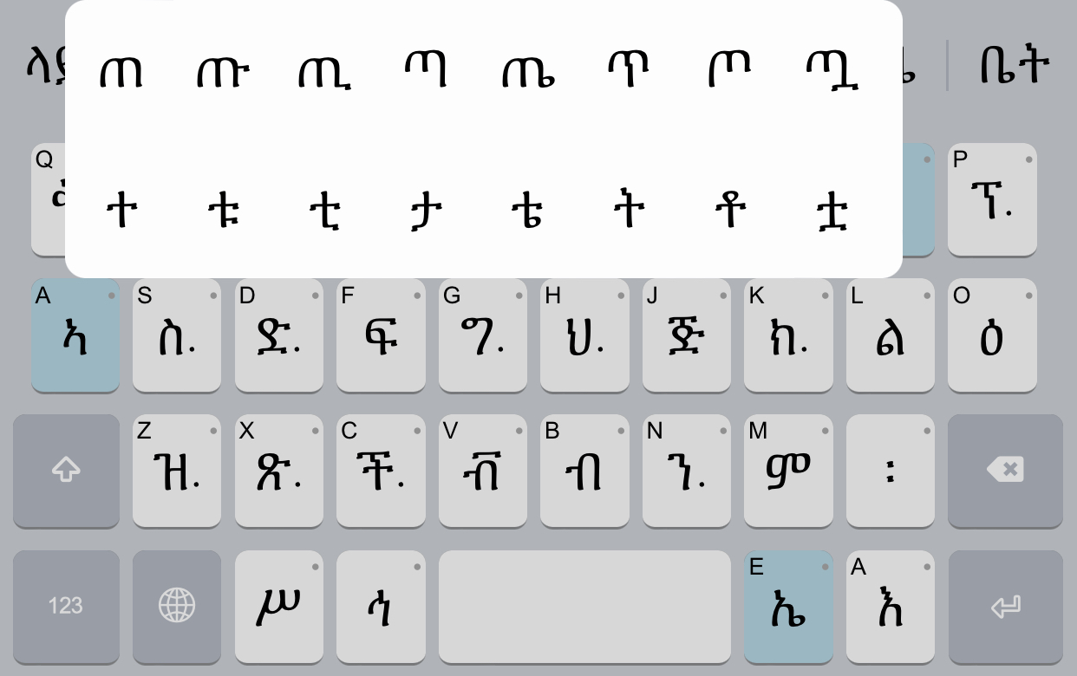

Long Press to Select Punctuations:
Long Press (means press and hold it a bit linger) the two dots (፡), a pop screen of two rows of punctuation symbols gets displayed. They are the most commonly used punctuation symbols for Geez and English as shown below. You can move up your finger to the popup screen to select the right symbol.

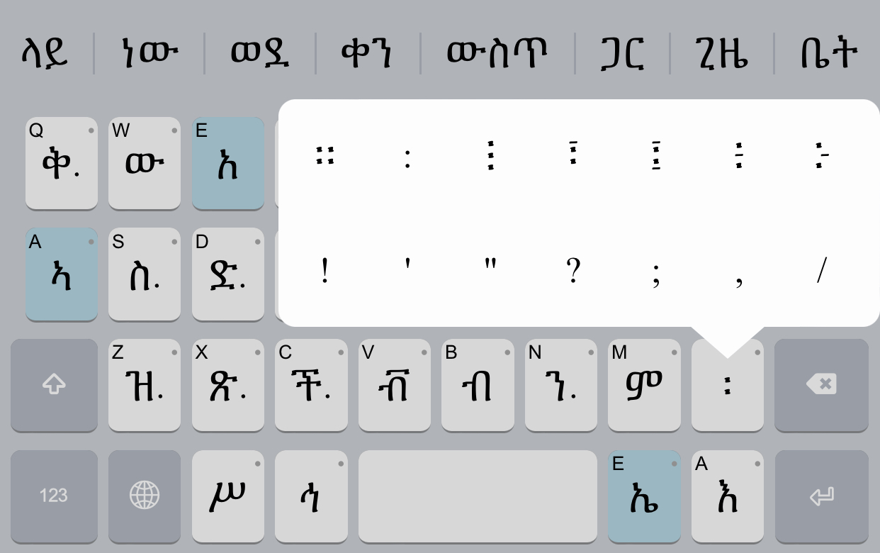
፡

Long Press to Select Geez Numerals:
Geez numerals can be accessed from the Numerals layer. Long Press (means press and hold it a bit longer) on any numeral key and the corresponding Geez numerals will pop up as shown below. You can move up your finger to the popup screen to select the desired Geez numeral.

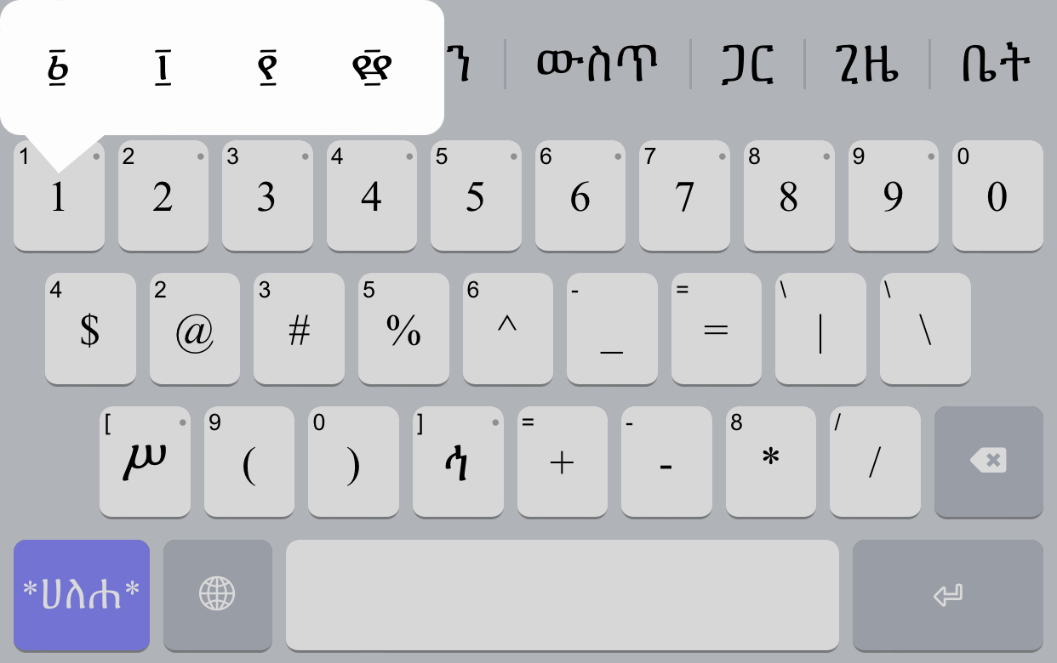
1

Special Key ( “^”) to Duplicate previous letter.
The “Press Twice” special letters, can be typed in duplicate with a little trick using “^”.
For example, to type ህህ , use the “^” symbol to duplicate previous letter, as shown below.
h^ = ህህ
The same rule applies to others in the table below.
ህህ | ስስ | ቅቅ | ትት | ችች | ንን | ክክ | ዝዝ | ድድ | ግግ | ጽጽ | ፕፕ
h^ | s^ | q^ | t^ | c^ | n^ | k^ | z^ | d^ | n^ | x^ | p^

Typing Diphthong Letters
How to type the Diphthong letters is the most challenging for most users. In Geezword, it is based on phonetic sound of the letters. The most important to remember is the additional key “u” inserted following the consonant key. The vowels are the same as the other letters. That is all. Here are some examples:
ድ ጓ = d gua
ጧ ት = ttua t or Tua t

Please, use the table below for guidance.
 | e | i | a | ie | w
q | ቈ  que | ቊ  qui | ቋ  qua | ቌ  quie | ቍ  quu
Q | ቘ  Que | ቚ  Qui | ቛ  Qua | ቜ  Quie | ቝ  Quu
] | ኈ  ]ue | ኊ  ]ui | ኋ  ]ua | ኌ  ]ie | ኍ  ]uu
k | ኰ  kue | ኲ  kui | ካ  kua | ኴ  kie | ኵ  kuu
K | ዀ  Kue | ዂ  Kui | ዃ  Kua | ዄ  Kuie | ዅ  Kuu
g | ጐ  gue | ጒ  gui | ጓ  gua | ጔ  guie | ጕ  guu

Blin Letters
 | e | u | i | a | ie |  | o
G | ጘ  Ge | ጙ  Gu | ጚ  Gi | ጛ  Ga | ጜ  Gie | ጝ  G | ጞ  Go
Gu | ⶓ  Gue |  | ⶔ  Gui | ጟ  Gua | ⶕ  Guie | ⶖ  Guu

