General description of the Bod keyboards for Tibetan:
- For Tibetan, two keyboards have been designed: BodLocal, the corresponding icon is , for local Tibetan and BodTransliterating, the corresponding icon is , for transliterating Tibetan.
- The two keyboards have the same visual layouts; however, they have different source files. The files for local Tibetan are Bod-L-KSF.kmx, Bod-L-SKF.kvk etc. with the letter L between two dashes while the files for transliterating Tibetan are Bod-T-KSF.kmx, Bod-T-SKF.kvk etc. with the letter T between two dashes.
- The other files such as the font, Readme, Copyrights, Help, and splash picture are same for the both keyboards.

The expected User Interface:
- As soon as the two keyboards layouts are installed, the BodLocal is the default keyboard and its icon, , is displayed in the system notification area, as shown in Figure 1.
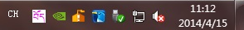
Figure 1. As soon as the two keyboards are installed, the icon for BodLocal is displayed in the system notification area.
- As shown in Figure 2, only the “Bodlocal ” keyboard and the “BodTransliterating” keyboard are listed.
- The hotkeys for BodLocal is Shift+Alt+L and the hotkeys for BodTransliterating is Shift+Alt+T, as shown in Figure 2.
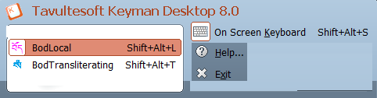
Figure 2. The two keyboards are listed , and the user can choose the other with left mouse down the current keyboard.
- Delete all other buttons except “On Screen Keyboard”, “Help”, and “Exit”.
- Replace the following four English captions with their Tibetan counterparts.
(1)(Both the icon and the caption)→Bod་བོད་ཡིག་གཏག་ཐབས
(2)On screen keyboard→བརྙན་ཡོལ་མཐེབ་གཞོང
(3)Help→རོགས་རམ
(4)Exit→ཕྱིར་ལོག
The expected user interface somehow looks like Fig. 3.
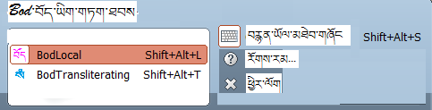
Figure 3. The expected user interface.
- The expected on screen keyboard somehow looks like Fig. 4.
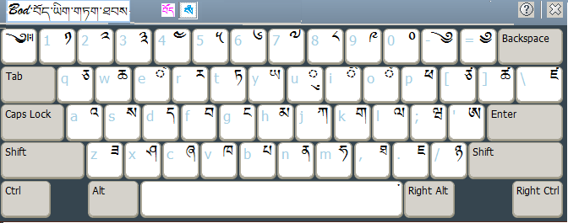
Figure 4. The expected on screen keyboard.
- Configure ‘Tibetan’ for the two newly developed Tibetan keyboard layouts, as shown in Figure 5.
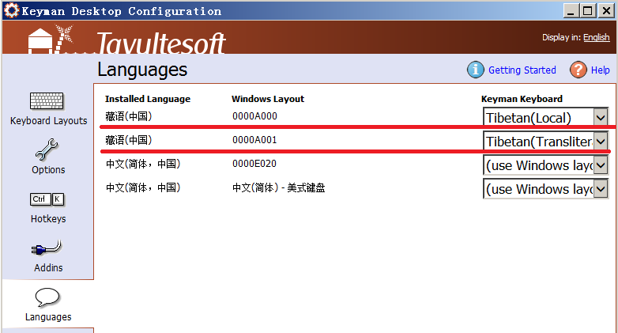
Figure 5. The default language configuration for the two newly developed Tibetan keyboard layouts, where the four Chinese characters 藏语（中国） mean Tibetan(P. R. China).
- Change the background colour of the on screen keyboard to one of the colours shown in Figure 6.

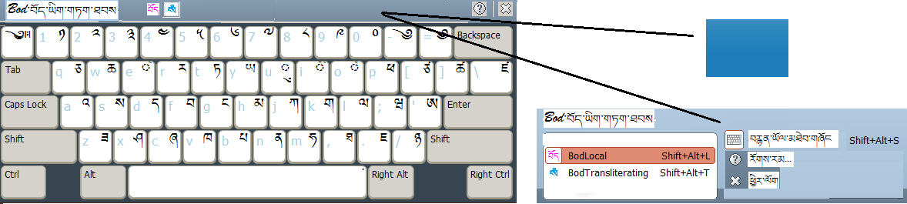
Figure 6. Change the background colour of the on screen keyboard.

