Abyssinica SIL Features

The Ethiopic script does not require much rendering except for some combining marks for gemination and vowel length. Abyssinica SIL provides both OpenType and Graphite rendering solutions for rendering the combining marks and for kerning as well as for the special glyph variations that can occur for the Ethiopic script. The tables below give lists of the Graphite features available in Abyssinica SIL.

Abyssinica SIL Graphite Features
New (version 1.500): To conform to the CSS four-character tag requirements, Graphite feature IDs for all variants in Abyssinica SIL have been changed since version 1.100.
When Abyssinica SIL is used in applications that support Graphite, and that provide an appropriate user interface, various user-controllable font features are available that allow access to alternatively-designed glyphs that might be preferable for use in some contexts. In LibreOffice 3.4+ the font features can be turned on by choosing the font (ie Abyssinica SIL), followed by a colon, followed by the feature ID, and then followed by the feature setting. So, for example, if the “dda alternates” are desired, the font selection would be “Abyssinica SIL:cv32=1”. If you wish to apply two (or more) features, you can separate them with an “&”. Thus, “Abyssinica SIL:cv32=1&cv20=1” would apply “dda alternates” plus the “nya alternates” feature.
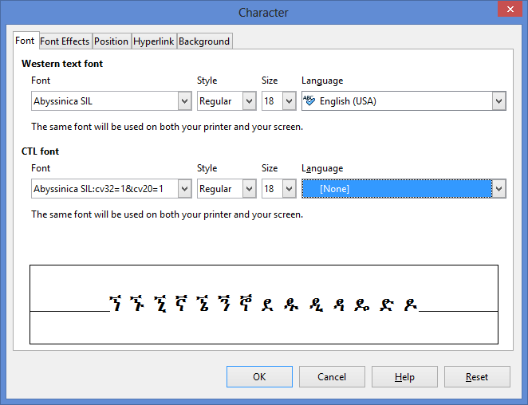

For XeTeX, Feature IDs are not used. Use the Feature Name and Feature setting, e.g., if Character Variant 32 was desired, the font selection would be: "Abyssinica SIL/GR:dda alternates=Alternate" at 12pt
The table below gives a visual representation of the featured character glyphs in the font. The shaded lines show the default character(s). The other lines show the first alternate and, if available, the second alternate.

List of Graphite features
Graphite Feature Name | Feature setting | Feature IDs for LibreOffice | Character shapes
Punctuation | Ethiopic-style | Abyssinica SIL (default) | ! $ % * + / 0 1 2 3 4 5 6 7 8 9 = ? ¡ © « ² ³ ¹ » × ‘ ’ “ ” ‹ › ⁰ ⁴ ⁵ ⁶ ⁷ ⁸ ⁹ €
 | Latin-style | Abyssinica SIL:cv01=1 | ! $ % * + / 0 1 2 3 4 5 6 7 8 9 = ? ¡ © « ² ³ ¹ » × ‘ ’ “ ” ‹ › ⁰ ⁴ ⁵ ⁶ ⁷ ⁸ ⁹ €
mwa alternates (U+121F) | Standard |  | ሟ
 | Alternate-1 | Abyssinica SIL:cv04=1 | ሟ1
 | Alternate-2 | Abyssinica SIL:cv04=2 | ሟ2
rwa alternate (U+122F) | Standard | Abyssinica SIL (default) | ሯ
 | Alternate | Abyssinica SIL:cv05=1 | ሯ²
xoa alternate (U+1287) | Standard | Abyssinica SIL (default) | ኇ
 | Alternate | Abyssinica SIL:cv17=1 | ኇ
xwa alternates (U+1288..U+128D) | Standard | Abyssinica SIL (default) | ኈ ኊ ኋ ኌ ኍ
 | Handwriting | Abyssinica SIL:cv18=1 | ኈ ኊ ኋ ኌ ኍ
nwa alternate (U+1297) | Standard | Abyssinica SIL (default) | ኗ
 | Alternate | Abyssinica SIL:cv19=1 | ኗ¹
nya alternates (U+1298..U+129E) | Standard | Abyssinica SIL (default) | ኘ ኙ ኚ ኛ ኜ ኝ ኞ
 | Disconnected | Abyssinica SIL:cv20=1 | ኘ ኙ ኚ ኛ ኜ ኝ ኞ3
nywa alternates (U+129F) | Standard | Abyssinica SIL (default) | ኟ
 | Disconnected | Abyssinica SIL:cv21=1 | ኟ³
 | Cohen | Abyssinica SIL:cv21=2 | ኟ²
kxwaa alternate (U+12C3) | Standard | Abyssinica SIL (default) | ዃ
 | Alternate | Abyssinica SIL:cv26=1 | ዃ²
zha alternates (U+12E0..U+12E6) | Standard | Abyssinica SIL (default) | ዠ ዡ ዢ ዣ ዤ ዥ ዦ
 | Cohen | Abyssinica SIL:cv31=1 | ዠ ዡ ዢ ዣ ዤ ዥ ዦ4
 | Chaine | Abyssinica SIL:cv31=2 | ዠ ዡ ዢ ዣ ዤ ዥ ዦ5
dda alternates (U+12F8..U+12FE) | Standard | Abyssinica SIL (default) | ዸ ዹ ዺ ዻ ዼ ዽ ዾ
 | Alternate | Abyssinica SIL:cv32=1 | ዸ ዹ ዺ ዻ ዼ ዽ ዾ6
gwaa alternates (U+1313) | Standard | Abyssinica SIL (default) | ጓ
 | Sebat Bet | Abyssinica SIL:cv40=1 | ጓ7
 | Alone Stokes | Abyssinica SIL:cv40=2 | ጓ8
gga alternates (U+1318..U+131E) | Standard | Abyssinica SIL (default) | ጘ ጙ ጚ ጛ ጜ ጝ ጞ
 | Disconnected | Abyssinica SIL:cv41=1 | ጘ ጙ ጚ ጛ ጜ ጝ ጞ9
ggwaa alternate (U+131F) | Standard | Abyssinica SIL (default) | ጟ
 | Disconnected | Abyssinica SIL:cv42=1 | ጟ⁹
phe alternate (U+1335) | Standard | Abyssinica SIL (default) | ጵ
 | Alternate | Abyssinica SIL:cv45=1 | ጵ10
tswa alternate (U+133F) | Standard | Abyssinica SIL (default) | ጿ
 | Alternate | Abyssinica SIL:cv46=1 | ጿ
fwa alternates (U+134F) | Standard | Abyssinica SIL (default) | ፏ
 | Cohen-1 | Abyssinica SIL:cv48=1 | ፏ¹
 | Cohen-2 | Abyssinica SIL:cv48=2 | ፏ¹
rya alternate (U+1358) | Standard | Abyssinica SIL (default) | ፘ
 | Alternate | Abyssinica SIL:cv49=1 | ፘ²
mya alternate (U+1359) | Standard | Abyssinica SIL (default) | ፙ
 | Alternate | Abyssinica SIL:cv50=1 | ፙ²
mwi alternates (U+1381) | Standard | Abyssinica SIL (default) | ᎁ
 | Sebat Bet | Abyssinica SIL:cv60=1 | ᎁ⁷
 | Leslau | Abyssinica SIL:cv60=2 | ᎁ¹¹
mwe alternates (U+1383) | Standard | Abyssinica SIL (default) | ᎃ
 | Sebat Bet | Abyssinica SIL:cv61=1 | ᎃ⁷
 | Leslau | Abyssinica SIL:cv61=2 | ᎃ¹¹
bwe alternate (U+1387) | Standard | Abyssinica SIL (default) | ᎇ
 | Alternate | Abyssinica SIL:cv62=1 | ᎇ¹¹
fwee alternate (U+138A) | Standard | Abyssinica SIL (default) | ᎊ
 | Alternate | Abyssinica SIL:cv63=1 | ᎊ11
fwe alternate (U+138B) | Standard | Abyssinica SIL (default) | ᎋ
 | Alternate | Abyssinica SIL:cv64=1 | ᎋ¹¹
pwe alternate (U+138F) | Standard | Abyssinica SIL (default) | ᎏ
 | Alternate | Abyssinica SIL:cv65=1 | ᎏ¹¹
ggwa alternates (U+2D93..U+2D96) | Standard | Abyssinica SIL (default) | ⶓ ⶔ ⶕ ⶖ
 | Disconnected | Abyssinica SIL:cv70=1 | ⶓ ⶔ ⶕ ⶖ⁹
3rd form alternates | Standard | Abyssinica SIL (default) | ቊ ኲ ዂ ጒ ᎅ ᎍ
(U+124A U+12B2 U+12C2 U+1312 U+1385 U+138D) | Alternate | Abyssinica SIL:cv80=1 | ቊ ኲ ዂ ጒ ᎅ ᎍ⁷
6th form alternates | Standard | Abyssinica SIL (default) | ቍ ኵ ዅ ጕ
(U+124D U+12B5 U+12C5 U+1315) | Alternate | Abyssinica SIL:cv85=1 | ቍ ኵ ዅ ጕ⁷

References
Alone, John Philip Herbert Mackenzie. 1946 (Fourth edition). The Alone-Stokes Short Manual of the Amharic Language (with vocabularies). Macmillan and Co. Limited: London.
Chaîne, Marius. 1907. Grammaire éthiopienne. Imprimerie catholique. Beyrouth.
Cohen, Marcel. 1970 Seconde edition. Traité de langue amharique (Abyssinie). Institut d'ethnologie: Paris.
Leslau, Wolf. 1966. Ethiopians Speak: Studies in Cultural Background. Part 2: Chaha. University of California Publication. Near Eastern Studies, Volume 9. University of California Press: Berkeley
Praetorius, Franz. 1955. Aethiopische Grammatik mit Paradigmen, Litteratur, Chrestomathie und Glossar. Frederick Ungar Publishing Co. New York.

Download here: http://www.libreoffice.org/download.
http://tug.org/xetex/
1Chaîne (p 3), Cohen (table 2)
2Cohen (table 2)
3Gumuz language preference
4Alone-Stokes, Chaîne (p 3), Cohen (table 1)
5Chaîne (p 3)
6Archaic Oromo language preference
7Sebat Bet language preference
8Alone-Stokes (inside back cover)
9Bilen language preference
10Praetorius (p 6)
11Leslau

