Naija Type
(Formerly known as Nigeria Unified)
by David Rowbory, December 2016

a | + | ; | = | ə | shape
 | + | ; | = | a̱ | shape
a | + | ` | = | à | tone
 | + | ` | = | á | tone
n | + | ; | = | ŋ | shape
b | + | ; | = | ɓ | shape
a | + | ~ | = | ã | nasal

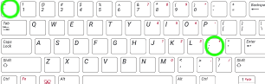
Type a normal letter than press the 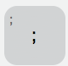 (semicolon) key to change its shape. Keep pressing this key to try different shapes related to the original letter.
After typing a letter that can have a tone accent mark, press the 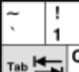 (~`) key (normally to the left of the number 1 key) to try different tone marks.
After typing a vowel, hold down the 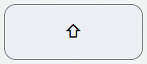 shift key then press the (~`)key to add or remove the nasal mark.

