# SIL Tai Dam keyboard layout charts

Note that high series consonants are assigned to shifted keys, and low series consonants are assigned to unshifted keys.

**Chart 1: SIL Tai Dam Keyboard—unshifted**

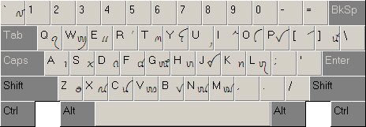

**Chart 2: SIL Tai Dam Keyboard—shifted**

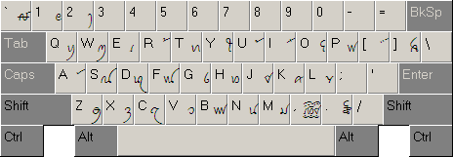

**Chart 3: SIL Tai Dam Keyboard—characters requiring two keystrokes**

| **Character** | **Keystrokes** |  | **Character** | **Keystrokes** |
| --- | --- | --- | --- | --- |
| ꪃ | K + K |  | ꪧ | R + R |
| ꪂ | k + k |  | ꪦ | r + r |
| ꪇ | G + G |  | ! | | + ! |
| ꪆ | g + g |  | @ | | + @ |
| ꪍ | C + C |  | < | | + < |
| ꪌ | c + c |  | > | | + > |
| ꪟ | P + P |  | ◌ | ( + ) |
| ꪞ | p + p |  |  |  |