SIL Tai Dam Keyboard

**January 2018**

**Jim Brase, SIL International**

# Background and overview

“Tai Viet” is the name of the script which the Tai people of northwestern Vietnam and surrounding regions use to write their languages. The Tai Viet script has been part of The Unicode Standard since version 5.2.

One of the challenges of implementing a keyboard for the Tai Viet script is to fit all of the required characters, including punctuation, onto the available keys. Thus, the **SIL Tai Dam** keyboard has been optimized for typing the Tai Viet script as it is used for writing the Tai Dam language. Those characters required for the Tai Dam language of Tai Dam language of Sơn La Province can be typed with a single keystroke. Other characters, including six aspirated consonants used by the Tai Dón language of Lai Châu province, and four consonants used only in loan words, have been assigned to less-than-optimal two-keystroke sequences. See the charts below for details.

The **SIL Tai Dam** keyboard is a mnemonic layout based in the US English keyboard. That is, each Tai Viet character is assigned to the key that has the nearest equivalent English letter. Low series consonants are assigned to unshifted keys, and high series consonants are assigned to the equivalent shifted key.

# SIL Tai Dam keyboard layout charts

Note that high series consonants are assigned to shifted keys, and low series consonants are assigned to unshifted keys.

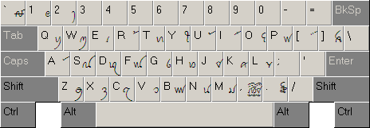

**Chart 1: SIL Tai Dam Keyboard—shifted**

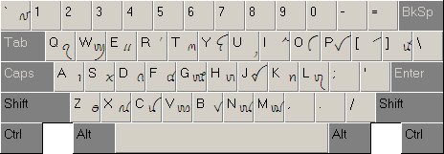

**Chart 2: SIL Tai Dam Keyboard—unshifted**

| **Character** | **Keystrokes** |  | **Character** | **Keystrokes** |
| --- | --- | --- | --- | --- |
| ꪃ | K + K |  | ꪞ | p + p |
| ꪂ | k + k |  | ꪧ | R + R |
| ꪇ | G + G |  | ꪦ | r + r |
| ꪆ | g + g |  | ! | | + ! |
| ꪍ | C + C |  | @ | | + @ |
| ꪌ | c + c |  | < | | + < |
| ꪟ | P + P |  | > | | + > |

**Chart 3: SIL Tai Dam Keyboard—characters requiring two keystrokes**