Tai Dam keyboard for the Lao alphabet

# Background

Many Tai Dam people living in the United States first learned to read and write their language with the Lao alphabet. This keyboard is designed for them.

The keyboard uses a mnemonic layout based on the US English keyboard. That is, a Lao character will be placed on the phonetically equivallent English letter. The layout is similar to a keyboard that has been designed for the Tai Viet script (the traditional Tai Dam script), which also had a mnemonic layout based on the US English keyboard.

# Layout

**Unshifted**

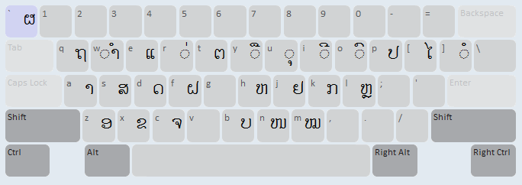

**Shifted**

