Layout for the

Tai Dam-Latin Optimized

keyboard

This keyboard is an implementation of the Latin alphabet designed for the Tai Dam language by SIL International. The ISO code for the writing system is **blt-Latn**.

# Keyboard Layout

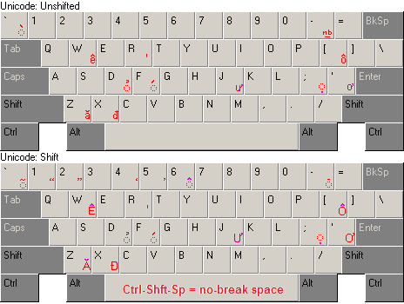

# Notes

* **Optimization:** The layout attempts to make typing easier by moving some of the most frequently used characters from the edges of the keyboard, where they must be typed with the little finger, to the center where they can be typed with the index finger. Thus:
  + The Saltillo (U+A78C), used as a consonant class marker to mark tones 4-6, is the most frequent letter and is placed on the R key.
  + The acute accent is the third most common character, and is placed on the ‘F’ key.
  + All of the Tai Dam tone marks (Acute, Hook, and Dot below) are place in both the shifted and unshifted position.
* The layout is based on a standard US English keyboard.
* Consonants and vowels not on a US English keyboard have been mapped to keys that are not used for Tai Dam.
* All combining accents (those shown on the layout chart with a dotted circle below them) are context sensitive, meaning they are output only after a vowel. E.g.:

If I press the keys:   
 C O F N  
the keyboard will output:   
 cón

But if I press:  
 C P F N  
the keyboard will output:  
 cpfn

Thus, the output of the F key depends on what key was pressed before it. This is true for the Tai Dam combining accents (Acute, Hook, and Dot below), as well as for the Vietnamese and White Tai combining accents (Grave, Tilde, Hat, and Macron).

If I want to force the keyboard to produce a combining accent regardless of what key comes before, I can do so by pressing the ‘=’ key before the accent. E.g.

If I press:  
 C P = F N  
the keyboard will output:  
 cṕn

* The default hyphen character is the No-Break Hyphen (U+2011). Press the hyphen key twice to get a regular hyphen.
* If I press [Left parenthesis] + [Right parenthesis], the keyboard will output a dotted circle.
* Any key that has been mapped to some other letter can be forced to produce its original output be pressing it twice. E.g.

I want to type an English word that contains the letter ‘w’ without bothering to turn the keyboard off. If I press:  
 W I L L  
the keyboard will output:  
 êill

But, if I press  
 W W I L L  
the keyboard will output:  
 will