KLYARA the back office for building firms

Klyara — The Day-by-Day Plan
Every day from today to day 90. Dated, timed, and written so it can be done without thinking.

*Launch: Monday 14 September 2026. Day 90: Saturday 12 December 2026. Setup phase: Tuesday 1 September - Sunday 13 September 2026. Nothing is scheduled before the 1st.*
How to use this
Each day has one thing — if the day goes wrong and you only do one item, do that one. Times are realistic, not aspirational. Weekends are mostly empty on purpose: a 90-day plan that eats every Saturday gets abandoned in week three.
docs/NN references point at the other documents in this pack.
Symbols: blocking · hard deadline · costs money · needs the other founder · has a waiting period
Added since this plan was first written
Four things arrived after the first version and they are slotted into the days below. If you have already started the plan, these are the catch-up items.
What | Where it slots | Why it matters
web/tools.html — four working tools | Sat 29 Aug, with the schema | Ten pages already link to it. Until it is live those are broken links, and it is the thing every outbound message gives away.
docs/21 — pricing, scope and quoting | Sun 6 Sep, with the sales pack | The scope schedule goes out with every engagement letter from client 1. Retrofitting scope onto an existing client is the hardest conversation in this business.
docs/22 — competitor and price benchmark | Sun 6 Sep, same sitting | Adds the "founding client rate" wording, which costs nothing now and is worth the whole price increase later.
docs/23 — outreach and partners | Week 1 onwards, as a standing weekly block | The content works in month four. This is what produces clients in month one.
docs/26 — the review engine | Read before client 1; first ask at day 35 | docs/19 found reviews are the single missing input for the whole AI-discovery channel. Twenty reviews needs about eighty asks, so the asking has to start immediately and be systematic.
docs/25 — the monthly client report | End of month 1 for client 1 | The only tangible thing a client receives, and the trigger for the day-35 review ask.

One standing addition to every week from Week 1: the outbound rhythm in docs/23 §PART 7. Two early-morning call blocks, two email blocks, one partner coffee, twenty minutes of group answering four days a week. Roughly four hours. Put it in the diary as recurring now — it is the single highest-yield block in the whole ninety days and it is the first thing to get skipped.
The line that matters
Put it in the diary as recurring now — it is the single highest-yield block in the whole ninety days and it is the first thing to get skipped.

In this part
Every day from today to day 90. Dated, timed, and written so it can be done without thinking. · How to use this · Added since this plan was first written

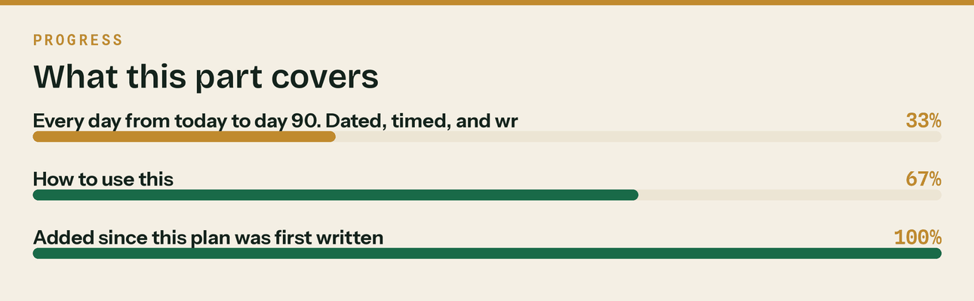
Read top to bottom. The bar is just how far through the part you are.

SETUP PHASE — Tue 1 Sep to Sun 13 Sep

*Thirteen days, and the first day either of you works on this. Roughly 18 hours in total. Two items have waiting periods attached and both start on day one, because everything else queues behind them: the ICB practice licence is 28 days, and the Google Business Profile verification is 5 to 14. Start those on the 1st and the rest of the fortnight is unblocked.*
*Nothing in this plan is scheduled for you or Craig before Tuesday 1 September.*
Tuesday 1 September · ⏱ 2h · both of you
One thing: Start the two clocks. Nothing else in the ninety days matters as much as these two going in today.
- Apply for the ICB Practice Licence. £94 application, then £373–£406 a year (£206 licence plus £167–£200 membership). It includes MLR supervision, which is the thing that lets Klyara lawfully take bookkeeping clients. Stated processing time is 28 days, so applying today means supervision lands around 29 September — before launch has had a month to produce anybody. Applying a fortnight later would put it into the middle of the launch. See docs/17 §1 for why this beats registering with HMRC directly (£300 plus £400 per premises, up to 45 days).
- Start the Google Business Profile claim. Verification is 5 to 14 days and every local-SEO result in this plan sits behind it.
- Write both dates on a wall. Every "when can we take a client" decision keys off the licence date, and it is the question you will be asked most.
- Get Professional Indemnity Insurance quotes — it is a condition of the licence, and ICB members get a discounted route.
- Sit down together for thirty minutes and read docs/18. It is the list of thirty decisions only the two of you can make, and the sooner they are made the less of this plan is guesswork.
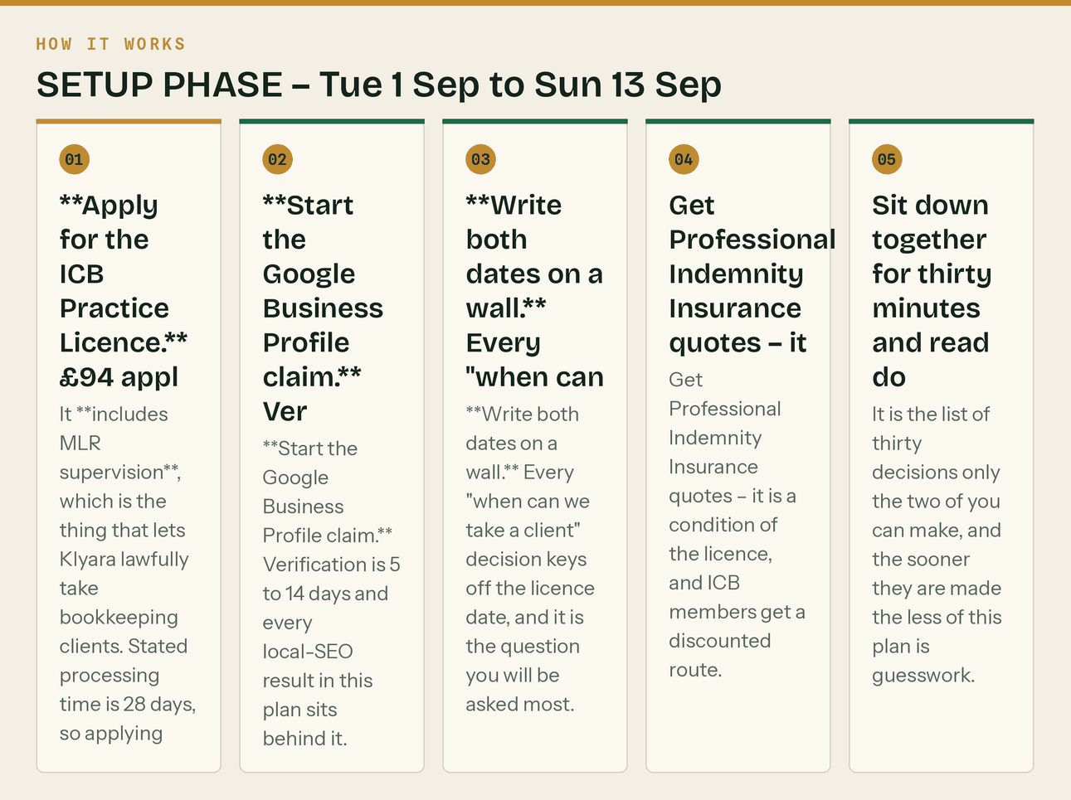
The same steps, in order.
Wednesday 2 September · ⏱ 2h
One thing: Kill the testimonials. Nothing else on the site matters until they are gone.
- Remove the five homepage testimonials. Marcus B., Dean W., Sam O., Priya T., Jodie F. Replace with the honest-new-firm block in docs/07 §Option B. This is not optional and nothing else in this plan matters until it is done.
- Read docs/07 top to bottom. It is 15 minutes and it is the only document that describes a legal exposure.
- Go through the site and future-tense every claim that is not true today: certifications, '24/7 answering', the AI services, the client portal. docs/07 has the checklist.
- Create social@klyara.com. Put it in Bitwarden. Turn on 2FA.
- Buy tryklyara.com (~£10). Do not point it anywhere yet.
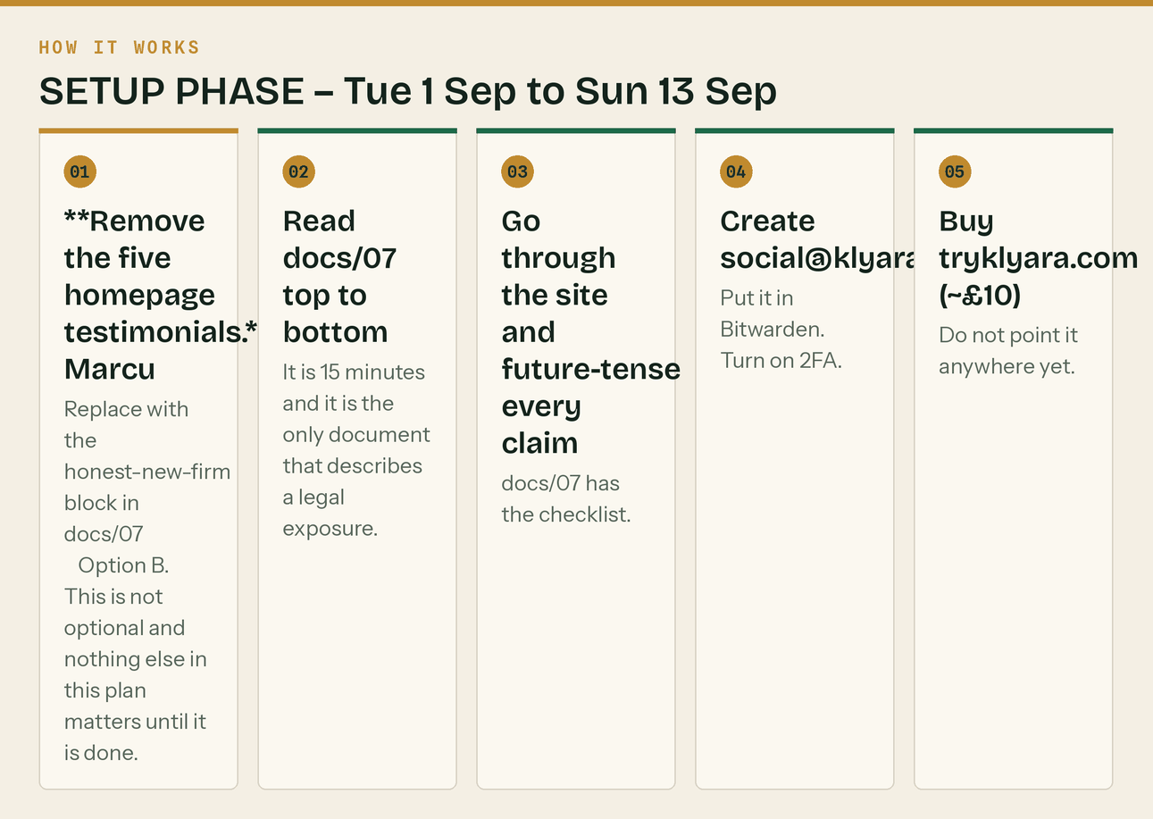
The same steps, in order.
Thursday 3 September · ⏱ 2h
One thing: Finish the Google Business Profile, and get the compliance admin off the list.
- Finish the Google Business Profile claim you started yesterday, now that the address decision is made. docs/02 has the full listing copy, written to Google's character limits.
- Seed the first four Google Q&A entries from docs/26 PART 4. Ten minutes, and it stops a stranger answering "how much does it cost?" on your behalf.
- Chase the PII quotes from yesterday if none have come back.
- Read docs/07 top to bottom. Fifteen minutes, and it is the only document that describes a legal exposure.
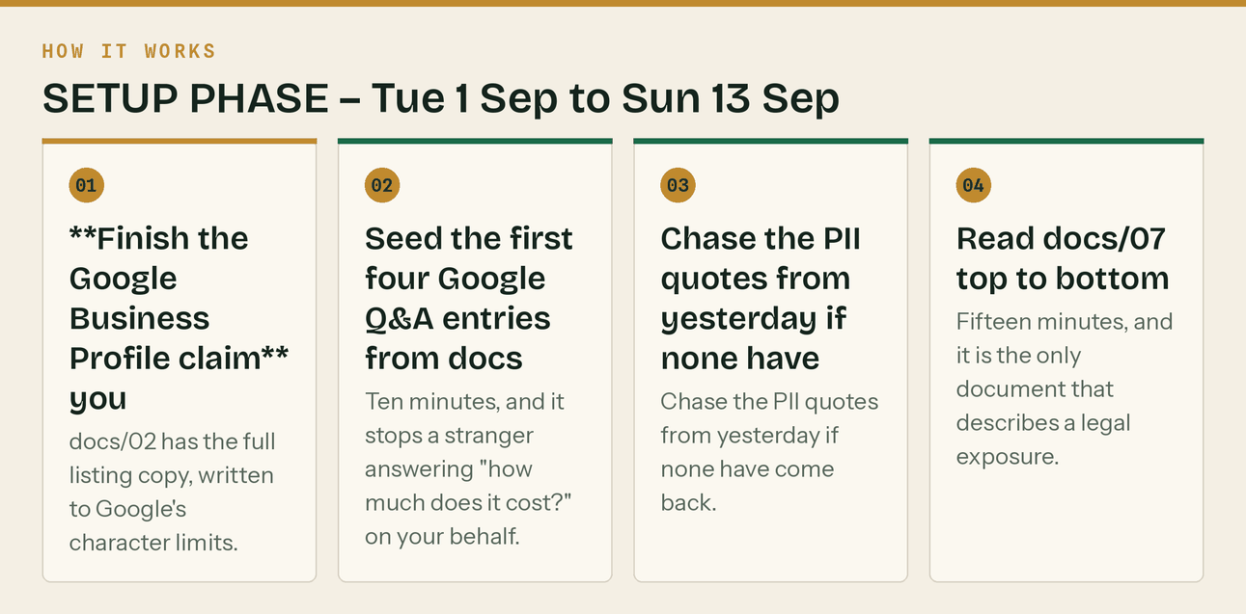
The same steps, in order.
Friday 4 September · ⏱ 1h 30m
One thing: Analytics and pixels, so you are collecting from day one.
- Install GA4 on klyara.com. Set two conversions: book_call and download_guide.
- Verify Google Search Console (domain property) and submit the sitemap.
- Install the Meta Pixel. Yes, with zero ad budget. The retargeting audience you do not collect this month does not exist next month.
- Install the LinkedIn Insight Tag.
- Check every calculator page is in the sitemap. docs/08 §10 has the full technical list.
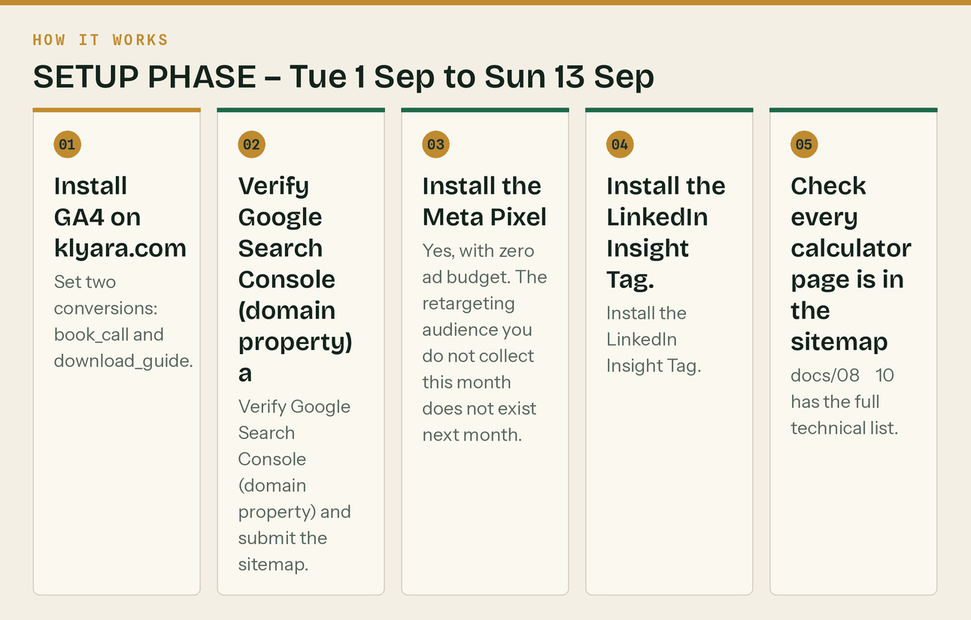
The same steps, in order.
Saturday 5 September · ⏱ 2h
One thing: Publish web/tools.html, then the schema. Ten pages already link to the tools page.
- Paste the AccountingService block from docs/08 §1 into the site-wide head. Fill in the bracketed address and founding date.
- Paste WebSite on the homepage (docs/08 §2).
- Paste FAQPage on the MTD page (docs/08 §3) — your 16 questions are currently earning nothing.
- Validate each page at search.google.com/test/rich-results. Ten seconds a page, and it catches the typos that silently kill a whole block.
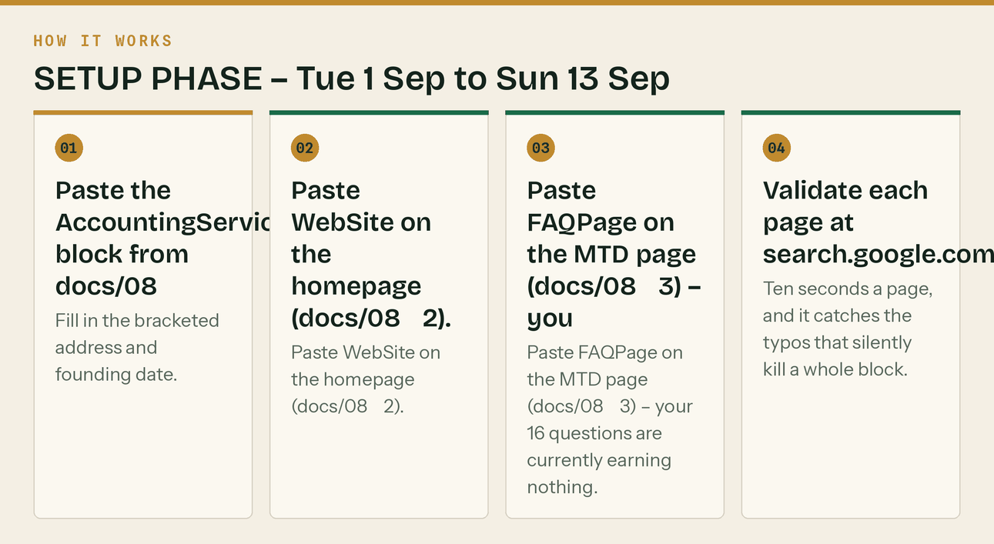
The same steps, in order.
Sunday 6 September · ⏱ rest
One thing: Rest. Genuinely.
- Nothing. You have a 90-day run starting in a week and starting tired is a bad trade.
Monday 7 September · ⏱ 2h
One thing: Publish the Guildford page.
- Upload web/construction-bookkeeping-guildford.html. Paste the page body into your template and delete the inline CSS — it is only there so the file stands alone for review.
- Replace [CAL_LINK] with your Cal.com URL and [STREET]/[POSTCODE] in the schema.
- Upload two images the schema points at: assets/logo/klyara-mark-disc-512.png and a 1200×630 crop of assets/banners/x-header-1500x500.png as /assets/og/klyara-og.png.
- Link to it from the homepage footer and the services page. An orphan page ranks for nothing.
- Submit the URL in Search Console.
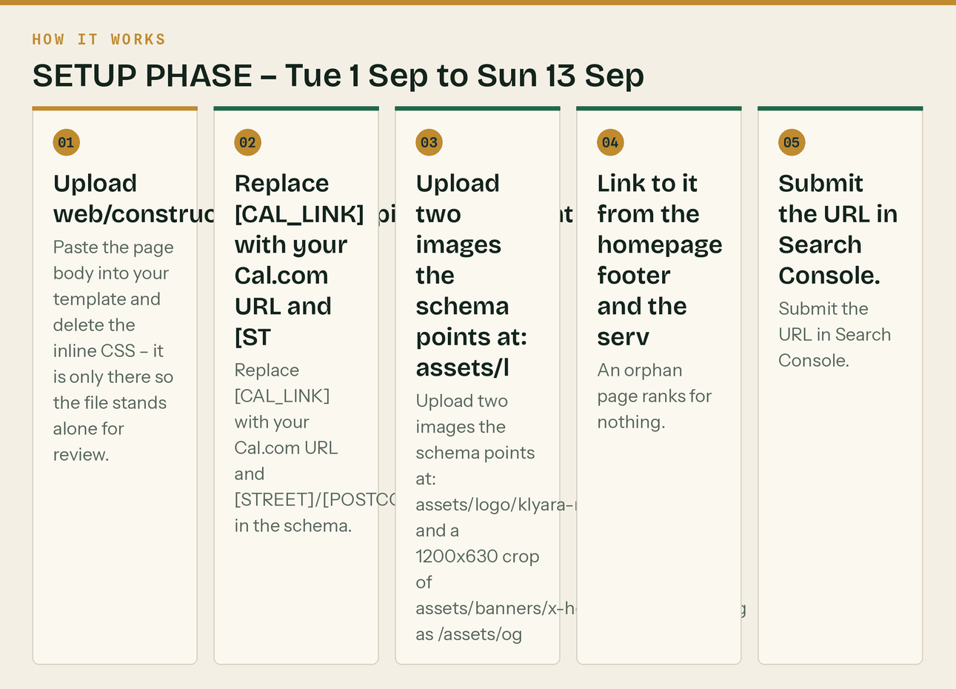
The same steps, in order.
Tuesday 8 September · ⏱ 2h
One thing: Brevo, and the DNS that has to propagate before you send anything.
- Create the Brevo account. docs/05 §1 explains why Brevo over the alternatives and when to migrate off it.
- Add the SPF, DKIM and DMARC records from docs/05 §4. DMARC at p=none to start. Do not go straight to reject.
- Create the six lists from docs/05 §2: Newsletter, MTD Guide, Launch Kit, Solo Waitlist, Clients, Partners.
- Add the seven contact attributes. Doing this now is ten minutes; retrofitting it onto a mixed list in November is a bad afternoon.
- Set the sender: Craig at Klyara <craig@klyara.com>. Never no-reply@.
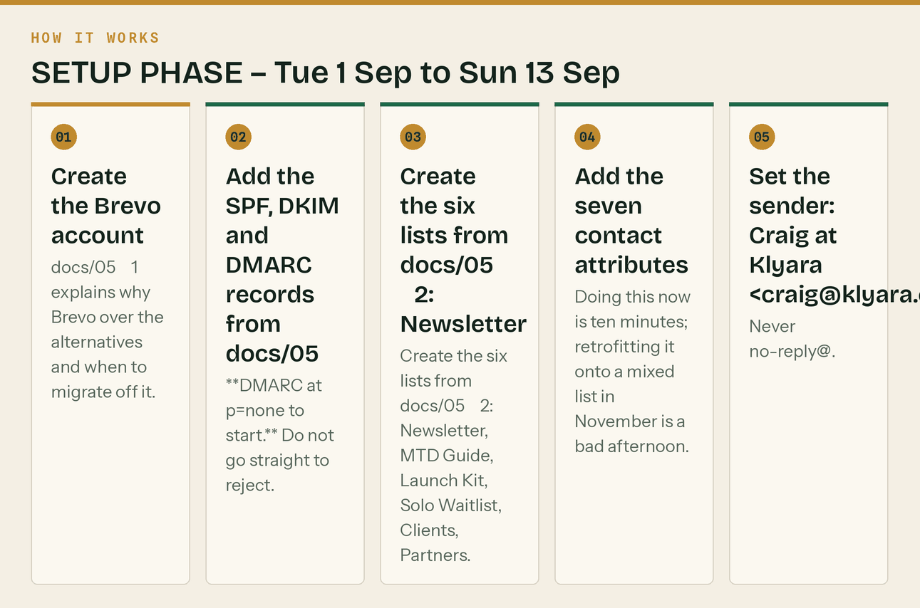
The same steps, in order.
Wednesday 9 September · ⏱ 2h
One thing: Load the email sequences while you have quiet.
- Build the three-email welcome sequence (docs/05 §5).
- Build the five-email MTD guide sequence (docs/05 §6).
- Build the four-email Launch Kit sequence (docs/05 §7).
- Paste email/template.html in as a custom template and email/signature.html into Gmail.
- Start the warm-up. Day 1–3 is 20 sends: yourself, both founders, friends, the partner accountant. The ramp in docs/05 §4 is not optional — a cold domain that suddenly sends 2,000 emails goes to spam and takes months to recover.
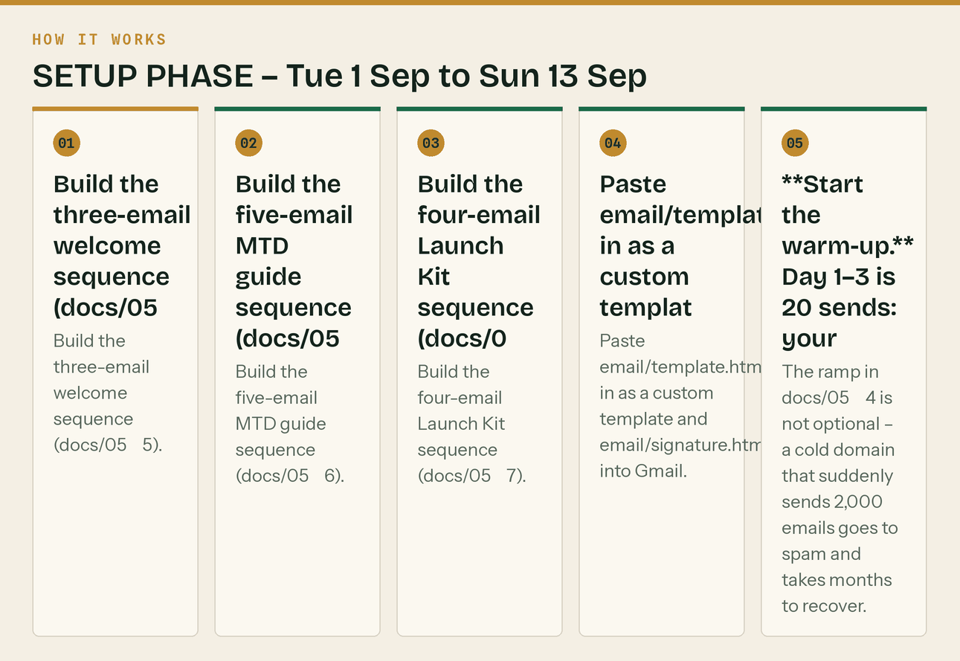
The same steps, in order.
Thursday 10 September · ⏱ 2h
One thing: Set up the profiles you can do without waiting on anything.
- Decide the handle. Order of preference: klyara → klyarahq → klyara_uk → getklyara. Whatever you land on, use it everywhere, even where a better one is free.
- LinkedIn Company Page — copy in docs/02 §2, logo assets/avatars/klyara-avatar-linkedin-512.png, cover assets/banners/linkedin-company-1128x191.png.
- Rebuild Craig's personal LinkedIn: headline, About, banner, Featured, custom URL, creator mode on. Copy in docs/02 §3. This profile does more work than the company page — LinkedIn gives personal posts several times the reach.
- Get a real headshot. On site, in a van, in hi-vis. Not a suit, not a logo, not AI.
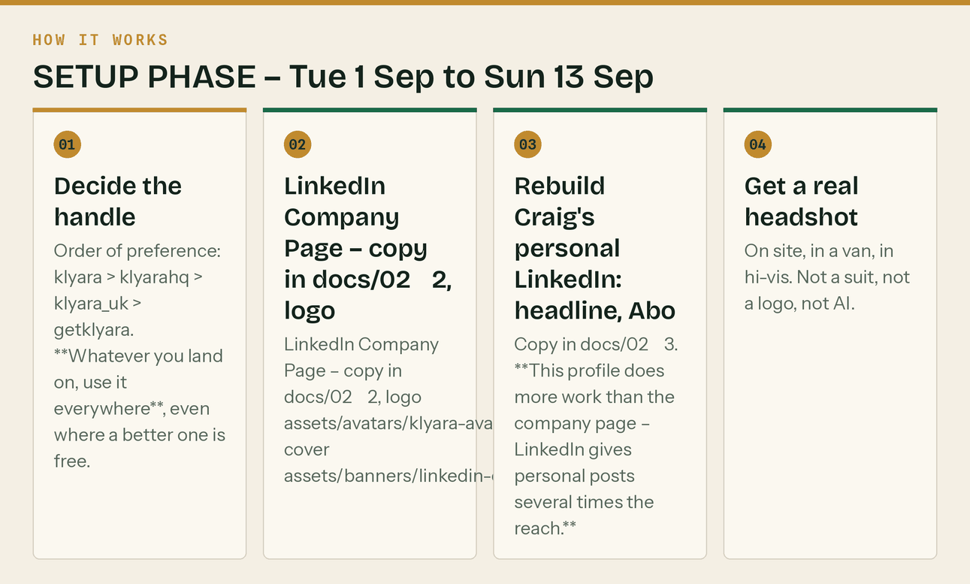
The same steps, in order.
Friday 11 September · ⏱ 2h 30m
One thing: The rest of the estate.
- Facebook Page (docs/02 §4) + set both founders as admins. Businesses lose pages when the one admin leaves.
- Instagram, converted to a Professional account → auto-creates Threads.
- X, YouTube (+ the five playlists), TikTok (Business account).
- Reddit ×2 — Craig's human account and the brand account. Then stop. Read only for three weeks. docs/01 §Reddit Protocol.
- Bluesky (+ verify the domain via DNS TXT — free, ten minutes, real trust signal), Pinterest, Snapchat (claim and leave), Nextdoor.
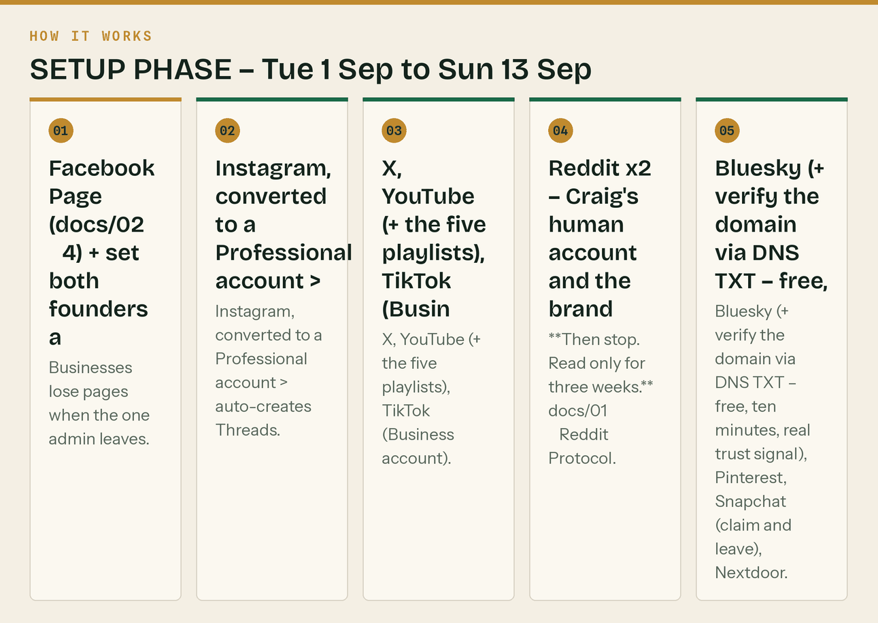
The same steps, in order.
Saturday 12 September · ⏱ 1h
One thing: Directories. Boring, one-off, and they compound.
- Lock the NAP string from docs/02 and never vary it by a character.
- Trustpilot, Yell, FreeIndex, Bing Places, Apple Business Connect.
2a. directory.getsurrey.co.uk — twenty minutes, and in the August 2026 search it was ranking third for "construction bookkeeper Surrey", above most of the actual firms. Free placement above your competitors is not something to skip because it feels unglamorous.
- Then Cylex, Scoot, Thomson Local, Hotfrog, 192.com.
- Surrey-specific: Surrey Chambers enquiry, Business Surrey, thebestof Guildford (docs/11 §6).
Sunday 13 September · ⏱ 1h
One thing: Load the week and then stop.
- Register on the forums — profiles only, no signature yet: Screwfix Community, UK Business Forums, BookaBuilderUK, ContractorsTalk, UKPlumbersForums, ElectriciansForums.
- Request to join 12–15 Facebook groups (docs/01 §Facebook groups has the search strings and the vetting rule). Approval can take days, so ask now.
- Schedule tomorrow's launch posts. Manually — you are not buying a scheduler until month two, and posting by hand for a month teaches you what a scheduler hides.
- Read docs/09 — the sales pack. Tomorrow the phone might ring.
- Read docs/21 and docs/22. Then do three small things that take twenty minutes between them and are very hard to add later: put "founding client rate, held for twelve months" on the pricing page; put the £285 bought-separately comparison on the pricing page and in the proposal template; and diarise the price review for 1 September 2027.
- Attach assets/sales/Klyara-Schedule-of-Services.pdf to the engagement letter template so it goes out with client 1, not client 12.
- Print assets/print/Klyara-Trade-Counter-Card-A4-4up.pdf — A4 at 100%, no scaling, trim to the crop marks. Fifty sheets is two hundred cards and costs about £15. They go on merchant trade counters in Week 2 (docs/23 §PART 5).
- Put the docs/23 §PART 7 outbound blocks into the diary as recurring appointments. Do this now, while it is quiet.
- Read docs/26. Then seed the first four Google Business Profile Q&A entries — they are written out and it is ten minutes. The panel being empty on launch day is a wasted asset, and if you leave it, a stranger eventually answers "how much does it cost?" on your behalf.

THE 90 DAYS

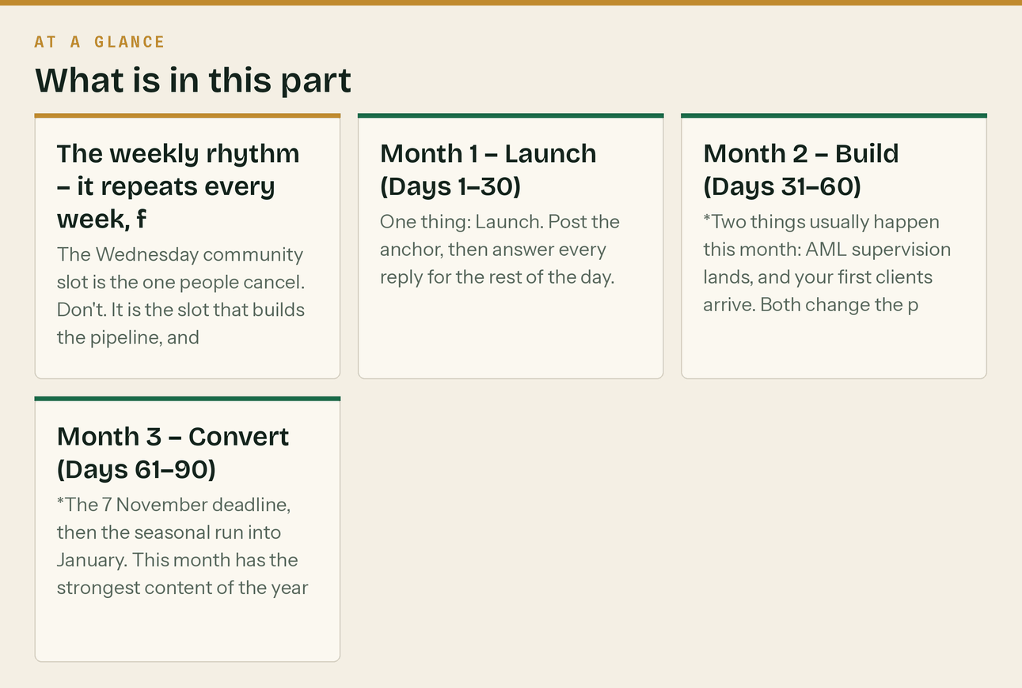
*Setup 1-13 September. Launch Monday 14 September. Day 90 is Saturday 12 December.*
The weekly rhythm — it repeats every week, forever
Mon 07:30 Anchor post + GBP post + reply to weekend comments 30 min
Tue Short video, native upload to each platform 20 min
Wed 17:30 Carousel + the community slot (no links) 45 min
Thu Long video or the week's big piece 2h
Fri 16:00 Practical post + production hour + log the numbers 90 min
Sat One light human post 15 min
Sun Week-ahead deadlines post 20 min
The Wednesday community slot is the one people cancel. Don't. It is the slot that builds the pipeline, and it is slow precisely because it works.
Month 1 — Launch (Days 1–30)
Day 1 — Mon 14 Sep · ⏱ 3h
One thing: Launch. Post the anchor, then answer every reply for the rest of the day.
- 07:30 — Publish the Day 1 anchor post to Craig's LinkedIn and pin it. Full copy in docs/03 Day 1. This is the single most important post of the month.
- 07:45 — Company Page version, X, Facebook Page, Instagram (assets/posts/post-day01-launch.png).
- 08:00 — First Google Business Profile post (docs/13 W1). Button: Learn more.
- Through the day: reply to every comment within the hour. Reach on day one is decided by early engagement.
- Send Newsletter #0 to your warm-up list of ~20: 'we're live'. Keep the warm-up ramp going.
- Chase the GBP verification if the postcard/video step has not arrived.
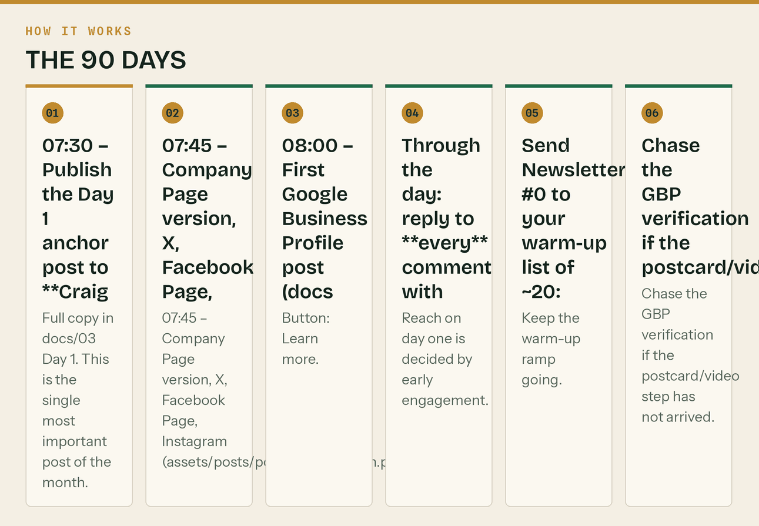
The same steps, in order.
Day 2 — Tue 15 Sep · ⏱ 1h 30m
One thing: Short video out, and start the accountant list.
- Post video/01-mtd-caught-you.mp4 to TikTok, Reels and YouTube Shorts. Upload natively to each — never cross-post a watermarked file. Caption in docs/03 Day 2.
- Add a trending audio at low volume from the platform's own commercial library. The videos are silent by design so you can.
- X post: the gross-income trap (docs/03 Day 2).
- Build the accountant target list: search 'accountants Guildford / Woking / Godalming / Farnham', take the first two pages of each, prioritise two-to-six partner firms. Target 20. docs/11 §8.
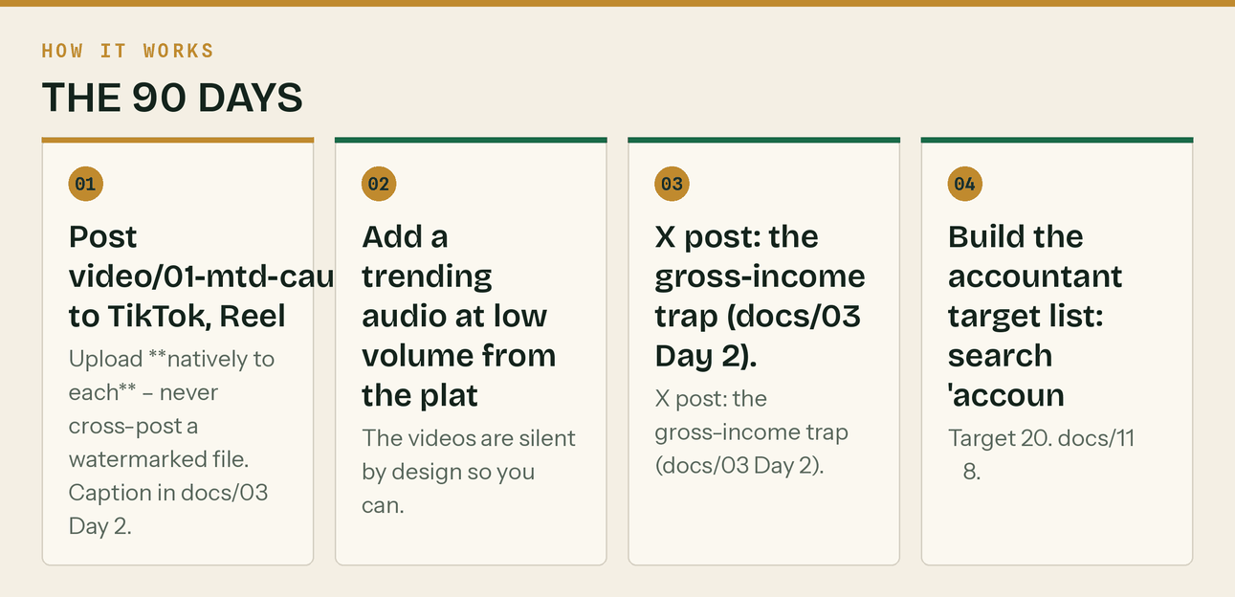
The same steps, in order.
Day 3 — Wed 16 Sep · ⏱ 1h 30m
One thing: Carousel, and your first community contribution.
- Instagram carousel + LinkedIn document post: assets/carousel/mtd-6slides/ (6 slides). Caption in docs/03 Day 3. For LinkedIn, upload the slides as a PDF so it renders as a document.
- Facebook version.
- 17:30 — First community slot. Pick one forum. Answer one question properly using docs/15. No link. No signature. Adapt the opening line — copy-paste answers read as copy-paste answers.
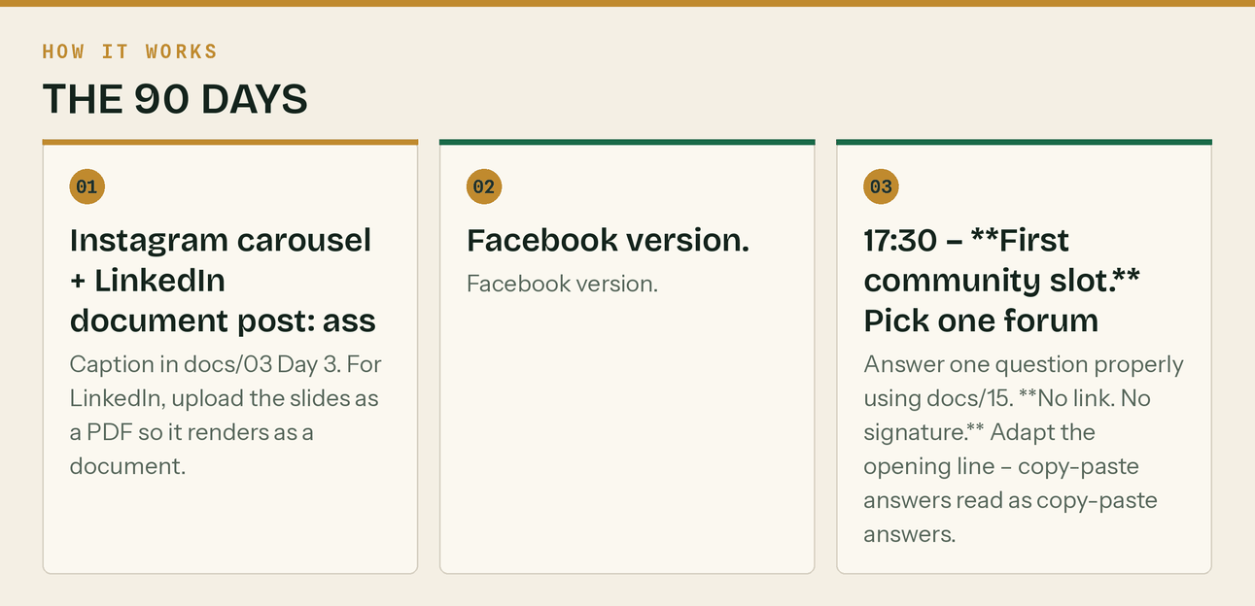
The same steps, in order.
Day 4 — Thu 17 Sep · ⏱ 2h 30m
One thing: Record the first long video. It is the asset everything else cuts from.
- Record *'Making Tax Digital for Builders: Are You In?'* — full script in docs/04. Seven minutes. Phone on a tripod is fine; audio matters more than video.
- Upload with the description and timestamps from docs/04. Add to the 'Making Tax Digital' playlist.
- LinkedIn announce post — link in the first comment, not the post. LinkedIn suppresses posts with outbound links.
- Newsletter #1 goes out 07:00 (docs/05 §8 №1). Check the warm-up ramp allows the volume.
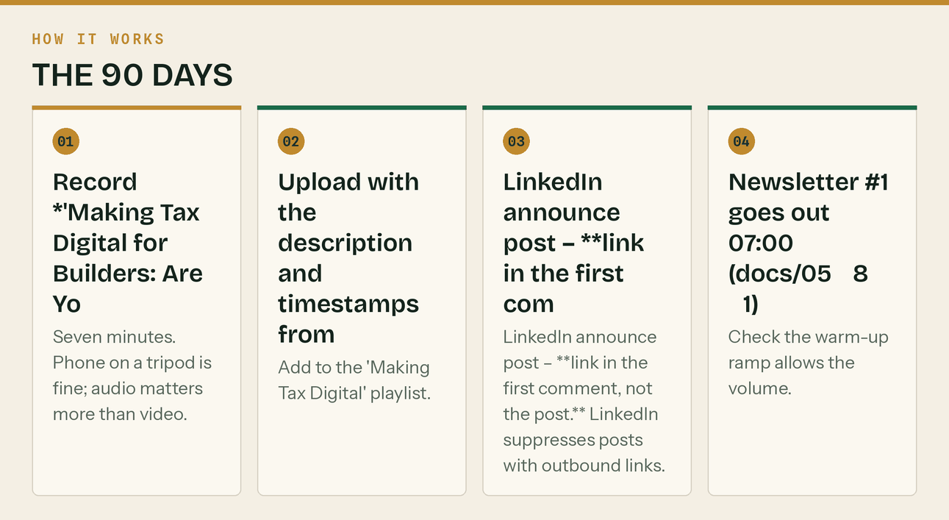
The same steps, in order.
Day 5 — Fri 18 Sep · ⏱ 1h 30m
One thing: The deadline thread. This is the format that gets saved and shared.
- X thread: every MTD date, 7 tweets (docs/03 Day 5).
- Facebook + the deadline graphic assets/posts/post-deadline-calendar.png.
- 16:00 — Production hour. Write next week's anchor post. Record one short video on your phone.
- Log the four numbers for week 1 (docs/06 §3). Even if they are all zero — the habit is the point.
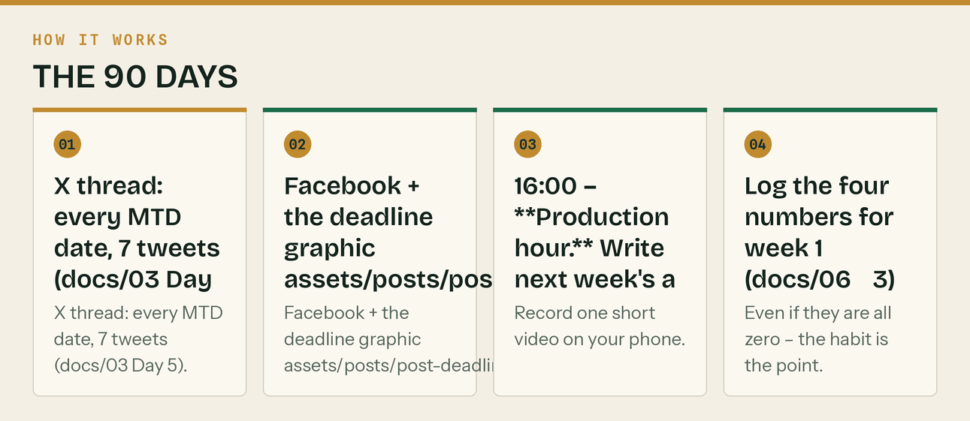
The same steps, in order.
Day 6 — Sat 19 Sep · ⏱ 30m
One thing: Light. One human post.
- Instagram Stories, 3 frames + Facebook: the Saturday post in docs/03 Day 6.
- Nothing else.
Day 7 — Sun 20 Sep · ⏱ 45m
One thing: Week-ahead post. Sets up the CIS deadline.
- LinkedIn + X + GBP: the week-ahead post (docs/03 Day 7). It flags the 19 September CIS deadline.
- Note for yourself: 19 September is a Saturday. Anyone filing CIS should work to Friday 18th.
Day 8 — Mon 21 Sep · ⏱ 2h
One thing: Week 2 anchor: CIS in real numbers.
- 07:30 — Anchor post to LinkedIn, X, Facebook (docs/03 Day 8), plus GBP (docs/13 W2).
- Post assets/posts/post-cis-penalties.png with it.
- Send the first 10 accountant partnership emails (docs/11 §8), with assets/sales/Klyara-For-Accountants-Partnership.pdf attached. Ten today, ten Thursday — do not blast 20 at once, because the first ten will teach you something.
- Reply to everything.
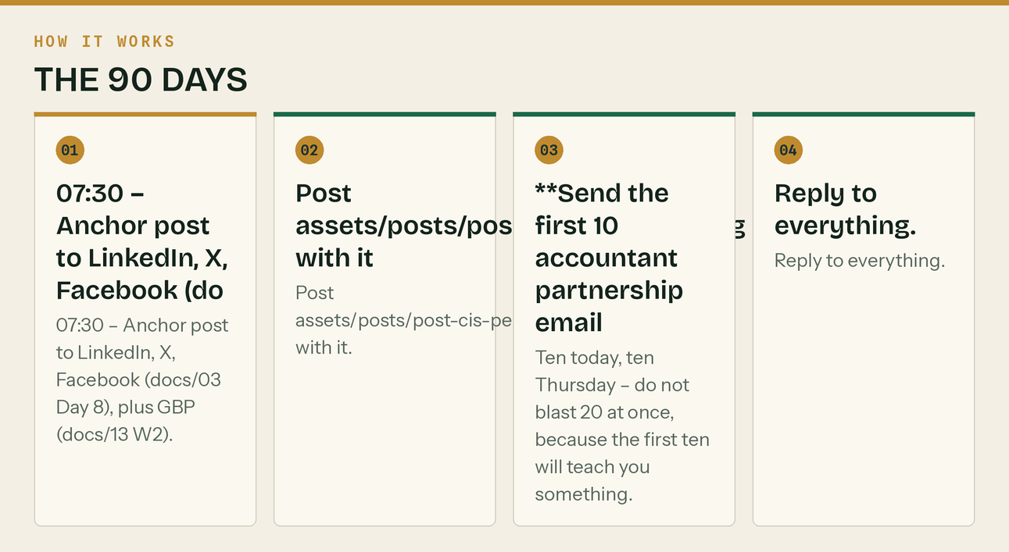
The same steps, in order.
Day 9 — Tue 22 Sep · ⏱ 1h 30m
One thing: Video, and the merchant round prep.
- Post video/02-cis-20-vs-30.mp4 to TikTok, Reels, Shorts.
- Order 250 A5 merchant cards from assets/print/merchant-card-A5-300dpi.png. Add a QR code first, pointing at the Guildford page with ?utm_source=merchant&utm_medium=qr&utm_campaign=slyfield. Without the UTM you will never know if it worked. ~£30–45.
- Plan the Slyfield route for Thursday: Selco (Slyfield Industrial Estate), Travis Perkins, Jewson, Howdens.
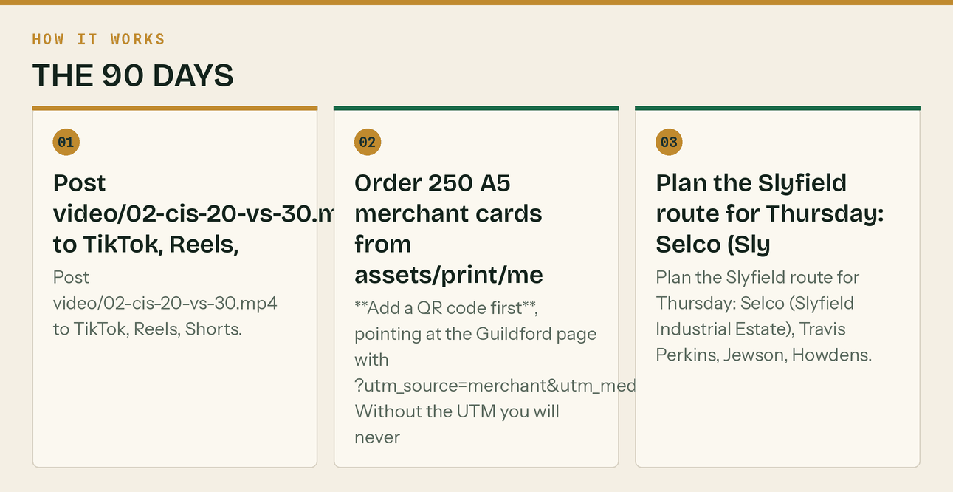
The same steps, in order.
Day 10 — Wed 23 Sep · ⏱ 1h 30m
One thing: CIS carousel + community.
- Instagram + LinkedIn document: assets/carousel/cis-7slides/.
- 17:30 — Community slot. Two forum answers or two Facebook group answers. Still no links.
Day 11 — Thu 24 Sep · ⏱ 3h
One thing: Record the reverse charge video, send the second ten emails.
- Record *'The VAT Domestic Reverse Charge, Explained Once and Properly'* (docs/04). Nine minutes.
- LinkedIn long post on the reverse charge (docs/03 Day 11) — the six tests and the end-user rule.
- Send accountant emails 11–20.
- If GBP is still not verified, chase it today. It is now over two weeks.
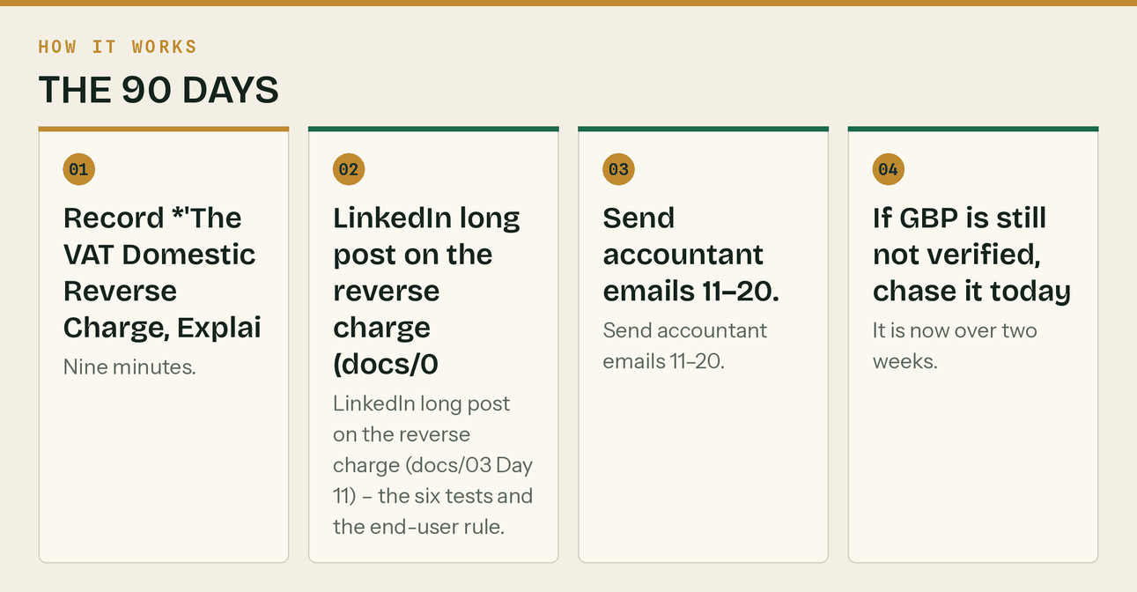
The same steps, in order.
Day 12 — Fri 25 Sep · ⏱ 1h 30m
One thing: CIS deadline messaging.
- Post the deadline warning across X, Facebook, GBP, LinkedIn (docs/03 Day 12). Say Friday, not Saturday — the 19th falls on a weekend.
- Use assets/posts/post-nil-return.png. The nil-return point is the one that saves people £100.
- 16:00 — Production hour.
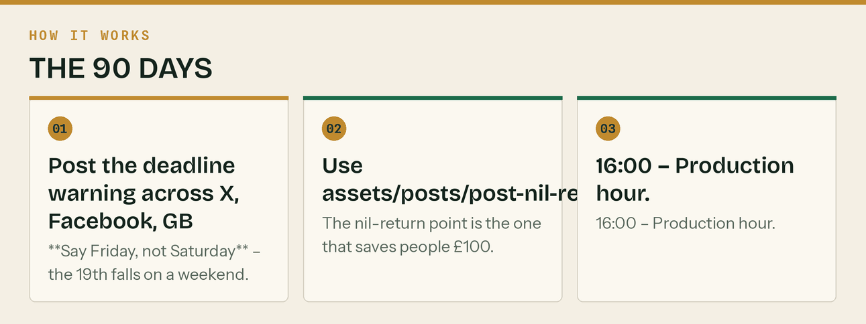
The same steps, in order.
Day 13 — Sat 26 Sep · ⏱ 30m
One thing: Light + the question post.
- The 'what's the worst bit of admin in your week' post (docs/03 Day 13). Genuine question, genuine replies. This one usually gets the most comments of the month.
Day 14 — Sun 27 Sep · ⏱ 45m
One thing: Week ahead. Money week next.
- Week-ahead post (docs/03 Day 14) — flags Tue 22 Sep electronic CIS payment and the 15 days to quarter end.
Day 15 — Mon 28 Sep · ⏱ 2h
One thing: Week 3 anchor: you are not a bank.
- 07:30 — The late payment anchor post (docs/03 Day 15), plus the X thread, Facebook, GBP (docs/13 W3).
- Use assets/posts/post-late-payment.png and post-retentions.png.
- The Facebook version has a comment-bait ('comment RETENTION and I'll send the tracker'). Actually send it to everyone who comments, within the hour.
- Statutory interest is 8% over base. Base rate is 3.75% as at 30 July 2026, so that is 11.75% — check it hasn't moved before you quote a number publicly. Next BoE decision 17 September.
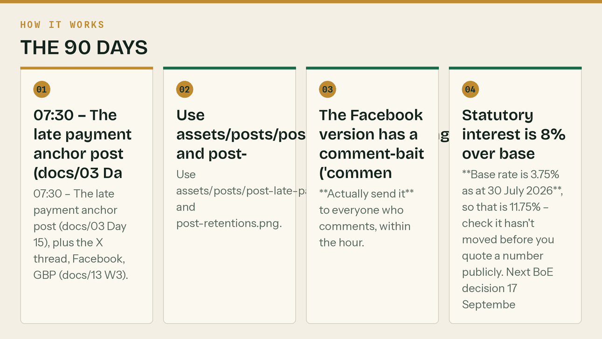
The same steps, in order.
Day 16 — Tue 29 Sep · ⏱ 1h 30m
One thing: Retentions video + the Slyfield round.
- Post video/03-retentions.mp4.
- The Slyfield merchant round. Cards to Selco, Travis Perkins, Jewson, Howdens. Ask each counter manager which local firms are busy — they see the account volumes and they will tell you. That conversation is worth more than the cards.
- Write down every firm name they mention. That is your prospect list.
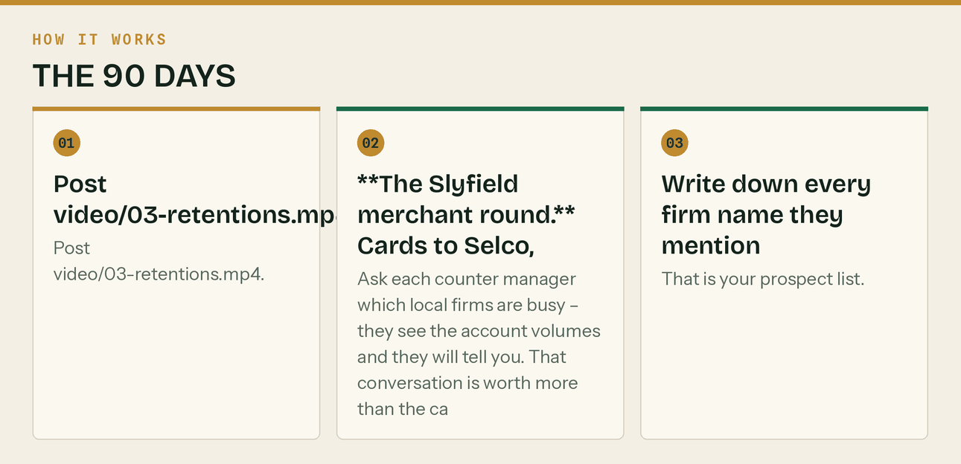
The same steps, in order.
Day 17 — Wed 30 Sep · ⏱ 1h 30m
One thing: Getting-paid carousel + community.
- Instagram + LinkedIn: assets/carousel/getpaid-6slides/.
- 17:30 — Community slot. You should be at 10–15 genuine answers by now.
- Publish web/cis-accountant-surrey.html. Link it from the Guildford page and the services page.
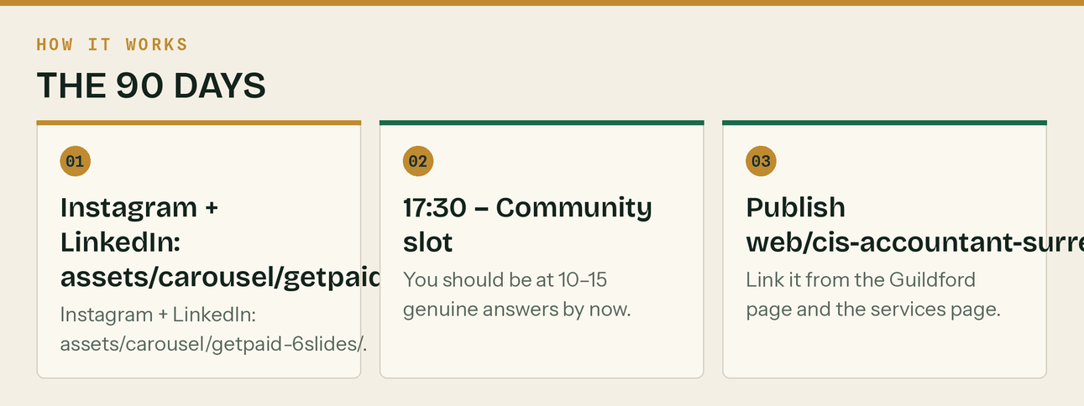
The same steps, in order.
Day 18 — Thu 1 Oct · ⏱ 3h
One thing: The cash flow video, and the first follow-up.
- Record *'Why Your Building Firm Is Always Skint'* (docs/04). Use the Day 18 LinkedIn post as the spine — it is written to be read aloud.
- LinkedIn: the four cash drains post (docs/03 Day 18).
- Follow up every accountant who has not replied. Once. One line: 'Just checking this reached you — happy to leave it if the timing's wrong.'
- Newsletter #2 (docs/05 §8 №2).
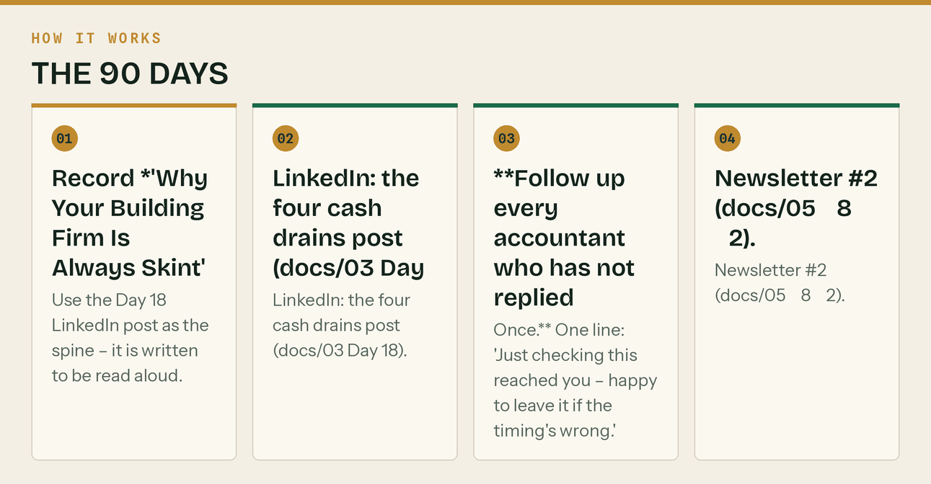
The same steps, in order.
Day 19 — Fri 2 Oct · ⏱ 1h 30m
One thing: Give the tracker away.
- Post the free retention tracker across X, Facebook, LinkedIn (docs/03 Day 19).
- Post two calculator cards from assets/tools/ into relevant forums — a free tool is welcome where a service link gets removed. This is the whole reason the calculators matter.
- 16:00 — Production hour.
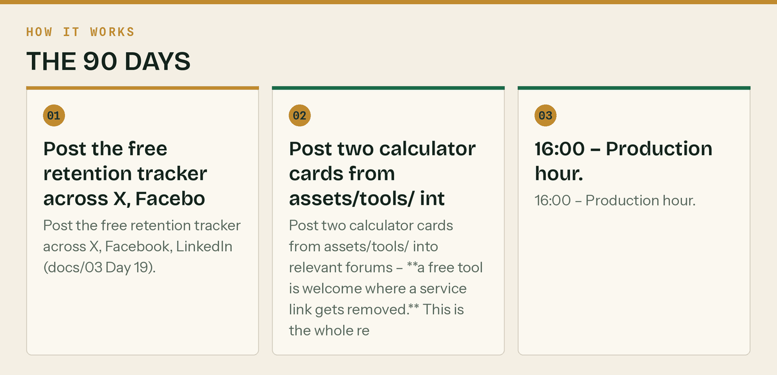
The same steps, in order.
Day 20 — Sat 3 Oct · ⏱ 30m
One thing: Light.
- The 'best builders aren't the ones who do well' post (docs/03 Day 20).
Day 21 — Sun 4 Oct · ⏱ 45m
One thing: Week ahead — quarter end week.
- Week-ahead post (docs/03 Day 21). Flags Mon 5 Oct quarter end and Sat 7 Nov update.
- Publish web/construction-bookkeeping-woking.html.
Day 22 — Mon 5 Oct · ⏱ 2h
One thing: Quarter-end countdown starts. This is the conversion week.
- 07:30 — Anchor: seven days to quarter end (docs/03 Day 22), all channels + GBP (docs/13 W4).
- assets/posts/post-quarter-end.png.
- From today, one checklist job a day for seven days. Each is a post and each is genuinely useful. This week produces more replies than the other three combined.
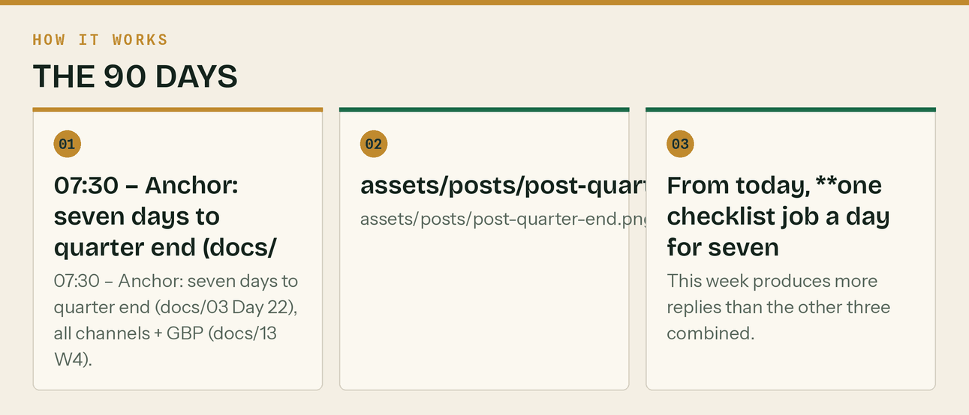
The same steps, in order.
Day 23 — Tue 6 Oct · ⏱ 1h 30m
One thing: Checklist 2 + video.
- Checklist day 2 — receipts (docs/03 Day 23), all channels.
- Post video/04-quarter-end-countdown.mp4.
Day 24 — Wed 7 Oct · ⏱ 1h 30m
One thing: Checklist 3 + the big carousel.
- Checklist day 3 — mixed-use costs (docs/03 Day 24).
- Instagram + LinkedIn: assets/carousel/quarterend-8slides/ (8 slides — the strongest set in the pack).
- 17:30 — Community slot.
- Publish web/construction-bookkeeping-godalming.html.
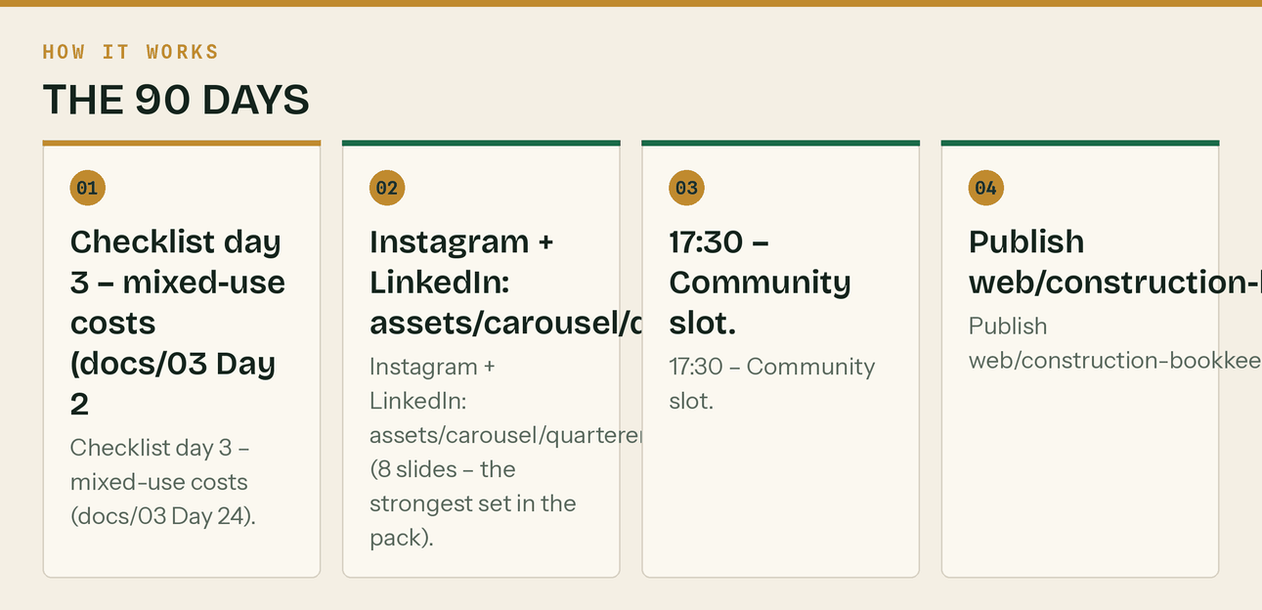
The same steps, in order.
Day 25 — Thu 8 Oct · ⏱ 3h
One thing: Checklist 4 + the quarter-end video.
- Checklist day 4 — reconcile (docs/03 Day 25).
- Record *'Quarter-End in Under an Hour'* (docs/04).
- Publish the quarter-end checklist as its own page with the HowTo schema from docs/08 §7. This one earns links.
- Publish web/construction-bookkeeping-farnham.html. That is all five local pages live.
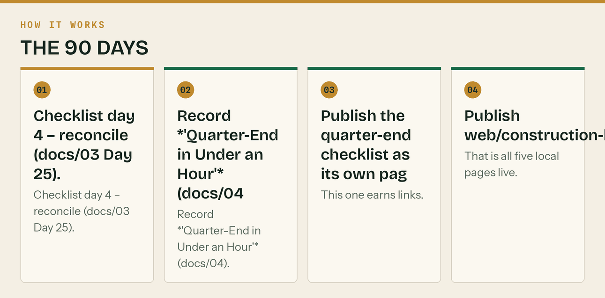
The same steps, in order.
Day 26 — Fri 9 Oct · ⏱ 1h 30m
One thing: Checklist 5 — the CIS one that matters most.
- Checklist day 5 — CIS reconciliation (docs/03 Day 26). This is the highest-value post in the whole 30 days for subcontractors.
- 16:00 — Production hour. Write the Day 28 conversion post carefully.
- Log the four numbers for month 1.
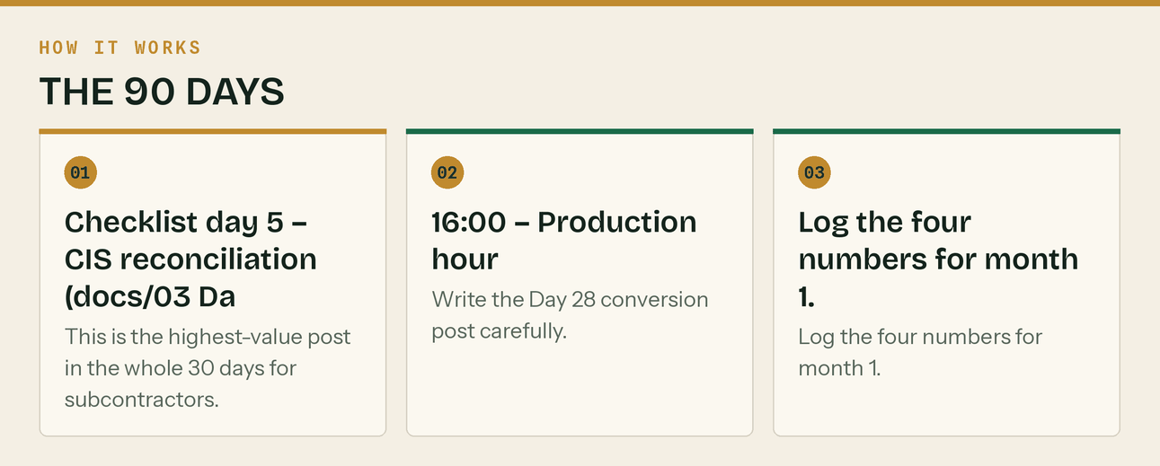
The same steps, in order.
Day 27 — Sat 10 Oct · ⏱ 45m
One thing: Checklist 6 — the two-minute check.
- Checklist day 6 — the reverse charge check (docs/03 Day 27).
Day 28 — Sun 11 Oct · ⏱ 1h 30m
One thing: Checklist 7. The ask.
- The conversion post (docs/03 Day 28). Use the HOLD version unless AML supervision is confirmed — waitlist and founding rate, not 'book a call to engage'.
- All channels. This is the post the month has been building to.
- Reply to every single response today, personally.
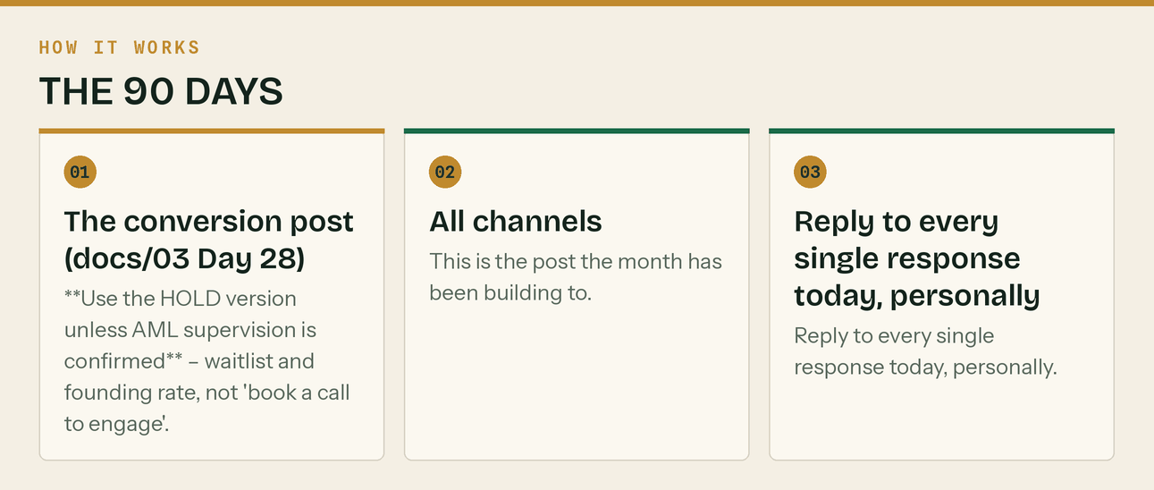
The same steps, in order.
Day 29 — Mon 12 Oct · ⏱ 1h
One thing: Quarter end. And 30 days of numbers.
- The quarter-closed post (docs/03 Day 29) + GBP (docs/13 W5).
- Month 1 review. Booked calls, cost per call, guide downloads, GBP calls/directions/clicks. Against target: 4+ Guildford-postcode calls.
- If it is under 4 — check GBP verification is actually live before you change anything else. It is the cause about nine times in ten.
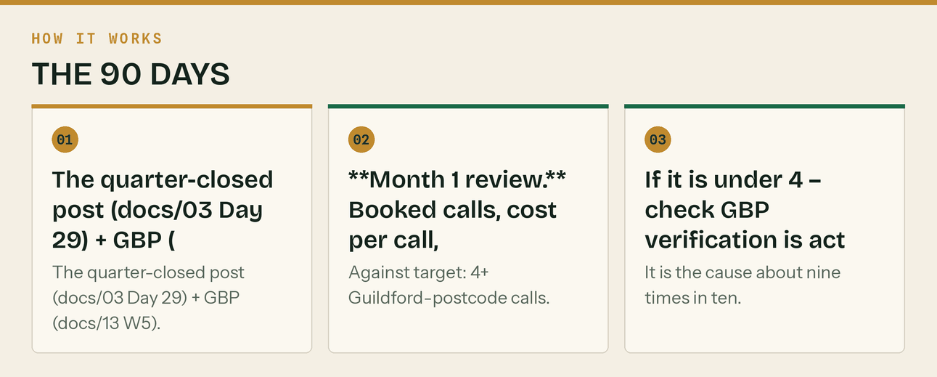
The same steps, in order.
Day 30 — Tue 13 Oct · ⏱ 1h 30m
One thing: Recap, and buy the scheduler.
- The 30-day recap post (docs/03 Day 30) — everything in one place. It gets saved.
- Now buy Metricool. You have posted by hand for a month and you know which channels earn their slot. ~£20–28/mo. docs/06 §1.
- Load weeks 5–8 of GBP posts (docs/13) and next week's content into it.
- Write down the three things that worked and the three that did not. Month 2 drops the bottom three.
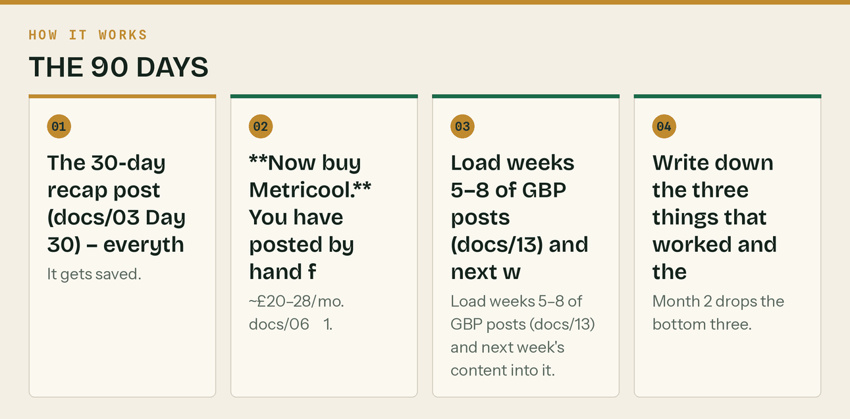
The same steps, in order.
Month 2 — Build (Days 31–60)
*Two things usually happen this month: AML supervision lands, and your first clients arrive. Both change the plan — see the two boxes below.*
** The moment AML supervision is confirmed, do all of this in the same
swap every HOLD CTA to the live version across site, ads, emails and calendar · turn Google Ads on with the £40/booked-call kill rule · send the press release to Surrey Advertiser and the Chambers · add the supervision line to the email signature · list on Find-a-ProAdvisor, Xero Advisor Directory, FreeAgent and the ICB directory · update the site's 'qualified' claims to what is now true. Details in docs/14 §Phase 3.

** The moment client 1 signs:** run the five-day onboarding runbook in
days-from-signing-to-live. Target is five. If it drifts past ten the runbook is not being followed.

Day 31 — Wed 14 Oct · ⏱ 1h 30m
One thing: Month 2 starts. Gross payment status week.
- Anchor: gross payment status — the three tests and why most who'd pass never apply (docs/03 Month 2 W1, content in assets/lead-magnets/ §Gross status).
- GBP post W6 (docs/13).
- Publish the gross payment status page — the text is already written in the CIS Compliance Pack. Copy and reformat, do not rewrite.
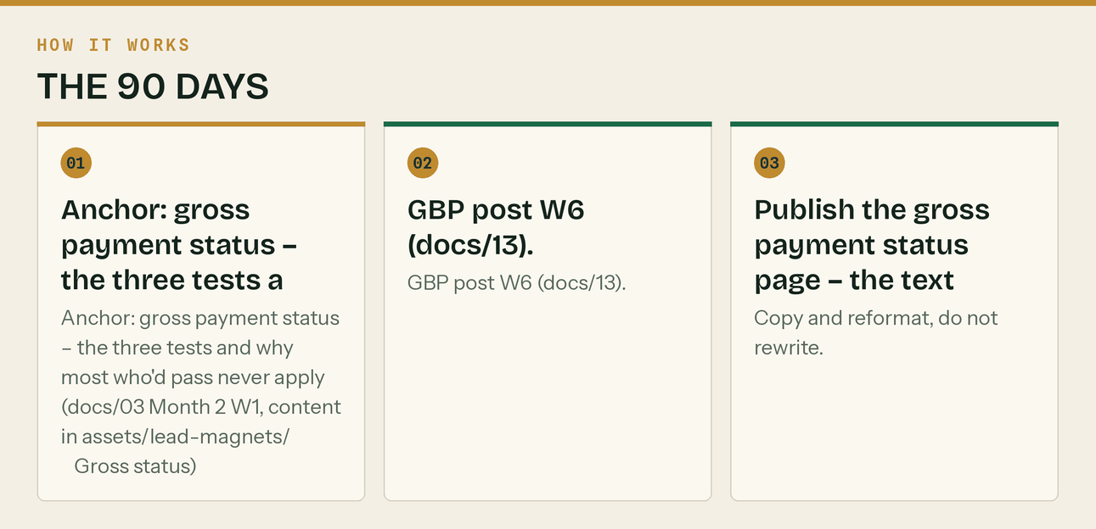
The same steps, in order.
Day 32 — Thu 15 Oct · ⏱ 1h
One thing: Video + second merchant lap.
- Post video/05-reverse-charge.mp4.
- Second merchant lap: Woking, Godalming, Farnham branches. Restock the cards that went.
Day 33 — Fri 16 Oct · ⏱ 1h 15m
One thing: Community + tools.
- Community slot. Post two more calculator cards into forums where tools are welcome.
- Check: are you at 25+ genuine community contributions? If not, you are behind on the slowest channel.
Day 34 — Sat 17 Oct · ⏱ 2h
One thing: Long video + the contractor magnet goes live.
- Record the gross payment status video (10 min) or repurpose the Skint video if you are short of time.
- Publish /cis-pack.html with assets/lead-magnets/Klyara-Contractors-CIS-Compliance-Pack.pdf behind a one-field form. This magnet targets the £199–£329 tier, which your other two magnets do not.
- Wire it to a Brevo list and a short nurture sequence.
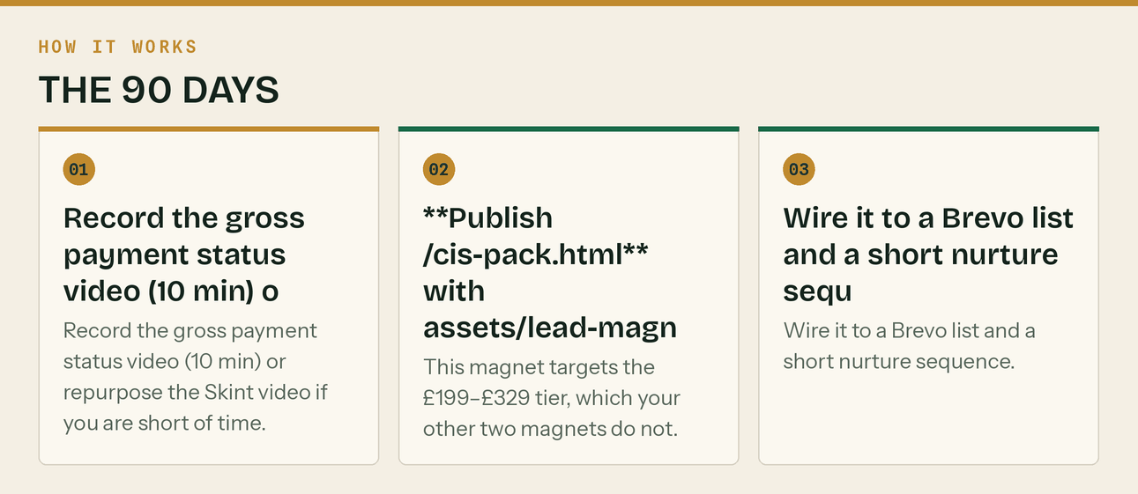
The same steps, in order.
Day 35 — Sun 18 Oct · ⏱ 1h 30m
One thing: Practical + numbers.
- Practical post: the CIS calculator.
- Production hour.
- Log the numbers.
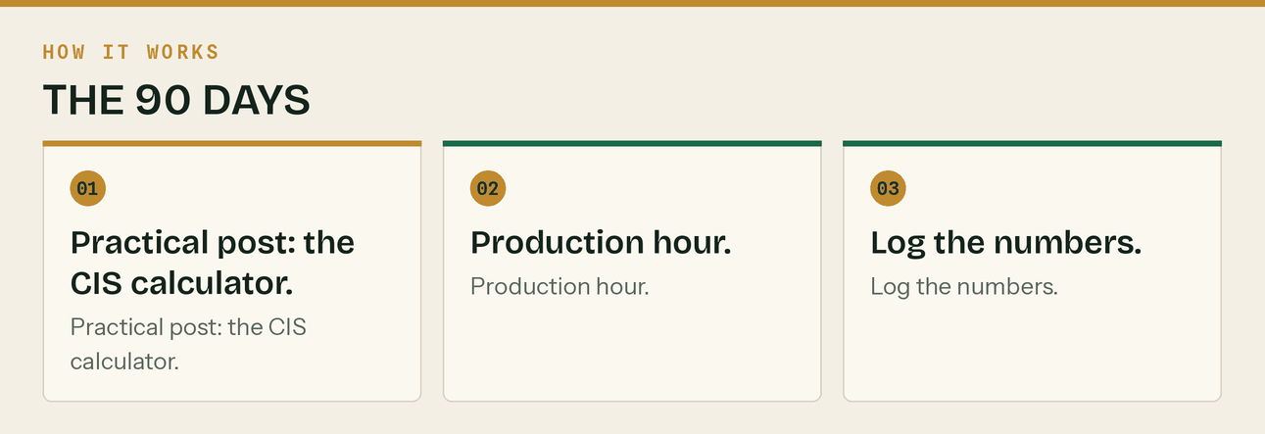
The same steps, in order.
Day 36 — Mon 19 Oct · ⏱ 30m
One thing: Light.
- One human post.
Day 37 — Tue 20 Oct · ⏱ 30m
One thing: Week ahead.
- Week-ahead post. Flags Mon 19 Oct CIS return.
Day 38 — Wed 21 Oct · ⏱ 2h
One thing: Pricing week.
- Anchor: the three costs that never make it into a quote (docs/05 §8 №6 has the full text — reuse it as a post).
- GBP W7.
- Build the 'which tier am I?' helper on the pricing page (docs/07 §Conversion 3). Three questions, recommends a tier, pre-fills the booking. Half a day of dev and it will move more revenue than any other single change on the site.
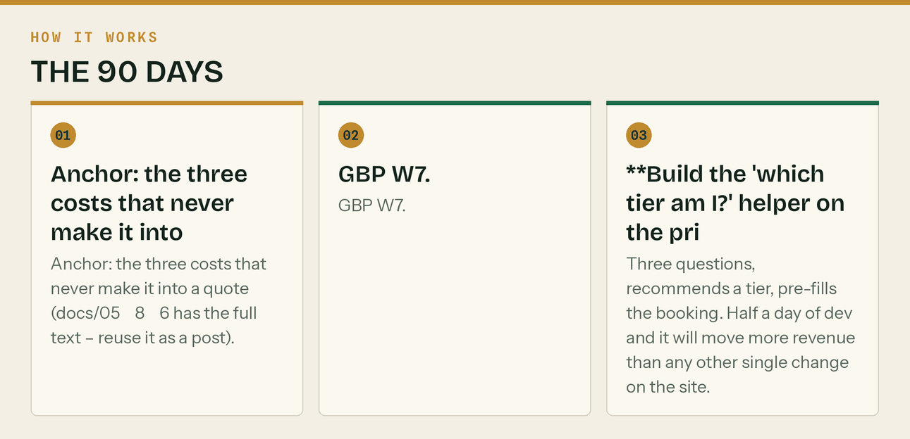
The same steps, in order.
Day 39 — Thu 22 Oct · ⏱ 1h
One thing: Video + review engine.
- Post video/06-late-payment.mp4.
- If you have any clients: ask each for a Google review at the report handover. Text the link on the spot. docs/06 §9.
Day 40 — Fri 23 Oct · ⏱ 1h 15m
One thing: Community + reddit escalation.
- Community slot. If you are past 30 comments and the sub allows it, post your first Reddit text post. Long-form, useful, no link in the body. docs/01 §Reddit Protocol.
Day 41 — Sat 24 Oct · ⏱ 2h
One thing: Long video + homepage conversion fix.
- Record or repurpose.
- Cut the homepage to one primary CTA per section (docs/07 §Conversion 2). Nineteen competing CTAs is a menu, not a conversion path.
Day 42 — Sun 25 Oct · ⏱ 1h 30m
One thing: Practical + per-page OG images.
- Practical post.
- Set per-page og:image using assets/posts/*.png. Every share this month currently uses the generic image.
- Production hour + numbers.
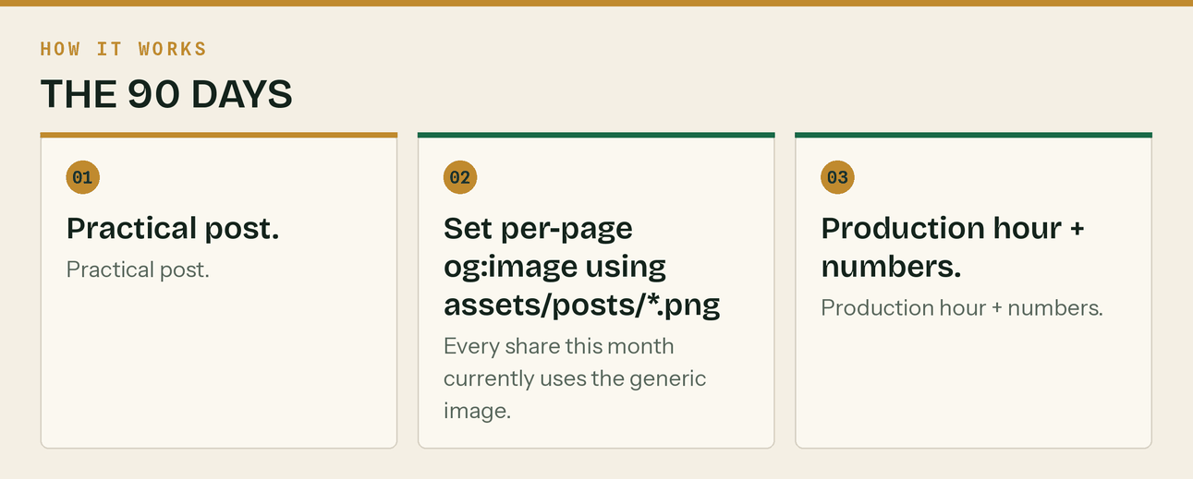
The same steps, in order.
Day 43 — Mon 26 Oct · ⏱ 1h
One thing: CIS deadline day.
- CIS return deadline post (month to 5 Oct). GBP W7 deadline version.
- If you have clients: their returns go in today, not tomorrow.
Day 44 — Tue 27 Oct · ⏱ 30m
One thing: Week ahead.
- Week-ahead post.
Day 45 — Wed 28 Oct · ⏱ 2h
One thing: First employee week.
- Anchor: what taking on your first person actually costs (docs/15 §19 has the substance).
- GBP W8.
- Calculator page SEO — titles, metas and SoftwareApplication schema for all twelve (docs/08 §6). This is the long-tail engine and it is a two-hour job.
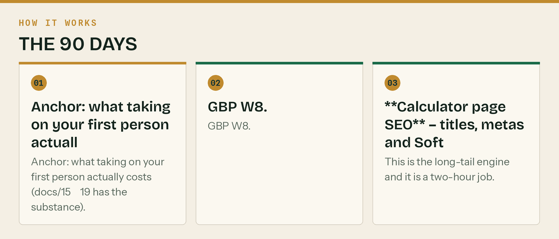
The same steps, in order.
Day 46 — Thu 29 Oct · ⏱ 1h
One thing: Video + podcast pitches.
- Post a short video.
- Pitch 20 podcasts using the 40-word template in docs/06 §6. Expect three replies and one booking — that is a normal, good result, and one episode beats a month of posting.
Day 47 — Fri 30 Oct · ⏱ 1h 15m
One thing: Community.
- Community slot. Answer bank docs/15.
Day 48 — Sat 31 Oct · ⏱ 2h
One thing: Long video + Chambers.
- Record.
- Surrey Chambers event, or Guildford & Waverley Business Question Time. Go to one. docs/11 §7.
Day 49 — Sun 1 Nov · ⏱ 1h 30m
One thing: Practical + numbers + Newsletter #3.
- Practical post.
- Newsletter #3.
- Production hour + numbers.
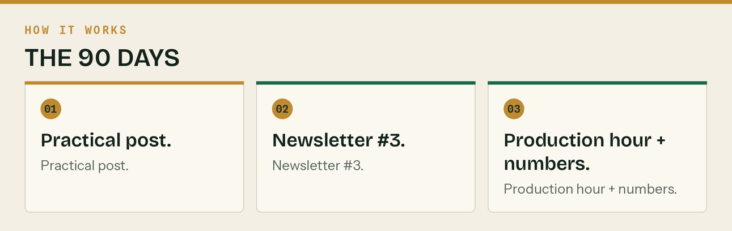
The same steps, in order.
Day 50 — Mon 2 Nov · ⏱ 30m
One thing: Light.
- Human post.
Day 51 — Tue 3 Nov · ⏱ 30m
One thing: Week ahead — flag 7 November.
- Week-ahead post. The 7 November MTD deadline is now two weeks out. Start the countdown.
Day 52 — Wed 4 Nov · ⏱ 2h
One thing: 7 November countdown week 1.
- Anchor: two weeks to the MTD update. What to do if you are behind.
- GBP W9 (docs/13).
- This is the highest-urgency content window of the whole 90 days. Use it.
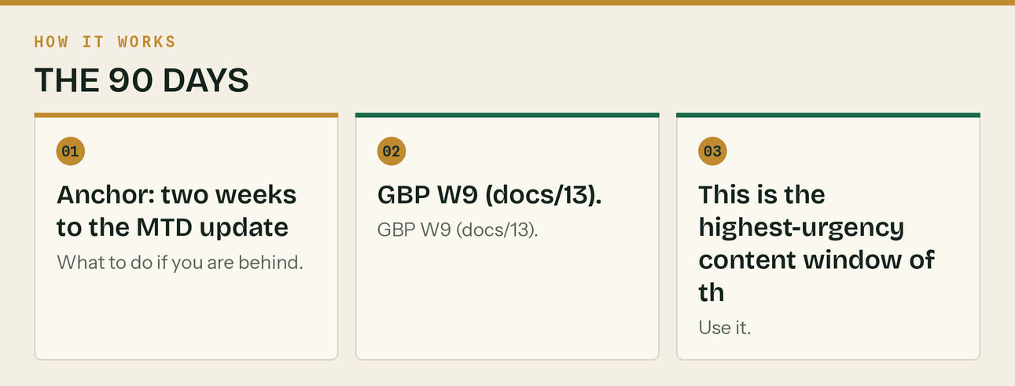
The same steps, in order.
Day 53 — Thu 5 Nov · ⏱ 1h
One thing: Video.
- Short video on the MTD deadline.
Day 54 — Fri 6 Nov · ⏱ 1h 15m
One thing: Community + town page check.
- Community slot.
- Check Search Console: are the five local pages indexed and getting impressions? If not, check they are linked from somewhere and resubmit.
Day 55 — Sat 7 Nov · ⏱ 2h
One thing: Long video + case study.
- Record.
- If you have three clients: agree the first case study. 'In three months, can I write up what we found?' Structure in docs/06 §10.
Day 56 — Sun 8 Nov · ⏱ 1h 30m
One thing: Practical + numbers.
- Practical post.
- Production hour.
- Month 2 review. Booked calls, cost per call, list growth, GBP actions, clients onboarded. Against target: 6–8 calls.
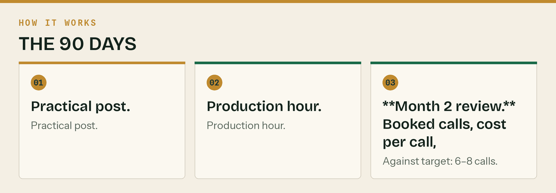
The same steps, in order.
Day 57 — Mon 9 Nov · ⏱ 2h
One thing: Five days to the MTD deadline.
- Anchor: the 40-minute version for people who have not started (docs/05 §8 №5 has the copy).
- All channels. GBP.
- Newsletter #5 goes out Thursday, two days before the deadline — that timing is deliberate.
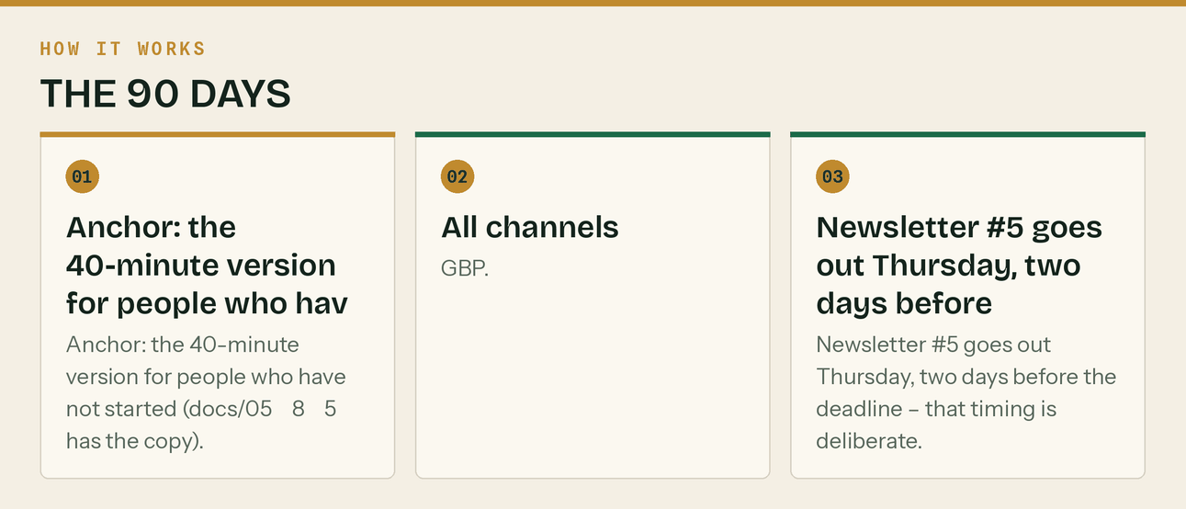
The same steps, in order.
Day 58 — Tue 10 Nov · ⏱ 1h
One thing: Video + reminders.
- Short video: the deadline.
- If you have clients in MTD: their updates go in this week, not on the 7th.
Day 59 — Wed 11 Nov · ⏱ 1h 15m
One thing: Community + deadline answers.
- Community slot. MTD deadline questions will be everywhere this week — this is the best community opportunity of the quarter.
Day 60 — Thu 12 Nov · ⏱ 2h
One thing: Newsletter #5 + long video.
- Newsletter #5: 'MTD update due Saturday' (docs/05 §8 №5).
- Record.
Month 3 — Convert (Days 61–90)
*The 7 November deadline, then the seasonal run into January. This month has the strongest content of the year in it and the first real numbers to judge the whole thing on.*
Day 61 — Fri 13 Nov · ⏱ 1h 30m
One thing: Day before the deadline.
- The 'if it isn't done, here's the fastest legitimate route' post. All channels.
- Reply to everything — panic drives engagement and this is the day people ask.
Day 62 — Sat 14 Nov · ⏱ 45m
One thing: 7 November. MTD quarterly update due.
- Deadline-day post: file something reasonable on time rather than something perfect late. It is a summary of totals, not a return.
- GBP post.
- If you have MTD clients, everything is already filed. If it is not, today is not the day to discover that.
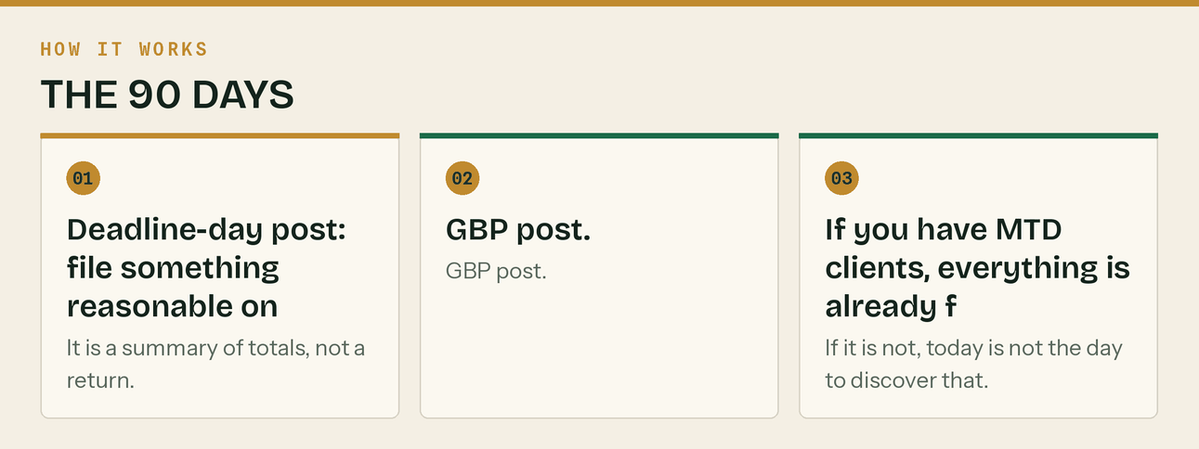
The same steps, in order.
Day 63 — Sun 15 Nov · ⏱ 30m
One thing: Week ahead.
- Week-ahead post. Next up: 19 Nov CIS.
Day 64 — Mon 16 Nov · ⏱ 2h
One thing: Pricing and margin week.
- Anchor: what that job actually cost you (docs/05 §8 №6).
- GBP W10.
- Post-deadline is a good week to publish something evergreen — the urgency audience has just been served.
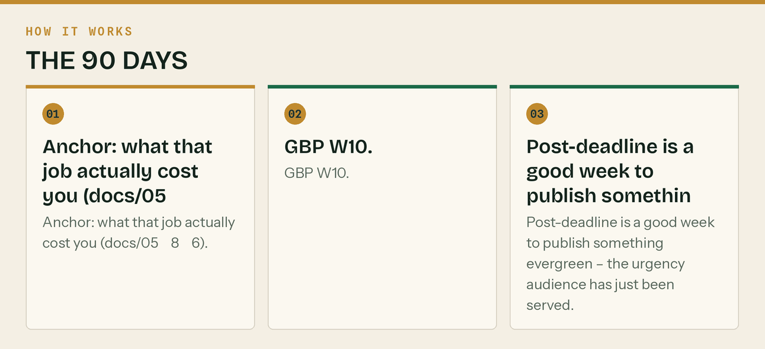
The same steps, in order.
Day 65 — Tue 17 Nov · ⏱ 1h
One thing: Video + reviews.
- Short video.
- Review asks: target 2/month, forever. Google first, Trustpilot second, nothing else.
Day 66 — Wed 18 Nov · ⏱ 1h 15m
One thing: Community.
- Community slot. You should be at 40+ contributions and able to link occasionally where rules allow.
Day 67 — Thu 19 Nov · ⏱ 2h
One thing: Long video + internal linking.
- Record.
- Internal linking pass: every local page links to the MTD page, the CIS service page, the tools page, and each other. Orphan pages rank for nothing.
Day 68 — Fri 20 Nov · ⏱ 1h 30m
One thing: Practical + numbers + Newsletter #6.
- Practical post.
- Newsletter #6.
- Production hour + numbers.
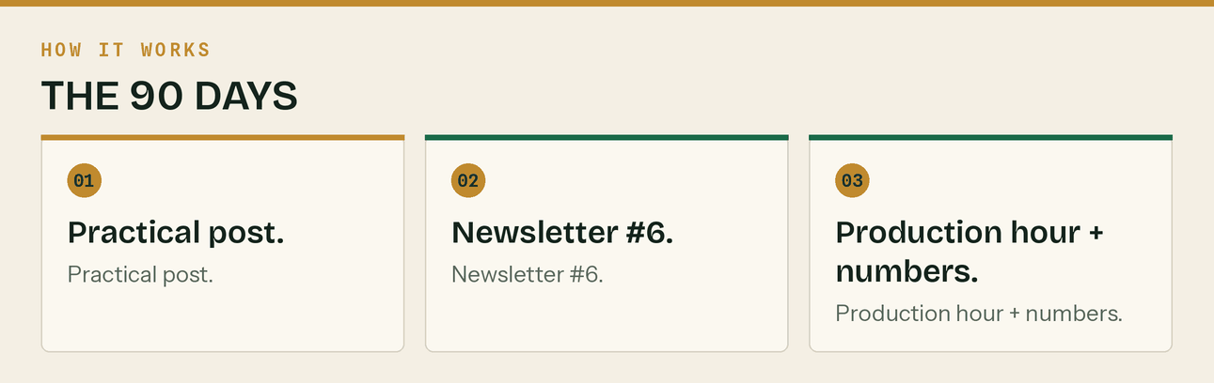
The same steps, in order.
Day 69 — Sat 21 Nov · ⏱ 30m
One thing: Light.
- Human post.
Day 70 — Sun 22 Nov · ⏱ 30m
One thing: Week ahead.
- Week-ahead. Flags Thu 19 Nov CIS.
Day 71 — Mon 23 Nov · ⏱ 2h
One thing: CIS + statements week.
- Anchor: chase your CIS deduction statements now, not in February.
- GBP W11.
- This is genuinely the right week for it — contractors still remember October jobs.
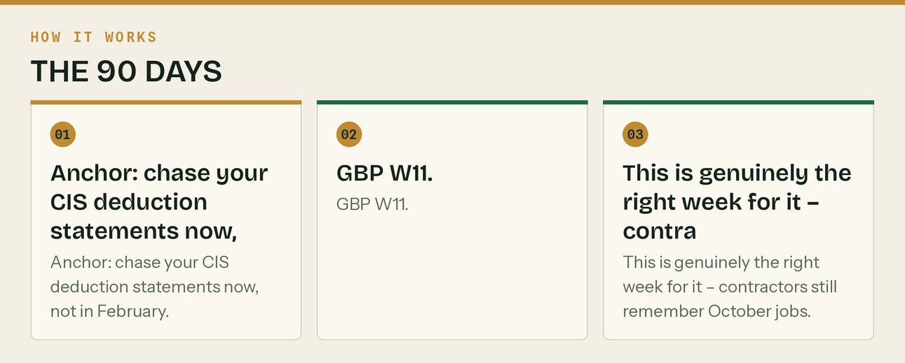
The same steps, in order.
Day 72 — Tue 24 Nov · ⏱ 1h
One thing: Video.
- Short video on deduction statements.
Day 73 — Wed 25 Nov · ⏱ 1h 15m
One thing: Community + partner follow-up.
- Community slot.
- Second round of accountant outreach. Another 20 firms, or a second contact to the first 20. Twenty emails is a small sample and this is your best channel.
Day 74 — Thu 26 Nov · ⏱ 1h
One thing: CIS deadline (month to 5 Nov).
- Deadline post, all channels.
- Client returns filed.
Day 75 — Fri 27 Nov · ⏱ 1h 30m
One thing: Practical + numbers.
- Practical post.
- Production hour + numbers.
Day 76 — Sat 28 Nov · ⏱ 30m
One thing: Light.
- Human post.
Day 77 — Sun 29 Nov · ⏱ 30m
One thing: Week ahead.
- Week-ahead. December is coming and the January hole content starts next week.
Day 78 — Mon 30 Nov · ⏱ 2h
One thing: The January hole. Best seasonal content of the year.
- Anchor: plan for January now (docs/05 §8 №7 has the full text). This post lands harder than anything else in the quarter because it is genuinely frightening and genuinely fixable.
- GBP W12.
- All channels, plus a video.
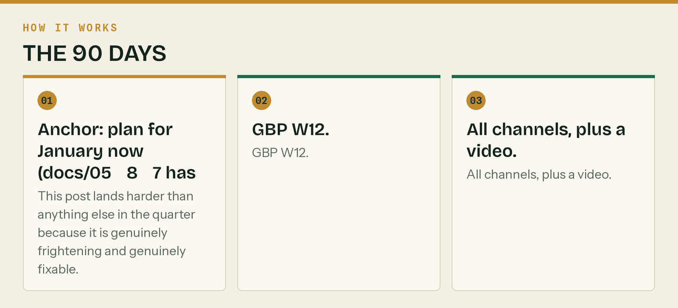
The same steps, in order.
Day 79 — Tue 1 Dec · ⏱ 1h
One thing: Video + capital allowances.
- Short video on the January hole.
- Second post: buying a van before 5 April, and why the invoice date decides the tax year (docs/05 §8 №11).
Day 80 — Wed 2 Dec · ⏱ 1h 15m
One thing: Community.
- Community slot.
Day 81 — Thu 3 Dec · ⏱ 2h
One thing: Long video + year-end content.
- Record: 'What to do before the tax year ends'.
- Publish it as a page too — it will get search traffic every February.
Day 82 — Fri 4 Dec · ⏱ 1h 30m
One thing: Practical + numbers + Newsletter #7.
- Practical post.
- Newsletter #7: the January hole.
- Production hour + numbers.
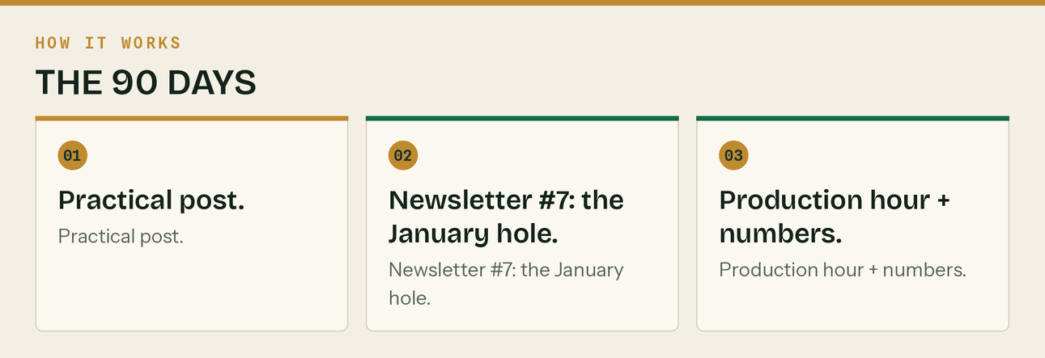
The same steps, in order.
Day 83 — Sat 5 Dec · ⏱ 30m
One thing: Light.
- Human post.
Day 84 — Sun 6 Dec · ⏱ 30m
One thing: Week ahead.
- Week-ahead post.
Day 85 — Mon 7 Dec · ⏱ 2h
One thing: Shutdown checklist week.
- Anchor: the nine-item shutdown checklist (docs/05 §8 №8).
- GBP W13.
- Highly practical, highly shared, and it positions you for January enquiries.
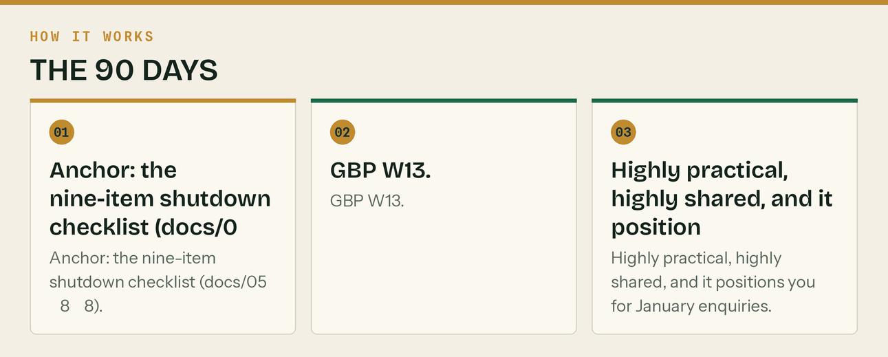
The same steps, in order.
Day 86 — Tue 8 Dec · ⏱ 1h
One thing: Video.
- Short video: get every invoice out before the 18th.
Day 87 — Wed 9 Dec · ⏱ 1h 15m
One thing: Community + 90-day reviews.
- Community slot.
- Run the 90-day review with every client onboarded in September (docs/12 Email 5). Twenty minutes each. This is where the £199 client becomes the £366 client.
Day 88 — Thu 10 Dec · ⏱ 2h
One thing: Case study + planning.
- Write up the first case study properly.
- Draft the month 4–6 content themes off the back of what actually got engagement, not what you assumed would.
Day 89 — Fri 11 Dec · ⏱ 2h
One thing: The 90-day review of the business.
- Full review against docs/14 §What good looks like at day 90. Be honest about every line.
- Cut the bottom half of the channel map. You now have real data on which channels produce calls and which produce nothing.
- Decide the month 4–6 plan.
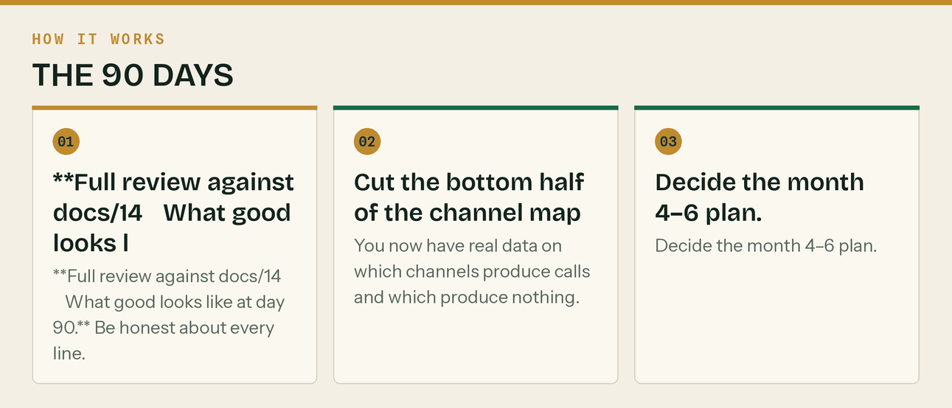
The same steps, in order.
Day 90 — Sat 12 Dec · ⏱ 1h
One thing: Day 90. Write down what you learned.
- Final numbers: booked calls/month, cost per call, clients, list size, reviews, community contributions.
- Write a one-page honest note: what worked, what did not, what you would not do again.
- Then book the session with me. The list of what I need from you is in docs/18.
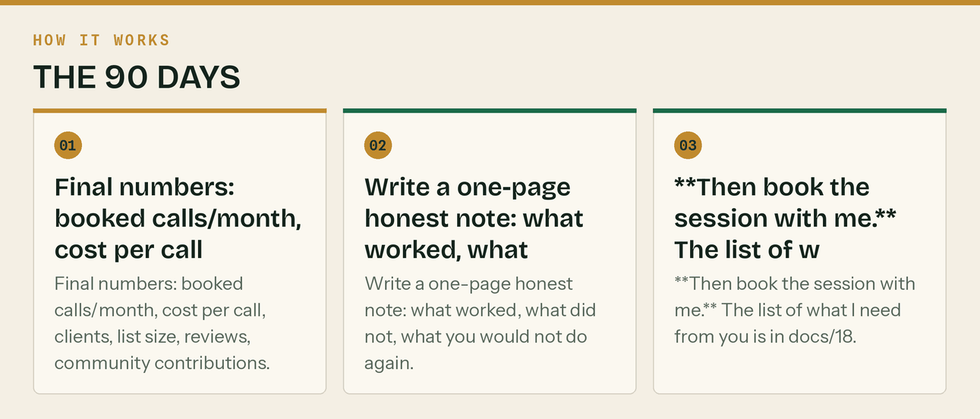
The same steps, in order.

The fallback plan — if a week goes wrong

It will. A big job lands, someone's off sick, the week disappears. Here is what to protect and what to drop, in order.
Never drop (25 minutes a week):
Monday GBP post 5 min Posts no longer expire, but only the newest shows prominently. A stale profile reads as "gone bust".
Monday anchor post 15 min The one post that carries the week.
Reply to comments 5 min Not replying is worse than not posting.
Drop in this order when you have to:
1. The Saturday light post — nobody notices
2. The Sunday week-ahead — merge it into Monday
3. Instagram and TikTok — lowest direct return of the set
4. The long video — batch two next week instead
5. The carousel — reuse an old one
6. The community slot — LAST. It is slow, it compounds, and stopping resets it.
Never drop the community slot for two weeks running. Reddit and forum credibility decays and the accounts go quiet in a way that is visible.
The line that matters
Reddit and forum credibility decays and the accounts go quiet in a way that is visible.

Also worth knowing
A big job lands, someone's off sick, the week disappears.

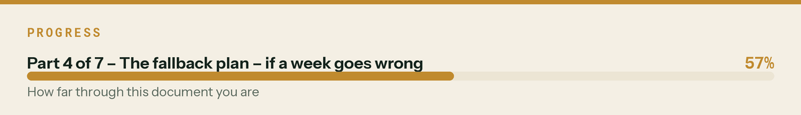

Total time commitment, honestly

Period | Hours/week | What it covers
Phase 0 (pre-launch) | ~16 hours total | One-off setup, most of it never repeated
Days 1–30 | 9–11 h/wk | Launch month, heaviest by design
Days 31–60 | 7–8 h/wk | Plus client onboarding when it starts
Days 61–90 | 6–7 h/wk | The rhythm is established and the library is built
Steady state | 2–3 h/wk | Monday anchor, Wednesday community, Friday production

If it is taking more than three hours a week after day 90, either it is working and you hire, or you are overproducing for channels that are not returning. Both have obvious answers.
The line that matters
If it is taking more than three hours a week after day 90, either it is working and you hire, or you are overproducing for channels that are not returning.

The printable week

Pin this up. It is the whole system.
┌──────────────────────────────────────────────────────────────┐
│ MON 07:30 Anchor post → LinkedIn, X, FB, IG │
│ GBP post (expires in 7 days — never skip) │
│ Reply to everything from the weekend │
├──────────────────────────────────────────────────────────────┤
│ TUE Short video → TikTok, Reels, Shorts │
│ Native upload to each. Never cross-post. │
├──────────────────────────────────────────────────────────────┤
│ WED 17:30 Carousel → Instagram + LinkedIn document │
│ COMMUNITY SLOT — one real answer, no link │
├──────────────────────────────────────────────────────────────┤
│ THU The week's big piece — long video or page │
│ Newsletter, on the fortnight │
├──────────────────────────────────────────────────────────────┤
│ FRI 16:00 Practical post (a tool, a template, a date) │
│ PRODUCTION HOUR — next week written & scheduled │
│ LOG THE FOUR NUMBERS │
├──────────────────────────────────────────────────────────────┤
│ SAT One light human post. 15 minutes. │
│ SUN Week-ahead deadlines post. 20 minutes. │
└──────────────────────────────────────────────────────────────┘
THE FOUR NUMBERS, every Friday:
Booked discovery calls · Cost per booked call
Guide downloads · GBP calls + directions + clicks
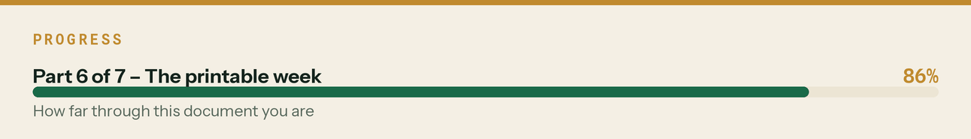

The hard dates inside these 90 days

Everything with against it in the plan above.
Date | Day | What
Fri 18 Sep | 12 | CIS return for month to 5 Sep — the 19th is a Saturday, work to Friday
Tue 22 Sep | 16 | CIS/PAYE electronic payment
Mon 5 Oct | 29 | MTD quarter ends (6 Jul – 5 Oct)
Mon 19 Oct | 43 | CIS return, month to 5 Oct
Sat 7 Nov | 62 | MTD quarterly update due — the biggest date in the window
Thu 19 Nov | 74 | CIS return, month to 5 Nov
Fri 18 Dec | — | Last useful invoicing day before the Christmas shutdown

*Verified against the standard quarterly periods and the CIS monthly cycle. Where a deadline falls on a weekend, work to the last working day before it.*
The line that matters
*Verified against the standard quarterly periods and the CIS monthly cycle.

