KLYARA the back office for building firms

Invoice
Blank template · CIS, VAT reverse charge and retention built in

Blank invoice — ready to use
Type over anything in [square brackets]. Delete the rows you do not need. Everything on this page is real Word text, so you can change it, save it and re-use it.

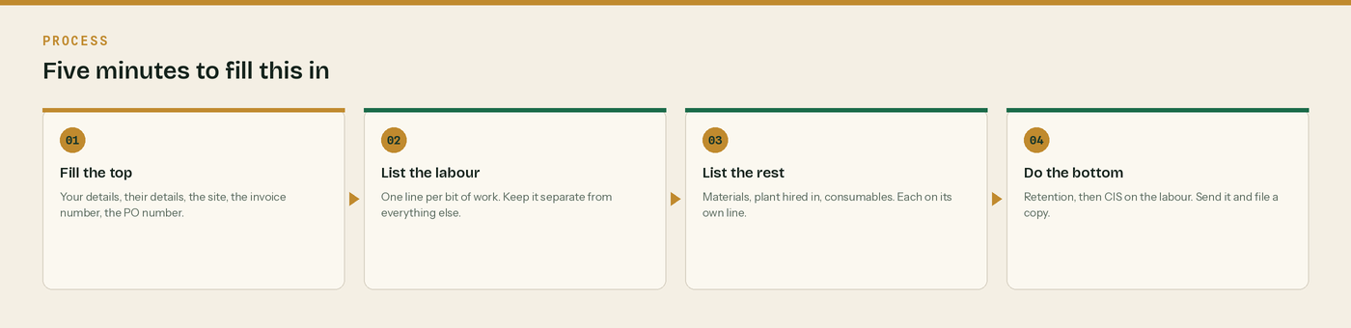
Five minutes, top to bottom.
From | Invoice to
[Your business name]  [Address line 1]  [Town]  [County and postcode]  VAT [registration number]  UTR [10 digits]  Company [number]  CIS: [registered net 20% / gross / not registered] | [Customer business name]  [Address line 1]  [Town]  [County and postcode]  For the attention of [name]  VAT [their number]

Invoice number | Invoice date | Their PO reference | Payment due
[INV-0000] | [date] | [PO number] | [date]

Site | Payment terms | Retention
[Plot and site name]  [Town and postcode] | [30] days from the invoice date | [5]% held to practical completion

The work
Description | Type | Amount
[Describe the work you did] | Labour | £0.00
[Second labour line] | Labour | £0.00
[Third labour line] | Labour | £0.00
Labour subtotal — the CIS is worked out on this |  | £0.00
[Materials you paid for] | Materials | £0.00
[More materials] | Materials | £0.00
[Plant hired in from a third party] | Plant hired in | £0.00
[Consumable stores used up on the job] | Consumable stores | £0.00
Everything else — no CIS on any of it |  | £0.00

How the total is built up
Line | Working | Amount
Net total of the work | Labour + materials + plant + consumables | £0.00
VAT | Reverse charge, or [20]% if it does not apply | £0.00
Invoice total |  | £0.00
Less retention at [5]% | [5]% of the net total | -£0.00
Less CIS at [20]% | [20]% of the labour being paid now | -£0.00
Amount payable now | By bank transfer, by [date] | £0.00

VAT: Reverse charge: customer to pay the VAT to HMRC
Leave this box exactly as it is written where the reverse charge applies. Fill in the rate that would have applied - [20]% standard or [5]% reduced - and the amount, £[0.00]. Do not add it to the total. If the reverse charge does not apply, delete this box and charge VAT in the normal way.

CIS: deducted from labour only
Write [20]% of £[labour being paid now] = £[0.00]. Never deduct from materials, plant hired in, consumable stores, fuel or VAT. If you hold gross payment status, delete this line.

Pay by bank transfer to | Detail
Bank | [Your bank]
Sort code | [00-00-00]
Account number | [00000000]
Reference to quote | [Your invoice number]

Retention held: £[0.00]
Say when it is due for release. When it is paid it carries its own CIS on the labour part. Put a reminder in the diary on the day you send the invoice.

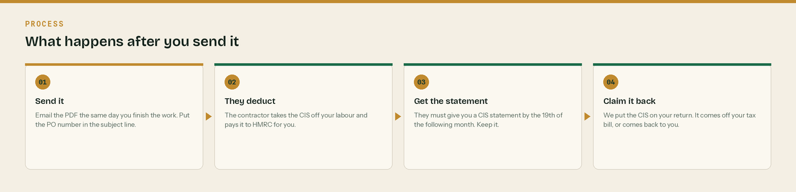
What happens after you send it.
Send page 1 only
Pages 2 onwards are notes for you, not for the customer. Delete them in Word before you send the invoice.

Three things to check before you send it

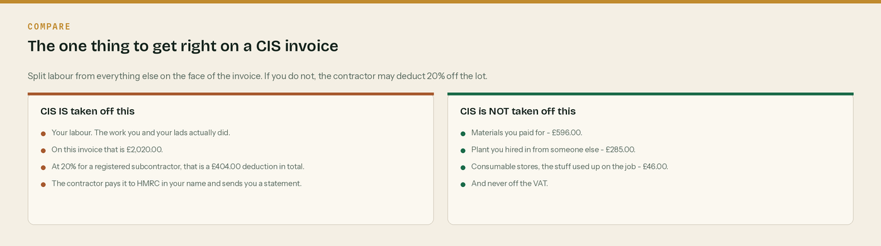
One. Is the labour on its own line, separate from everything else?
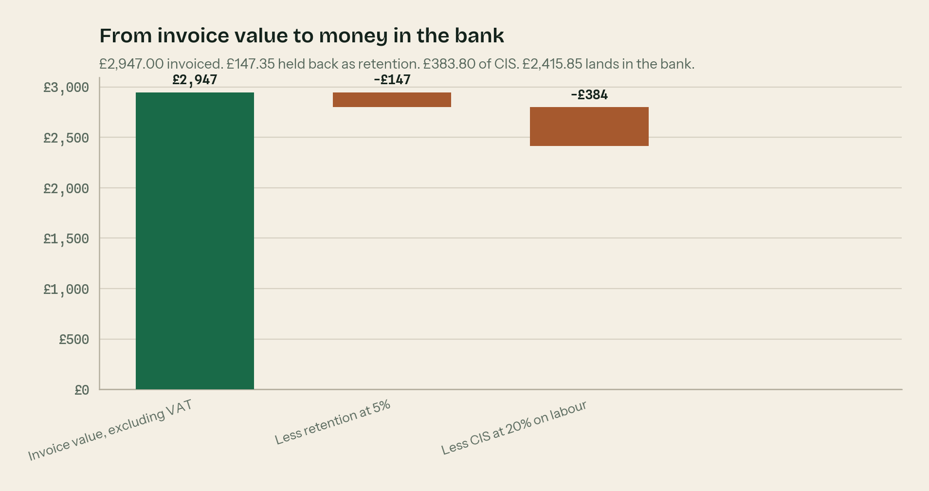
Two. Does the bottom line agree once retention and CIS come off?
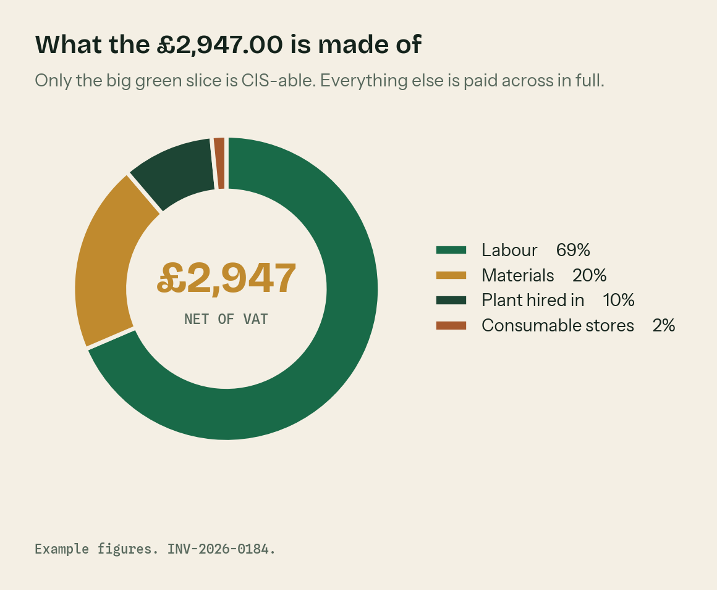
Three. Does the split of the job look right when you draw it?

The rules behind this invoice

CIS comes off labour. Nothing else.
The deduction is worked out on the labour only. It never comes off materials you paid for, plant you hired in from someone else, consumable stores, fuel used on the job, or the VAT. Split them on the face of the invoice and the contractor has no excuse to deduct off the lot.

The three CIS rates
20% if you are registered with HMRC and paid under deduction. 30% if you are not registered, or HMRC cannot match you. 0% if you hold gross payment status. The contractor checks this with HMRC before every payment - it is not your choice on the day.

Reverse charge - the exact words
Where the reverse charge applies the invoice must say so. The wording HMRC give is “Reverse charge: customer to pay the VAT to HMRC”. Show the rate of VAT that would have applied - 20% standard or 5% reduced - and the amount, but do not add it to the total you are charging.

When the reverse charge does not apply
It only bites on standard rated and reduced rated construction work reported under CIS, between two VAT registered businesses. It does not apply to zero rated work. It does not apply if your customer has given you an end user or intermediary supplier declaration in writing. No written declaration means you still apply the reverse charge.

Retention is a separate payment
Money held back as retention has not been paid to you yet, so there is no CIS on it yet. When the retention is released it is treated as its own contract payment, split into labour and materials, and the CIS is worked out then. On this example that is £20.20 later, so £404.00 of CIS in total.

Keep the CIS statement
The contractor must give you a payment and deduction statement by the 19th of the month following the tax month the payment fell in. It is the only proof you have that the money went to HMRC. Photograph it into the app the day it lands.

WHERE THIS COMES FROM
Every rule on this page was checked against gov.uk on Wednesday 26 August 2026. If a rate changes, the wording stays the same and only the number moves.
· CIS deduction rates — https://www.gov.uk/what-you-must-do-as-a-cis-contractor/make-deductions-and-pay-subcontractors
· What comes out before the CIS deduction (CIS 340) — https://www.gov.uk/government/publications/construction-industry-scheme-cis-340/construction-industry-scheme-a-guide-for-contractors-and-subcontractors-cis-340
· When to use the VAT domestic reverse charge — https://www.gov.uk/guidance/vat-domestic-reverse-charge-for-building-and-construction-services
· The wording HMRC accept on a reverse charge invoice (VATREVCON37100) — https://www.gov.uk/hmrc-internal-manuals/vat-reverse-charge-for-building-and-construction-services-manual/vatrevcon37100
· End user and intermediary supplier declarations — https://www.gov.uk/guidance/vat-reverse-charge-technical-guide
· Retention payments and CIS (CISR15040) — https://www.gov.uk/hmrc-internal-manuals/construction-industry-scheme-reform/cisr15040

