KLYARA the back office for building firms

Quotation
Blank template · fixed price, validity date and exclusions built in

Blank quotation — ready to use
Type over anything in [square brackets]. Delete the rows you do not need. Everything on this page is real Word text, so you can change it, save it and re-use it.

Quote or estimate? Change the word at the top.
A quotation is a fixed price you are bound by. An estimate is your best guess and can move. Pick one, write it at the top, and say underneath what the price is based on.


The four things every quote has to carry.
From | Quotation for
[Your business name]  [Address line 1]  [Town]  [County and postcode]  [Phone]  [Email]  VAT [registration number] | [Customer name]  [Address line 1]  [Town]  [County and postcode]  For the attention of [name]

Quotation number | Date | Valid until | Priced from
[QUO-0000] | [date] | [date, 30 days later] | [drawing or spec reference and revision]

Site | Start on site | Programme
[Plot and site name]  [Town and postcode] | [weeks] from acceptance | [weeks] on site

What we will do, and what it costs
Description | Type | Amount
[Describe the work] | Labour | £0.00
[Describe the work] | Labour | £0.00
[Describe the work] | Labour | £0.00
[Describe the work] | Labour | £0.00
[Plant you will hire in] | Plant hired in | £0.00
[Materials allowance] | Materials | £0.00
Total, excluding VAT |  | £0.00

What is included, and what is not
Included in the price | NOT included - charged extra
[List every thing the price covers. Be specific. Depths, quantities, tip charges, welfare, setting out, clean down.] | [List every thing it does not. Rock below a stated depth, contaminated ground, concrete, steel, standing time caused by others, anything not on the drawing, VAT.]

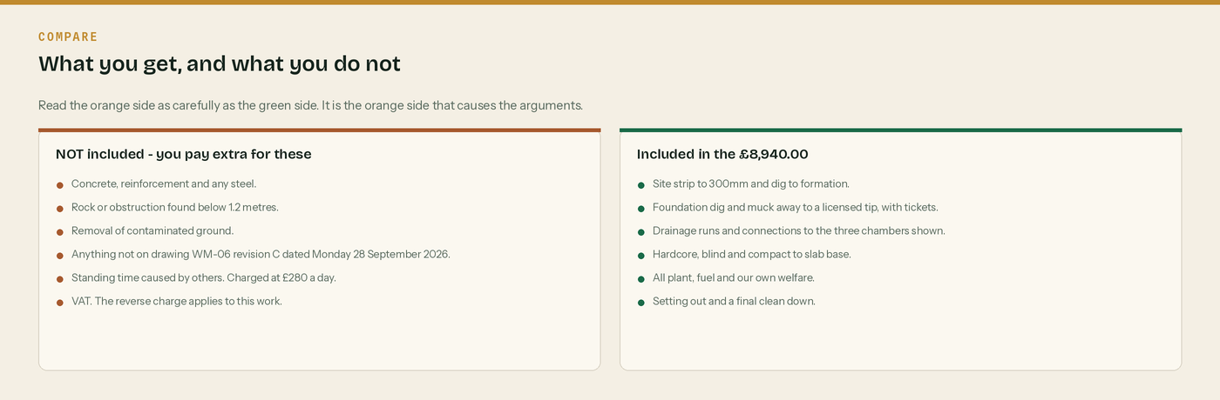
A worked example of the two lists, so you can see the level of detail.
VAT: Reverse charge: customer to pay the VAT to HMRC
Keep this box where the reverse charge applies - standard or reduced rated construction work under CIS, between two VAT registered businesses, with no written end user declaration. State the rate that would have applied, [20]% or [5]%, and the amount, £[0.00]. Delete the box if you are charging VAT normally.

CIS: say what will be held
Write [20]% of £[labour] = £[0.00] across the job. Nothing comes off plant hired in or materials. Saying it in the quote stops the argument on the first payment.

Payment terms | Retention | Validity
[Applied for monthly].  [30] days from each invoice. | [5]% to practical completion. | This price holds until [date].  After that we re-check it.

To accept this quotation
Sign below, write the date and your purchase order number, and email this page back to [your email].
Signed | Print name | Position | Date | Your PO number

Three things to check before you send it

One. Is the exclusions list long enough to protect you?

Two. Is there a validity date, and does the customer know the programme?
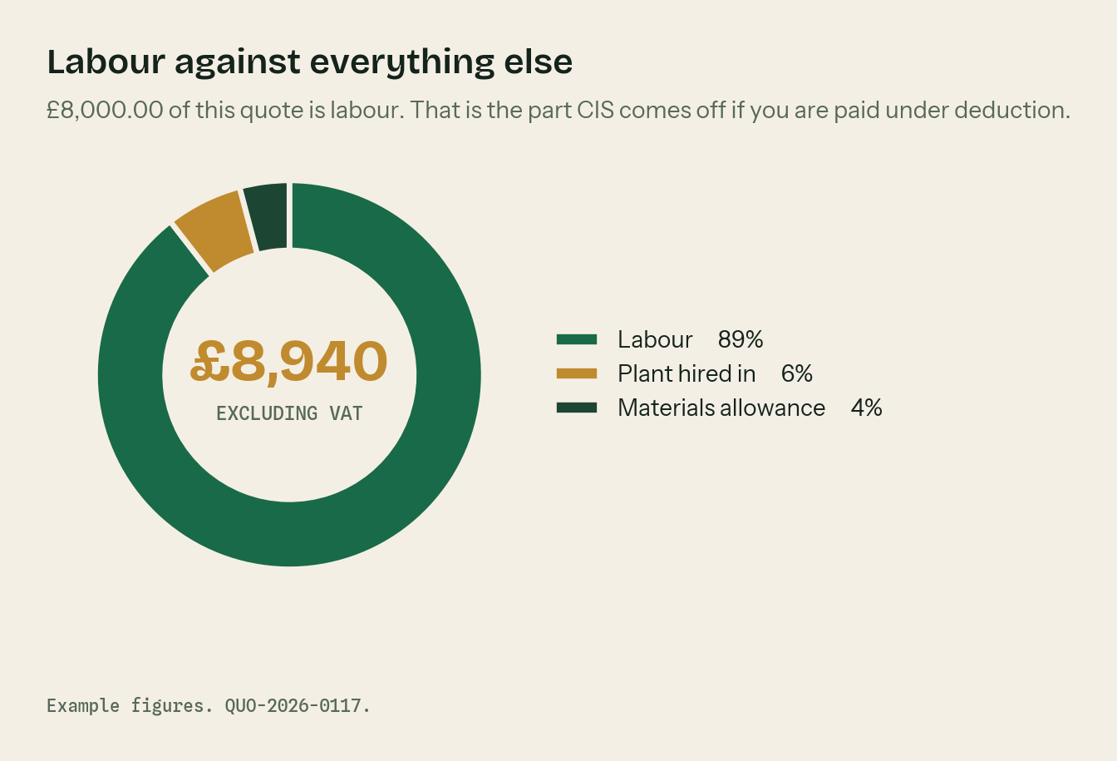
Three. Do you know how much of the price is labour, and so how much CIS is coming?

The rules behind this quotation

A quote is a fixed price. An estimate is a guess.
If you write quote at the top you are offering to do the job for that money. If the ground turns out worse than the drawing said, you carry it unless the exclusions cover you. If you are not sure of the scope, write estimate and say what it is based on.

Always put a validity date on it
Thirty days is normal. Materials and plant prices move. Without a date the customer can hold you to a price you gave last spring.

Exclusions are the whole game
Most arguments on site are about something nobody wrote down. The orange panel is not you being difficult. It is you being clear.

Say what the VAT does
Where the reverse charge applies, say so on the quote as well as the invoice. The customer needs to budget for cash, and reverse charge changes their cash. The wording is “Reverse charge: customer to pay the VAT to HMRC”.

Say what the CIS does
If the customer is a contractor and you are paid under deduction, they will hold 20% of the labour. On this quote that is £1,600.00 across the job. Say it now so nobody is surprised on the first payment.

WHERE THIS COMES FROM
Checked against gov.uk on Wednesday 26 August 2026. If a rate changes, the wording stays the same and only the number moves.
· When to use the VAT domestic reverse charge — https://www.gov.uk/guidance/vat-domestic-reverse-charge-for-building-and-construction-services
· The wording HMRC accept on a reverse charge invoice (VATREVCON37100) — https://www.gov.uk/hmrc-internal-manuals/vat-reverse-charge-for-building-and-construction-services-manual/vatrevcon37100
· End user and intermediary supplier declarations — https://www.gov.uk/guidance/vat-reverse-charge-technical-guide
· CIS deduction rates — https://www.gov.uk/what-you-must-do-as-a-cis-contractor/make-deductions-and-pay-subcontractors

