KLYARA the back office for building firms

Receipt
Blank template · for money received against an invoice

Blank receipt — ready to use
Type over anything in [square brackets]. Delete the rows you do not need. Everything on this page is real Word text, so you can change it, save it and re-use it.

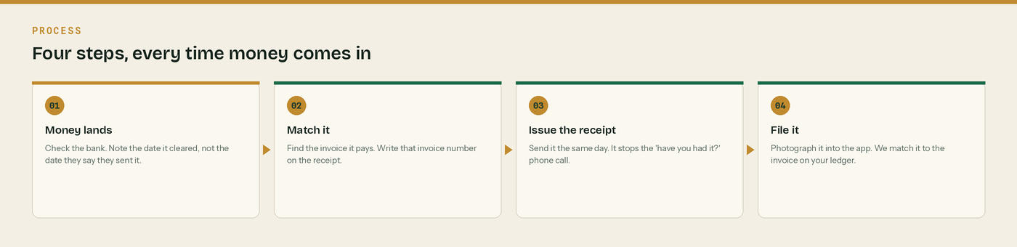
Four steps, every time money comes in.
From | Money received from
[Your business name]  [Address line 1]  [Town]  [County and postcode]  VAT [registration number]  Company [number] | [Customer business name]  [Address line 1]  [Town]  [County and postcode]  For the attention of [name]

Receipt number | Date money cleared | How it was paid | Their reference
[RCT-0000] | [date it cleared your bank] | [Bank transfer / cash / card] | [their reference]

What this receipt pays
Line | Working | Amount
[Invoice number], dated [date] | [What the invoice was for] | £0.00
Less retention at [5]% | Held by them to practical completion | -£0.00
Less CIS at [20]% | Paid to HMRC in your name | -£0.00
Received with thanks | Cleared [date] | £0.00
Still to pay on this invoice | [Nothing outstanding / £0.00] | £0.00
Retention still held | [When it is due for release] | £0.00

VAT: Reverse charge: customer to pay the VAT to HMRC
Keep this box where the invoice was raised under the reverse charge. State the rate that would have applied - [20]% standard or [5]% reduced - and the amount, £[0.00]. Delete the box if VAT was charged normally. A receipt is never a VAT invoice.

CIS statement - chase it
Write the date it is due here: [14 days after the end of the tax month the payment fell in]. Tax months run from the 6th to the 5th. Put it in the diary the day you issue this receipt.

Retention still held: £[0.00]
Write when it is due for release. Retention is the money most firms never chase and never see.

Three things to check before you send it

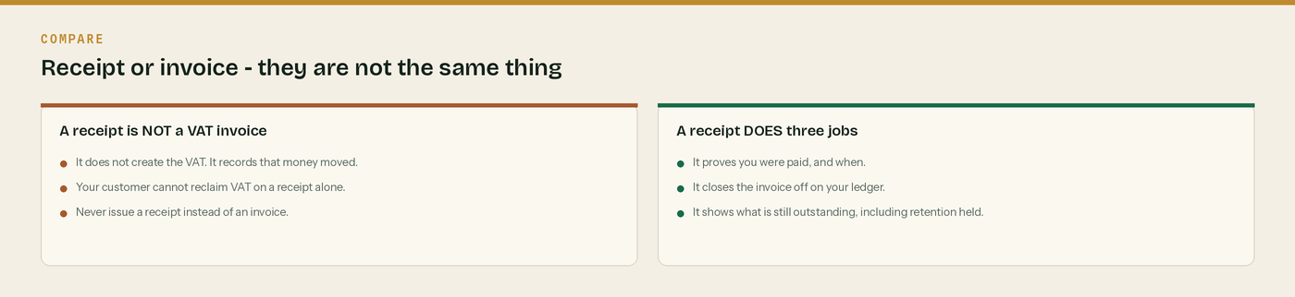
One. Is this a receipt, and did the invoice go out first?
Two. Is the date the date the money actually cleared?
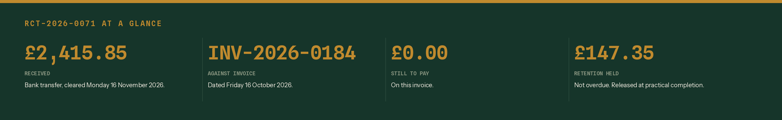
Three. Does it say what is still outstanding, retention included?
A receipt records money. An invoice creates the debt.
Send the invoice first, always. The receipt goes out when the money clears, not when they tell you they have paid it. Two different documents, two different numbers, two different jobs.

Date it the day the money cleared
Not the day they say they sent it. Your bank statement is the record HMRC will look at, and the receipt has to agree with it.

Say what is still outstanding
Retention held is not a bad debt and it is not overdue - but it is money you have not got. Put it on the receipt every time so nobody forgets it exists.

Chase the CIS statement
The contractor must give you a payment and deduction statement within 14 days of the end of the tax month the payment fell in. Without it you cannot prove the deduction. No statement, no relief.

Keep it for six years
A limited company must keep its records for six years from the end of the last company financial year they relate to. Photograph it into the app and the six years look after themselves.

WHERE THIS COMES FROM
Checked against gov.uk on Wednesday 26 August 2026. If a rate changes, the wording stays the same and only the number moves.
· CIS payment and deduction statements (CISR12160) — https://www.gov.uk/hmrc-internal-manuals/construction-industry-scheme-reform/cisr12160
· What a VAT invoice must show (VAT Notice 700 section 16) — https://www.gov.uk/guidance/vat-guide-notice-700
· Keeping company and accounting records — https://www.gov.uk/running-a-limited-company/company-and-accounting-records

