KLYARA the back office for building firms

Receipt
RCT-2026-0071 · a worked example against INV-2026-0184

Worked example — not a real job
Every name, number and date on this document is made up to show you how the form works. Klyara has no clients yet and this is not a record of any job. Replace the lot with your own.

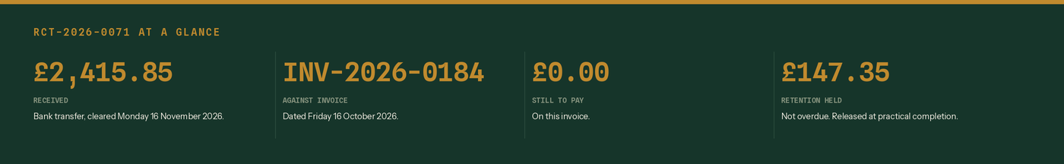
What this receipt says, in four numbers.
From | Money received from
Hatcher Groundworks Ltd  Unit 4, Ladymead Yard  Guildford  Surrey GU1 1DB  VAT GB 412 8890 55  Company 09884412 | Pennistone Construction Ltd  Pennistone House, Chertsey Road  Woking  Surrey GU21 5BJ  For the attention of Marie Odell, Commercial

Receipt number | Date money cleared | How it was paid | Their reference
RCT-2026-0071 | Monday 16 November 2026 | Bank transfer | PC-4471

What this receipt pays
Line | Working | Amount
INV-2026-0184, dated 16 October 2026 | Groundworks, Plot 6, Wey Meadow, Cranleigh | £2,947.00
Less retention at 5% | Held by Pennistone Construction Ltd to practical completion | -£147.35
Less CIS at 20% | Paid to HMRC in our name. Statement to follow. | -£383.80
Received with thanks | Cleared 16 November 2026 | £2,415.85
Still to pay on this invoice | Nothing outstanding | £0.00
Retention still held | Due for release at practical completion | £147.35

VAT: Reverse charge: customer to pay the VAT to HMRC
The work this receipt relates to was invoiced under the domestic reverse charge. The rate that would have applied is 20%, which on £2,947.00 is £589.40. No VAT was charged and none was paid. This receipt is not a VAT invoice.

CIS statement due by Saturday 19 December 2026
The payment fell in the tax month 6 November to 5 December 2026. The contractor has 14 days from the end of that tax month to send the statement showing the £383.80 deducted. Chase it on the 20th if it has not arrived.

Retention still held: £147.35
Not overdue, but not yours yet either. Put a diary note against practical completion. When it is paid it carries its own £20.20 of CIS and £127.15 reaches the bank.

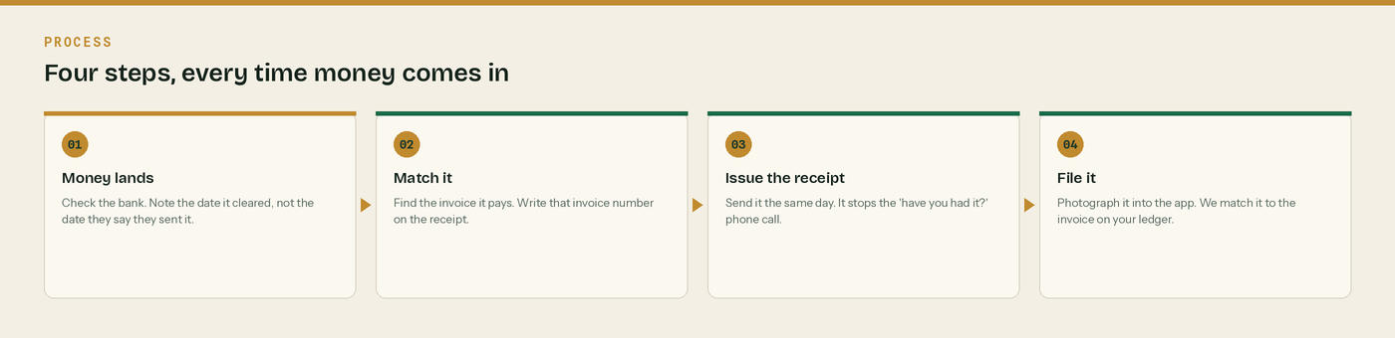
Four steps, every time money comes in.

Receipt or invoice - and why it matters

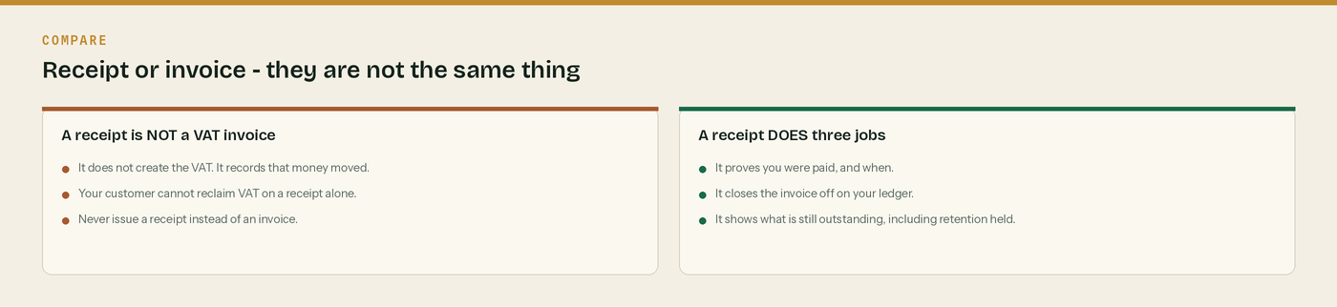
They do different jobs. Do not swap one for the other.
The same four steps again. Step two is the one that saves the phone call.
And the four numbers this receipt has to carry.
A receipt records money. An invoice creates the debt.
Send the invoice first, always. The receipt goes out when the money clears, not when they tell you they have paid it. Two different documents, two different numbers, two different jobs.

Date it the day the money cleared
Not the day they say they sent it. Your bank statement is the record HMRC will look at, and the receipt has to agree with it.

Say what is still outstanding
Retention held is not a bad debt and it is not overdue - but it is money you have not got. Put it on the receipt every time so nobody forgets it exists.

Chase the CIS statement
The contractor must give you a payment and deduction statement within 14 days of the end of the tax month the payment fell in. Without it you cannot prove the deduction. No statement, no relief.

Keep it for six years
A limited company must keep its records for six years from the end of the last company financial year they relate to. Photograph it into the app and the six years look after themselves.

WHERE THIS COMES FROM
Checked against gov.uk on Wednesday 26 August 2026. If a rate changes, the wording stays the same and only the number moves.
· CIS payment and deduction statements (CISR12160) — https://www.gov.uk/hmrc-internal-manuals/construction-industry-scheme-reform/cisr12160
· What a VAT invoice must show (VAT Notice 700 section 16) — https://www.gov.uk/guidance/vat-guide-notice-700
· Keeping company and accounting records — https://www.gov.uk/running-a-limited-company/company-and-accounting-records

