KLYARA the back office for building firms

Client Intake Form
Everything we need on day one. Twenty minutes, once, and then never again.

BEFORE YOU START
This is the form we send the day you say yes. It is the longest twenty minutes of the whole relationship and it is the last time we ask you for most of this.
Fill in what you know. Leave what you do not.
Nothing here is a test. If you do not know your UTR or which VAT scheme you are on, write not sure and we will find it. The only lines we cannot start without are your name, your business name and your identity documents in Section 8.

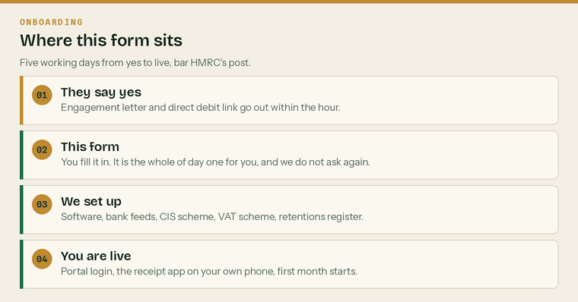
Where this form sits. It is day one, and it unlocks days two to five.
Have these to hand before you start
 | Last year's tax return or accounts |  | UTR and National Insurance number
 | Three months of bank statements |  | VAT certificate, if registered
 | Your last three CIS statements |  | Passport or driving licence

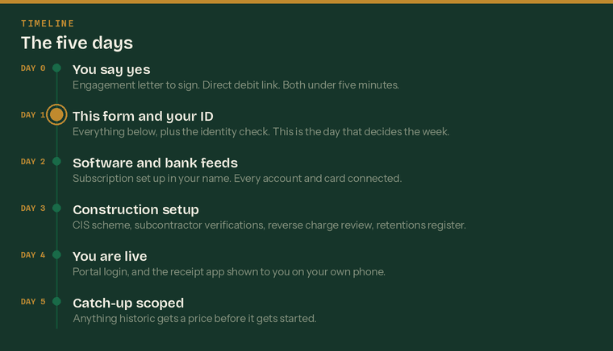
The five working days from yes to live. The only step we cannot compress is HMRC's post.
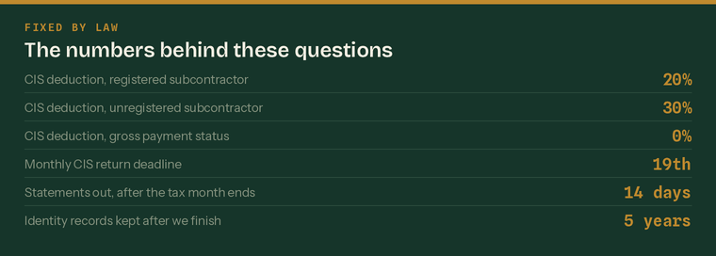
The rules behind the questions. Every one is set by HMRC or by the Money Laundering Regulations.

Trading name | the name on the van and the invoices
Legal name, if different | as registered at Companies House
Trading address
Postcode
Correspondence address, if different
Main contact name
Mobile
Email
Best way to reach you | phone, WhatsApp or email
What the business actually does | groundworks, electrical, roofing, general build

Business structure
 | Sole trader |  | Partnership |  | Limited company |  | LLP

Trading since
 | Under 1 year |  | 1-3 years |  | 3-10 years |  | Over 10 years

Company registration number | eight digits, limited companies and LLPs only
Date of incorporation
Accounting reference date / year end
Directors, partners or owners — names | list everyone, we need ID for each
Registered office, if we do not provide it

Why we ask about structure first
It sets everything else. A sole trader is Self Assessment and possibly Making Tax Digital for Income Tax. A limited company is annual accounts, a CT600, a confirmation statement and director payroll. Getting this wrong at the start means getting the plan wrong.


These are the reference numbers HMRC uses to find you. They are on old letters, on your Government Gateway account, or on last year's tax return. If you cannot find one, write not sure.
Unique Taxpayer Reference (UTR) | 10 digits — the sole trader's or the company's
Second UTR, if you have both | directors of a limited company usually have a personal one too
National Insurance number | sole traders, partners and directors
Date of birth | required for the identity check
PAYE reference | three digits, a slash, then letters and numbers
Accounts Office reference
VAT registration number | 9 digits, starts GB
Government Gateway user ID | we do not need the password, ever

We will never ask for your Government Gateway password
We act as your agent through HMRC's agent services, which is a separate authorisation you approve. Anyone who asks you for your Gateway password is either careless or not who they say they are.

Who acts for you now
Current bookkeeper or accountant | name and firm
Their email | so we can write the professional clearance letter
Are they aware you are moving? | yes, no, or not yet
Anything unfinished with them | a return not filed, a year not closed


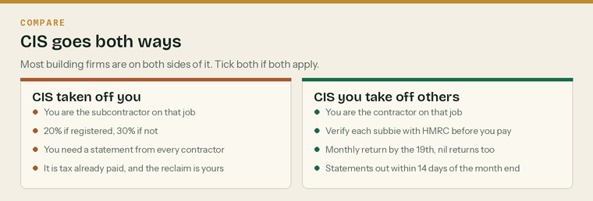
CIS runs in both directions and most building firms are on both sides of it. Tick everything that applies.
CIS is deducted from your payments
 | Yes |  | No |  | Not sure

You deduct CIS from subcontractors
 | Yes |  | No |  | Not sure

Registered with HMRC as a contractor
 | Yes |  | No |  | Not sure

Registered with HMRC as a subcontractor
 | Yes |  | No |  | Not sure

Your deduction rate as a subcontractor
 | 20% (registered) |  | 30% |  | 0% (gross)

Roughly how many contractors pay you
Roughly how many subcontractors you pay
Last CIS return you filed, month | if you file them
Any CIS returns outstanding | be honest — the penalties compound

Gross payment status
Do you hold gross payment status?
 | Yes |  | No |  | Applied for |  | Not sure

If you do not, and you turn over more than £30,000 net of materials, you may pass the three tests and get paid gross. We check this for every client. On Trade and Pro we prepare the application at no extra charge.
 | Copies of the last three CIS statements you received | One per contractor, per month
 | Your list of current subcontractors | Names, UTRs and verification numbers if you have them
 | Any HMRC letters about CIS | Penalties, verification notices, compliance checks


VAT registered
 | Yes |  | No |  | Applied for

Which scheme
 | Standard |  | Cash accounting |  | Flat rate
 | Annual |  | Not sure

Return frequency
 | Quarterly |  | Monthly |  | Annual

Domestic reverse charge in use
 | Yes, both ways |  | Sales only |  | Purchases only
 | No |  | Not sure

VAT quarter ends | for example March, June, September, December
Date of registration
If flat rate, the percentage you use
Any VAT owed or under query with HMRC

The reverse charge is where we find money
Roughly half the firms we look at have it wrong in one direction. If most of your sales are reverse charged you are probably in a repayment position, and you should be on monthly returns rather than quarterly. That is your money back twelve times a year instead of four. We review your last ten sales invoices in the first week.

Who are your main customers, and are any of them end users?
An end user is the person the building is actually for — not a main contractor invoicing your work onward. End user status changes the VAT treatment and it has to be confirmed in writing.


Software you use now
 | QuickBooks |  | Xero |  | Sage
 | FreeAgent |  | Spreadsheet |  | None

Receipt capture app
 | Dext |  | Hubdoc |  | Built into software |  | None

Login email for the software | we do not need your password
Who pays for it now | you, your accountant, or nobody
Anything you are paying for and not using | there is usually one

Your Klyara plan includes the software subscription and it goes in your name, not ours. That is deliberate. If you ever leave, the subscription and all the data stay with you and nothing has to be untangled.
Bank accounts and cards to connect
Business current account — bank and last four digits
Second account, if any
Business credit card
Savings or tax reserve account
Finance, HP or lease agreements | vans, plant, machinery
Payment apps in use | Sumup, Zettle, Stripe, PayPal

Bank feeds are the single highest-value step in the whole setup
A connected feed is the difference between us knowing where you stand on the 3rd and you sending us a statement on the 20th. It is read-only. We cannot move money and we would not want the ability to.


Do you run a payroll
 | Yes |  | No |  | About to

Number of employees | not counting subcontractors
Pay frequency | weekly, fortnightly, four-weekly, monthly
Usual pay day
Pension provider | Nest, Peoples Pension, Smart Pension, other
Pension scheme reference
Duties start date for auto-enrolment | the day your first member of staff started
Declaration of compliance done | yes, no, or not sure
Employers' liability insurer and policy number
Employment allowance claimed | yes, no, or not sure

Three employer duties that carry a penalty
Employers' liability insurance must cover at least £5 million and the fine is £2,500 for every day you are not properly insured. The certificate has to be where staff can see it or that is a further £1,000. And the declaration of compliance goes to The Pensions Regulator within five months of your duties start date.

Anyone paid cash, or paid without a payslip?
Tell us now. It is fixable now and it is very expensive later. We are not here to tell you off.


Subcontractors and retentions are where construction bookkeeping stops looking like ordinary bookkeeping. Both need their own register from day one.
How many subcontractors you use in a typical month
How many are limited companies
Do you hold verification numbers for all of them | yes, no, or not sure
Do you check their insurance | yes, no, or not sure
Do any of them work only for you | this is the employment status question

If a subcontractor cannot be evidenced as verified, treat them as unverified
An unverified subcontractor is a 30% deduction, not 20%. The exposure sits with you as the contractor, not with them. We re-verify anyone whose verification you cannot produce, in the first week, and it costs you nothing.

Retentions
Do main contractors hold retention from you
 | Yes |  | No |  | Not sure

Do you hold retention from your subcontractors
 | Yes |  | No |  | Not sure

Roughly how much is being held from you now | £
Oldest retention you are still waiting on | job and rough date
Do you keep a retention schedule now | yes, no, or a mental list

Building the retention register is a day-three job and it almost always finds money nobody has asked for. Bring whatever you have — applications for payment, valuations, final accounts, or just the name of the job.
Live jobs right now — name, main contractor, rough value, retention held
One per line. Rough is fine.


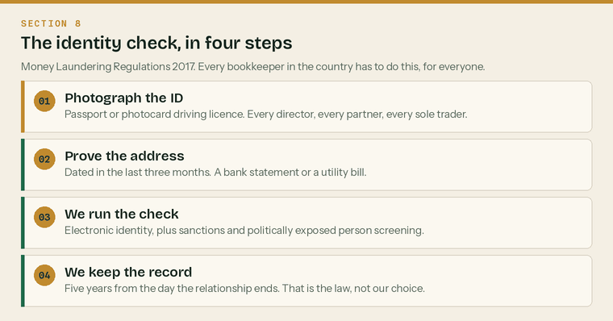
The identity check. Every bookkeeper in the country has to do this, for every client, before any work starts.
This is the Money Laundering Regulations 2017 and there is no way round it for anybody. We need it for every director, every partner, every sole trader, and for anyone who owns or controls more than 25% of the business.
 | Photo identity document | Passport, or a photocard driving licence
 | Proof of address | Dated within the last three months
 | Second proof of address if the first is a bank statement | A utility bill or council tax bill
 | Confirmation of who owns and controls the business | Anybody with more than 25%
 | Source of funds, where the work calls for it | Only asked if the risk assessment says so

Who we need this for
Person 1 — full name | exactly as it appears on the document
Date of birth
Home address, last three years
Person 2 — full name
Date of birth
Home address, last three years

What we do with it, and how long we keep it
We run an electronic identity check that also screens sanctions lists and politically exposed persons. We keep the record for five years from the day our relationship ends — that period is set by the Money Laundering Regulations, not by us, and it overrides a request to delete. Everything else is in our Privacy Notice.


By signing you confirm that the information above is true to the best of your knowledge, that you will tell us if it changes, and that you authorise Klyara to act as your agent with HMRC for the taxes set out in your engagement letter.
You also confirm you have read the Privacy Notice, which explains what we do with your information and what rights you have over it.
 | I have read and signed the engagement letter |  | I have set up the direct debit
 | I have sent my identity documents |  | I have read the Privacy Notice

Signatures
Client | signed by the sole trader, partner or director
Signed | Print name
Position | Date
Klyara | countersigned on receipt
Signed | Print name
Position | Date

What happens next
Nothing, from you. We take it from here. Day two is software and bank feeds, day three is the construction setup, day four you are live. We will write to you at each step and we will tell you the moment HMRC's authorisation code lands.
If a letter turns up from HMRC that looks like it is about an agent, do not bin it
That is the authorisation code. Send us a photo of it and we are away. It is the one step in the whole week that we cannot speed up.

Sources
Every figure and deadline in this document was checked against the page listed beside it on Wednesday 26 August 2026. Re-check before each use — thresholds and penalties change.
What was checked | Source
Money Laundering Regulations — record keeping, five years | https://www.gov.uk/guidance/money-laundering-regulations-your-responsibilities
CIS deduction rates 20%, 30%, 0% and what is excluded | https://www.gov.uk/what-you-must-do-as-a-cis-contractor/make-deductions-and-pay-subcontractors
CIS monthly return by the 19th, nil returns, penalties | https://www.gov.uk/what-you-must-do-as-a-cis-contractor/file-your-monthly-returns
Contractor duty to verify and to check employment status | https://www.gov.uk/what-you-must-do-as-a-cis-contractor
Employers' liability insurance — £5m, £2,500 a day, £1,000 certificate | https://www.gov.uk/employers-liability-insurance
Auto-enrolment — who must be enrolled, duties start date | https://www.gov.uk/workplace-pensions-employers
Declaration of compliance within five months | https://www.thepensionsregulator.gov.uk/en/employers/new-employers/im-an-employer-who-has-to-provide-a-pension/declare-your-compliance
ICB Practice Licence includes AML supervision, 28 days to process | https://www.bookkeepers.org.uk/Running-a-Practice/Regulation/Practice-Licence

