KLYARA the back office for building firms

Klyara — 30-Day Launch Content Calendar
Full copy. Not outlines. Ready to schedule.

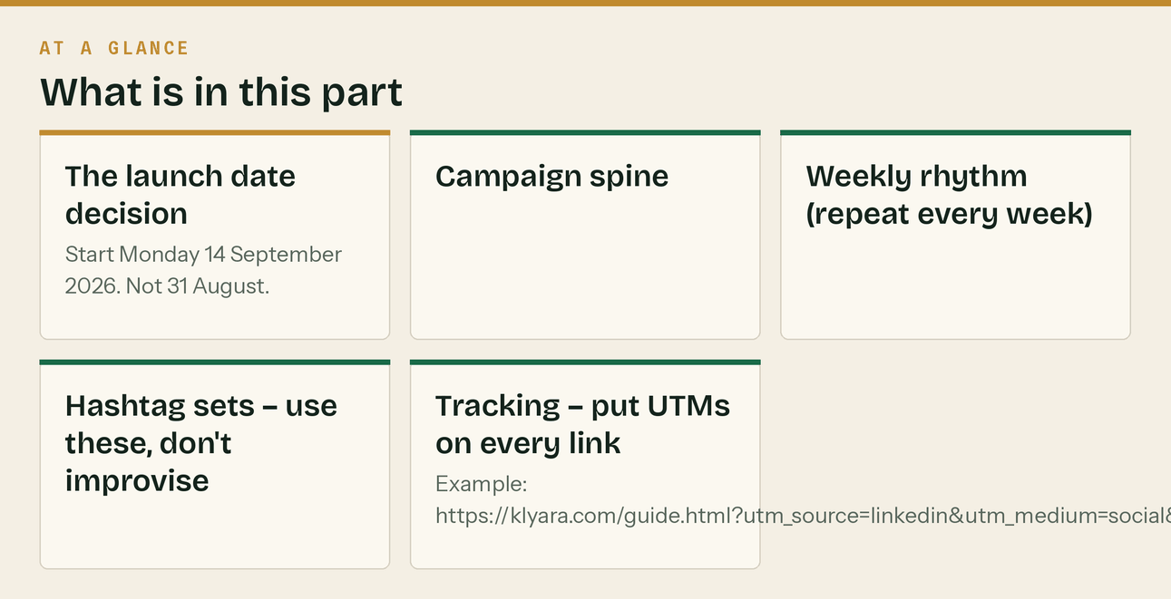
The launch date decision
Start Monday 14 September 2026. Not 31 August.
31 August 2026 is the Summer Bank Holiday. Half your audience is off, B2B engagement on a bank holiday Monday is the worst of the year, and you'd spend your single best post — the launch — on a dead day. The week of 1–4 September is also the school-return week, which is noisy.
7 September also lines the campaign up with something better: the MTD quarter ending 5 October, with its filing deadline of 7 November. That gives the whole 30 days a real countdown to build towards instead of a manufactured one.
Day 1 = Mon 7 Sep 2026. Day 30 = Tue 6 Oct 2026.
If you insist on launching 31 August, shift every date in this document back by seven days. Nothing else changes.
Campaign spine
Week | Dates | Theme | Emotional job
1 | Mon 7 – Sun 13 Sep | "We exist, and here's why" | Introduce Craig. Establish the specialism. Make MTD real.
2 | Mon 14 – Sun 20 Sep | "CIS and the reverse charge" | Demonstrate depth. Be the one who explains it properly.
3 | Mon 21 – Sun 27 Sep | "Getting paid" | Hit the pain that isn't tax. Widen the audience.
4 | Mon 28 Sep – Sun 4 Oct | "Quarter end" | Urgency. The 5 October quarter close, the 7 November deadline.
5 | Mon 5 – Tue 6 Oct | "Quarter closed. Now what." | Convert the attention into waitlist and calls.

Weekly rhythm (repeat every week)
Day | Slot | Channels
Mon | Anchor post — the week's big idea | LinkedIn (Craig) + Company Page + X + Facebook + GBP
Tue | Short video | TikTok + Reels + YouTube Shorts
Wed | Carousel / explainer graphic | Instagram + LinkedIn document + Facebook
Thu | Long-form video | YouTube (+ clip to Shorts Fri)
Fri | Practical / tool / checklist | X thread + Facebook + LinkedIn
Sat | Light / human / behind the scenes | Instagram Stories + Facebook
Sun | Week-ahead deadlines post | LinkedIn + X + GBP
Weekly | 1 forum/Reddit contribution (no link) | Rotating
Fortnightly | Newsletter | Email

Hashtag sets — use these, don't improvise
LinkedIn (3–5 max, they hurt reach above that):
#Construction #CIS #MakingTaxDigital #UKConstruction #SmallBusinessUK
Instagram / Threads (8–12):
#ukbuilders #tradesmenuk #cis #constructionuk #selfemployeduk #bookkeeping
#makingtaxdigital #buildersuk #subcontractor #tradesman #ukbusiness #vat
TikTok (3–5):
#ukbuilders #tradesmen #cis #tax #selfemployed
X (1–2 max):
#CIS #MakingTaxDigital
Tracking — put UTMs on every link
?utm_source=<platform>&utm_medium=social&utm_campaign=launch30&utm_content=day<N>
Example: https://klyara.com/guide.html?utm_source=linkedin&utm_medium=social&utm_campaign=launch30&utm_content=day01
HOLD markers: posts marked contain a direct "hire us" CTA and should not go out until AML supervision is confirmed. Swap the CTA for the waitlist version given underneath each one.
The line that matters
Half your audience is off, B2B engagement on a bank holiday Monday is the worst of the year, and you'd spend your single best post — the launch — on a dead day.

In this part
Full copy. Not outlines. Ready to schedule. · The launch date decision · Campaign spine · Weekly rhythm (repeat every week) · Hashtag sets — use these, don't improvise · Tracking — put UTMs on every link

WEEK 1 — "We exist, and here's why"


Mon 7 – Sun 13 September
DAY 1 — Monday 14 September · LAUNCH
🔷 LinkedIn — Craig's personal profile *(the most important post of the month — pin it)*
I've spent eleven years doing the books for building firms.
In that time I've never once met a builder who went into the trade because they enjoyed paperwork.
But I've met plenty who lost a Sunday to it. Who found a bag of receipts in the van in February.
Who paid a CIS penalty because the 19th landed on a week they were three men down. Who genuinely
didn't know whether the reverse charge applied to a job until after they'd invoiced it wrong.
So I've started something.
Klyara is the back office for small construction firms. Bookkeeping, CIS returns, VAT reverse charge
coding, payroll, and the new Making Tax Digital quarterly filing. One fixed monthly fee. You run the
jobs, we run the rest.
Construction only. Not "we have a few building clients." Only.
That matters more than it sounds. Gross payment status, 20% versus 30% deductions, retentions,
materials splits, subcontractor verification, the domestic reverse charge — for most accountants
that's the awkward bit at the end of the month. Here it's the whole job.
The timing isn't an accident either.
Making Tax Digital for Income Tax went live in April 2026 for sole traders and landlords with
qualifying income over £50,000. It drops to £30,000 in April 2027, and £20,000 in April 2028.
Qualifying income is measured GROSS — before CIS is taken off. So a subbie invoicing £55,000 who
takes home £44,000 after deductions is already in it, and a lot of them don't know.
Four updates a year instead of one return. The shoebox doesn't survive that.
Over the next month I'm going to post everything I know about CIS, the reverse charge, MTD and
getting paid on time. No gate, no email capture, just the answers. If it's useful, follow along.
And if you're a builder wondering whether MTD has caught you — message me. I'll tell you straight.
Takes two minutes and there's no pitch on the end of it.
klyara.com
#Construction #CIS #MakingTaxDigital #UKConstruction #SmallBusinessUK
🔷 LinkedIn — Company Page
Klyara is live.
The back office for small construction firms — bookkeeping, CIS returns, VAT reverse charge coding,
payroll and Making Tax Digital quarterly filing, for one fixed monthly fee.
Construction only. Plans from £59 + VAT a month.
Over the next 30 days we're publishing everything we know about CIS, the reverse charge and MTD.
Free, no email required.
Start here — the free MTD guide for sole traders and subcontractors: klyara.com
#Construction #CIS #MakingTaxDigital
🔷 X
New: Klyara — the back office for small building firms.
Bookkeeping. CIS returns. VAT reverse charge. Payroll. MTD quarterly filing.
One fixed monthly fee.
You run the jobs. We run the rest.
Construction only — because CIS isn't the awkward bit at the end of our month, it's the whole job.
klyara.com
🔷 Facebook Page
Klyara is open. 🧱
We're the back office for small building firms — bookkeeping, CIS returns, VAT reverse charge,
payroll and the new Making Tax Digital quarterly filing. One fixed monthly fee, no hourly billing,
no surprise invoices.
Construction only. That's the whole point.
Here's the bit most people haven't clocked: MTD for Income Tax started in April 2026 for anyone with
qualifying income over £50,000 — and qualifying income is GROSS, before CIS comes off. Invoice £55k,
take home £44k after deductions? You're already in it.
It drops to £30,000 in April 2027.
Over the next month we're posting everything we know about CIS, the reverse charge and MTD. No
email required, no gate. Just the answers.
Free MTD guide and 12 free calculators (job margin, CIS, VAT, day rate, deadlines) 👉 klyara.com
🔷 Google Business Profile post — type: *Update*
Klyara is now open — the back office for small construction firms.
Bookkeeping, VAT coding, payroll and Making Tax Digital quarterly filing,
for one fixed monthly fee from £59 + VAT.
Construction specialists, not general accountants.
Free MTD guide and 12 free calculators at klyara.com.
*Button: Learn more → klyara.com*
🔷 Instagram — single image (post-day01-launch.png)
Klyara is open. 🧱
The back office for small building firms.
Bookkeeping ✅
CIS returns ✅
VAT reverse charge ✅
Payroll ✅
Making Tax Digital quarterly filing ✅
One fixed monthly fee. Construction only.
You run the jobs. We run the rest.
Over the next 30 days we're posting everything we know about CIS, reverse charge and MTD — free, no
email needed.
Free guide + 12 calculators — link in bio 🔗
#ukbuilders #tradesmenuk #cis #constructionuk #selfemployeduk #bookkeeping #makingtaxdigital
#buildersuk #subcontractor #ukbusiness
DAY 2 — Tuesday 15 September · SHORT VIDEO
Video: 01-mtd-caught-you.mp4 (34s, vertical) — script and rendered file in the video pack.
🔷 TikTok / Reels / Shorts caption
If you're self-employed and you invoiced more than £50,000 last year, HMRC now wants an update every
three months. Not once a year. Four times.
And it's measured on your GROSS invoices — before CIS comes off.
So: invoiced £55k, took home £44k after 20% deductions? You're in it. Already.
Next threshold: £30,000, April 2027.
#ukbuilders #tradesmen #cis #tax #selfemployed
🔷 X (same day, text)
The bit about Making Tax Digital that catches subbies out:
Qualifying income is measured GROSS. Before CIS deductions.
Invoice £55,000 → CIS takes £11,000 → you bank £44,000.
HMRC counts the £55,000.
You're over the £50k threshold and in MTD. Your bank statement says otherwise.
DAY 3 — Wednesday 16 September · CAROUSEL
Asset: carousel-mtd-6slides/ — 6 slides, rendered.
🔷 Instagram carousel + LinkedIn document post
Making Tax Digital, in 6 slides. No jargon. 👉
Slide 1: What actually changed
Slide 2: Who's in, and when
Slide 3: The gross income trap that catches subbies
Slide 4: What a "quarterly update" actually is
Slide 5: The four dates you need
Slide 6: What happens if you ignore it
Save this one — the next deadline is 7 November and it comes round faster than you'd think.
Free 15-page MTD guide, no email needed — link in bio.
#makingtaxdigital #cis #ukbuilders #selfemployeduk #tradesmenuk #constructionuk #subcontractor
#ukbusiness #tax #bookkeeping
🔷 Facebook (same carousel)
Making Tax Digital in 6 slides — swipe 👉
Every builder and subbie I have ever worked with has asked some version of the same four
questions. So here they are, answered, in plain English.
The one that surprises people most is slide 3.
Free 15-page guide if you want the long version: klyara.com
DAY 4 — Thursday 17 September · LONG VIDEO
YouTube: *"Making Tax Digital for Builders: Are You In? (2026 rules, explained in 7 minutes)"* Full script in the video pack.
🔷 YouTube description
Making Tax Digital for Income Tax went live in April 2026. If you're a sole trader builder or a CIS
subcontractor, this video tells you in seven minutes whether it applies to you, what you actually have
to do, and the four dates that matter.
No jargon. No ten-minute intro.
00:00 The one-sentence version
00:38 Who's in — the £50k, £30k and £20k thresholds
02:05 The gross income trap (this catches most subbies)
03:20 What a quarterly update actually is — and isn't
04:41 The four dates: 7 Aug, 7 Nov, 7 Feb, 7 May
05:35 The final declaration, 31 January
06:10 What happens if you just... don't
06:48 What to do this week
📘 Free 15-page MTD guide: klyara.com/guide.html
🧮 Free calculators — CIS, VAT, job margin, day rate: klyara.com/tools.html
Klyara is the back office for small construction firms — bookkeeping, CIS returns, VAT reverse charge,
payroll and MTD quarterly filing for a fixed monthly fee. klyara.com
Nothing here is tax advice for your specific situation. Rules change — check the current HMRC
position or ask us directly.
#MakingTaxDigital #CIS #UKConstruction
🔷 LinkedIn (Craig) — video announce
"Am I actually in this MTD thing or not?"
I've been asked that eleven times in three weeks, so I've made a seven-minute video that answers it
properly.
The short version, if you'd rather read it:
→ You're in from April 2026 if your qualifying income was over £50,000
→ From April 2027 if it was over £30,000
→ From April 2028 if it was over £20,000
Qualifying income = your gross self-employment and property income, added together, BEFORE expenses
and BEFORE CIS deductions.
That last part is what catches subcontractors. Your gross invoices are the number HMRC uses, not what
landed in the bank.
Link in the comments.
#MakingTaxDigital #CIS #Construction
*(Put the link in the first comment, not the post — LinkedIn suppresses posts with outbound links.)*
DAY 5 — Friday 18 September · PRACTICAL
🔷 X thread
1/ Every MTD date a self-employed builder needs, in one post. Screenshot it.
2/ Quarterly update periods (standard):
6 Apr – 5 Jul
6 Jul – 5 Oct
6 Oct – 5 Jan
6 Jan – 5 Apr
3/ Deadlines for those updates:
7 August
7 November
7 February
7 May
One month and two days after each quarter ends. Every time.
4/ Final declaration — the one that replaces your Self Assessment return:
31 January after the tax year ends.
Same date you already know. That bit hasn't changed.
5/ You can elect to use calendar quarters instead (30 Jun / 30 Sep / 31 Dec / 31 Mar).
The deadlines stay the same. It just makes the bookkeeping tidier if your records run to month end.
6/ The next one that matters: the quarter ending 5 October 2026, due 7 November 2026.
That's eight weeks away.
7/ If you haven't got digital records running yet, that's the deadline to work back from — not
January.
🔷 Facebook
Every MTD date a self-employed builder needs, on one graphic. Save it to your phone. 📅
Quarters end: 5 Jul · 5 Oct · 5 Jan · 5 Apr
Updates due: 7 Aug · 7 Nov · 7 Feb · 7 May
Final declaration: 31 Jan
Next one up: quarter ends 5 October, due 7 November. Eight weeks.
We built 12 free calculators for exactly this stuff — CIS deductions, VAT, job margin, day rate and a
deadline checker. No email needed: klyara.com
DAY 6 — Saturday 19 September · HUMAN
🔷 Instagram Stories (3 frames) + Facebook
Saturday. Which for a lot of you means the paperwork you didn't do on Tuesday.
Here's the honest test of whether your system is working:
Can you tell me, right now, without opening anything — what your gross profit was on the last job you
finished?
If the answer's "roughly" or "I'd have to check", that's not a you problem. That's a system problem.
Most builders find out whether a job made money about four months after it finished, which is about
three months too late to do anything about it.
That's fixable. It's mostly just getting the receipts in as they happen instead of in a carrier bag
in February.
Free job margin calculator if you want to check the last one: klyara.com
DAY 7 — Sunday 20 September · WEEK AHEAD
🔷 LinkedIn + X + GBP
Week ahead for anyone running a building firm — Monday 14 September.
📌 Saturday 19 September — CIS return deadline for the month to 5 September. It falls on a
weekend, so work to Friday the 18th. Late filing is £100 from
day one, and it goes up.
📌 Also 19 September — CIS and PAYE payment due if you pay by post. Tuesday the 22nd if you pay
electronically.
📌 22 working days until the MTD quarter ends on 5 October.
Nothing else urgent this week. Use it.
Next week I'm doing CIS properly — verification, the 20/30/0 rates, what counts as materials, and the
retentions question I get asked more than any other.
#CIS #Construction #UKConstruction
The line that matters
Video: 01-mtd-caught-you.mp4 (34s, vertical) — script and rendered file in the video pack.

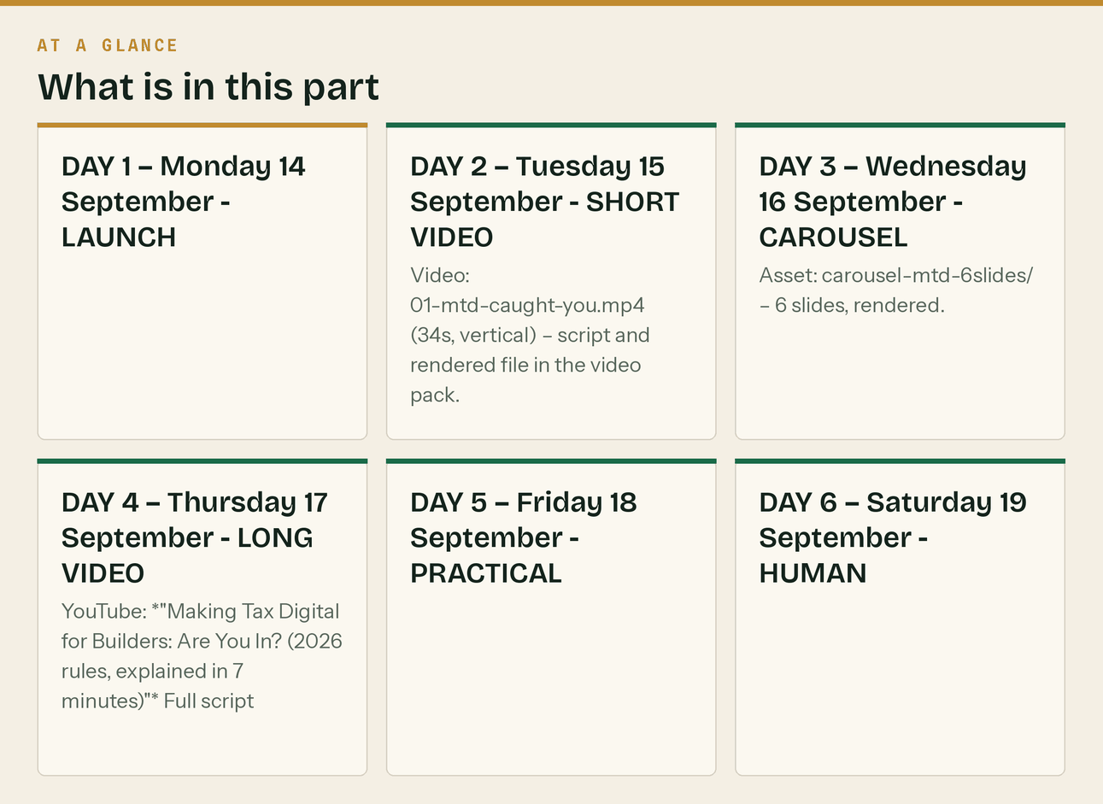

WEEK 2 — "CIS and the reverse charge"


Mon 14 – Sun 20 September
DAY 8 — Monday 21 September · ANCHOR
🔷 LinkedIn (Craig)
The most expensive four words in construction: "I'll sort it later."
Here's what CIS actually costs when it goes wrong, and I mean in real numbers, not scare stories.
MISSED THE 19th
£100 the day you're late.
£200 at two months.
£300 or 5% of the deductions — whichever is higher — at six months.
Same again at twelve.
Beyond twelve months, where it was deliberate, up to £3,000 or 100% of the deductions.
That's on a single monthly return. Miss four in a row and you're into four figures on paperwork you
could have done in twenty minutes.
WRONG DEDUCTION RATE
Verify a subbie properly and you deduct 20%. Don't verify, and you're obliged to deduct 30%.
The 10% difference doesn't come out of thin air. If you under-deducted, HMRC can come to YOU for the
shortfall — not the subcontractor. You paid him the money, and you still owe HMRC the difference.
MATERIALS
CIS is deducted on labour, not on materials the subcontractor genuinely paid for. If you're deducting
on the whole invoice because it's simpler, you're taking money off your subbies that isn't yours to
take, and they'll eventually work it out.
If you're not itemising materials on your invoices, you're the subbie losing the money.
GROSS PAYMENT STATUS
If you qualify for gross status and haven't applied, you're handing HMRC an interest-free loan of 20%
of every invoice for up to a year. For a subbie invoicing £120,000, that's £24,000 sat with HMRC
instead of in your account.
The turnover test, the compliance test and the business test are all passable by a well-run firm.
Most people just never apply.
None of this is complicated. It's just nobody's job until it's a problem.
This week I'm posting the whole thing — verification, rates, materials, retentions, and the reverse
charge question that still catches people five years on.
#CIS #Construction #UKConstruction #Subcontractors
🔷 X
CIS penalties, plainly:
Day 1 late: £100
2 months: £200
6 months: £300 or 5% of deductions, whichever is higher
12 months: same again
On one monthly return.
The 19th isn't a guideline.
🔷 Facebook
CIS, in real numbers. 🧱
Miss the 19th → £100 straight away. £200 at two months. £300 or 5% at six.
Don't verify a subbie → you MUST deduct 30%, not 20%. Get it wrong and HMRC comes to you for the
difference, not to him.
Deducting on materials → you're taking money off your subbies that isn't yours.
Not applied for gross status when you qualify → you're lending HMRC 20% of every invoice, interest
free, for up to a year.
We're doing CIS properly all week. Ask anything in the comments — genuinely, ask. I'd rather answer
it here than have you pay £100 to find out.
Free CIS calculator: klyara.com
🔷 GBP post
CIS returns are due by the 19th of every month. Late filing starts at £100 and climbs to £300 or 5%
of your deductions by six months.
Klyara files CIS returns for construction firms every month, on time, as part of a fixed monthly fee
from £199 + VAT.
Free CIS deduction calculator at klyara.com.
DAY 9 — Tuesday 22 September · SHORT VIDEO
Video: 02-cis-20-vs-30.mp4 (28s)
🔷 TikTok / Reels / Shorts
20% or 30%? It's not a choice. It's whether you verified him.
Verified subcontractor, registered with HMRC → 20%
Not verified, or not registered → 30%
Gross payment status → 0%
And here's the part that hurts: if you should have deducted and didn't, HMRC comes to YOU for the
money. Not to him. You've already paid him.
Verify before the first payment. Every time. Takes two minutes.
#ukbuilders #cis #tradesmen #tax #construction
DAY 10 — Wednesday 23 September · CAROUSEL
Asset: carousel-cis-7slides/
🔷 Instagram + LinkedIn document
CIS explained properly, in 7 slides. 👉
1. What CIS actually is (and who it applies to)
2. Contractor or subcontractor — you might be both
3. The three rates: 0%, 20%, 30%
4. Verification: the two minutes that save you thousands
5. Materials — the bit everyone gets wrong
6. The monthly return and the 19th
7. Gross payment status: are you leaving 20% with HMRC?
Slide 5 is the one that costs subbies real money every single month.
Save it. Send it to whoever does your invoices.
#cis #ukbuilders #constructionuk #subcontractor #tradesmenuk #selfemployeduk #bookkeeping
#buildersuk #ukbusiness #tax
DAY 11 — Thursday 24 September · LONG VIDEO
YouTube: *"The VAT Domestic Reverse Charge for Construction, Explained Once and Properly"*
🔷 YouTube description
Five years in and the domestic reverse charge still gets invoiced wrong every day. This video does it
properly in nine minutes — when it applies, when it doesn't, what goes on the invoice, and how to
handle the cash flow hit nobody warned you about.
00:00 Why this still confuses people
00:45 What the reverse charge actually does
01:50 The six tests — does it apply to this job?
04:10 End users and intermediary suppliers (the big exception)
05:30 What must appear on your invoice, word for word
06:40 How to fill in your VAT return, box by box
07:50 The cash flow problem — and why you might now be due monthly repayments
08:40 The three mistakes I see most
🧮 Free VAT reverse charge checker: klyara.com/tools.html
📘 Free guides: klyara.com
Klyara — the back office for small construction firms. klyara.com
Not tax advice for your specific situation. Check the current HMRC position or ask us.
#VAT #ReverseCharge #UKConstruction #CIS
🔷 LinkedIn (Craig)
The domestic reverse charge has been law since March 2021 and I still see it invoiced wrong every
single week.
Here's the whole thing in one post.
WHEN IT APPLIES — all five must be true:
1. The supply is construction services within the CIS definition
2. Both parties are VAT registered
3. Both parties are registered for CIS
4. The customer is NOT an end user
5. The supply is standard or reduced rated (not zero-rated)
If all five are yes: you don't charge VAT. Your customer accounts for it themselves.
THE BIT PEOPLE MISS — "end user"
If your customer is the one who actually occupies or owns the finished building, they're an end user
and the reverse charge does NOT apply. You charge VAT as normal.
Property developer building to sell? End user.
Main contractor who'll invoice it onward? Not an end user — reverse charge applies.
The customer has to TELL you they're an end user, in writing. Get it in writing. Keep it.
WHAT GOES ON THE INVOICE
No VAT amount charged. A clear statement that the reverse charge applies, and the VAT rate or amount
the customer must account for. Something like:
"Reverse charge: VAT Act 1994 Section 55A applies. Customer to account to HMRC for the reverse
charge output tax on the VAT-exclusive price of items marked 'reverse charge'."
THE CASH FLOW THING NOBODY WARNED ANYONE ABOUT
If most of your sales are now reverse-charged, you're not collecting VAT on them — but you're still
paying VAT on your materials.
That means you may be in a permanent repayment position. If you are, apply to move to MONTHLY VAT
returns. You'll get the money back twelve times a year instead of four.
I've seen firms sit on quarterly returns for two years, wondering why cash is always tight, while
HMRC held four figures of their money for an extra two months at a time.
Free checker in the comments.
#VAT #ReverseCharge #Construction #CIS
DAY 12 — Friday 25 September · PRACTICAL CIS DEADLINE TOMORROW
🔷 X
Reminder: CIS returns for the month to 5 September are due TOMORROW, 19 September.
£100 the moment you're late. Not at the end of the month — the moment.
If you're a contractor and you paid a single subbie in that window, you file. Even if it's nil, you
file a nil return.
Twenty minutes now beats £100 and the letter.
🔷 Facebook + GBP
⚠️ CIS returns due TOMORROW — Saturday 19 September — for the month to 5 September.
Paid a subcontractor in that window? You file.
Paid nobody? You still file a nil return.
£100 penalty the day you're late.
If you've got a nil month and you're not sure whether to bother — bother. Nil returns are two minutes
and skipping them is the single most common £100 anyone in construction pays.
🔷 LinkedIn (Craig)
CIS returns due tomorrow, 19 September, for the month to 5 September.
Two things people get wrong at this exact point in the month:
1. NIL RETURNS STILL HAVE TO BE FILED.
If you're registered as a contractor and you paid no subcontractors that month, you file a nil
return. Not filing it is a £100 penalty for the sake of two minutes. It's the most common penalty in
the scheme.
2. If you've genuinely stopped using subcontractors, tell HMRC to make the scheme inactive.
Otherwise you're filing nil returns forever, and eventually you'll forget one.
Go and do it now if it isn't done. It's Friday, and tomorrow is a Saturday, and we both know how that
ends.
#CIS #Construction
DAY 13 — Saturday 26 September · LIGHT
🔷 Instagram Stories + Facebook
A genuine question, and I'd like actual answers.
What's the single worst bit of admin in your week?
Not the biggest. The worst. The one you'd pay to never do again.
I'll go first: for most of the firms I work with it isn't the tax. It's chasing invoices. Ringing a
main contractor for the fourth time about money you earned nine weeks ago, and being made to feel
like you're the problem.
That's next week's subject.
What's yours? 👇
DAY 14 — Sunday 27 September · WEEK AHEAD
🔷 LinkedIn + X + GBP
Week ahead — Monday 21 September.
📌 CIS returns for the month to 5 September were due Friday. If you missed it, file today. The
penalty is fixed at £100 until two months, so filing late still beats filing later.
📌 Tuesday 22 September — electronic payment deadline for CIS/PAYE for the month to 5 September.
📌 15 days until the MTD quarter ends, 5 October.
This week: getting paid. Late payment, retentions, what your contract actually entitles you to, and
the statutory interest almost nobody claims.
#Construction #CIS #CashFlow
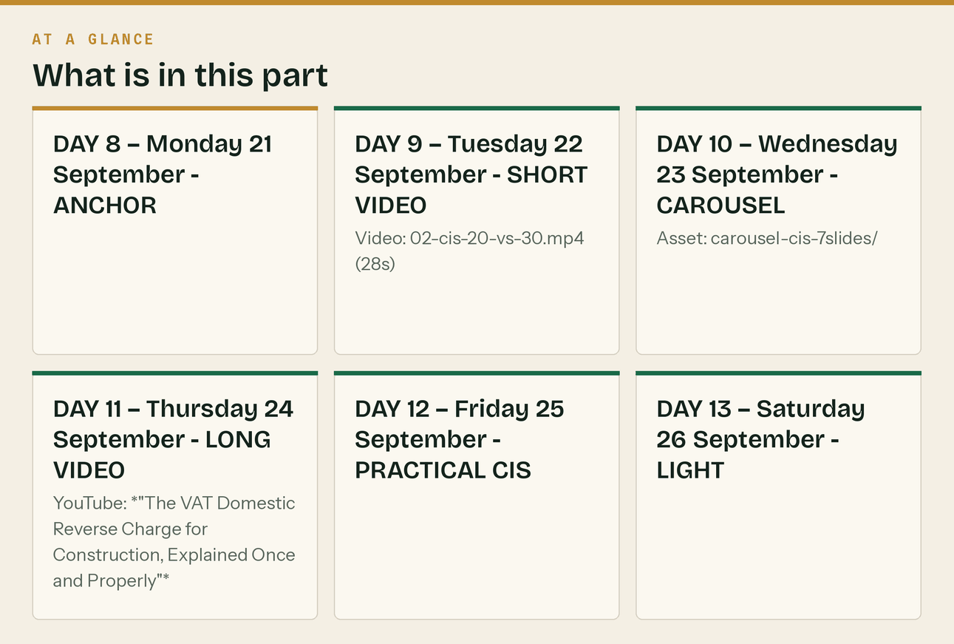
In this part
Mon 14 – Sun 20 September · DAY 8 — Monday 21 September · ANCHOR · 🔷 LinkedIn (Craig) · 🔷 X · 🔷 Facebook · 🔷 GBP post

WEEK 3 — "Getting paid"


Mon 21 – Sun 27 September
DAY 15 — Monday 28 September · ANCHOR
🔷 LinkedIn (Craig)
You are not a bank. You keep being treated like one.
The average small building firm I look at is owed somewhere between one and two months of turnover at
any given moment. On a firm turning over £400,000, that's £40,000–£70,000 of your money sitting in
someone else's account.
You borrowed to buy the materials. You paid the lads on Friday. And you're waiting.
Here's what you're actually entitled to, because most builders have no idea.
STATUTORY INTEREST — you can charge it, and almost nobody does
Under the Late Payment of Commercial Debts legislation, on a business-to-business debt you can charge
interest at 8% above the Bank of England base rate, plus a fixed compensation sum per invoice —
£40, £70 or £100 depending on the size of the debt. On top of the money you're owed.
You don't need it in your contract. It's statutory. It applies by default.
You can also claim reasonable costs of recovering the debt above that fixed sum.
Most firms never invoice it because they're frightened of losing the customer. Fair enough. But
knowing you can charge it changes the conversation, and putting it on the invoice as a line item —
"late payment interest may be applied under the Late Payment of Commercial Debts (Interest) Act
1998" — costs you nothing and moves you up the payment run.
WHAT ACTUALLY GETS YOU PAID FASTER
It isn't chasing harder. It's four boring things:
1. Invoice the day the work is done, not at month end. Every day you sit on an invoice is a day added
to your own payment terms, self-inflicted.
2. Invoice to a named person, not to "accounts". Accounts inboxes are where invoices go to wait.
3. Ask for the payment run date at the start of the job, not at the end. "When's your payment run?"
asked in week one is a normal question. Asked in week nine it's a complaint.
4. Chase on a schedule, automatically, politely, forever. Day 1 after due, day 7, day 14, day 21,
then a phone call. The firms that get paid aren't the loudest, they're the most consistent.
RETENTIONS
If you've got 3% or 5% held on jobs finished eighteen months ago, go and count it. Actually count it.
In my experience a firm doing this properly usually finds between four and fifteen thousand pounds of retention they'd mentally
written off. Some of it is genuinely still claimable. The defects liability period ended; nobody
asked for it back.
Put every retention on a dated list with the release date. Diarise the release date. Ask on the day.
That's not clever accounting. That's just having a list. But nobody has the list.
#Construction #CashFlow #LatePayment #SmallBusinessUK
🔷 X thread
1/ Late payment, for builders. What you're actually owed and never claim.
2/ Statutory interest on B2B debts: 8% above base rate.
Plus a fixed sum per invoice: £40 / £70 / £100 by debt size.
Plus reasonable recovery costs.
You don't need it in your contract. It applies by law.
3/ Almost nobody invoices it. Fine.
But putting the entitlement as a line on your invoice template costs nothing and quietly moves you up
the payment run.
4/ The four things that actually get you paid faster, in order of effect:
- Invoice the day the work's done
- Invoice a named person, not "accounts"
- Ask the payment run date in week 1, not week 9
- Chase on a fixed schedule, forever
5/ And go and count your retentions.
3% held on jobs that finished 18 months ago. Defects period over. Nobody asked for it back.
Most firms find £4k–£15k they'd written off.
6/ It's not clever. It's a list with dates on it.
Nobody has the list.
🔷 Facebook
Go and count your retentions. 💷
Not "roughly". Actually count them.
3% or 5% held back on jobs that finished a year and a half ago. Defects liability period long over.
Nobody ever asked for it back, so nobody ever sent it.
A firm doing this properly usually finds somewhere between four and fifteen grand they'd mentally written off.
All it takes is a list: job, amount held, release date. Then diarise the release date and ask on the
day.
That's it. That's the whole trick. But almost nobody has the list.
Comment "RETENTION" and I'll send you the tracker template we use. Free, no email needed.
🔷 GBP post
Owed money you've stopped chasing?
Most small building firms are carrying one to two months of turnover in unpaid invoices, plus
retentions from jobs that finished over a year ago.
Klyara's Trade and Pro plans include automated invoice chasing and a retention tracker as standard —
so the asking happens whether or not you have time to do it.
Free discovery call at klyara.com.
DAY 16 — Tuesday 29 September · SHORT VIDEO
Video: 03-retentions.mp4 (31s)
🔷 TikTok / Reels / Shorts
Go and count your retentions. Right now.
3% held on a job you finished eighteen months ago. Defects period's over. Did anyone send it back?
No. Because nobody asked.
In eleven years doing this, a building firm looking properly usually finds four to fifteen grand they'd written off in their head.
It's not clever accounting. It's a list with three columns: job, amount, release date.
Nobody has the list. Be the one who has the list.
#ukbuilders #construction #tradesmen #cashflow #selfemployed
DAY 17 — Wednesday 30 September · CAROUSEL
Asset: carousel-getpaid-6slides/
🔷 Instagram + LinkedIn document
Six things that get builders paid faster. 👉
1. Invoice the day the work's done
2. Invoice a named person, not "accounts"
3. Ask the payment run date in week one
4. Chase on a schedule — day 1, 7, 14, 21, then phone
5. Put the statutory interest line on your template
6. Track every retention with its release date
None of it is clever. All of it works. Most firms do about one and a half of the six.
Which one are you missing? 👇
#ukbuilders #constructionuk #cashflow #tradesmenuk #selfemployeduk #buildersuk #subcontractor
#smallbusinessuk #latepayment #invoicing
DAY 18 — Thursday 1 October · LONG VIDEO
YouTube: *"Why Your Building Firm Is Always Skint (And It Isn't Your Prices)"*
🔷 YouTube description
Profitable on paper, no money in the bank. It's the most common thing I see in construction, and it
almost never means the pricing is wrong.
Ten minutes on where the cash actually goes, and the four numbers that tell you the truth.
00:00 Profit is an opinion, cash is a fact
01:15 The construction working capital trap
02:40 Your real payment terms (not the ones on the invoice)
04:00 Retentions: the money you've already written off
05:20 The VAT reverse charge cash flow shift nobody flagged
06:35 CIS deductions as an interest-free loan to HMRC
07:40 Four numbers to look at every single month
09:10 What to change this week
🧮 Free calculators — job margin, day rate, CIS, VAT: klyara.com/tools.html
Klyara — the back office for small construction firms. klyara.com
Not tax or financial advice for your specific situation.
#Construction #CashFlow #CIS #UKBusiness
🔷 LinkedIn (Craig)
"We're busier than we've ever been and there's no money in the bank."
I hear this every month, and it's almost never a pricing problem.
Four things drain cash out of a building firm while the P&L says you're doing fine:
1. YOUR REAL PAYMENT TERMS
Invoice dated the 30th, terms 30 days, customer pays on the 15th payment run following. That's not 30
days. That's 46. Now add the eleven days you sat on the invoice before sending it. That's 57 days of
funding the job yourself.
2. RETENTIONS
3% of everything, held for twelve to twenty-four months. On £400k of turnover that's £12,000
permanently out of the business, and growing as you grow.
3. THE REVERSE CHARGE
Before March 2021 you collected VAT on sales and held it until the quarter end. It was never yours,
but it was in your account. That float is gone. Nobody sent a letter explaining that your working
capital had just structurally dropped.
4. CIS DEDUCTIONS
20% off every invoice, sat with HMRC until you reconcile it. On £120k of labour invoicing, that's
£24,000 lent to HMRC, interest free, for up to a year.
Add those four together on a typical firm turning over £400k and you're looking at £50,000–£80,000 of
working capital that exists on paper and not in the bank.
You cannot price your way out of that. You can only shorten it — invoice faster, chase harder, claim
retentions, get on monthly VAT returns if you're in repayment, and apply for gross payment status if
you qualify.
That's the whole job, really.
#Construction #CashFlow #CIS #VAT
DAY 19 — Friday 2 October · PRACTICAL
🔷 X + Facebook + LinkedIn
Free retention tracker. No email, no signup, no catch.
Three columns: job, amount held, release date.
That's genuinely it. Put every retention on it, diarise the release date, and ask on the day it falls
due.
The firms that get their retentions back aren't tougher negotiators. They're just the ones who
remembered.
Grab it, along with 12 free calculators — job margin, CIS, VAT, day rate, deadlines:
klyara.com/tools.html
DAY 20 — Saturday 3 October · HUMAN
🔷 Instagram + Facebook
Something I've noticed after eleven years of this.
The building firms that end up doing well are almost never the best builders.
They're the ones who know their numbers. Who can tell you what a job made within a week of finishing
it. Who know which customer pays in 30 days and which one takes 70, and price accordingly.
The best builder in any given town is very often the one working the hardest for the least, because
he's never once sat down and worked out that the job he loves doing is the one that loses money.
That's not a criticism of anyone. Nobody teaches this. You learn to build, and then one day you have
a business and nobody mentioned that was going to happen.
It's learnable, though. It's about six numbers.
Free job margin calculator — put your last job through it and see: klyara.com/tools.html
DAY 21 — Sunday 4 October · WEEK AHEAD QUARTER END WEEK NEXT
🔷 LinkedIn + X + GBP
Week ahead — Monday 28 September. This one matters.
📌 Monday 5 October — the MTD quarterly period ENDS. If you're in MTD for Income Tax, everything from
6 July to 5 October has to be in digital records.
📌 Saturday 7 November — that quarter's update is due to HMRC.
📌 Monday 19 October — CIS returns for the month to 5 October.
If your records for July, August and September are currently a bag in the van, this is the week to
deal with it. Not November.
All week I'm posting a quarter-end checklist — one thing a day, each takes under twenty minutes.
#MakingTaxDigital #CIS #Construction
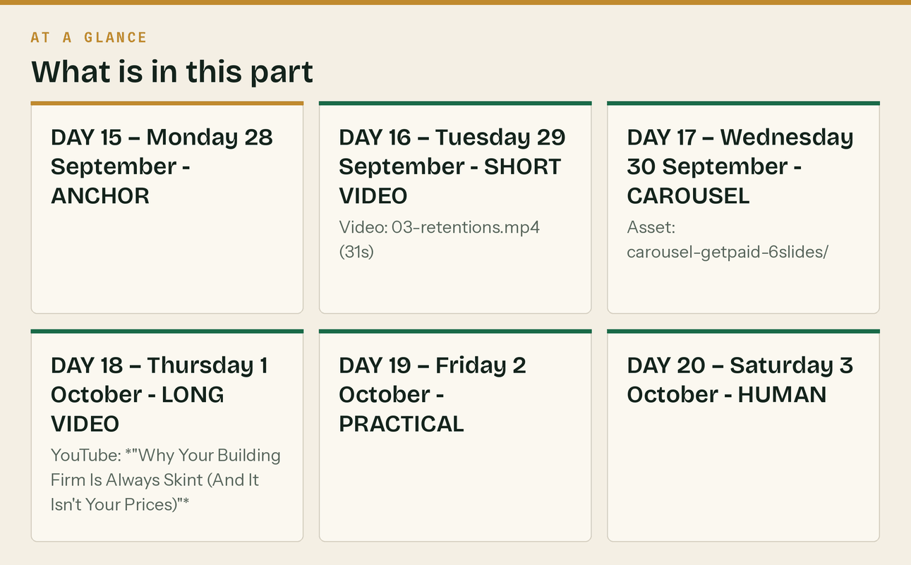
In this part
Mon 21 – Sun 27 September · DAY 15 — Monday 28 September · ANCHOR · 🔷 LinkedIn (Craig) · 🔷 X thread · 🔷 Facebook · 🔷 GBP post

WEEK 4 — "Quarter end"

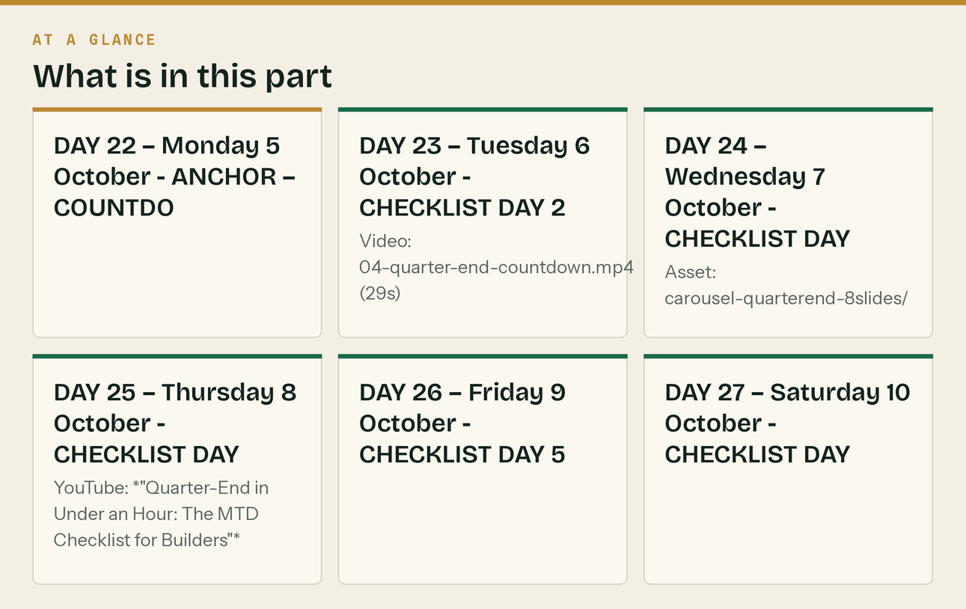
Mon 28 September – Sun 4 October
*This is the conversion week. Everything before it earned the right to ask.*
DAY 22 — Monday 5 October · ANCHOR — COUNTDOWN STARTS
🔷 LinkedIn (Craig)
Seven days until the MTD quarter closes on 5 October.
If you're in Making Tax Digital for Income Tax — sole trader or landlord, qualifying income over
£50,000 — then everything from 6 July to 5 October needs to be in digital records, and the update
goes to HMRC by 7 November.
Here's the honest position most people are in right now: July and August are a folder of photos on a
phone and a bag in the van, and September hasn't happened yet.
That's recoverable in a week. It is not recoverable on 6 November.
So, one job a day for the next seven days. Each under twenty minutes.
Day 1 (today): BANK
Get every business bank account connected to your software. Not exported — connected, so it feeds
automatically. If you're still typing statements in by hand, this single change saves you more time
than everything else on this list put together.
I'll post one a day. By Sunday you'll be closed off and ahead of the deadline instead of six weeks
behind it.
If you don't know whether you're even in MTD — qualifying income is your GROSS self-employment and
property income added together, before expenses and before CIS deductions. Not what landed in the
bank. If that number was over £50,000 for 2024/25, you're in.
Ask me in the comments. I'll tell you straight.
#MakingTaxDigital #CIS #Construction #UKConstruction
🔷 X
7 days until the MTD quarter closes (5 October). Update due 7 November.
If July and August are currently a bag in the van, that's fixable this week and not fixable in
November.
One job a day, each under 20 minutes. Starting today: connect your bank feed.
I'll post the rest daily.
🔷 Facebook + GBP
⏳ Seven days until the MTD quarter ends — Monday 5 October.
Everything from 6 July to 5 October has to be in digital records, and the update is due to HMRC by
7 November.
We're posting one quarter-end job a day this week. Each takes under twenty minutes.
TODAY: connect your bank feed. Properly connected, not exported and typed in. It's the single biggest
time-saver there is and most people still haven't done it.
Follow along and you'll be closed off by Sunday.
DAY 23 — Tuesday 6 October · CHECKLIST DAY 2 + SHORT VIDEO
Video: 04-quarter-end-countdown.mp4 (29s)
🔷 All channels
Quarter-end job 2 of 7: RECEIPTS.
Every photo on your phone, every crumpled thing in the van, every "I'll remember what that was for" —
in, today.
Do it as one job while the kettle's on. Twenty minutes for three months of receipts, because you're
only entering the ones that aren't already on the bank feed.
The ones you'll lose money on if you skip: fuel, parking, tools under £100, materials paid cash,
trade counter purchases on a personal card, phone, van insurance, PPE, and anything bought on a
Sunday because a job needed it.
Missed receipts aren't a compliance problem. They're just tax you didn't need to pay.
Job 3 tomorrow.
🔷 TikTok / Reels / Shorts caption
Every receipt photo sat in your camera roll is money you're about to hand HMRC for no reason.
Fuel. Parking. Tools under £100. Trade counter stuff on the personal card. PPE. The Sunday emergency
screwfix run.
Twenty minutes with the kettle on and it's done.
Quarter ends 5 October.
#ukbuilders #tradesmen #tax #selfemployed #cis
DAY 24 — Wednesday 7 October · CHECKLIST DAY 3 + CAROUSEL
Asset: carousel-quarterend-8slides/
🔷 All channels
Quarter-end job 3 of 7: THE MIXED-USE STUFF.
The things you pay for personally that are partly business, and that most builders either claim
wrongly or don't claim at all.
VAN — if it's a genuine commercial vehicle and private use is incidental, it's a business cost. Keep
it that way. Don't start school runs in it.
PHONE — split it. If it's 70% business, claim 70%. Pick a defensible number and be consistent.
HOME OFFICE — if you do the paperwork at the kitchen table, HMRC's simplified flat rate is the
easiest defensible claim there is. Not huge, but it's yours and it takes no records.
TOOLS — most are an allowable cost. Larger items may need capital allowances rather than a
straight deduction. If it's over about £1,000 and it'll last years, flag it rather than guessing.
CLOTHING — protective gear and branded workwear: yes. Ordinary jeans and boots you also wear down the
pub: no, however muddy they get.
TRAINING — keeping an existing qualification current: usually fine. A brand new qualification that
takes you into new work: usually not.
The rule that keeps you out of trouble: claim what's genuinely business, be consistent, and write down
why you picked the split. HMRC has never once objected to a defensible number that was applied
consistently.
Job 4 tomorrow.
🔷 Instagram carousel caption
Quarter-end: the 8-slide checklist. 👉
1. Connect the bank feed
2. Receipts in
3. Mixed-use costs — van, phone, home, tools
4. Reconcile every account
5. Match CIS deductions to statements
6. Check the reverse charge coding
7. Chase what's owed before quarter end
8. Look at the number
Quarter ends Monday 5 October. Update due 7 November.
Save this and work through it. One a day, under 20 minutes each.
#makingtaxdigital #cis #ukbuilders #constructionuk #selfemployeduk #tradesmenuk #tax #bookkeeping
#subcontractor #ukbusiness
DAY 25 — Thursday 8 October · CHECKLIST DAY 4 + LONG VIDEO
YouTube: *"Quarter-End in Under an Hour: The MTD Checklist for Builders"*
🔷 All channels
Quarter-end job 4 of 7: RECONCILE.
Every business account, every card, matched to the bank feed. Zero unmatched transactions.
This is the boring one and it's the one that matters, because an unreconciled account means your
figures are wrong and you don't yet know which direction.
What you're looking for:
- Transactions on the feed with nothing matched to them
- Payments in you can't identify (that's usually a customer who paid and you never marked the invoice)
- Duplicates from a manual entry AND a bank feed for the same thing
- Anything personal that's gone through the business account
That last one — just recategorise it as drawings and move on. Everyone does it. It only becomes a
problem when it's left as an unexplained business cost.
If you find a payment in that you can't identify, don't leave it. Nine times out of ten it's an
invoice you'd have chased next week for money you already had.
Job 5 tomorrow: CIS statements.
🔷 YouTube description
The full quarter-end routine for a small building firm, done in under an hour. Seven jobs, in order,
with the specific things to look for at each step.
Written for MTD for Income Tax quarterly updates, but it's the same routine whether you're filing
quarterly or annually.
00:00 Why quarter-end is now a real event
00:50 1. Bank feeds — connect, don't export
02:00 2. Receipts — the ones people lose money on
03:30 3. Mixed-use costs — van, phone, home, tools, clothing
05:15 4. Reconciling — zero unmatched, and what to look for
06:50 5. CIS deductions vs subcontractor statements
08:20 6. Reverse charge coding — the check that takes 2 minutes
09:30 7. Chasing before quarter end
10:20 The one number to look at when you're done
🧮 Free calculators: klyara.com/tools.html
📘 Free MTD guide: klyara.com/guide.html
#MakingTaxDigital #CIS #Construction
DAY 26 — Friday 9 October · CHECKLIST DAY 5
🔷 All channels
Quarter-end job 5 of 7: CIS RECONCILIATION.
This is the one that quietly costs subcontractors thousands, so read it properly.
IF YOU'RE A SUBCONTRACTOR:
Every contractor who deducted CIS from you must give you a payment and deduction statement, within 14
days of the end of the tax month.
Get them all out. Add up the deductions. Now compare that total to what your own records say was
taken.
They will not match. They never do. Common causes: a contractor deducted 30% because they never
verified you, a contractor deducted on materials they shouldn't have, or a statement was never sent
at all.
Every pound of CIS deducted is a pound already paid toward your tax bill. If you can't evidence it,
you can't claim it, and you'll pay it twice.
Chase the missing statements NOW, while the contractor still remembers the job. In February they
won't.
IF YOU'RE A CONTRACTOR:
Check you issued a statement to every subbie you deducted from. It's a legal obligation, not a
courtesy, and it's a penalty if you don't.
Also check your verification records. Anyone you deducted 20% from — can you show you verified them?
If not, HMRC's position is you should have deducted 30%, and they will come to you for the
difference.
Free CIS calculator: klyara.com/tools.html
Job 6 tomorrow.
DAY 27 — Saturday 10 October · CHECKLIST DAY 6
🔷 All channels
Quarter-end job 6 of 7: THE REVERSE CHARGE CHECK. Two minutes.
Open your last ten sales invoices. For each one, answer:
Was this construction work under CIS? Yes/No
Is the customer VAT registered? Yes/No
Is the customer CIS registered? Yes/No
Did the customer confirm IN WRITING they're an end user? Yes/No
If the first three are yes and the fourth is no → reverse charge applies. You should NOT have charged
VAT.
If you charged VAT when you shouldn't have, you've collected money that isn't yours and you'll owe it
to HMRC anyway. Fix it with a credit note and reissue.
If you DIDN'T charge VAT when you should have — because your customer is actually an end user and
told you so — you owe HMRC that VAT out of your own pocket unless you can go back and charge it.
Now do the same on your last ten purchase invoices. Did a subbie charge you VAT on a reverse-charge
supply? If so, you can't reclaim it. Send it back.
Two minutes, ten invoices. It's the single highest-value two minutes in this whole checklist.
Last job tomorrow.
DAY 28 — Sunday 11 October · CHECKLIST DAY 7 — THE ASK
🔷 LinkedIn (Craig) — the conversion post HOLD variant below
Quarter-end job 7 of 7: LOOK AT THE NUMBER.
Not the turnover. Everyone knows their turnover. It's the number people quote in the pub and it tells
you almost nothing.
Look at these four instead:
1. GROSS MARGIN BY JOB. Which jobs actually made money. Not which felt busy.
2. WHAT YOU'RE OWED, by age. Under 30 days, 30–60, 60–90, over 90. The over-90 column is the one.
3. RETENTIONS OUTSTANDING, with release dates.
4. WHAT'S IN THE BANK versus what's due out in the next 30 days.
That's the whole dashboard. Four numbers. If you know those four on the first of every month, you're
running a business. If you don't, you're doing a job that happens to have your name on the van.
The quarter closes tomorrow — 5 October. The update is due 7 November.
That's the end of the checklist. Thank you for following it — the response to this week has been
useful, which is the whole point of writing it.
One last thing, and then I'll go back to just posting useful stuff.
I've spent this month explaining what the back office of a building firm should look like. Klyara is
me doing it for you: bookkeeping, CIS returns, reverse charge coding, payroll and MTD quarterly
filing, for a fixed monthly fee from £59 + VAT.
⛔ HOLD-UNTIL-AML VERSION — use this until supervision is confirmed:
"We open for clients shortly, and I'm keeping the founding rate for the first ten firms who join the
list. No payment, no commitment — you go on a list and I call you when we open. If you'd rather just
keep reading the free stuff, that's genuinely fine too. klyara.com"
✅ POST-AML VERSION — swap to this once supervised:
"If you want that off your plate, book a free discovery call. Twenty minutes, I'll tell you what your
situation actually needs, and if that's nothing, I'll tell you that too. klyara.com"
#MakingTaxDigital #CIS #Construction #SmallBusinessUK
🔷 X + Facebook + Instagram + GBP
Quarter-end job 7 of 7: look at the number.
Not turnover. These four:
→ Gross margin by job
→ What you're owed, by age
→ Retentions outstanding, with release dates
→ Bank balance vs what's due out in 30 days
Know those four on the 1st of every month and you're running a business.
Quarter closes tomorrow. Update due 7 November.
That's the checklist done. If you want it as one page, it's on the site — free, no email.
klyara.com
In this part
Mon 28 September – Sun 4 October · DAY 22 — Monday 5 October · ANCHOR — COUNTDOWN STARTS · 🔷 LinkedIn (Craig) · 🔷 X · 🔷 Facebook + GBP · DAY 23 — Tuesday 6 October · CHECKLIST DAY 2 + SHORT VIDEO

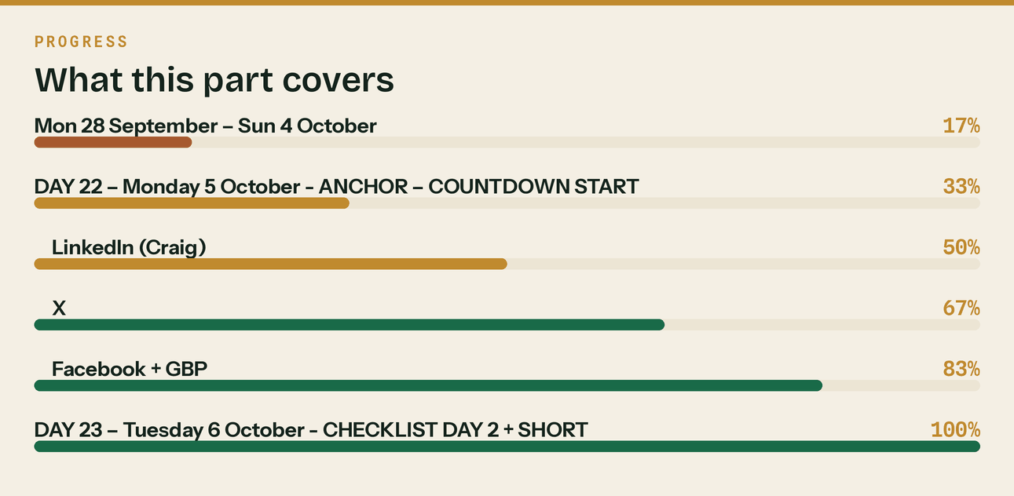
Read top to bottom. The bar is just how far through the part you are.

WEEK 5 — "Quarter closed. Now what."


Mon 5 – Tue 6 October
DAY 29 — Monday 12 October · QUARTER END DAY
🔷 All channels
The MTD quarter closes today.
6 July to 5 October is now a closed period. Nothing else goes in it.
What happens next:
📌 The quarterly update is due by 7 November. That's 33 days.
📌 The next quarter runs 6 October to 5 January, due 7 February.
📌 The final declaration for the year is 31 January, same as always.
If you worked through last week's checklist, you're done — genuinely done, six weeks early, and you
can forget about it until November.
If you didn't: you've got 33 days, and it's a weekend's work rather than a crisis. Start with the
bank feed. Everything else follows from it.
The full seven-step checklist is on the site as one page. Free, no email, no signup.
klyara.com
🔷 LinkedIn (Craig)
Quarter closed.
Four weeks ago I started posting because I couldn't find a single explanation of MTD, CIS or the
reverse charge written for the person who actually has to deal with it rather than for other
accountants.
Since then:
— A lot of people found out they were in MTD and hadn't realised, because qualifying income is
measured gross and their bank balance told them a different story
— More than one person went and counted their retentions after that post, and messaged me about what
they found
— Several found reverse charge coded wrong on live invoices
None of that needed an accountant. It needed someone to say it out loud in plain English.
I'll keep doing that. Next month: gross payment status — the application, the three tests, and why
most firms who'd pass have never applied.
The seven-step quarter-end checklist is on the site as a single page. Free, no email capture, take
it and use it whether you ever speak to me or not.
klyara.com
#MakingTaxDigital #CIS #Construction
DAY 30 — Tuesday 13 October · RECAP + FORWARD
🔷 LinkedIn + Facebook + X
Thirty days of posting. Here's all of it in one place, because a few people asked.
MAKING TAX DIGITAL
→ Live since April 2026 at £50,000 qualifying income. £30,000 from April 2027. £20,000 from April 2028.
→ Qualifying income is GROSS, before expenses and before CIS. This is what catches subbies out.
→ Quarters end 5 Jul / 5 Oct / 5 Jan / 5 Apr. Updates due 7 Aug / 7 Nov / 7 Feb / 7 May.
→ Final declaration 31 January, as before.
CIS
→ 0% gross status, 20% verified, 30% unverified. Verification is not optional.
→ Under-deduct and HMRC comes to you, not to the subcontractor.
→ CIS comes off labour, not materials the subbie genuinely paid for.
→ Returns by the 19th. Nil months still need a nil return. £100 from day one.
→ Payment and deduction statements within 14 days of the tax month end.
VAT REVERSE CHARGE
→ Six tests: CIS work · both VAT registered · the payment is reported under CIS · standard or reduced
rated (zero-rated new build is out) · you are not an employment business supplying workers ·
the customer has not confirmed in writing that they are an end user or intermediary supplier.
→ End user status must be confirmed in writing. Keep it.
→ If most sales are reverse charged, you may be in permanent repayment — apply for monthly returns.
GETTING PAID
→ Statutory interest at 8% over base, plus £40/£70/£100 fixed sum per invoice. Applies by law.
→ Invoice same day, to a named person, ask the payment run date in week one.
→ Count your retentions. Put them on a list with release dates.
Everything above is on the site, free, no email required.
Next month: gross payment status, and how to pass the three tests.
klyara.com
#CIS #MakingTaxDigital #Construction #UKConstruction
🔷 GBP post
Thirty days of free guidance on CIS, VAT reverse charge and Making Tax Digital — all now collected in
one place at klyara.com. No email required.
Klyara is the back office for small construction firms: bookkeeping, CIS returns, payroll and MTD
quarterly filing, for a fixed monthly fee from £59 + VAT.
Book a free discovery call at klyara.com.
In this part
Mon 5 – Tue 6 October · DAY 29 — Monday 12 October · QUARTER END DAY · 🔷 All channels · 🔷 LinkedIn (Craig) · DAY 30 — Tuesday 13 October · RECAP + FORWARD · 🔷 LinkedIn + Facebook + X

What happens on day 31

Do not stop. The 30 days build the audience; months 2 and 3 convert it. The rhythm carries on unchanged — Monday anchor, Tuesday video, Wednesday carousel, Thursday long video, Friday practical, Sunday deadlines.
Month 2 themes (Oct–Nov):
Week | Theme | Peg
1 | Gross payment status — the three tests | Evergreen, high value
2 | Pricing and quoting — what jobs actually cost | Evergreen
3 | Taking on your first employee — PAYE, pensions, the real cost | Evergreen
4 | 7 November — MTD update deadline | Hard date, run a countdown

Month 3 themes (Nov–Dec):
Week | Theme | Peg
1 | Year-end planning for builders | Seasonal
2 | Vans, tools and capital allowances before 5 April | Seasonal
3 | Christmas shutdown cash flow — the January hole | Highly seasonal, strong engagement
4 | 31 January countdown starts | Hard date

The four hard dates that carry the whole content plan forever: 19th of every month (CIS) · 7 Aug / 7 Nov / 7 Feb / 7 May (MTD) · 31 January (final declaration) · 5 April (tax year end).
You will never run out of content. Set a recurring reminder against each one.
The line that matters
The rhythm carries on unchanged — Monday anchor, Tuesday video, Wednesday carousel, Thursday long video, Friday practical, Sunday deadlines.

Also worth knowing
The 30 days build the audience; months 2 and 3 convert it.

MONTHS 4–6 — so the calendar never runs dry

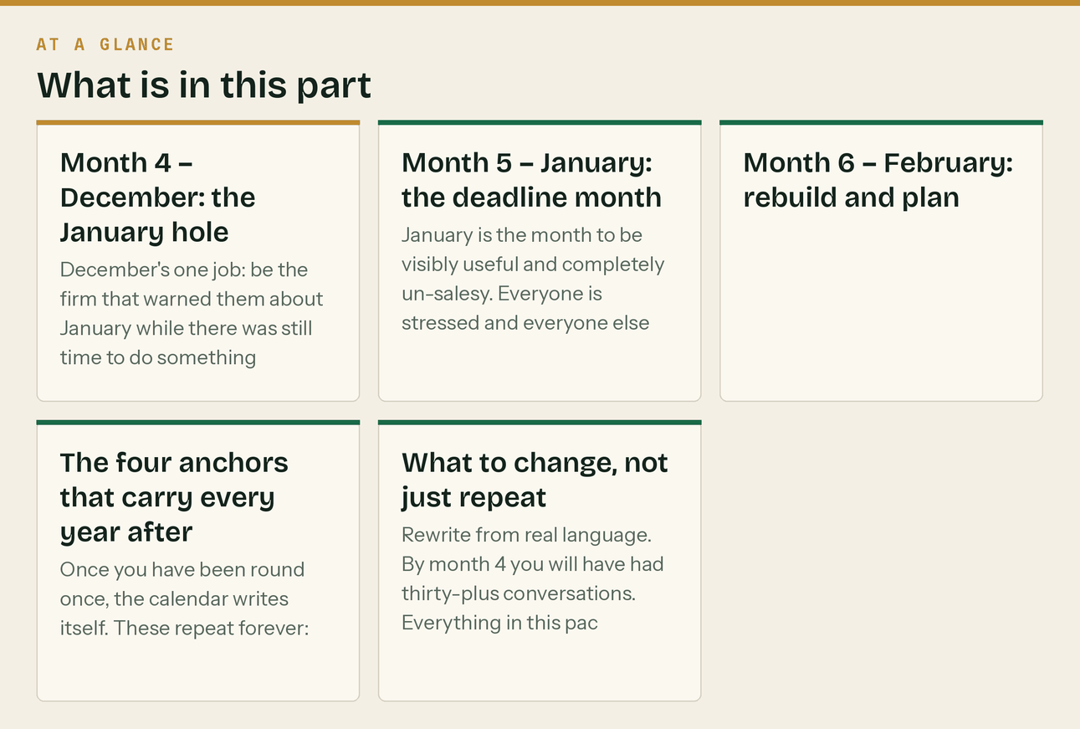
December 2026 to February 2027
*The 30 days get you launched. This is what stops it stalling in month four, which is when most content plans quietly die.*
The principle: months 1–3 were built around deadlines you could see coming. Months 4–6 are built around the single biggest date in the self-employed year — 31 January — and the seasonal cash crisis that surrounds it. This is the strongest content window of the entire year for a construction bookkeeper, and most firms sleep through it.
Month 4 — December: the January hole
Week | Anchor theme | Why now | Source text
1 | The January hole | Five weeks of reduced income followed by the largest payment of the year. Genuinely frightening, genuinely fixable, and nobody warns them. | docs/05 §8 №7
2 | Get every invoice out before the 18th | Anything invoiced after that sits until the second week of January regardless of terms. | docs/05 §8 №8
3 | The shutdown checklist | Nine items, one hour. Highly practical, highly shared, and it positions you for January enquiries. | docs/05 §8 №8
4 | Quiet week | One post. CIS due Sat 19 Dec — file by Fri 18 Dec. Then stop until 5 January. | docs/13 W16

December's one job: be the firm that warned them about January while there was still time to do something about it. That is the post people forward.
Month 5 — January: the deadline month
Week | Anchor theme | Why now
1 | Two payments, not one | The payment on account catches people every single year. A £6,000 bill becomes £9,000.
2 | CIS deductions are tax you already paid | Subbies who cannot evidence deductions pay twice. Last useful week to chase statements.
3 | Ten days | File even if you cannot pay — the two penalties are separate. Time to Pay before the 31st, not after.
4 | The 31st, and then the 7 February trap | People file on the 31st, exhale, and miss the MTD update a week later.

January is the month to be visibly useful and completely un-salesy. Everyone is stressed and everyone else is selling at them. Answer questions, publish the dates, take the calls. The business comes in February from people who remember who helped.
Expect the highest inbound enquiry volume of the year in the last week of January and the first week of February. Clear the diary. docs/09 is the document that matters that fortnight.
Month 6 — February: rebuild and plan
Week | Anchor theme | Why now
1 | Capital allowances before 5 April | The invoice date decides the tax year. Real money, and a genuine decision.
2 | The £30,000 wave | Six weeks out. Most of the trade is in it and does not know. The biggest demand event in the plan.
3 | What good looks like | Post-deadline evergreen: the monthly rhythm, the four numbers.
4 | Year-end run-in | Five things to do before 5 April. Sets up March.

The four anchors that carry every year after this
Once you have been round once, the calendar writes itself. These repeat forever:
The 19th of every month CIS return and payment
7 Aug / 7 Nov / 7 Feb / 7 May MTD quarterly updates
31 January Final declaration, balancing payment, payment on account
5 April Tax year end — and each April, the next MTD threshold
Set a recurring reminder against each with three weeks' warning. Between them they generate roughly half your content, they are never wrong, and your audience genuinely needs them.
What to change, not just repeat
Rewrite from real language. By month 4 you will have had thirty-plus conversations. Everything in this pack is written in my words, informed by research. It should be in theirs. Six discovery calls in, start rewriting the anchors from what people actually said.
Cut the bottom half. By day 90 you will know which channels produce booked calls and which produce nothing. Months 4–6 should run on fewer channels, harder — not the same spread out of habit.
Promote what worked. Whichever three posts got the most replies in months 1–3 should each become a page on the site, an email, and a video. Most firms make something good once and never use it again.
Add the case studies. By month 4 you should have at least one client with three months of history and something worth writing up. A real case study outperforms every generic post in this document.
The line that matters
Expect the highest inbound enquiry volume of the year in the last week of January and the first week of February.

In this part
December 2026 to February 2027 · Month 4 — December: the January hole · Month 5 — January: the deadline month · Month 6 — February: rebuild and plan · The four anchors that carry every year after this · What to change, not just repeat

