KLYARA the back office for building firms

Klyara — Video & Animation Pack
VIDEO 1 — "Making Tax Digital for Builders: Are You In?" (target 7 min)

What's rendered and ready

Fourteen vertical videos (1080×1920, H.264, no audio, burned-in kinetic typography). They work silently — which matters, because most social video is watched on mute — and they're brand-locked to the same pine/orange system as everything else.
File | Length | Use on | Calendar day
01-mtd-caught-you.mp4 | 24s | TikTok · Reels · Shorts | Day 2
02-cis-20-vs-30.mp4 | 19s | TikTok · Reels · Shorts | Day 9
03-retentions.mp4 | 23s | TikTok · Reels · Shorts | Day 16
04-quarter-end-countdown.mp4 | 22s | TikTok · Reels · Shorts | Day 23
05-reverse-charge.mp4 | 24s | TikTok · Reels · Shorts | Month 2
06-late-payment.mp4 | 23s | TikTok · Reels · Shorts | Month 2
07-guildford.mp4 | 17s | TikTok · Reels · Shorts · local | Week 1, Guildford launch
08-materials-split.mp4 | 20s | TikTok · Reels · Shorts | Pairs with the CIS materials page
09-switching.mp4 | 20s | TikTok · Reels · Shorts | Pairs with the switching page
10-end-user.mp4 | 20s | TikTok · Reels · Shorts | Pairs with the end user declaration page
11-nil-returns.mp4 | 27s | TikTok · Reels · Shorts | Pairs with the nil CIS returns page
12-what-a-bookkeeper-does.mp4 | 27s | TikTok · Reels · Shorts · LinkedIn | Pairs with "what a bookkeeper actually does"
13-quarter-end.mp4 | 30s | TikTok · Reels · Shorts | Quarter end weeks — Jan, Apr, Jul, Oct

Posting notes
- Upload natively to each platform. Never cross-post a TikTok-watermarked file to Reels — the
algorithm demotes it.
- Add a trending audio track at low volume on TikTok/Reels. The videos are silent by design so
you can do this. Use the platform's own commercial sound library on business accounts.
- Add a text hook in the platform's own caption overlay for the first 1.5s — platform-native text is
weighted by the algorithm in a way burned-in text isn't.
- Post 12:00–13:00 or 18:00–20:00 UK. Builders check phones at lunch and after they've packed up.
The line that matters
They work silently — which matters, because most social video is watched on mute — and they're brand-locked to the same pine/orange system as everything else.

Also worth knowing
Fourteen vertical videos (1080×1920, H.264, no audio, burned-in kinetic typography).

Long-form YouTube scripts

These are full scripts. Read them out or feed them to HeyGen/ElevenLabs (both already in the Build Manual's stack at ~£25/mo combined).
**[0:00 — HOOK, no intro, straight in]**
If you're self-employed in the building trade, there's a decent chance HMRC changed your obligations in April and nobody told you. This video tells you in seven minutes whether it applies to you and what you actually have to do. No intro, no jargon. [0:38 — WHO'S IN] Making Tax Digital for Income Tax. It started in April 2026, and it applies to sole traders and landlords with qualifying income over fifty thousand pounds. April 2027, that threshold drops to thirty thousand. April 2028, twenty thousand. So even if you're out now, look at the year after next, because a lot of people reading twenty grand as a low bar for a building firm are going to find they're in it by 2028. HMRC looks at your qualifying income from the tax year *two years* before. So for the April 2026 start, they're looking at your 2024/25 figures. The ones you already filed. [2:05 — THE GROSS TRAP] Here's the pa

VIDEO 2 — "The VAT Domestic Reverse Charge, Explained Once and Properly" (target 9 min)
**[0:00]** Five years this has been law, and I still see it invoiced w
is, properly, in nine minutes. If you invoice construction work to another business, this affects what goes on your invoice and how much cash is in your account. [0:45 — WHAT IT DOES] Normally you charge VAT, you collect it, you hand it to HMRC at the quarter end. Under the reverse charge you don't charge it at all. Your customer accounts for both sides of the VAT themselves. Same tax, different person handling it. HMRC brought it in to stop missing-trader fraud in construction — someone charging VAT, collecting it, and disappearing. [1:50 — THE FIVE TESTS] All five must be true. One: the supply is construction work within the CIS definition. Two: both of you are VAT registered. Three: both of you are registered for CIS. Four: the customer is not an end user. Five: it's standard or reduced rated — zero-rated work, like a new build, is out. All five yes, reverse charge. Any one no

VIDEO 3 — "Why Your Building Firm Is Always Skint" (target 10 min)
Structure follows the Day 18 LinkedIn post exactly: the four drains (real payment terms, retentions, the reverse charge float, CIS deductions), worked on a £400k firm, then the four numbers to watch. Use the Day 18 post as the script spine — it's written to be read aloud.
VIDEO 4 — "Quarter-End in Under an Hour" (target 11 min)
Walk through the seven jobs from Week 4, one per chapter, showing each on screen.
The line that matters
Structure follows the Day 18 LinkedIn post exactly: the four drains (real payment terms, retentions, the reverse charge float, CIS deductions), worked on a £400k firm, then the four numbers to watch.

Shorts extraction — get 5 clips from every long video

Every long-form video should produce at least four Shorts. Cut at the natural chapter marks:
Long video | Clip | Hook line for the first 1.5s
MTD | The gross trap (2:05–3:20) | "Your bank balance is lying to you about MTD"
MTD | The four dates (4:41–5:35) | "Four dates. Screenshot this."
MTD | What an update actually is (3:20–4:41) | "It's not a tax return. Calm down."
Reverse charge | End users (4:10–5:30) | "This one word decides whether you charge VAT"
Reverse charge | Cash flow (7:50–8:40) | "You might be owed money every single month"
Skint | Real payment terms (2:40–4:00) | "Your 30-day terms are actually 57 days"
Skint | Retentions (4:00–5:20) | "Go and count your retentions"

Cut command (change the timestamps):
ffmpeg -i long.mp4 -ss 00:02:05 -to 00:03:20 \
-vf "crop=ih*9/16:ih,scale=1080:1920" -c:a copy short-clip.mp4
The line that matters
Every long-form video should produce at least four Shorts.

If you want AI presenter videos (HeyGen)

The Build Manual already budgets HeyGen + ElevenLabs at ~£25/mo. My recommendation: don't use an AI avatar as the face of Klyara. The whole positioning is "a real construction specialist, not a call centre" — an obviously synthetic presenter undercuts that, and UK trades audiences are unusually quick to call it out.
Use them for what they're genuinely good at:
- Voiceover only (ElevenLabs) over the kinetic typography videos, where there's no claimed face
- Client-facing explainer videos inside the portal — "how to snap a receipt", "how to read your
P&L" — where nobody expects a personality
- The website's how-it-works video, if Craig genuinely won't go on camera
For social, a 30-second phone video of Craig in a van beats a polished avatar every time. That's not a style preference, it's what converts in this market.
The line that matters
My recommendation: don't use an AI avatar as the face of Klyara.

Also worth knowing
The whole positioning is "a real construction specialist, not a call centre" — an obviously synthetic presenter undercuts that, and UK trades audiences are unusually quick to call it out.

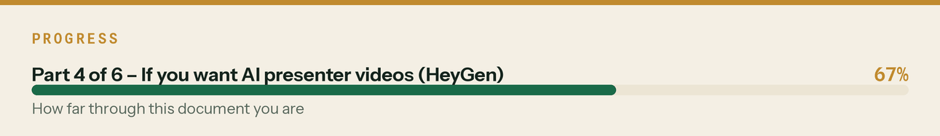

Animated logo sting

ffmpeg recipe for a 2-second intro/outro sting using the rendered logo — drop it on the front of long-form videos:
ffmpeg -y -loop 1 -i assets/logo/klyara-lockup-pine-bg.png -t 2 \
-vf "scale=1920:-2,zoompan=z='min(zoom+0.0008,1.06)':d=48:s=1920x1080,\
fade=t=in:st=0:d=0.4,fade=t=out:st=1.6:d=0.4" \
-r 24 -c:v libx264 -pix_fmt yuv420p video/sting-logo-2s.mp4
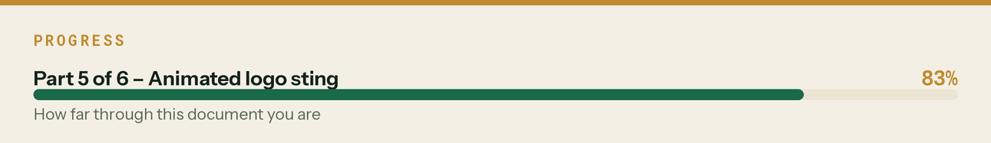

Thumbnail rule for YouTube

Four words maximum, in Bricolage 800, on pine, with one brass word. Face optional but helps. Never use a red arrow and a shocked face — it's wrong for a financial services brand and the audience distrusts it.
Working thumbnail lines:
ARE YOU IN? (brass: IN)
20% OR 30%? (brass: 30%)
COUNT YOUR RETENTIONS (brass: COUNT)
ALWAYS SKINT? (brass: SKINT)
The line that matters
Never use a red arrow and a shocked face — it's wrong for a financial services brand and the audience distrusts it.



