KLYARA the back office for building firms

Klyara — Website Audit
What to do instead — today

*klyara.com reviewed 26 August 2026, before launch*
The site is good. The copy is better than most firms ten times your size — "Three waves. Everyone gets wet", "Twelve tools. Zero email walls", "Builders talk straight. So do reviews" — that's real writing, and the MTD page is the best piece of MTD content I've seen aimed at trades.
So this audit is short on praise and long on the four things that will cost you.
The line that matters
So do reviews" — that's real writing, and the MTD page is the best piece of MTD content I've seen aimed at trades.

Also worth knowing
So this audit is short on praise and long on the four things that will cost you.

CRITICAL — deal with this before Monday

The testimonials on the homepage
There are five named testimonials on your homepage:
Marcus B. — roofing firm, 12 crew · Dean W. — groundworks, 8 on books
contractor · Priya T. — sole-trader plasterer · Jodie F. — kitchen fitter

Klyara has not traded yet. It isn't AML supervised, so it cannot legally have taken on bookkeeping clients by way of business. Those five people therefore cannot be Klyara clients.
If they're placeholder copy left in from the build, they have to come off the site before you drive a single visitor to it. I'm assuming that's what happened — but I have to be direct about why it matters, because this one isn't a marketing preference.
Why this is the most serious item in this pack:
- It's unlawful. Under the Digital Markets, Competition and Consumers Act 2024, publishing fake consumer reviews or testimonials — or commissioning them — is a banned practice, directly enforceable by the CMA with penalties running to a percentage of global turnover. This isn't a grey area any more; it changed in 2025 specifically to catch this.
- It threatens your practice licence. You are about to apply to ICB or AAT for AML supervision and a practice licence. Both have professional conduct requirements covering honesty and professional behaviour in how you market the practice. A firm whose website carried invented client testimonials before it had clients is a bad look in front of that application, and a worse one if a competitor points at it.
- It destroys the exact thing you're selling. Your whole positioning is "a real construction specialist you can trust with your money, not a call centre". Five invented builders is the single most damaging thing that could sit on that page.
- It is genuinely discoverable. Companies House shows your incorporation date. The reviews claim a service history you didn't have. Anyone doing due diligence — a prospect, a partner accountant, a journalist responding to the press release in this pack — can join those two dots in a minute.
Replace the testimonial section with things that are true and still persuasive. You have plenty:
Option A — Craig's track record, correctly labelled. Not "Klyara clients" but "Craig has been doing this for eleven years." A short, honest paragraph about the work, plus — if any former clients or employers will give one — a testimonial that says explicitly *"on Craig's previous work"*. That's legitimate and it does most of the same job.
Option B — the founding-client offer, which is stronger than fake reviews anyway. Replace the section with honesty as the pitch:
We're new. Here's what that's worth to you.
Klyara opened in 2026. We don't have a wall of reviews yet, and we're not going to
pretend otherwise.
What we do have: eleven years of construction bookkeeping behind the person doing your
work, a fixed price, and thirty days' notice with no lock-in.
And because we're building the review wall from scratch, the first ten firms get a
founding rate held for twelve months from their start date — and considerably more of our attention
than client fifty will get.
[Join the founding list →]
That converts. "We're new and here's the honest deal" outperforms generic testimonials with this audience, because builders are professionally suspicious of anyone who sounds too polished.
Option C — proof that isn't a review. Certifications (once held), the professional body membership (once granted), the partner accountant's written endorsement, and the free tools themselves. Twelve working calculators are a better credibility signal than five anonymous quotes.
Related: audit every other claim on the site the same way
While you're in there, check each of these is true *today*, and remove or future-tense anything that isn't:
Claim on site | Check
"Qualified, not just confident" | Which qualifications are actually held right now?
Xero / QuickBooks / FreeAgent certified | The Build Manual has ProAdvisor certification as a week-1 task. Is it done?
"24/7 answering" | Is the Hey Jodie white-label actually live and wired to the number?
AI receptionist, chatbot, invoice chasing as live services | Manual Part 10 says month 1 sells core tiers + receptionist + website + phone only. Everything else should read "coming soon".
Client portal | Is the Lovable build live at app.klyara.com?
Review collection service | You're selling a review service. It has to be beyond reproach on your own site.

Nothing on that list is hard to fix. Future-tense it ("from October", "coming soon") or take it down. But a bookkeeping firm caught overstating its own credentials has a much shorter conversation with a prospect than one that says "we're new".
The line that matters
Option B — the founding-client offer, which is stronger than fake reviews anyway.

In this part
The testimonials on the homepage · What to do instead — today · Related: audit every other claim on the site the same way

🟠 HIGH — the biggest free win available to you

There is no structured data anywhere on the site
Not on the homepage, not on pricing, not on the MTD page. No Organization, no LocalBusiness, no Service, no FAQPage, no Breadcrumb.
This is the cheapest significant SEO win you will ever get, and you're leaving it entirely.
The MTD page alone has sixteen FAQ questions on it. With FAQPage schema, those become eligible for expanded results in Google — you occupy dramatically more vertical space on the results page for exactly the queries you want. Without it, they're just text.
Every block of JSON-LD you need is written out and ready to paste in docs/08-seo-schema-pack.md. It's about forty minutes of copy-paste for the whole site.
Other technical items
# | Issue | Fix | Effort
1 | No JSON-LD | Paste the blocks from docs/08 | 40 min
2 | The twelve calculators are your best link asset and nothing points at them | Each already has its own URL — good. Now give each a proper title tag, meta description and SoftwareApplication schema. Details in docs/08. | 90 min
3 | No visible town/area targeting | "Construction bookkeeping in [town]" needs to appear in the homepage H1 area or a dedicated local page. Local intent is where the money is and you're currently invisible to it. | 1 hr
4 | Meta descriptions strip the £ sign | "from 59 pounds a month" reads as an escaping workaround. Use £ — it renders fine in SERPs and "£59" is far more scannable than "59 pounds". | 10 min
5 | No Meta Pixel / LinkedIn Insight Tag | Install both now even with zero ad spend. The retargeting audience you don't collect today is gone forever. | 15 min
6 | No og:image per page (only site-wide) | Every share of the MTD page uses the generic image. Use the rendered post graphics in assets/posts/ as per-page OG images. | 30 min
7 | Newsletter capture only on tools page footer | Put it on the guide page, the MTD page and every calculator result. See below. | 30 min

The line that matters
With FAQPage schema, those become eligible for expanded results in Google — you occupy dramatically more vertical space on the results page for exactly the queries you want.

In this part
There is no structured data anywhere on the site · Other technical items

🟡 CONVERSION — where you're losing people

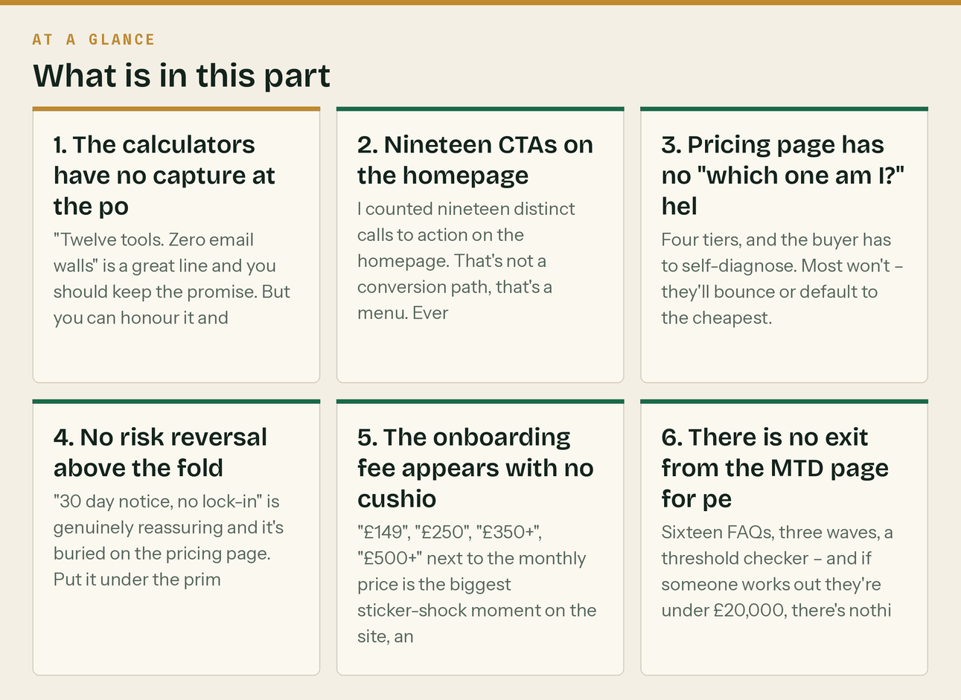
1. The calculators have no capture at the point of pain
"Twelve tools. Zero email walls" is a great line and you should keep the promise. But you can honour it and still capture.
The rule: never gate the tool. Offer after the result.
[Result displayed]
──────────────────────────────
Want the deadlines emailed to you before they bite?
[ your@email.com ] [ Send them → ]
Two emails a month. Unsubscribe any time. We'll never gate a calculator.
──────────────────────────────
Someone who has just calculated their CIS deduction is your exact buyer at their exact moment of pain. This is the single highest-intent capture point on the entire site and it currently does nothing.
2. Nineteen CTAs on the homepage
I counted nineteen distinct calls to action on the homepage. That's not a conversion path, that's a menu. Every extra choice reduces the odds of any of them being taken.
Pick one primary action per section, and one primary action for the page. The page's job is "book a free discovery call" (or, pre-AML, "join the founding list"). Everything else should be visually secondary — text links, not buttons.
Specifically: "Hear the receptionist", "See invoice chasing", "See websites and search", "See the AI toolkit" are four buttons competing with your actual conversion goal in the same viewport.
3. Pricing page has no "which one am I?" helper
Four tiers, and the buyer has to self-diagnose. Most won't — they'll bounce or default to the cheapest.
Add three questions above the table:
Not sure which? Answer three things.
Sole trader or limited company? [Sole trader] [Limited]
Do you have anyone on payroll? [No] [Yes]
Are you VAT registered? [No] [Yes]
→ Recommends the tier and pre-fills the call booking.
This is a half-day of work and it will move more revenue than any other single change on the site.
4. No risk reversal above the fold
"30 day notice, no lock-in" is genuinely reassuring and it's buried on the pricing page. Put it under the primary CTA everywhere it appears. It costs nothing to say and it removes the main objection this audience has to a monthly commitment.
5. The onboarding fee appears with no cushioning on the tier cards
"£149", "£250", "£350+", "£500+" next to the monthly price is the biggest sticker-shock moment on the site, and it appears before the explanation.
The explanation you already have — *"we clean up the past so the monthly fee only covers the future"* — is good. It needs to be adjacent to the number, not in a separate section further down.
6. There is no exit from the MTD page for people who aren't in scope
Sixteen FAQs, three waves, a threshold checker — and if someone works out they're under £20,000, there's nothing for them.
Give them somewhere to go: *"Under the threshold for now? Join the list and we'll tell you the year before it catches you."* That's a free, zero-effort subscriber who becomes a client in 2028, and right now they just leave.
The line that matters
Pick one primary action per section, and one primary action for the page.

In this part
1. The calculators have no capture at the point of pain · 2. Nineteen CTAs on the homepage · 3. Pricing page has no "which one am I?" helper · 4. No risk reversal above the fold · 5. The onboarding fee appears with no cushioning on the tier cards · 6. There is no exit from the MTD page for people who aren't in scope

🟢 WHAT'S GOOD — don't let anyone talk you out of these

- "Twelve tools. Zero email walls." Keep this promise permanently. It is a genuine
differentiator in a sector where everything is gated, and it will earn you links and Reddit goodwill that a gated PDF never will.
- The MTD page. Sixteen real FAQs answered plainly. This is the best asset you own. It should be
the destination for every MTD ad, every Reddit answer, and every press mention.
- "Three waves. Everyone gets wet." Best line on the site.
- The tier names. Solo / Start / Trade / Pro is clear, ladder-shaped and lets people
self-identify without jargon.
- 30 days notice, no lock-in. Market it harder.
- Straight answers / Jargon, translated / Regulation radar. Excellent resource architecture. Most
firms have "Blog". These are three distinct, genuinely useful content types with names that tell you what they are.
The line that matters
differentiator in a sector where everything is gated, and it will earn you links and Reddit goodwill that a gated PDF never will.

Also worth knowing
These are three distinct, genuinely useful content types with names that tell you what they are.

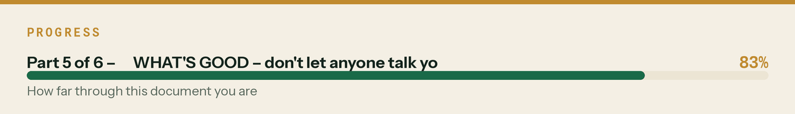

Priority order

When | What | Why
Today | Remove or correctly label the testimonials | Legal, regulatory and reputational. Nothing else matters until this is done.
Today | Audit every other claim for present-tense truth | Same reason
Before Monday | Paste the JSON-LD from docs/08 | Biggest free SEO win; needs to be indexed before traffic arrives
Before Monday | Meta Pixel + LinkedIn Insight Tag | Audience you don't collect is gone
Before Monday | Newsletter capture after calculator results | Highest-intent capture on the site
Week 1 | Cut homepage CTAs to one primary per section | Conversion
Week 1 | Per-page og:image from assets/posts/ | Every social share this month uses it
Week 2 | "Which tier am I?" helper on pricing | Highest revenue impact of any single build
Week 2 | Calculator page titles + SoftwareApplication schema | The long-tail SEO engine
Week 3 | Town/area targeting | Local intent is the money

Correction, 26 August 2026 — read this with the document above
- FAQPage and HowTo schema no longer produce rich results. FAQ rich results stopped appearing in
Google Search on 7 May 2026; HowTo was retired in September 2023. Keep the FAQ content and the markup, but move the effort to AccountingService, Organization, BreadcrumbList and Service. Full note in docs/08 §12.
- Google Business Profile posts no longer expire. Google stopped that in January 2021. Post
weekly anyway — only the newest shows prominently and a stale profile reads as abandoned.
- The verified figures live in docs/17 §8, checked against gov.uk on 26 August 2026. Never
publish a figure that is not in that table.
- Current inventory: 27 documents, 20 web pages, 180+ assets, 12 PDFs, 14 videos, one workbook.
Anywhere this document quotes a smaller count, it predates the later passes.
- Twelve calculators vs four tools: the twelve are the individual calculator pages already on
klyara.com; the four are the consolidated web/tools.html. docs/08 §12 explains which schema goes where.
- ICB cost: £94 application, then £373–£406 a year (£206 licence plus £167–£200 membership).
Anywhere this document says "£206 a year", it is quoting the licence only.
The line that matters
Keep the FAQ content and the markup, but move the effort to AccountingService, Organization, BreadcrumbList and Service.

In this part
Correction, 26 August 2026 — read this with the document above

Also worth knowing
weekly anyway — only the newest shows prominently and a stale profile reads as abandoned.

