KLYARA the back office for building firms

Klyara — The Answer Bank
22 pre-written answers for Reddit, forums and Facebook groups

*The community strategy in docs/01 fails for one reason: writing a good answer takes twenty minutes and Craig doesn't have twenty minutes on a Wednesday evening. These are written. Adapt, don't paste verbatim — copy-paste answers read as copy-paste answers, and this audience notices.*
The rules, once more
- Answer the question. Never link. The link is what gets you removed.
- Disclose the interest, once, in a clause: *"For context, I do construction bookkeeping, so this
is my day job."* It costs nothing and buys enormous goodwill.
- Adapt the opening line to what they actually asked. The body can be reused; the first sentence
cannot.
- If someone asks for a resource in the replies, then link. That's a request, not promotion.
- Never answer a question you're not sure about. "I'd check that one with HMRC directly" is a
perfectly good answer and it protects you.
The line that matters
*The community strategy in docs/01 fails for one reason: writing a good answer takes twenty minutes and Craig doesn't have twenty minutes on a Wednesday evening.

In this part
22 pre-written answers for Reddit, forums and Facebook groups · The rules, once more

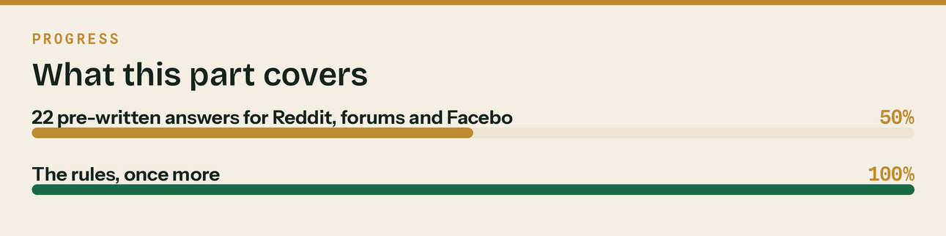
Read top to bottom. The bar is just how far through the part you are.

CIS

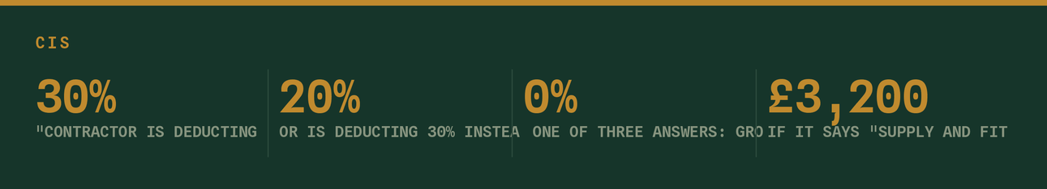
1. "Contractor is deducting 30% instead of 20% — can they do that?"
They can, and if you're not verified they have to.
When a contractor takes you on they're supposed to verify you with HMRC before the first payment.
HMRC comes back with one of three answers: gross (0%), net (20%), or unmatched (30%). If HMRC can't
match your details — or you're not registered under CIS as a subcontractor — the contractor is
obliged to deduct 30%. It's not a punishment they've chosen, and if they under-deduct HMRC comes
after them for the difference, so they won't budge on it.
Two things to check:
First, are you actually registered for CIS as a subcontractor? Registering for self assessment isn't
the same thing.
Second, do your details match exactly? The commonest cause of a failed verification is a trading name
being given instead of the registered name, or a digit wrong in the UTR. Give the contractor your
name exactly as HMRC has it and ask them to verify again.
The money isn't lost either way — it all counts toward your tax bill and you'll get the difference
back when you file. But 30% instead of 20% for a year is a lot of your cash sitting with HMRC
instead of in your account.
2. "Contractor is deducting CIS off my materials"
They shouldn't be, and this is worth sorting because it adds up fast.
CIS comes off labour. The cost of materials you genuinely paid for is excluded before the percentage
is applied, along with VAT and any CITB levy shown separately. Plant you hired in from a third party
usually comes out too — plant you already own doesn't.
The usual cause is your invoice. If it says "supply and fit, £3,200" the contractor has nothing to
exclude, so they deduct on the lot. If it says "labour £2,000, materials £1,200" they deduct on the
£2,000.
So: itemise. Every time, on every invoice. It's the single highest-value change most subbies can make
to their invoicing.
If they're still deducting on the full amount after you've itemised, ask them why in writing. They're
required to give you a payment and deduction statement showing the materials figure they used, so
that statement will tell you exactly what they've done.
3. "Do I have to file a nil CIS return?"
Yes, if you're registered as a contractor, and this is the most commonly paid penalty in the whole
scheme.
If you have a contractor scheme open and you paid no subcontractors in a tax month, you still file —
you just file it as nil. It takes about two minutes. Not filing it is £100 the day you're late, and
it climbs from there.
The bit worth knowing: if you've genuinely stopped using subcontractors, tell HMRC to make the scheme
inactive. Otherwise you're filing nil returns every month forever, and sooner or later you'll forget
one and pay £100 for a return with nothing on it.
4. "What's gross payment status and should I apply?"
It means contractors pay you in full with no deduction, and you settle your tax through your own
return instead.
Worth doing the maths on. If you invoice £120,000 of labour a year, 20% is £24,000 sitting with HMRC
rather than in your business — and you don't get it back until you file and reconcile, which can be a
year after you earned it. Meanwhile you're borrowing to buy materials.
Three tests:
Business — you do construction work in the UK and run it through a bank account. Easy.
Turnover — your construction turnover excluding VAT and materials has to be over a threshold. It
differs for sole traders, partnerships and companies, and there's an alternative test for companies.
Check the current figures rather than going off a number someone quoted you.
Compliance — everything filed and paid on time over the last twelve months. This is the one that
catches people. A few minor slips are tolerated; a pattern isn't.
If you failed before, note that the compliance test only looks back twelve months. Twelve clean
months and you can apply again — plenty of people who tried once years ago would pass now.
Worth saying: HMRC reviews it periodically and it can be withdrawn if you start missing deadlines.
Losing it midway through a year hurts more than never having had it, because your cash flow has
already adjusted.
5. "I've lost my CIS deduction statements — does it matter?"
Yes, quite a lot, because you can only claim deductions you can evidence.
Every contractor who deducted from you has to give you a payment and deduction statement within 14
days of the end of the tax month. That statement is what proves the money went to HMRC on your
behalf. Without it, HMRC's position is that you haven't shown the deduction was made, and you can end
up paying that tax twice.
Chase them now rather than in January. Contractors are much more helpful about a job they finished
last month than one they finished eight months ago, and the person who ran the payroll may not even
be there by then.
If a contractor won't provide them, they're in breach of their obligations, and HMRC can be told. But
try asking nicely first — it's usually an oversight, not a refusal.
In this part
1. "Contractor is deducting 30% instead of 20% — can they do that?" · 2. "Contractor is deducting CIS off my materials" · 3. "Do I have to file a nil CIS return?" · 4. "What's gross payment status and should I apply?" · 5. "I've lost my CIS deduction statements — does it matter?"

Making Tax Digital


6. "Does MTD apply to me?"
Depends on one number, and it's probably not the number you think.
MTD for Income Tax applies to sole traders and landlords based on qualifying income:
over £50,000 — from April 2026
over £30,000 — from April 2027
over £20,000 — from April 2028
Qualifying income means your gross self-employment income plus gross property income, added together.
Gross means before expenses, and — this is the one that catches people in the trade — before CIS
deductions.
HMRC's own wording is "the amount before expenses (also known as turnover), based on the tax return
you submitted in the previous tax year".
Here's why that catches subbies specifically. CIS deductions don't reduce your turnover — they go in
a separate box on your return as tax you've already paid. So if you invoiced £55,000 and 20% CIS came
off, your turnover box still says £55,000 even though you banked £44,000.
Check the turnover box on your last tax return, not your bank statement. And add any rental income to
it — HMRC's own example is £25,000 rental plus £27,000 self-employment giving £52,000 qualifying
income, so in scope.
7. "What does a quarterly update actually involve?"
Less than people think.
It's a summary of your income and expenses cumulatively — from 6 April to the end of that quarter, not just the three months since the last one, by category, sent from
compatible software. Totals. That's the whole thing.
It is not a tax return. There's no tax calculation, nothing to pay, and nothing is final — you can
correct figures later. All the actual tax work still happens once a year at the final declaration on
31 January, same as it always did.
What has genuinely changed is the record keeping. You now need income and expenses recorded digitally
as you go, rather than reconstructed in January from a carrier bag. Practically, that's the whole
reform — asking for four updates is just how HMRC makes sure it happens.
If your books are already up to date monthly, a quarterly update is about twenty minutes. If they're
not, MTD isn't four times the work — it's four times the panic.
8. "Can I just use a spreadsheet?"
Sometimes, but probably not the way you're picturing it.
A spreadsheet can be part of a compliant setup if it's linked to software that can submit to HMRC —
"bridging software" — with digital links between the two. Digital links matter: the data has to move
electronically. Reading a figure off a spreadsheet and typing it into something else breaks the chain
and isn't compliant, however accurate the number is.
In practice, for most people in the trade, a spreadsheet plus bridging software is more moving parts,
more to go wrong and often more cost than just using proper software from the start.
Whatever you use, the single biggest thing you can do is connect your business bank account to it
properly — feeding automatically, not exported and typed in. That does most of the work of digital
record keeping on its own and takes about ten minutes.
9. "What happens if I miss a quarterly update?"
HMRC runs a points-based system for late submissions rather than an instant fine. You accrue a point
per late update, and when you hit the threshold a financial penalty follows. Late payment penalties
sit separately on top, and they escalate the longer the tax is outstanding.
Worth checking the current thresholds on gov.uk rather than taking my word for the numbers — they've
been adjusted before.
The honest answer though: the penalties aren't really the risk. The risk is that if your records
aren't running properly, MTD doesn't give you one bad week in January any more. It gives you four bad
weeks a year, permanently. That's the thing worth fixing.
10. "I'm a limited company — does MTD for Income Tax apply?"
Not to the company. MTD for Income Tax covers sole traders and landlords.
If you run through a limited company, the company files its own accounts and corporation tax return
exactly as it does now. Nothing in this wave changes that.
Where it can still catch you personally: if you have income outside the company — property, or a bit
of self-employed work on the side — that's assessed on you as an individual, and if it crosses the
threshold you're in.
Be a bit wary of anyone using MTD panic to sell limited company directors something they don't need
yet.
In this part
6. "Does MTD apply to me?" · 7. "What does a quarterly update actually involve?" · 8. "Can I just use a spreadsheet?" · 9. "What happens if I miss a quarterly update?" · 10. "I'm a limited company — does MTD for Income Tax apply?"

VAT and the reverse charge

11. "Do I charge VAT on this job or not?"
Six tests. All six have to be yes for the reverse charge to apply:
1. It's construction work within the CIS definition
2. You're both VAT registered
3. The payment will be reported under CIS
4. Your customer has NOT confirmed in writing that they're an end user or intermediary supplier
5. It's standard or reduced rated — zero-rated work like a new build is out
6. You're doing the work, not supplying workers as an employment business
All six yes: you don't charge VAT, and your customer accounts for it themselves.
Any one no: charge VAT as normal.
Test 4 is where it goes wrong. An end user is whoever actually uses the finished building rather than
selling the work on. A homeowner is an end user. A developer building to sell is usually an end user.
A main contractor who'll invoice your work onward is not.
And crucially, the customer has to tell you they're an end user, in writing. It's their declaration,
not your guess. Get it in an email at the start of the job and keep it, because if it turns out to be
wrong the first question is what you were told.
12. "What wording goes on a reverse charge invoice?"
No VAT amount charged, but you still show either the VAT rate that would have applied or the amount
of VAT the customer needs to account for. Plus a clear statement that the reverse charge applies.
Something like:
"Reverse charge: VAT Act 1994 Section 55A applies. Customer to account to HMRC for the reverse charge
output tax on the VAT-exclusive price of items marked 'reverse charge'."
HMRC accepts various forms of wording as long as it's clear, so don't agonise over the exact phrasing.
Put it on your invoice template once and stop thinking about it.
13. "Since the reverse charge came in my cash flow is worse — is that normal?"
Yes, and nobody sent a letter explaining it.
Before, you charged VAT on your sales, collected it, and held it until the quarter end. It was never
your money, but it sat in your account and a lot of firms were quietly using it as working capital
without really thinking of it that way.
That float has gone. If most of your sales are now reverse charged, you're not collecting VAT on
them — but you're still paying VAT on your materials.
Which means you may now be in a permanent repayment position: HMRC owing you every quarter rather
than the other way round.
If that's you, apply to move to monthly VAT returns. You'll get the money back twelve times a year
instead of four. It's a straightforward application and I've seen firms sit on quarterly for two
years wondering why cash is always tight.
14. "Subcontractor charged me VAT when it should have been reverse charged"
You can't reclaim it, unfortunately. If VAT was charged when it shouldn't have been, it isn't
properly due, and HMRC's position is that you have no right to deduct it as input tax.
Send the invoice back and ask for a corrected one. Most subbies will sort it without any fuss —
it's usually a template that never got updated rather than anything deliberate.
Worth doing a quick check across your other suppliers while you're at it. If one has it wrong,
others often do too.
In this part
11. "Do I charge VAT on this job or not?" · 12. "What wording goes on a reverse charge invoice?" · 13. "Since the reverse charge came in my cash flow is worse — is that normal?" · 14. "Subcontractor charged me VAT when it should have been reverse charged"

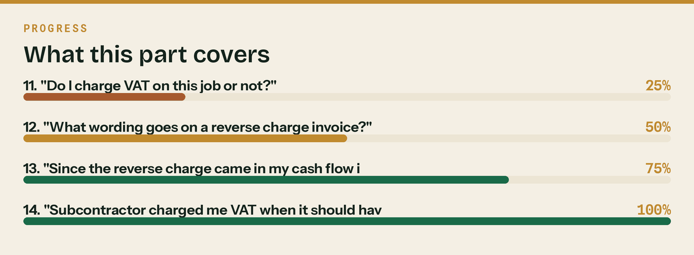
Read top to bottom. The bar is just how far through the part you are.


Getting paid

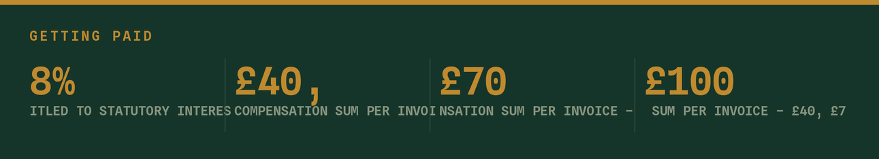
15. "Main contractor is 90 days late — what can I actually do?"
More than most people realise.
On a business-to-business debt you're entitled to statutory interest at 8% above the Bank of England
base rate, plus a fixed compensation sum per invoice — £40, £70 or £100 depending on the size of the
debt — plus reasonable costs of recovering it. You don't need any of that in your contract. It applies
by default under the late payment legislation.
Almost nobody invoices it, usually out of a reasonable fear of losing the customer. Fair enough. But
knowing you can changes the conversation, and putting a line on your invoice template noting the
entitlement costs nothing and quietly moves you up the payment run.
Practically, before you get to that: find out who actually signs off the payment run and speak to
them rather than the accounts inbox. Ask what's needed to get it in the next run. Nine times out of
ten there's a missing document or an unsigned application rather than a decision not to pay.
16. "How do I get my retention back?"
Make a list. That's genuinely most of it.
Three columns: job, amount held, release date. Put every retention on it, diarise the release date,
and ask on the day it falls due rather than three months later when you remember and feel awkward
bringing up old business.
The firms that get their retentions back aren't better negotiators. They're the ones who wrote it
down.
For anything already overdue: work out which half you're chasing — usually half at practical
completion and half at the end of the defects liability period — check the contract for what triggers
release, and ask in writing with the dates in it. A polite email with specifics beats a phone call
with "you owe me some money".
Most firms who do this exercise properly for the first time find several thousand pounds they'd
mentally written off.
17. "Should I be charging late payment interest?"
You're entitled to. Whether you should is a commercial judgement about that specific customer, and
anyone who tells you to always charge it has never had to keep a main contractor sweet.
What I'd say is: there's a middle ground people miss. You don't have to invoice the interest to
benefit from it existing. Putting a line on your invoice template — "late payment interest may be
applied under the Late Payment of Commercial Debts (Interest) Act 1998" — costs you nothing, changes
nothing about the relationship, and quietly signals you know what you're owed.
Then keep the actual charge for the customer you've decided you're finished with, or the one who has
genuinely taken the mickey.
In this part
15. "Main contractor is 90 days late — what can I actually do?" · 16. "How do I get my retention back?" · 17. "Should I be charging late payment interest?"

Running the firm

18. "Can I claim for my van / phone / working from home?"
Broadly yes, with the usual caveats about being honest and consistent.
Van — if it's a genuine commercial vehicle and private use is incidental, it's a business cost. Keep
it that way; regular private use changes the picture.
Phone — split it. Pick a defensible percentage and apply it consistently. If it's 70% business, claim
70%.
Home — if you do the paperwork at home, HMRC's simplified flat rate is the easiest defensible claim
going. It isn't huge but it's yours and it needs almost no records.
Tools — usually allowable. Larger items may need capital allowances rather than a straight deduction;
if it's over about a grand and will last years, flag it rather than guessing.
Clothing — protective gear and branded workwear yes. Ordinary jeans and boots no, however muddy.
The rule that keeps you out of trouble: claim what's genuinely business, be consistent year to year,
and write down why you picked the split. I've never seen HMRC object to a defensible number applied
consistently.
19. "What does taking on my first employee actually cost?"
More than the salary, and this catches people out badly.
On top of gross pay you've got employer's National Insurance, employer pension contributions under
auto-enrolment, holiday pay — which for a full-timer is a meaningful chunk of the year — plus
statutory sick pay when it happens, and the downtime that isn't billable but is paid.
Then the non-obvious ones: employer's liability insurance, extra PPE, tools, possibly a vehicle, and
the time you spend supervising instead of earning.
A useful rule of thumb is to budget somewhere around 25–30% above gross salary for the direct
statutory costs, then think separately about utilisation — how many of their paid hours you can
actually bill.
Also worth knowing: taking on an employee means running PAYE, which means real deadlines every month
on top of your CIS ones. That's the bit people underestimate more than the money.
20. "How much should a bookkeeper cost?"
Depends enormously on what's included, and the honest answer is that comparing quotes in this trade
is difficult because nobody scopes the same way.
Things that move the number: whether VAT returns are in it, whether CIS returns are in it, whether
payroll is in it, how many transactions you have, how many bank accounts, whether they're cleaning up
a backlog first, and whether you're on a fixed monthly fee or hourly.
What I'd say to look for rather than a price:
Fixed monthly rather than hourly, so you know what you're paying and they're not incentivised to be
slow. Clear scope in writing — specifically whether CIS and VAT are included or extra. Software in
your own name, so you can leave and take your books. And notice terms that aren't a twelve-month
tie-in.
For context so I'm not being sneaky: this is my day job, so I'm not a neutral party. But those four
things are worth checking whoever you go with.
In this part
18. "Can I claim for my van / phone / working from home?" · 19. "What does taking on my first employee actually cost?" · 20. "How much should a bookkeeper cost?"


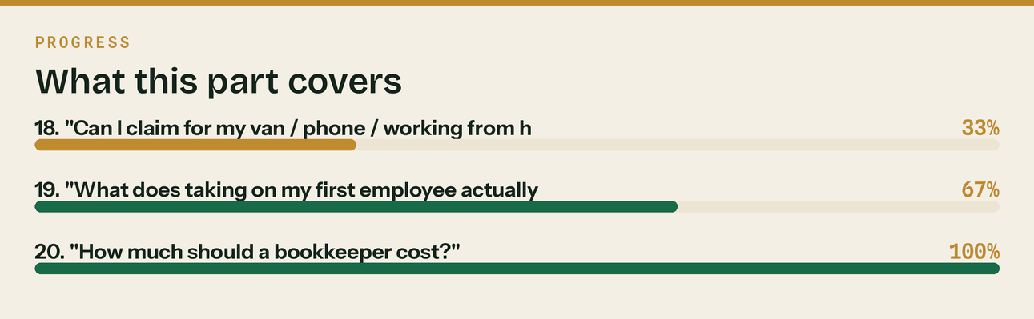
Read top to bottom. The bar is just how far through the part you are.

Two answers for when it's not your question

21. When someone is clearly being given bad advice in the thread
I'd gently push back on [X] above — [correct position], and it's worth checking because [consequence].
Not having a go at anyone, this one catches a lot of people out.
Never name the person, never say "wrong", and never do this more than once in a thread. Correct the fact, not the human.
22. When you genuinely don't know
I don't know that one well enough to answer properly, and it sounds like the kind of thing where the
detail matters. I'd ring HMRC's [CIS/VAT] helpline rather than take an answer off a forum — including
mine.
This answer builds more credibility than any of the others in this document. Use it whenever it's true.
How to run this
Weeks 1–3: comment only, no links, anywhere. Target 30–40 genuine answers from this bank, adapted. That builds the karma most subreddits gate posting behind, and it teaches you each community's tolerance.
Week 4 onward: one text post a week maximum, only where the rules allow.
Track what gets asked. Every question you answer three times is a page on your site, and it should be written in the exact words people used to ask it — not in mine.
The line that matters
Every question you answer three times is a page on your site, and it should be written in the exact words people used to ask it — not in mine.

In this part
21. When someone is clearly being given bad advice in the thread · 22. When you genuinely don't know · How to run this

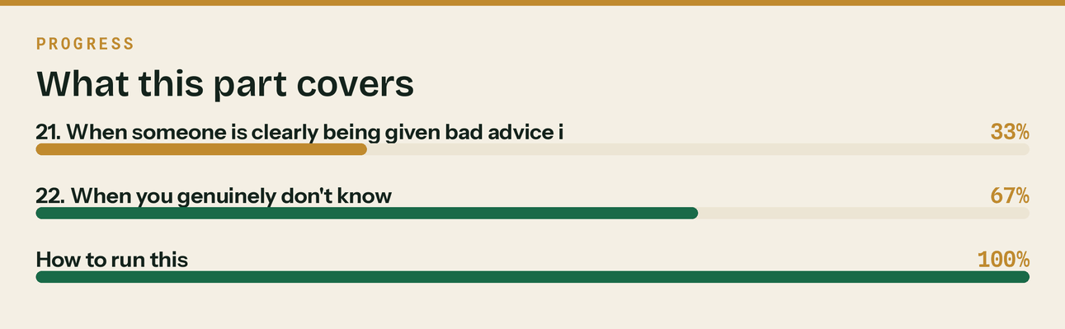
Read top to bottom. The bar is just how far through the part you are.

