KLYARA the back office for building firms

Klyara — AI Visibility Playbook
Getting recommended when someone asks an AI for a bookkeeper

*This channel did not meaningfully exist eighteen months ago. It is now in roughly a quarter of local search journeys and growing faster than anything else in local discovery.*
The line that matters
*This channel did not meaningfully exist eighteen months ago.

1. Why this is worth an hour a month


Finding | Source
45% of consumers now use AI for local business recommendations — up from 6% a year earlier | BrightLocal
AI appears in 23% of local search journeys | BrightLocal
88% of people verify AI recommendations by checking the underlying sources | BrightLocal

*Via Trades marketing statistics 2026*
A 6% → 45% shift in twelve months is the steepest change in local discovery since mobile. The data is US and the UK typically trails — but not by much, and not for long.
The 88% figure is the important one. People do not take the AI's word for it; they go and check the sources. Which means this is not a separate channel you optimise in isolation. It is your existing footprint, read by a machine, and then verified by a human. Everything that makes you recommendable also has to survive the click.
The line that matters
A 6% → 45% shift in twelve months is the steepest change in local discovery since mobile.

2. How AI assistants actually pick a local business

There is no ranking algorithm to game. Assistants assemble an answer from sources:
Business website and service pages Google Business Profile
Directories and local citations Customer reviews and ratings
Professional credentials Social presence
News and media mentions Industry-specific sites
The consistent finding across the research is that completeness and consistency beat optimisation — "AI performs better when information is complete."
The recurring factors: information completeness · identical NAP everywhere · detailed individual service pages · explicit geographic service areas · FAQ content answering real questions · structured data · topical depth on a narrow subject · reviews · fast, mobile, secure site.
*Source: How ChatGPT Recommends Local Businesses in 2026 — CMC SEO*
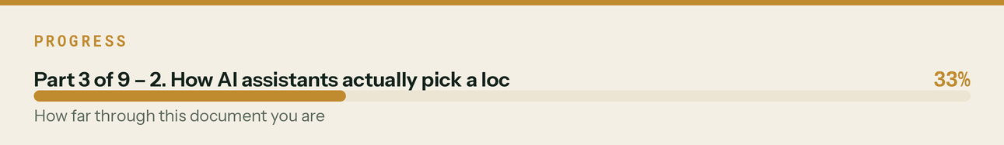

3. Where Klyara already stands

Unusually well, and mostly by accident. The things these systems reward are the things a narrow specialist with a lot of written content naturally has.
Factor | Status | Evidence
Detailed service pages | Strong | Services split by function, twenty pages built, including a guide index and a published pricing page
Explicit geographic areas | Strong | Five local pages, named towns, areaServed in schema
FAQ content | Strong | 16 on the MTD page, 6 per local page, 6 per guide page — all schema-marked
Structured data | Strong | AccountingService, FAQPage, Article, Breadcrumb, SoftwareApplication, HowTo
Consistent NAP | Good | Canonical string, 12+ citations planned
Topical depth, narrow subject | Exceptional | Construction-only. ~70,000 words on CIS, MTD and VAT.
Ungated tools | Unusual | Twelve calculators, no email wall
Plain-language fact block | Added | On all twenty pages
Professional credentials | ⏳ Pending | Publish the moment the ICB licence lands
Reviews | ❌ The gap | Zero. This is the whole weakness.
News / media mentions | ❌ Not yet | Press release is written and held

The honest read: Klyara is one input short of being a strong candidate for "who does CIS bookkeeping near Guildford", and that input is reviews. Everything else is either done or written.
The line that matters
The honest read: Klyara is one input short of being a strong candidate for "who does CIS bookkeeping near Guildford", and that input is reviews.

Also worth knowing
The things these systems reward are the things a narrow specialist with a lot of written content naturally has.

4. The five things to do

1. Reviews. Everything else is already done.
Twenty is the working minimum (47% of consumers filter below it). Two a month from client one, asked at the first report handover with the link texted on the spot. Google first, Trustpilot second, nothing else. This is in docs/06 §9 and it is now the highest-priority marketing task you have.
2. Publish credentials as text, never as an image
The moment the ICB licence lands: membership number, supervision status, and any software certifications, as plain text on an About page. A badge image is invisible to everything that matters here.
3. Keep the fact block current
Every page now carries a short, plain, unambiguous paragraph stating what Klyara does, where, for whom, at what price, and what it explicitly does not do. That last part matters — "we do not provide year-end accounts or regulated financial advice" prevents an assistant recommending you for the wrong thing, which is worse than not being recommended.
When pricing changes, change it there first. A stale price in a fact block is worse than no fact block.
4. Get one media mention
The press release in docs/06 §5 to the Surrey Advertiser, sent the week supervision lands. One local news mention is a source these systems can cite, and you currently have none.
5. Answer the questions people actually ask
Not keywords — questions, in the words people use. The 22 answers in docs/15 are already in that form. Every question you answer three times in a community should become a page.
The line that matters
That last part matters — "we do not provide year-end accounts or regulated financial advice" prevents an assistant recommending you for the wrong thing, which is worse than not being recommended.

In this part
1. Reviews. Everything else is already done. · 2. Publish credentials as text, never as an image · 3. Keep the fact block current · 4. Get one media mention · 5. Answer the questions people actually ask

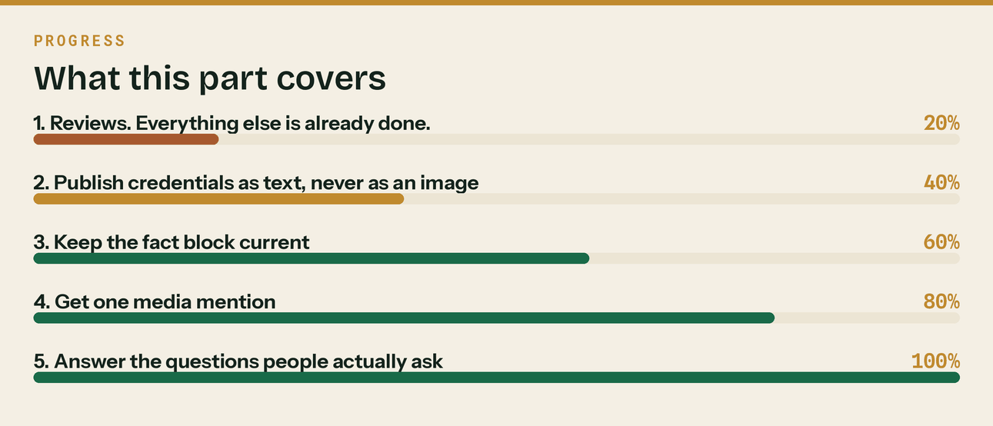
Read top to bottom. The bar is just how far through the part you are.

5. The monthly test — 10 minutes, first Friday

Add this to the Friday production hour from day 30.
Ask each of ChatGPT, Claude, Gemini and Perplexity, in a fresh session:
1. "Who does CIS bookkeeping for builders near Guildford?"
2. "I'm a self-employed builder in Surrey. Who can help me with Making Tax Digital?"
3. "Recommend a construction-specialist bookkeeper in Surrey."
4. "I invoice £55,000 a year as a CIS subcontractor. Am I in Making Tax Digital?"
5. "What's the best free CIS deduction calculator?"
Log four things per question: were you mentioned · what was said about you · which sources were cited · who else appeared.
Questions 4 and 5 matter as much as 1–3. Being the source an assistant *cites* is more durable than being a name it lists, and your calculators and guide pages are built for exactly that.
The log
Date | Assistant | Q# | Mentioned? | What it said | Sources cited | Competitors named
Keep it in the KPI workbook. Three months of this tells you more about this channel than any article will.
What to do with the results
- Not mentioned anywhere — expected at first. Check the fact block is live and the schema
validates, then wait. This channel lags your footprint by months.
- Mentioned but described wrongly — a fact-block or service-page problem. Fix the source.
- Competitors mentioned, you are not — look at what it cited about them. It is usually reviews.
- Cited as a source without being recommended — a good sign, and the normal first step.
The line that matters
Being the source an assistant *cites* is more durable than being a name it lists, and your calculators and guide pages are built for exactly that.

In this part
The log · What to do with the results

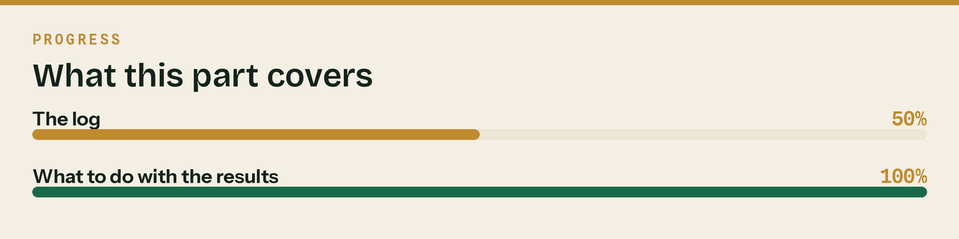
Read top to bottom. The bar is just how far through the part you are.

6. What not to do

Do not buy "GEO services". The market filled with agencies selling AI-visibility packages within about a month of the first research landing. There is no ranking factor to buy. The work is completeness, consistency, content and reviews — all of which you are already doing, and all of which also serve normal search.
Do not write for machines. Content stuffed with question-shaped headings and no substance reads badly to humans and is not rewarded anyway. The 88%-verify figure means a human lands on the page straight after. Write for them.
Do not create pages you cannot maintain. A thin page with a stale price does more harm than not having it.
Do not treat this as separate from SEO. Same inputs, different consumer. Everything in docs/08 serves both.
The line that matters
The work is completeness, consistency, content and reviews — all of which you are already doing, and all of which also serve normal search.

Also worth knowing
The market filled with agencies selling AI-visibility packages within about a month of the first research landing.

7. The honest position

This is a real and fast-moving channel and it is worth ten minutes a month of measurement. It is not worth a budget line, a separate strategy, or reordering your priorities around.
If you did nothing in this document except get to twenty genuine Google reviews, you would capture most of the available upside — because reviews are simultaneously the biggest AI input you are missing, the thing 65% of consumers use to reject businesses, and the thing that closes the sale when a human clicks through to check.
Which is a fairly typical outcome for a new marketing channel: the answer turns out to be the thing you already knew you should be doing.
The line that matters
Which is a fairly typical outcome for a new marketing channel: the answer turns out to be the thing you already knew you should be doing.

Also worth knowing
This is a real and fast-moving channel and it is worth ten minutes a month of measurement.

8. Baseline test — run 26 August 2026, before launch

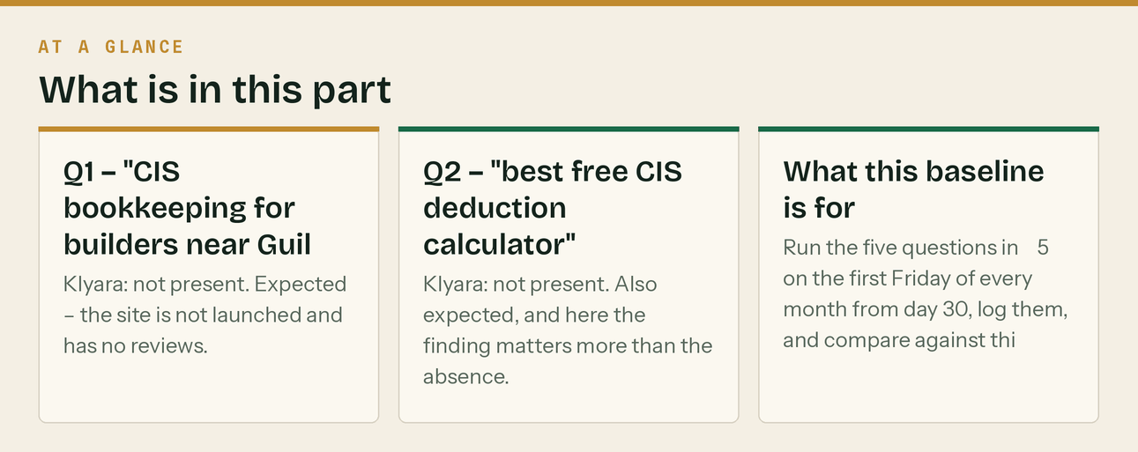
*Run properly, so that month one has something to compare against. This is what "not visible yet" actually looks like, and it is worth having on record.*
Q1 — "CIS bookkeeping for builders near Guildford / construction specialist bookkeeper Surrey"
Klyara: not present. Expected — the site is not launched and has no reviews.
Who came back, in order: dns accountants (national, Guildford landing page) · Accountant for Construction (national, Guildford landing page) · getsurrey directory · Bookkeeper Surrey · David Howard · Ordinem Finance · Guildford Accounting · CVH · Blue Matrix · Treetops.
Three things worth noticing.
The top two are national sites with a town-name page. That is beatable on local signals — a real Google Business Profile with real reviews, a Guildford number, and pages that name the towns you actually work in. It is not beatable on domain authority, so do not try.
A local directory ranks third. Getting listed in directory.getsurrey.co.uk is a twenty-minute job and it is currently outranking most of the actual firms.
Blue Matrix appears with a price in the result snippet — "Bookkeeping Services From £35 Per Month". A number in the snippet earns the click. Klyara's web/pricing.html should be built to do the same thing: the meta description carries the four figures deliberately.
Q2 — "best free CIS deduction calculator"
Klyara: not present. Also expected, and here the finding matters more than the absence.
At least eight free CIS calculators rank for this — Experi, TaxCalculate, UK Tax Tools, Complys, QuoteLedger, Fastjobs, Toolfy, Graftum. Several handle the labour/materials split correctly and most need no sign-up.
So this query is not winnable and should not be chased. The full analysis is in docs/22 PART 6, and the copy on web/tools.html has been corrected — it no longer claims there was nothing good online, because there is.
What to chase instead: the questions nobody has built a tool for. "Do I charge VAT on this invoice." "How much are my late CIS returns costing me." "Am I in Making Tax Digital as a CIS subcontractor." Those are the three tools on the page that have no direct competitor, and they are the ones an assistant has nothing better to cite for.
What this baseline is for
Run the five questions in §5 on the first Friday of every month from day 30, log them, and compare against this. The useful signal is not "am I mentioned" for the first three or four months — it is which sources get cited. The first time an assistant cites a klyara.com guide page while answering somebody else's question, this channel has started working, and that will happen months before your name appears in a list.
Do not conclude anything from a single month. Assistants vary their answers run to run, and one absence proves nothing.
The line that matters
So this query is not winnable and should not be chased.

In this part
Q1 — "CIS bookkeeping for builders near Guildford / construction specialist bookkeeper Surrey" · Q2 — "best free CIS deduction calculator" · What this baseline is for

