KLYARA the back office for building firms

21 — Pricing, scope and quoting
What is in each tier, what is not, what you charge for it, and how to say no without losing the client.

### Read this before using anything below
Klyara cannot trade as a bookkeeper by way of business until AML supervision is in place (docs/01, docs/06 §5). Everything in this document that offers, prices or sells the service is written for the day supervision lands. Before then, run the education-first and waitlist variants in docs/03 — the content, the guides and the free tools are all fine to publish now; the "we do your books for £X a month" half is not. Ask a client for a review only after you have lawfully done work for them. Delete this box on the day the licence arrives, and not before.

Why this document exists
Every fixed-fee firm dies the same way. Not from bad pricing — from undefined scope. The fee is agreed once and the work grows quietly for eighteen months until a £199 client is taking six hours a month and you resent them. By then the conversation is impossible, because nothing was ever written down that says where the line was.
This document draws the line. It is written to be used three ways: as your own reference when quoting, as the scope schedule attached to every engagement letter, and as the script when something falls outside it.
Benchmarking against real market prices is in docs/22. This document is about scope, not level.
The line that matters
It is written to be used three ways: as your own reference when quoting, as the scope schedule attached to every engagement letter, and as the script when something falls outside it.

In this part
What is in each tier, what is not, what you charge for it, and how to say no without losing the client. · Why this document exists

PART 1 — The four tiers, precisely

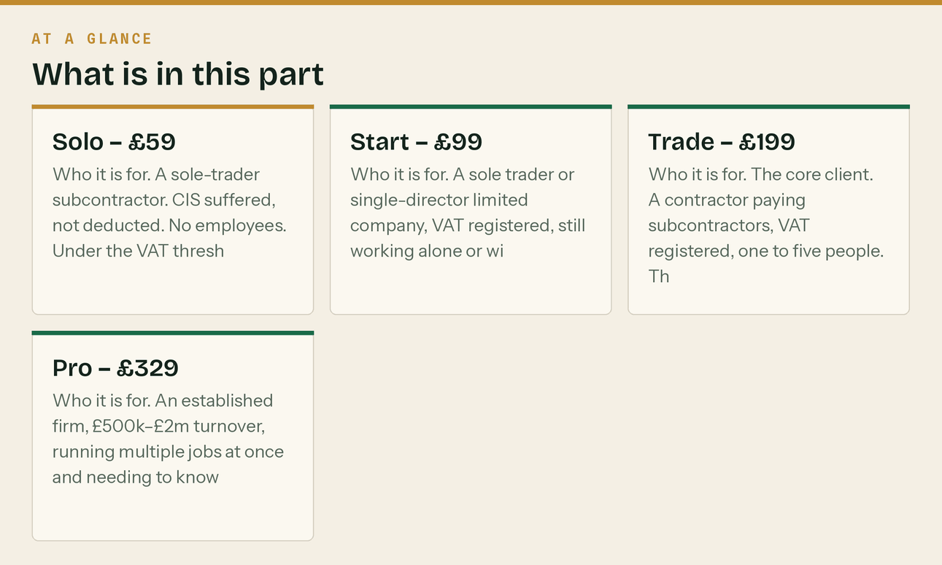
Prices are per month, excluding VAT, on a founding client rate held for twelve months from the client's start date. Billed monthly in advance by Direct Debit or standing order.
Solo — £59
Who it is for. A sole-trader subcontractor. CIS suffered, not deducted. No employees. Under the VAT threshold, or newly over it and not yet registered. Typically 20–60 transactions a month.
In scope
- Bank feed reconciled monthly
- Sales invoices raised from your job sheet or WhatsApp, up to 10 per month
- Purchase receipts captured and coded, up to 50 items per month
- CIS suffered recorded and reconciled to the statements you are given
- Chasing missing CIS statements from your contractors, up to 3 chases per month
- Self Assessment prepared and filed, once a year, including the CIS reclaim
- Software subscription included, in your name
- Monthly one-page summary: what you invoiced, what you were paid, what CIS was taken
- Email and WhatsApp support, answered within one working day
Out of scope — VAT registration or returns · payroll of any kind · limited company accounts or CT600 · acting as a contractor and filing monthly returns · management accounts · mortgage references beyond issuing the SA302 · catch-up of prior years
The natural upgrade trigger. They take on their first subcontractor, or they register for VAT. Both move them to Start at minimum.
Start — £99
Who it is for. A sole trader or single-director limited company, VAT registered, still working alone or with one hand. Typically 60–150 transactions a month.
In scope — everything in Solo, plus
- VAT returns prepared, reverse charge applied correctly in both directions, and filed
- Sales invoices raised, up to 25 per month
- Purchase items, up to 120 per month
- Director-only payroll, if a limited company — one payslip a month, RTI filed
- Limited company year-end accounts and CT600, or Self Assessment for a sole trader
- Confirmation statement filed
- Quarterly fifteen-minute call, if you want it
Out of scope — filing monthly CIS returns as a contractor · payroll beyond the director · CIS verification of subcontractors · management accounts · budgeting and forecasting · catch-up of prior years
The natural upgrade trigger. The first subcontractor they pay. That is Trade, immediately — not next month, not at the year end.
Trade — £199
Who it is for. The core client. A contractor paying subcontractors, VAT registered, one to five people. This is the tier the whole business is built around and it should be roughly 60% of the book. Typically 150–350 transactions a month.
In scope — everything in Start, plus
- Subcontractor verification with HMRC — unlimited
- Monthly CIS returns prepared and filed on the 12th, every month, including nil returns
- Subcontractor payment and deduction statements issued by the 19th, up to 10 subcontractors
- Materials and labour split checked on every subcontractor invoice
- Payroll for up to 5 employees, RTI, and the pension submission
- Sales invoices raised, up to 60 per month
- Purchase items, up to 300 per month
- Retentions tracked on a separate schedule and reported monthly
- Reverse charge handled on sales and purchases, with the end user declarations chased and filed
- Debtor list issued monthly with a suggested chase order
- Monthly management summary: turnover, gross margin, CIS position, retentions outstanding, cash
- Monthly fifteen-minute call
Out of scope — CITB levy returns · construction contract review · job costing beyond the monthly split · more than 5 employees · more than 10 subcontractors · catch-up of prior years · tax planning beyond the obvious · anything requiring a site visit
The natural upgrade trigger. Six employees, eleven subcontractors, or the first month they ask for a job-by-job profit figure.
Pro — £329
Who it is for. An established firm, £500k–£2m turnover, running multiple jobs at once and needing to know which ones make money. Typically 350–700 transactions a month.
In scope — everything in Trade, plus
- Payroll for up to 15 employees
- Up to 25 subcontractors verified, deducted, and statemented
- Sales invoices raised, unlimited within reason
- Purchase items, up to 700 per month
- Job costing — cost and margin tracked per job, reported monthly
- Applications for payment and valuations recorded against the retention schedule
- CIS suffered and deducted both reconciled — for firms in the middle of the chain
- Management accounts with a short written commentary each month
- Cash flow forecast, rolled forward quarterly
- Monthly thirty-minute call
- Same-day response on anything urgent, in working hours
Out of scope — CITB levy returns · audit · corporate finance · contract or legal review · site attendance · anything a chartered accountant is properly required for
Above Pro. Do not invent a tier. Quote it, using PART 3.
The line that matters
Prices are per month, excluding VAT, on a founding client rate held for twelve months from the client's start date.

In this part
Solo — £59 · Start — £99 · Trade — £199 · Pro — £329

PART 2 — The rate card for everything else


Publish this. Firms that hide it end up doing the work for free.
Work | Price
Gross payment status application, prepared and submitted | £195 (free on Trade and Pro)
Reverse charge setup and supplier/customer review | £125 (free at onboarding)
Catch-up of prior-period books | £45/hour, quoted after a look, capped at the quote
Additional subcontractor beyond the tier limit | £8/month each
Additional employee on payroll beyond the tier limit | £6/month each
Extra sales invoices beyond the tier limit | £1.50 each
CIS return for a month we did not do the bookkeeping | £45
Missed-return catch-up filing, per return | £35
Mortgage or lending pack beyond the SA302 | £75
Reference letter to a lender or main contractor | £45
Ad hoc management report, one-off | £120
Company formation | £150, or referred out
VAT registration | £95
CIS registration as contractor or subcontractor | £65
HMRC enquiry support | £65/hour
Software migration from another package | £195
Out-of-scope work, general | £45/hour, billed in 15-minute units

Two rules about this card.
It exists so you can say yes cheerfully. "Yes, absolutely — that one is outside the monthly, it is £75, want me to go ahead?" is a completely normal sentence and clients hear it as competence.
And nothing on it gets billed without being agreed first, in writing, before the work starts. A surprise invoice costs more goodwill than the fee is worth.
The line that matters
"Yes, absolutely — that one is outside the monthly, it is £75, want me to go ahead?" is a completely normal sentence and clients hear it as competence.

PART 3 — Quoting a non-standard job

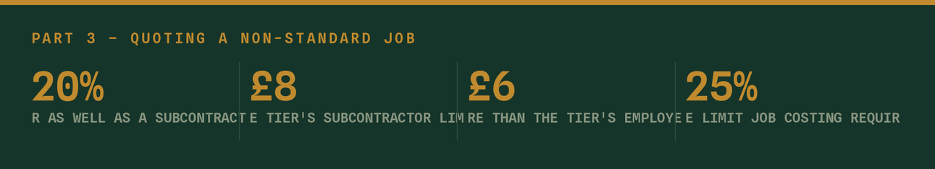
For anything that does not fit a tier. Do this on paper before you say a number.
Step 1 — Count the volume. Ask for three months of bank statements and count the lines. Not a guess. Transactions per month is the single best predictor of your time.
Step 2 — Find the tier it lands in by volume.
Transactions/month | Base tier
Under 60 | Solo
60–149 | Start
150–349 | Trade
350–699 | Pro
700 or more | Quoted individually, use step 4

Step 3 — Apply the complexity multipliers. Percentages apply to the base fee; the per-head lines are added in pounds on top. Work through them in order and total once at the end.
Factor | Add
Acts as a contractor as well as a subcontractor | +20%
More than the tier's subcontractor limit | +£8 each above the limit
More than the tier's employees | +£6 each above the limit
Job costing required | +25%
Retentions on more than 5 live jobs | +10%
Two or more trading entities | +60% of the smaller entity's tier
Books currently in a carrier bag | Catch-up quoted separately, not folded in
Client is chronically disorganised (be honest) | +15%, or decline
More than one bank account or a credit card | +5% each

Step 4 — Sanity check against your own time. Divide the fee by the hours you think it will take. If it is below £38/hour you have underquoted. Below £30, walk away. Your target across the book is £45–£60 an hour of your time; the rate card above is set at £45 for a reason.
Step 5 — Round up, never down. £284 becomes £295. Never quote an odd number you cannot defend.
Step 6 — Quote a review date. "That is £295 a month. I will review it with you at ninety days and again at twelve months, and if the volume is not what we thought I will tell you either way." This single sentence is what makes a fixed fee survivable, because it makes going *up* a normal event rather than a confrontation.
The line that matters
Your target across the book is £45–£60 an hour of your time; the rate card above is set at £45 for a reason.

PART 4 — Scope creep, and what to say

Scope creep is not a client problem. It is a documentation problem, and it always happens the same way: a small favour, granted twice, becomes an expectation.
The three-strike rule
First time. Do it. Say nothing about the fee. It is goodwill and it is cheap.
Second time. Do it, and name it.
"Happy to — done. Just so you know for next time, that one sits outsid
sort of thing I would normally pick up at £45 an hour. Not charging you for this one, but if it becomes a regular thing let's build it into the fee properly."

Third time. Do not do it silently.
"This is the third of these, so it has stopped being a one-off. Two op
monthly — it works out about £30 — or I bill it as it comes at £45 an hour. The monthly is cheaper if it keeps happening. Which suits?"

You have now had a fee increase conversation without it being a fee increase conversation.
The phrases that hold the line
When they ask for something outside the tier
"Yes, I can do that. It is outside the monthly so it is £[x] — want me
"Yes, I can do that. It is outside the monthly so it is £[x] — want me to crack on?"

When they push back on being charged
"The monthly fee covers a defined list, and it is fixed precisely so i
Anything outside it, I tell you the price before I start. You will never get a surprise invoice from me — but you will occasionally get a quote."

When the volume has clearly grown
"When we set the fee you were doing about 90 transactions a month. Las
240 and you have taken on two subbies, which is great. That is genuinely a Trade-sized job now. I would move you to £199 from [date, at least 30 days out]. You are getting more back for it — the CIS returns and the payroll come in at that level."

When they want a discount for paying annually
"Sure — twelve months up front is eleven months' fee. It helps my cash
your planning."

That is an 8.3% discount for a year of cash up front. Offer it. Do not offer more.
When they simply cannot afford the right tier
"Then let's do less, not the same for less. I will do [reduced scope]
keep doing [x] yourself. When it gets too much, we move you up. I would rather do a smaller job properly than a big one badly."

Never discount the same scope. The moment you do, the price becomes the opening bid for everyone they talk to on site.

PART 5 — Getting paid


You are a bookkeeper. Being bad at your own credit control is a positioning problem as well as a cash problem.
Terms. Monthly in advance, Direct Debit preferred, standing order accepted, on the 1st. Invoice issued on the 25th of the preceding month.
Set up Direct Debit from day one. GoCardless or the equivalent inside your accounting software. Clients on Direct Debit pay on time roughly universally; clients on standing order forget when the fee changes; clients on bank transfer pay when they feel like it. Make Direct Debit the default on the engagement letter and standing order the exception.
If the payment fails
When | What happens
Day 1 | Automatic retry, no contact
Day 3 | Friendly text. "Direct debit bounced — worth a check?"
Day 7 | Phone call. Nothing else works as well.
Day 14 | Written notice: work pauses at day 21 if unresolved
Day 21 | Work pauses. Filing deadlines within 14 days are still met — see below.
Day 30 | Formal notice, engagement ends at day 60

The exception you must honour. If a statutory deadline falls in the pause window and the work is already done, file it. You do not create a penalty for a client over a fee dispute, and you do not want that on your record with your professional body. File it, tell them you filed it, and tell them the pause continues.
Never hold the records hostage. Their data is theirs. The software subscription is in their name specifically so that this is never a lever, and that fact is a selling point on the way in — it should not become a weapon on the way out. Chase the fee as a debt, properly and separately.
Two different things, and do not confuse them.
*The founding-rate step-up* happens once, at each client's twelve-month anniversary, and it is not small — Trade goes £199 to £279, which is 40%. That is defensible only because it was stated as a time-limited founding rate on the day they joined, in writing, and because the letter in PART 6 says so plainly. Take that wording away and the same increase becomes indefensible.
*The annual increase thereafter* is small and predictable — inflation and a bit, same month every year, sixty days' written notice. A predictable small increase is accepted; an unpredictable large one is why people leave. The founding-rate schedule and the September 2027 targets are in docs/22.
The line that matters
The software subscription is in their name specifically so that this is never a lever, and that fact is a selling point on the way in — it should not become a weapon on the way out.

PART 6 — The annual increase letter

Send by email, 60 days before the effective date. Change the bracketed parts and nothing else.
**Subject: Your fee from [1 November]**
Hi [Name], Quick note about your monthly fee, well ahead of it changing so there are no surprises. You joined on our founding client rate of £[199] a month. That rate was held for twelve months and it comes to an end on [31 October]. From [1 November] your fee will be £[279] a month plus VAT. Nothing about the service changes. Same work, same deadlines, same person. Two things worth saying plainly. First, this is the first increase since you joined — the founding rate did what it was meant to do and it held for the full year. Second, [279] is still below what this work costs bought separately; the CIS returns alone run from £95 a month on the open market and light bookkeeping from £125. If the shape of your business has changed and the tier is no longer right, tell me and we will look at it properly rather than have you pay for something you do not need. Your direct debit will up

Do not apologise in this letter. No "unfortunately", no "due to rising costs", no "we have had to". You are stating a price. Confident and brief gets accepted; apologetic and long invites a negotiation.
The line that matters
Confident and brief gets accepted; apologetic and long invites a negotiation.



PART 7 — The numbers to hold yourself to

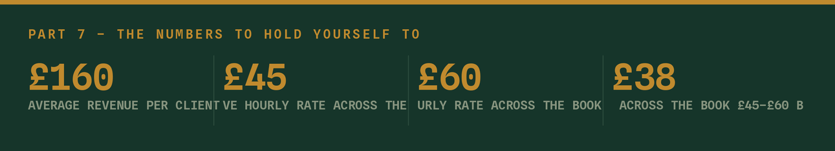
Review these monthly against the KPI workbook.
Metric | Target | Why
Average revenue per client | £160+ by month 12 | Weighted to Trade, not Solo
Effective hourly rate across the book | £45–£60 | Below £38 on any client, requote it
Proportion on Trade or Pro | 60%+ | Where the business actually is
Clients on Direct Debit | 90%+ | Everything else is unpaid admin
Debtor days | Under 5 | You bill in advance; there is no excuse
Out-of-scope work billed vs done | 80%+ | The single biggest silent leak
Clients on a founding rate past 12 months | 0 | The whole point of dating it
Fee increases accepted without loss | 90%+ | Below that, the increase was a surprise

The one to watch hardest is the sixth. Out-of-scope work that gets done and not billed is invisible in every report — it does not show up as a loss, it shows up as you being tired. Keep a running note in the client file every time you do something off the rate card, billed or not. At the ninety-day review you will be able to see the pattern and price it in.
Related
- docs/22 — the market benchmark these prices sit against, and the September 2027 review
- docs/09 — the discovery call, and the three-minute pricing conversation inside it
- docs/12 — onboarding, including where the scope schedule gets attached
- docs/06 — the operating rhythm that makes these scope limits real
- tools/Klyara-KPI-Tracker-and-Model.xlsx — where the metrics in PART 7 are tracked
The line that matters
Out-of-scope work that gets done and not billed is invisible in every report — it does not show up as a loss, it shows up as you being tired.

In this part
Related

