KLYARA the back office for building firms

Klyara Marketing Pack — Start Here
web/pricing.html — publish it at the same time

*Built 26 August 2026 · for launch Monday 14 September 2026*
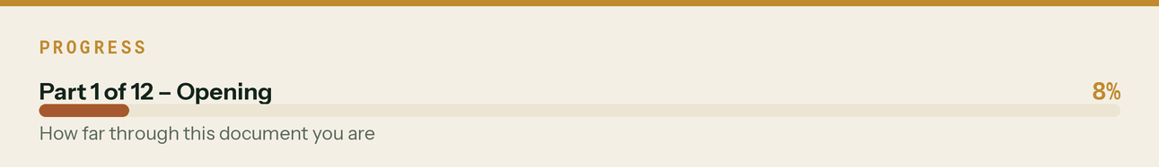

What I could not do, and why

I cannot create accounts on your behalf. Signing up to Reddit, X, Facebook, Instagram, Snapchat or the trade forums means entering credentials, accepting terms of service, and clearing bot checks — all outside what I'm permitted to do, regardless of authorisation. It's also the wrong outcome: platforms flag auto-registered accounts, and a banned handle on day one is unrecoverable.
So the pack is built to make you fast instead. Every profile field is written to the platform's exact character limit, every image is rendered at the right pixel dimensions, and the setup order is sequenced so the slow steps start first. Budget six hours across two sittings and you'll have the whole estate live.
Second thing, flagged once: your Build Manual is explicit that Klyara can't do bookkeeping by way of business until AML supervision is in place. Everything here is therefore written education-first, with waitlist CTAs. Direct "hire us" copy exists and is marked HOLD with the compliant alternative written underneath it. Swap them the day supervision lands.
The line that matters
Every profile field is written to the platform's exact character limit, every image is rendered at the right pixel dimensions, and the setup order is sequenced so the slow steps start first.

Also worth knowing
Second thing, flagged once: your Build Manual is explicit that Klyara can't do bookkeeping by way of business until AML supervision is in place.

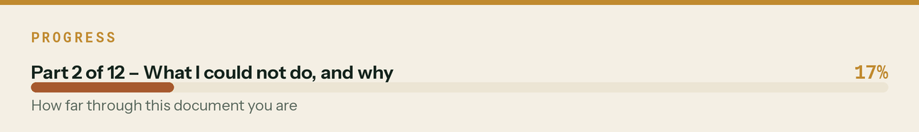

The running order

Fifteen documents is a lot to hold in your head. docs/14-the-90-day-plan.md is the running order — everything sequenced, with owners and decision gates. Start there after this page.
The line that matters
docs/14-the-90-day-plan.md is the running order — everything sequenced, with owners and decision gates.

Do these three things today

- Google Business Profile — start verification. 5–14 day wait. Everything local-SEO depends on it and nothing else on this list is blocked by it. docs/02 has the full listing copy.
- Create social@klyara.com and put it in Bitwarden. Every platform signup runs through it.
- Buy tryklyara.com. Build Manual Part 0 #9. It's £10 and you'll need it before you remember.
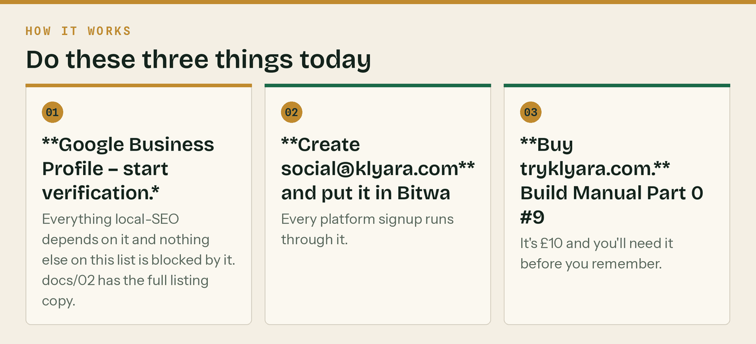
The same steps, in order.


What's in the pack

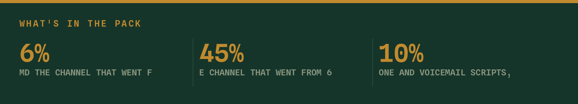
File | What it is
docs/01-channel-map.md | Every platform, subreddit, forum and directory, ranked by return per hour. Includes each community's self-promotion rules and the Reddit protocol that keeps the account alive.
docs/02-account-setup-pack.md | Copy-paste profile fields for 14 platforms + all directories. Written to exact character limits. Setup order and time budget.
docs/03-content-calendar.md | 30 days, dated. Full copy, not outlines — every LinkedIn post, X thread, Facebook post, Instagram caption, GBP post and YouTube description, written out. Plus months 2–3 themes.
docs/04-video-pack.md | Fourteen rendered vertical videos + full long-form YouTube scripts + Shorts extraction plan + the honest answer on AI avatars.
docs/05-email-programme.md | Provider decision (Brevo, with reasoning and a migration trigger), list architecture, deliverability DNS, welcome sequence, two lead-magnet sequences, 24 fortnightly newsletters in full — a full year, transactional emails, signature.
docs/07-website-audit.md | Read the CRITICAL section first. Audit of klyara.com — one legal/regulatory problem, the missing structured data, six conversion fixes, and what's genuinely good.
docs/08-seo-schema-pack.md | Paste-ready JSON-LD for every page type, title tags and meta for all twelve calculators, six keyword clusters, and the ten pages to build next.
docs/09-sales-pack.md | The discovery call script, seven diagnostic questions, ten objections answered, qualify-out list, follow-up cadence and the 90-day review. This is the document that turns the marketing into money.
docs/10-brand-guidelines.md | Colour, type, the mark, layout, voice, photography, and how to drive the generators. Hand this to anyone who touches the brand.
docs/19-ai-visibility-playbook.md | The channel that went from 6% to 45% of consumers in a year. Where Klyara already stands (unusually well), the one gap, and a 10-minute monthly test.
docs/20-risk-register.md | The fourteen things that actually kill this, scored, with the early warning sign for each. Five need a decision this month.
docs/16-day-by-day-plan.md | The one to actually work from. Every day from today to day 90, dated and timed, with a "one thing" per day so a bad day still moves. Includes Phase 0 (the 12 days before launch), the fallback plan for when a week goes wrong, and an honest time commitment.
docs/17-market-intelligence.md | Real data with sources: verified compliance facts, market size, how your buyers actually decide, the AI-discovery angle, and the five Guildford competitors. Also lists what I could not verify.
docs/18-what-i-need-from-you.md | The 30 decisions I could not make alone, grouped into a 105-minute working session — including six new pricing decisions that come out of the market benchmark.
docs/15-answer-bank.md | 22 pre-written answers for Reddit, forums and Facebook groups. The community strategy fails because writing a good answer takes twenty minutes on a Wednesday evening. These are written — adapt, don't paste.
docs/14-the-90-day-plan.md | Read this second. One ordered list: everything in the pack sequenced across 90 days, with owners, dependencies, decision gates, and what good looks like at day 90.
docs/13-gbp-year-of-posts.md | 52 Google Business Profile posts, dated and tied to the real deadline calendar. GBP posts do not expire, but only the newest shows prominently, so this is the difference between a profile that looks active and one that looks abandoned.
docs/12-client-onboarding-pack.md | The five-day signed-to-live runbook, the five client onboarding emails, what to look for in month one, the monthly rhythm, and a graceful offboarding policy. Build Manual §6.5 asked for this "before client 1".
docs/11-guildford-local-pack.md | Guildford & Surrey. The local landing page written and ready to publish, Guildford GBP copy, service-area towns, local keyword clusters, seven town pages in build order, the Slyfield merchant round, Surrey citations, partnership outreach, press list and local ad targeting.
docs/24-content-calendar-month-2.md | Days 31-60 in full copy, Wed 7 Oct to Thu 5 Nov. Gross payment status, pricing and quoting, taking on your first employee, and a ten-day countdown to the 6 November MTD deadline. Same format as days 1-30 - written posts, not themes.
docs/26-the-review-engine.md | The one missing input. Every word: the in-person ask, the text, the email, the reply templates for 5/3/1 star, twelve Google Q&A entries to seed, the once-only nudge, and the six things that would get a bookkeeping practice in trouble. Printed card included.
docs/25-the-monthly-client-report.md | The one tangible thing a client receives each month, and the reason they can answer "what do you actually pay them for?". Template included, with worked figures.
docs/21-pricing-scope-and-quoting.md | The document that stops a fixed-fee firm dying. Exactly what is in and out of all four tiers, the rate card for everything else, how to quote a non-standard job, the three-strike scope-creep script, payment terms and the annual increase letter.
docs/22-competitor-and-price-benchmark.md | Real market prices, sourced, gathered 26 August 2026. What UK firms actually charge for CIS and construction bookkeeping, where Klyara sits against it, who ranks in Guildford, and a dated price-review recommendation.
docs/23-outreach-and-partners.md | The outbound half of the business. LinkedIn and cold-email sequences written out, phone and voicemail scripts, the 10%-ongoing partner programme with terms, Facebook group rules, and a weekly rhythm with numbers to hit.
docs/06-ops-playbook.md | Scheduling tool decision, the 2-hour weekly rhythm, UTM scheme, Google Ads campaigns (paused), press release, podcast pitch, accountant partnership email, merchant campaign, review engine, and 12 things you were missing.

Tools

tools/Klyara-KPI-Tracker-and-Model.xlsx
Five sheets: Read me, Assumptions, a 26-week Weekly tracker (four numbers, two minutes each Friday), a 12-month Pipeline model, and a Dashboard. 184 formulas, zero errors, and every figure hand-checked — the first build had a clean recalc with wrong cell references and computed to zero throughout, which is exactly the failure mode worth catching.
What it says on the current assumptions: you pass the 15-client hire trigger around April 2027 and are over Craig's 20–25 ceiling by month 12. Every conversion rate in it is an assumption, not a measurement — replace them once you have six discovery calls of real data.
The line that matters
184 formulas, zero errors, and every figure hand-checked — the first build had a clean recalc with wrong cell references and computed to zero throughout, which is exactly the failure mode worth catching.

Also worth knowing
Five sheets: Read me, Assumptions, a 26-week Weekly tracker (four numbers, two minutes each Friday), a 12-month Pipeline model, and a Dashboard.

Web pages — production-ready


web/construction-bookkeeping-guildford.html The local landing page, fully built
web/construction-bookkeeping-woking.html Commercial work, applications and retention
web/construction-bookkeeping-godalming.html Small firms and the £30k MTD wave
web/construction-bookkeeping-farnham.html Listed buildings and the 2012 VAT change
web/cis-accountant-surrey.html County-level, targets the CIS keyword
web/mtd-for-cis-subcontractors.html The gross-income trap — highest-intent page in the set
web/cis-gross-payment-status.html The three tests, and re-applying after a fail
web/vat-reverse-charge-end-user-declaration.html Free declaration wording — a template page earns links
web/cis-penalties-explained.html Why four missed months isn't £400
web/cis-materials-deduction.html The £240-per-invoice arithmetic
web/switching-bookkeepers-mid-year.html Removes the biggest objection to changing
web/construction-retentions-guide.html The content that got most engagement, as a page
web/nil-cis-returns.html The most avoidable £100 in construction
web/what-a-bookkeeper-actually-does.html Answers the question before the sales call does
web/quarter-end-checklist.html Seven steps, with HowTo schema
web/cis-payment-and-deduction-statement.html How to read one, and the verification number that means 30%
web/late-payment-interest-construction.html 8% over base plus a fixed sum, and how to use it
web/resources.html The guide index. Twelve pages already pointed here
web/pricing.html THE FOUR TIERS, PUBLISHED — see below
web/tools.html FOUR WORKING TOOLS — see below
web/sitemap.xml 21 URLs, priorities by commercial intent
web/robots.txt AI crawlers allowed, deliberately and explicitly
Twenty pages, fully cross-linked, no orphans, no broken internal links. pricing.html and the Guildford page are joint hubs with 19 inbound links each, resources.html also has 19 and tools.html has 17; every page has at least three. All twenty render clean in Chromium at desktop and at 390px with no horizontal overflow — four pages failed that second test when it was first run and all four are fixed — and all 63 JSON-LD blocks validate.
The five local pages target *place*, the twelve guide pages target *problem*, and tools.html, pricing.html and resources.html target *intent* — someone with a specific number they need right now. Between them they cover all three ways somebody finds you.
Of eleven firms surveyed in and around Guildford on 26 August 2026, exactly one published a full price list, and it was the London one. One local firm publishes a headline "from £35 a month" with nothing behind it. Everybody else makes you fill in a form.
That is the gap. The page carries the four tiers, what is in each one, the rate card for everything else, the founding-client-rate wording, and the honest £285 bought-separately comparison — plus AccountingService with a full OfferCatalog, so the prices are machine-readable. The full research is in docs/22.
web/tools.html — the page to publish first
Four tools, all working, all client-side, nothing stored or sent anywhere:
Tool | What it answers
CIS deduction calculator | What actually lands in the bank, with labour/materials split and 0/20/30%
Reverse charge decision tool | Four questions, ending in the exact invoice wording
Late CIS return penalty estimator | Why four missed months is not £400
MTD for Income Tax date checker | Which threshold band and which April, from gross qualifying income

It carries four SoftwareApplication blocks plus FAQPage and BreadcrumbList. Free tools of this kind are the single most reliable way a small site earns links, and this one is also what every outbound message in docs/23 gives away. Ten other pages already link to it — it is not optional, it is load-bearing.
Each uses your own tokens and typefaces, carries three validated JSON-LD blocks (AccountingService, FAQPage, BreadcrumbList), and has a genuinely distinct local section — not a spun duplicate. Paste the page body into your template and delete the inline CSS.
Build order: Guildford first, then Surrey, then Woking, Godalming, Farnham. Do not add more towns until these are indexed and getting impressions.
The line that matters
Twenty pages, fully cross-linked, no orphans, no broken internal links.

In this part
web/pricing.html — publish it at the same time · web/tools.html — the page to publish first

Assets

assets/logo/ 18 files — lockups on pine/paper/card, disc and bare-K marks, transparent PNGs
assets/avatars/ 17 files — brass disc on pine, sized per platform
assets/banners/ 9 files — X, LinkedIn x2, Facebook, YouTube, Reddit, Pinterest, GBP, email
assets/posts/ 21 files — square graphics incl. one per town, plus the deadline card
assets/carousel/ 9 sets — MTD (6), CIS (7), Getting Paid (6), Quarter End (8), Gross Status (6),
Reverse Charge (6), Switching (5), Pricing (8), First Employee (8) = 60 slides
assets/tools/ 12 files — one shareable card per free calculator
assets/stories/ 8 files — Instagram highlight covers incl. Guildford
assets/print/ 9 files — A3 wall planner, A4 brand sheet, A5 merchant card,
trade-counter card and review card, each A6 single + 4-up A4
with crop marks and a QR code
assets/lead-magnets/ 1 file — The Contractor's CIS Compliance Pack, 14pp
assets/sales/ 5 files — client proposal, partner one-pager, discovery call card,
6-page Schedule of Services for the engagement letter,
3-page monthly client report template with worked figures
video/ 14 files — vertical MP4 incl. a Guildford cut, plus a logo sting
email/ 2 files — responsive HTML template + email signature
web/ 22 files — five local pages, twelve guides, the tools page, the pricing page,
the guide index, plus sitemap.xml and robots.txt
brand/fonts/ 15 files — your own fonts, extracted and converted to static TTF
brand/ 16 files — token module, print system, fourteen generators
The generators are included deliberately, and they have been tested. brand/gen_posts.py will produce any new post graphic in the same system — edit the text list at the bottom and re-run.
The whole asset set was rebuilt from scratch into an empty directory on 26 August 2026 to prove it: 158 files produced, identical file list, all 148 PNGs byte-for-byte identical, and the ten PDFs identical in text and layout (they differ only in the timestamp ReportLab embeds). Thirteen of the fourteen videos were byte-identical too.
That test found three things worth fixing and they are fixed: four generators assumed their output folder already existed and would have failed on a fresh copy, the logo sting existed only as an ffmpeg recipe in a document rather than in a script, and two web pages had hand edits applied after generation that a re-run would silently have lost.
brand/README.md documents all of it — what each generator produces, which three you will actually edit, and the two things that will bite you.
The line that matters
The generators are included deliberately, and they have been tested.

Also worth knowing
brand/README.md documents all of it — what each generator produces, which three you will actually edit, and the two things that will bite you.

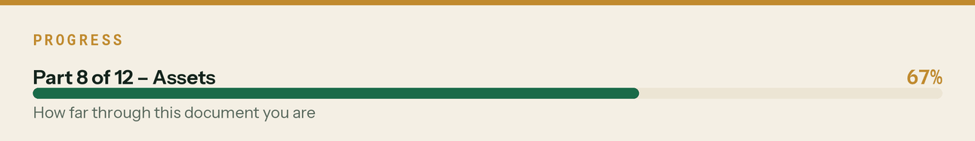

Brand system — extracted from the site, not invented

--paper #F4EFE4 warm bone, page ground --pine #16352A deep green, dark sections
--paper2 #ECE5D4 deeper cream --pine2 #1D4534 lighter pine, ghost numerals
--card #FBF8F0 warm white surface --em #196A48 emerald, positive/data
--ink #14231C green-black, primary text --brass #C08A2E THE accent
--mute #57685C muted sage on paper --warn #A6592E terracotta, bad news only
--dim #87947F muted sage on pine
Type is Bricolage Grotesque (display 600–800) / Instrument Sans (body 400–700) / Spline Sans Mono (kickers, tags, footers — always uppercase, wide tracking). The actual woff2 files were extracted from your site HTML and converted to static TTF at brand/fonts/, so every asset uses your real fonts rather than a lookalike.
The mark is the angular K polygon from your inline SVG — not a typeset letter — either bare in bone or set in a brass disc. The wordmark is sentence-case Klyara on screen and KLYARA in print headers. Headlines end with a full stop.
One constraint to know: your embedded fonts are 108-glyph subsets. Em dashes, ticks, crosses and warning symbols do not exist in them and render as gaps. Every generator routes text through a safe() substitution; if you hand-set copy anywhere else, use – and · instead.
Full system in docs/10-brand-guidelines.md.
The line that matters
The actual woff2 files were extracted from your site HTML and converted to static TTF at brand/fonts/, so every asset uses your real fonts rather than a lookalike.

Also worth knowing
Type is Bricolage Grotesque (display 600–800) / Instrument Sans (body 400–700) / Spline Sans Mono (kickers, tags, footers — always uppercase, wide tracking).

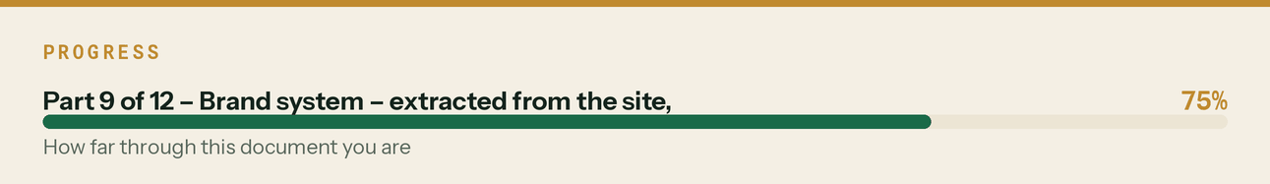

Third pass — the brand was wrong, and is now right

I built the first two passes from the Build Manual's written direction — "navy, graphite and safety orange" — instead of extracting the tokens from the live site. That was my mistake and it ran through every asset.
Everything has been rebuilt from klyara.com's own :root block and its own embedded fonts:
- Colour is warm bone paper, deep pine, brass, emerald and terracotta. No navy anywhere.
- Type is Bricolage Grotesque, Instrument Sans and Spline Sans Mono. I extracted the woff2 files
from your HTML and converted them to static TTF, so every asset renders in *your* fonts.
- The mark is your angular K polygon, not a typeset letter — bare in bone, or in a brass disc.
- The wordmark is sentence-case Klyara on screen, KLYARA in print headers.
- Headlines end with a full stop, as they do everywhere on your site.
- The PDFs now follow your guide's actual architecture: pine cover with brass rule, paper
interiors with a pine header band, mono chapter kicker, ghosted numeral, brass rule, mono footer.
One constraint discovered along the way: your embedded fonts are 108-glyph subsets. Em dashes, ticks, crosses and warning symbols do not exist in them and render as blank gaps. Every generator now routes text through a substitution function, so it cannot recur.
Also new this pass: the Guildford & Surrey local pack (docs/11) and the client onboarding runbook (docs/12), plus a partner-accountant one-pager PDF for the twenty-firm outreach.
The line that matters
Also new this pass: the Guildford & Surrey local pack (docs/11) and the client onboarding runbook (docs/12), plus a partner-accountant one-pager PDF for the twenty-firm outreach.

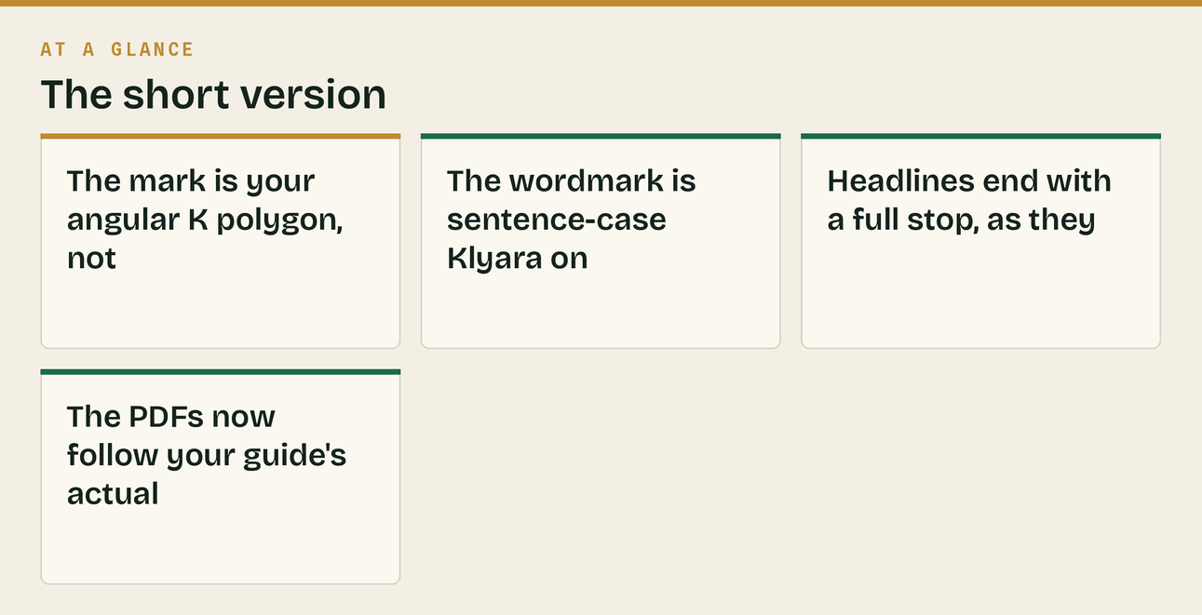
Also worth knowing
I built the first two passes from the Build Manual's written direction — "navy, graphite and safety orange" — instead of extracting the tokens from the live site.

The one number to hold me to

Everything in this pack exists to produce discovery calls. Not followers, not impressions.
Target by month 3: 8–12 booked calls a month at under £40 each. If the pack isn't producing that by December, the channel mix is wrong and you should cut the bottom half of the channel map rather than working harder at all of it.
The line that matters
If the pack isn't producing that by December, the channel mix is wrong and you should cut the bottom half of the channel map rather than working harder at all of it.

Also worth knowing
Target by month 3: 8–12 booked calls a month at under £40 each.

Added after the first pass

Two things I flagged as gaps in docs/06 and then built rather than leaving on a list.
klyara-30day-schedule.csv — the whole calendar as 81 dated rows: day, date, weekday, week, channel, post, asset filename, pre-built UTM, notes, and a blank Status column. Import it into a scheduler or work down it as a checklist. It's the operational form of docs/03.
assets/lead-magnets/Klyara-Contractors-CIS-Compliance-Pack.pdf — an 11-page branded guide, print-ready.
That second one exists because of a real gap: your two current lead magnets (the MTD guide and the Launch Kit) both speak to solo operators. Your highest-value client — the 5–15-person firm on Trade or Pro at £199–£329 — had no magnet aimed at them at all. This one is written entirely for the contractor side: deemed contractor rules, verification, the three rates, what CIS comes off, four worked examples, statements, the monthly return and nil-return trap, the penalty ladder, gross payment status, a printable new-subcontractor checklist and the 2026/27 CIS calendar.
Put it behind a form on a new /cis-pack.html page and point the CIS ad group at it instead of the services page. It targets the tier that pays five times more than Solo does.
*Note on typography: the PDF is set in Open Sans rather than Inter — Inter ships as OTF and ReportLab needs TrueType. It's close in feel and it's a real embedded font, so the text stays selectable and searchable. If you want exact brand consistency later, convert Inter to TTF and swap the two font paths at the top of brand/gen_leadmagnet.py.*
The line that matters
That second one exists because of a real gap: your two current lead magnets (the MTD guide and the Launch Kit) both speak to solo operators.


Also worth knowing
*Note on typography: the PDF is set in Open Sans rather than Inter — Inter ships as OTF and ReportLab needs TrueType.

