KLYARA the back office for building firms

Start here
Everything Klyara needs to launch, and what happens on the morning of Tuesday 1 September 2026.

Craig - this is the map. Ten minutes, and you will know where everything is, what to read, and what the two of you do on the first morning.
Nothing in this pack is scheduled for you or Key before Tuesday 1 September. Everything downstream of that date has been sequenced from it.

The one thing that matters most on the 1st
Apply for the ICB practice licence that morning. It takes about 28 days and it is the thing that lets Klyara lawfully take a bookkeeping client. Apply on the 1st and supervision lands around 29 September - a fortnight after launch. Apply two weeks late and it lands in the middle of it.

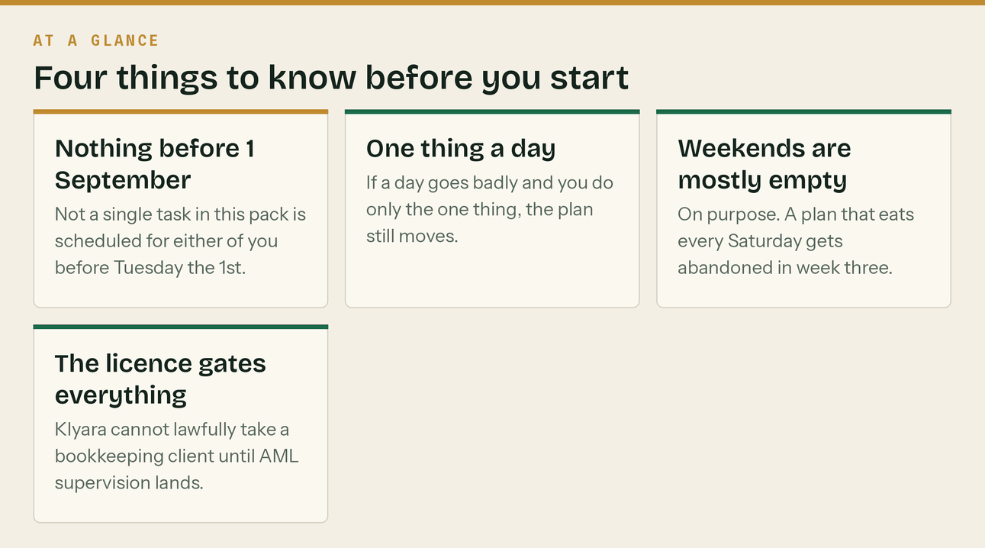

What is in each folder

Nine folders, numbered in the order you are likely to want them. Every document that started life as a plain-text file has a Word version and a PDF, so nothing needs a special program to open.
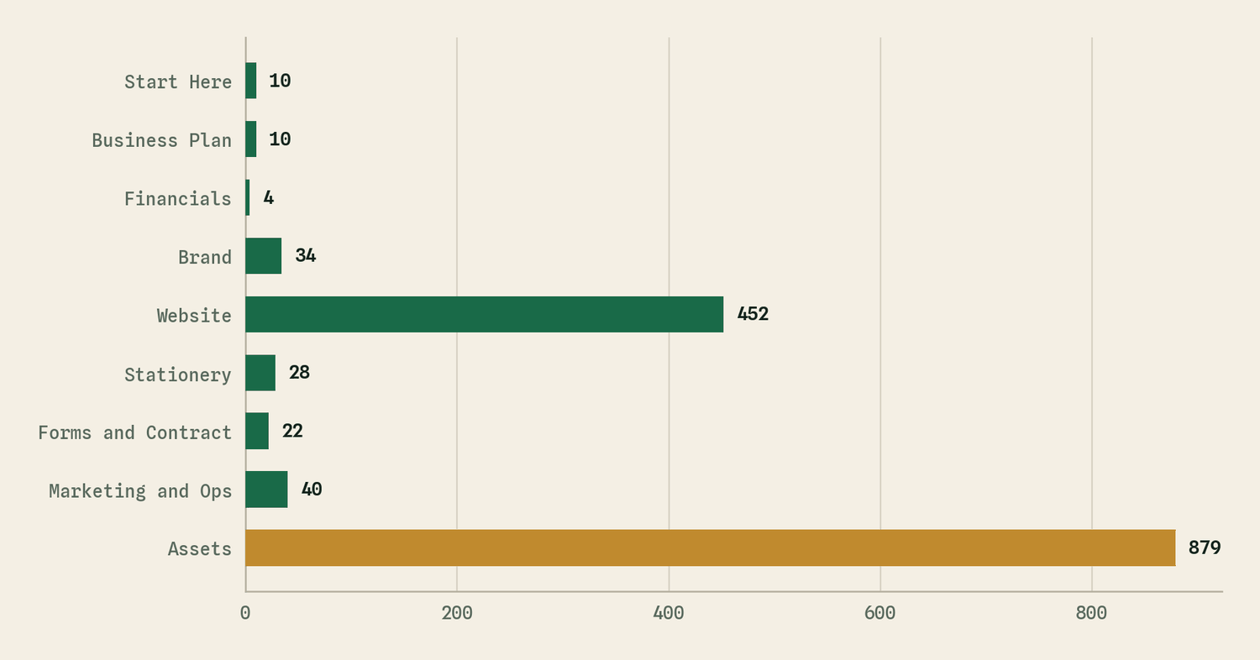
Number of files in each folder. The assets folder is the biggest and the least urgent.
Folder | What is in it | When | Files
01 Start Here | This file, the 90-day plan, the day-by-day plan, and the thirty decisions we need from you. | Read first | 10
02 Business Plan | The business plan, the market and competitor research, and the risk register. | Read second | 10
03 Financials | The financial model. A live Excel workbook - change the blue cells and everything else moves. | Read with a coffee | 4
04 Brand | Business cards, letterhead, compliment slips, envelopes, service sheets, the leaflet and the brand rules. | Send to a printer | 34
05 Website | The whole klyara.com site, including the hidden admin panel. | Hand to whoever hosts it | 452
06 Stationery | Invoice, receipt, purchase order, quote, credit note, statement, timesheet, expense claim, job sheet. | Use from day one | 28
07 Forms and Contracts | Engagement letter, terms, privacy notice, intake and onboarding forms, subcontractor and employment packs, complaints. | A solicitor reads these | 22
08 Marketing and Ops | Every marketing and operations document: content calendars, sales pack, onboarding, pricing, outreach, reviews. | Work through as you go | 40
09 Assets | Every image, video, chart, print file, font and the scripts that generated them. | Only if you are rebuilding something | 879

Both formats, everywhere
Where a document could sensibly be a Word file, it is one - editable, with real tables you can change. Every one of those also has a PDF beside it, so you can read it on a phone. The financial model is a real Excel workbook: change the blue cells and every other number moves.

What to read, and in what order

There are a lot of documents here. You do not need most of them in the first week.
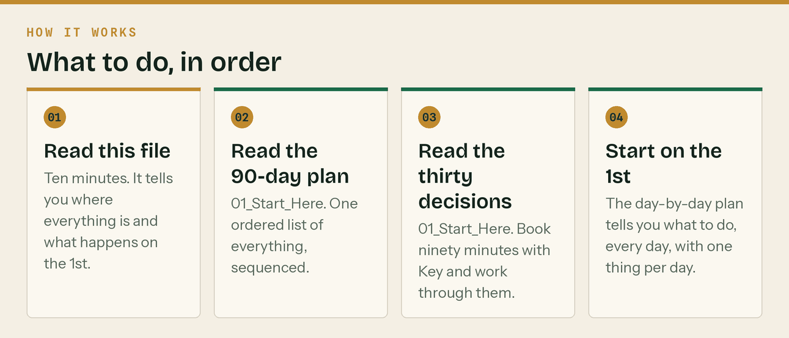
The four that actually matter first
Read | Where | Why | How long
The 90-day plan | 01_Start_Here | One ordered list. Everything sequenced, with owners and dependencies. | 20 min
The day-by-day plan | 01_Start_Here | Every day from 1 September to 12 December, with one thing per day. | Skim, then use daily
What we need from you | 01_Start_Here | Thirty decisions only you and Key can make. Book ninety minutes. | Before the session
The business plan | 02_Business_Plan | The whole case, with the market and competitor research behind it. | 45 min

Everything else is a reference. Pick it up when the plan tells you to.

The morning of Tuesday 1 September

Two hours, both of you, and it is the most valuable two hours in the whole ninety days - because two of the four items have a waiting period attached and everything else queues behind them.
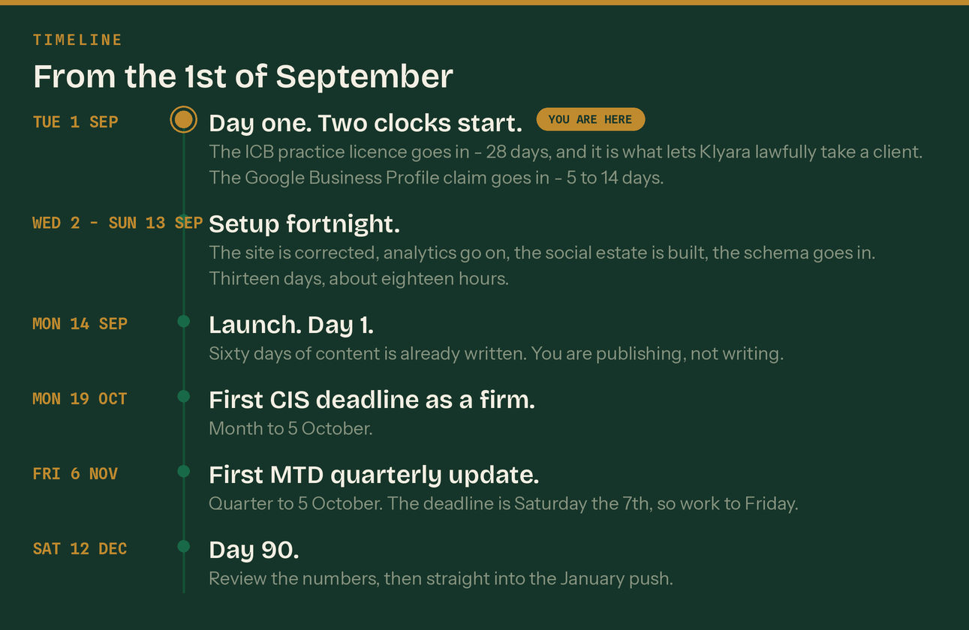
The running order
- Apply for the ICB practice licence. £94 application, then £373 to £406 a year (£206 licence plus £167 to £200 membership). It includes the anti-money-laundering supervision, which is the thing that lets Klyara take clients. Stated processing time is 28 days.
- Start the Google Business Profile claim. Verification takes 5 to 14 days and every local search result in the plan sits behind it.
- Write both dates on a wall. Every 'when can we take a client' decision keys off the licence date.
- Get professional indemnity insurance quotes. It is a condition of the licence, and ICB members get a discounted route.
- Sit down together for thirty minutes and read the thirty decisions. The sooner they are made, the less of this plan is guesswork.
What NOT to do on the first morning
Do not start posting. Do not start ringing builders. Do not take a client. Until the licence lands Klyara cannot lawfully carry on bookkeeping by way of business, and everything in this pack that sells the service is written for the day that changes. The content, the guides and the free tools are all fine to publish now - the 'we do your books for £X a month' half is not.

Where the project actually is

An honest read, so nobody starts on the 1st with the wrong idea.
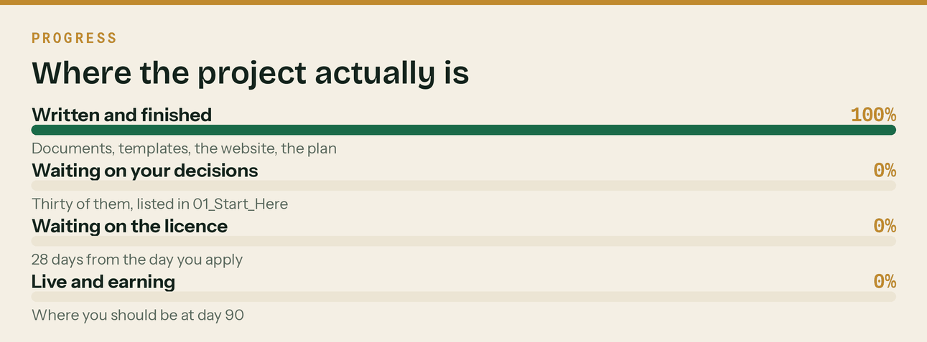
What is finished
- The website. Twenty new pages on top of the existing site, cross-linked, with a hidden admin panel.
- The plan. Every day from 1 September to 12 December, dated and written.
- The content. Sixty days of posts written out in full, a year of Google posts, twenty-four newsletters.
- The paperwork. Invoice, quote, receipt, purchase order, credit note, statement, timesheet, expense claim, job sheet.
- The contracts. Engagement letter, terms, privacy notice, subcontractor and employment packs. All flagged for a solicitor.
- The numbers. A working financial model with a P&L, cash flow, break-even and three scenarios.
What is not
- The licence. Not applied for. That is the first job on the 1st.
- The thirty decisions. Listed and waiting. Some of them block other work.
- The homepage testimonials. They are invented and they have to come down before anything else happens.
- A solicitor's eye on the contracts. They are working drafts, and they say so on the first page.
- Reviews. Klyara has none, and that is the single missing input for everything else.

How to use the admin panel

There is a hidden control panel built into the website. It shows the 90-day plan as a live timeline with a 'you are here' marker, the business plan, every document with a download button, and the compliance status board.
Step | What to do
1 | Open the website and go to the login page.
2 | Username klyara-admin. The password is in the README file in 05_Website.
3 | Any other username and password behaves like the normal client preview.
4 | Everything in the panel is view-and-download only. Editing happens on OneDrive.

It is a convenience gate, not a lock
This is a static website, so the login is a shortcut rather than real security. Anyone who looks at the page source can read the password. Nothing that would matter if it leaked should ever go in the panel.

If you only remember four things

One. The licence goes in on the morning of the 1st. Everything else waits on it.
Two. The testimonials come down before anything is published.
Three. One thing a day. The plan survives a bad week; it does not survive being abandoned.
Four. Ask every client for a review, from the first one. Twenty reviews is roughly twenty-five asks.

Everything in this pack was built and checked in August 2026. Figures were verified against gov.uk on the 26th and the sources are recorded in the market intelligence document. Rates and thresholds move - re-check them every April, and before any print run.

