KLYARA the back office for building firms

Klyara — The 90-Day Plan
One ordered list. Everything in the pack, sequenced, with owners and dependencies.

*Thirteen documents is a lot to hold in your head. This is the running order.*
Assume: launch Monday 14 September 2026, Guildford, AML supervision in progress. Owner column: K = Key, C = Craig, — = either.
The line that matters
Assume: launch Monday 14 September 2026, Guildford, AML supervision in progress.

In this part
One ordered list. Everything in the pack, sequenced, with owners and dependencies.

PHASE 0 — This week, before launch

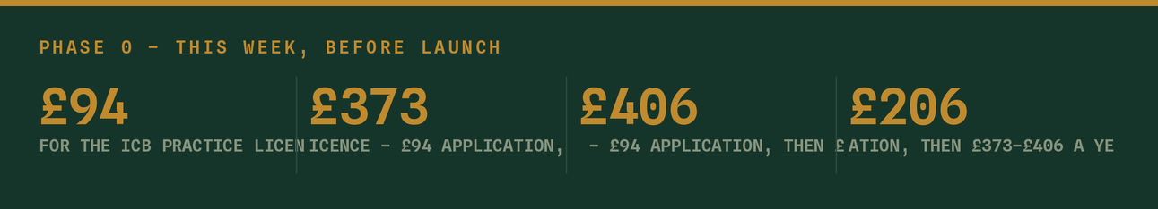
*Everything here is blocking. Nothing in Phase 1 works properly until these are done.*
# | Do | Owner | Doc | Why it's blocking
0 | Apply for the ICB Practice Licence — £94 application, then £373–£406 a year (£206 licence + £167–£200 membership), includes AML supervision, 28 days. Cheaper and faster than registering with HMRC direct (£300 + £400/premises, up to 45 days). See docs/17 §1. | C | 17 | 28-day wait; everything revenue-generating sits behind it
1 | Pull the homepage testimonials. Replace with the honest-new-firm block. | K | 07 | Legal and regulatory. Everything else is downstream of the site being defensible.
2 | Audit every other site claim for present-tense truth. Future-tense what isn't live. | K | 07 | Same reason
3 | Create social@klyara.com, into Bitwarden, 2FA on | — | 02 | Every signup runs through it
4 | Buy tryklyara.com | K | Build Manual §0.9 | Cold outreach must never use the main domain
5 | Start Google Business Profile verification | C | 11 | 5–14 day wait. Longest lead time in the whole plan.
6 | Paste the JSON-LD onto every page. Validate each in the Rich Results test. | K | 08 | Needs to be indexed before traffic arrives
7 | Install Meta Pixel, LinkedIn Insight Tag, GA4, Search Console | K | 06, 08 | The audience you don't collect from day one is gone permanently
8 | Publish the Guildford landing page | K | 11, web/ | The only page with buying intent behind it
9 | Add newsletter capture after every calculator result | K | 07 | Highest-intent capture point on the site, currently doing nothing
10 | Set up Brevo. SPF, DKIM, DMARC at p=none. Start the warm-up. | K | 05 | DNS propagation plus a 21-day ramp — start now or your first send lands in spam

Do 1, 3 and 5 today. The rest can spread across the week.

PHASE 1 — Week 1 (7–13 September)

Monday 7 — launch day
Do | Owner | Doc
Publish the Day 1 anchor post to LinkedIn (Craig's profile — pin it), Company Page, X, Facebook, Instagram | C | 03
First GBP post | C | 13 W1
Sign up: LinkedIn Company Page, Facebook Page, Instagram → Threads, X | — | 02
Rebuild Craig's personal LinkedIn — headline, About, banner, featured, creator mode on | C | 02

Rest of week 1
Do | Owner | Doc
Remaining platform signups: YouTube + playlists, TikTok, Reddit ×2, Bluesky (+ domain verify), Pinterest, Snapchat, Nextdoor | — | 02
Directory tier 1: Trustpilot, Yell, FreeIndex, Bing Places, Apple Business Connect | — | 02
Forum registrations — profiles only, no signature yet | C | 01
Request to join 12–15 Facebook groups | C | 01
Run the Day 2–7 content | C | 03
Reddit: read only. Post nothing. | C | 01
Newsletter #1 goes out Thursday 10th | K | 05

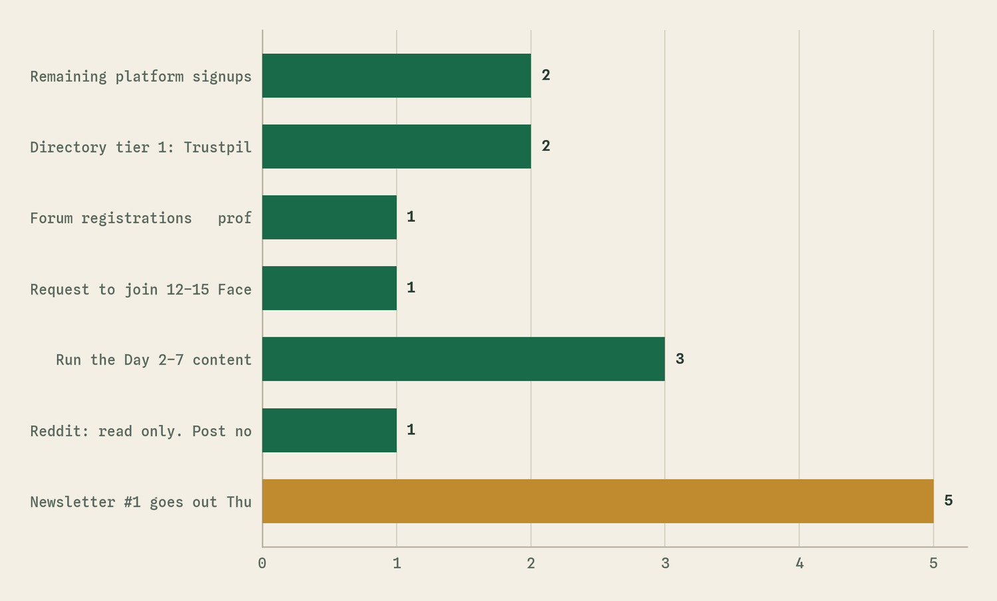
The same table as a picture. Newsletter #1 goes out Thu is the largest at 5.

PHASE 2 — Weeks 2–4 (14 September – 4 October)

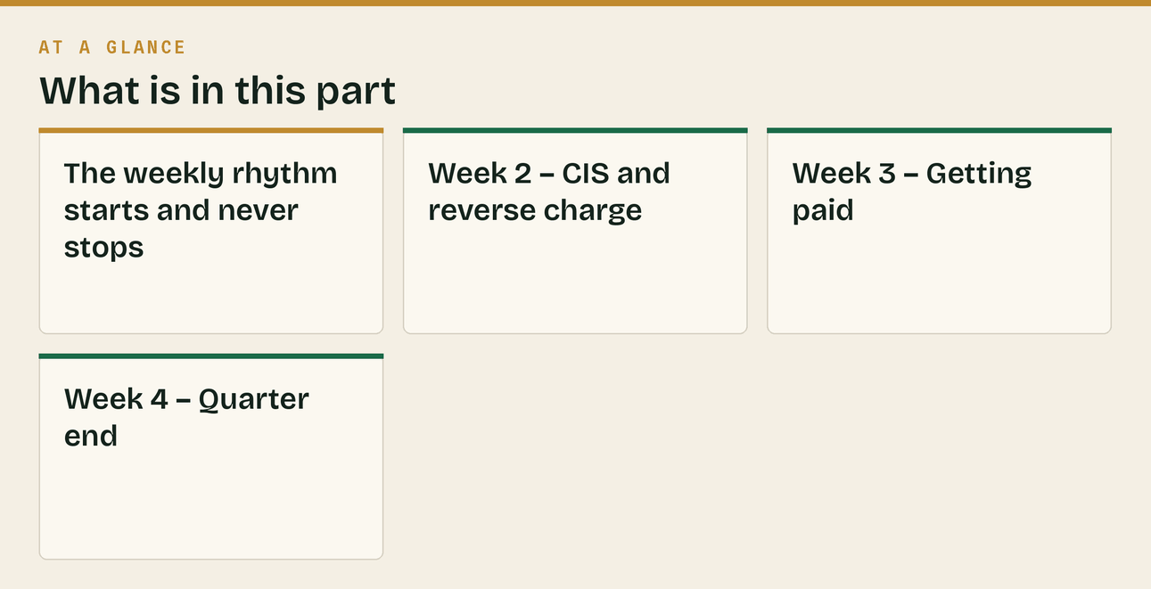
The weekly rhythm starts and never stops
Mon 07:30 Anchor post + GBP post + reply to weekend comments 30 min
Wed 17:30 One forum/Reddit contribution (no link) + group answers 30 min
Fri 16:00 Record a video, write next week's anchor, schedule 60 min
Week 2 — CIS and reverse charge
Do | Owner | Doc
Run Days 8–14 content | C | 03
Slyfield merchant round — Selco, Travis Perkins, Jewson, Howdens. Cards out, ask counter managers who's growing. | C | 11 §7
Print 250 A5 cards with the QR + UTM added first | K | assets/print/
Send 20 accountant partnership emails with the partner one-pager attached | C | 11 §8
Surrey citations: Chambers enquiry, Business Surrey, thebestof Guildford | — | 11 §6
Directory tier 2: Cylex, Scoot, Thomson Local, Hotfrog, 192.com | — | 02

Week 3 — Getting paid
Do | Owner | Doc
Run Days 15–21 content | C | 03
Publish Surrey + Woking town pages | K | web/
Newsletter #2, Thursday 24th | K | 05
Follow up every accountant who didn't reply. Once. | C | 11 §8
Forums: add signature once you've posted 8–10 genuine answers | C | 01
Second merchant lap — Woking, Godalming, Farnham | C | 11 §7

Week 4 — Quarter end
Do | Owner | Doc
Run Days 22–28 content — the seven-job checklist, one a day | C | 03
Publish Godalming + Farnham pages | K | web/
Publish the quarter-end checklist as its own page with HowTo schema | K | 08
Reddit: start commenting. Target 30–40 genuine comments over the next fortnight. No links. | C | 01
Draft the press release, hold it | K | 06 §5
Pitch 20 podcasts | C | 06 §6

In this part
The weekly rhythm starts and never stops · Week 2 — CIS and reverse charge · Week 3 — Getting paid · Week 4 — Quarter end

PHASE 3 — Month 2 (October)

Do | Owner | Doc
Days 29–30, then Month 2 themes: gross payment status, pricing, first employee, the 7 Nov countdown | C | 03
Buy Metricool — you now know which channels earn their slot | K | 06 §1
Newsletters #3 and #4 | K | 05
GBP posts W5–W8 | C | 13
Build the "which tier am I?" helper on the pricing page | K | 07
Cut homepage CTAs to one primary per section | K | 07
Per-page og:image from assets/posts/ | K | 07
Calculator page titles, metas and SoftwareApplication schema — all twelve | K | 08
Log the four numbers for the first time | K | 06 §3
Reddit: first text post, if the rules permit and karma allows | C | 01
Surrey Chambers event, or Guildford & Waverley Business Question Time | — | 11 §7

The moment AML supervision lands
Everything below is written and waiting. Do it the same week.
Do | Doc
Swap every HOLD CTA to the live version across site, ads, emails, calendar | 03, 05, 06
Turn Google Ads on — three ad groups, negatives loaded, £40/booked-call kill rule | 06 §4
Send the press release to Surrey Advertiser, Chambers, local outlets | 06 §5
Add the professional body and supervision line to the email signature | 05 §10
List on Find-a-ProAdvisor, Xero Advisor Directory, FreeAgent, the body's directory | 01, 11 §6
Open Bark.com if lead economics work | 01
Update the site's "qualified" claims to what is now true | 07

In this part
The moment AML supervision lands

PHASE 4 — Month 3 (November)

Do | Owner | Doc
Month 3 themes: year-end planning, capital allowances, the January hole, 31 Jan countdown | C | 03
7 November — the MTD deadline. Run a countdown. Newsletter #5 lands two days before. | C | 03, 05
Newsletters #5 and #6 | K | 05
GBP W9–W13 | C | 13
First clients onboarded — run the five-day runbook properly, every time | C | 12
Ask every client for a Google review at the first report handover | C | 06 §9
First case study agreed with client 1 | C | 06 §10
Review the four numbers. Kill or scale accordingly. | K | 06 §3

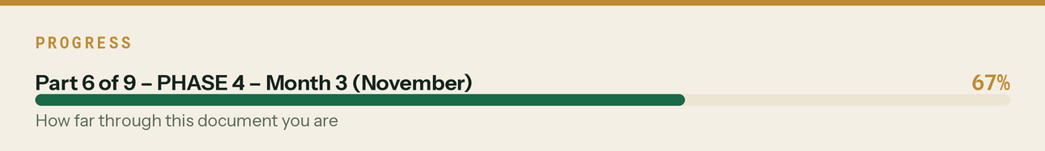

The decision gates

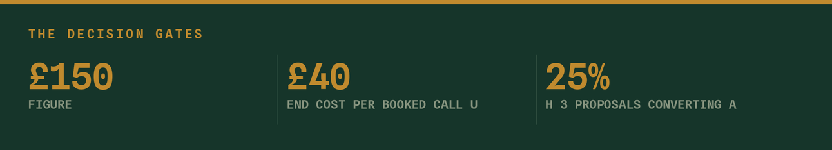
Don't carry on doing something that isn't working because it's in the plan.
When | Question | If no
End of week 2 | Is GBP verified? | Chase it. Nothing local works until it is, and it is the single most common launch failure.
End of month 1 | Four or more discovery calls from Guildford postcodes? | Almost always GBP verification. Check that before changing content.
£150 of ad spend | Cost per booked call under £40? | Pause ads. Organic, GBP and referrals cost nothing.
End of month 2 | Any accountant partnership conversations live? | Send 20 more. This channel is the fastest route to clients 1–5 and 20 emails is a small sample.
End of month 3 | 8–12 booked calls a month? | Cut the bottom half of the channel map and put those hours into the top half.
End of month 3 | Proposals converting above 25%? | Do not cut prices. Record three calls and listen to whether you're diagnosing or describing.
Any time | Are you doing more than 2 hours a week on social? | Either it's working and you hire, or you're overproducing for channels that aren't returning.

What good looks like at day 90

Google Business Profile verified, 12 weekly posts, 5+ real reviews
Website 5 local pages indexed, schema on everything, capture on the calculators
Email list 150–400 subscribers, 6 newsletters sent, above 35% open
LinkedIn 12 anchor posts, Craig's profile doing the work
Reddit / forums 40+ genuine contributions, account healthy, first links earned
Partnerships 20+ accountants contacted, 2–4 conversations, 1 referral arrangement
Merchants 250 cards out, 2 counter managers who know your name
Clients 3–5 onboarded, each live within 5 working days
Calls 8–12 booked per month, under £40 each
Case studies 1 agreed, 2 more diarised
If the only thing you achieve is GBP verified, the Guildford page live with schema, twenty accountant emails sent and the weekly rhythm actually running — that is a successful 90 days. Everything else compounds off those four.
The line that matters
If the only thing you achieve is GBP verified, the Guildford page live with schema, twenty accountant emails sent and the weekly rhythm actually running — that is a successful 90 days.


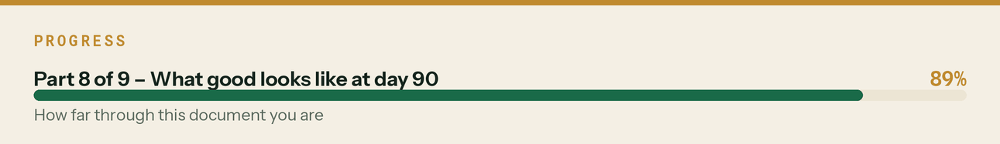

The honest risk list

Once, plainly, then it's your call.
- The testimonials. Until they're off, everything else is building on a liability.
- AML timing. The whole revenue plan sits behind it. If it slips past November the waitlist is the only thing keeping the pipeline warm — so keep publishing regardless.
- Craig is the whole product. Every channel here is fronted by one person. That's why it works, and it's also the single point of failure. The continuity arrangement isn't paperwork.
- Two founders, no signed agreement. Build Manual §0.3. Not marketing, but it kills more small firms than competition does, and marketing that works makes it more urgent, not less.
- Capacity arrives faster than hiring. Craig's ceiling is 20–25 full-service equivalents and the hire trigger is 15. Decide the waitlist policy before you need it.
- This pack assumes Guildford. If you end up trading from somewhere else, the local pack and the five web pages need the town swapped — the generator makes that a ten-minute job, but somebody has to remember to do it.
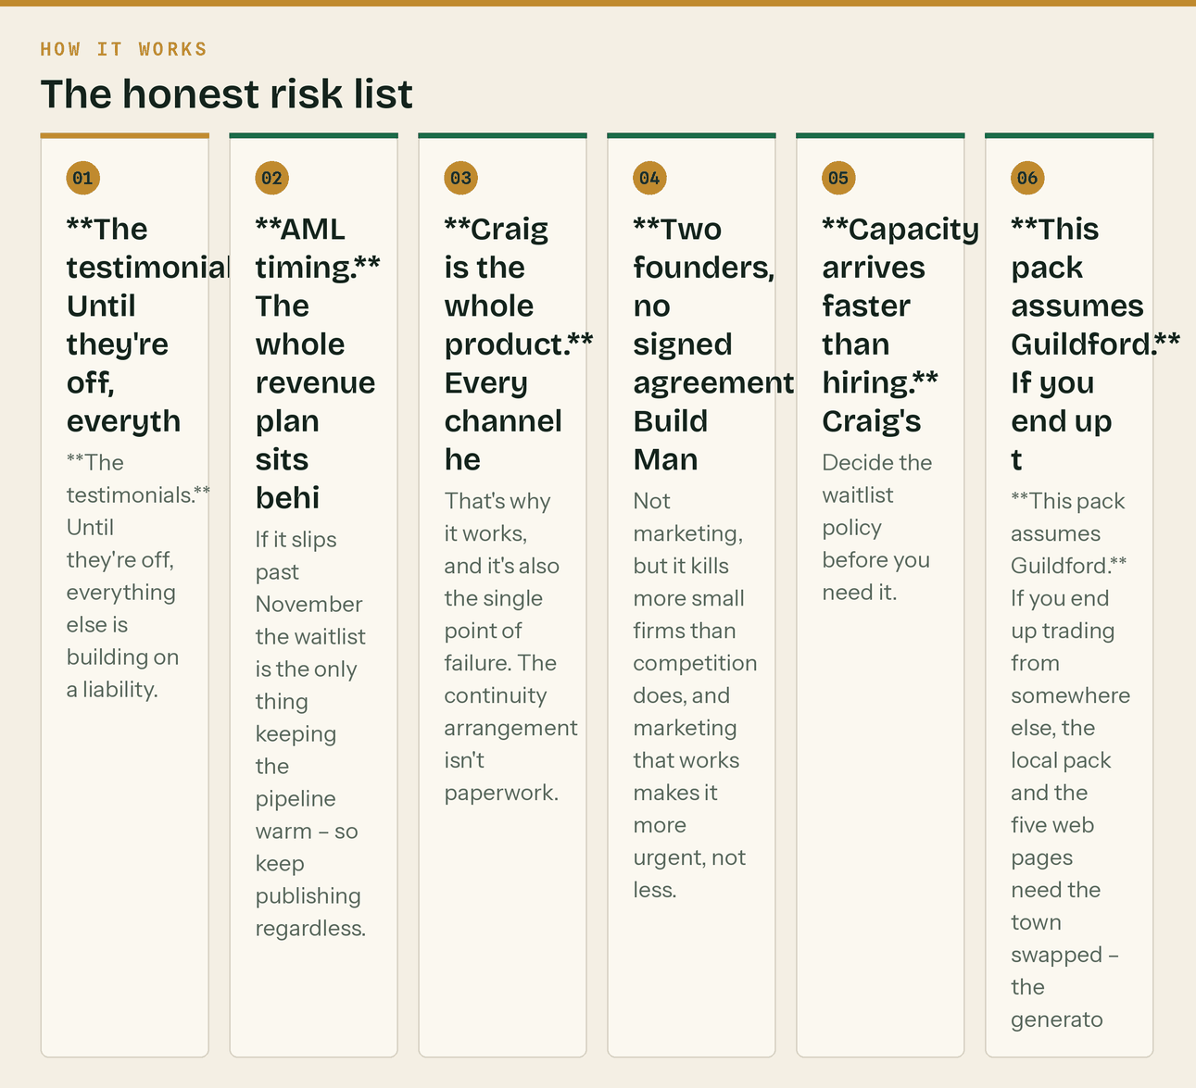
The same steps, in order.
Correction, 26 August 2026 — read this with the document above
- FAQPage and HowTo schema no longer produce rich results. FAQ rich results stopped appearing in
Google Search on 7 May 2026; HowTo was retired in September 2023. Keep the FAQ content and the markup, but move the effort to AccountingService, Organization, BreadcrumbList and Service. Full note in docs/08 §12.
- Google Business Profile posts no longer expire. Google stopped that in January 2021. Post
weekly anyway — only the newest shows prominently and a stale profile reads as abandoned.
- The verified figures live in docs/17 §8, checked against gov.uk on 26 August 2026. Never
publish a figure that is not in that table.
- Current inventory: 27 documents, 20 web pages, 180+ assets, 12 PDFs, 14 videos, one workbook.
Anywhere this document quotes a smaller count, it predates the later passes.
- Twelve calculators vs four tools: the twelve are the individual calculator pages already on
klyara.com; the four are the consolidated web/tools.html. docs/08 §12 explains which schema goes where.
- ICB cost: £94 application, then £373–£406 a year (£206 licence plus £167–£200 membership).
Anywhere this document says "£206 a year", it is quoting the licence only.
The line that matters
Keep the FAQ content and the markup, but move the effort to AccountingService, Organization, BreadcrumbList and Service.

In this part
Correction, 26 August 2026 — read this with the document above

