KLYARA the back office for building firms

Klyara — What I Need From You
The decisions I could not make alone, structured for one working session.

*Everything in this pack that could be built without you, has been. This is the remainder: 24 questions where guessing would have produced confident, plausible, wrong work.*
Format: grouped by session block, each with why it blocks things, what happens if we don't decide, and — where there is one — my recommendation so you can just say yes.
Time needed: about 105 minutes. Bring the Build Manual and your bank balance.
The line that matters
Format: grouped by session block, each with why it blocks things, what happens if we don't decide, and — where there is one — my recommendation so you can just say yes.

In this part
The decisions I could not make alone, structured for one working session.

BLOCK 1 — Facts I had to leave as placeholders (15 min)

These are blanks in shipped files. Everything works without them except the bits that don't.
# | I need | Where it's blocking | If we don't
1 | Registered trading address and postcode | Schema on all 5 web pages, GBP, every directory, email footer (PECR requires a postal address) | GBP can't be verified, schema is incomplete, newsletters are non-compliant
2 | Home-based or commercial premises? | Whether GBP is a service-area business or an address listing | Wrong GBP type is painful to change later
3 | Cal.com booking URL | [CAL_LINK] on 5 pages, every CTA, the email sequences | Every call-to-action in the pack is inert
4 | Craig's surname | Email signature, LinkedIn, proposals, press release | Signature ships as [SURNAME]
5 | Company incorporation date / founding date | foundingDate in schema | Minor, but it's a trust signal AI systems read
6 | Final social handle | Every profile, every doc that references it | Inconsistent handles across platforms is the one thing you can't undo cheaply
7 | Which towns are genuinely in the service radius | The pack assumes Guildford + 15 miles | Over-broad service areas get penalised by Google

The line that matters
Everything works without them except the bits that don't.

BLOCK 2 — The compliance chain (20 min)

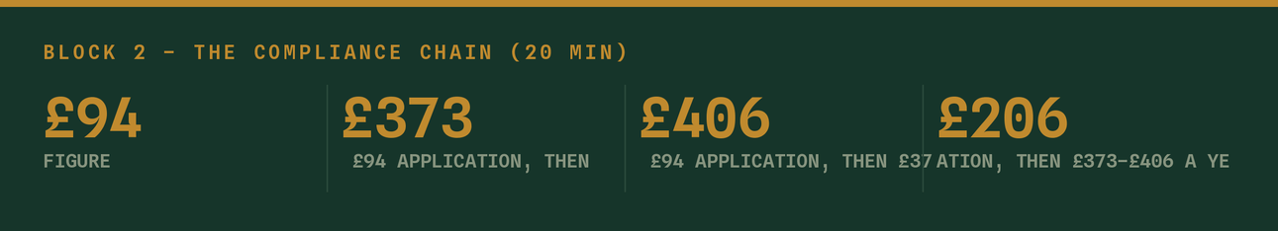
This block gates revenue. Nothing else in the plan matters until it's resolved.
8. ICB or AAT — which route?
My recommendation: ICB. £94 application, then £373–£406 a year (£206 licence + £167–£200 membership), AML supervision included, 28-day processing, plus a professional body, public directory, discounted PII and engagement letter templates. Registering with HMRC direct is £300 up front, £400 per premises annually, up to 45 days, and gets you supervision and nothing else.
But — it depends entirely on Craig's qualifications and which body he can join. That's the question. *(Detail and sources in docs/17 §1.)*
9. Has the application actually gone in, and on what date?
Every "when can we take clients" decision keys off this date. If it hasn't gone in, it goes in the day after our session.
10. What can Klyara legally do *today*, before supervision?
The pack assumes: education, waitlist, deposits no, bookkeeping by way of business no. I want that confirmed rather than assumed, because ~40 pieces of content are written in two versions and I need to know which one ships.
11. PII insurance — arranged, and at what cover level?
It's a condition of the ICB licence. Also the thing that lets you sleep.
12. Who is the AML-nominated officer, and is the firm-wide risk assessment written?
MLR 2017 requires both. docs/12 assumes they exist by client one.
13. Continuity arrangement — who covers if Craig is hit by a bus?
Required by most professional bodies, and it's also the answer to the single biggest risk in this whole business. The accountant partnership channel in docs/11 §8 is the natural place to solve it.
The line that matters
This block gates revenue. Nothing else in the plan matters until it's resolved.

In this part
8. ICB or AAT — which route? · 9. Has the application actually gone in, and on what date? · 10. What can Klyara legally do *today*, before supervision? · 11. PII insurance — arranged, and at what cover level? · 12. Who is the AML-nominated officer, and is the firm-wide risk assessment written? · 13. Continuity arrangement — who covers if Craig is hit by a bus?

BLOCK 3 — Money (20 min)


14. What is the actual monthly budget, and what's the runway?
The pack assumes roughly £180–245/month fixed cost plus ~£25 for a scheduler. I've held every recommendation inside that. If the real number is different, the plan changes — particularly ads.
15. Google Ads: how much, and when?
Currently written and paused. The £500 credit is a match offer — you spend ~£400 to get £500. My recommendation: don't switch on until AML lands, then £300/month with a hard £40/booked-call kill rule, reviewed at £150 spent.
16. Is the pricing final?
£59 / £99 / £199 / £329 plus onboarding. Neither Guildford construction-specialist competitor publishes pricing at all (docs/17 §5), so publishing yours is a real edge — but it also means there's no local benchmark. Worth one mystery-shop enquiry to see where £199 actually sits.
17. The founding rate — what exactly are you promising?
"First ten firms, rate held for twelve months from their start date" is in the content. That's a permanent discount on your first ten clients. Is that genuinely what you want? An alternative: rate held for 24 months, then standard. Say now, because it's in writing the moment we launch.
18. Late-records surcharge — £25 after the 10th. Will you actually charge it?
A surcharge you never apply is worse than none, because it teaches people the deadline is soft.
The line that matters
Neither Guildford construction-specialist competitor publishes pricing at all (docs/17 §5), so publishing yours is a real edge — but it also means there's no local benchmark.

In this part
14. What is the actual monthly budget, and what's the runway? · 15. Google Ads: how much, and when? · 16. Is the pricing final? · 17. The founding rate — what exactly are you promising? · 18. Late-records surcharge — £25 after the 10th. Will you actually charge it?

BLOCK 4 — The two founders (15 min)

19. Is there a signed founders' agreement?
Build Manual §0.3 flags it. It isn't marketing, and it kills more small firms than competition does. Marketing that works makes it *more* urgent, not less.
20. Who owns social? Name one person.
Two founders means it's nobody's job by default. The 2-hour weekly rhythm needs a name against it, in writing, or it stops in week four. I've written the plan assuming Craig fronts everything and Key does the build/technical — confirm or swap.
21. Who takes the discovery calls?
docs/09 assumes Craig. If it's both, the script needs to be run identically by both or the experience is inconsistent.
22. What happens at 15 clients?
The Build Manual puts Craig's ceiling at 20–25 and the hire trigger at 15. Marketing that works will hit that faster than hiring will. Decide the waitlist policy before you need it — it is much better to hold a founding-rate waitlist than to take on client 26 badly and lose client 4.
The line that matters
Decide the waitlist policy before you need it — it is much better to hold a founding-rate waitlist than to take on client 26 badly and lose client 4.

In this part
19. Is there a signed founders' agreement? · 20. Who owns social? Name one person. · 21. Who takes the discovery calls? · 22. What happens at 15 clients?

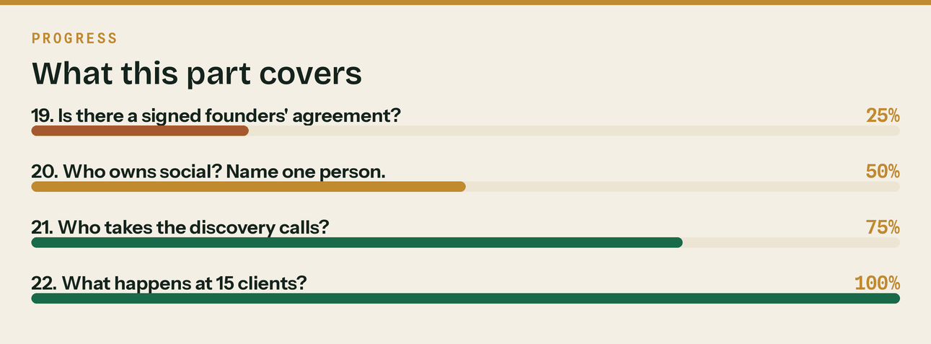
Read top to bottom. The bar is just how far through the part you are.

BLOCK 5 — Things only you can supply (15 min)

23. Photography
Every channel is currently running on rendered graphics. They're good, and they're not a substitute for a human. I need:
- A real headshot of Craig — on site, in a van, in hi-vis. Not a suit, not AI.
- 10–15 real photos: a desk with actual paperwork, a phone photographing a crumpled receipt on a van
dashboard, a Guildford site, hands, tools, a laptop on a workbench.
- This is the single biggest quality upgrade available to the pack and I can't make it.
24. The first three client conversations
Once you've had them, tell me what people actually said — the words they used for their own problems. Everything I've written is in my language, informed by the Build Manual and research. It should be in theirs. Six discovery calls in, the content should be rewritten from the transcripts.
The line that matters
Six discovery calls in, the content should be rewritten from the transcripts.

In this part
23. Photography · 24. The first three client conversations

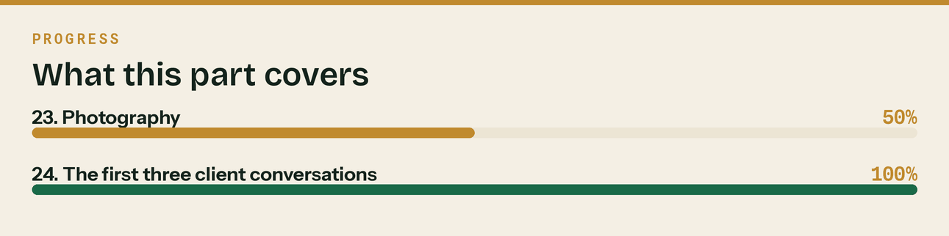
Read top to bottom. The bar is just how far through the part you are.

What I'll do the moment I have each answer

You give me | I build, same session
Address + postcode + Cal link | Fill every placeholder across 5 pages, all schema, all emails
ICB/AAT confirmation + date | The exact go-live sequence with dates, and the AML-landed switchover checklist
Photography | Rebuild the top 20 assets with real photos; new hero for every local page
Real client language | Rewrite the calendar, newsletters and answer bank in their words
Budget confirmation | A month-by-month spend plan against the KPI model
Pricing decision | Final proposal templates and the tier-selector logic for the pricing page

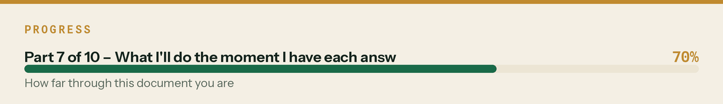

What I do NOT need from you

So you know where the boundary is — I'll keep building all of this without asking:
✓ All content, all channels, indefinitely ✓ SEO, schema, technical fixes
✓ All graphics, video, PDFs ✓ Landing pages and copy
✓ Email sequences and newsletters ✓ Competitor and market monitoring
✓ Community answers and posting plans ✓ Reporting, dashboards, analysis
✓ Sales collateral and scripts ✓ Process docs and runbooks
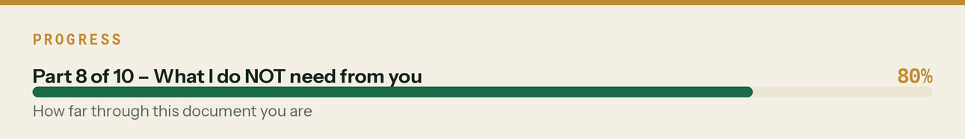

BLOCK 7 — Pricing decisions (added after the market benchmark)

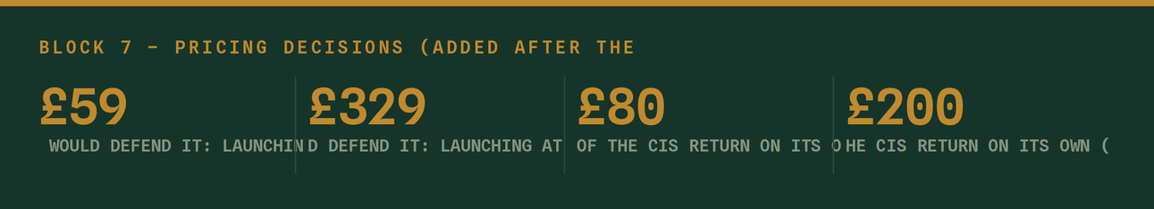
*Fifteen minutes. All six come out of docs/22, which put real published UK prices next to yours for the first time. Craig not needed for any of these.*
24b. Is 020 8058 1496 the right number for a Guildford business?
It appears seventy-one times across the pack and it has been treated as settled. It is a London number, and docs/22 names a Guildford phone number as one of the four things that beat the national competitor on local signals. A subcontractor in Cranleigh reading an 020 number does not think "London office", he thinks "call centre".
What I need: either confirmation that the 020 stays and why, or a 01483 number — at which point it is a global find-and-replace across the pack and about ten minutes of my time.
25. Do we hold the launch prices, or raise them now?
My recommendation is hold, and I would defend it: launching at £59–£329 with no reviews, no case studies and no licence displayed yet means price is currently doing a real job — it is buying the first ten clients, and those are worth more as proof than as revenue.
But the market data says Solo at £59 is below the published price of the CIS return on its own (£80–£200/month standalone, from £95 at the nearest specialist), and Trade at £199 is a third to two thirds under the direct comparator (£300–£500 for a contractor-with-subbies bundle).
What I need: a yes to hold, or a decision to move now. If we hold, I need agreement to 26 and 27, because without them the low price becomes permanent by default.
26. Can I add "founding client rate, held for twelve months" to every price we publish?
This is the single cheapest decision in the whole pack. It costs nothing today and it is what makes the increase in September 2027 a scheduled event rather than a confrontation. Without it, every client who joins in the next twelve months has an implied permanent price.
What I need: yes or no. If yes, it goes on the pricing page, the proposal template and the schedule of services this week.
27. Do you accept the September 2027 target prices?
Solo £89 · Start £149 · Trade £279 · Pro £449. Every one of those still sits under the published comparator, so the position stays *better value than the specialists* rather than *cheapest*.
What I need: agreement in principle, so the founding-rate wording has a number behind it. It can be revised in twelve months with real data — but the review date should go in the diary now.
28. What do we charge for the one-off services we are currently giving away?
The nearest specialist charges £400 for a gross payment status application, £250 for reverse charge setup and from £400 for a company formation. My proposal is £195, £125 and £150 respectively, with the first two included free on Trade and Pro.
The gross payment status one matters most: it is a defined piece of work worth roughly £24,000 of cash flow to the client, and it is an excellent first transaction with someone who is not ready to move their whole bookkeeping yet.
What I need: approval of the rate card in docs/21 §PART 2, or your changes to it.
29. Is 10% of the monthly fee, ongoing, the right partner commission?
On a Trade client that is £19.90 a month, £239 a year, for as long as they stay. An accountant with four builders sending all four is roughly £950 a year for work they did not want.
The alternative is a one-off finder's fee, which is cheaper and produces one referral instead of a partner who thinks about you in October. I think ongoing is clearly right, but it is your margin.
What I need: the rate confirmed, and agreement to the term that Klyara will not offer year-end accounts to an introduced client where the partner provides them. That term is what makes the whole programme sellable and it has to be real.
30. Who makes the outbound calls, and when?
docs/23 assumes twenty cold calls a week in two early-morning blocks, because builders answer at 7:30am and do not answer at 11am. That is the highest-yield hour in the plan and it is the first thing that gets skipped.
What I need: whose diary it goes in, and confirmation that 07:30–08:30 Monday and Wednesday is actually realistic for that person. If it is not, say so now and we will design around it rather than have it quietly not happen.
The line that matters
What I need: either confirmation that the 020 stays and why, or a 01483 number — at which point it is a global find-and-replace across the pack and about ten minutes of my time.

In this part
24b. Is 020 8058 1496 the right number for a Guildford business? · 25. Do we hold the launch prices, or raise them now? · 26. Can I add "founding client rate, held for twelve months" to every price we publish? · 27. Do you accept the September 2027 target prices? · 28. What do we charge for the one-off services we are currently giving away? · 29. Is 10% of the monthly fee, ongoing, the right partner commission?

Before the session — 10 minutes of prep

☐ Have the Build Manual open
☐ Know the bank balance and the monthly fixed cost
☐ Know whether the ICB/AAT application has gone in, and when
☐ Have Craig on the call for blocks 2 and 4 — I can't answer 8, 12, 13, 19 or 21 without him
☐ Read `docs/22` before block 7. It is fifteen minutes and it is the only document with real competitor prices in it.
☐ Take five photos on your phone before we start. Any five. It'll show you how easy it is.
And the one thing that shouldn't wait for the session: the homepage testimonials. That's not a decision, it's a fix, and it's in docs/07.
The line that matters
And the one thing that shouldn't wait for the session: the homepage testimonials.

Also worth knowing
That's not a decision, it's a fix, and it's in docs/07.

