KLYARA the back office for building firms

22 — Competitor and price benchmark
Real market data, gathered 26 August 2026. Every figure is sourced.

### Read this before using anything below
Klyara cannot trade as a bookkeeper by way of business until AML supervision is in place (docs/01, docs/06 §5). Everything in this document that offers, prices or sells the service is written for the day supervision lands. Before then, run the education-first and waitlist variants in docs/03 — the content, the guides and the free tools are all fine to publish now; the "we do your books for £X a month" half is not. Ask a client for a review only after you have lawfully done work for them. Delete this box on the day the licence arrives, and not before.

In this part
Real market data, gathered 26 August 2026. Every figure is sourced.

Why this document exists


Klyara's tiers — Solo £59, Start £99, Trade £199, Pro £329, all plus VAT — were set before anybody checked what the market actually charges. This document checks. It does three things:
- Puts Klyara's prices next to real published UK prices for the same work.
- Names who you are actually competing with in and around Guildford, and how they position.
- Says, plainly, what to do about it.
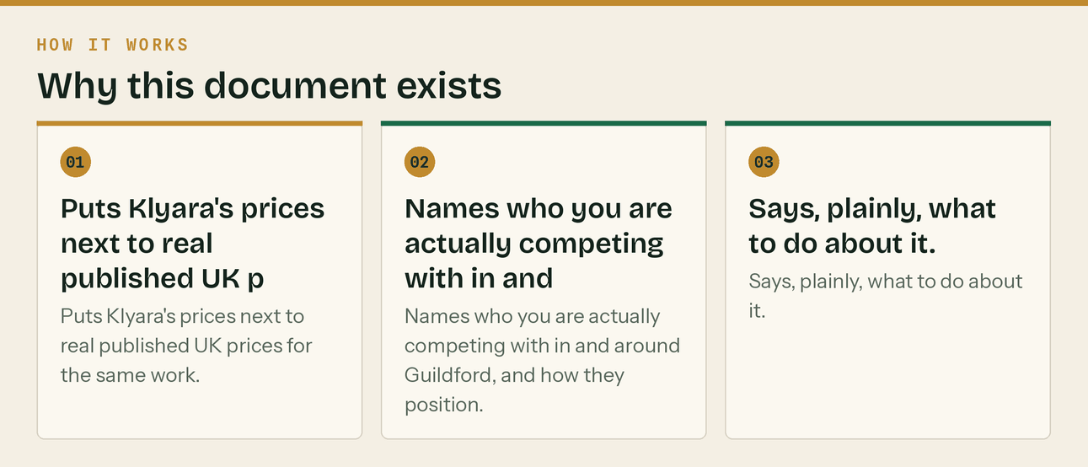
The same steps, in order.
Every figure below came off a live page on 26 August 2026 and the URL is given. Prices move. Re-run this in January 2027 — it is a two-hour job and Day 84 of the plan has a slot for it.

PART 1 — What the market charges


General UK bookkeeping, fixed monthly fee
Business size | Published monthly range | Source
Sole trader / freelancer | £100–£250 | A One Outsourcing
Sole trader, under 50 transactions | £100–£200 + VAT | Gro
Small business, up to 100 transactions | £250–£500 | A One Outsourcing
Small Ltd, 50–200 transactions | £200–£400 + VAT | Gro
Growing Ltd, 200–500 transactions | £400–£700 + VAT | Gro
Medium, 100–300 transactions | £500–£950+ | A One Outsourcing
Established Ltd, 500–1,000 transactions | £700–£1,200 + VAT | Gro

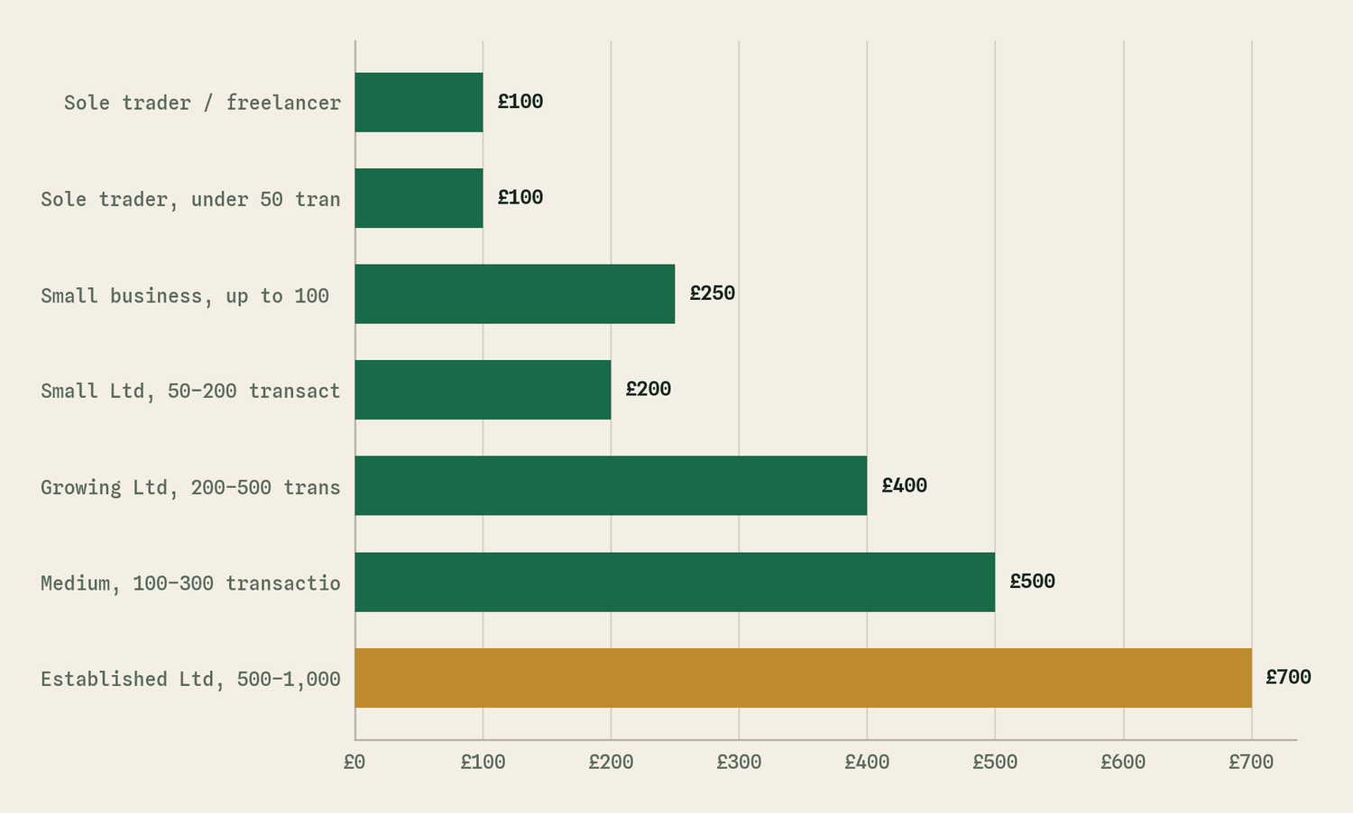
The same table as a picture. Established Ltd, 500–1,000 is the largest at £700.
Hourly, for comparison
Level | Rate | Source
Junior / unqualified | £18–£30/hr | A One Outsourcing · Gro
Qualified AAT or ICB | £30–£45/hr | A One Outsourcing · Gro
Xero-certified senior | £40–£50 + VAT/hr | Gro
South East regional average | £28–£50/hr | A One Outsourcing

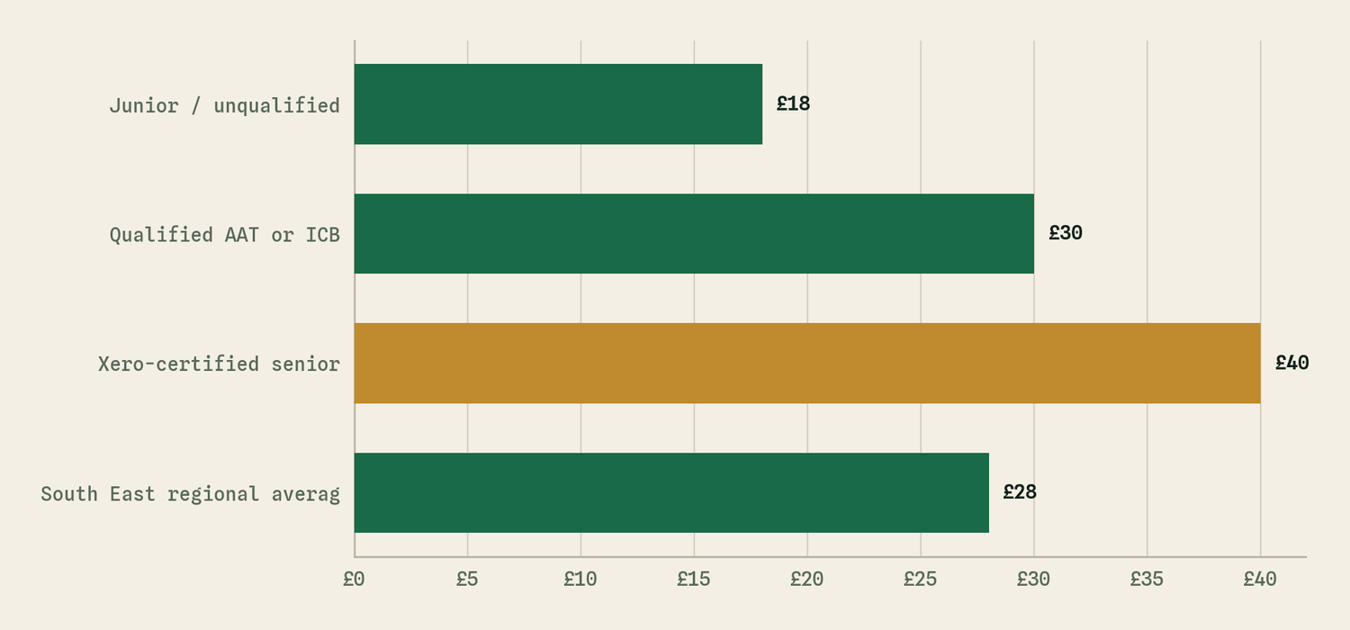
The same table as a picture. Xero-certified senior is the largest at £40.
Construction and CIS specifically — the important table
Item | Published price | Source
CIS premium over standard bookkeeping | 15–25% | A One Outsourcing
Monthly CIS return management, standalone | £80–£200/month | A One Outsourcing
CIS returns, per submission | £15–£30 | Gro
Monthly CIS returns | from £95/month | LOYALS
Light bookkeeping | from £125/month | LOYALS
Contractor with subcontractors, bundled | £300–£500/month | LOYALS
Multi-trade business, bundled | £600–£1,500/month | LOYALS
CIS subcontractor self assessment | £350/year fixed | LOYALS
Limited co, solo director | £1,200–£2,200/year | LOYALS
MTD for Income Tax | £150/quarter (£600/yr) | LOYALS
VAT returns | from £195/quarter | LOYALS
Gross payment status application | £400 one-off | LOYALS
Reverse charge VAT setup | £250 one-off | LOYALS
VAT returns, general market | £25–£150 per return | A One · Gro
Payroll, per employee | £4–£6 per payslip | Gro
Payroll, 1–10 employees | £20–£80/month | A One Outsourcing
Data migration / setup | £200–£800 | A One Outsourcing

Contractor accountants, monthly
Structure | Range | Source
Sole trader | £30–£70/month | Accounting Firms
Limited company | £95–£150/month | Accounting Firms
Complex (IR35, VAT schemes) | £150–£230+/month | Accounting Firms

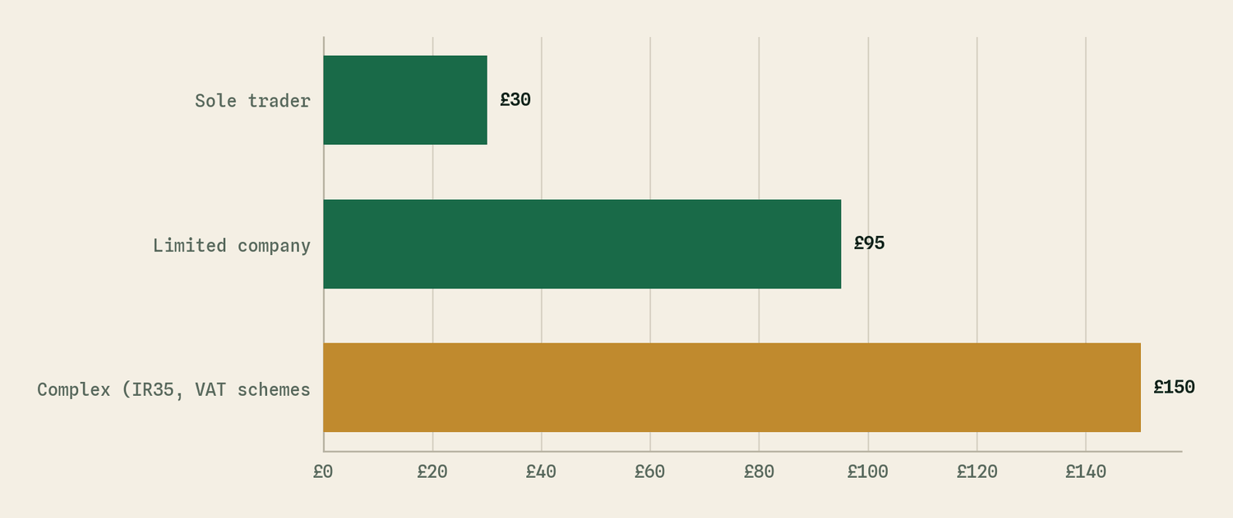
The same table as a picture. Complex (IR35, VAT schemes is the largest at £150.

PART 2 — Where Klyara sits

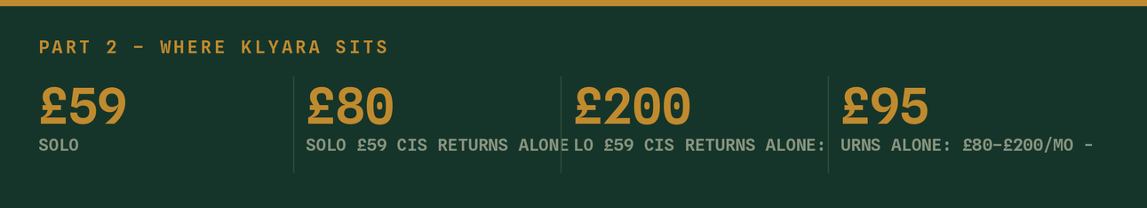
Klyara tier | Price + VAT | Nearest published comparator | Verdict
Solo | £59 | CIS returns alone: £80–£200/mo · from £95/mo | Below the price of the CIS return on its own
Start | £99 | Sole trader bookkeeping £100–£250 | Bottom of the range, before the CIS premium
Trade | £199 | Contractor-with-subbies bundle £300–£500 | £101–£301/month under the direct comparator
Pro | £329 | Multi-trade bundle £600–£1,500 | Roughly half the bottom of the range

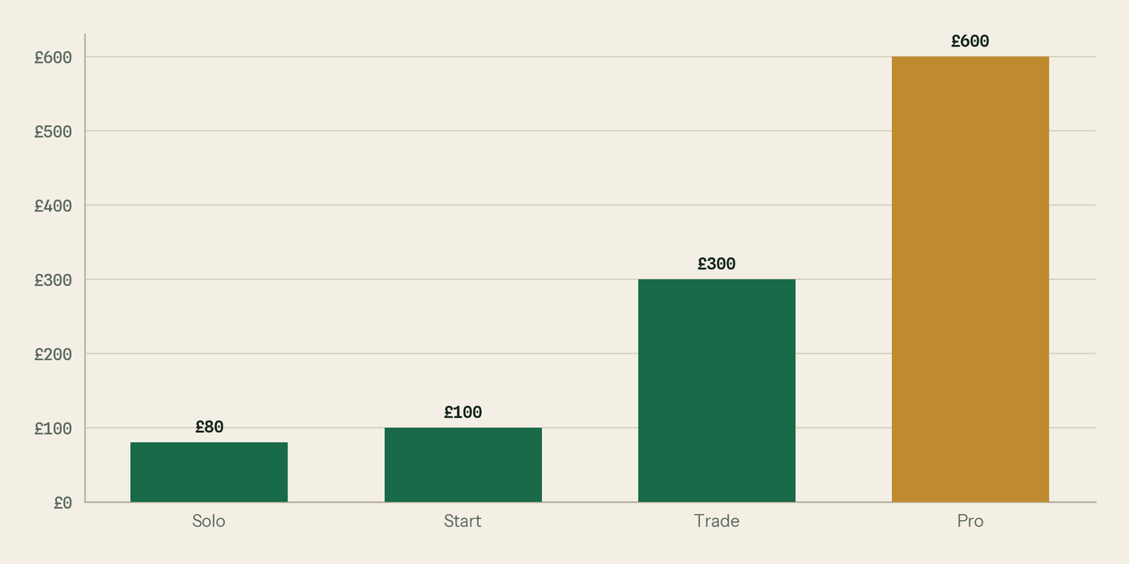
The same table as a picture. Pro is the largest at £600.
Three things fall out of that, and none of them are comfortable.
One. Solo at £59 is priced below the cost of the single service inside it. The cheapest published monthly CIS return management in this research is £95, and the general range starts at £80. Solo includes CIS returns *and* bookkeeping *and* the software *and* the statements. It is not a cheap tier; it is a loss leader, and it needs to be treated as one deliberately rather than accidentally.
Two. Trade is the tier that is most obviously mispriced. LOYALS publishes £300–£500 a month for exactly the client Trade is aimed at — a contractor paying subcontractors. Trade is £199. That is a discount of a third to two thirds against a firm that is not local, not in Surrey, and by its own description charges more because it is chartered.
Three. The bundle economics are on Klyara's side and are not being used. Bought separately at published rates, a Trade client's work — light bookkeeping (from £125) + CIS returns (from £95) + VAT quarterly (from £195/qtr, so £65/mo) — is £285/month before payroll, before MTD, before the year-end pack. Trade sells all of that for £199. The saving is real and it is roughly £86–£300 a month. Nobody is being told this number. It belongs on the pricing page, in the proposal, and in the third minute of every discovery call.
The Surrey adjustment
Two of the sources give a South East premium: hourly rates in the South East run £28–£50 against a £22–£42 Midlands and North West band. That is roughly a 20% regional uplift. Klyara is priced in Guildford — one of the more expensive towns in one of the more expensive counties — at national *floor* rates. There is no version of this where £59 reads as anything other than surprisingly cheap, and docs/11 already flagged that cheap in Surrey can read as unqualified.
The line that matters
One. Solo at £59 is priced below the cost of the single service inside it.

PART 3 — The recommendation


Do not change the launch prices. Change the framing, and put a dated increase in the diary.
The reasoning, in order.
Launching at £59–£329 with nothing to show — no reviews, no case studies, no track record, no licence yet displayed — is defensible. Price is doing a job right now: it is buying the first ten clients cheaply, and the first ten clients are worth more as proof than as revenue. Raising prices before you have a single Google review would be trading the one advantage you currently hold.
But three things have to be true or the low price becomes permanent:
- The price is stated as an introductory rate from day one. Not "our prices", but "founding client rate, held for twelve months from the date you join". The wording is in §Pricing language below. This costs nothing now and buys the entire increase later.
- The comparison number appears everywhere. "Bought separately, this work is £285 a month at published market rates" is the single most persuasive sentence available, and it is true and sourced. Cheap without a reference point reads as low quality. Cheap against a stated £285 reads as a good deal from someone who knows what they are doing.
- The increase is diarised now, not decided later. Review on 1 September 2027. Founding clients keep their rate to their twelve-month anniversary and then move to the standard rate, with sixty days' written notice. New clients from the review date pay the new rate.
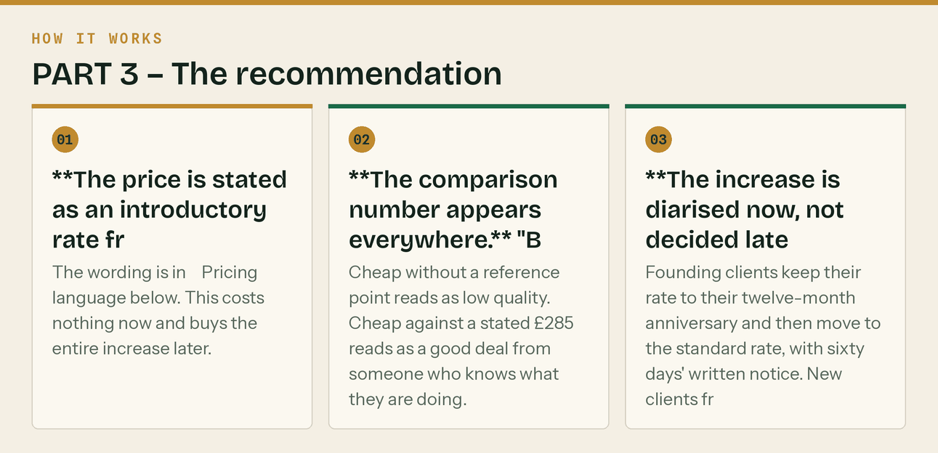
The same steps, in order.
The target prices at the September 2027 review
Set against the comparator, not against a percentage of the old price.
Tier | Now | Sept 2027 target | Comparator it should sit under
Solo | £59 | £89 | CIS returns alone, £95–£200
Start | £99 | £149 | Sole trader bookkeeping, £100–£250
Trade | £199 | £279 | Contractor bundle, £300–£500
Pro | £329 | £449 | Multi-trade bundle, £600–£1,500

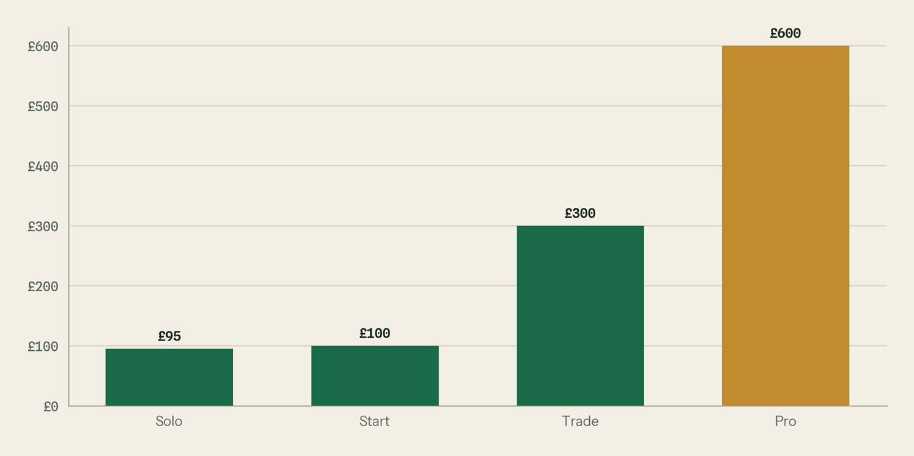
The same table as a picture. Pro is the largest at £600.
Every one of those still undercuts the published comparator. That is the point: the position is *better value than the specialists*, not *cheapest available*. Those are different businesses.
What the increase is actually worth — and what it can survive
Modelled in tools/Klyara-KPI-Tracker-and-Model.xlsx, on the Price scenario sheet. On the current tier mix (35% Solo, 25% Start, 30% Trade, 10% Pro) and twenty clients:
 | Founding rate | Target rate | Difference
Average monthly fee | £138 | £197 | +£59
MRR at 20 clients | £2,760 | £3,940 | +£1,180
Annual revenue | £33,120 | £47,280 | +£14,160
Uplift on the fee |  |  | 42.8%

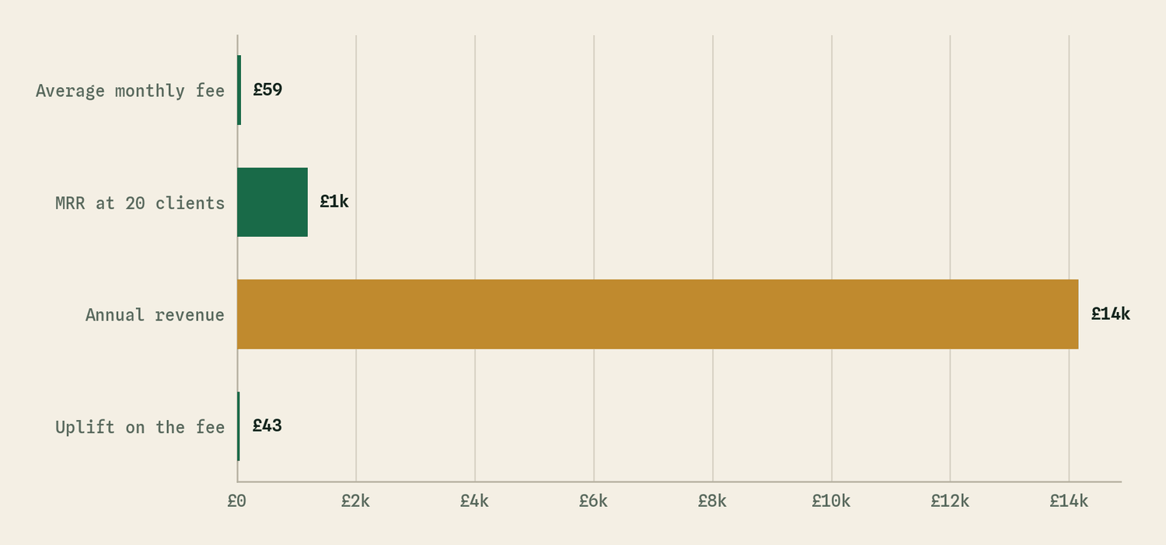
The same table as a picture. Annual revenue is the largest at £14,160.
And the number that actually settles the argument: you could lose five clients out of twenty over the increase and still be ahead. Break-even is 14.01 clients, so the sixth one takes you £2 a month below where you started — which is why the sentence says five. docs/21 targets 90% acceptance on a properly-notified increase, which would be two.
That asymmetry is why the founding-rate wording matters so much and why it costs nothing to add today. The downside of the increase is bounded at two clients. The upside is fourteen thousand pounds a year on a twenty-client book, and you have five clients of headroom before it even costs you anything.
Change the client count on that sheet to model it at whatever size the book actually reaches.
What to do this week
- Done. "Founding client rate" wording is on web/pricing.html, in the proposal PDF and in
the Schedule of Services. The £285 comparison is on the pricing page and in the proposal.
- Diarise the price review for 1 September 2027. This is the one thing on the list that still
needs a human to do it.
- Add the one-off services below to the price list. They are pure margin and everyone else charges
for them.
One-off services Klyara currently gives away
LOYALS charges for all three. Klyara should charge for at least the first two.
Service | LOYALS price | Suggested Klyara price
Gross payment status application | £400 | £195, or free on Trade and Pro
Reverse charge VAT setup | £250 | £125, or free at onboarding
Company formation | from £400 | £150, or refer it out
Catch-up / clean-up of a bad set of books | (setup £200–£800) | £45/hour, quoted after a look

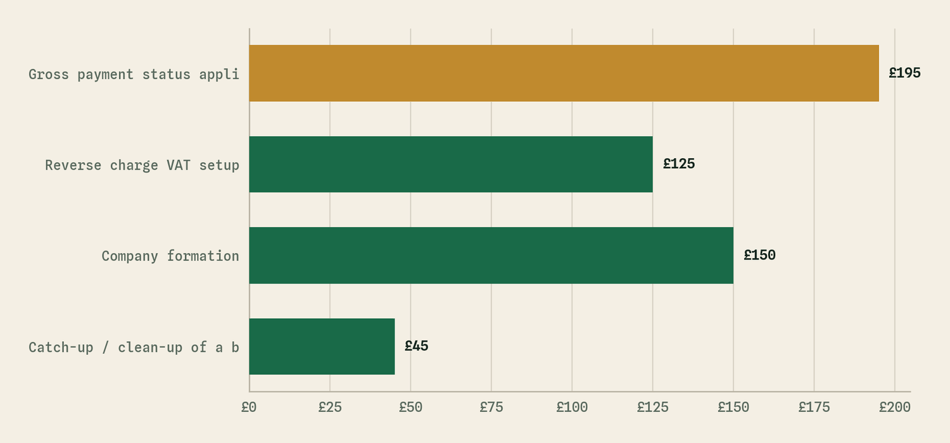
The same table as a picture. Gross payment status appli is the largest at £195.
The gross payment status application is the strongest of these. It is a defined piece of work with a number attached to it — docs/15 puts the value to the client at around £24,000 of cash flow — and £195 against £400 is an easy sell. It is also a superb first transaction with a client who is not ready to move their whole bookkeeping yet.

PART 4 — Who you are actually competing with in Guildford


Searched 26 August 2026 on "CIS bookkeeping construction accountant Guildford Surrey monthly fee". These are the firms that surface. This is the page one you are trying to get onto.
Firm | What they are | Publishes prices? | Notes
Accountant for Construction (Guildford page) | National site with a Guildford landing page | No — "free no obligation quote" | Claims "the go-to experts" and "leading provider". Two five-star testimonials on the page. Construction-only positioning, same as Klyara. This is the closest competitor.
Graham Barnes Accountant | Local Guildford accountant with a builders page | No | Generalist with a construction page
Castle Accounts | "Accountants For Builders Guildford — Low Cost Fixed Fees" | Page blocked automated access | Competing explicitly on low fixed fees. Worth a manual look.
CloudCo Books | CIS tax return service, Guildford page | No | Return-only, not a back office
Guildford Accounting | CIS accountants service page | No
Buttmiller, Treetops, AccFirm | General Guildford / Surrey accountants | No | Not construction specialists
Blue Matrix | Guildford bookkeeping, construction listed as a sector, Xero Gold Partner | A headline figure only | Advertises "from as little as £35 per month" plus VAT, with no tiers, no transaction limits and no statement of what is in it. CIS is not mentioned on the Guildford page at all.
dns accountants | National, Guildford landing page | No | High domain authority. Will outrank you on generic terms.
David Howard | Surrey, construction and property sector page | No | Established local practice
Ordinem Finance | Construction accountants, builders and contractors | No
LOYALS | London construction and CIS accountants | Yes, in detail | Not local, but the price benchmark

The four things this tells you
Almost nobody publishes a real price. Of the thirteen firms in the table above, exactly one published a full price list and it was the London one. One local firm — Blue Matrix — publishes a headline "from as little as £35 per month", with no tiers, no scope and no mention of CIS. Everyone else makes you fill in a form.
That is still the gap, and it is a large one: a subcontractor at 7pm wants to know whether this costs £80 or £800 before he gives anybody his phone number. But the claim has to be worded honestly, because "nobody round here publishes prices" is not quite true and a competitor could say so. The accurate line, and the one now on web/pricing.html, is:
Almost none of them publish anything — you fill in a form and wait. Th
number shows "from" and nothing behind it.

The £35 headline needs an answer, and it is not "we are worth more". It is three questions, which are now a published FAQ on the pricing page: is that a "from" price with the real quote arriving after you hand over your number; are the CIS returns in it or billed per submission at £15–£30 a time; and is the software subscription in the fee and in whose name. A genuinely cheaper bookkeeper exists. A cheaper-*looking* one is much more common, and those three questions separate them.
"Construction specialist" is a claim, not a moat. The nearest competitor uses the same words Klyara does. The difference has to be visible in thirty seconds, and the honest differences are: published prices, a named person who answers the phone, a Guildford address, and content that demonstrates the specialism rather than asserting it. Twelve guide pages, four working tools and a published price list do more work here than any strapline.
The nearest competitor is a national site with a town-name page. That is beatable on local signals — a real Google Business Profile with real reviews, a Guildford phone number, and pages that mention Woking, Godalming, Farnham and Cranleigh because you actually work there. It is not beatable on domain authority. Compete where you can win.
Testimonials on a competitor's page are two names and five stars. Klyara's homepage currently carries invented testimonials and that has to be fixed before launch — it is flagged in docs/20 as the highest-severity item and it is a banned practice under the DMCC Act 2024. The competitive point is that the bar here is *low*: two real, named, verifiable reviews would already match the firm currently ranking. There is no need for fifteen.
The line that matters
The £35 headline needs an answer, and it is not "we are worth more".

PART 5 — Pricing language


Copy these. They are written to be said out loud.
On the website, under the tiers
Founding client rate. Whatever you join on, that price is held for twe
date. Bought separately at published market rates, the work in Trade runs to about £285 a month — light bookkeeping from £125, monthly CIS returns from £95, VAT from £65. We do it all for £199.

When someone says it seems cheap
It is cheap, and there is a reason rather than a catch. We do one indu
learning your scheme on your time — the CIS work that takes a general practice half a day takes us twenty minutes because we do forty of them a month. And we are new. You are getting a founding rate because your review is worth more to us right now than the difference in fee.

When someone says another firm quoted less
Ask them two things. Is the CIS return in that price or billed per sub
time is normal. And is the software subscription in the fee or on top. Most of the cheap quotes in this trade are cheap because the CIS is extra, and CIS is the whole reason you are calling.

When someone asks why it is not free like their bank's app
Because the app does not ring HMRC to verify a subcontractor, does not
out before the deduction, and does not file anything on the 19th. It records what happened. We are the bit that makes sure the right thing happened.

At the twelve-month increase
Your founding rate runs to [date]. From [date + 60 days] you will move
£[x] a month. Everything in the service stays the same. If that does not work, tell me now and we will talk about the scope rather than have you leave over £40.

Sources

All accessed 26 August 2026.
- A One Outsourcing — How Much Does Bookkeeping Cost in the UK? 2026 Pricing Guide & Fees — https://www.aoneoutsourcing.uk/blog/how-much-does-bookkeeping-cost-in-the-uk
- Gro — How Much Does a Bookkeeper Cost UK? 2026 Fees Guide — https://wearegro.co.uk/blog/how-much-does-a-bookkeeper-cost-uk-2026-guide
- LOYALS — Construction Accountants London: CIS, Ltd Co, Trades — https://www.loyals.uk/industries/construction-cis-accountants
- Accounting Firms — Contractor Accountant Fees: How Much Should You Pay in 2026? — https://www.accountingfirms.co.uk/blog/contractor-accountant-fees/
- Accountant for Construction — Guildford — https://accountantforconstruction.co.uk/near-me/surrey-guildford/
- Castle Accounts — Guildford — https://castleaccounts.co.uk/guildford/ (returned 403 to automated access; check manually)
- Graham Barnes Accountant — Guildford — https://grahambarnesaccountant.co.uk/guildford/
- CloudCo Books — CIS Return Guildford — https://www.cloudcobooks.co.uk/cis-return-guildford/
- Guildford Accounting — CIS Accountants — https://guildfordaccounting.com/services/cis-accountants/
- HMRC — CIS 340, Construction Industry Scheme guide — https://www.gov.uk/government/publications/construction-industry-scheme-cis-340/construction-industry-scheme-a-guide-for-contractors-and-subcontractors-cis-340
- Blue Matrix — Bookkeeping services, Guildford — https://www.bluematrix.co.uk/bookkeeping-services-guildford-surrey/
- dns accountants — Accountants in Guildford — https://www.dnsassociates.co.uk/accountants-in-guildford
- David Howard — Construction, trades and property — https://www.davidhoward.co.uk/construction-trades-property
- Ordinem Finance — Construction accountants — https://www.ordinemfinance.co.uk/who-we-work-with/construction-accountants/
- Experi — CIS deduction calculator — https://www.experi.co.uk/tools/cis-deduction-calculator
- Other free CIS calculators surveyed: taxcalculate.co.uk, uktax.tools, complys.co.uk, quoteledger.co.uk, fastjobs.uk, toolfy.io, graftum.com
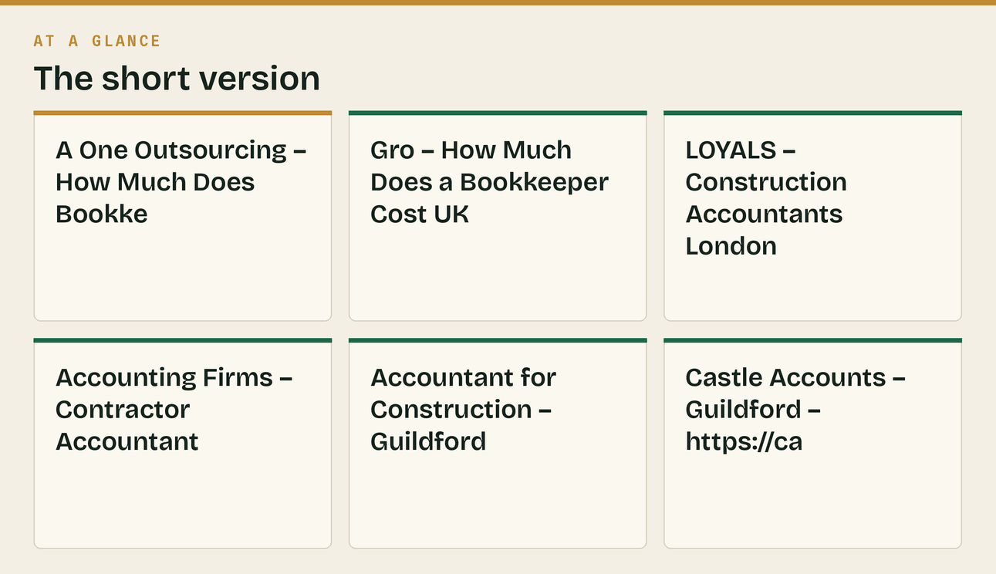
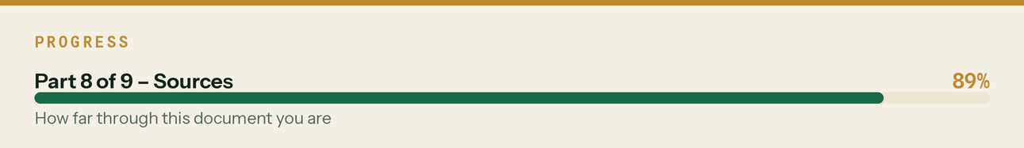

PART 6 — The free-tools landscape

Checked the same day, because web/tools.html was built on an assumption that turned out to be half wrong.
Searched: "best free CIS deduction calculator UK subcontractor labour materials".
At least eight free CIS calculators rank for this, including Experi, TaxCalculate, UK Tax Tools, Complys, QuoteLedger, Fastjobs, Toolfy and Graftum. Several handle the labour/materials split properly — Experi's, for instance, takes gross, labour and materials separately and states plainly that CIS applies to labour only. Most need no sign-up.
So "a free CIS calculator" is not a differentiator and the page should not claim it is. The copy has been corrected accordingly.
What is genuinely unusual is the set. None of those eight also answers *do I charge VAT on this invoice*, *what are my unfiled returns costing*, and *when does MTD start for me*. Those three questions, plus the MTD date, arrive in the same week for the same person, and having them on one page, from a firm that only does construction, is a defensible position in a way that a lone calculator is not.
What this means for the SEO plan. Do not target "CIS calculator" — it is saturated and the incumbents have years of links. Target the combinations and the intent nobody else serves:
Target instead | Why
"do I charge VAT on this invoice construction" | The reverse charge decision tool. Almost nothing serves this as a tool.
"how much are my late CIS returns costing" | The penalty estimator. Fear-driven, high intent, no competitor tool.
"am I in Making Tax Digital CIS subcontractor" | The gross-income trap. Already the highest-intent page in the set.
"CIS calculator Guildford / Surrey" | Local qualifier. The national tools do not compete locally.
"end user declaration template" | docs/08 already flags template pages as passive link earners.

Re-run date: January 2027. Prices in this market move annually and two of these sources re-publish their guides each year.
The line that matters
So "a free CIS calculator" is not a differentiator and the page should not claim it is.

Also worth knowing
Several handle the labour/materials split properly — Experi's, for instance, takes gross, labour and materials separately and states plainly that CIS applies to labour only.



