KLYARA the back office for building firms

Business Plan
Klyara Ltd · Guildford, Surrey · Written 1 September 2026 for launch on Monday 14 September 2026

Klyara is the back office for small construction firms. Bookkeeping, CIS, VAT and payroll. Construction only. Nothing else.
This plan is written to be read by Craig, by a bank, and by anyone Klyara asks for money or a partnership. It is the same document for all three, because there is nothing in it that changes depending on who is reading.
Read this before anything else
Klyara has no clients. Not one. It is not yet AML supervised, so it cannot lawfully carry on bookkeeping by way of business. The ICB practice licence application goes in on Tuesday 1 September 2026 and takes about 28 days. Every revenue figure in this document is a model, built from real market prices and stated assumptions. None of it is a result. A plan that pretends otherwise is worthless, and in front of a licence application it is dangerous.

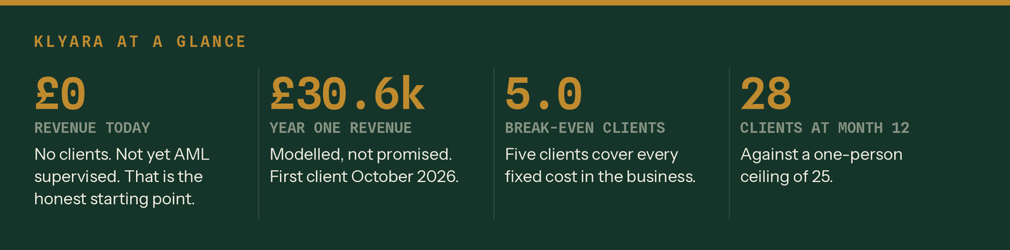
Four numbers, one of which is zero. Source: Klyara Financial Model.
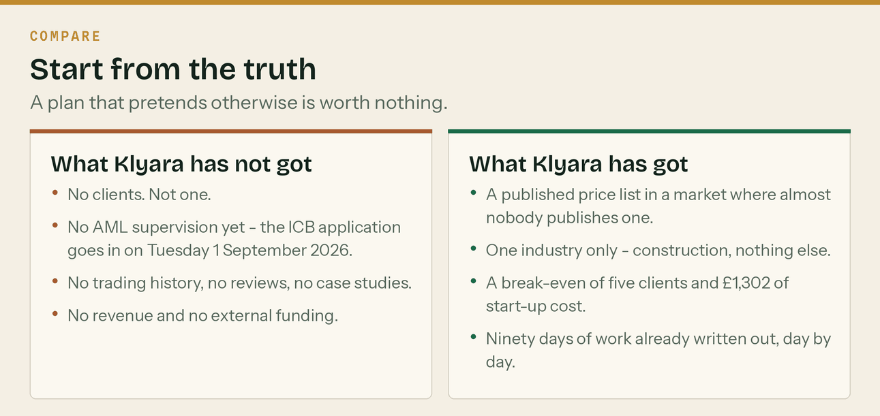
The honest position on the day the plan was written.
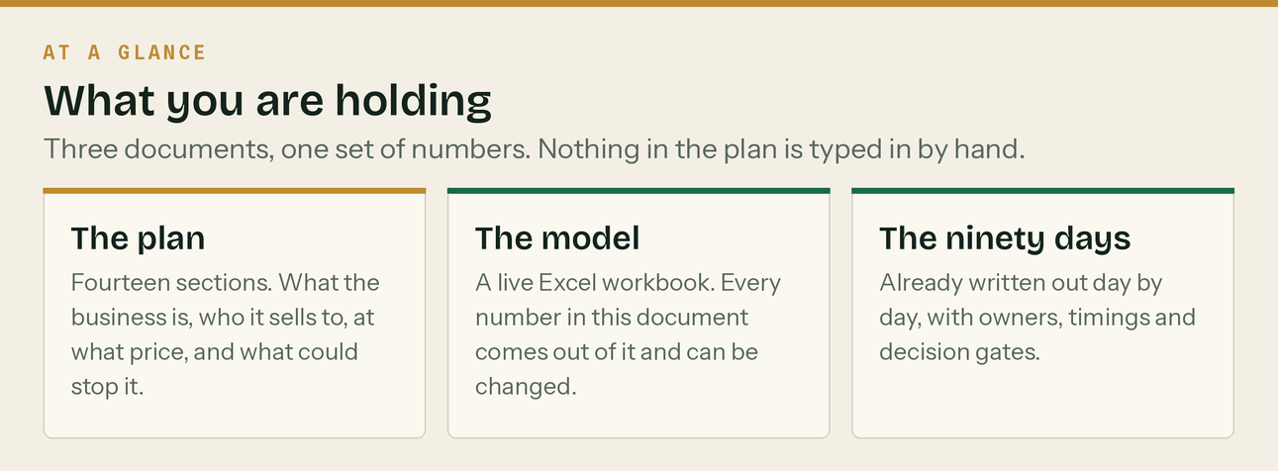
Three documents, one set of numbers.

1. Executive summary

Klyara does the books for builders. That is the whole business.
Small construction firms have an admin problem that is specific, repeating and expensive. The Construction Industry Scheme means a return every month, on the 19th, whether or not anyone got paid. VAT in construction runs on a reverse charge that most general bookkeepers apply wrongly in at least one direction. Making Tax Digital pulls another wave of sole traders into quarterly filing in April 2027. None of it is optional and all of it is fiddly.
The gap in the market is not competence. It is that almost nobody will tell you the price. Of thirteen firms that surface for construction bookkeeping around Guildford, one publishes a full price list and it is a London firm. One local firm shows a headline number with nothing behind it. Everyone else makes you fill in a form and wait.
Klyara publishes four prices, says what is in each, and works one industry.
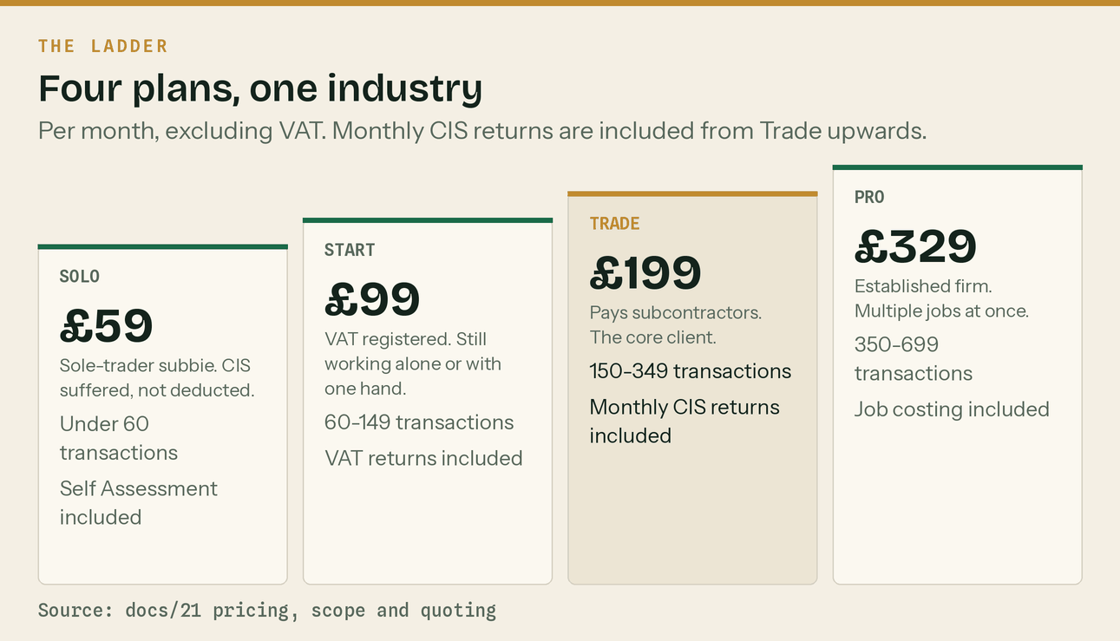
The four plans. Prices exclude VAT. Source: docs/21 pricing, scope and quoting.
What the plan says will happen
 | Year 1 | Year 2 | Year 3
Revenue | £30,562 | £102,020 | £169,575
Clients at year end | 28 | 50 | 75
Average monthly fee | £138 | £197 by the year end | £197
People | 1, then 2 from month 12 | 2 | 3
Profit before founder pay | £19,707 | £57,168 | £88,636

Year one revenue is £30,562 on twenty-eight clients. The business breaks even on five clients and needs £1,302 to start trading. Neither founder draws a salary in year one.
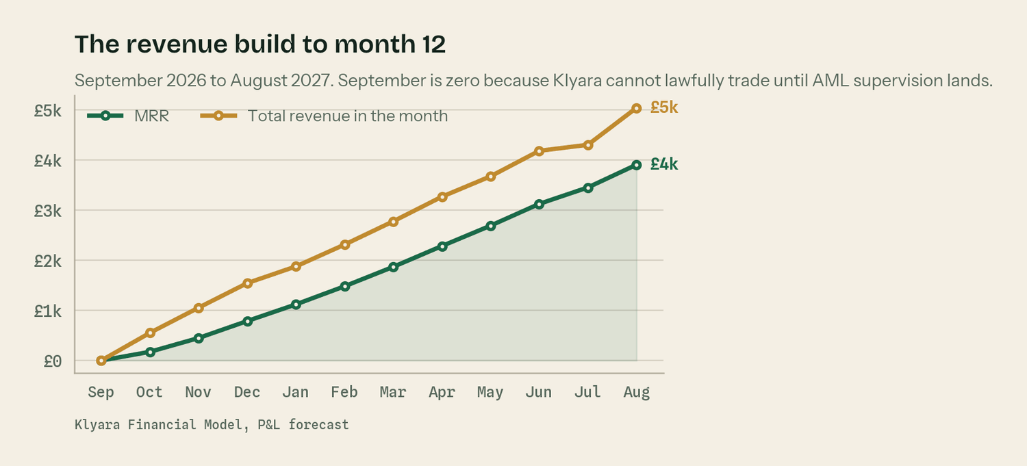
The revenue build. September 2026 is deliberately zero.
The six things this plan turns on
- Supervision first. Nothing revenue-generating happens until the ICB practice licence lands. Application Tuesday 1 September 2026, about 28 days, first client October 2026.
- Published prices. Four numbers on a page in a market where twelve of thirteen competitors hide them.
- Construction only. Every competitor has construction as a division. None of them can say it is all they do.
- A founding rate with a date on it. Whatever a client joins on is held for twelve months from their own start date, then it steps up. That sentence costs nothing today and is worth £14,160 a year at twenty clients.
- Trade is the tier the business is built around. £199 against a published comparator of £300 to £500.
- Reviews are the gap. 47% of buyers will not use a firm with under twenty reviews. Klyara has none.
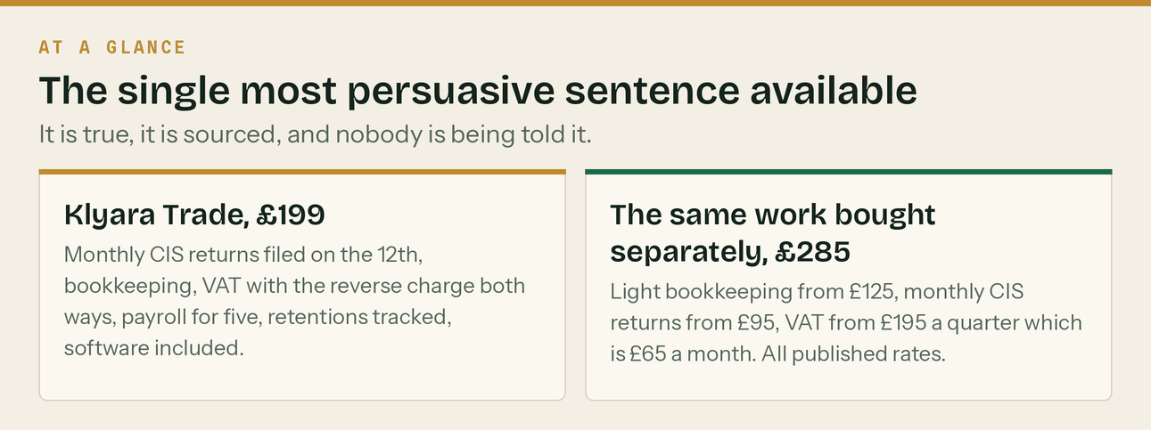
Trade against the same work bought separately, at published rates.
What could stop this
Four risks score 15 or higher on the register in section 11: the invented testimonials still on the website, AML supervision slipping past November, Craig being the entire product, and there being no signed founders' agreement. Three of the four are closed by paperwork and one is closed in ten minutes. None of them are market risks.

2. The problem, and why it is worth money

A builder's admin is not hard. It is relentless, and it lands on the worst day of the month.
The sequence every subcontractor lives in
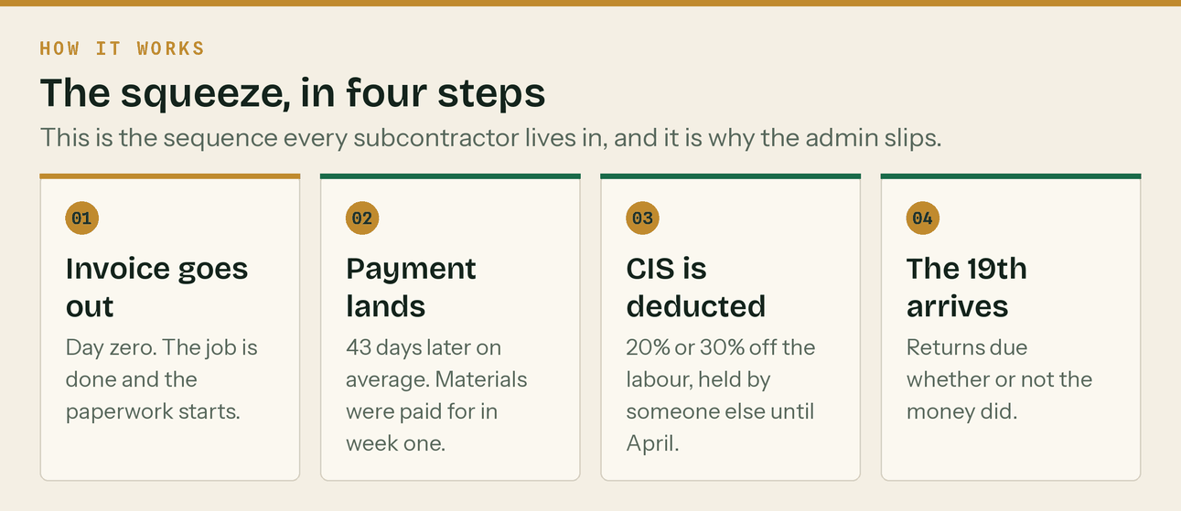
Four steps, and the money arrives last.
The average UK construction invoice is paid 43 days after it is issued. Materials were paid for in week one. CIS takes 20% or 30% off the labour and holds it until the tax return. 62% of small firms report cash flow difficulty from slow payment, and construction is consistently about 17% of every UK business failure — the highest of any sector.
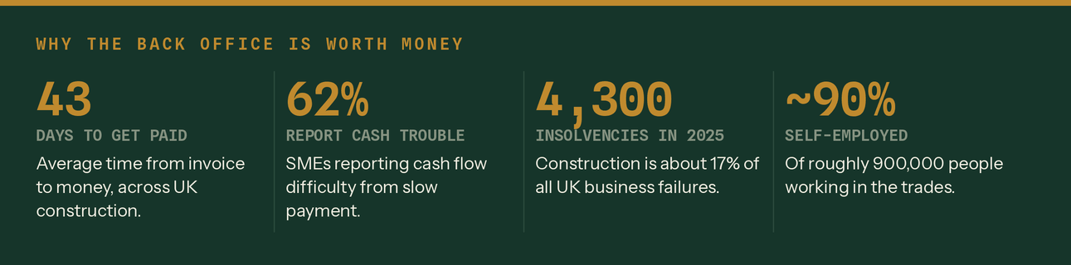
Source: ONS, Insolvency Service, Checkatrade, via docs/17 §2.
What it costs to get it wrong
The Construction Industry Scheme has a penalty ladder, and it is steep at the bottom.
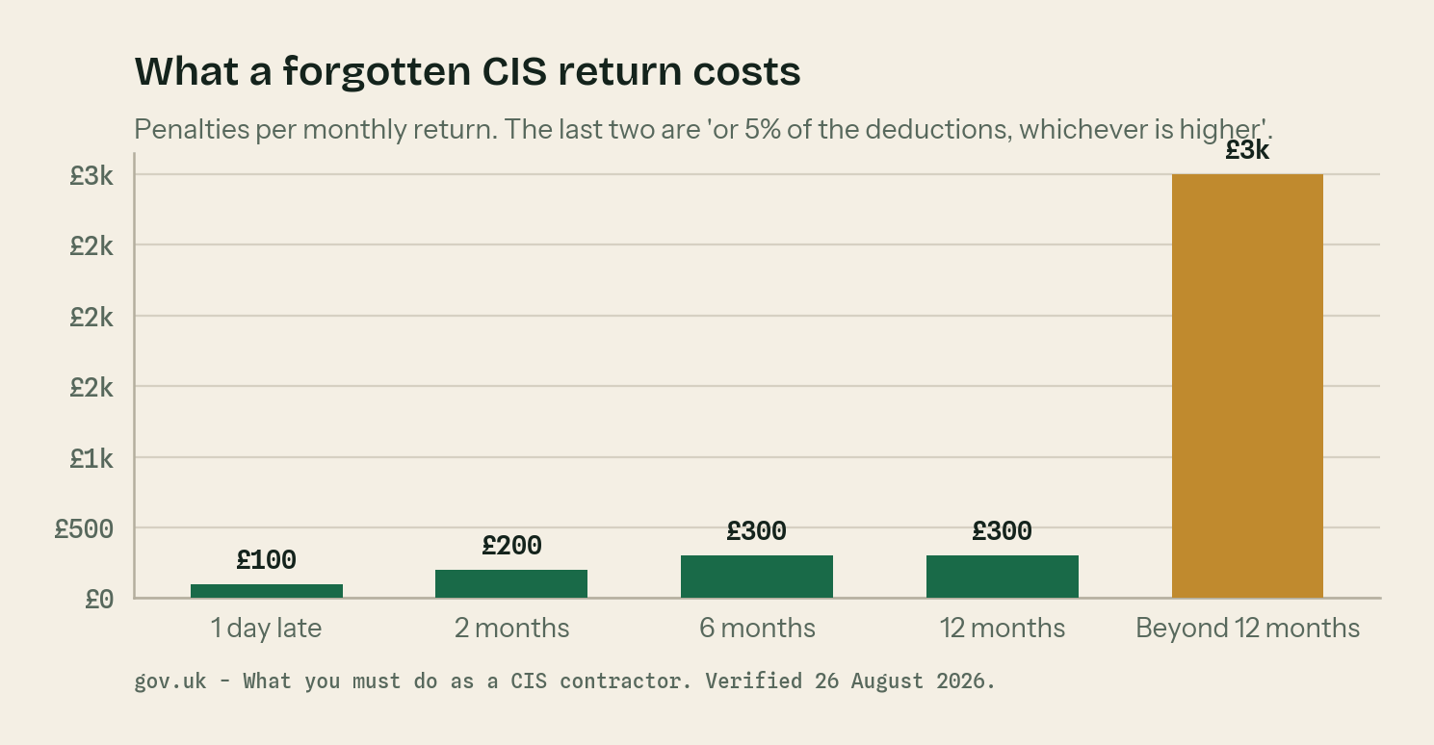
Per monthly return. Verified against gov.uk on 26 August 2026.
When | Penalty | Notes
1 day late | £100 | Per return, per month
2 months late | £200
6 months late | £300 | Or 5% of the CIS deductions, whichever is higher
12 months late | £300 | Or 5% of the CIS deductions, whichever is higher
Beyond 12 months | Up to £3,000 | Or 100% of the CIS deductions, whichever is higher

A forgotten scheme with three years of nil returns behind it is not a £100 problem. It is the reason 'file the oldest one first' is the right advice, and it is the reason people ring a bookkeeper at nine o'clock at night.
What changes when someone else does it
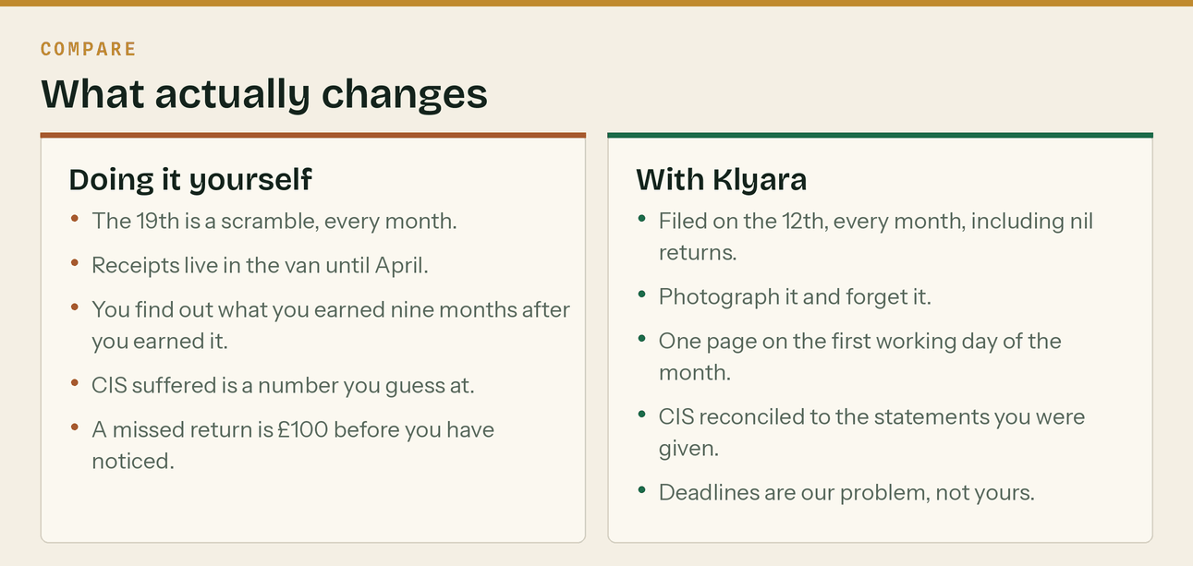
The service, stated as a difference rather than a list.
Klyara files on the 12th, seven days before the deadline, every month, including nil returns. Statements go out by the 19th. A one-page summary lands on the first working day of the month: what you invoiced, what you were paid, what CIS was taken, and what to do about it.
The honest size of the prize
Bought separately at published market rates, the work inside a Trade plan is about £285 a month — light bookkeeping from £125, monthly CIS returns from £95, VAT from £65. Klyara does all of it for £199. That is a real, sourced, checkable number and it belongs in the third minute of every discovery call.

3. The market

Big enough not to matter, which is the point. Klyara does not need market share. It needs twenty-five clients.
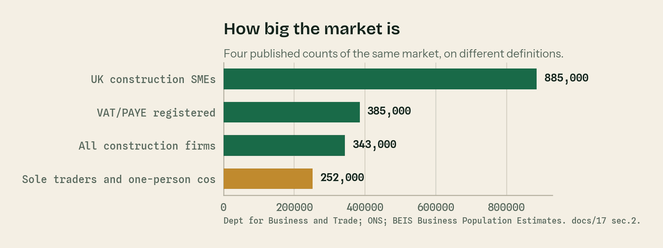
Four published counts of the same market on different definitions.
Figure | What it counts | Source
885,000 | UK construction SMEs — 16% of all private sector businesses | Dept for Business and Trade
385,000 | VAT or PAYE registered construction businesses — 14.1% of UK enterprises | ONS
343,000 | Construction businesses, of which 99.1% are SMEs | BEIS Business Population Estimates
252,000 | Sole traders and one-person companies | BEIS Business Population Estimates
£185bn | Construction output — 6.7% of UK GDP, 2.4m workers | ONS
~900,000 | People working in the trades, about 90% self-employed | Checkatrade

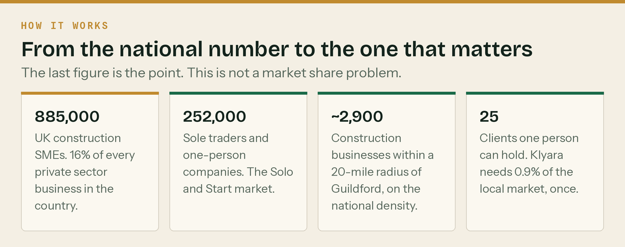
From the national number to the one that matters.
The last figure is the whole argument. One person can hold about twenty-five clients. Klyara needs roughly nine tenths of one per cent of the construction businesses within twenty miles of Guildford, once, and then it needs to keep them.
The demand event that is already dated
Making Tax Digital for Income Tax pulls sole traders into quarterly filing in three waves. The threshold is qualifying income — turnover before expenses, tested on the previous year's return. CIS deductions do not reduce it, because they go in a different box as tax already paid.
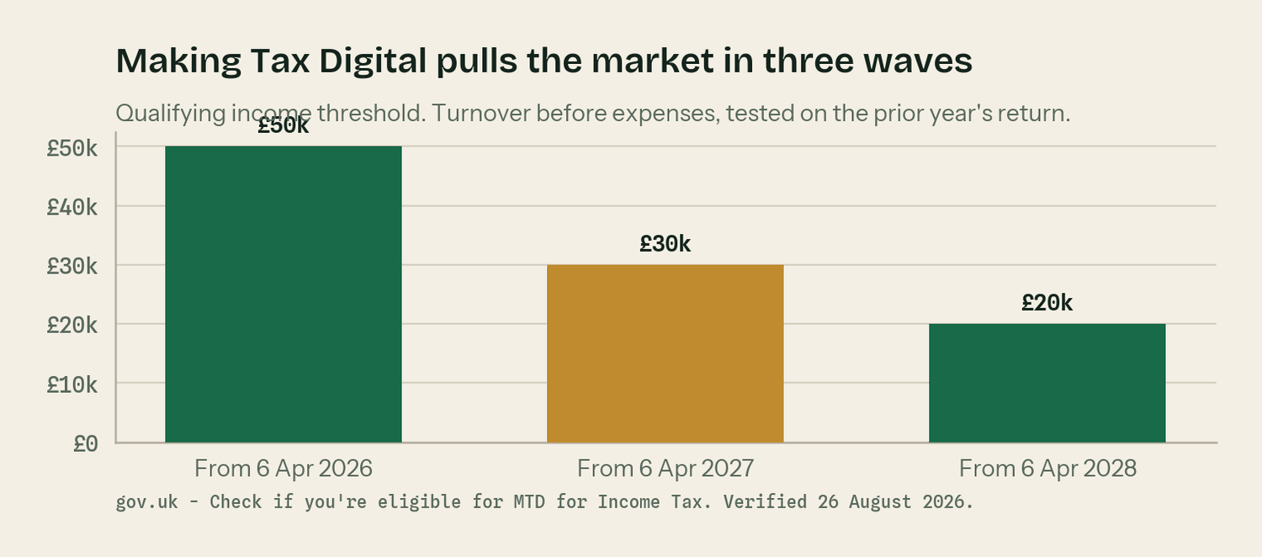
Verified against gov.uk on 26 August 2026.
Threshold | Assessed on | Applies from
Over £50,000 | 2024–25 Self Assessment return | 6 April 2026
Over £30,000 | 2025–26 return | 6 April 2027
Over £20,000 | 2026–27 return | 6 April 2028

The April 2027 wave is the single biggest demand event in this plan. It catches a very large share of the 252,000 sole traders and one-person companies, and it arrives eight months after launch.
How the buyer decides
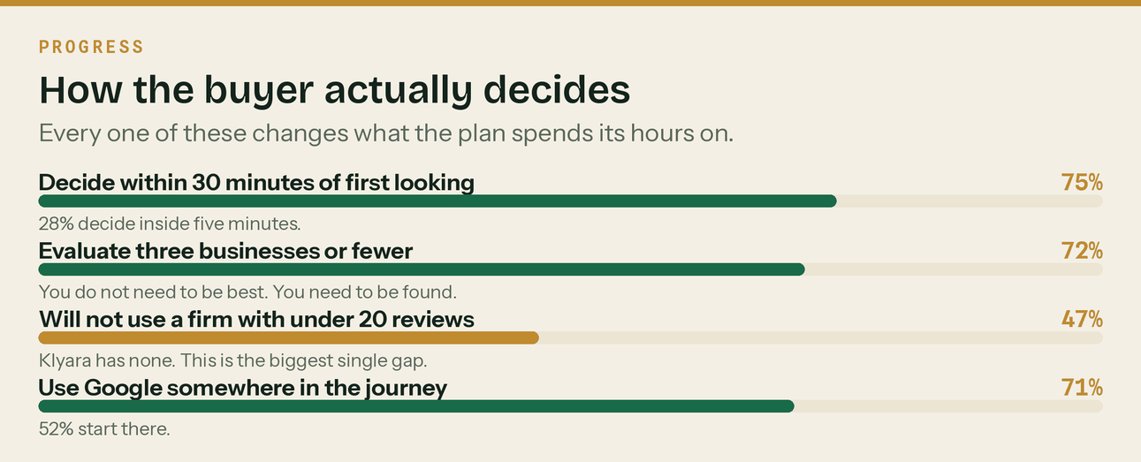
Source: BrightLocal, Checkatrade and Ofcom, via docs/17 §3.
Three of those four numbers change what the plan spends its hours on. 75% decide within thirty minutes and 28% within five, so speed of reply is a rule rather than a tip. 72% look at three firms or fewer, so this is a being-found problem rather than a being-best problem. And 47% will not use a firm with fewer than twenty reviews, which is the one input Klyara has none of.

4. Who Klyara competes with, and at what price

Searched on 26 August 2026 for construction bookkeeping and CIS accountants around Guildford and Surrey. Thirteen firms surface. Every price below came off a live page on that day, and every URL is in the source list at the end of this section.
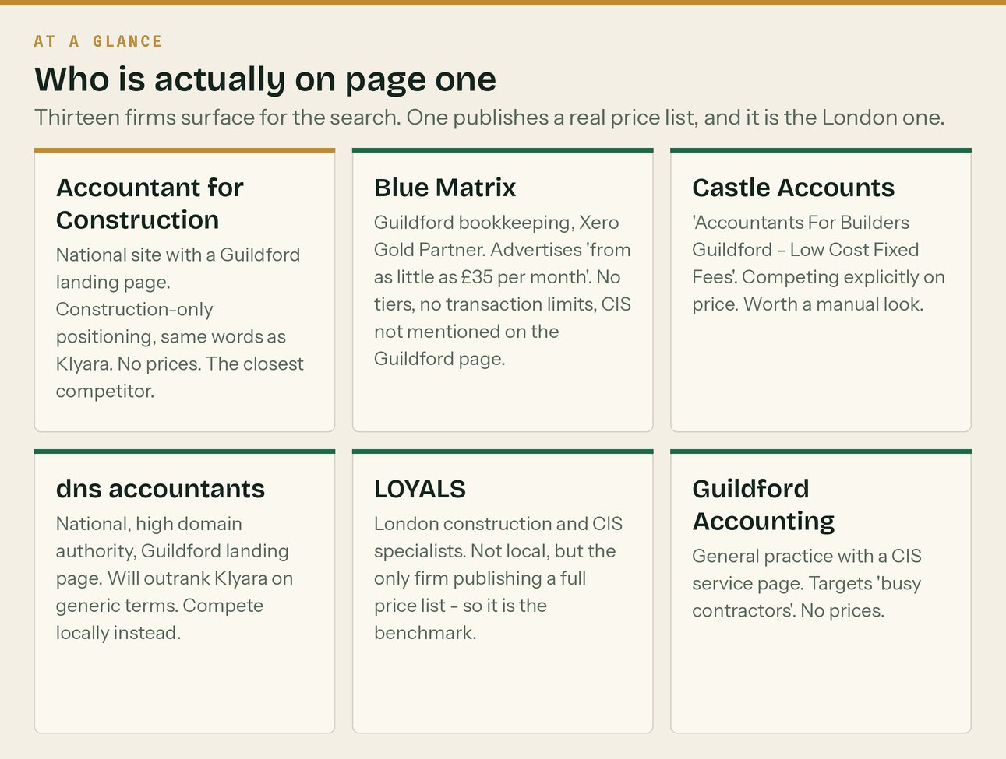
The page one Klyara is trying to get onto.
What the market actually charges
Work | Published price | Source
Monthly CIS return management, standalone | £80–£200 / month | A One Outsourcing
Monthly CIS returns | from £95 / month | LOYALS
CIS returns, per submission | £15–£30 | Gro
Light bookkeeping | from £125 / month | LOYALS
Sole trader bookkeeping | £100–£250 / month | A One Outsourcing
Small Ltd, 50–200 transactions | £200–£400 + VAT | Gro
Contractor with subcontractors, bundled | £300–£500 / month | LOYALS
Multi-trade business, bundled | £600–£1,500 / month | LOYALS
VAT returns | from £195 / quarter | LOYALS
CIS premium over standard bookkeeping | 15–25% | A One Outsourcing
Qualified AAT or ICB, hourly | £30–£45 / hour | A One Outsourcing · Gro
South East regional average, hourly | £28–£50 / hour | A One Outsourcing

Where Klyara sits against it
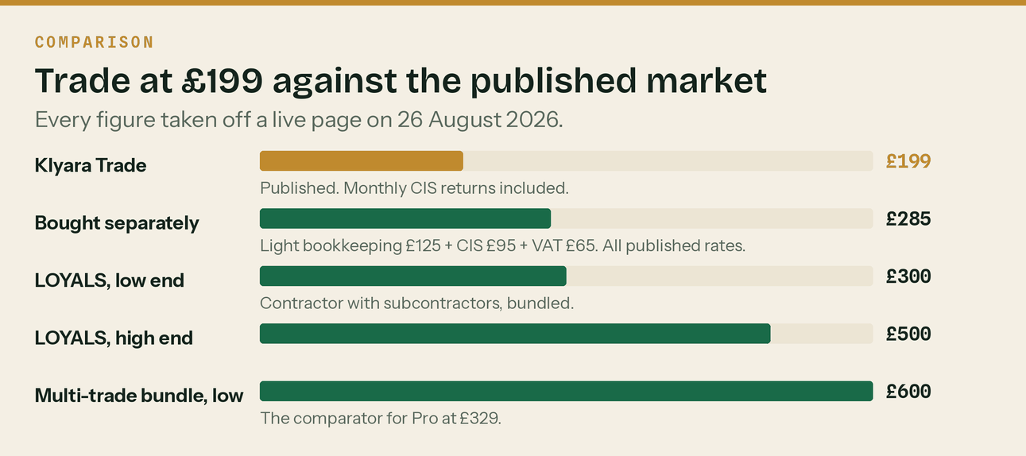
Trade at £199 against the published comparators for the same client.
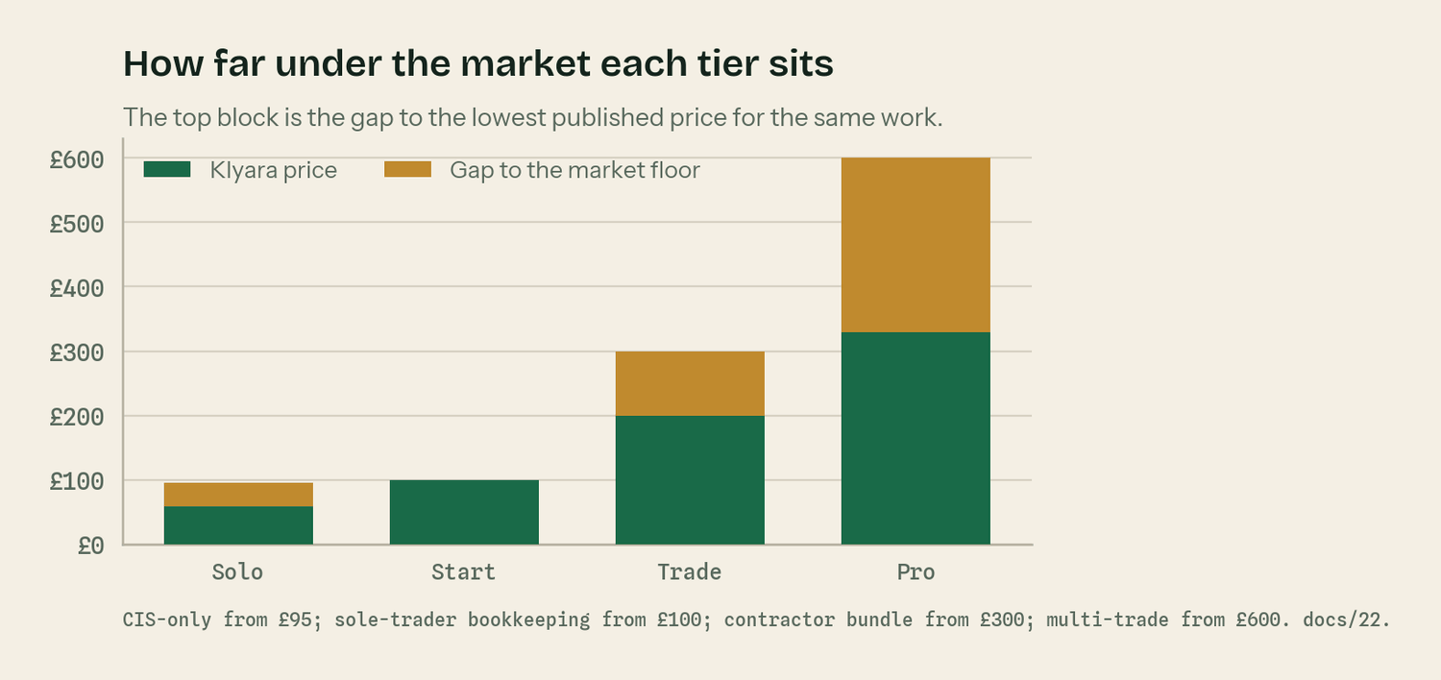
Every tier sits under the floor of its comparator range.
Tier | Price | Nearest published comparator | Verdict
Solo | £59 | CIS returns alone: £80–£200, from £95 | Below the price of the CIS return on its own
Start | £99 | Sole trader bookkeeping £100–£250 | Bottom of the range, before the CIS premium
Trade | £199 | Contractor with subbies £300–£500 | £101–£301 a month under the direct comparator
Pro | £329 | Multi-trade bundle £600–£1,500 | Roughly half the bottom of the range

Two of the sources give a South East premium — hourly rates of £28 to £50 here against £22 to £42 in the Midlands and North West, roughly a 20% regional uplift. Klyara is priced in Guildford at national floor rates. There is no version of this where £59 reads as anything other than surprisingly cheap, and cheap in Surrey can read as unqualified. That is a framing problem, and section 6 deals with it.
The four things the competitor research actually tells you
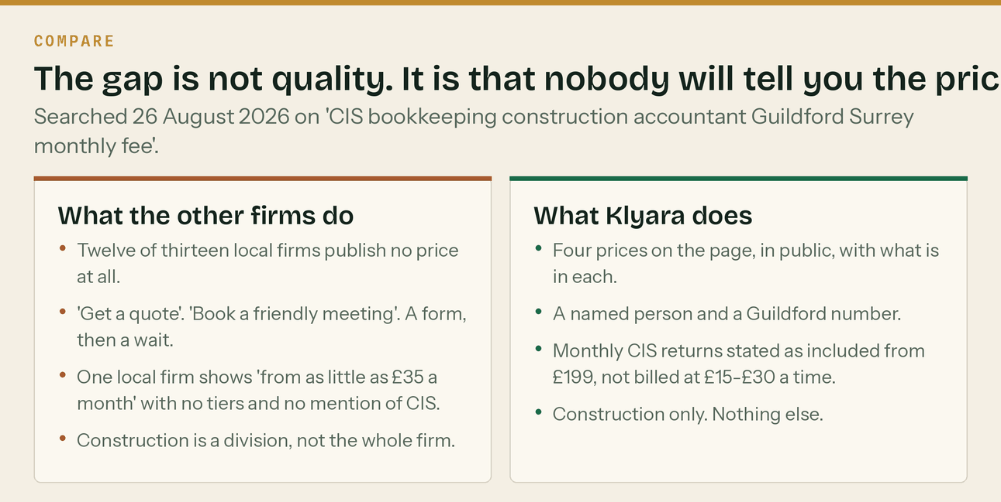
The difference has to be visible in thirty seconds.
- Almost nobody publishes a real price. One of thirteen published a full list, and it was the London firm. One local firm shows 'from as little as £35 a month' with no tiers, no transaction limits and no mention of CIS on the Guildford page.
- The £35 headline needs an answer, and it is not 'we are worth more'. It is three questions: is that a 'from' price; are the CIS returns in it or billed at £15 to £30 a submission; and is the software subscription in the fee and in whose name.
- 'Construction specialist' is a claim, not a moat. The nearest competitor uses the same words. The honest differences are published prices, a named person who answers the phone, a Guildford address, and content that demonstrates the specialism rather than asserting it.
- The nearest competitor is a national site with a town-name page. Beatable on local signals. Not beatable on domain authority. Compete where you can win.
Where they beat Klyara, honestly
Trading history and real reviews. They have them. Klyara does not, and that is the whole gap. They also do year-end, corporation tax and advisory, and some buyers want one supplier. Klyara deliberately does not — the answer to that is the accountant partnership channel, not scope creep.

Sources for every price in this section
- A One Outsourcing — How Much Does Bookkeeping Cost in the UK? 2026 Pricing Guide — aoneoutsourcing.uk/blog/how-much-does-bookkeeping-cost-in-the-uk
- Gro — How Much Does a Bookkeeper Cost UK? 2026 Fees Guide — wearegro.co.uk/blog/how-much-does-a-bookkeeper-cost-uk-2026-guide
- LOYALS — Construction Accountants London: CIS, Ltd Co, Trades — loyals.uk/industries/construction-cis-accountants
- Accounting Firms — Contractor Accountant Fees 2026 — accountingfirms.co.uk/blog/contractor-accountant-fees/
- Accountant for Construction, Guildford — accountantforconstruction.co.uk/near-me/surrey-guildford/
- Blue Matrix, Guildford bookkeeping — bluematrix.co.uk/bookkeeping-services-guildford-surrey/
- Castle Accounts, Guildford — castleaccounts.co.uk/guildford/ (returned 403 to automated access; check manually)
- dns accountants, Guildford — dnsassociates.co.uk/accountants-in-guildford
- All accessed 26 August 2026. Re-run this in January 2027. Day 84 of the plan has a slot for it.

5. The offer, and the four tiers

Four plans. Monthly in advance. Thirty days' notice either way and no tie-in. Software subscription included on every plan and in the client's name, so it is never a lever on the way out and it is a selling point on the way in.
Prices exclude VAT. Trade is the tier the business is built around.
What is in each plan
 | Solo £59 | Start £99 | Trade £199 | Pro £329
Typical transactions a month | Under 60 | 60–149 | 150–349 | 350–699
Bank feed reconciled | Yes | Yes | Yes | Yes
Sales invoices raised | 10 | 25 | 60 | Unlimited within reason
Purchase items coded | 50 | 120 | 300 | 700
CIS suffered recorded and reclaimed | Yes | Yes | Yes | Yes
Monthly CIS returns filed | — | — | Yes, on the 12th | Yes, on the 12th
Subcontractor verification | — | — | Unlimited | Unlimited
Deduction statements issued | — | — | 10 subbies | 25 subbies
VAT returns and reverse charge | — | Yes | Yes | Yes
Payroll | — | Director only | 5 employees | 15 employees
Year end — SA or accounts and CT600 | SA only | Yes | Yes | Yes
Retentions tracked | — | — | Yes | Yes
Job costing | — | — | — | Yes
Management accounts with commentary | — | — | Summary | Yes
Call each month | — | Quarterly 15 min | 15 min | 30 min

Where the monthly CIS returns start, and why
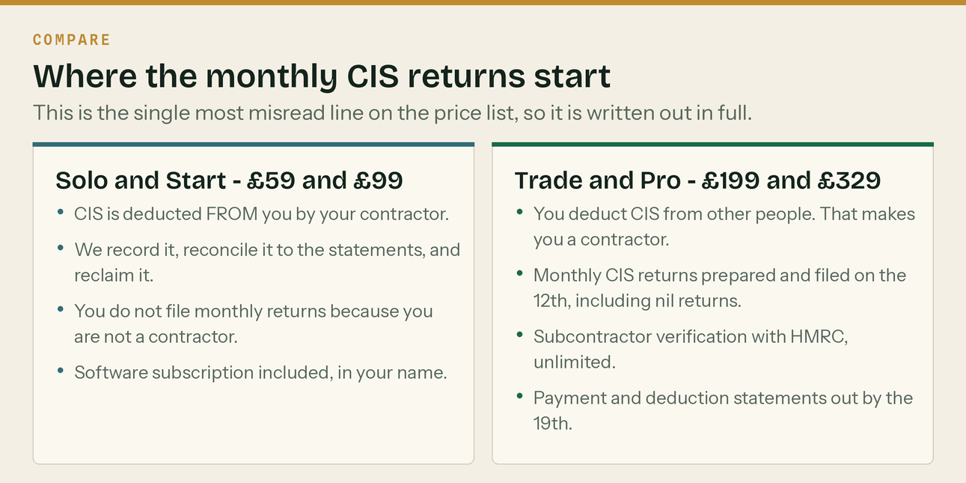
The single most misread line on the price list.
On Solo and Start, CIS is deducted from the client. Klyara records it, reconciles it to the statements the client was given, chases the ones that never arrived, and reclaims it. The client is a subcontractor, not a contractor, so there is no monthly return to file.
On Trade and Pro, the client deducts CIS from other people. That makes them a contractor and a monthly return becomes compulsory. Klyara files it on the 12th, every month, nil returns included, and issues the payment and deduction statements by the 19th.
The upgrade triggers
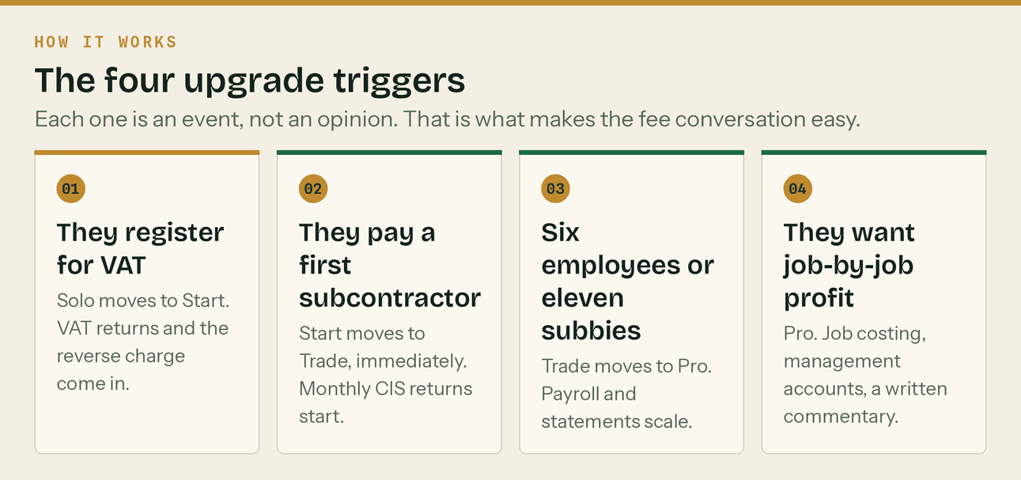
Four events. Not four opinions.
Every trigger is a thing that happens, not a judgement call. That is what makes the fee conversation survivable: *'When we set the fee you were doing about 90 transactions a month. Last three months have been 240 and you have taken on two subbies, which is great. That is a Trade-sized job now.'*
The planned mix, and why it matters
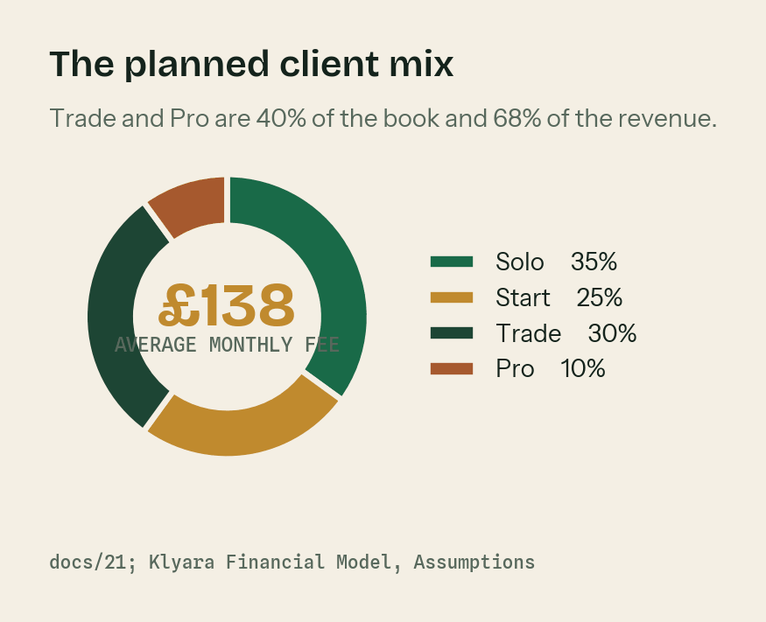
Source: Klyara Financial Model, Assumptions sheet.
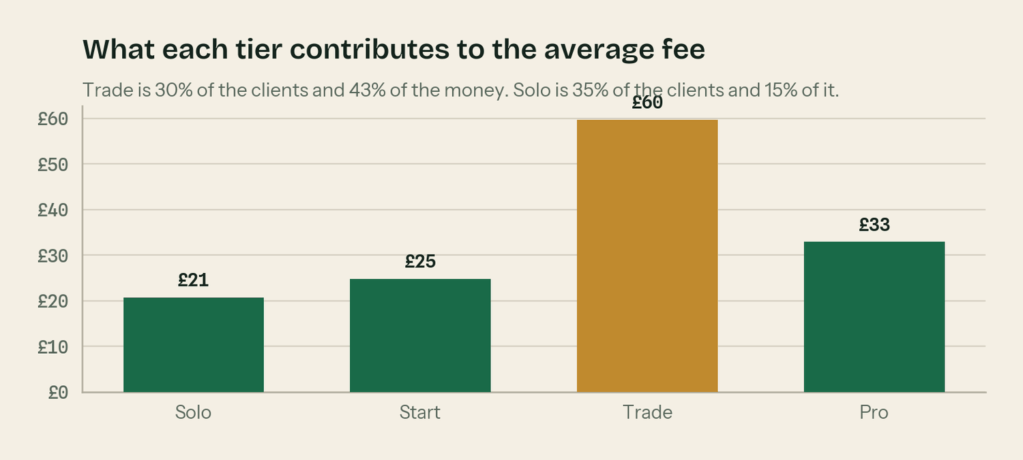
Trade is 30% of the clients and 43% of the money.
The book is planned at 35% Solo, 25% Start, 30% Trade and 10% Pro, which gives an average monthly fee of £138. docs/21 sets a standard of 60% of the book on Trade or Pro. The plan starts at 40% and the whole point of the upgrade triggers is to move it.
Everything that is not in a plan
Published, because firms that hide this end up doing the work for free.
Work | Price
Gross payment status application, prepared and submitted | £195, free on Trade and Pro
Reverse charge setup and supplier review | £125, free at onboarding
Catch-up of prior-period books | £45/hour, quoted after a look, capped at the quote
Additional subcontractor beyond the tier limit | £8/month each
Additional employee on payroll beyond the limit | £6/month each
CIS return for a month we did not do the books | £45
Missed-return catch-up filing, per return | £35
Mortgage or lending pack beyond the SA302 | £75
Ad hoc management report | £120
VAT registration | £95
CIS registration as contractor or subcontractor | £65
HMRC enquiry support | £65/hour
Software migration from another package | £195
Out-of-scope work, general | £45/hour, in 15-minute units

Two rules about the rate card
It exists so you can say yes cheerfully. *'Yes, absolutely — that one is outside the monthly, it is £75, want me to go ahead?'* is a normal sentence and clients hear it as competence. And nothing on it gets billed without being agreed first, in writing, before the work starts. A surprise invoice costs more goodwill than the fee is worth.

6. Pricing, and the founding-rate model

The prices were set before anybody checked what the market charges. Section 4 checked. The answer is that every tier sits under the floor of its published comparator, and that Solo at £59 is below the cheapest published price for the single service inside it.
The recommendation is not to change the launch prices. It is to change the framing and put a dated increase in the diary.
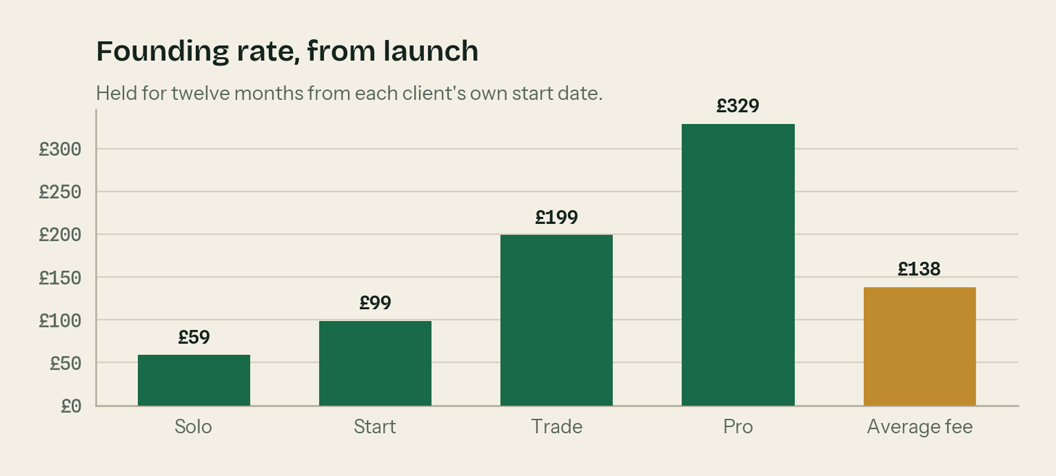
The founding rate, held for twelve months from each client's own start date.
Why launch low
Launching at £59 to £329 with nothing to show — no reviews, no case studies, no track record, no licence yet displayed — is defensible. Price is doing a job: it is buying the first ten clients cheaply, and the first ten clients are worth more as proof than as revenue. Raising prices before a single Google review exists would trade away the one advantage Klyara currently holds.
But three things have to be true or the low price becomes permanent.
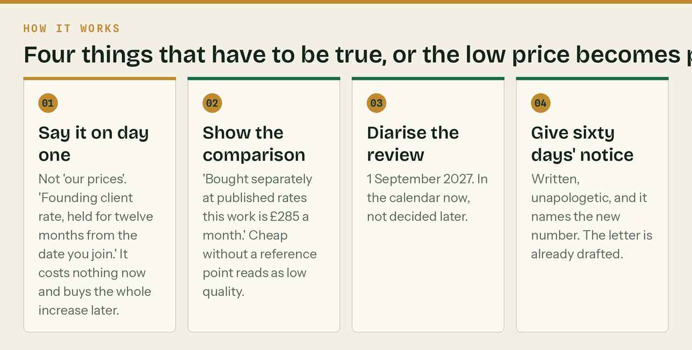
Four rules. The first one costs nothing and buys the whole increase.
The September 2027 review
Set against the comparator, not against a percentage of the old price.
Tier | Now | Sept 2027 target | Comparator it still sits under
Solo | £59 | £89 | CIS returns alone, £95–£200
Start | £99 | £149 | Sole trader bookkeeping, £100–£250
Trade | £199 | £279 | Contractor bundle, £300–£500
Pro | £329 | £449 | Multi-trade bundle, £600–£1,500
Average fee | £138 | £197 | A 42.8% uplift on the fee

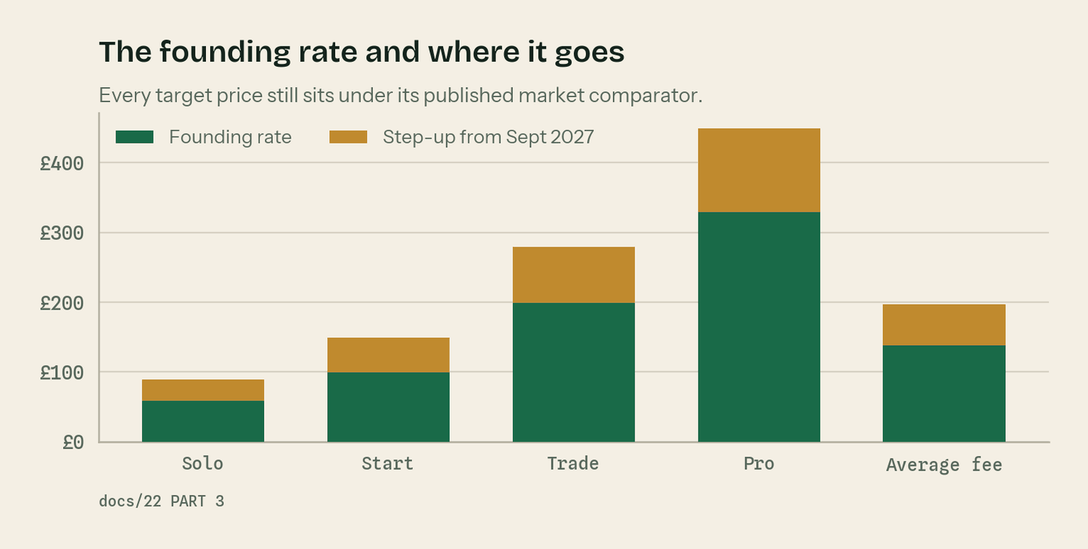
Every target price still undercuts its published comparator.
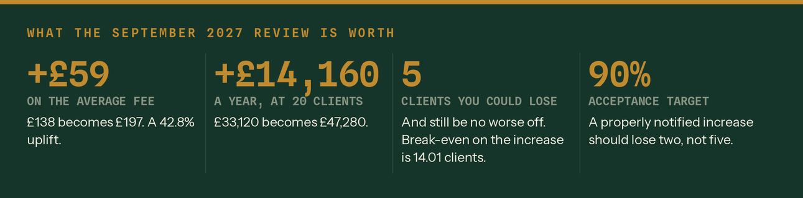
Modelled on the Price scenario sheet of the Financial Model.
The number that settles the argument
On twenty clients, break-even on the increase is 14.01 clients. You could lose five clients out of twenty and still be ahead — the sixth one takes you £2 a month below where you started. docs/21 targets 90% acceptance on a properly notified increase, which would be two. The downside is bounded at two clients. The upside is £14,160 a year. That asymmetry is why the founding-rate wording matters and why it costs nothing to add today.

Getting paid
Monthly in advance. Direct Debit preferred, standing order accepted, on the 1st, with the invoice issued on the 25th of the preceding month. Clients on Direct Debit pay on time roughly universally. Clients on bank transfer pay when they feel like it.
When a payment fails | What happens
Day 1 | Automatic retry, no contact
Day 3 | Friendly text — 'direct debit bounced, worth a check?'
Day 7 | Phone call. Nothing else works as well.
Day 14 | Written notice: work pauses at day 21 if unresolved
Day 21 | Work pauses — but a statutory deadline inside the window is still met
Day 30 | Formal notice, engagement ends at day 60

Never hold the records hostage. The data is theirs and the software subscription is in their name specifically so this is never a lever. Chase the fee as a debt, properly and separately. And if a filing deadline falls inside a pause and the work is already done, file it — you do not create a penalty for a client over a fee dispute, and you do not want that in front of your professional body.

7. Operations and capacity

Four fixed points a month. Everything else moves around them.
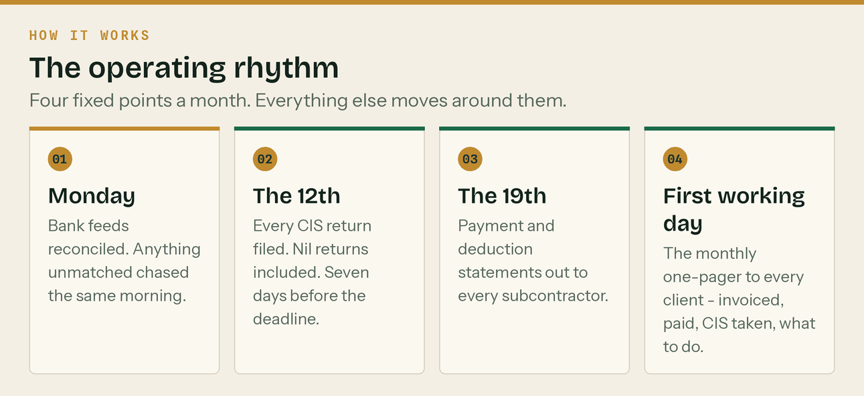
The operating rhythm.
What one client actually costs in time
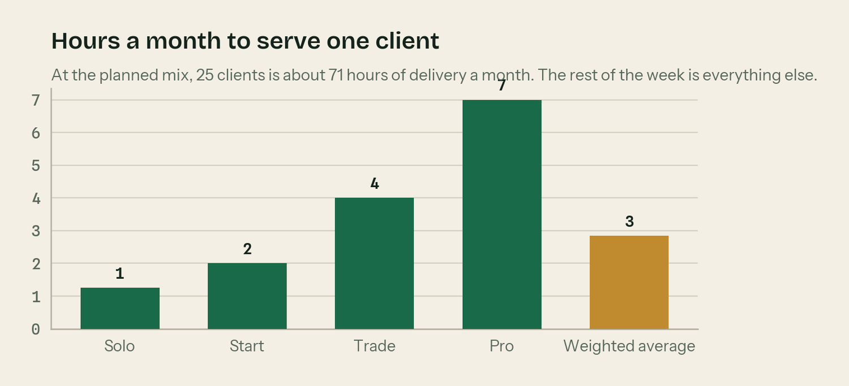
Estimated hours to serve one client for a month, by tier.
Tier | Hours a month | Fee | Effective hourly rate | At the 2027 price
Solo | 1.25 | £59 | £47.20 | £71.20
Start | 2.00 | £99 | £49.50 | £74.50
Trade | 4.00 | £199 | £49.75 | £69.75
Pro | 7.00 | £329 | £47.00 | £64.14
Weighted average | 2.84 | £138 | £48.63 | £69.42

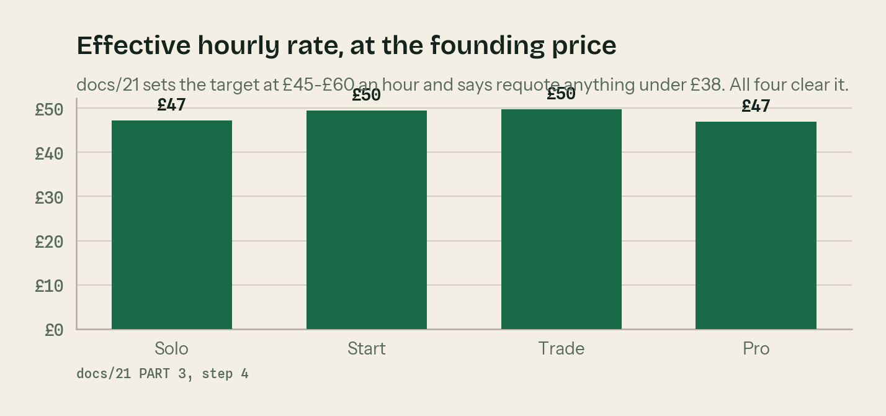
docs/21 sets the standard at £45–£60 an hour. All four tiers clear it.
The hours are estimates and they are a blue input in the Financial Model, so they can be replaced with measured time as soon as there is any. The rule from docs/21 is that anything under £38 an hour gets requoted and anything under £30 gets walked away from.
Where the ceiling is, and where the hire falls
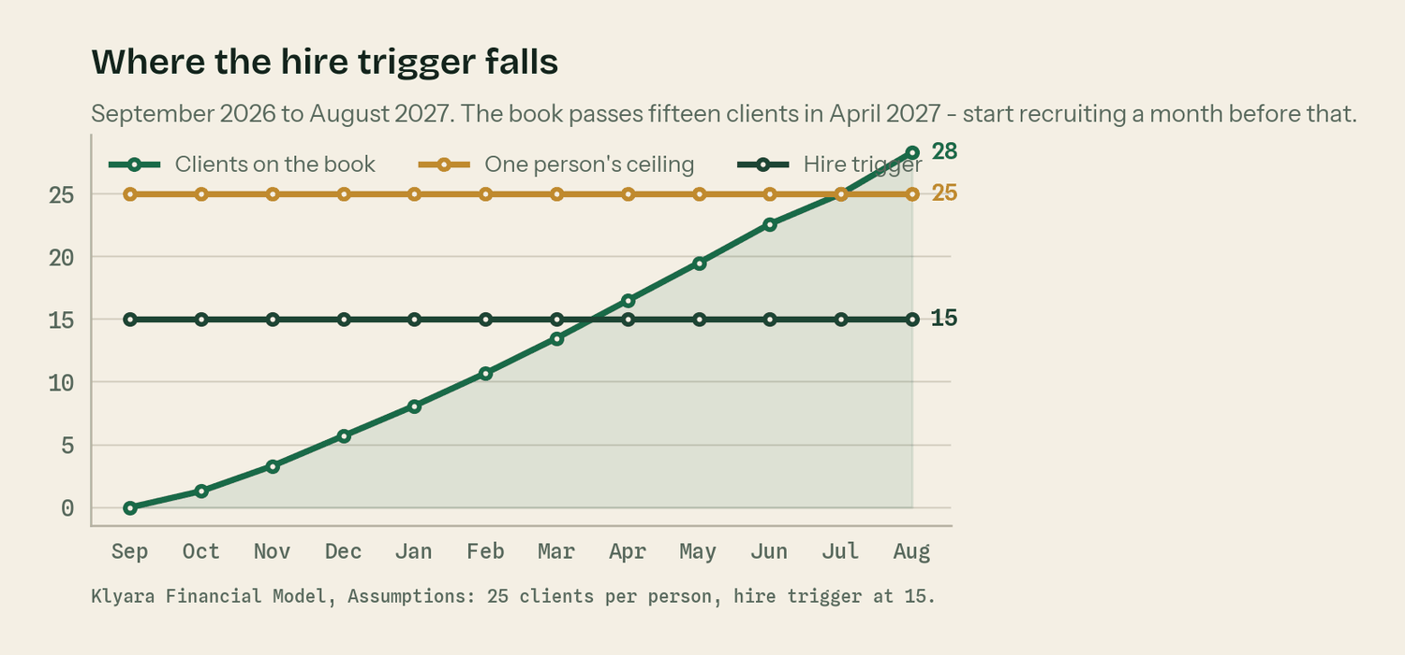
Source: Klyara Financial Model. 25 clients per person, hire trigger at 15.
At the planned mix, twenty-five clients is about 71 hours of delivery a month. That leaves the rest of a working month for selling, answering the phone, marketing and the things that always take longer than the estimate. Twenty-five is the ceiling for one person, and it matches the 20 to 25 in the Build Manual.
The book passes fifteen clients in April 2027 — month 8 of trading. That is the hire trigger. The recruitment conversation starts a month before it, not after.
Decide the waitlist policy before you need it
Holding a founding-rate waitlist is a far better outcome than taking on client 26 badly and losing client 4. The Financial Model gates new clients against capacity for exactly this reason, and it shows the waitlist forming in month eleven and again in mid-2028.

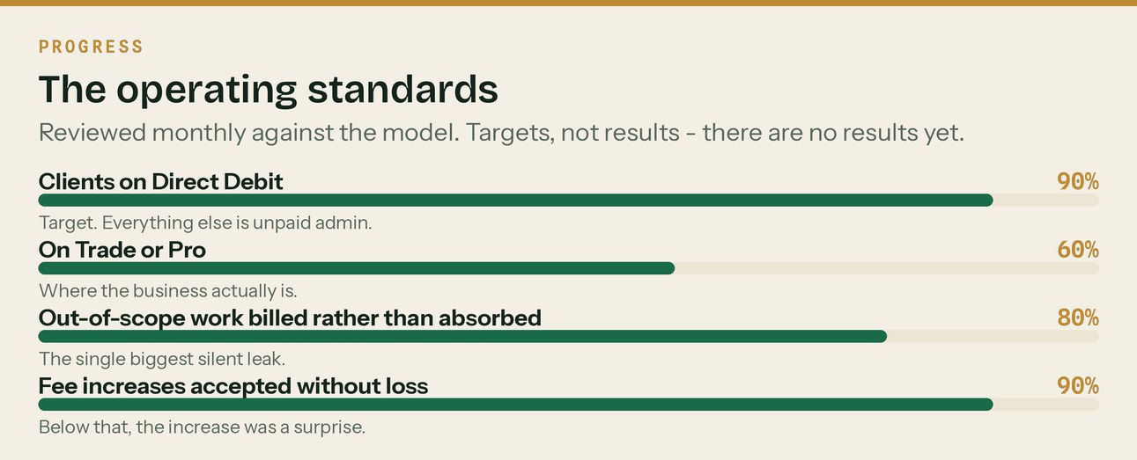
Reviewed monthly. These are targets, not results — there are no results yet.

8. Marketing, and the ninety-day plan

Everything in this section is already written out day by day, with owners and timings, in the day-by-day plan. This is the shape of it.
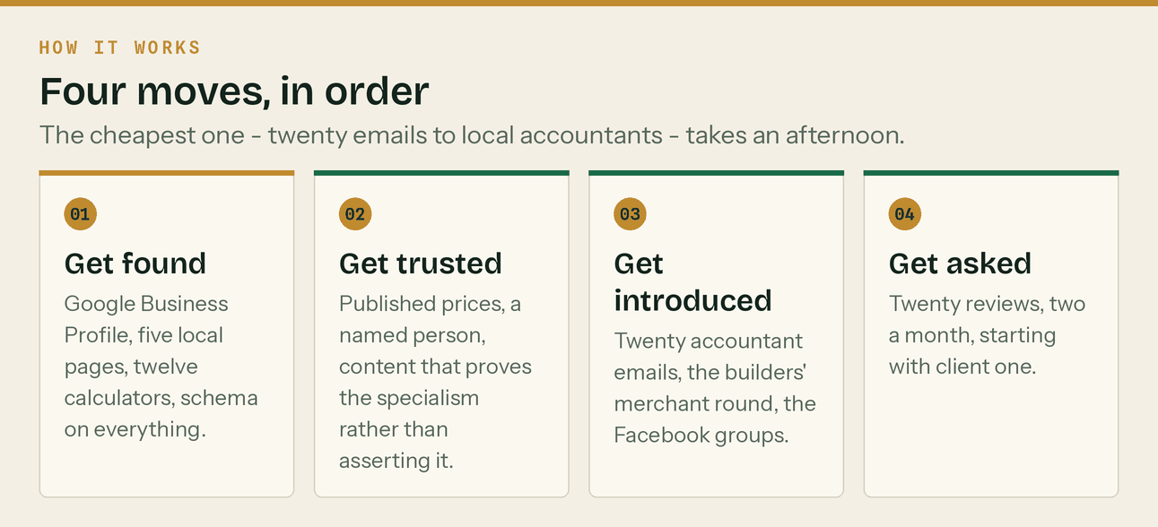
Four moves. The cheapest one takes an afternoon.
The ninety days
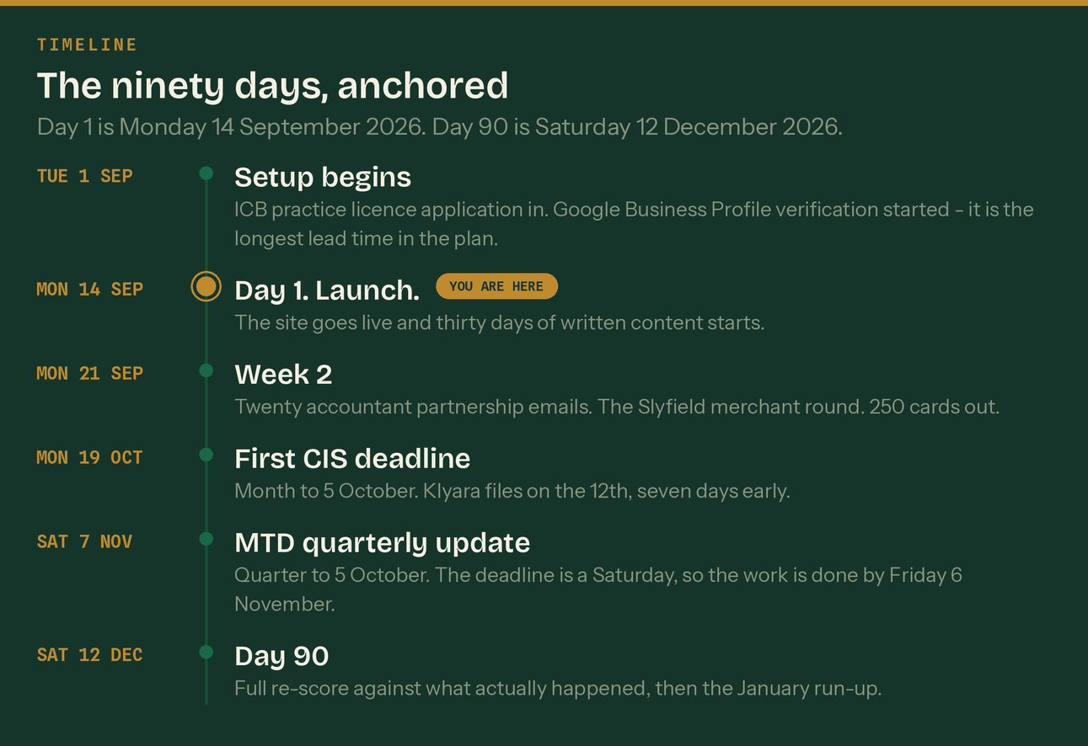
Day 1 is Monday 14 September 2026. Day 90 is Saturday 12 December 2026.
Phase | Dates | What happens
Setup | Tue 1 Sep – Sun 13 Sep | ICB licence application in. Google Business Profile verification started. Testimonials pulled. Analytics, schema and email warm-up live.
Week 1 | Mon 14 Sep – Sun 20 Sep | Launch. The anchor post, the platform signups, the first thirty days of content begins.
Weeks 2–4 | Mon 21 Sep – Sun 11 Oct | Twenty accountant emails. The Slyfield merchant round. 250 cards. Local town pages published.
Month 2 | Mon 12 Oct – Thu 12 Nov | Gross payment status, pricing and first-employee content. Ads on the moment supervision lands. First clients.
Month 3 | Fri 13 Nov – Sat 12 Dec | Year-end and the January run-up. The 7 November MTD update. First case study. Full re-score at day 90.

The funnel, and what it is built on
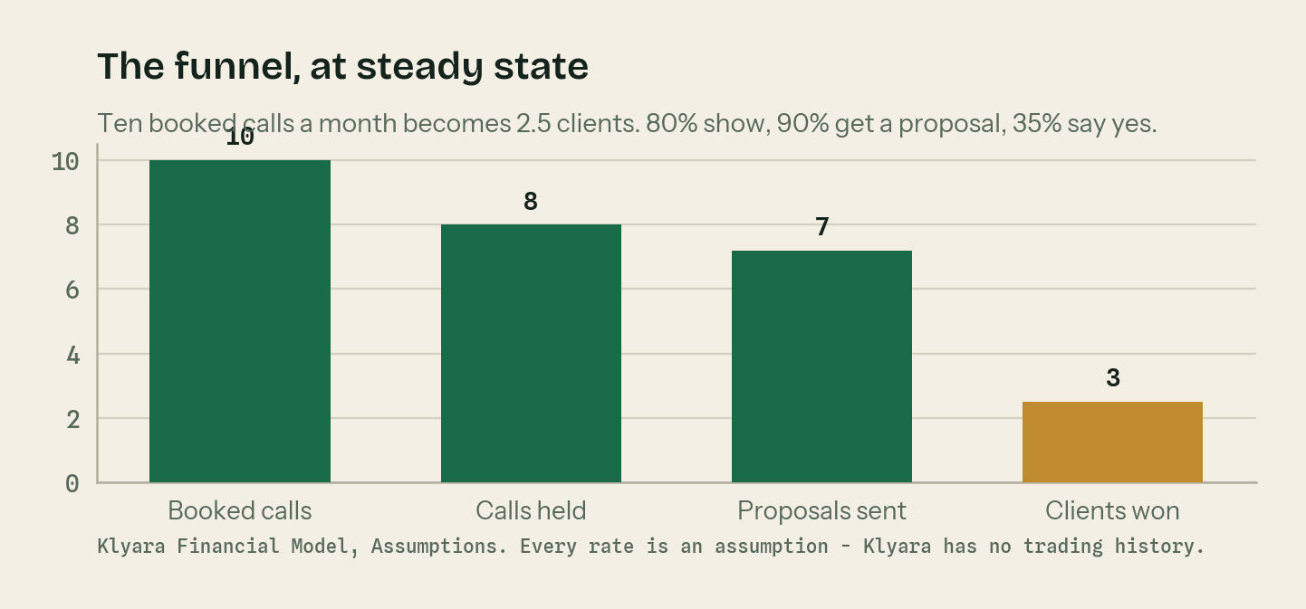
Every rate here is an assumption. Klyara has no trading history.
Ten booked calls a month is the steady-state target from month three. 80% show up. 90% get a proposal, because the price is given on the call. 35% say yes. That is 2.5 new clients a month, and it is what the whole financial model rests on.
Replace all four numbers with measured ones after six discovery calls. Until then they are reasoned guesses and the model says so on every sheet.
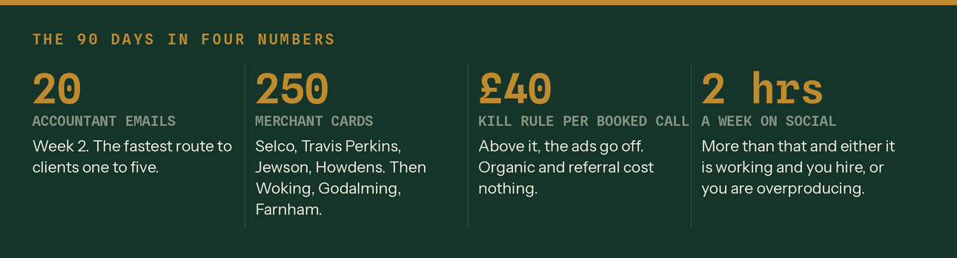
The ninety days in four numbers.
The decision gates
Do not carry on doing something that is not working because it is written in a plan.
When | The question | If the answer is no
End of week 2 | Is Google Business Profile verified? | Chase it. Nothing local works until it is, and it is the most common launch failure.
End of month 1 | Four or more discovery calls from Guildford postcodes? | Almost always GBP verification. Check that before changing any content.
£150 of ad spend | Cost per booked call under £40? | Pause the ads. Organic, GBP and referrals cost nothing.
End of month 2 | Any accountant partnership conversations live? | Send twenty more. Twenty emails is a small sample.
End of month 3 | Eight to twelve booked calls a month? | Cut the bottom half of the channel map and move those hours to the top half.
End of month 3 | Proposals converting above 25%? | Do not cut prices. Record three calls and listen to whether you are diagnosing or describing.

9. The team

Two founders. Key builds it, Craig runs it.
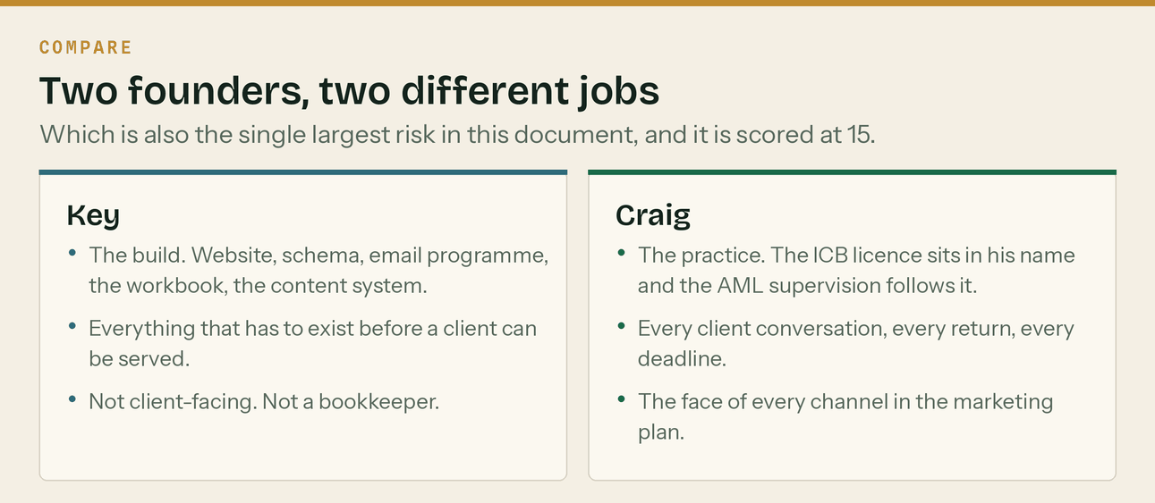
Two founders, two entirely different jobs.
Craig holds the practice licence. The ICB application is in his name and the AML supervision follows it, which means Craig is the regulated person and every client relationship runs through him. He is also the face of every marketing channel in section 8. That is exactly why the plan works, and it is the single largest operational risk in it.
Key builds everything that has to exist before a client can be served — the website, the schema, the email programme, the workbook, the content system, the templates. Not client-facing and not a bookkeeper.
The two pieces of paper that are missing
There is no signed founders' agreement. It is not a marketing problem and it kills more small firms than competition does. Heads of terms this month. And there is no continuity arrangement — an agreement with a partner accountant to pick up the client work if Craig is out for a month. That is the actual answer to the single-point-of-failure risk. Neither is expensive. Both are on the register at 15.

How the team gets built
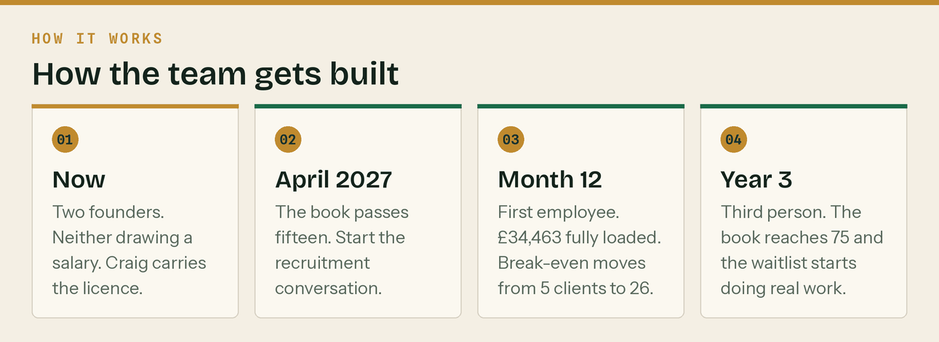
Three steps over three years.
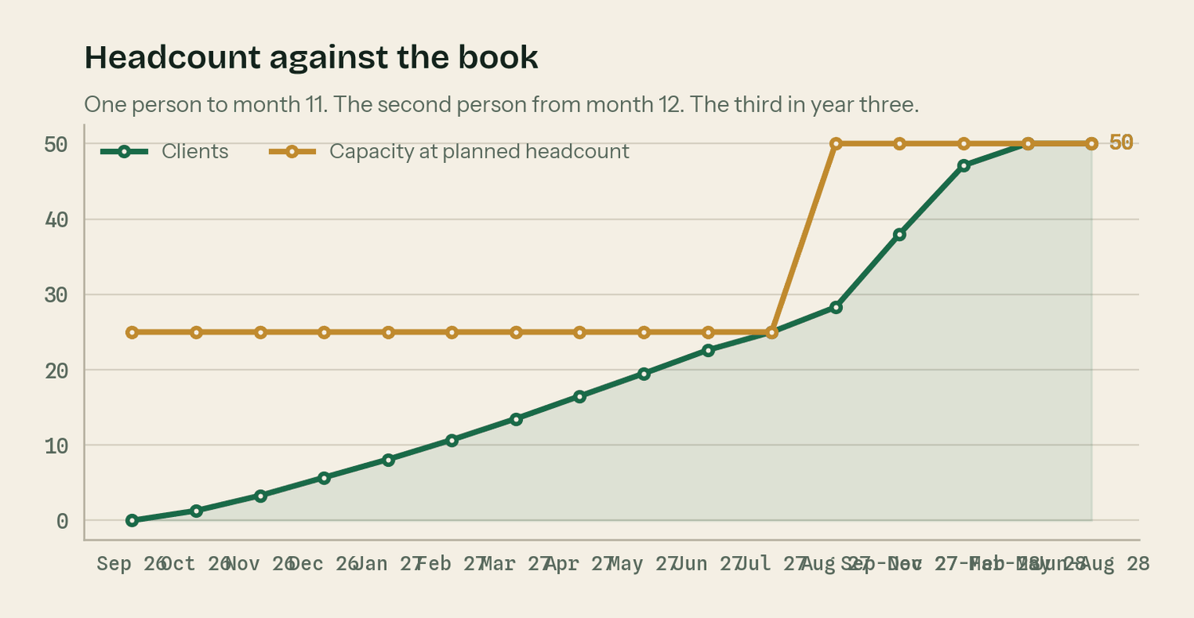
Capacity is a step function. The book is not.
 | Year 1 | Year 2 | Year 3
People delivering | 1, then 2 from month 12 | 2 | 3
Capacity | 25, then 50 | 50 | 75
Clients at year end | 28 | 50 | 75
Employment cost | £2,872 | £34,463 | £68,926
Founder salary drawn | £0 | To be decided | To be decided

The first employee is modelled at a £30,000 salary, £34,463 fully loaded with employer National Insurance and the 3% auto-enrolment minimum. That figure is an estimate and it is a blue input in the Financial Model. Hiring moves break-even from five clients to twenty-six, which is why the trigger is set at fifteen and not at twenty-four.

10. The regulatory position, stated plainly

Where Klyara actually stands today
Klyara is not AML supervised. It therefore cannot lawfully carry on bookkeeping by way of business. It has no clients, has taken no fees, and has done no client work. The ICB practice licence application goes in on Tuesday 1 September 2026 and ICB states 28 days. Nothing in this plan brings a single pound of revenue forward of that date.

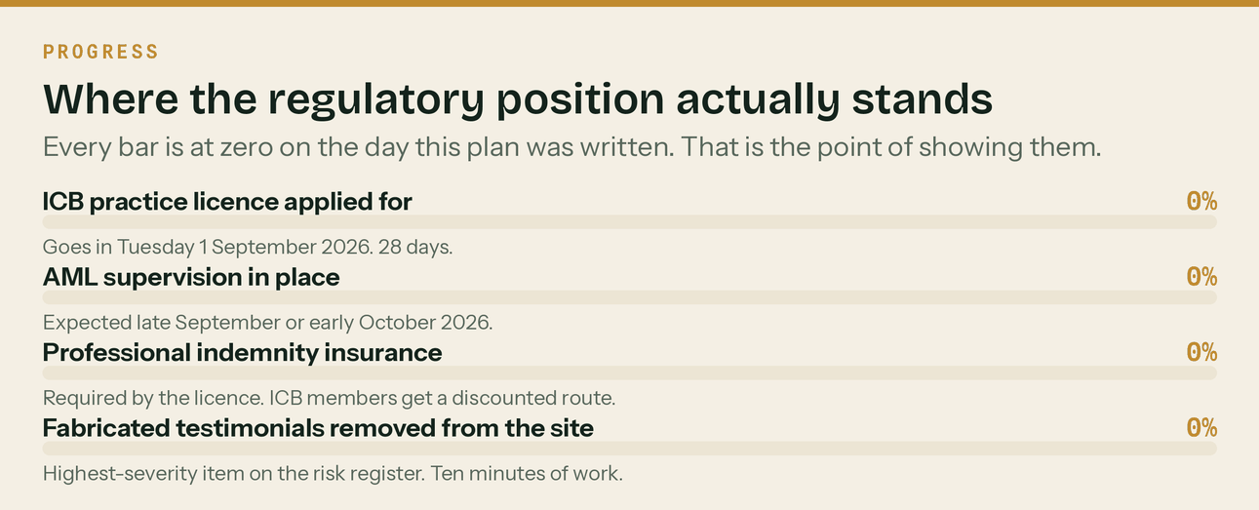
Every bar is at zero. That is the point of showing them.
Which route, and why
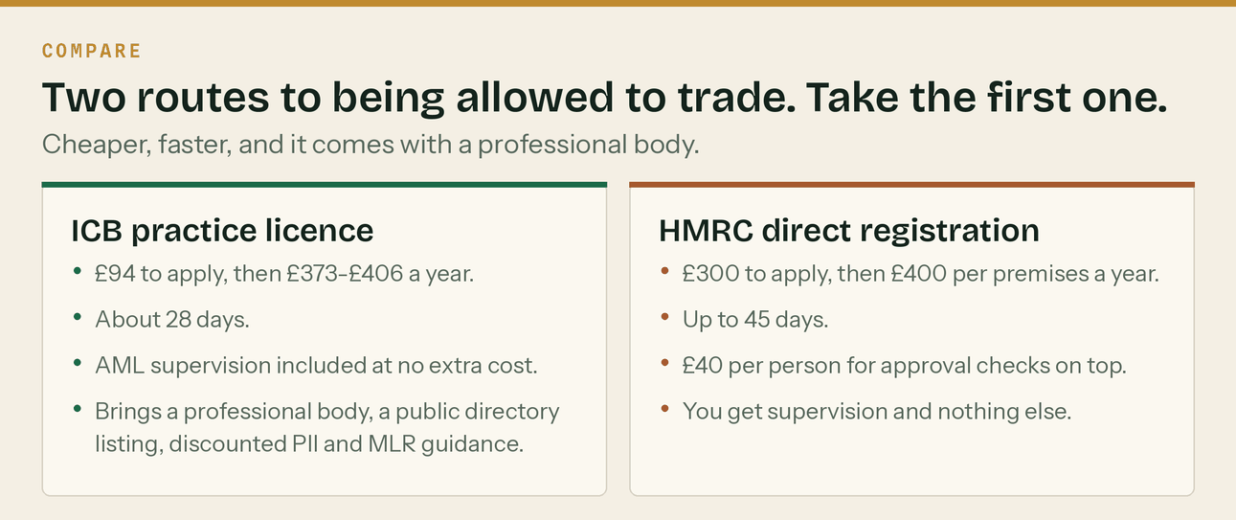
Source: bookkeepers.org.uk and gov.uk, checked 26 August 2026.
Route | Up front | Annual | Processing | AML supervision
ICB practice licence | £94 | £373–£406 (£206 licence + £167–£200 membership) | About 28 days | Included at no extra cost
HMRC direct registration | £300 | £400 per premises, plus £40 per person for approval checks | Up to 45 days | It is the supervision, and nothing else

Go ICB. Cheaper, faster, and it brings a professional body, a public directory listing, discounted professional indemnity insurance, engagement letter templates and money laundering regulations guidance. The HMRC route gets you supervision on its own. There is a £500 small business reduction on the HMRC fee but it only applies under £5,000 of turnover, which will not apply.
The ICB licence also requires professional indemnity insurance and annual renewal, and changes must be notified within thirty days.
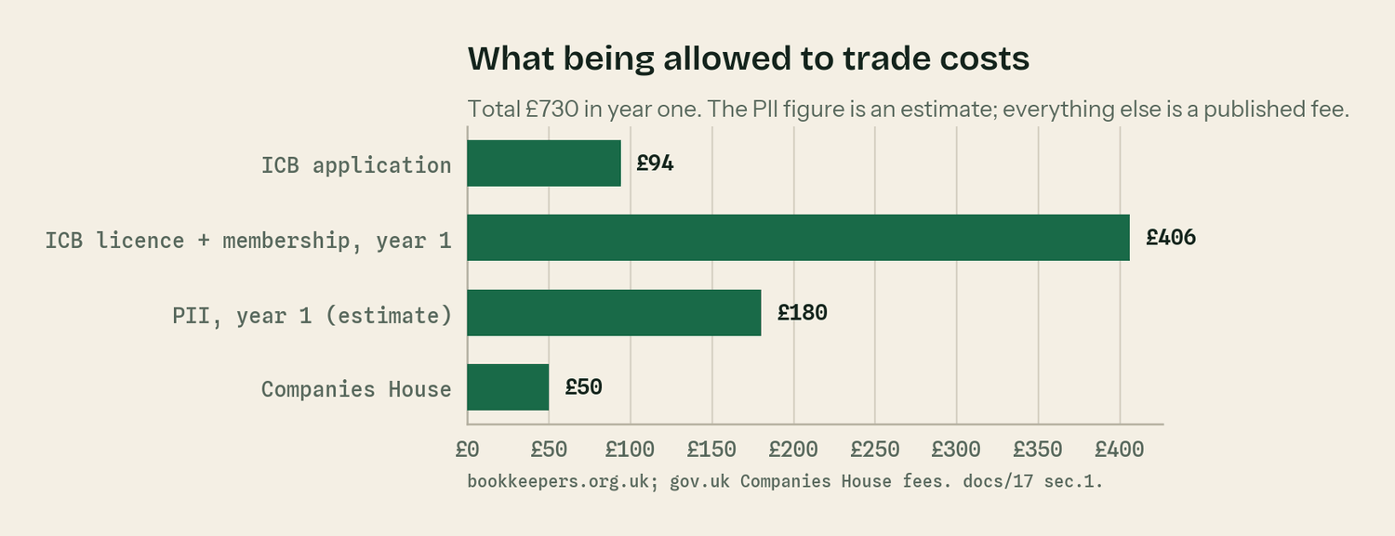
Total £730 in year one. The PII figure is the only estimate on the chart.
What Klyara can and cannot do before the licence lands
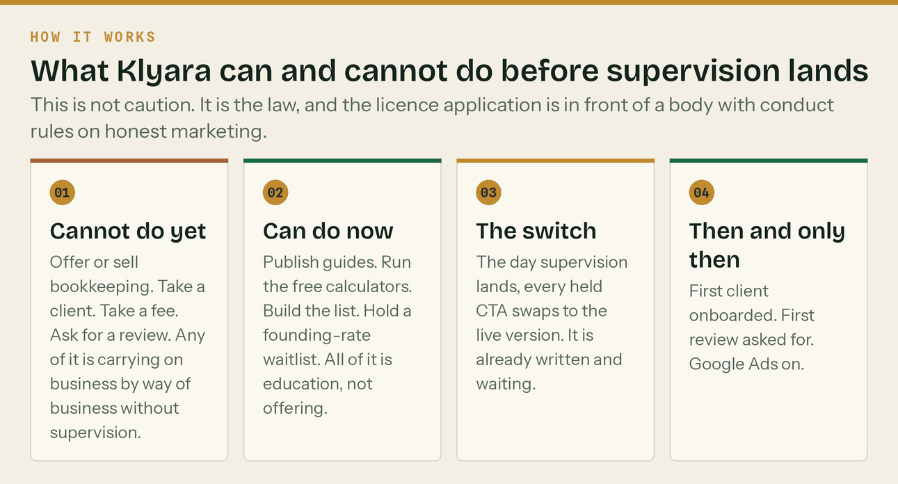
This is the law, not caution.
Publishing guides, running free calculators, building an email list and holding a founding-rate waitlist are all fine now. They are education, not offering. Offering or selling the service, taking a client, taking a fee or asking anyone for a review are not. Every call to action that sells is written and held, and swaps to the live version on the day supervision lands.
Two other legal points, said once
- The homepage currently carries invented testimonials. Fake reviews and testimonials are a banned practice under the Digital Markets, Competition and Consumers Act 2024, enforceable by the CMA. They also sit in front of a licence application to a body with conduct rules on honest marketing. Remove them before anything else in this plan happens. It takes ten minutes.
- Data protection. Client records are the client's. The software subscription is in the client's name precisely so that the data never becomes a lever, and a privacy notice and the client-facing paperwork are already drafted.
What could not be verified, and should be checked
- Whether Craig's qualifications route to ICB or AAT. Both are statutory supervisors and the same logic applies, but it changes the application.
- The professional indemnity insurance premium. Quotes vary by turnover and cover level; ICB members get a discounted route. £180 a year is an estimate in the model, and it is marked as one.
- The current HMRC list of MTD-compatible software. HMRC maintains it and it changes.
- CIS penalty amounts before they are published anywhere. They were verified against gov.uk on 26 August 2026 and they should be re-checked every April.

11. Risks, and what is being done about them

Likelihood and impact are scored one to five. The score is the product. Anything at fifteen or over needs a decision this month, not a note.
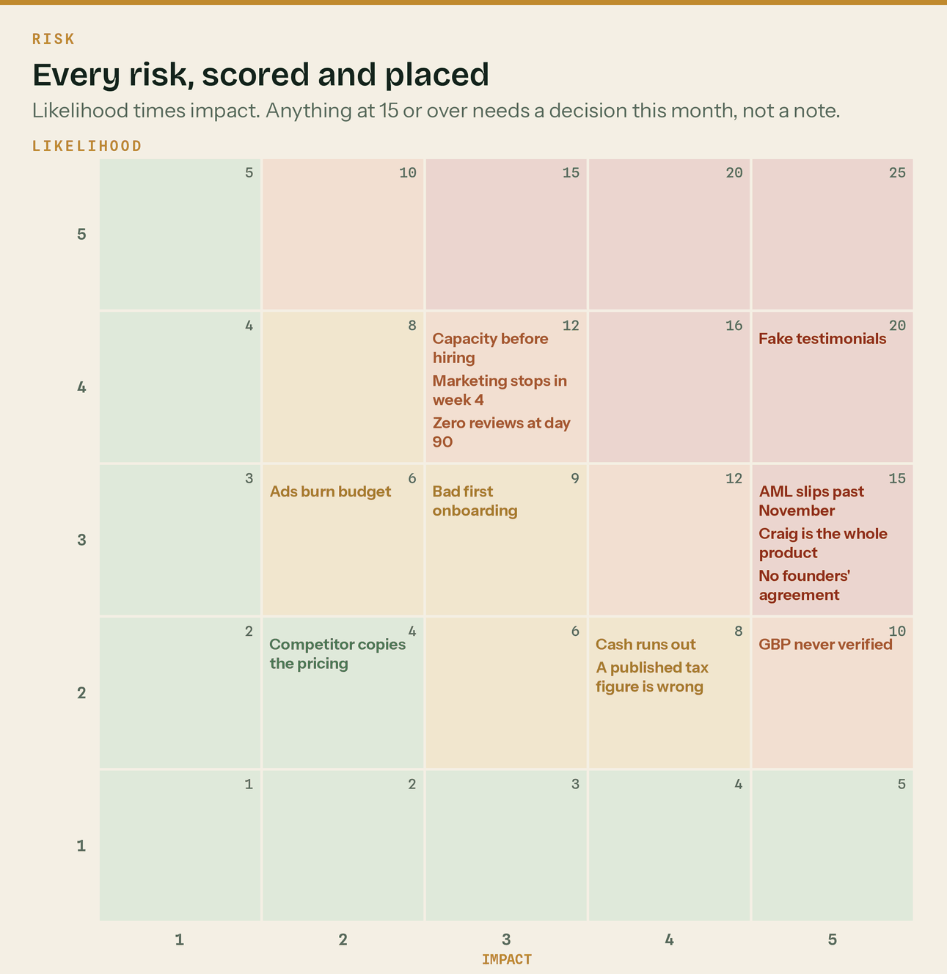
Every risk on the register, placed. Source: docs/20.
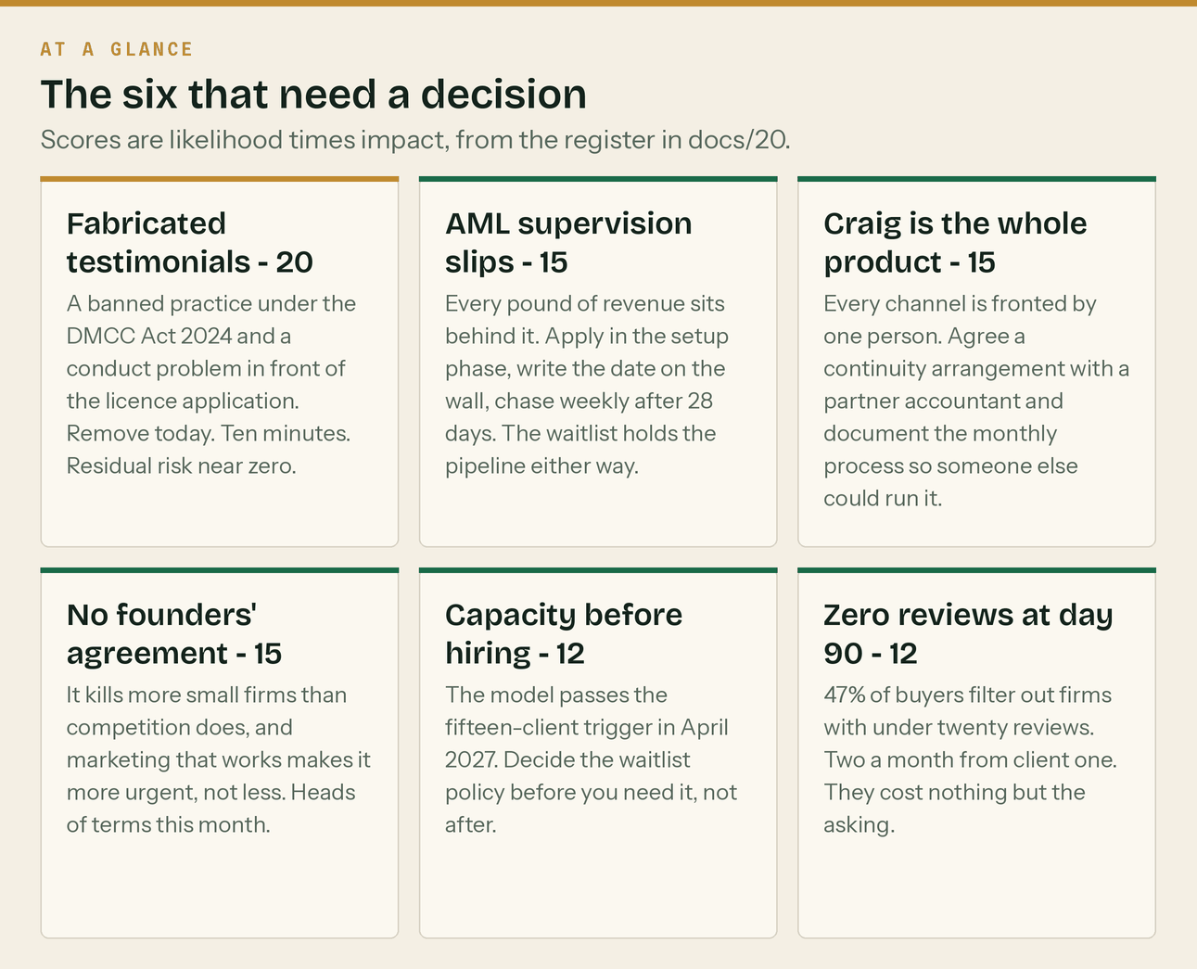
The six that need a decision.
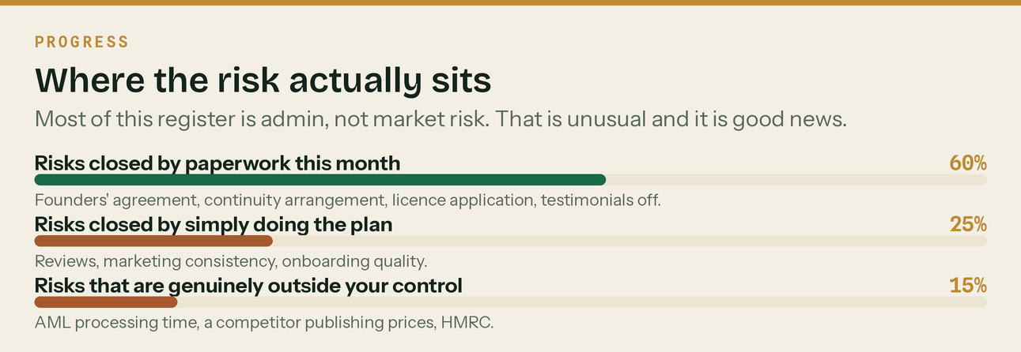
Most of this register is admin, not market risk.
Risk | Score | Mitigation | Early warning sign
1. Fabricated testimonials stay live | 4 x 5 = 20 | Remove today. Replacement copy is already written. | They are still there. That is the warning sign.
2. AML supervision slips past November | 3 x 5 = 15 | Apply via ICB in the setup phase. Chase weekly after 28 days. The waitlist holds the pipeline either way. | No application submitted by mid-September
3. Craig is the entire product | 3 x 5 = 15 | Continuity arrangement with a partner accountant. Document the monthly process so someone else could run it. | Any week Craig is unavailable and nothing ships
4. No founders' agreement | 3 x 5 = 15 | Heads of terms this month. It does not need to be elaborate; it needs to exist. | It still is not signed
5. Capacity arrives before hiring | 4 x 3 = 12 | Waitlist policy decided in advance. Recruit a month before the fifteen-client trigger, not after it. | 12 or more clients and no recruitment started
6. Marketing stops in week 4 | 4 x 3 = 12 | The fallback list names exactly what to protect and what to drop in a bad week. | Two consecutive missed Wednesday community slots
7. Zero reviews at day 90 | 4 x 3 = 12 | Ask at the first report handover, every time, with the link texted on the spot. | Three clients onboarded and no review asked for
8. Google Business Profile never verified | 2 x 5 = 10 | Start verification on day one of setup. It is a 5 to 14 day wait and the longest lead time in the plan. | No verification by day 14
9. Client 1 has a bad onboarding | 3 x 3 = 9 | Run the five-day onboarding runbook properly, every time. | Days from signing to live over 10
10. Cash runs out before revenue | 2 x 4 = 8 | £1,302 to start and break-even at five clients. The cash low point is month one. | Cumulative net still negative at month 4
11. A published tax figure is wrong | 2 x 4 = 8 | Never publish a figure that is not in the verified table. Re-check every April. | Anything published without checking gov.uk that week
12. Reddit or forum accounts banned | 2 x 4 = 8 | Read-only for the first fortnight. No signature or link until 8 to 10 genuine answers. | Any post removed by a moderator
13. Ads burn budget with no calls | 3 x 2 = 6 | A £40 per booked call kill rule, checked at £150 of spend. | £150 spent and cost per call over £40
14. A competitor copies the pricing play | 2 x 2 = 4 | Publishing first is most of the advantage. Reviews and the single-industry focus are the rest. | A local firm publishes tiered pricing

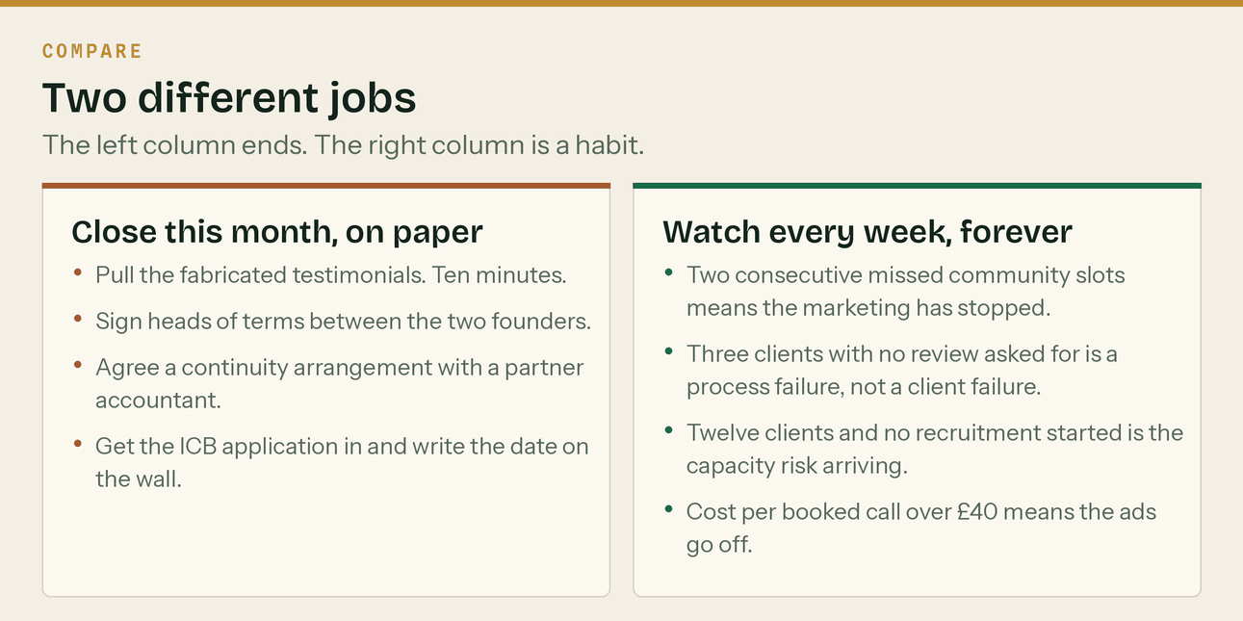
The left column ends. The right column is a habit.
The risk that is not on the register
The pack is bigger than the business. Twenty-seven documents, twenty web pages and a ninety-day plan is a lot of apparatus for a firm with no clients. There is a real risk of doing the marketing instead of doing the business — a satisfying Tuesday spent scheduling posts while nobody has been rung. If you are ever choosing between a post and a phone call, make the call.

12. Milestones

Every date below is computed, not typed. Nothing for Key or Craig is scheduled before Tuesday 1 September 2026.
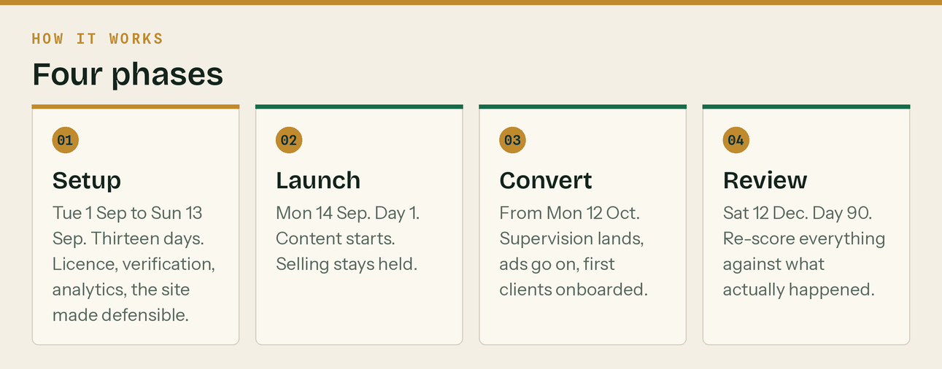
Four phases across the first ninety days.
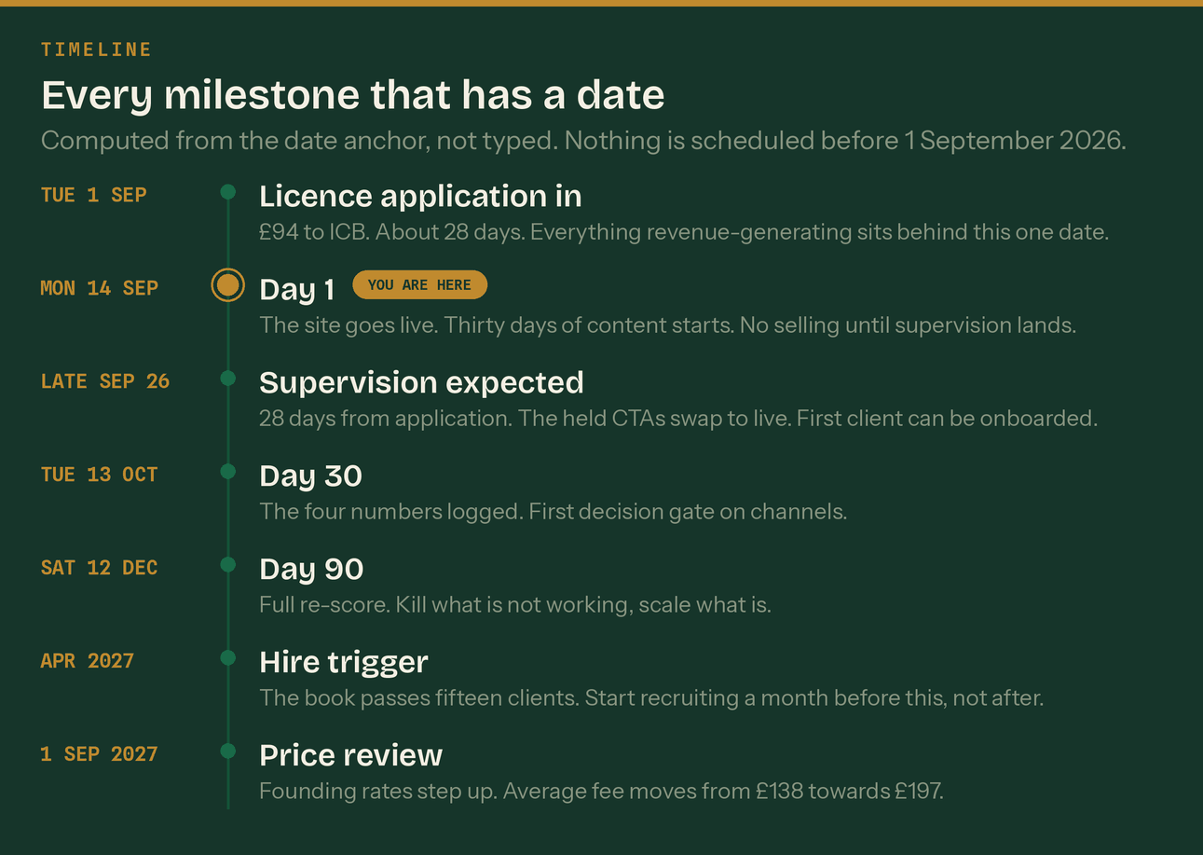
Every milestone that has a date on it.
Date | Milestone | Why it matters
Tuesday 1 September 2026 | Setup begins. ICB practice licence application submitted. | 28-day wait. Everything revenue-generating sits behind it.
Tuesday 1 September 2026 | Google Business Profile verification started. | 5–14 day wait. The longest lead time in the plan after the licence.
Sunday 13 September 2026 | Setup phase ends. | Site defensible, analytics live, email warm-up running.
Monday 14 September 2026 | Day 1. Launch. | The site goes live and thirty days of written content starts.
Monday 21 September 2026 | Twenty accountant partnership emails go out. | The fastest route to clients one to five.
Late September 2026 | AML supervision expected. | 28 days from application. First client can be onboarded.
Tuesday 13 October 2026 | Day 30 review. The four numbers logged for the first time. | First decision gate on channels.
Monday 19 October 2026 | First CIS filing deadline of the plan. | Month to 5 October. Klyara files on the 12th.
Saturday 7 November 2026 | MTD quarterly update deadline, quarter to 5 October. | It is a Saturday, so the work is done by Friday 6 November.
Thursday 12 November 2026 | Day 60. First clients onboarded and the first review asked for. | Reviews are the biggest single gap in the plan.
Friday 18 December 2026 | CIS deadline, month to 5 December. | The 19th is a Saturday, so file by Friday 18 December.
Saturday 12 December 2026 | Day 90. Full re-score of the risk register and the channel map. | Kill what is not working. Scale what is.
Sunday 31 January 2027 | Self Assessment deadline. | The busiest month of the year for this client base.
April 2027 | The book passes fifteen clients. Hire trigger. | Start the recruitment conversation a month earlier.
Monday 5 April 2027 | Tax year end. MTD £30,000 threshold takes effect the next day. | The single biggest demand event in the plan.
1 September 2027 | Founding rate review. | Average fee moves from £138 towards £197.

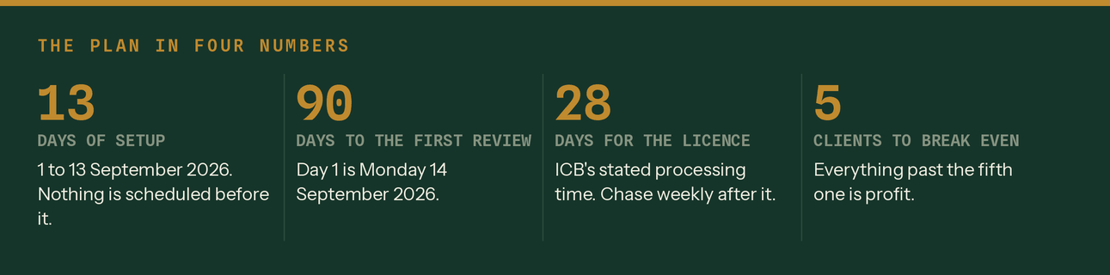
The plan in four numbers.
What good looks like at day 90: Google Business Profile verified with twelve weekly posts and five or more real reviews; five local pages indexed; 150 to 400 email subscribers; twenty accountants contacted with two to four conversations live; three to five clients onboarded, each live within five working days; eight to twelve booked calls a month.
And if only four things happen
Google Business Profile verified, the Guildford page live with schema, twenty accountant emails sent, and the weekly rhythm actually running — that is a successful ninety days. Everything else compounds off those four.

13. What happens in year two and year three

Two things drive years two and three, and neither of them is finding more customers.
The first is the founding-rate step-up. Every client passes their own twelve-month anniversary and moves to the standard rate, with sixty days' written notice. Across the twelve months from September 2027 the average fee moves from £138 to £197 without a single new client.
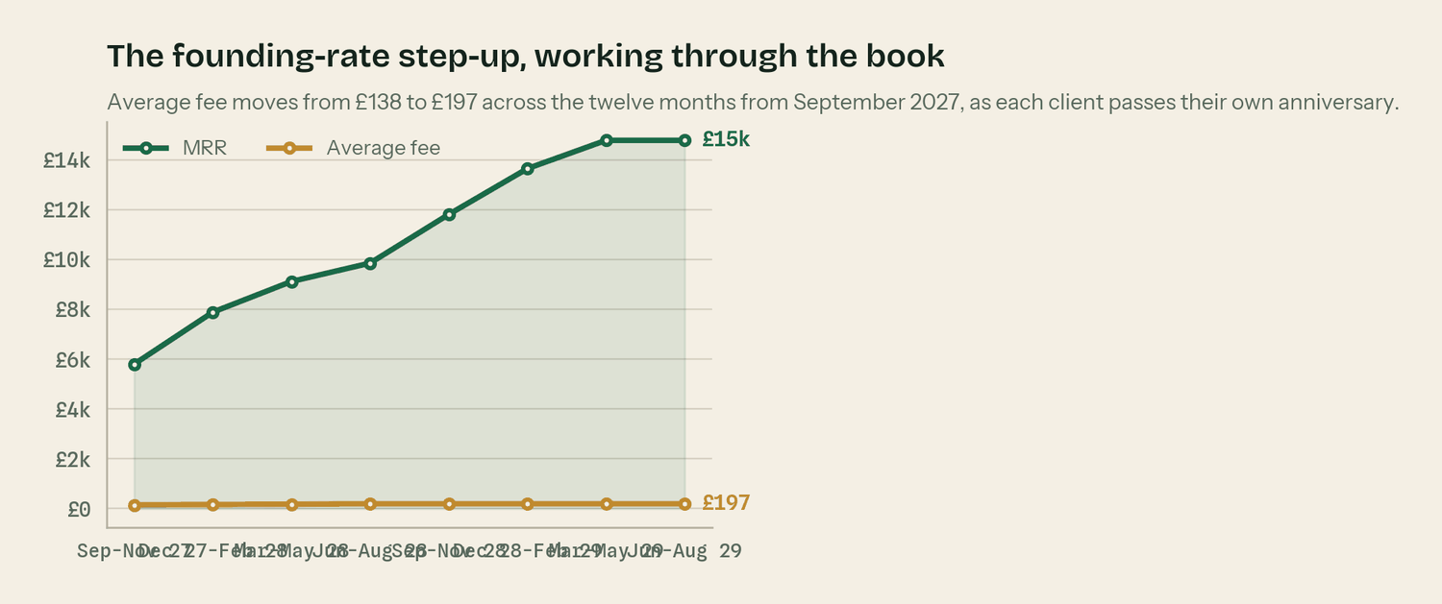
The step-up working through the book, client by client.
The second is capacity. The book runs into a wall twice — once in mid-2028 on two people and again in mid-2029 on three. Each time the choice is the same: hire, or hold a waitlist and let the price do the work.
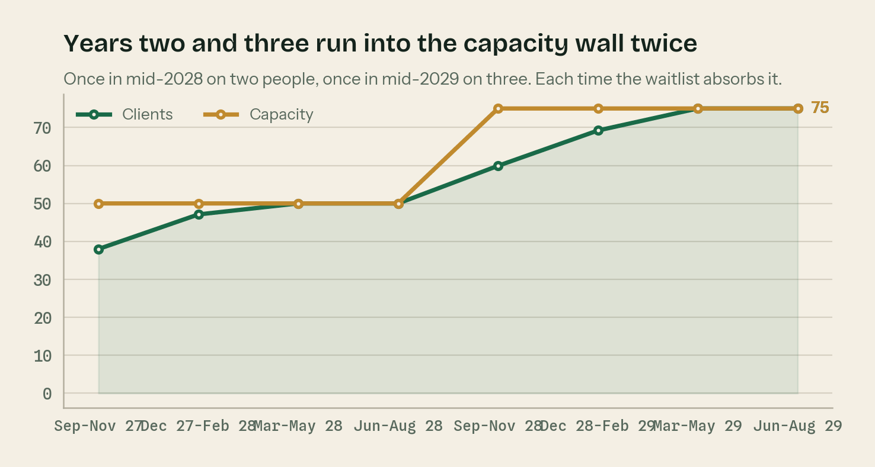
Capacity is a step. Demand is a slope.
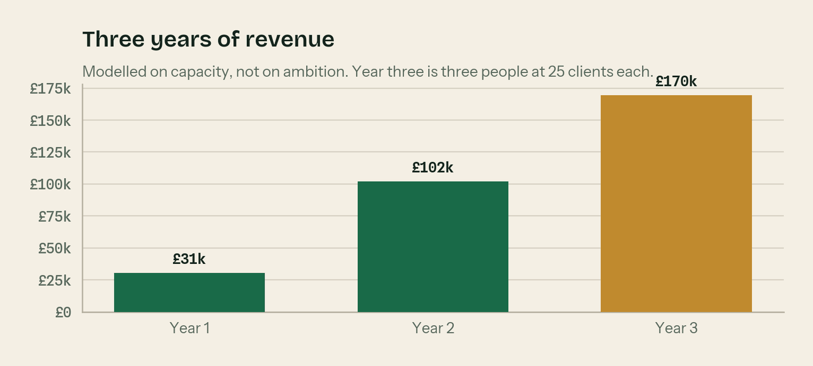
Modelled on capacity, not on ambition.
 | Year 1 (Sep 26 – Aug 27) | Year 2 (Sep 27 – Aug 28) | Year 3 (Sep 28 – Aug 29)
Revenue | £30,562 | £102,020 | £169,575
Costs | £10,855 | £44,852 | £80,939
Profit before founder pay | £19,707 | £57,168 | £88,636
Clients at year end | 28 | 50 | 75
Average monthly fee at year end | £138 | £197 | £197
People | 1 then 2 | 2 | 3
Closing cash | £23,153 | £75,241 | £159,144

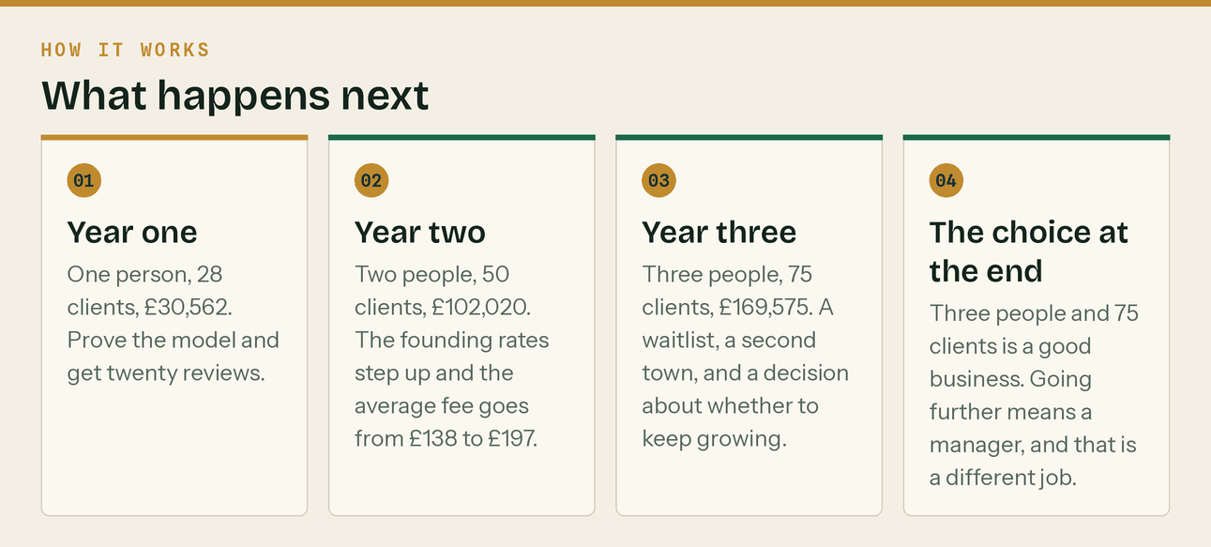
Three years, and the decision at the end of them.
Two things that happen to Klyara itself
- Klyara crosses the VAT registration threshold in the year to August 2028. Rolling twelve-month turnover reaches £102,020 against a £90,000 threshold, so registration takes effect from September 2028. The model has it dated and treated properly in the cash flow.
- Corporation tax becomes real. Year one tax is due nine months after the 31 August year end, which lands in the spring of 2028. The model sets it aside monthly rather than finding it later.
The choice at the end of year three
Three people and seventy-five clients is a good business — roughly £170,000 of revenue on a cost base that is mostly salary. Going further than that means hiring a manager, and that is a different job from the one described in this plan. It is worth deciding which one you want before the book forces the answer.

14. How to check any number in this plan

Every financial figure in this document comes from Klyara_Financial_Model.xlsx. It is a live workbook, not a picture of one. Blue cells are inputs and you can change them. Black cells are formulas. Green cells are links to another sheet.
Sheet | What it does
Read me | How to use it, what to change, what not to touch
Assumptions | Every lever in one place — prices, mix, funnel, churn, costs, capacity, the step-up
Startup costs | What it takes to get trading, with the estimates marked as estimates
P&L forecast | 36 months. Monthly for year one, quarterly for years two and three.
Cash flow forecast | The same 36 periods, with VAT and tax set aside properly and a cash low point
Break-even | Clients needed to cover fixed costs, at both mixes and with an employee
Pricing and margin | Cost to serve in hours, effective hourly rate, and the market comparator per tier
Dashboard | The six numbers that matter, all driven off the sheets above
Scenarios | Slow, plan and fast, driven by one input cell

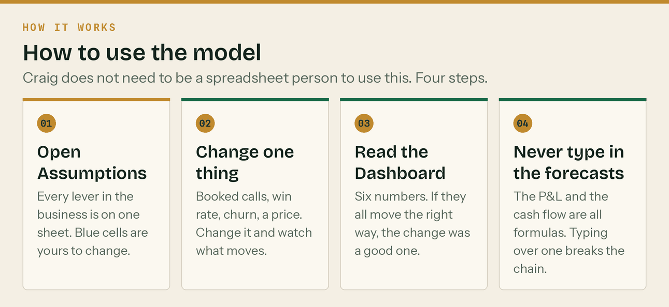
Four steps. No spreadsheet literacy required.
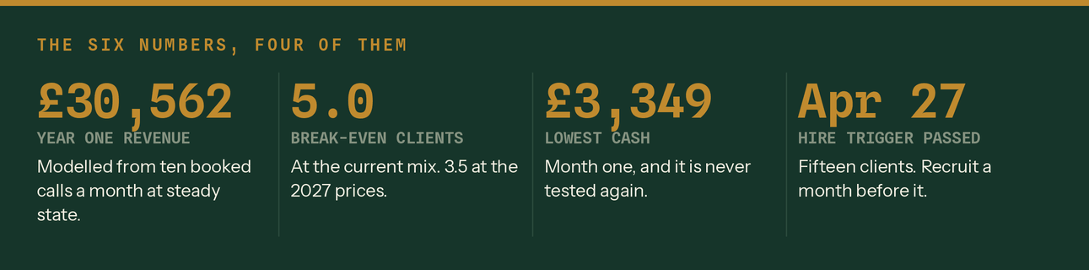
Four of the six numbers on the Dashboard.
Three assumptions are worth arguing about before anything else: ten booked calls a month at steady state, a 35% proposal win rate, and 2% monthly churn. Change any of them on the Assumptions sheet and every other number in the workbook moves. Replace all three with measured figures after six discovery calls and the model stops being a guess.
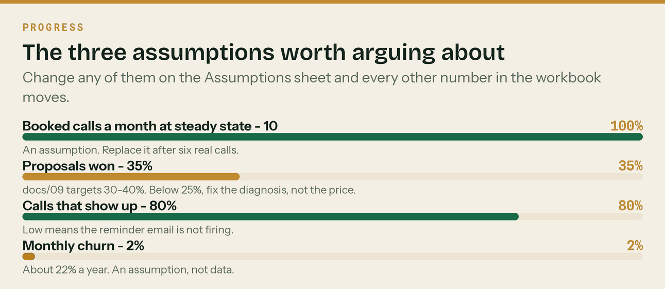
Change any of these and every other number moves.
One last time, plainly
Klyara has no clients and is not yet supervised. Every number in this plan is a model built on stated assumptions and real published market prices. It is not a forecast of what will happen. It is a description of what would happen if the assumptions hold — which is the only honest thing a plan for a business with no trading history can be.

