KLYARA the back office for building firms

Financial Summary
Klyara Ltd · The model, read out loud · Six charts and what each one means

This is Klyara_Financial_Model.xlsx with the spreadsheet taken off. Six charts, two sentences each. If you never open the workbook, this is the part you need.
Before any of the numbers
Klyara has no clients and is not yet AML supervised. Everything here is a model built on stated assumptions and real published market prices. It is not a forecast and it is not a promise. The first month a client can be onboarded is October 2026, because the ICB practice licence application goes in on Tuesday 1 September 2026 and takes about 28 days.

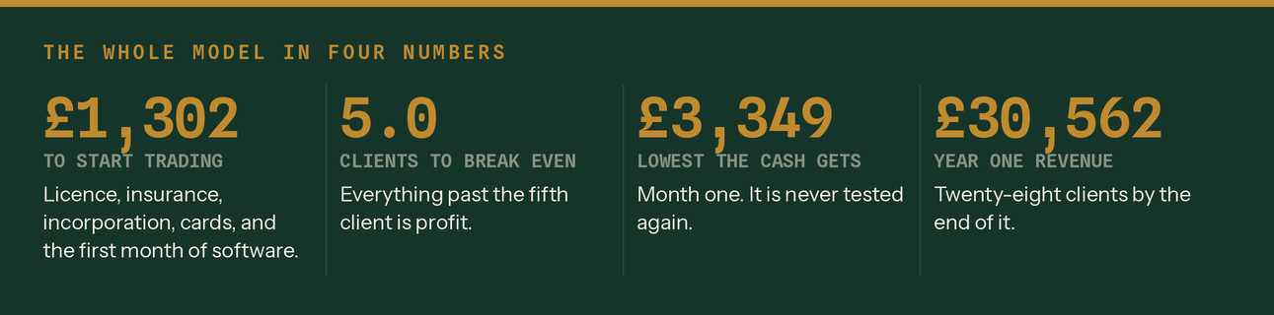
The whole thing in four numbers.
1. What comes in, and what goes out
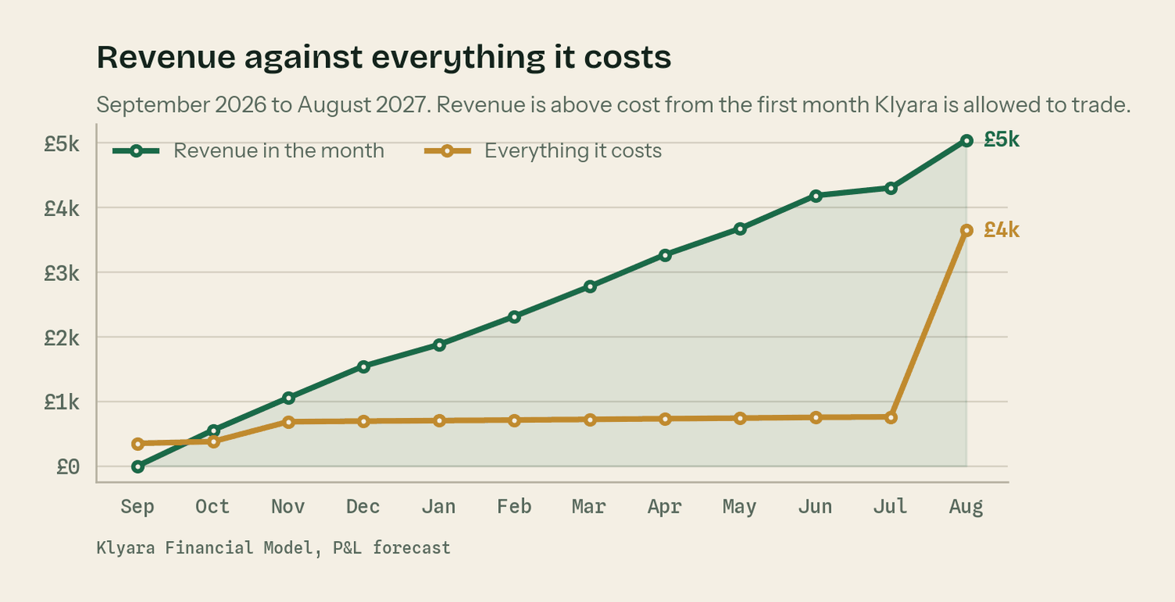
Source: Klyara Financial Model, P&L forecast.
Revenue is above cost from the very first month Klyara is allowed to trade, because the cost base is £673 a month and two clients cover most of it. The line stays above from then on.
The jump at the right-hand end is the first employee. One salary is £2,872 a month fully loaded, which is more than four times the entire rest of the cost base. That is the single biggest financial decision in the first two years.
2. How many clients keep the lights on
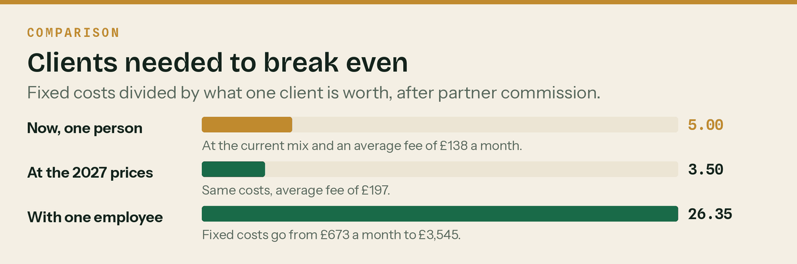
Fixed costs divided by what one client is worth after partner commission.
Five clients. That is the whole answer. £673 of fixed cost a month divided by £134.55, which is the average fee of £138 after the partner commission that gets paid on a quarter of the book. The model reaches five clients in December 2026.
The middle bar is the argument for the price review, and the right-hand bar is the argument for hiring on time. At the 2027 prices you need three and a half clients instead of five. With one employee you need twenty-six, so the book has to be nearly there before you hire.
3. The cash never gets tight
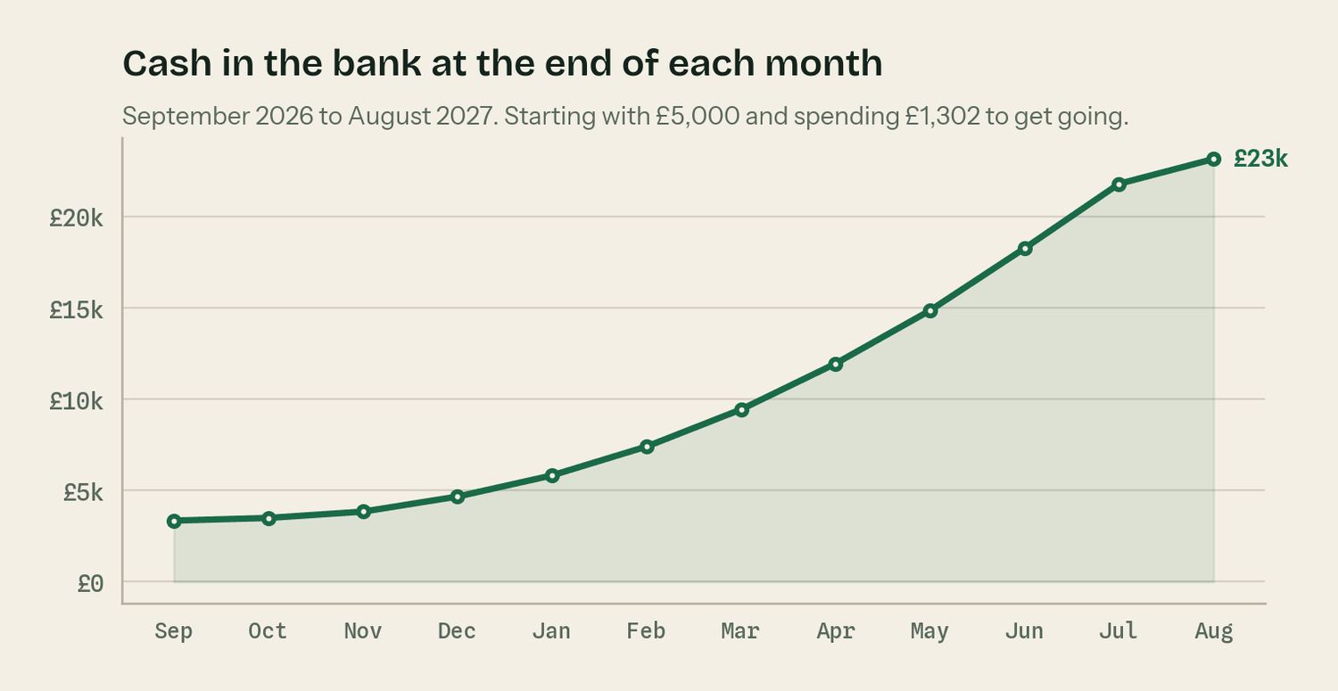
Opening balance £5,000, less £1,302 of start-up cost.
The lowest the bank account ever gets is £3,349, and that is in the first month — before there is any revenue at all. From October 2026 it only goes up.
That is because Klyara bills monthly in advance. Invoice on the 25th, direct debit on the 1st, so the money for a month is in the bank on the first working day of it. A practice billing in arrears waits thirty days longer for every pound. That is free, and it is the biggest structural advantage in the whole cash flow.
The money in the account that is not yours
Once Klyara is VAT registered — the model puts that at September 2028, when rolling twelve-month turnover crosses £90,000 — a fifth of everything that comes in belongs to HMRC. Corporation tax is another 19% of the profit. Both are shown as set aside from the moment they arise on the cash flow sheet. Run the business on the 'cash that is actually free' row, not the closing balance.

4. When you run out of hours
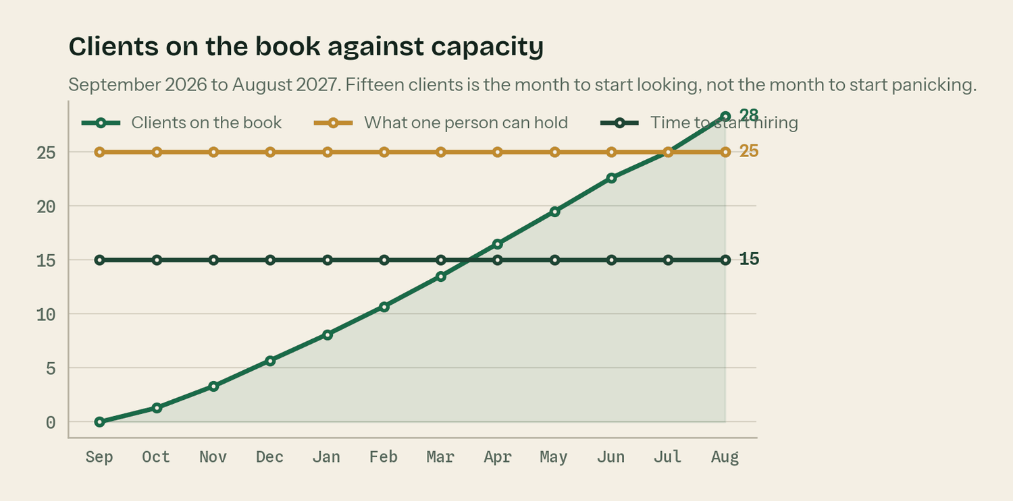
25 clients per person, hire trigger at 15. Source: Assumptions sheet.
One person can hold about twenty-five clients. At the planned mix that is roughly 71 hours of delivery a month, which leaves the rest of the month for selling, answering the phone and everything that takes longer than the estimate.
The book passes fifteen clients in April 2027, and fifteen is the trigger to start looking. Start the recruitment conversation a month before that, not after. If you leave it, the model shows a waitlist forming in month eleven — which is not a disaster, but it is a decision you want to have already made.
5. What the price review is worth
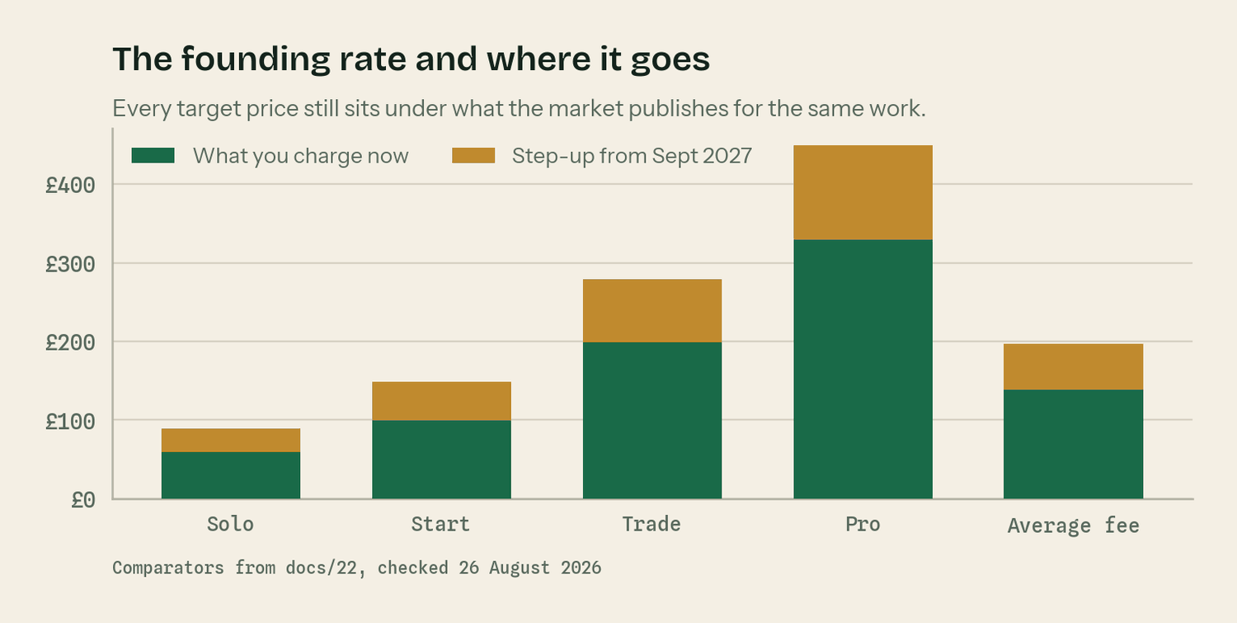
Comparators from docs/22, checked 26 August 2026.
Every client holds the price they joined on for twelve months, then moves to the standard rate. Across the year from September 2027 the average fee goes from £138 to £197 — a 42.8% uplift — without winning a single new client.
On twenty clients that is £14,160 a year, and you could lose five of them and still be ahead. Break-even on the increase is 14.01 clients. That asymmetry is why the words 'founding client rate, held for twelve months from the date you join' have to be said on day one. They cost nothing now and they buy the entire increase later.
6. Three years, if the assumptions hold
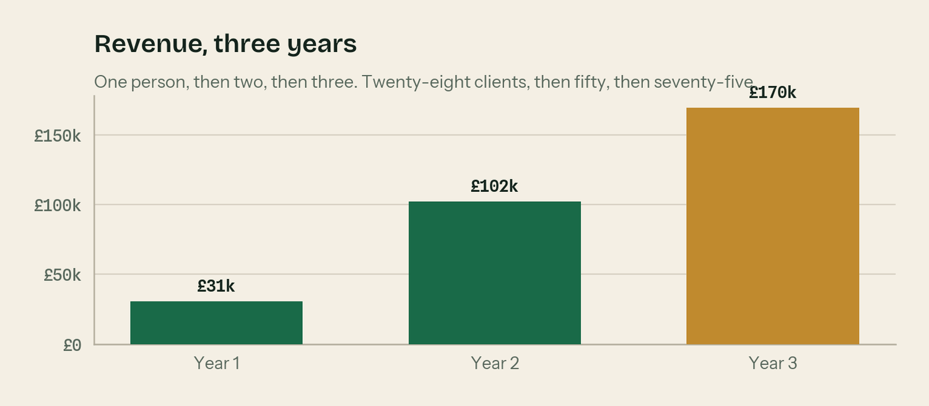
One person, then two, then three.
 | Year 1 | Year 2 | Year 3
Revenue | £30,562 | £102,020 | £169,575
Costs | £10,855 | £44,852 | £80,939
Profit before founder pay | £19,707 | £57,168 | £88,636
Clients at year end | 28 | 50 | 75
Average monthly fee at year end | £138 | £197 | £197
People | 1, then 2 | 2 | 3
Cash at year end | £23,153 | £75,241 | £159,144

Neither founder draws a salary anywhere in this model. Put a number on the Assumptions sheet and every profit figure moves. It is left at zero deliberately, so you can see what the business generates before anybody takes anything out of it.

The numbers behind the charts

What it costs to start
Item | Cost | Verified?
ICB practice licence, application | £94 | Published or quoted
ICB licence + membership, first year | £406 | Published or quoted
Professional indemnity insurance, first year | £180 | Estimate
Companies House incorporation | £50 | Published or quoted
Software stack, first month up front | £200 | Published or quoted
Merchant cards, 250 A5 at 300dpi | £40 | Published or quoted
tryklyara.com domain | £10 | Published or quoted
klyara.com renewal | £12 | Estimate
Print pack - cards, folders, forms | £60 | Estimate
Photography | £0 | Deliberate
Contingency | £250 | Estimate
Total | £1,302

The ICB practice licence is £94 to apply and £373 to £406 a year including membership. That is a published fee. The professional indemnity insurance figure is an estimate — get a real quote, because ICB members have a discounted route and the premium depends on turnover.
What it costs to run, every month
Cost | A month | Note
Software and tools stack | £200 | Included on every client plan, in their name
Scheduler | £24 | From month two
Google Ads | £300 | From month three, with a £40 per booked call kill rule
ICB licence and membership | £34 | £406 a year
Professional indemnity insurance | £15 | £180 a year — an estimate
Other and contingency | £100 | Phone, bank charges, the things nobody budgets for
Total fixed cost | £673 | This is the number break-even divides
Partner commission | 2.5% of fees | A quarter of the book at 10%. It varies, so it is not fixed.
First employee | £2,872 | £30,000 salary fully loaded. From month twelve.

What each tier earns an hour
Tier | Price | Hours a month | £ per hour | At the 2027 price
Solo | £59 | 1.25 | £47.20 | £71.20
Start | £99 | 2.00 | £49.50 | £74.50
Trade | £199 | 4.00 | £49.75 | £69.75
Pro | £329 | 7.00 | £47.00 | £64.14
Weighted average | £138 | 2.84 | £48.63 | £69.43

The standard from docs/21 is £45 to £60 an hour across the book, requote anything under £38 and walk away below £30. All four tiers clear it at the founding price. The hours are estimates and they are the first thing worth measuring — keep a note of time per client for one month and this table stops being a guess.

Using the workbook

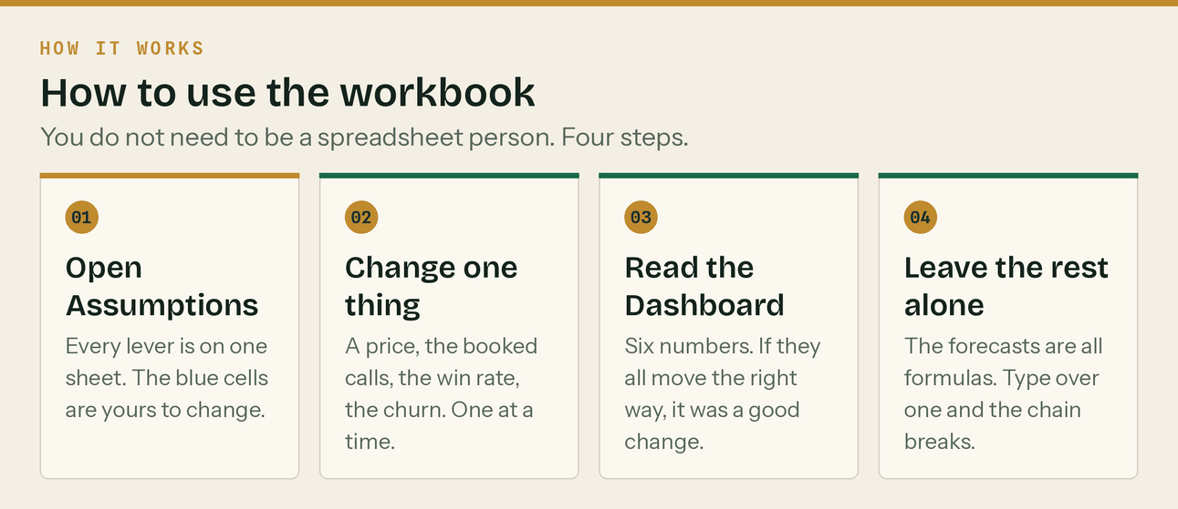
Four steps. No spreadsheet literacy required.
Colour | What it means
Blue on cream | An input. Change these.
Black | A formula. Leave it alone.
Green | A link to another sheet. Leave it alone.

There are nine sheets. Assumptions holds every lever. Dashboard holds the six numbers. Scenarios has one cell at the top — put 1, 2 or 3 in it for a slow, planned or fast year and read the answer underneath.
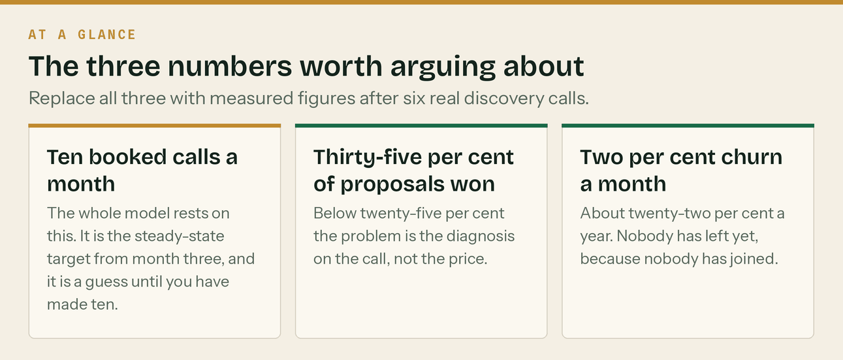
Replace all three after six real discovery calls.
What the scenarios say
All three survive. A slow year — three quarters of the booked calls, a one in four win rate, churn at 3.5% a month — still ends with fourteen clients, £15,026 of revenue and cash never below £3,059. A fast year passes the hire trigger in February 2027 instead of April. Klyara does not have a cash problem. It has a speed-of-growth question, and those are very different things to worry about.

One thing this model does that the old KPI workbook does not
It refuses to earn anything before AML supervision lands. The old pipeline model books half a client and £69 of revenue in September 2026. This one holds September at zero and starts in October, because that is what the law requires. It also caps new clients at what the team can actually serve, and shows the surplus as a waitlist rather than as revenue.

