KLYARA the back office for building firms

Credit note
Blank template · CIS and reverse charge handled correctly

Blank credit note — ready to use
Type over anything in [square brackets]. Delete the rows you do not need. Everything on this page is real Word text, so you can change it, save it and re-use it.

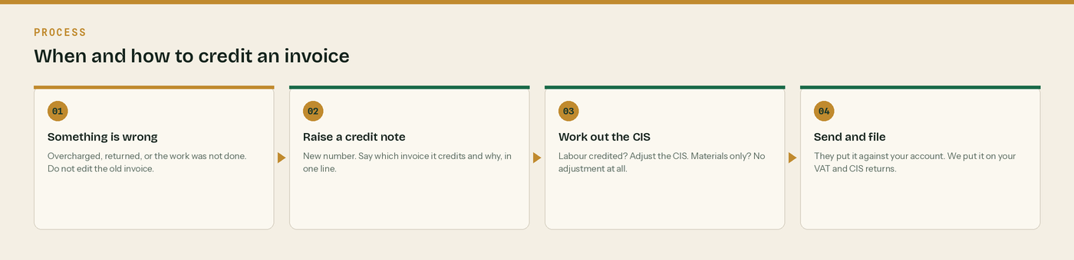
When and how to credit an invoice.
From | Credit to
[Your business name]  [Address line 1]  [Town]  [County and postcode]  VAT [registration number]  Company [number] | [Customer business name]  [Address line 1]  [Town]  [County and postcode]  For the attention of [name]

Credit note number | Date | Credits invoice | Invoice dated
[CRN-0000] | [date] | [INV-0000] | [date]

Why this credit note was raised
One line, in plain words. [What was wrong, and what is being put right.] This is the line that stops the query email six months from now.

What is being credited
Description | Type | Amount
[What you are crediting] | [Labour / Materials / Plant hired in] | £0.00
[Second line if you need it] | [type] | £0.00
Total credited, excluding VAT |  | £0.00

How the credit works through
Line | Working | Amount
Amount credited | [the total above] | £0.00
VAT | Reverse charge. [20]% of the credit is £[0.00], to reverse on their return. | £0.00
CIS adjustment | [20]% if you credited labour. £0.00 if you credited materials. | £0.00
Less retention already withheld on this line | [5]% of the credit | -£0.00
Credit to their account |  | £0.00
Retention they now hold on that invoice | [old figure] less [the line above] | £0.00

VAT: Reverse charge: customer to pay the VAT to HMRC
If the original invoice was reverse charged, the credit note is too. State the rate that would have applied, [20]% or [5]%, and the amount, £[0.00]. If VAT was charged normally, delete this box and credit the VAT in the normal way.

Get the CIS adjustment right
Materials, plant hired in or consumables credited: the CIS adjustment is £0.00. CIS never came off them. Labour credited: [20]% of the labour credited moves too. Tell us in the same month so your return agrees with the contractor's.

Three things to check before you send it

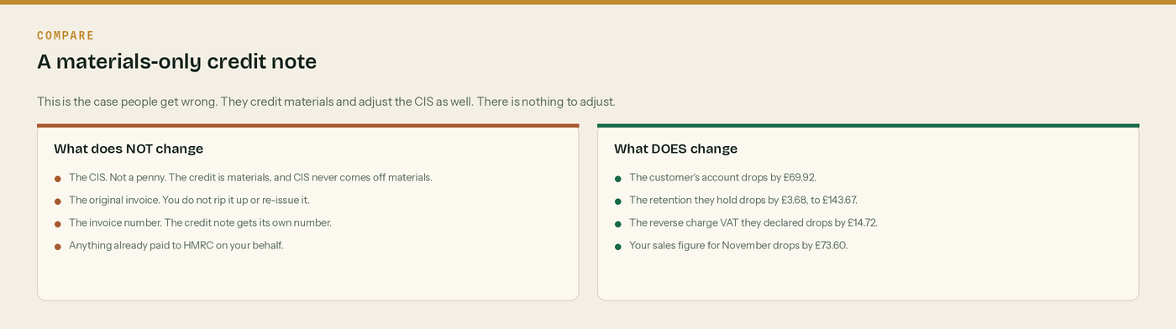
One. Have you worked out whether the CIS moves or not?
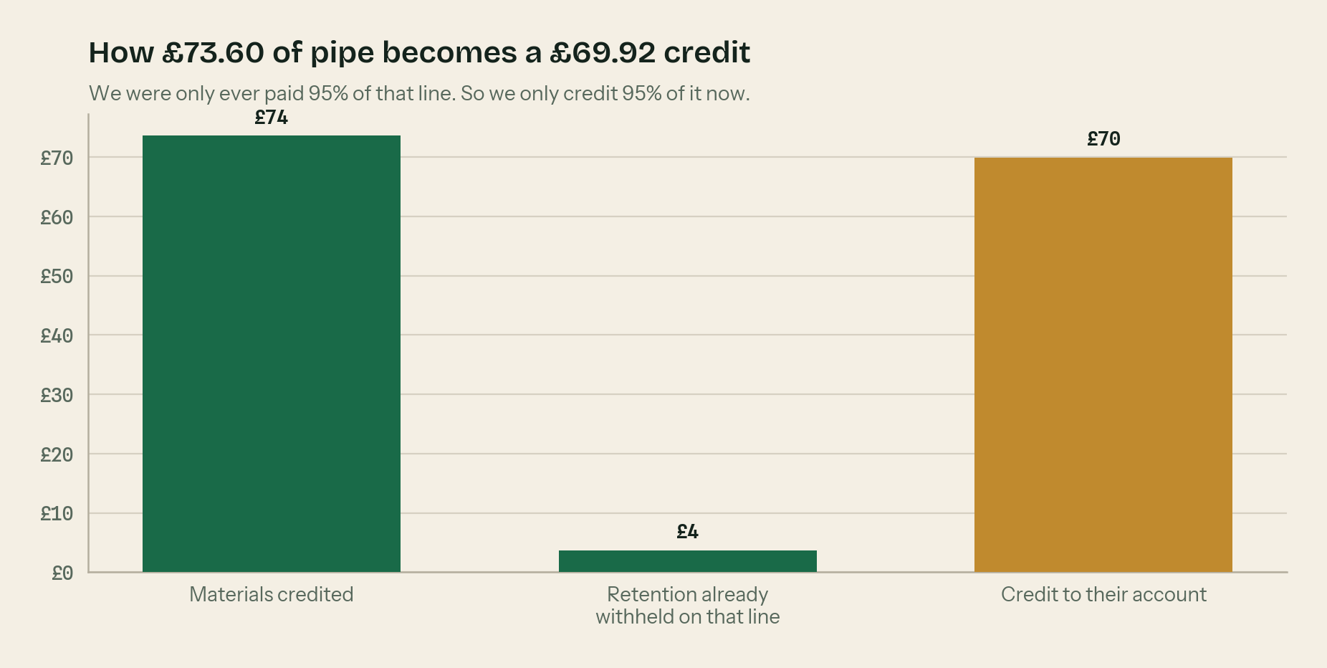
Two. Have you taken off retention that was never paid to you?

Three. Does it name the invoice it credits, and say why?

The rules behind a credit note

Never edit an invoice you have already sent
Once it has gone out and it is on a VAT return, it is a record. Correcting it by typing over the old one is how firms end up with two versions of the same invoice number and a very awkward VAT check. Raise a credit note instead.

Credit notes get their own number series
CRN, not INV. Same order, no gaps. A gap in the numbers is the first thing an inspector counts.

Say which invoice it credits, and why
One line. “Credits INV-2026-0184. Four lengths of 110mm pipe returned unused.” That single line is what stops the query email six months later.

Materials credited: no CIS. Labour credited: the CIS moves too.
CIS never came off materials, plant hired in or consumables, so there is nothing to put back. But if you credit £1,000 of labour that was paid under a 20% deduction, £200 of CIS goes back as well. Tell us in the same month so your return agrees with the contractor's.

Reverse charge credit notes carry the same wording
The credit note shows “Reverse charge: customer to pay the VAT to HMRC” and the rate that would have applied, exactly like the invoice did. The customer reverses that VAT on their own return.

WHERE THIS COMES FROM
Checked against gov.uk on Wednesday 26 August 2026. If a rate changes, the wording stays the same and only the number moves.
· What comes out before the CIS deduction (CIS 340) — https://www.gov.uk/government/publications/construction-industry-scheme-cis-340/construction-industry-scheme-a-guide-for-contractors-and-subcontractors-cis-340
· CIS deduction rates — https://www.gov.uk/what-you-must-do-as-a-cis-contractor/make-deductions-and-pay-subcontractors
· The wording HMRC accept on a reverse charge invoice (VATREVCON37100) — https://www.gov.uk/hmrc-internal-manuals/vat-reverse-charge-for-building-and-construction-services-manual/vatrevcon37100
· Retention payments and CIS (CISR15040) — https://www.gov.uk/hmrc-internal-manuals/construction-industry-scheme-reform/cisr15040

