KLYARA the back office for building firms

Invoice
INV-2026-0184 · a worked example with CIS, reverse charge and retention

Worked example — not a real job
Every name, number and date on this document is made up to show you how the form works. Klyara has no clients yet and this is not a record of any job. Replace the lot with your own.

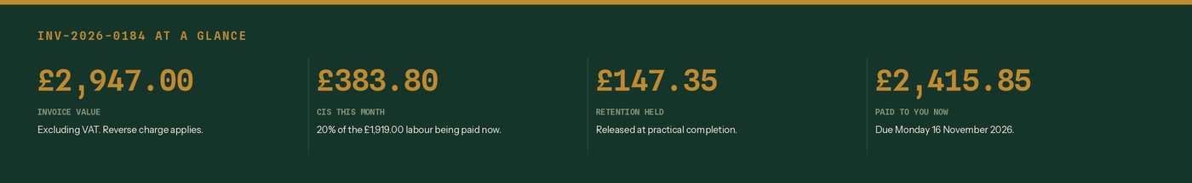
The four numbers that matter on this invoice.
From | Invoice to
Hatcher Groundworks Ltd  Unit 4, Ladymead Yard  Guildford  Surrey GU1 1DB  VAT GB 412 8890 55  UTR 1234567890  Company 09884412  CIS: Registered - net status (20%) | Pennistone Construction Ltd  Pennistone House, Chertsey Road  Woking  Surrey GU21 5BJ  For the attention of Marie Odell, Commercial  VAT GB 288 4417 02

Invoice number | Invoice date | Your PO reference | Payment due
INV-2026-0184 | Friday 16 October 2026 | PC-4471 | Monday 16 November 2026

Site | Payment terms | Retention
Plot 6, Wey Meadow  Cranleigh  Surrey GU6 8TF | 30 days from the invoice date.  30 days falls on a Sunday, so the next working day. | 5% held to practical completion

The work
Description | Type | Amount
Site strip and dig to formation, 340 sq m - 5 days | Labour | £1,400.00
Drainage run and connection to chamber IC2 | Labour | £620.00
Labour subtotal — the CIS is worked out on this |  | £2,020.00
MOT Type 1, 12 tonnes (merchant invoice attached) | Materials | £384.00
110mm pipe, bends and junctions | Materials | £212.00
1.5t excavator hired in, 3 days at £95 | Plant hired in | £285.00
Cutting discs, fixings, marker spray | Consumable stores | £46.00
Everything else — no CIS on any of it |  | £927.00

How the total is built up
Line | Working | Amount
Net total of the work | Labour, materials, plant and consumables | £2,947.00
VAT | Reverse charge. See the box below. | £0.00
Invoice total | The amount that goes on your VAT return as a sale | £2,947.00
Less retention at 5% | 5% of £2,947.00 | -£147.35
Less CIS at 20% | 20% of the £1,919.00 of labour being paid now | -£383.80
Amount payable now | By bank transfer, by 16 November 2026 | £2,415.85

VAT: Reverse charge: customer to pay the VAT to HMRC
The rate of VAT that would have applied is 20%, which on £2,947.00 is £589.40. That figure is shown for information only. It is not added to the invoice and it is not included in the total VAT charged. Pennistone Construction Ltd account for it to HMRC on their own return.

CIS: £383.80 deducted from labour only
20% of the £1,919.00 of labour being paid on this invoice. Nothing has been deducted from the £596.00 of materials, the £285.00 of plant hired in or the £46.00 of consumable stores. The £147.35 retention carries its own £20.20 of CIS when it is released.

Pay by bank transfer to | Detail
Bank | Lloyds Bank
Sort code | 30-96-14
Account number | 41889022
Reference to quote | INV-2026-0184

Retention held: £147.35
Released at practical completion. When it is paid, CIS of £20.20 comes off the labour part of it and £127.15 reaches the bank. Across both payments the CIS is £404.00, which is 20% of the £2,020.00 of labour. Chase it. Retention is the money most firms never see.

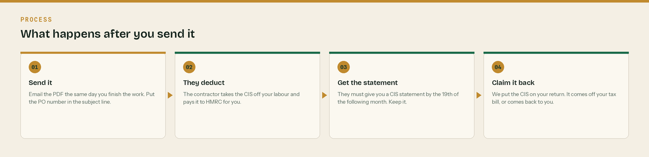
What happens after you send it. The third step is the one people forget.
Send page 1 only
Pages 2 onwards are notes for you, not for the customer. Delete them in Word before you send the invoice.

How the total is built up, in pictures

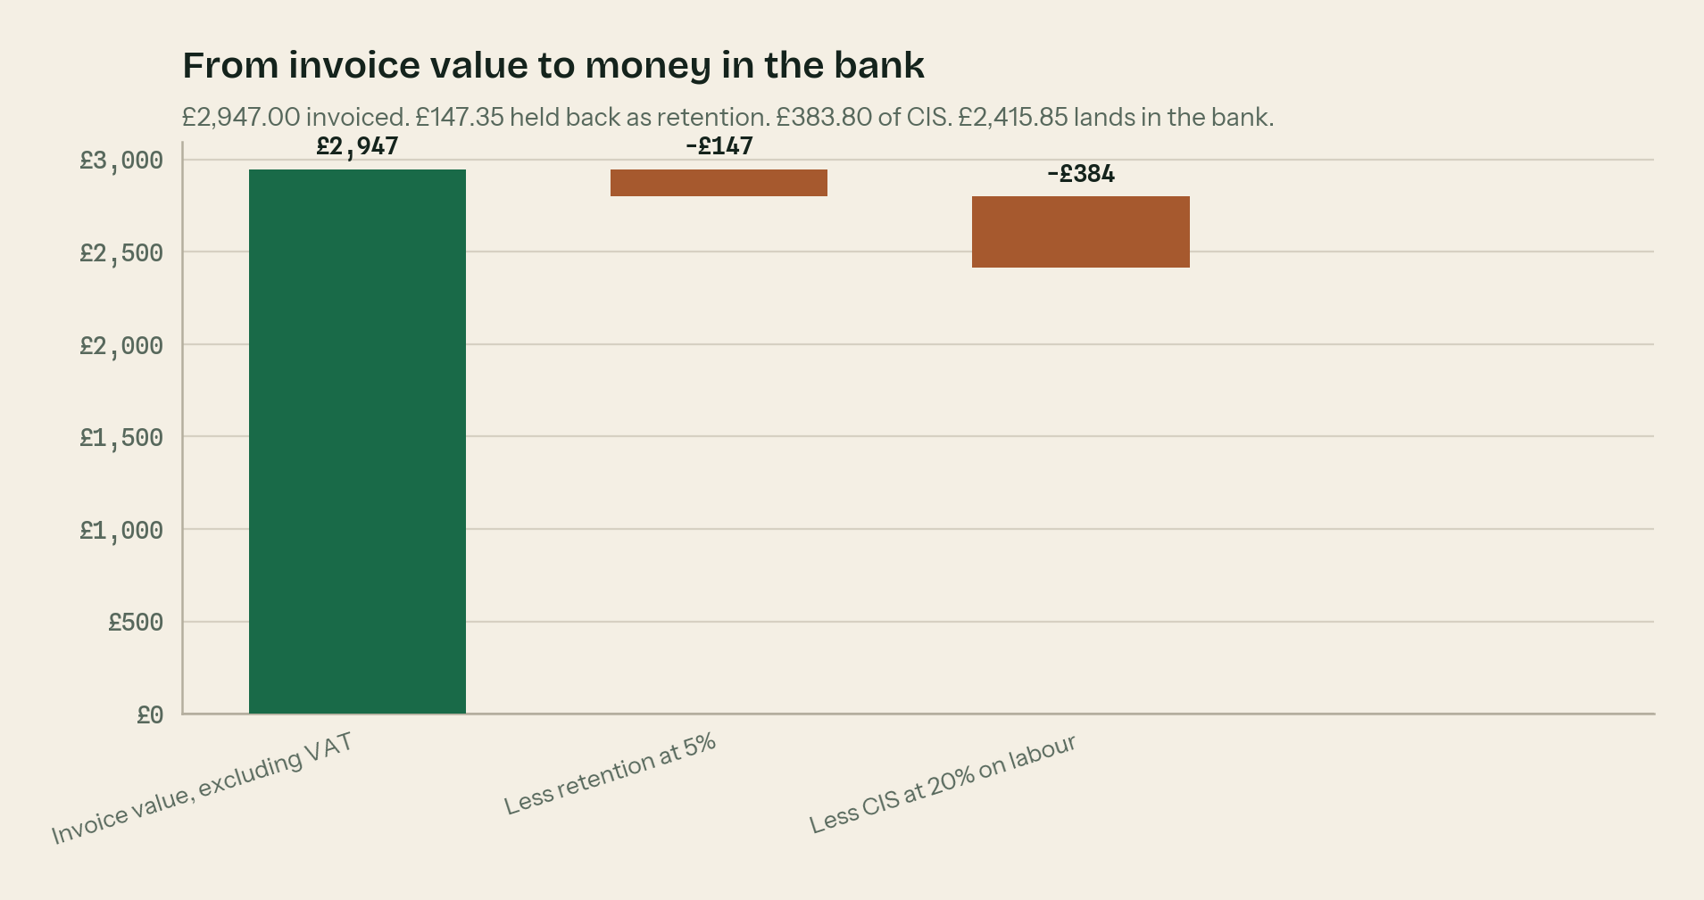
From £2,947.00 invoiced to £2,415.85 in the bank.
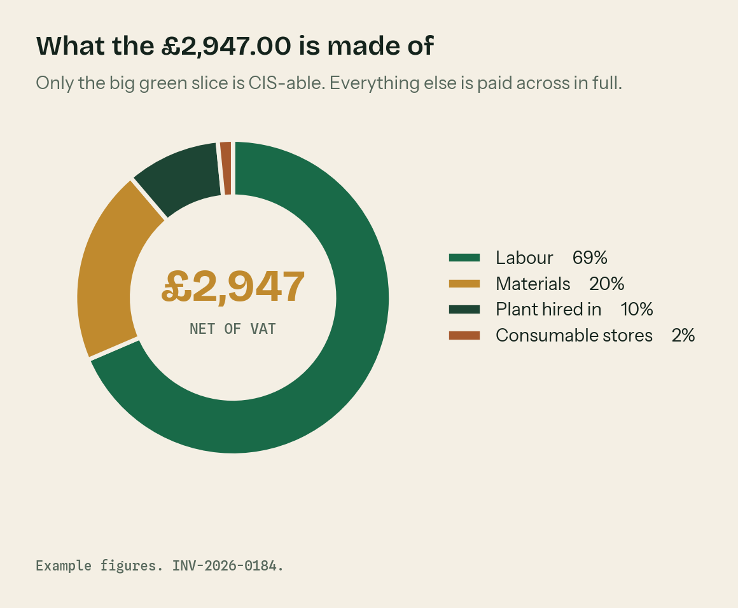
The same invoice split by type. Only the labour slice is CIS-able.
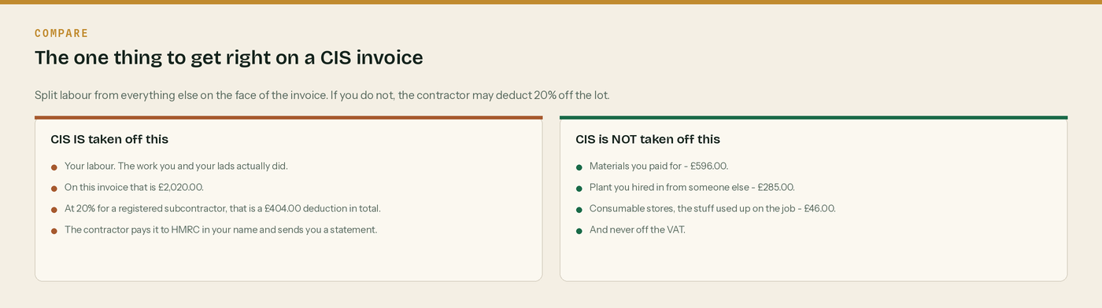
The rule that costs firms the most money when they get it wrong.

The rules behind this invoice

CIS comes off labour. Nothing else.
The deduction is worked out on the labour only. It never comes off materials you paid for, plant you hired in from someone else, consumable stores, fuel used on the job, or the VAT. Split them on the face of the invoice and the contractor has no excuse to deduct off the lot.

The three CIS rates
20% if you are registered with HMRC and paid under deduction. 30% if you are not registered, or HMRC cannot match you. 0% if you hold gross payment status. The contractor checks this with HMRC before every payment - it is not your choice on the day.

Reverse charge - the exact words
Where the reverse charge applies the invoice must say so. The wording HMRC give is “Reverse charge: customer to pay the VAT to HMRC”. Show the rate of VAT that would have applied - 20% standard or 5% reduced - and the amount, but do not add it to the total you are charging.

When the reverse charge does not apply
It only bites on standard rated and reduced rated construction work reported under CIS, between two VAT registered businesses. It does not apply to zero rated work. It does not apply if your customer has given you an end user or intermediary supplier declaration in writing. No written declaration means you still apply the reverse charge.

Retention is a separate payment
Money held back as retention has not been paid to you yet, so there is no CIS on it yet. When the retention is released it is treated as its own contract payment, split into labour and materials, and the CIS is worked out then. On this example that is £20.20 later, so £404.00 of CIS in total.

Keep the CIS statement
The contractor must give you a payment and deduction statement by the 19th of the month following the tax month the payment fell in. It is the only proof you have that the money went to HMRC. Photograph it into the app the day it lands.

WHERE THIS COMES FROM
Every rule on this page was checked against gov.uk on Wednesday 26 August 2026. If a rate changes, the wording stays the same and only the number moves.
· CIS deduction rates — https://www.gov.uk/what-you-must-do-as-a-cis-contractor/make-deductions-and-pay-subcontractors
· What comes out before the CIS deduction (CIS 340) — https://www.gov.uk/government/publications/construction-industry-scheme-cis-340/construction-industry-scheme-a-guide-for-contractors-and-subcontractors-cis-340
· When to use the VAT domestic reverse charge — https://www.gov.uk/guidance/vat-domestic-reverse-charge-for-building-and-construction-services
· The wording HMRC accept on a reverse charge invoice (VATREVCON37100) — https://www.gov.uk/hmrc-internal-manuals/vat-reverse-charge-for-building-and-construction-services-manual/vatrevcon37100
· End user and intermediary supplier declarations — https://www.gov.uk/guidance/vat-reverse-charge-technical-guide
· Retention payments and CIS (CISR15040) — https://www.gov.uk/hmrc-internal-manuals/construction-industry-scheme-reform/cisr15040

