KLYARA the back office for building firms

Job sheet
Print it. Take it with you. Fill it in with a pen.

How to use this sheet
Print one for every job. Write on it as you go, not from memory on Sunday night. Get it signed before you drive off. Then take a photo of it and send it in the same day.

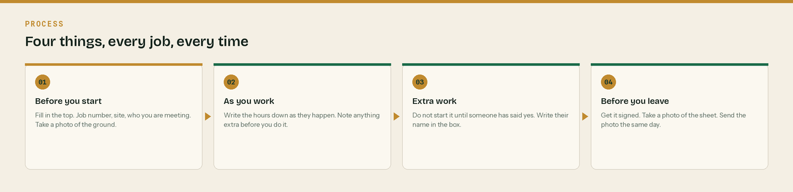
Four things, every job, every time.
Job number | Date | Day

Customer | Site address

Who you are meeting on site | Their mobile

What needs doing
Write it in your own words. One line per job.

Who was on site, and for how long
Name | Start | Break | Finish | Hours

Extra work — do not start it until someone says yes
No name, no payment
If you do work that is not on the sheet above, write it here and write the name of the person who told you to do it. Without a name it is your word against theirs in three months.

What the extra work was | Who told you to do it | When they said it

Materials and plant used on this job
What | How much | Whose it was — ours or hired in

Before you leave site
Tick | Check
[ ] | Photos taken of the work, before and after
[ ] | Site left clean and safe. Nothing left in the road.
[ ] | Everything hired in is accounted for
[ ] | This sheet is filled in, top to bottom
[ ] | This sheet is signed below
[ ] | Photo of this sheet sent to the office

Signed off on site
Customer signature | Print name | Date

Our signature | Print name | Date

Anything to come back for
What is left, and roughly when

Sketch or notes
Draw it if it is easier than writing it. Levels, runs, chamber positions, where the obstruction was.
Anything else worth having a record of

Why this sheet is worth five minutes

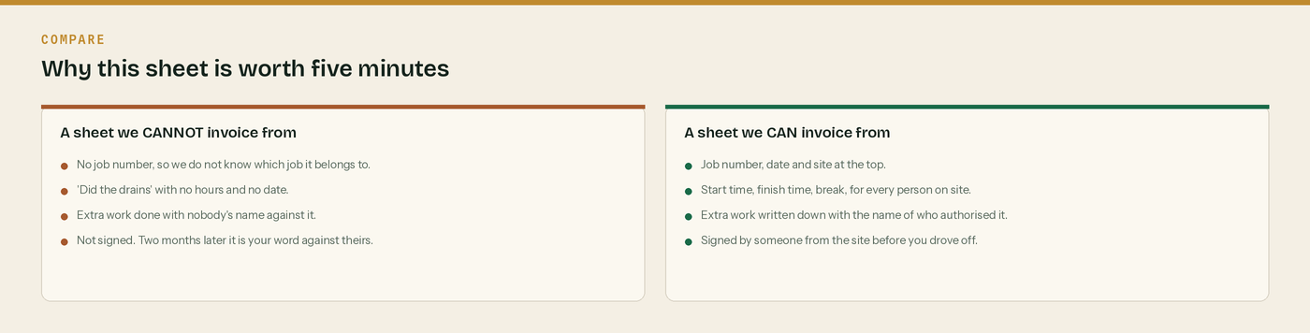
The left hand sheet costs you money. Every time.
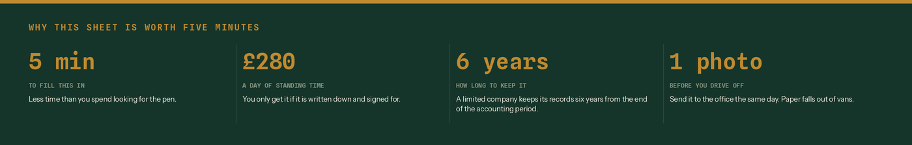
Four reasons to fill it in before you drive off.
And the four steps once more.
The sheet is where the invoice comes from
Hours on the sheet become hours on the invoice. If the hours are not written down, they get guessed, and a guess is always lower than the truth.

Extra work is where the money is
Variations are the most common thing a subcontractor does for nothing. Write it down, get a name against it, and it gets paid.

Materials and plant belong on here too
What you paid for yourself stays out of the CIS deduction. What you hired in from a third party stays out as well. The sheet is the first place that split gets recorded.

A photograph beats a bit of paper
Paper falls out of vans and goes through the wash. Photograph the sheet before you drive off and send it in the same day. The photo is the record.

Keep it for six years
A limited company must keep its records six years from the end of the last company financial year they relate to. Photograph it into the app and that looks after itself.

WHERE THIS COMES FROM
Checked against gov.uk on Wednesday 26 August 2026. If a rate changes, the wording stays the same and only the number moves.
· Keeping company and accounting records — https://www.gov.uk/running-a-limited-company/company-and-accounting-records
· What comes out before the CIS deduction (CIS 340) — https://www.gov.uk/government/publications/construction-industry-scheme-cis-340/construction-industry-scheme-a-guide-for-contractors-and-subcontractors-cis-340
· Approved mileage rates, if you claim travel off this sheet — https://www.gov.uk/government/publications/rates-and-allowances-travel-mileage-and-fuel-allowances/travel-mileage-and-fuel-rates-and-allowances

