KLYARA the back office for building firms

Purchase order
PO-2026-0043 · a worked example, materials for Plot 6

Worked example — not a real job
Every name, number and date on this document is made up to show you how the form works. Klyara has no clients yet and this is not a record of any job. Replace the lot with your own.


The four numbers on this order.
Order from | Order placed by
Guildford Building Supplies Ltd  Slyfield Industrial Estate  Guildford  Surrey GU1 1RU  Trade counter - Dan Pryce  Our account HAT0142 | Hatcher Groundworks Ltd  Unit 4, Ladymead Yard  Guildford  Surrey GU1 1DB  VAT GB 412 8890 55  Company 09884412

Order number | Date ordered | Required on site by | Job reference
PO-2026-0043 | Monday 12 October 2026 | Wednesday 14 October 2026 | J-2026-06 Wey Meadow Plot 6

Deliver to | Site contact | Access
Plot 6, Wey Meadow  Cranleigh  Surrey GU6 8TF | D. Cole, 07700 900118 | Gate open 07:00 to 16:30.  No deliveries after 15:30.

What we are ordering
Description | Quantity | Unit price | Amount
MOT Type 1 hardcore | 12 tonnes | £32.00 | £384.00
110mm underground pipe, 6m lengths | 8 lengths | £18.40 | £147.20
110mm bends and junctions - set | 1 set | £64.80 | £64.80

Line | Working | Amount
Net total | Goods only. Delivery is free over £250. | £596.00
VAT at 20% | Normal VAT. This is a supply of goods, not construction work. | £119.20
Order total | To pay on the monthly statement, 30 days. | £715.20

Why there is normal VAT on this order and none on our sales invoice
The reverse charge only applies to construction work reported under CIS between two VAT registered businesses. A builders merchant selling materials is supplying goods. So they charge 20% and we reclaim it. Our own invoice for the groundworks is reverse charged. Two different rules, same site.

Keep the delivery note with this order
The order, the delivery note and the merchant invoice all carry PO-2026-0043. That is what proves the £596.00 of materials was ours, which is what keeps the CIS deduction off it.

Raised by | Authorised by | Date
R. Hatcher | R. Hatcher, Director | 12 October 2026

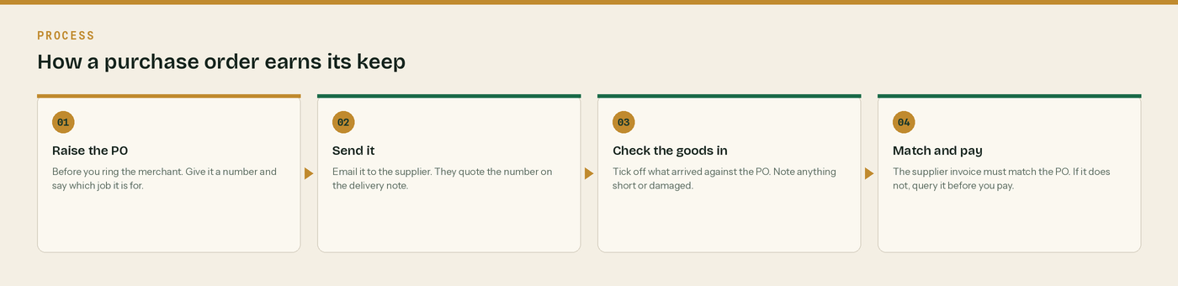
Four steps. The last one is where the money is saved.

Why we ask you to raise one every time

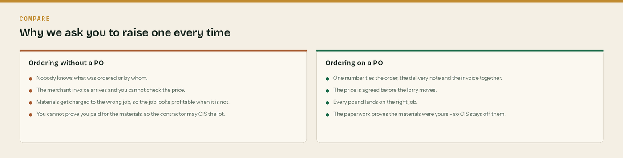
The difference a number on a bit of paper makes.
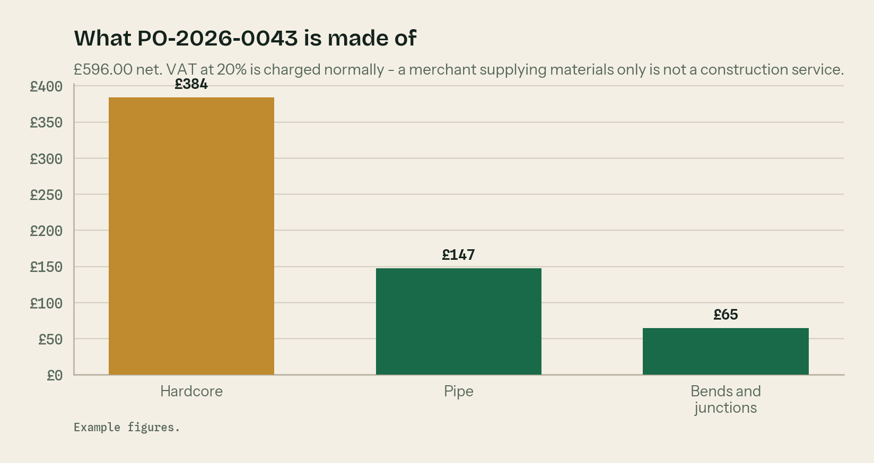
What this order is made of. Hardcore is two thirds of it.
Raise it, send it, check it in, match it. Then pay it.
A materials-only order is not a construction service
A merchant selling you hardcore and pipe is supplying goods, not construction work. So the reverse charge does not apply and they charge you VAT at 20% in the normal way. Reverse charge is for construction work reported under CIS, not for the builders merchant.

The PO is what keeps CIS off your materials
To keep materials out of the CIS deduction you have to show you paid for them yourself. A purchase order, a delivery note and a supplier invoice that all carry the same number is the cleanest proof there is. No proof, and the contractor is entitled to deduct 20% off the lot.

One number ties three pieces of paper together
The order, the delivery note and the supplier invoice. Put the PO number on all three and the month-end takes minutes instead of an afternoon.

Check the goods in on the day
Count it against the order before the lorry leaves. Write short deliveries and damage on the delivery note and get the driver to initial it. After the lorry goes it is your word against theirs.

Put the job reference on it
Every order belongs to a job. Without the job reference the cost lands nowhere and the job looks more profitable than it was.

WHERE THIS COMES FROM
Checked against gov.uk on Wednesday 26 August 2026. If a rate changes, the wording stays the same and only the number moves.
· What comes out before the CIS deduction (CIS 340) — https://www.gov.uk/government/publications/construction-industry-scheme-cis-340/construction-industry-scheme-a-guide-for-contractors-and-subcontractors-cis-340
· CIS deduction rates — https://www.gov.uk/what-you-must-do-as-a-cis-contractor/make-deductions-and-pay-subcontractors
· When to use the VAT domestic reverse charge — https://www.gov.uk/guidance/vat-domestic-reverse-charge-for-building-and-construction-services

