KLYARA the back office for building firms

Complaints Form
Four short sections. You do not have to use this form, but it makes sure we ask you nothing twice.

BEFORE YOU FILL THIS IN
You do not have to use this form. A phone call, an email or a letter all count and all start the same clock. The form exists because it collects everything in one go, which usually means we can answer you faster.
There is no wrong way to complain
Write it however you like. Do not worry about tone, do not worry about spelling, and do not soften it. We would much rather have it straight.

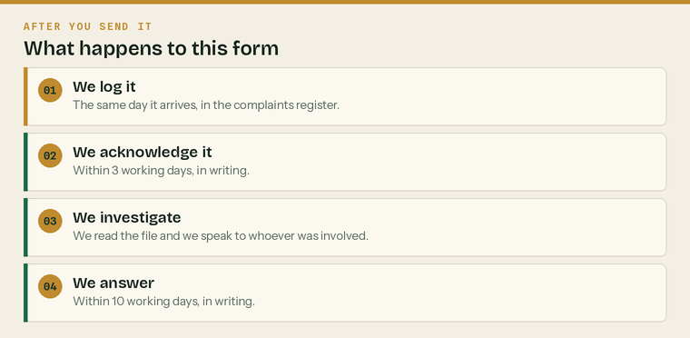
What happens to this form once it reaches us.
The clock, in one line each
 | Acknowledged | Within 3 working days, in writing
 | Answered | Within 10 working days, in writing
 | Reviewed by a second director if you ask | Within 20 working days
 | Kept in the complaints register | For six years


Your name
Business name | if this is about work we did for a business
Address
Postcode
Mobile
Email
How you would like us to reply | phone, email or letter
Best time to ring you

Are you
 | A client |  | A former client |  | An employee
 | A subcontractor |  | Somebody else

If somebody else, your connection to Klyara
If you are complaining on somebody's behalf, their name
Do you have their written permission? | we will need it before we can discuss their affairs


Tell us what happened, in your own words. If it helps, work through it in order — what you expected, what actually happened, and when you first noticed.
What happened
Use as much space as you need. Continue on the back or on another sheet.

When did it happen? | a rough date is fine
When did you first notice?
Who did you deal with? | if you know
Have you raised it with us already? | yes or no
If yes, when, and with whom?
What were you told?

What kind of thing is it?
Tick anything that applies
 | A deadline was missed |  | The work was wrong
 | An invoice or fee |  | We were slow to answer
 | How we spoke to you |  | Something about your data
 | Something else

Anything you are sending with this form
Emails, letters, invoices, screenshots. List them here so we can tick them off.


This is the most useful question on the form and the one people most often skip. Tell us what would actually resolve it. It is usually simpler and cheaper than we would have guessed.
What would put this right?
An explanation, an apology, the work redone, a fee credit, or a change to how we do something. Say what you actually want.

What we can and cannot do
We can | We cannot
Explain what happened, honestly | Undo a filing deadline that has already passed
Redo work at our own cost | Overturn an HMRC decision
Credit or refund a fee | Give you legal advice about a dispute
Change how we do something | Discuss another person's affairs without their consent
Put you in touch with the ICB or the ICO | Speed up HMRC

If a deadline is at risk while this is being sorted out
Tell us on the phone as well as on this form. We will always protect a statutory deadline first and argue about the complaint afterwards. Nobody should collect a penalty because a complaint was in progress.


Sign and date it, then send it however suits you.
How to send it | Where
Email | hello@klyara.com
Post | Klyara, [address]
By hand | Give it to either director
Photograph it | Take a picture of each page and email or WhatsApp it — that is fine

Signatures
You | the person complaining
Signed | Print name
Position | Date

What we do with what you write here
We use it to investigate and answer your complaint, and we keep it in our complaints register for six years. We do not use it for anything else and we do not share it, except with our insurer if it might become a claim, or with our professional body if they ask to see it. Our Privacy Notice has the full detail and explains your rights over this information.

For Klyara use

Do not send this page to the client. It stays on the file.
Date received
How it arrived | phone, email, post, in person
Logged in the complaints register on
Reference
Handled by
Date acknowledged | must be within 3 working days
Insurer notified? | yes, no, or not applicable
If yes, date notified
ICO notification needed? | only if there is a reportable data breach
Stage 1 answer sent | must be within 10 working days
Stage 2 requested? | yes or no
Stage 2 answer sent | must be within 20 working days

Immediate escalation check
 | Does it allege dishonesty? | Both directors, and the insurer, the same day
 | Could it become a claim? | Notify the professional indemnity insurer now, not later
 | Is there a data breach? | 72-hour clock to the ICO if it is reportable
 | Is a statutory deadline at risk? | Fix the filing first, then handle the complaint
 | Has the professional body been involved? | Both directors, same day

Root cause — what in the process allowed this?
Not who made the mistake. What would have caught it.

What changed as a result, and by when
A specific process change with a date. Not a promise to be more careful.

Sources
Every figure and deadline in this document was checked against the page listed beside it on Wednesday 26 August 2026. Re-check before each use — thresholds and penalties change.
What was checked | Source
Complaining to the ICO, and complaining to the organisation first | https://ico.org.uk/make-a-complaint/data-protection-complaints/
ICB Professional Conduct Regulations — the conduct route for members | https://www.bookkeepers.org.uk/out/262546/ICB-Professional-Conduct-Regulations.pdf
ICB Complaints Policy — address, telephone and timescales | https://www.bookkeepers.org.uk/out/189133/ICB-Complaints-Policy.pdf
One calendar month to answer a data protection rights request | https://ico.org.uk/for-the-public/time-limits-for-responding-to-data-protection-rights-requests/

