KLYARA the back office for building firms

Engagement Letter
The covering letter, the Schedule of Services, and the fee. Signed once, held for twelve months.

Read this before you use this document
This is a working template. It has been drafted carefully and checked against the sources listed at the end, but it is not legal advice and it has not been settled by a solicitor. Have it reviewed by a solicitor, or by the Institute of Certified Bookkeepers, before you issue it to anybody. And it cannot be used to take on a bookkeeping client until Klyara's AML supervision is in place — an ICB Practice Licence includes AML supervision and takes about 28 days to process. Until that licence is granted, Klyara cannot lawfully carry on bookkeeping by way of business.

HOW TO USE THIS TEMPLATE
Replace everything in [square brackets]. Delete the schedule rows that do not apply to the plan the client is on. Send it with the direct debit link in the same email, and with the Terms & Conditions and the Privacy Notice attached — this letter does not stand on its own.
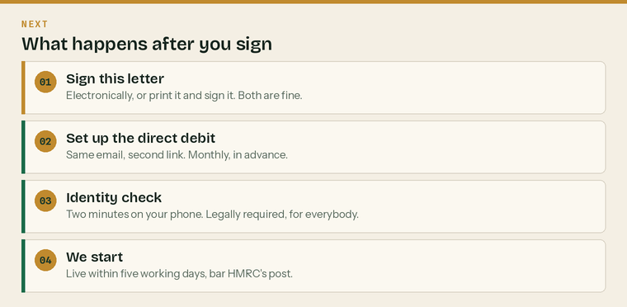
What the client does after they sign. Four steps, and only two of them are theirs.
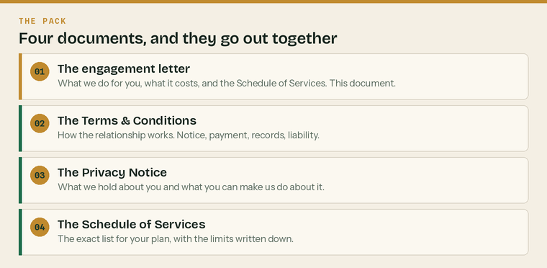
This letter does not stand on its own. Four documents go out together.
Before you send it
 | Fee and plan agreed on the call |  | Liability cap decided, with advice
 | Professional indemnity cover in place |  | AML supervision granted
 | Schedule 1 trimmed to their plan |  | Direct debit link ready in the same email

The letter

Client name
Business name
Address
Date of this letter
Start date of the engagement
Plan | Solo, Start, Trade or Pro
Monthly fee, excluding VAT | £

Dear [Name],
Bookkeeping, VAT, CIS and payroll for [Business name]
Thank you for asking Klyara to look after the books. This letter sets out exactly what we will do, what it costs, and how either of us ends it. It is deliberately short. The detail sits in the Schedule of Services below and in our Terms & Conditions, which are attached and form part of this agreement.
What we are doing for you. You are on the [Plan] plan. Everything in Schedule 1 below is included in the monthly fee. Anything not in Schedule 1 is out of scope — we will still do it, but we will tell you the price before we start and we will not begin until you have said yes in writing. Schedule 2 is our published rate card for that work.
What it costs. £[FEE] a month plus VAT, billed monthly in advance. The invoice is issued on the 25th of the preceding month and collected by direct debit on the 1st. Standing order is accepted if direct debit does not suit.
Your fee is held for twelve months
£[FEE] is a founding client rate and it is held for twelve months from your start date. It will not go up inside that period for any reason. At the end of the twelve months we will write to you at least sixty days before any change, telling you the new figure and the date it takes effect. After that first review, any increase is small, predictable, in the same month each year, and always with sixty days' written notice.

Ending it. Thirty days' notice, in writing, either way. There is no minimum term, no tie-in and no exit fee. You do not have to give a reason and we will not ask for one.
Your records stay yours. Your software subscription is included in the fee and it is set up in your name, not ours. Your records, your data and your logins belong to you at all times. If you leave, everything stays where it is and we hand over cleanly. We will never hold records back over money — a fee dispute is chased as a debt, separately, and never by making your own books hard to reach.
What you need to do. Get your records to us by the 10th of each month. That one habit is what makes the rest of it work. Tell us straight away if anything changes — a new subcontractor, a new employee, a VAT registration, a new bank account. And answer the identity check quickly, because we cannot lawfully start until it is done.
If any of this is not what you expected, ring me on 020 8058 1496 before you sign it.
Yours sincerely,

[Name]
Klyara
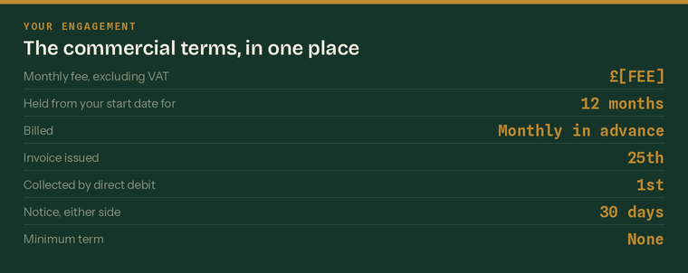
The commercial terms, in one place. Everything above, on one line each.
Schedule 1 — Services

Tick the plan that applies and delete the rest. The limits are real limits: they are what makes a fixed fee survivable, and they are the reason your fee does not creep.
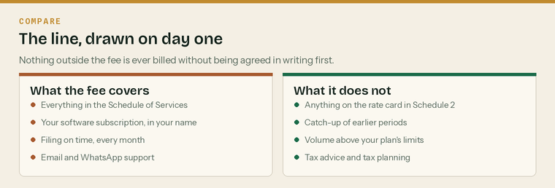
The line, drawn on day one, so nothing has to be renegotiated later.
Solo — £59 a month
In the monthly fee | Limit
Bank feed reconciled monthly | All accounts
Sales invoices raised from your job sheet or WhatsApp | 10 a month
Purchase receipts captured and coded | 50 items a month
CIS suffered recorded and reconciled to your statements | All
Chasing missing CIS statements from your contractors | 3 chases a month
Self Assessment prepared and filed, including the CIS reclaim | Once a year
Software subscription, in your name | Included
Monthly one-page summary | Every month
Email and WhatsApp support | Answered in 1 working day

Not included on Solo. VAT registration or returns · payroll of any kind · limited company accounts or CT600 · filing monthly CIS returns as a contractor · management accounts · mortgage references beyond issuing the SA302 · catch-up of prior years.
Start — £99 a month
Everything in Solo, plus:
Added on Start | Limit
VAT returns prepared and filed, reverse charge applied both ways | Every return
Sales invoices raised | 25 a month
Purchase items | 120 a month
Director-only payroll with RTI, if a limited company | 1 payslip a month
Year-end accounts and CT600, or Self Assessment for a sole trader | Once a year
Confirmation statement filed | Once a year
Quarterly call | 15 minutes

Not included on Start. Filing monthly CIS returns as a contractor · payroll beyond the director · CIS verification of subcontractors · management accounts · budgeting and forecasting · catch-up of prior years.
Trade — £199 a month
Everything in Start, plus:
Added on Trade | Limit
Subcontractor verification with HMRC | Unlimited
Monthly CIS returns prepared and filed on the 12th, nil returns included | Every month
Subcontractor payment and deduction statements issued by the 19th | 10 subcontractors
Materials and labour split checked on every subcontractor invoice | All
Payroll, RTI and the pension submission | 5 employees
Sales invoices raised | 60 a month
Purchase items | 300 a month
Retentions tracked on a separate schedule and reported | Monthly
Reverse charge on sales and purchases, end user declarations chased | All
Debtor list with a suggested chase order | Monthly
Management summary: turnover, margin, CIS, retentions, cash | Monthly
Call | 15 minutes a month

Not included on Trade. CITB levy returns · construction contract review · job costing beyond the monthly split · more than 5 employees · more than 10 subcontractors · catch-up of prior years · tax planning · anything requiring a site visit.
Pro — £329 a month
Everything in Trade, plus:
Added on Pro | Limit
Payroll | 15 employees
Subcontractors verified, deducted and statemented | 25
Sales invoices raised | Unlimited within reason
Purchase items | 700 a month
Job costing — cost and margin per job | Reported monthly
Applications for payment and valuations against the retention schedule | All
CIS suffered and deducted both reconciled | Monthly
Management accounts with a short written commentary | Monthly
Cash flow forecast | Rolled forward quarterly
Call | 30 minutes a month
Response on anything urgent, in working hours | Same day

Not included on Pro. CITB levy returns · audit · corporate finance · contract or legal review · site attendance · anything a chartered accountant is properly required for.
Schedule 2 — The rate card

This is our published price list for work outside the monthly fee. Nothing on it is ever billed without being agreed in writing first. You will never get a surprise invoice from us, but you will occasionally get a quote.
Work | Price
Gross payment status application, prepared and submitted | £195, free on Trade and Pro
Reverse charge setup and supplier review | £125, free at onboarding
Catch-up of prior-period books | £45/hour, capped at the quote
Additional subcontractor beyond the plan limit | £8 a month each
Additional employee on payroll beyond the plan limit | £6 a month each
Extra sales invoices beyond the plan limit | £1.50 each
CIS return for a month we did not do the bookkeeping | £45
Missed-return catch-up filing, per return | £35
Mortgage or lending pack beyond the SA302 | £75
Reference letter to a lender or main contractor | £45
Ad hoc management report, one-off | £120
Company formation | £150
VAT registration | £95
CIS registration as contractor or subcontractor | £65
HMRC enquiry support | £65/hour
Software migration from another package | £195
Out-of-scope work, general | £45/hour, in 15-minute units
Late records surcharge, after the 10th | £25

How out-of-scope work actually gets handled
The first time something falls outside the plan, we usually just do it and say nothing. The second time, we do it and tell you it sits outside. The third time it has stopped being a one-off, so we will offer you a choice: fold it into the monthly fee, or bill it as it comes. Either is fine. What we will not do is quietly resent it.

Schedule 3 — The limits of what we do

This section matters more than it looks. It is here so that nobody is relying on us for something we are not doing.
We are bookkeepers, not tax advisers
Nothing in this engagement is tax advice
We prepare and file returns from the records and information you give us. We will point out things we notice — a reverse charge coded wrongly, a CIS reclaim not asked for, a gross payment status application worth making. That is bookkeeping, not tax advice. We do not give tax planning advice, we do not advise on the structure of your business, and we do not advise on employment status determinations. Where you need any of those, we will say so and refer you to a chartered accountant, a tax adviser or a solicitor.

What we do not do
 | Audit |  | Corporate finance
 | Legal or contract review |  | Construction contract advice
 | Site attendance or measurement |  | CITB levy returns
 | Investment or pension advice |  | Employment law advice

What sits with a different professional
If you need | Go to | We will
Tax planning or a structure decision | A chartered accountant or tax adviser | Say so and refer you
A status determination you can rely on | An employment status specialist | Point you at CEST first
A contract read before you sign it | A construction solicitor | Tell you which clause worried us
An audit | A registered auditor | Hand over cleanly
Pension or investment advice | An IFA | Not comment at all

What we rely on you for
We rely on | Which means
The records being complete | We work from what you send. We cannot account for what we never see.
The records being on time | By the 10th. A late month is a rushed month.
You telling us when things change | A new subbie, a new employee, a new account, a VAT registration.
The information being accurate | We do not audit it and we are not required to. We will query anything that looks wrong.
Approval before filing | Nothing goes to HMRC without you approving it first.

Responsibility for the records, and for the returns made from them, remains yours. That is not us stepping back from the work — it is how the law allocates it, for every firm.
The three-strike rule on out-of-scope work
 | First time | We do it. Nothing is said about the fee.
 | Second time | We do it, and we tell you it sits outside the monthly.
 | Third time | We offer a choice: fold it in, or bill it as it comes.

Money laundering
We are required to verify your identity before we start, to keep that evidence for five years after the engagement ends, and to report knowledge or suspicion of money laundering. We are not permitted to tell you if we make such a report. This is the same for every supervised bookkeeper and accountant in the country.
Liability
Our liability to you for any claim is limited to £[CAP], except where liability cannot lawfully be limited — which includes death or personal injury caused by negligence, and fraud or fraudulent misrepresentation. We carry professional indemnity insurance; the Institute of Certified Bookkeepers requires a minimum of £50,000 for members in practice and our cover is £[PII COVER].
Set the liability cap and the insurance figure before you send this
A cap that is higher than the insurance is worth nothing, and a cap that is obviously unreasonable will not be enforceable under the Unfair Contract Terms Act 1977. Take advice on the number. This is one of the two clauses in the whole pack most worth paying a solicitor to look at.

Signing

By signing below you confirm that you have read this letter, the Schedule of Services, our Terms & Conditions and our Privacy Notice, and that you accept them. You also authorise Klyara to act as your agent with HMRC for the taxes named in Schedule 1.
 | Engagement letter read and signed |  | Terms & Conditions attached and read
 | Privacy Notice attached and read |  | Direct debit mandate set up
 | Identity documents sent |  | Schedule 1 plan confirmed

Signatures
The client | [Business name]
Signed | Print name
Position | Date
Klyara | [Name], for Klyara
Signed | Print name
Position | Date

Two copies. One back to us, one for your file.
Sources
Every figure and deadline in this document was checked against the page listed beside it on Wednesday 26 August 2026. Re-check before each use — thresholds and penalties change.
What was checked | Source
Scope, prices, limits and payment terms — the internal source of truth | docs/21-pricing-scope-and-quoting.md (Klyara internal)
Onboarding sequence this letter triggers | docs/12-client-onboarding-pack.md (Klyara internal)
ICB Practice Licence includes AML supervision, processed in 28 days | https://www.bookkeepers.org.uk/Running-a-Practice/Regulation/Practice-Licence
ICB minimum professional indemnity cover of £50,000, Rule 27 | https://www.bookkeepers.org.uk/out/262546/ICB-Professional-Conduct-Regulations.pdf
AML record retention — five years from the end of the relationship | https://www.gov.uk/guidance/money-laundering-regulations-your-responsibilities
CIS monthly return deadline and nil returns | https://www.gov.uk/what-you-must-do-as-a-cis-contractor/file-your-monthly-returns

