KLYARA the back office for building firms

New Client Questionnaire
Twenty minutes before we speak, so the call is about your business and not about admin.

WHAT THIS IS, AND WHAT IT IS NOT
This is not the onboarding form. Nothing here signs you up to anything and nothing here is binding. It is the set of questions we would ask you on the phone anyway — written down, so you can answer them at the kitchen table instead of on a site with a wagon reversing behind you.
Rough answers are fine
We are not checking your arithmetic. “About 300 grand” and “four or five subbies” are perfectly good answers. If you genuinely do not know, write do not know — that is useful information too, and it is often the most honest answer on the page.

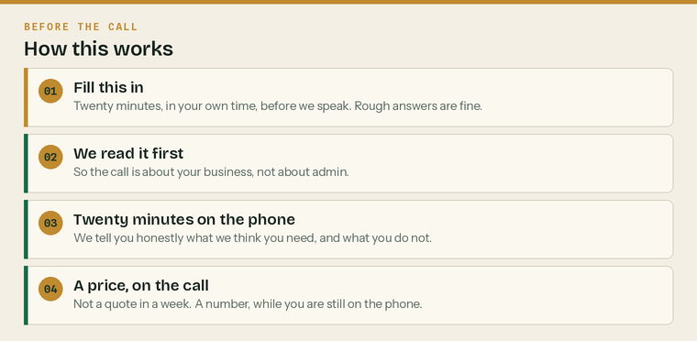
Fill it in, send it back, and we will have read it before we ring you.
What you get out of it
 | An honest read on what you actually need |  | A price on the call, not in a week
 | The things you do not need, named out loud |  | No obligation and no follow-up sequence

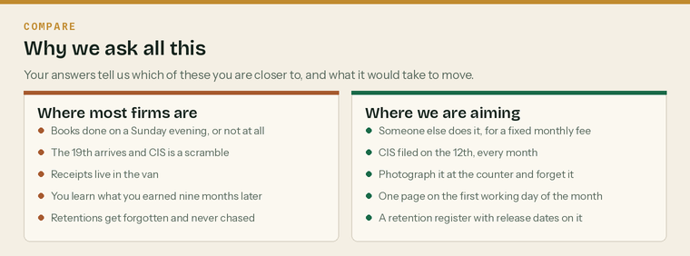
The answers below tell us which side of this you are closer to.
Part 1 — The business

Nine questions. They map exactly onto the twenty-minute call, so if you would rather just talk, ring 020 8058 1496 and we will do it that way instead.
1. Tell us about the business
What do you do, and how many are you?
Trade, roughly how many people, and whether you say we or I.

2. How you are set up
Structure
 | Sole trader |  | Partnership |  | Limited company |  | LLP

Trading name
Based where | town is enough
How far you travel for work
Trading since | roughly

3. Who does the books at the moment
Who does them
 | Me |  | My partner or family |  | An accountant
 | A bookkeeper |  | Nobody, really

And when do they get done?
Evenings, Sunday afternoons, or the week before the deadline. There is no wrong answer.

If it is your wife, husband or partner doing them, say so
It changes the conversation and it changes what we suggest. We are not here to tell anybody they have been doing it wrong. Most of the time they have been doing it perfectly well and would simply rather have their Sundays back.

4. Turnover
Roughly last year
 | Under £85k |  | £85k - £250k |  | £250k - £500k
 | £500k - £1m |  | £1m - £2m |  | Over £2m

Is that figure
 | Gross, before CIS |  | Net, after CIS |  | Not sure

This is the single most useful question on the page. It sets which plan fits, whether Making Tax Digital for Income Tax applies to you, and — if CIS comes off you — whether you are sitting on a reclaim you have not asked for.
5. CIS
CIS is deducted from you
 | Yes |  | No |  | Not sure

You deduct CIS from others
 | Yes |  | No |  | Not sure

If both, how many subbies
 | 1-3 |  | 4-10 |  | 11-25 |  | More than 25

Both is the normal answer
Most building firms are in the middle of the chain — CIS comes off them from the main contractor and they take it off their own subbies. If that is you, monthly CIS returns are part of your life whether anybody has told you or not, and that puts you on Trade at a minimum.

6. VAT
VAT registered
 | Yes |  | No |  | About to be |  | Not sure

Reverse charge
 | Using it both ways |  | Sales only |  | Not using it |  | Never heard of it

Ask us about the reverse charge on the call even if you are confident. About half the firms we look at have it wrong in one direction, and it is usually worth money rather than costing it.
7. What annoys you most
The bit of the admin that actually gets to you
It is almost never tax. It is usually chasing money, or evenings, or not knowing where you stand.

8. Two more, if you have a minute
How do people find you at the moment?

Is anybody missing your calls while you are on site?

Part 2 — Volume, and what it tells us

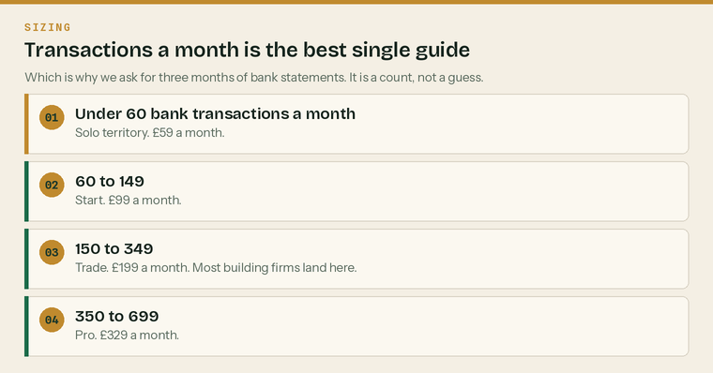
Transactions a month is the best single predictor of what the work takes.
9. Roughly how much goes through the bank
Transactions a month, all accounts
 | Under 60 |  | 60 - 149 |  | 150 - 349
 | 350 - 699 |  | 700+ |  | No idea

Business bank accounts | how many
Business credit cards | how many
Sales invoices you raise a month | roughly
Purchase receipts a month | roughly

If you do not know, send three months of statements instead
We will count them. It takes ten minutes and it is the difference between a real price and a guess. Nobody has ever been quoted higher because they were honest about the volume, and plenty have been quoted lower.


The four plans. Where you land is driven by volume and by whether you pay subbies.
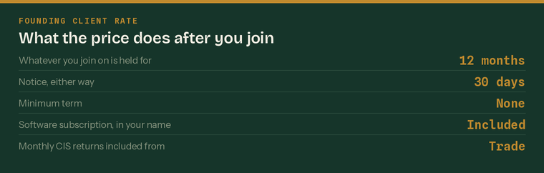
What the price does after you join. There is no introductory trick here.
Anything else we should know
Anything at all — a mess you would rather flag now, a deadline coming up, a bad experience with a previous firm
Especially the mess. It is much cheaper to price it than to discover it.

Where to send it
Email it to hello@klyara.com, or take a photograph of each page on your phone and send those. A photograph is completely fine.
Your name
Best number
Best time to ring
Date

What happens after you send this
We read it, we look you up on Companies House and on the trade sites, and we ring you at the time you asked for. Twenty minutes. We tell you what we think you need, what you do not need, and a price. If it is not us, we will tell you that too and it costs you nothing.

