KLYARA the back office for building firms

Offer Letter
Short, warm and correct. The formal terms follow on the first day.

HOW TO USE THIS
Replace everything in [square brackets] and delete this page before you send it. Keep the letter to one page. An offer letter that reads like a contract makes a good candidate nervous; the contract itself comes on day one and does the legal work.
Two things an offer letter must do, and one it must not
It must name the job, the money and the start date, and it must say what is conditional — the right-to-work check and, if you use them, references. What it must not do is set out every term, because the written statement of employment particulars does that on the first day and the two must not contradict each other.

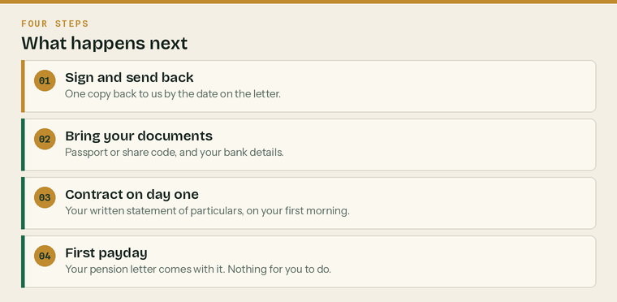
What happens after they say yes. Four steps, and two of them are ours.
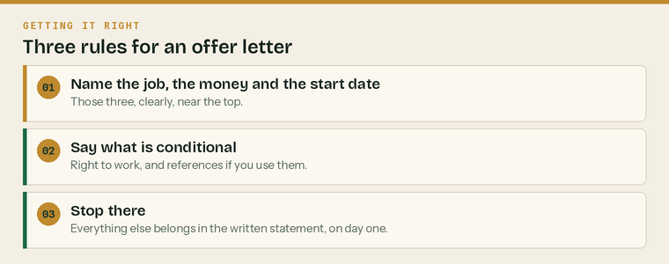
Three rules. An offer letter that follows them is very hard to get wrong.
Before you send it
 | Salary agreed and affordable |  | Start date agreed with them
 | Employers' liability insurance arranged |  | Right-to-work check booked in

The rest of the hire checklist — HMRC registration, the pension scheme, the written statement — is in the Employment Contract and Hire Pack.
The letter

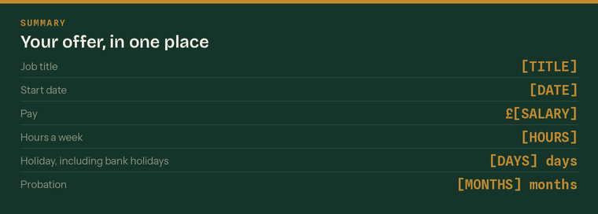
Fill this in first. Everything in the letter has to match it.
Candidate name
Address
Date of the letter
Reply by | give them at least a week

Dear [First name],
An offer — [Job title] at Klyara
We would like you to join us. Thank you for the time you have given to this; it was an easy decision.
Here is the offer, in plain terms.
The offer | Detail
Job title | [Job title]
Reporting to | [Name and role]
Start date | [Date]
Salary | £[Salary] a year, paid monthly on the [date]
Hours | [Hours] a week, [days]
Place of work | [Address], with [x] days a week from home
Holiday | [Days] days a year, including bank holidays
Probation | [x] months
Pension | Auto-enrolment from your start date, with our contribution at [x]%

Two conditions, and they are the usual ones. This offer depends on us seeing evidence of your right to work in the UK before your first day — a passport, or a share code, whichever is easier for you. And on [two references / a reference from your current employer]. Neither is a formality we expect any trouble with; they are simply things every employer has to do.
What happens next. If you are happy, sign the copy enclosed and send it back by [date]. Bring your passport or share code and your bank details on your first morning. Your written statement of employment particulars — the formal terms — will be given to you on your first day, as the law requires.
What your first week looks like. [One or two sentences. Who is meeting them, what they will be doing, and one thing to look forward to. Keep it specific and keep it short.]
If you want to talk anything through before you decide, ring me on 020 8058 1496. Ask about anything, including the things people usually feel awkward asking about.
We are looking forward to it.
Yours sincerely,

[Name]
Klyara
Acceptance

Sign and return one copy. Keep the other.
I accept the offer of employment set out in this letter on the terms stated. I confirm that I have the right to work in the UK and that I will provide evidence of it before my first day.
Start date I am accepting
Any notice I have to give my current employer
Anything already booked that I need time off for | holidays, appointments — tell us now, it is fine

Signatures
The candidate | [name]
Signed | Print name
Position | Date
Klyara | [name], for Klyara
Signed | Print name
Position | Date

If they say no
What they say | What to do
The money is not enough | Decide your ceiling before you ring back, not during the call
They have another offer | Ask what would make yours the better one. Then decide honestly.
They need more time | Give a date, not an open ended wait
Nothing — silence | One call, one email, then move on

A note on tone
This letter is warm because warmth costs nothing and because the first impression of an employer is set here, not on the first day. It is also short, because everything binding is in the written statement.
Three things not to put in an offer letter
 | A bonus you have not decided how to calculate | It becomes contractual the moment you write it
 | A promise about promotion or a pay review | Unless you mean it, in writing, with a date
 | Every term of employment | That is the written statement's job, on day one

Sources
Every figure and deadline in this document was checked against the page listed beside it on Wednesday 26 August 2026. Re-check before each use — thresholds and penalties change.
What was checked | Source
Written statement is due on the first day | https://www.gov.uk/employment-contracts-and-conditions/written-statement-of-employment-particulars
Right-to-work check before employment begins | https://www.gov.uk/check-job-applicant-right-to-work
Auto-enrolment duties start date | https://www.gov.uk/workplace-pensions-employers
Holiday: 5.6 weeks, and bank holidays | https://www.gov.uk/holiday-entitlement-rights

