KLYARA the back office for building firms

Privacy Notice
What we hold about you, why we are allowed to, how long we keep it, and what you can make us do about it.

Read this before you use this document
This is a working template. It has been drafted carefully and checked against the sources listed at the end, but it is not legal advice and it has not been settled by a solicitor. Have it reviewed by a solicitor, or by the Institute of Certified Bookkeepers, before you issue it to anybody. And it cannot be used to take on a bookkeeping client until Klyara's AML supervision is in place — an ICB Practice Licence includes AML supervision and takes about 28 days to process. Until that licence is granted, Klyara cannot lawfully carry on bookkeeping by way of business.

One extra thing to check before this is published
The Data (Use and Access) Act 2025 changed parts of UK data protection law, and the ICO's own guidance pages carry a note saying they are under review because of it. The substance below — the lawful bases, the rights, the one-month deadline — is unchanged, but re-read the ICO pages listed in the Sources before this notice goes on the website, and again every twelve months.

WHO THIS IS ABOUT
This notice explains what Klyara does with personal information. It covers our clients, the people who work for our clients, people who enquire about us, our own staff and our own subcontractors. If you deal with us in any way, this applies to you.
We are the data controller for the information described here. That means we decide what is collected and why, and we are the ones you hold responsible for it.
Who we are | Klyara
Address | [registered address]
Email | hello@klyara.com
Telephone | 020 8058 1496
ICO registration number | [to be completed once registered]
Who to ask about your data | [name], hello@klyara.com

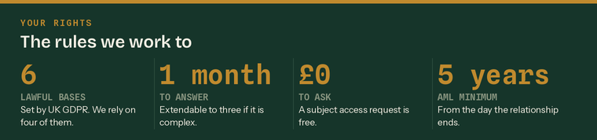
The four numbers that matter most in this notice.
This notice in six lines
 | We hold what we need to do your books | And the identity evidence the law requires
 | We never sell it, to anybody | There is no exception to that one
 | Most of it is held to perform our contract | The rest is a legal obligation
 | We keep it for five or six years | Both periods are set by law
 | You can see it, correct it, and object | Free, and within one calendar month
 | The ICO is there if we get it wrong | 0303 123 1113

What we hold, and where it comes from

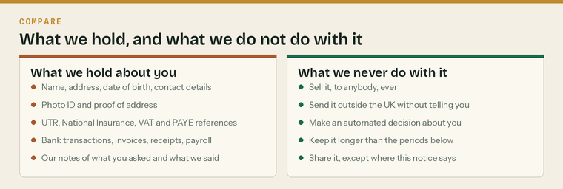
Everything we hold, and the five things we will not do with it.
What we collect
Category | What that means in practice
Who you are | Name, date of birth, home and business address, phone, email
Identity evidence | Passport or driving licence, proof of address, the result of the electronic check
Tax references | UTR, National Insurance number, VAT number, PAYE and Accounts Office references
Financial records | Bank transactions, invoices, receipts, CIS statements, retentions, loans and finance
Payroll data | For your employees — pay, tax codes, National Insurance, pension, absence
Subcontractor data | UTR, verification number, deduction rate, insurance, right to work
Correspondence | Emails, WhatsApp messages, call notes, and our notes of what we advised
Website and marketing | What you filled in on a form, and how you found us

Where it comes from
 | From you | Most of it. On the intake form, in emails, in your records
 | From your bank | Through the bank feed you connect. Read-only.
 | From HMRC | Where we act as your agent
 | From Companies House | Public record
 | From identity and sanctions screening providers | The result of the check we run
 | From your employees and subcontractors | Where you pass their details to us to run payroll or CIS

Special category data, and criminal offence data
We do not normally hold health data, and we do not ask for it. Where payroll requires it — statutory sick pay, maternity or paternity pay, a disability adjustment — we hold only what the payroll needs, we rely on the employment-law condition in Schedule 1 of the Data Protection Act 2018, and we keep it separately from everything else.

Why we are allowed to hold it

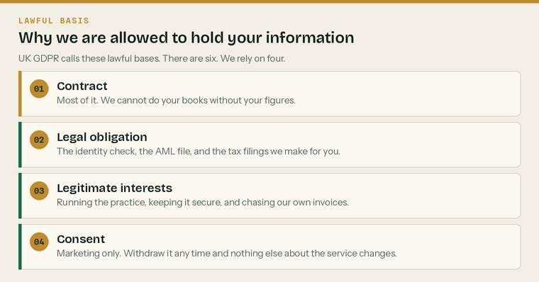
UK GDPR calls these lawful bases. There are six. We rely on four of them.
UK GDPR requires us to have a lawful basis for every use of your information, to write it down, and to tell you what it is. This is where we tell you.
What we do with it | Our lawful basis | The detail
Keeping your books, filing your returns | Contract | We cannot do the work we agreed to do without it
Verifying your identity, keeping the AML file | Legal obligation | Money Laundering Regulations 2017
Filing with HMRC and Companies House | Legal obligation | Tax and company law
Running your payroll | Legal obligation | PAYE, National Insurance and pension law
Invoicing you, and chasing our own invoices | Legitimate interests | Running the practice. We have weighed this against your interests.
Keeping our systems and records secure | Legitimate interests | Preventing fraud and protecting everybody's data
Keeping records after you leave, for the periods below | Legal obligation | AML five years, tax records six years
Sending you marketing you asked for | Consent | Withdraw it any time. Nothing about the service changes.

Where we rely on legitimate interests, you can object
Legitimate interests is the only basis above that you can push back on directly. If you object, we have to stop unless we can show compelling grounds that override your interests. Tell us and we will look at it properly, in writing, within one month.

The two bases we do not rely on are vital interests — protecting somebody's life — and public task. Neither applies to a bookkeeping practice.
How we keep it safe

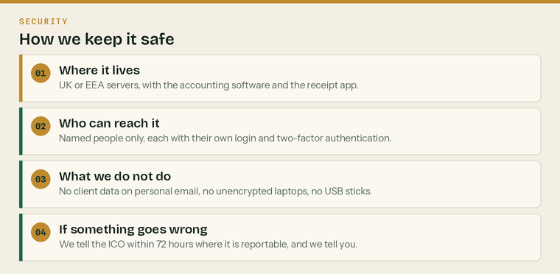
Four things, and the fourth is the one that matters when something goes wrong.
Control | What it means here
Access | Named people only, each with their own login
Two-factor authentication | On every system that holds client data
Encryption | Devices encrypted, and data encrypted in transit
Backups | Held by the software providers, in the UK or EEA
Devices | No client data on personal email, personal storage or USB sticks
Leavers | Access removed the day somebody stops working with us
Breaches | Reported to the ICO within 72 hours where reportable, and to you

A breach is not always a hack
The commonest personal data breach in a bookkeeping practice is an email sent to the wrong person. We treat that as seriously as anything else: it gets logged, assessed against the 72-hour reporting threshold, and told to you if it is likely to affect you.

Who we share it with

We do not sell your information to anybody, and we never will. We share it only with the organisations below, and only as much of it as they need.
Who | Why | What they get
HMRC | Filing your returns as your agent | What the return requires
Companies House | Accounts and confirmation statements | What the filing requires
Your accounting software provider | The subscription is in your name | Your records
Receipt capture provider | Processing what you photograph | Your receipts
Identity and sanctions screening provider | The AML check | Name, address, date of birth, ID
Your pension provider | Auto-enrolment submissions | Payroll data for your staff
Our own insurers and professional advisers | If there is a claim or a dispute | Only what is relevant
The Institute of Certified Bookkeepers | Practice inspection and AML supervision | Files selected for review
The National Crime Agency | If we are required to report | What the report requires
Your new bookkeeper or accountant | If you leave and ask us to hand over | Your records

Two things about sharing that are worth saying plainly
We keep everything on servers in the United Kingdom or the European Economic Area. If that ever changes we will tell you and we will put the required safeguards in place first. And we cannot tell you if we make a report to the National Crime Agency — that is a criminal offence, for every supervised firm, and it is the one exception to everything else in this notice.

How long we keep it

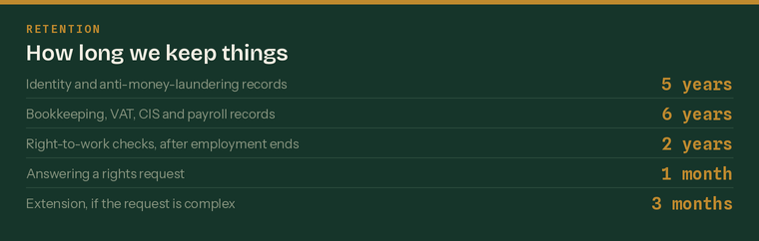
The retention periods. Two of them are set by law and we cannot shorten them.
What | How long | Why
Identity and AML records | 5 years after the relationship ends | Money Laundering Regulations 2017
Bookkeeping, VAT and CIS records | 6 years after the end of the period | Tax law, and the limitation period
Payroll records | 6 years after the tax year they relate to | PAYE requirements
Right-to-work checks | 2 years after employment ends | Home Office requirement
Correspondence and file notes | 6 years after the engagement ends | Limitation period
Enquiries that did not become clients | 12 months | So we do not hold what we do not need
Marketing consents | Until you withdraw them, then a record that you did | Proof of the withdrawal

The five years is not negotiable, and neither is the six
If you ask us to delete everything, we will delete what we can and we will keep the AML file for five years and the tax records for six. That is a legal obligation, not a preference. We will tell you exactly what we have kept and why.

Your rights

UK GDPR gives you rights over your information. They are not absolute — some of them do not apply where we have a legal obligation to keep something — but they are real, they are free to use, and we will answer within one calendar month.
Your right | What it means | Any limit
To be informed | To know what we hold and why. This notice is that. | None
Of access | To get a copy of what we hold about you | Free. One month.
To rectification | To have anything wrong corrected | None
To erasure | To have information deleted | Not where the law requires us to keep it
To restrict processing | To make us stop using it while something is sorted out | Limited grounds
To data portability | To get it in a machine-readable form, or moved | Only for contract and consent data
To object | To stop processing based on legitimate interests or marketing | Marketing objection is absolute
About automated decisions | Not to be subject to a decision made purely by a machine | We do not make any

How to use any of them
Email hello@klyara.com and say what you want. You do not need to use any particular words, you do not need to mention GDPR, and there is no fee. We will answer within one calendar month from the day we receive it. If the request is complex, or if you make several at once, we may extend that to three months — and if we do, we will tell you within the first month and tell you why.

What we may ask you for
Proof of who you are, if we are not sure
Which information you mean, if it is a wide request
Nothing else — and never a reason

If you are not happy

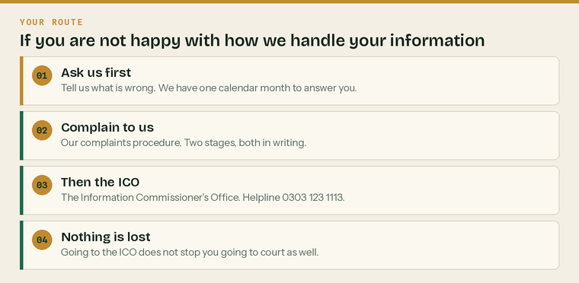
Four steps. Most people stop at the first one.
Tell us first. Email hello@klyara.com or ring 020 8058 1496. Most data questions are a misunderstanding and are cleared up the same day.
Then use our complaints procedure. It is a separate document, it is on our website, and it is two stages: acknowledged in three working days, answered in ten, reviewed by a second director within twenty if you are not satisfied.
Then the Information Commissioner's Office
You can complain to the ICO at any point, including before you have finished with us — but the ICO will normally ask whether you have raised it with us first, so it is worth doing that.
The ICO | Details
Helpline | 0303 123 1113
Website | ico.org.uk/make-a-complaint
Post | Information Commissioner's Office, Wycliffe House, Water Lane, Wilmslow, Cheshire, SK9 5AF
Cost | Free

Going to the ICO does not use up your other options
You can complain to the ICO and still take a claim to court for compensation if you have suffered damage or distress. One does not replace the other.

Two things we will never ask you for
 | Your Government Gateway password | We act as your agent through HMRC's agent services
 | Your online banking password | The bank feed is read-only and you authorise it yourself

Changes to this notice
We review this notice at least once a year, and whenever we change what we do with information. The current version is always on klyara.com. If we make a material change we will tell you directly rather than expecting you to notice.
Version | 1.0 — draft, not yet issued
Written | Wednesday 26 August 2026
Next review due | [one year from issue]
Approved by | [name]

Sources
Every figure and deadline in this document was checked against the page listed beside it on Wednesday 26 August 2026. Re-check before each use — thresholds and penalties change.
What was checked | Source
The six UK GDPR lawful bases, and the duty to document and publish them | https://ico.org.uk/for-organisations/uk-gdpr-guidance-and-resources/lawful-basis/a-guide-to-lawful-basis/
Individual rights under UK GDPR | https://ico.org.uk/for-organisations/uk-gdpr-guidance-and-resources/individual-rights/
One calendar month to respond, extendable to three if complex | https://ico.org.uk/for-the-public/time-limits-for-responding-to-data-protection-rights-requests/
How a person complains to the ICO, and what they need first | https://ico.org.uk/make-a-complaint/data-protection-complaints/
ICO helpline 0303 123 1113 | https://ico.org.uk/make-a-complaint/data-protection-complaints/
ICO head office postal address, Wycliffe House, Wilmslow | https://ico.org.uk/about-the-ico/who-we-are/directions-head-office/
Every organisation using personal information must pay the data protection fee | https://ico.org.uk/for-organisations/data-protection-fee/
AML records — five years from the end of the relationship or the transaction | https://www.gov.uk/guidance/money-laundering-regulations-your-responsibilities
Right-to-work copies kept for the employment plus two years | https://www.gov.uk/check-job-applicant-right-to-work

